­

# Owner’s Manual

Fan-aspirated Radiation Shield

Models TS-100/110/120/130

Rev: 5-Nov-2021

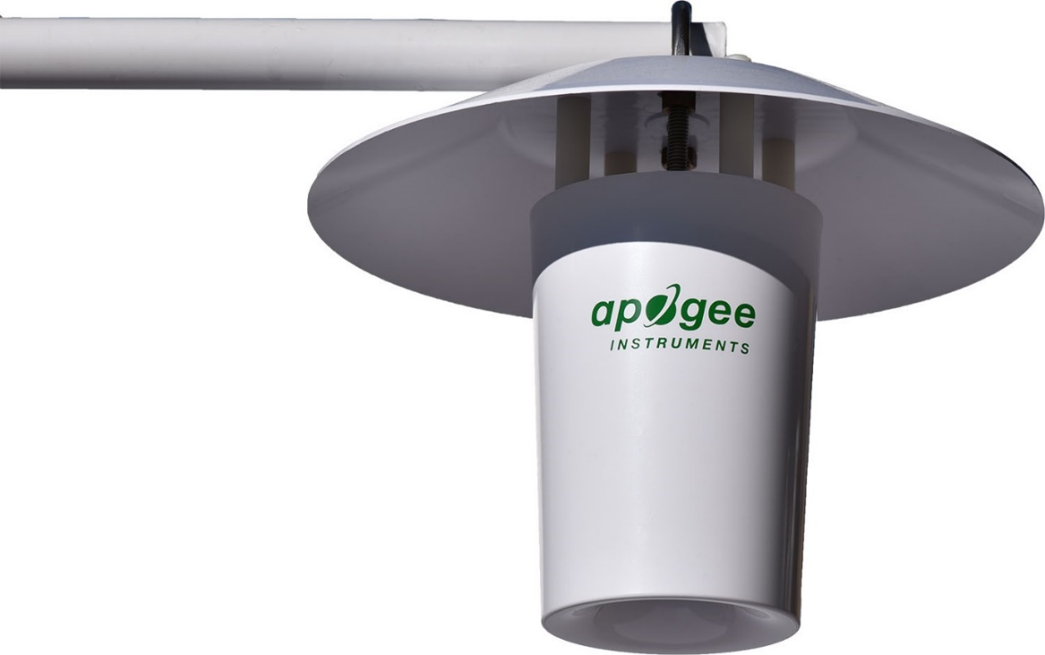

# Table of Contents

Owner’s Manual 1

Table of Contents 2

Certificate of Compliance 3

Introduction 4

Sensor Models 5

Specifications 6

Deployment and Installation 9

Cable Connectors 10

Operation and Measurement 11

Maintenance and Recalibration 15

Troubleshooting and Customer Support 16

Return and Warranty Policy 18

### Certificate of Compliance

**EU Declaration of Conformity**

This declaration of conformity is issued under the sole responsibility of the manufacturer:

Apogee Instruments, Inc.  
721 W 1800 N  
Logan, Utah 84321  
USA

for the following product(s):

Models: TS-100, TS-110, ST-110, ST-300   
Type: Fan-aspirated Radiation Shield and Temperature Sensor

The object of the declaration described above is in conformity with the relevant Union harmonization legislation:

2014/30/EU Electromagnetic Compatibility (EMC) Directive

2011/65/EU Restriction of Hazardous Substances (RoHS 2) Directive

2015/863/EU Amending Annex II to Directive 2011/65/EU (RoHS 3)

Standards referenced during compliance assessment:

EN 61326-1:2013 Electrical equipment for measurement, control, and laboratory use – EMC requirements

EN 50581:2012 Technical documentation for the assessment of electrical and electronic products with respect to the restriction of hazardous substances

Please be advised that based on the information available to us from our raw material suppliers, the products manufactured by us do not contain, as intentional additives, any of the restricted materials including lead (see note below), mercury, cadmium, hexavalent chromium, polybrominated biphenyls (PBB), polybrominated diphenyls (PBDE), bis (2-ethylhexyl) phthalate (DEHP), butyl benzyl phthalate (BBP), dibutyl phthalate (DBP), and diisobutyl phthalate (DIBP). However, please note that articles containing greater than 0.1% lead concentration are RoHS 3 compliant using exemption 6c.

Further note that Apogee Instruments does not specifically run any analysis on our raw materials or end products for the presence of these substances, but we rely on the information provided to us by our material suppliers.

Signed for and on behalf of:

Apogee Instruments, November 2021



Bruce Bugbee  
President  
Apogee Instruments, Inc.

### Introduction

Properties of materials and nearly all biological, chemical, and physical processes are temperature dependent. Temperature is also a fundamental weather variable. As a result, temperature is perhaps the most widely measured environmental variable.

Fan-aspirated radiation shields are designed to shield temperature and humidity sensors from incident solar radiation while maintaining equilibrium with ambient air through active aspiration by a fan. Typical applications of fan-aspirated radiation shields include air temperature and humidity measurements in weather networks, often for weather forecasting. In addition, air temperature and humidity are critical input variables for calculation of evapotranspiration and irrigation scheduling. Fan-aspirated shields are also important in the precise measurement of air temperature and humidity gradients above the land surface.

Apogee Instruments model TS-100 fan-aspirated radiation shields are made from high-quality injection-molded plastic with low thermal conductivity, maximum weather resistance, and a gloss white finish for high reflectivity. The small size makes it easy to work with and reduces the surface area exposed to incoming radiation. The shield is designed as a lightweight, low power, and low-cost alternative to other fan-aspirated and naturally aspirated (passive) shields for air temperature and humidity measurements. The efficient, low-power fan draws ambient air into the shield using a rocket nozzle contour to maximize airflow around the internal sensors. The curved inlet helps draw air into the shield during high cross winds. These unique properties make the TS-100 ideal for use in remote locations with limited power supply.

The TS-100 does not come packaged with any other sensors to accommodate users using other probes, however, TS-100 shields are designed to optionally accommodate PRTs with a custom adapter. Apogee strongly recommends using the ST-110 and recommends the TS-110 fan-aspirated radiation shield package, which comes with a precision air temperature sensor (model ST-110, thermistor). ST-110 air temperature sensors are weatherproof, have excellent long-term stability, and are designed for continuous air temperature measurement when housed in the TS-100. ST-110 thermistors offer improved accuracy over thermocouples because they do not require accurate measurement of datalogger panel temperature. The advantages of thermistors over platinum resistance thermometers (PRTs) are high signal-to-noise ratio, requirement of only a single-ended channel for measurement, and lower cost. Accelerated aging tests indicate that the epoxy-encased ST-110 thermistor has a long-term stability equal to more expensive reference PRTs.

In 2019, Apogee added two additional sensor packages. The TS-120 package includes a TS-100 and an EE08 air temperature/RH probe manufactured by E + E Elektronik in Austria. The version sold by Apogee Instruments (Apogee model number EE08-SS) includes a M12 stainless steel connector and custom cable with a ninety-degree connector that optimizes the fit of the probe inside the Apogee TS-100 fan-aspirated radiation shield. The EE08-SS offered by Apogee includes the proprietary coating from E + E Elektronik for the relative humidity sensing element that provides maximum long-term stability. Additionally, the temperature and RH sensing elements are protected by a stainless-steel filter for maximum long-term stability. The TS-130 package includes a TS-100, EE08-SS, and ST-110. Apogee Instruments also offers a 24 V DC fan option for purchase.

Measurement errors due to thermal conduction of heat to the sensor are minimized by reflective white heat shrink tubing and shading of lead wire on the north side of the shield (in the northern hemisphere; south side of shield in southern hemisphere). Thermal conductivity to the precision thermistor is further minimized by using constantan wire, which has twenty-fold lower thermal conductivity than copper wire.

### Sensor Models

TS-100 fan-aspirated radiation shields accommodate multiple air temperature and humidity sensors using sensor port adapters. The following standard port adapter options are available (probes not included, the TS-110 includes the ST-110 thermistor, the TS-120 includes the EE08-SS humidity probe, the TS-130 includes both the EE08-SS and ST-110):

Apogee Instruments model ST-110 (thermistor for air temperature)

Apogee Instruments model EE08-SS (probe for air temperature and humidity)

Apogee Instruments model ST-300 (PRT option for air temperature)

Campbell Scientific model CS215 (probe for air temperature and humidity)

Vaisala models HMP155, HMP110, and HMP60 (probes for air temperature and humidity)

Rotronic model HC2-S3* (probe for air temperature and humidity)

E + E models EE071 (probes for air temperature and humidity)

All sensor port adapters can hold an ST-110 or ST-300 (user selected) air temperature sensor and a temperature/humidity probe (if desired).

A fan-aspirated shield’s model and serial number are printed on a white heat-shrink label located near the pigtail leads on the fan cable. If you need the manufacturing date of your sensor, please contact Apogee Instruments with the serial number of your sensor.

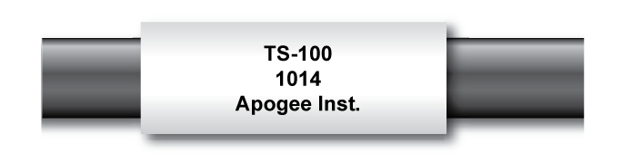

A temperature sensor’s model number and serial number are located near the pigtail leads on the sensor cable. If you need the manufacturing date of your sensor, please contact Apogee Instruments with the serial number of your sensor.

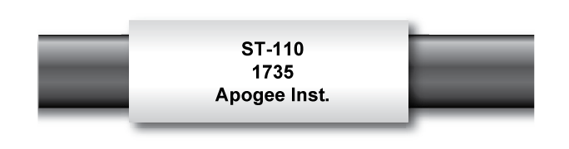

**EE08-SS:** A sensor’s model number and serial number are located on the probe body between the connector and filter cap.

*If the Rotronic HC2-S3 probe is used with the E3 Active Set module, it must be water-proofed before use with the Apogee TS-100 radiation shield. The E3 Active Set module is not waterproof (water can infiltrate at the point where the cable enters the housing). A small length of water-proof heat shrink (ATUM heat shrink) can be used to seal the gasket where the cable enters the housing for the E3 Active Set. For more detail, contact technical support at Apogee Instruments: <mailto:techsupport@apogeeinstruments.com>

### Specifications

**TS-100/110/120/130**

**Radiation-induced Temperature Increase (RITI):**

There is no reference standard for the elimination of radiation effects on air temperature measurement, but well-designed fan-aspirated shields minimize this effect. In the absence of a standard, radiation-induced temperature increase (RITI) was analyzed in long-term experiments over snow and grass surfaces by comparing temperature measurements from nine replicate Apogee Instruments model TS-100 shields to measurements from two replicate fan-aspirated shields from Met One (model 076B) and two replicate fan-aspirated shields from R. M. Young (model 43502). Comparisons among shields were made with ST-110 thermistors in all shields. Despite careful placement of shields away from each other and the tower (see photo below), and filtering for wind direction, these experiments indicate that there is more variability among replicate shields (± 0.1 C) of the same model than between models of shields (± 0.05 C), thus there is no statistical difference among the three models of shields.

Field tests indicate that low wind speed has a greater effect on RITI than high radiation load. For conditions of solar radiation greater than 800 W m-2 and wind speeds less than 2 m s-1, the mean of the model TS-100 shields has been within 0.05 C of the means of the other two models of shields. At higher wind speeds, the TS-100andR. M. Young shields read slightly cooler (-0.05 C) than the mean of the Met One shields, but the difference is not statistically significant.

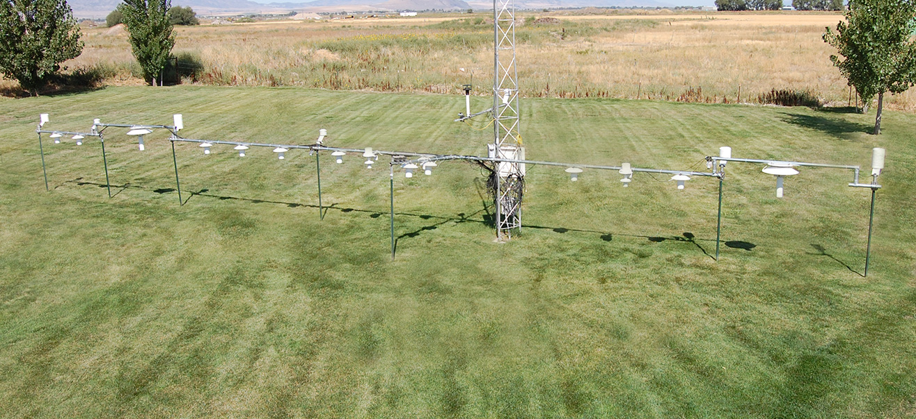

|  |  |
| --- | --- |
|  | **TS-100/110/120/130** |
| Difference among Individual Replicate Shields | Less than 0.1 C |
| Aspiration Rate | 6 m s-1 at full-speed; 3 m s-1 at half-speed |
| Fan Input Voltage Requirement | 10.8 to 13.2 V DC |
| Fan Current Draw | 80 mA at full-speed; 25 mA at half-speed |
| Fan Dust and Water Protection | IP55* |
| Operating Temperature | -40 to 70 C |
| Dimensions | 220 mm height, 270 mm diameter |
| Mass | 840 g |
| Cables | 5 m of shielded, twisted-pair wire for fan and air temperature sensors; TPR jacket (high water resistance, high UV stability, flexibility in cold conditions); pigtail lead wires; stainless steel (316), M8 connector located 25 cm from sensor head |

**\*IP55**

The fan inside the TS-100 is extremely well sealed against water and dust, with an ingress protection (IP) rating of 55, called IP55. Higher numbers indicate better protection. Fans typically range from IP11 to IP55. The first digit in the IP rating indicates protection against particle entry. A 5 indicates minimal dust entry with no interference with fan operation. The second digit indicates water protection. A 5 indicates that water sprayed on the fan from any direction shall have no harmful effects. Typical fans have particle and water protection ratings of 2 to 3, indicating moderate particle and water protection, but no dust protection. Apogee Instruments also offers a 24 V DC fan option for purchase.

**ST-110 (Precision Thermistor, not included w/ TS-100 or TS-120; included w/ TS-110 & TS-130)**

|  |  |
| --- | --- |
|  | **ST-110** |
| Measurement Range | -50 to 70 C |
| Measurement Uncertainty | 0.1 C (from 0 to 70 C); 0.15 C (from -35 to 0 C) |
| Measurement Repeatability | less than 0.01 C |
| Non-stability  (Long-term Drift) | less than 0.02 C per year (when used in non-condensing environments where the annual average temperature is less than 30 C; continuously high temperatures or continuously humid environments increase drift rate) |
| Equilibration Time | 5 s |
| Self-Heating | less than 0.01 C (typical, assuming pulsed excitation of 2.5 V DC); 0.08 C at 5 C (maximum, assuming continuous input excitation of 2.5 V DC |
| Operating Environment | -50 to 70 C; 0 to 100 % relative humidity |
| Input Voltage Requirement | 2.5 V DC excitation (recommended, see (OPERATION AND MEASUREMENT section) |
| Output Voltage Range | 0 to 2.5 VDC (assuming continuous input excitation of 2.5 V DC) |
| Current Drain | 0.1 mA DC at 70 C (maximum, assuming continuous input excitation of 2.5 V DC) |
| Dimension | 70 mm length; 2 mm diameter |
| Mass | 60 g |

**EE08-SS (Air Temperature and Humidity Probe, not included w/ TS-100 or TS-110; included w/ TS-120 & TS-130)**

|  |  |
| --- | --- |
|  | **EE08-Probe** |
| Input Voltage | 7 to 30 V DC |
| Current Draw | Less than 1.3 mA |
| Start-up Time | 2 s |
| Housing | Polycarbonate, IP65 |
| Filter | Stainless steel wire mesh, 30-micron pore size |
| Connector | M12, IP67 |
| Dimensions | 83 mm length, 12 mm diameter |
| Mass with 5 m Cable | 270 g |
| Operating Environment | -40 to 80 C; 0 to 100 % relative humidity |
| Cable | M12 connector (IP67 rating) to interface to sensor housing, 5 m of four conductor, shielded, twisted-pair wire (10 m and 20 m cables also available), white TPR jacket (high water resistance, high UV stability, flexibility in cold conditions), pigtail lead wires |
| Warranty | 1 year against defects in materials and workmanship |
|  | **Temperature Measurement** |
| Sensor | PT1000 (Class A) |
| Measurement Range | -40 to 80 C |
| Output Signal range | 0 to 2.5 V DC |
| Accuracy at 20 C | ± 0.2 C |
| Long-term Stability | Less than 0.1 C per year |
| Time Constant | Less than 30 s |
|  | **Relative Humidity Measurement** |
| Sensor | Capacitance Chip |
| Measurement Range | 0 to 100 % |
| Output Signal Range | 0 to 2.5 V DC |
| Accuracy at 20 C | ± 2 % from 0 to 90 %; ± 3 % from 90 to 100 % |
| Temperature Response | Less than -0.05 % per C |
| Long-term Stability | Less than 1 % per year |
| Time Constant | Less than 30 s |

### Deployment and Installation

TS-100 fan-aspirated radiation shields come partially pre-assembled and has few parts, facilitating easy transport, deployment, and maintenance.

Avoid placing the shield near buildings, paved surfaces, or any other locations which may create a micro-environment significantly different than ambient environment. The World Meteorological Organization (WMO) recommends a mounting height of 1.25 to 2 meters above ground. Air temperature typically decreases with increasing height above the ground surface.

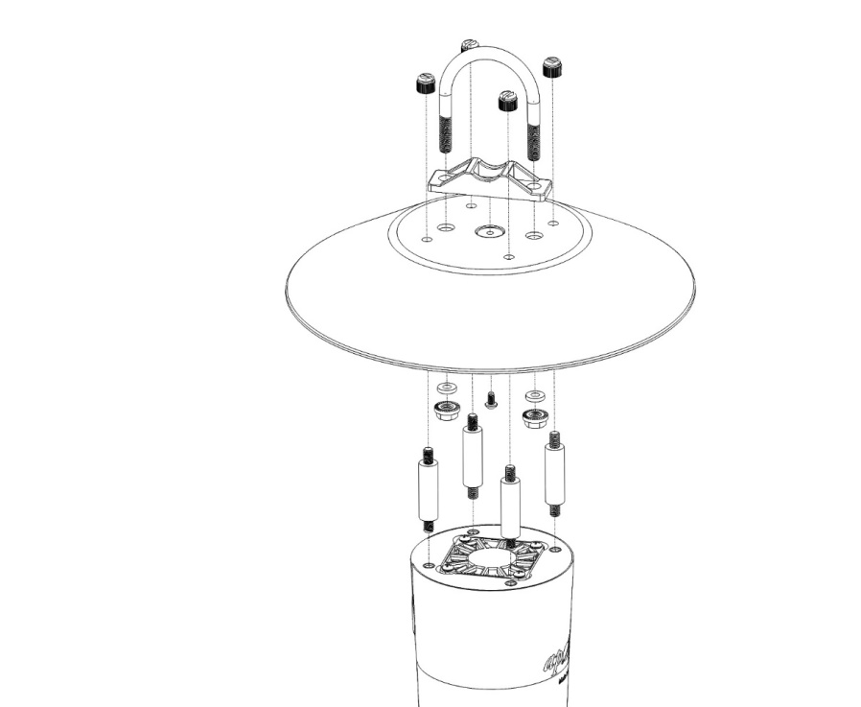The shield is designed to hang from a standard IPS horizontal pipe ranging from 1¼ inch (32 mm) to 2 inch (51 mm) in diameter. Attach the hat to the pipe with the U-bolt, nuts, and rubber washers provided (see diagram at left). Then, insert the shorter threaded end of the nylon standoffs into the shield body. Once in place, align the other end of the standoffs to the four corresponding holes in the hat and secure with nylon nuts. **Ensure that the *sensor port* (the hole in the side of the shield where the air temperature and/or humidity probe mounts) faces the nearest global pole (north for northern hemisphere, south for southern hemisphere) to maximize shading of the lead wires.**

When ordered with the TS-110, the ST-110 precision thermistor comes fixed inside the desired *sensor port adapter* (an example is shown on the next page). If not already installed, insert the *adapter* into the *sensor port* (shown on next page) and push the adapter in until it stops. Look through the opening at the bottom of the shield to verify that the thermistor tip is located concentrically in the middle of the airstream. If it is not, remove the *adapter* and adjust the thermistor tip accordingly.

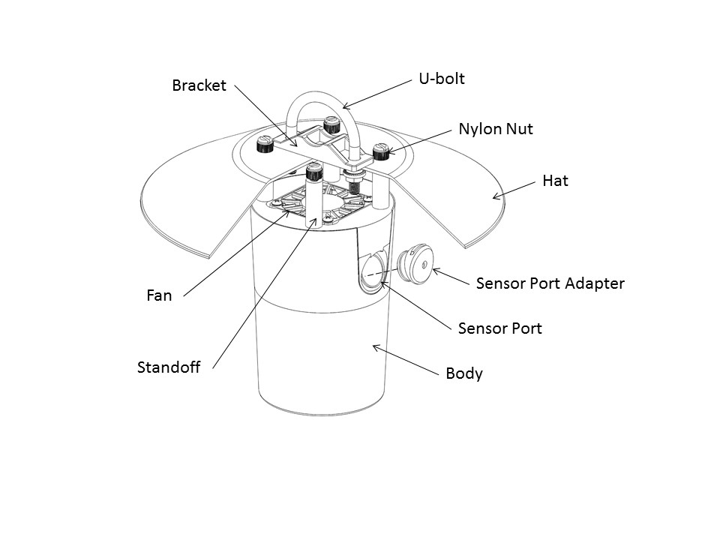If desired, a humidity probe may be used with its accompanying *sensor port adapter.* If not pre-installed, slowly insert the humidity probe into the *adapter* until the tip is in far enough to be centered in the air stream (about as far as the included thermistor). If the o-rings bind or come lose, back out the probe, fix the o-ring positioning, and retry. Rotating the humidity probe into the adapter while inserting it will help the o-rings stay in place. Additionally, the light use of a lubricant, such as petroleum jelly, will greatly help humidity probe installation, and reduce risk of misplaced o-rings. While installing the humidity probe, be sure not to put any unnecessary force on the neighboring pre-installed thermistor cable; it has very thin internal wires which could easily break if handled incorrectly.

The underside of the hat has eight flat surfaces where one or more included cable tie mounts may affix. Using the cable tie mounts is optional but provides an anchor to zip-tie cables to, providing strain relief, extra shading of cable, and a drip loop in the cable.

### Cable Connectors

|  |  |
| --- | --- |
| Apogee started offering in-line cable connectors on some bare-lead sensors in March 2018 to simplify the process of removing sensors from weather stations for calibration (the entire cable does **not** have to be removed from the station and shipped with the sensor).  The ruggedized M8 connectors are rated IP68, made of corrosion-resistant marine-grade stainless-steel, and designed for extended use in harsh environmental conditions. | Inline cable connectors are installed 30 cm from the head  (pyranometer pictured) |

**Instructions**

|  |  |
| --- | --- |
| **Pins and Wiring Colors:** All Apogee connectors have six pins, but not all pins are used for every sensor. There may also be unused wire colors inside the cable. To simplify datalogger connection, we remove the unused pigtail lead colors at the datalogger end of the cable.  If you ever need a replacement cable, please contact us directly to ensure ordering the proper pigtail configuration.  **Alignment:** When reconnecting your sensor, arrows on the connector jacket and an aligning notch ensure proper orientation.  **Disconnection for extended periods:**  When disconnecting the sensor for an extended period of time from a station, protect the remaining half of the connector still on the station from water and dirt with electrical tape or other method. | A reference notch inside the connector ensures  proper alignment before tightening.    When sending sensors in for calibration, only send the short end of the cable and half the connector. |
| **Tightening:** Connectors are designed to be firmly finger-tightened only. There is an o-ring inside the connector that can be overly compressed if a wrench is used. Pay attention to thread alignment to avoid cross-threading. When fully tightened, 1-2 threads may still be visible. | Finger-tighten firmly |

### Operation and Measurement

Connect the temperature sensor or RH probe sensor to a measurement device (meter, datalogger, controller). If you are using the ST-110, this device must be capable of inputting 2.5 V DC and measuring and displaying or recording a millivolt (mV) signal (an input measurement range of 0-2500 mV is required to cover the entire temperature range of the ST-110 air temperature sensor). To maximize measurement resolution and signal-to-noise ratio, the input range of the measurement device should closely match the output range of the sensor.

Connect the fan to a 12 V DC power supply capable of supplying at least 80 mA. If the datalogger has the capability for pulse width modulation (PWM) it can be used to reduce fan speed at night or under conditions of low solar radiation and/or high wind speed. The datalogger or controller must have a pulse width modulation (PWM) output of approximately 20 kHz and a duty cycle of 50 to 100 %.

The tachometer output is measured by a pulse counter. The tachometer also requires an input voltage, where maximum voltage output to the pulse counter is the input voltage to the counter. The tachometer output allows monitoring of the fan to ensure it is functioning properly.

The following instructions are for the ST-110 thermistor included with the TS-110 option. For wiring other sensors, including PRT sensors, please see their respective manuals.

**VERY IMPORTANT: Apogee changed all wiring colors of our bare-lead sensors in March 2018. To ensure proper connection to your data device, please note your serial number or if your sensor has a stainless-steel connector 30 cm from the sensor head then use the appropriate wiring configuration below.**

**Wiring for ST-110 Serial Numbers 2725 and above**

**White**: Single-ended channel (positive thermistor lead)

**Red**: Excitation channel (excitation for thermistor)

**Black**: Ground (negative thermistor lead)

**Clear**: Shield/Ground

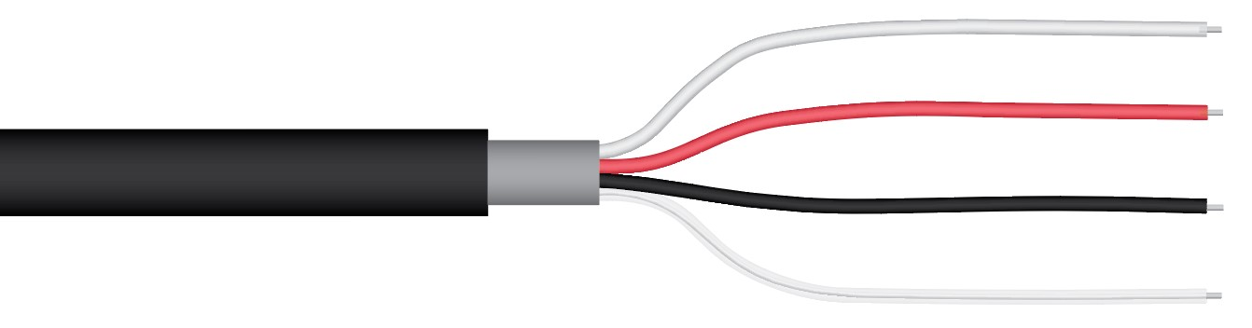

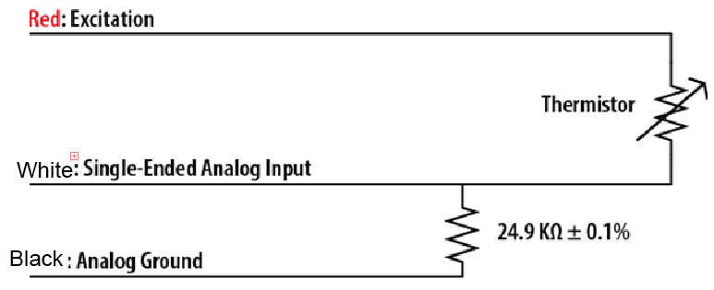

An excitation voltage of 2.5 V DC is recommended to minimize self-heating and current drain, while still maintaining adequate measurement sensitivity (mV output from thermistor per C). However, other excitation voltages can be used. Decreasing the excitation voltage will decrease self-heating and current drain but will also decrease thermistor measurement sensitivity. Increasing the excitation voltage will increase thermistor measurement sensitivity but will also increase self-heating and current drain.

**Wiring for ST-110 Serial Numbers range 0-2724**

Plug each wire into the appropriate data logger terminal following the illustrations below:

**Thermistor**

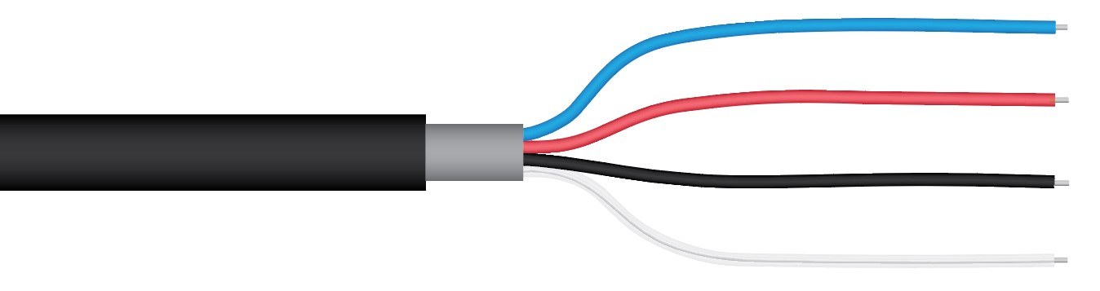

**Blue**: Analog Ground (negative thermistor lead)

**Red**: Excitation Channel (excitation for thermistor)

**Black**: Single-ended channel (positive thermistor lead)

**Clear**: Ground (shield wire)

Measurement devices (e.g., datalogger, controller) do not measure resistance directly, but determine resistance from a half-bridge measurement, where an excitation voltage is input across the thermistor and an output voltage is measured across the bridge resistor.

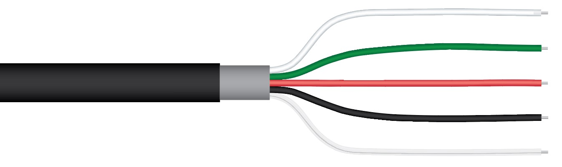**Wiring for EE08-SS**

**White**: Single-ended channel (signal output by relative humidity sensor)

**Green**: Single-ended channel (signal output by air temperature sensor)

**Red**: Input voltage (7 to 30 V DC)

**Black**: Ground

**Clear**: Ground (shield)

**\*For more information, please see the EE08-SS manual:** <https://www.apogeeinstruments.com/content/EE08-manual.pdf>

**Conversion of Thermistor Resistance to Temperature**

The thermistor is a resistive element, where resistance changes with temperature. Thermistor resistance (RT, in Ω) is measured with a half-bridge measurement, requiring a known excitation voltage input (VEX) and a measurement of output voltage (VOUT):

 (1)

where 24900 is the resistance of the bridge resistor in Ω. From resistance, temperature (TK, in Kelvin) is calculated with the Steinhart-Hart equation and thermistor specific coefficients:

 (2)

where A = 1.129241 x 10-3, B = 2.341077 x 10-4, and C = 8.775468 x 10-8 (Steinhart-Hart coefficients). If desired, measured temperature in Kelvin can be converted to Celsius (TC):

. (3)

**Fan Operation**

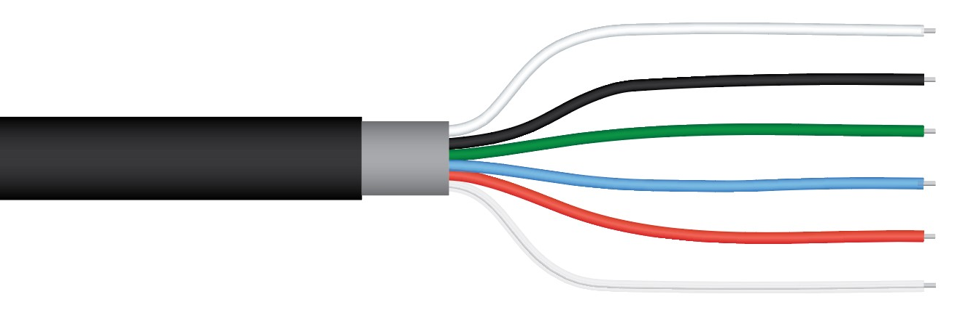

**White**: Pulse Counter or Control Port (tachometer output)

**Black**: Ground (power)

**Green**: Control port (controls fan speed using pulse width  
modulation)

**Blue**: Voltage Source (power input for tachometer; must be less than 30 V)

**Red**: 12 V DC (positive fan lead)

**Clear**: Shield Ground

Under some environmental conditions (e.g., high wind speed, low solar radiation), accurate measurements can be made without running the fan at full speed. Fan speed and power consumption can be decreased using a pulse width modulation (PWM) signal. The PWM signal should have a frequency of approximately 20 kHz and a duty cycle of 50 to 100 %, where a duty cycle of 100 % is full power and 50 % is low power. Running the fan in a low power mode reduces the current draw from 80 mA to approximately 25 mA. The only way to completely stop the fan is to turn the power off. Apogee Instruments also offers a 24 V DC fan option for purchase.

The fan also has a tachometer to monitor blade revolutions per minute (RPM). The tachometer outputs a pulse voltage signal. The pulse multiplied by 30 yields fan RPMs. The RPM should be near 4500 in full power mode and 2500 in low power mode. In addition to the tachometer output wire, there is a pull-up wire (power input). This allows a user-defined maximum output voltage from the tachometer and facilitates interfacing with multiple measurement devices.

### Maintenance and Recalibration

At full duty, the fan is designed to last 50,000 hours (5.7 years). Ultimately, this depends on operating conditions, and actual results may vary. If the fan runs less than approximately 4500 RPM at full power, then there may be a blockage or the fan may need to be replaced. The fan is secured by four nylon screws and can be easily removed. When a replacement fan is installed, verify that it is oriented the correct way, with air being pulled upwards through the shield towards the hat. Ensure that the replacement fan is wired correctly as outlined in the OPERATION AND MEASUREMENTsection.

Inspect the shield regularly and clean as needed to maintain optimum performance. If the shield or hat is dirty, wipe the surface with a moist rag to remove buildup and return the surface to its original condition. Check all mounting nuts and tighten if they are loose.

For optimal accuracy, check the yellow-bead thermistor every three months for dust/dirt buildup. If needed, twist and pull out the sensor port adapter, then wipe the thermistor tip clean. Be sure to return the thermistor to its proper position as outlined in the DEPLOYMENT AND INSTALLATION section.

Apogee ST-110 temperature sensors are factory verified to ensure accuracy. Sensors are compared for absolute temperature against the mean of two reference PRTs in a constant temperature bath, over a range of approximately -35 to 60 C.

EE08 probes are rugged and weatherproof and designed for air temperature and relative humidity measurements inside radiation shields. When probes are not in use, it is recommended they be removed from the measurement environment, cleaned, and stored. EE08 probes, especially the filter cap, should be periodically cleaned to remove all dust and debris. Additional filter caps are available from Apogee to replace clogged filter caps. For more information about filter cap replacement, call or email Apogee technical support: 435.245.8012, [techsupport@apogeeinstruments.com](mailto:techsupport@apogeeinstruments.com).

EE08 probes are factory calibrated and preprogrammed and come with a generic calibration factor (see Sensor Calibration in OPERATION AND MEASUREMENT section). A custom calibration can be derived by comparing the air temperature or relative humidity measurements from the probe to reference air temperature or relative humidity measurements. Probes can also be recalibrated at the factory. Recalibration is recommended every two years. Recalibration information is found on the Apogee webpage: <https://www.apogeeinstruments.com/recalibration-and-repairs/>. Questions about recalibration can be emailed to: [calibration@apogeeinstruments.com](mailto:calibration@apogeeinstruments.com).

### Troubleshooting and Customer Support

**Independent Verification of Functionality**

Apogee ST-110 temperature sensors yield a resistance proportional to temperature. A quick and easy check of sensor functionality can be accomplished with an ohmmeter. Connect the lead wires of the ohmmeter to the red and white wires from the sensor. The resistance should read 10 kΩ (10,000 ohms) at 25 C. If the sensor temperature is less than 25 C, the resistance will be higher. If the sensor temperature is greater than 25 C, the resistance will be lower. Connect the lead wires of the ohmmeter to the white and black wires from the sensor. The resistance should read 24.9 kΩ and should not vary. Connect the lead wires of the ohmmeter to the red and black wires from the sensor. The resistance should be the sum of the resistances measured across the red and white wires, and white and black wires (e.g., 10 kΩ plus 24.9 kΩ at 25 C).

A quick and easy check of fan functionality can be determined using a DC power supply. Power the fan with 12 V DC by connecting the positive voltage signal to the red wire from the fan and the negative (or common) to the black wire from the fan. When powered, the fan blades should spin. **Make sure to keep fingers clear of blades before connecting fan to 12 V DC.** Apogee Instruments also offers a 24 V DC fan option for purchase.

EE08 probes output voltage signals linearly proportional to air temperature and relative humidity. A quick and easy check of probe functionality can be accomplished with a voltmeter and 9 V battery. Connect the red wire from the probe to the positive terminal on the 9 V battery and connect the black wire from the probe to the negative terminal on the 9 V battery. Connect the positive lead wire of the voltmeter to the green wire from the probe and the negative lead wire of the voltmeter to the black wire from the probe. The voltage measurement should be 1.25 V DC at 20 C and 1.350 V DC at 25 C (20 to 25 C is the approximate room temperature range). Move the positive lead wire of the voltmeter to the white wire from the probe. The voltage measurement should be 0.5 V DC at 20 %, 1.25 V DC at 50 %, and 2.0 V DC at 80 %.

**Compatible Measurement Devices (Dataloggers/Controllers/Meters)**

Measurement of ST-110 thermistor resistance requires an input excitation voltage, where 2.5 V DC is recommended. A compatible measurement device should have the capability to supply the necessary voltage for the specific sensor.

The sensitivity (mV output from thermistor per C) of the temperature measurement from the ST-110 thermistor varies with the excitation voltage and varies as a function of temperature. With an excitation voltage of 2.5 V DC, the sensitivity is lowest near the ends of the measurement range, -50 and 70 C. A compatible measurement device (e.g., datalogger or controller) should have resolution of at least 0.6 mV, to produce temperature resolution of less than 0.1 C across the entire temperature measurement range (less than 0.05 C from -35 to 45 C).

To operate the fan, a 12 V DC power supply capable of supplying at least 80 mA is required. All fans also include pulse width modulation (PWM; allows for reduction of fan speed under certain conditions) and a tachometer (allows for monitoring of fan speed). To use the PWM option, the fan must be connected to a datalogger or controller that has a PWM output of approximately 20 kHz, a duty cycle of 50 to 100 %, and a 0 to 5 V DC square waveform. To measure the output from the tachometer, a pulse counter is required. The maximum voltage input from the tachometer to the pulse counter is determined by the input voltage to the tachometer, which should be fixed at a given voltage in the range of 0 to 30 V DC. The measurement device should be capable of supplying a fixed voltage in this range.

An example datalogger program for Campbell Scientific dataloggers can be found on the Apogee webpage at <http://www.apogeeinstruments.com/content/Aspirated-Radiation-Shield-Thermistor.cr1>.

Operation of the EE08 requires a voltage input of 7 to 30 V DC. Measurement of the output signals requires a single-ended voltage measurement over a range of 0 to 2.5 V DC. A compatible measurement device should have the capability to supply and measure these voltages.

The sensitivity of the air temperature sensor (voltage output from sensor per degree C) is 20.8 mV per C (reciprocal of the slop listed in the OPERATION AND MEASUREMENT section). This means a voltage measurement resolution of 2.08 mV is required to yield an air temperature measurement resolution of 0.1 C, and 0.208 mV is required to yield an air temperature measurement resolution of 0.01 C. The sensitivity of the relative humidity sensor (voltage output from sensor per % RH) is 25 mV per % (reciprocal of the slope listed in the OPERATION AND MEASUREMENT section). This means a voltage measurement resolution of 2.5 mV is required to yield a relative humidity measurement resolution of 0.1 % C, and 0.25 mV is required to yield a relative humidity measurement resolution of 0.01 %.

An example datalogger program for Campbell Scientific dataloggers can be found on the Apogee webpage at: <https://www.apogeeinstruments.com/content/EplusE-EE08-Temp-RH-Probe.CR1>

**Effect of Cable Length & Modifying Cable Length**

When the temperature sensor is connected to a measurement device with high input impedance, sensor output signals are not changed by shortening the cable or splicing on additional cable in the field. Tests have shown that if the input impedance of the measurements device is 1 mega-ohm or higher then there is negligible effect on the sensors, even after adding up to 100 m of cable. TS-100 aspirated radiation shields use shielded, twisted pair cable, which minimizes electromagnetic interference. This is particularly important for long lead lengths in electromagnetically noisy environments.

Standard Apogee cable lengths for the EE08 are 5 m, 10 m, and 20 m. If a length greater than 20 m is required, additional cable can be spliced onto a standard cable. For cable extensions, shielded, twisted-pair cable is recommended, to minimize electromagnetic interference. This is particularly important for long lead lengths in electromagnetically noisy environments. However, additional cable adds resistance and may influence the accuracy of the measurement.

See Apogee webpage for details on how to extend sensor cable length (<http://www.apogeeinstruments.com/how-to-make-a-weatherproof-cable-splice/>).

### Return and Warranty Policy

RETURN POLICY

Apogee Instruments will accept returns within 30 days of purchase as long as the product is in new condition (to be determined by Apogee). Returns are subject to a 10 % restocking fee.

WARRANTY POLICY

**What is Covered**All products manufactured by Apogee Instruments are warranted to be free from defects in materials and craftsmanship for a period of four (4) years from the date of shipment from our factory. To be considered for warranty coverage an item must be evaluated by Apogee.

Products not manufactured by Apogee (spectroradiometers, chlorophyll content meters, EE08-SS probes) are covered for a period of one (1) year.

**What is Not Covered**The customer is responsible for all costs associated with the removal, reinstallation, and shipping of suspected warranty items to our factory.

The warranty does not cover equipment that has been damaged due to the following conditions:

1. Improper installation, use, or abuse.

2. Operation of the instrument outside of its specified operating range.

3. Natural occurrences such as lightning, fire, etc.

4. Unauthorized modification.

5. Improper or unauthorized repair.

Please note that nominal accuracy drift is normal over time. Routine recalibration of sensors/meters is considered part of proper maintenance and is not covered under warranty.

**Who is Covered**This warranty covers the original purchaser of the product or other party who may own it during the warranty period.

**What Apogee Will Do**At no charge Apogee will:

1. Either repair or replace (at our discretion) the item under warranty.

2. Ship the item back to the customer by the carrier of our choice.

Different or expedited shipping methods will be at the customer’s expense.

**How To Return An Item**1. Please do not send any products back to Apogee Instruments until you have received a Return Merchandise Authorization (RMA) number from our technical support department by submitting an online RMA form at [www.apogeeinstruments.com/tech-support-recalibration-repairs/](http://www.apogeeinstruments.com/tech-support-recalibration-repairs/). We will use your RMA number for tracking of the service item. Call (435) 245-8012 or email techsupport@apogeeinstruments.com with questions.

2. For warranty evaluations, send all RMA sensors and meters back in the following condition: Clean the sensor’s exterior and cord. Do not modify the sensors or wires, including splicing, cutting wire leads, etc. If a connector has been attached to the cable end, please include the mating connector – otherwise the sensor connector will be removed in order to complete the repair/recalibration. ***Note:*** *When sending back sensors for routine calibration that have Apogee’s standard stainless-steel connectors, you only need to send the sensor with the 30 cm section of cable and one-half of the connector. We have mating connectors at our factory that can be used for calibrating the sensor.*

3. Please write the RMA number on the outside of the shipping container.

4. Return the item with freight pre-paid and fully insured to our factory address shown below. We are not responsible for any costs associated with the transportation of products across international borders.

**Apogee Instruments, Inc.   
721 West 1800 North Logan, UT  
84321, USA**

5. Upon receipt, Apogee Instruments will determine the cause of failure. If the product is found to be defective in terms of operation to the published specifications due to a failure of product materials or craftsmanship, Apogee Instruments will repair or replace the items free of charge. If it is determined that your product is not covered under warranty, you will be informed and given an estimated repair/replacement cost.

Products Beyond the Warranty Period

For issues with sensors beyond the warranty period, please contact Apogee at [techsupport@apogeeinstruments.com](mailto:techsupport@apogeeinstruments.com) to discuss repair or replacement options.

Other Terms

The available remedy of defects under this warranty is for the repair or replacement of the original product, and Apogee Instruments is not responsible for any direct, indirect, incidental, or consequential damages, including but not limited to loss of income, loss of revenue, loss of profit, loss of data, loss of wages, loss of time, loss of sales, accruement of debts or expenses, injury to personal property, or injury to any person or any other type of damage or loss.

This limited warranty and any disputes arising out of or in connection with this limited warranty ("Disputes") shall be governed by the laws of the State of Utah, USA, excluding conflicts of law principles and excluding the Convention for the International Sale of Goods. The courts located in the State of Utah, USA, shall have exclusive jurisdiction over any Disputes.

This limited warranty gives you specific legal rights, and you may also have other rights, which vary from state to state and jurisdiction to jurisdiction, and which shall not be affected by this limited warranty. This warranty extends only to you and cannot by transferred or assigned. If any provision of this limited warranty is unlawful, void, or unenforceable, that provision shall be deemed severable and shall not affect any remaining provisions. In case of any inconsistency between the English and other versions of this limited warranty, the English version shall prevail.

This warranty cannot be changed, assumed, or amended by any other person or agreement

**APOGEE INSTRUMENTS, INC. |** 721 WEST 1800 NORTH, LOGAN, UTAH 84321, USA

TEL: (435) 792-4700 | FAX: (435) 787-8268 | WEB: APOGEEINSTRUMENTS.COM

*Copyright © 2021 Apogee Instruments, Inc.*