

# Owner’s Manual

USB uv sensor

Models SU-420

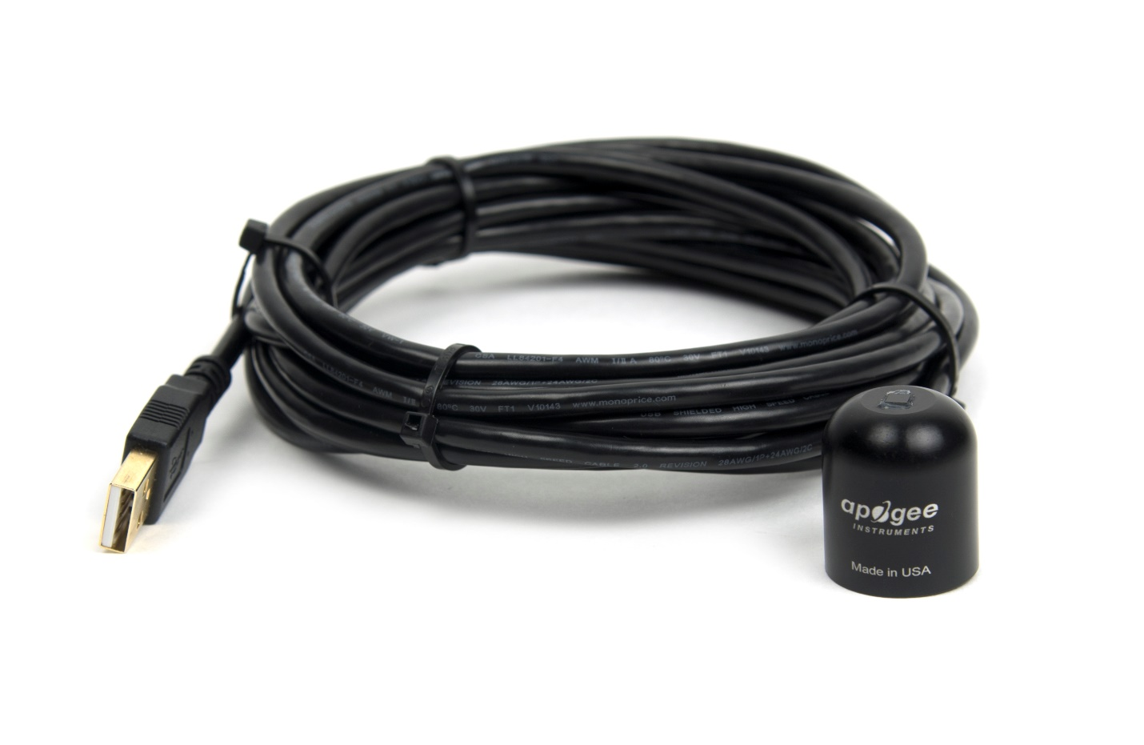

Table of Contents

Owner’s Manual 1

Certificate of Compliance 3

Introduction 4

Sensor Models 5

Specifications 6

Deployment and Installation 7

Software Installation 8

Operation and Measurement 9

Windows Software 10

MAC software 15

Maintenance and Recalibration 20

Troubleshooting and Customer Support 22

Return and Warranty Policy 23

### Certificate of Compliance

**EU Declaration of Conformity**

This declaration of conformity is issued under the sole responsibility of the manufacturer:

Apogee Instruments, Inc.  
721 W 1800 N  
Logan, Utah 84321  
USA

for the following product(s):

Models: SU-420  
Type: UV Sensor

The object of the declaration described above is in conformity with the relevant Union harmonization legislation:

2014/30/EU Electromagnetic Compatibility (EMC) Directive

2011/65/EU Restriction of Hazardous Substances (RoHS 2) Directive

Standards referenced during compliance assessment:

EN 61326-1:2013 Electrical equipment for measurement, control and laboratory use – EMC requirements

EN 50581:2012 Technical documentation for the assessment of electrical and electronic products with respect to the restriction of hazardous substances

Please be advised that based on the information available to us from our raw material suppliers, the products manufactured by us do not contain, as intentional additives, any of the restricted materials including cadmium, hexavalent chromium, lead, mercury, polybrominated biphenyls (PBB), polybrominated diphenyls (PBDE).

Further note that Apogee Instruments does not specifically run any analysis on our raw materials or end products for the presence of these substances, but rely on the information provided to us by our material suppliers.

Signed for and on behalf of:

Apogee Instruments, May 2016



Bruce Bugbee  
President  
Apogee Instruments, Inc.

### Introduction

Ultraviolet (UV) radiation constitutes a portion of the electromagnetic spectrum from 100 to 400 nm, and is further subdivided into three wavelength ranges: UV-A (315 to 400 nm), UV-B (280 to 315 nm) and UV-C (100 to 280 nm). Much of the UV-B and all of the UV-C wavelengths from the sun are absorbed by the Earth’s atmosphere. There are also many artificial UV light sources available that output a select wavelength range or offer a broadband UV radiation source.

Most UV sensors designed for sunlight measurements are sensitive to UV radiation in the UV-A and UV-B ranges. Apogee Instruments SU-420 UV sensors detect UV radiation from 250 to 400 nm and are calibrated in photon flux units of micromoles per square meter per second (µmol m-2 s-1). The output can also be expressed in energy flux units of watts per square meter (W m-2, equal to Joules per second per square meter).

Typical applications of UV sensors include incoming UV radiation measurement in outdoor environments (not recommended for continuous outdoor deployment) or in laboratory use with artificial light sources (e.g., germicidal lamps).

Apogee Instruments SU series UV sensors consist of a photodiode and signal processing circuitry mounted in an anodized aluminum housing, and a cable to connect the sensor to a measurement device. Sensors are potted solid with no internal air space, and are designed for UV radiation measurement in indoor or outdoor environments. The SU-420 outputs a signal that is directly proportional to UV radiation incident on a planar surface (does not have to be horizontal), where the radiation emanates from all angles of a hemisphere.

### Sensor Models

|  |  |  |
| --- | --- | --- |
| Model | Signal | |
| SU-420 | **USB** |
| SU-100 | Self-powered |

This manual covers the USB smart sensor model SU-420. Additional models are covered in their respective manuals.

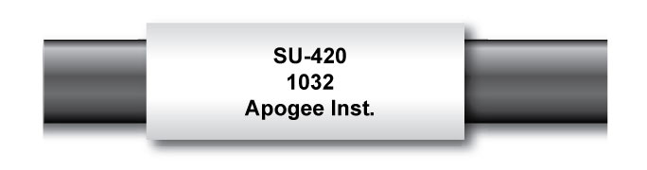

Sensor model number and serial number are located near the pigtail leads on the sensor cable. If you need the manufacturing date of your sensor, please contact Apogee Instruments with the serial number of your sensor.

### Specifications

|  |  |
| --- | --- |
|  | SU-420 |
| Resolution | 0.1 W m-2 |
| Calibration Factor | Custom for each sensor and stored in firmware |
| Calibration Uncertainty | ± 10 % (see Calibration Traceability below) |
| Measurement Repeatability | Less than 1 % |
| Long-term Drift  (Non-stability) | Less than 3 % per year |
| Non-linearity | less than 1 % (up to 300 µmol m-2 s-1) |
| Response Time | Software updates every second |
| Field of View | 180º |
| Spectral Range | 250 nm to 400 nm (see Spectral Response below) |
| Directional (Cosine) Response | ± 10 % at 75º zenith angle (see Cosine Response below) |
| Temperature Response | Approximately 0.1 % per C |
| Operating Environment | -40 to 70 C; 0 to 100 % relative humidity |
| Dimensions | 24 mm diameter, 28 mm height |
| Mass | Sensor head weighs 90 g |
| USB Cable | 4.6 m (15 ft) |
| Current Draw (when Logging) | 61 mA |

**Calibration Traceability**

Apogee SU series UV sensors are calibrated through side-by-side comparison to the mean of four Apogee model SU-100 transfer standard UV sensors under high intensity discharge metal halide lamps. The transfer standard UV sensors are calibrated through side-by-side comparison to an Apogee model PS-200 spectroradiometer under sunlight (clear sky conditions) in Logan, Utah. The PS-200 is calibrated with a LI-COR model 1800-02 Optical Radiation Calibrator using a 200 W quartz halogen lamp. The 1800-02 and quartz halogen lamp are traceable to the National Institute of Standards and Technology (NIST).

**Spectral Response**

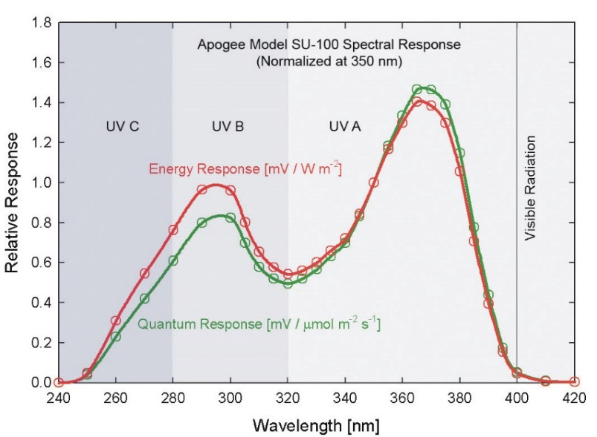

Spectral response estimate of Apogee SU-420 UV sensors. Spectral response measurements were made at 10 nm increments across a wavelength range of 200 to 450 nm in a monochromator with an attached electric light source. Measured spectral data were normalized at 350 nm.

### Deployment and Installation

Mount the sensor to a solid surface with the nylon mounting screw provided. To accurately measure PPFD incident on a horizontal surface, the sensor must be level. An Apogee Instruments model AL-100 Leveling Plate is recommended to level the sensor when used on a flat surface or being mounted to surfaces such as wood. To facilitate mounting on a mast or pipe, the Apogee Instruments model AL-120 Solar Mounting Bracket with Leveling Plate is recommended.

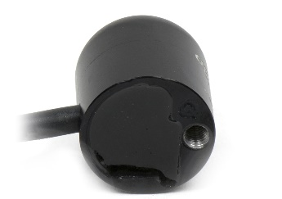C:\Users\emyers\AppData\Local\Microsoft\Windows\INetCache\Content.Word\screw.png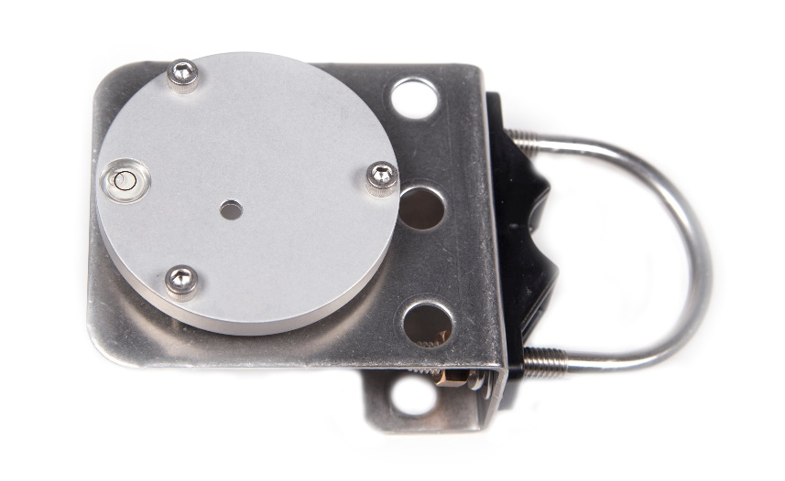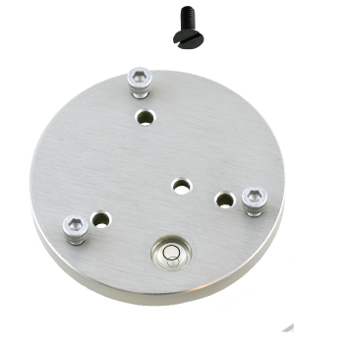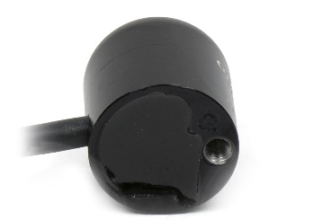

Nylon Screw: 10-32x3/8

Nylon Screw: 10-32x3/8

Model AL-120

Model AL-100

To minimize azimuth error, the sensor should be mounted with the cable pointing toward true north in the northern hemisphere or true south in the southern hemisphere. Azimuth error is typically less than 1 %, but it is easy to minimize by proper cable orientation.

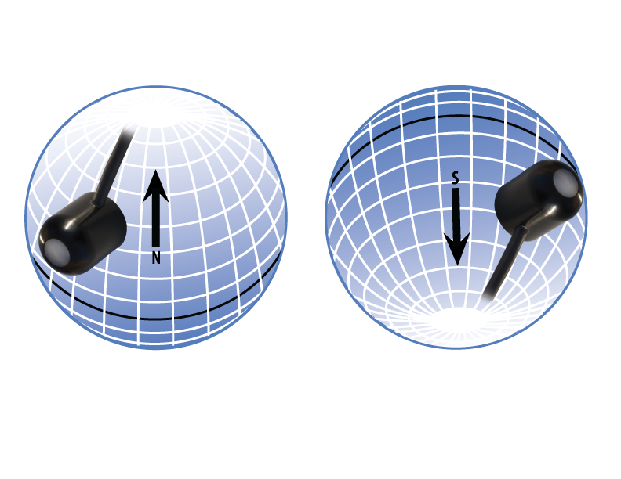

In addition to orienting the cable to point toward the nearest pole, the sensor should also be mounted such that obstructions (e.g., weather station tripod/tower or other instrumentation) do not shade the sensor. **Once mounted, the green cap should be removed from the sensor.** The green cap can be used as a protective covering for the sensor when it is not in use.

### Software Installation

**The most recent version of ApogeeConnect software can be downloaded at** [**http://www.apogeeinstruments.com/downloads/**](http://www.apogeeinstruments.com/downloads/)**.**

C:\Users\emyers\Desktop\apogee-connect.jpg**Installing the software on a PC (Windows compatible, XP and later)**

1. Double click on the installer package:
2. On the ‘Welcome’ screen, please click ‘Next’ to continue.
3. Select the radio button next to “I Agree” to the UELA… and click ‘Next’ to continue.
4. On the ‘Ready to Install the Program’ screen, click ‘Install’ to continue.
5. Click ‘Finish’ to complete the installation. There are shortcuts on your desktop and in your start bar.

**Installing the software on a Mac (Mac compatible, 10.10 and later)**

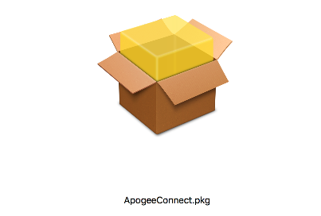

1. Double click on the installer package
2. On the ‘Introduction’ screen, please click ‘Continue’ to proceed.
3. Select ‘Continue’ on the ‘Read Me’ screen to continue, this screen contains a history of updates made to the ApogeeConnect software versions.
4. Select ‘Continue’ on the ‘License’ screen to receive a prompt to agree to the terms of the software license agreement. Click ‘Agree’ to continue once you receive the prompt.
5. On the ‘Installation Type’ screen, click ‘Install’ to install the software. You can change the location the software installs to by clicking ‘Change Install Location…’. *Note: You may be prompted for an administrator password at this time. If you are, proceed by entering your respective password and clicking ‘Install Software’.
6. Once you receive the message “The installation was successful.” on the ‘Summary’ screen click ‘Close’. Your software is now ready to be used.

### Operation and Measurement

**UV-B Measurements and Spectral Errors**

Apogee Instruments SU series UV Sensors measure ultraviolet radiation between 250 and 400 nm in micromoles of photons per square meter per second. Although the UV radiation between 280 and 315 nm (UV-B) is critically important in photochemical and photobiological reactions, less than 3 % of the UV photons are in this range. Because only a small fraction of the photons are in the UV-B range, the SU-420 cannot be used to selectively measure UV-B radiation. The SU-420 is sensitive to UV-B radiation, but it is included with the UV-A radiation to provide a total measurement of UV radiation.

In addition to naturally occurring UV radiation from the sun, there are many electric light sources that emit UV radiation (e.g., cool white fluorescent, metal halide, mercury arc, and germicidal lamps). Although the relative wavelengths of UV radiation differ among sunlight and electric lights, the error estimates shown in the table below indicate that the SU-420 provides reasonable estimates of UV radiation coming from electric lamps (table provides spectral error estimates for UV radiation measurements from radiation sources other than clear sky solar radiation). For common lamps, the error is less than 10 %. The SU-420 is particularly useful for determining the UV filtering capacity of the transparent plastic and glass barriers that are commonly used below electric lamps.

**Spectral Errors for UV Radiation Measurements with Apogee SU series UV Sensors**

|  |  |
| --- | --- |
| **Radiation Source (Error Calculated Relative to Sun, Clear Sky)** | **Error [%]** |
| Sun (Clear Sky) | 0.0 |
| Sun (Cloudy Sky) | < 0.5 |
| Reflected from Grass Canopy | < 0.5 |
| Reflected from Deciduous Canopy | < 0.5 |
| Reflected from Conifer Canopy | < 0.5 |
| Reflected from Agricultural Soil | < 0.5 |
| Reflected from Forest Soil | < 0.5 |
| Reflected from Desert Soil | < 0.5 |
| Reflected from Water | < 0.5 |
| Reflected from Ice | < 0.5 |
| Reflected from Snow | < 0.5 |
| Cool White Fluorescent (T5) | 9.0 |
| Metal Halide | 2.8 |
| High Pressure Sodium | -1.7 |
| Incandescent | -3.3 |
| Mercury Arc | 17.8 |

### Windows Software

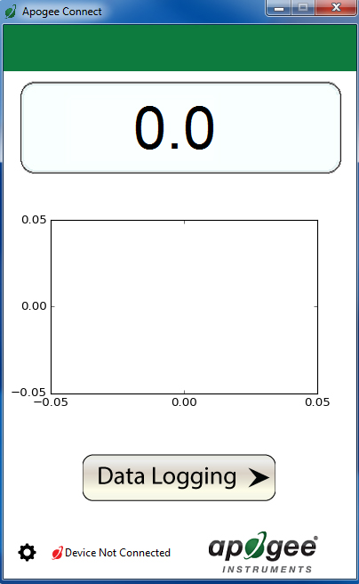

When the SU-420 sensor is not plugged into the USB port, the software will display a message in the lower left corner, “Device Not Connected,” indicating it cannot establish communication with the sensor.

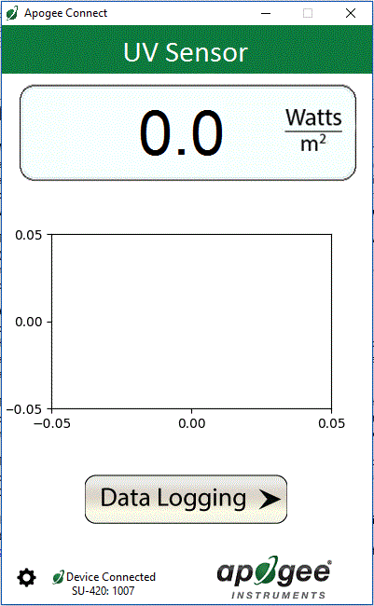

Plug the sensor into a USB port and allow some time for the sensor to automatically establish communication with the software. Once established, the message in the lower left corner will display “Device Connected SN: ####” and real-time shortwave radiation readings will update on the screen. Moving the sensor closer to a light source should increase the readings, while blocking all light from the sensor should drop the reading to zero.

Click the ‘**Settings**’ icon to display the software options. Note **‘Light Source’** and ‘**Immersion Setting’** is not a setting for the SU-420.

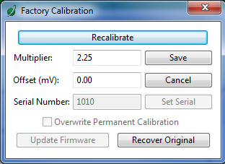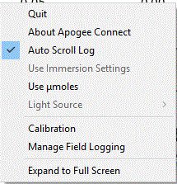

Clicking **‘Calibration’** will display the factory calibrated multiplier and offset values. These values are saved in firmware and can be recovered by clicking the ‘Recover Original’ button. Deriving a new calibration multiplier and offset is accomplished by clicking the ‘Recalibrate’ button. This is applicable if users want to calibrate the sensor to their own specific light source. Note that a reference value of the light source is required to complete a recalibration.

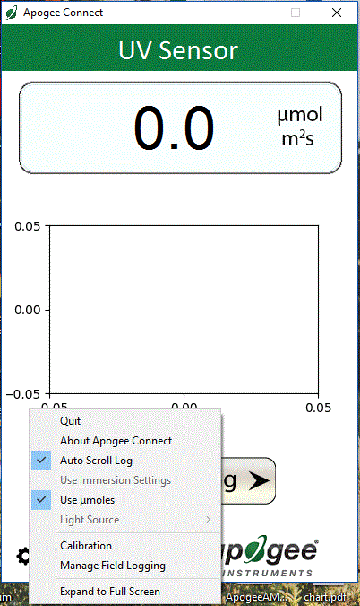

Clicking the **‘Use µmoles’** setting option will change the units from W m-2 to µmol m-2 s-1.

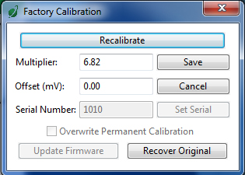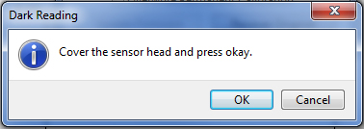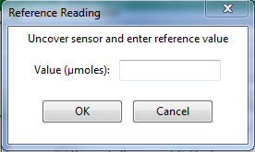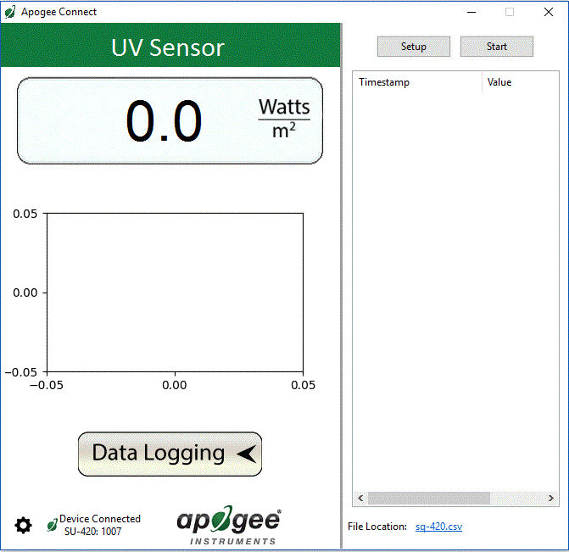

After clicking the ‘Recalibate’ button the user will be prompted to cover the sensor. Place a dark cap over the sensor and wait for the real-time shortwave readiation reading to settle at zero. Click OK.

Uncover the sensor and wait for the shortwave radiation reading to settle ***before*** entering the reference value. Click OK.

Clicking **‘Data Logging’** will allow the user to log interval measurements in a csv file while the software is open and communicating with the sensor.

The multiplier and offset values will automatically calculate and update in the appropriate field. Be sure to click ‘Save’ to retain the new multiplier and offset.

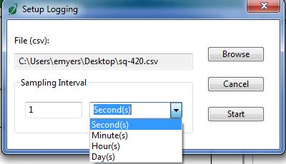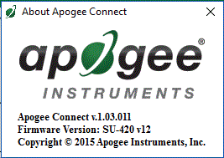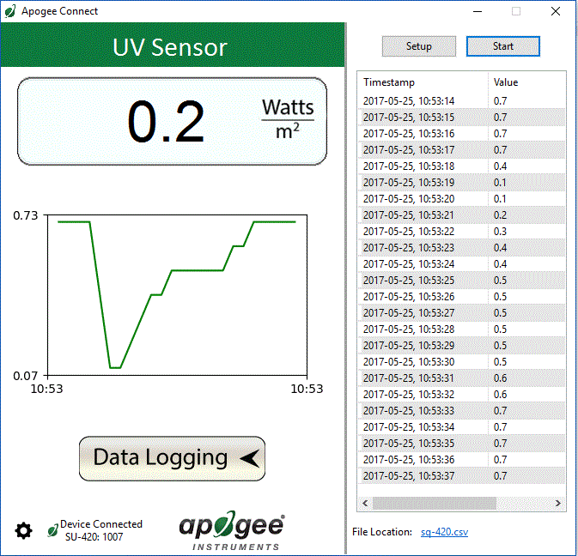

Click ‘Setup’ and the Setup Logging window appears. Click the ‘Browse’ button to create or select a csv file.

Select the desired sampling interval. Note that 1 second is the minimum interval allowed. Click ‘Start’.

The data logging window will start to update at the specified sampling interval and display the Timestamp and Data Value. At the same time, data will be written to the csv file. Note that if the csv file is open in another program new data will not be saved to it.

The data logging window can be closed without affec­ting logged data by clicking the ‘Exit’ button. The ‘Stop’ button must be clicked to end data logging.

The about screen tells you the software and firmware versions. These can be used to help troubleshoot if problems arise.

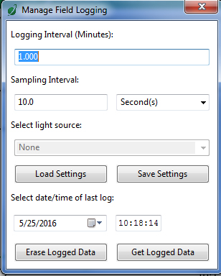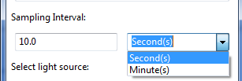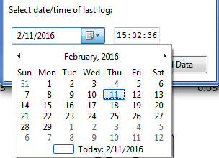C:\Users\emyers\Desktop\logged-data.PNG

**‘Manage Field Logging’** is used to setup the SU-420 for use in the field. When the SU-420 is supplied power from a USB power source it will log data which you can retrieve. Choose the interval that data is saved as well as the interval that data is sampled and the light source used. The shortest sampling interval is 1 second. The longest sampling or logging interval is 1440 minutes (1 day). Click ‘Load Settings’ to see current settings and ‘Save Settings’ to save the settings you want to the sensor. Note: If you don’t click save the sensor won’t change the settings.

Set the sampling interval in minutes or seconds. The sampling interval is how often a measurement is taken and logging interval is how often the data is saved. The logged data is the average of the samples. The logging interval must be evenly divided by the sampling interval. For example if the logging interval is 5 minutes and the sampling interval is 2 minutes it causes an error. But a sampling interval of 1 minute is acceptable.

Before clicking ‘Get Logged Data’ it is important to set the time of the last logged data point. This is used to back calculate the timestamps for the remaining data points. If you just unplugged the sensor and plugged it into the computer the preloaded day and time should be sufficient.

Click **‘Get Logged Data’** to save the data to your computer. You will be asked where you want to save the data.

Click **‘Erase Data’** to erase all the saved data. This can’t be undone.

To use additional SU-420 devices, open additional ApogeeConnect software windows. The device serial number will display in the lower left hand corner of the corresponding software window. Devices may be selected by serial number in the tool bar.

### Inline image 6C:\Users\emyers\Desktop\start-m.pngMAC software

Plug the sensor into a USB port and allow some time for the sensor to automatically establish communication with the software. Once established, the message in the lower left corner will display “Device Connected Model: SN ####” and real-time shortwave radiation readings will update on the screen. Moving the sensor closer to a light source should increase the readings, while blocking all light from the sensor should drop the reading to zero.

When the SU-420 sensor is not plugged into the USB port, the software will display a message in the lower left corner, “Device Not Connected,” indicating it cannot establish communication with the sensor.

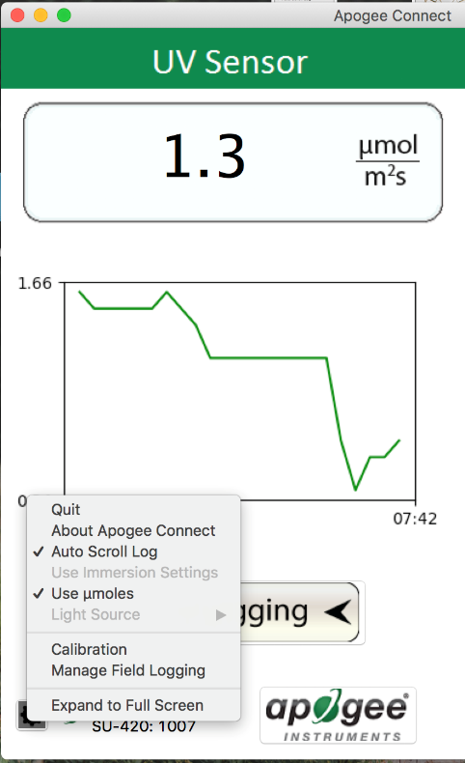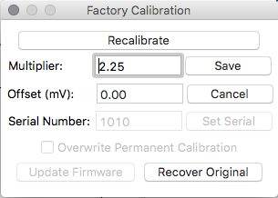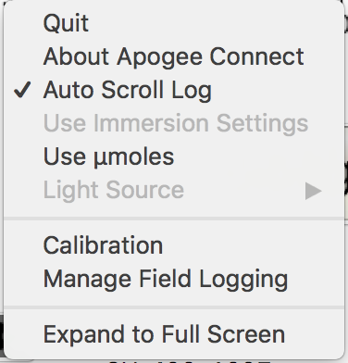

Clicking the **‘Use µmoles’** setting option will change the units from W m-2 to µmol m-2 s-1.

Clicking **‘Calibration’** will display the factory calibrated multiplier and offset values. These values are saved in firmware and can be recovered by clicking the ‘Recover Original’ button. Deriving a new calibration multiplier and offset is accomplished by clicking the ‘Recalibrate’ button. This is applicable if users want to calibrate the sensor to their own specific light source. Note that a reference value of the light source is required to complete a recalibration.

Click the **gear icon** to display the software options. Note **‘Light Source’ and ‘Immersion Setting’** is not a setting option for the SU-420.

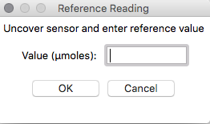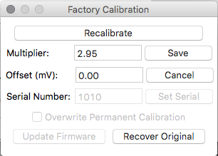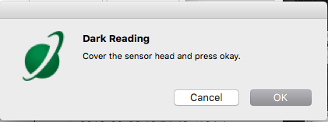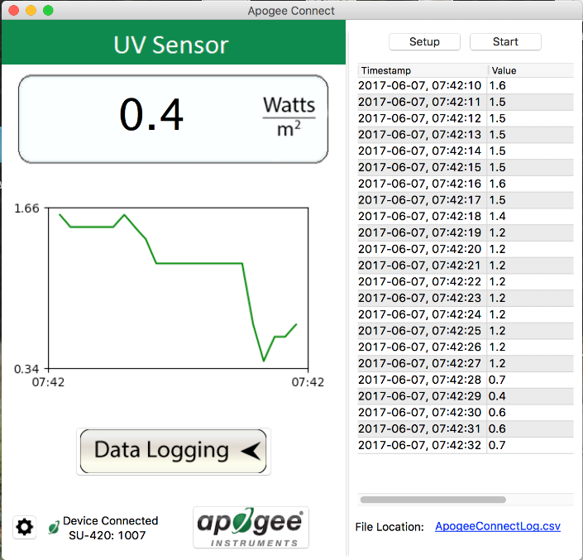

Uncover the sensor and wait for the shortwave radiation reading to settle ***before*** entering the reference value. Click OK.

The multiplier and offset values will automatically calculate and update in the appropriate field. Be sure to click ‘Save’ to retain the new multiplier and offset.

After clicking the ‘Recalibrate’ button the user will be prompted to cover the sensor. Place a dark cap over the sensor and wait for the real-time shortwave radiation reading to settle at zero. Click OK.

Clicking **‘Data Logging’** will allow the user to log interval measurements in a csv file while the software is open and communicating with the sensor.

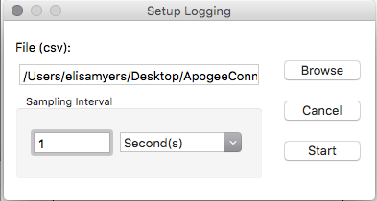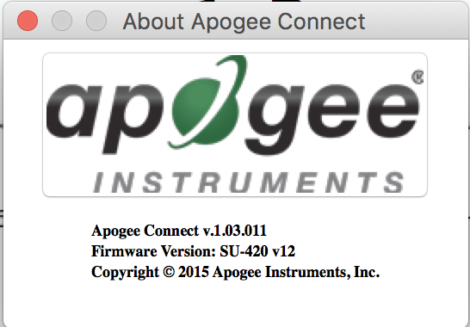

Click ‘Setup’ and the Setup Logging window appears. Click the ‘Browse button to create or select a csv file.

Select the desired sampling interval. Note that 1 second is the minimum interval allowed. Click ‘Start’.

The data logging window will start to update at the specified sampling interval and display the Timestamp and Data Value. At the same time, data will be written to the csv file. Note that if the csv file is open in another program new data will not be saved to it.

The data logging window can be closed without affecting logged data by clicking the ‘Exit’ button. The ‘Stop’ button must be clicked to end data logging.

The about screen tells you the software and firmware versions. These can be used to help troubleshoot if problems arise.

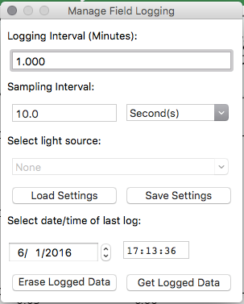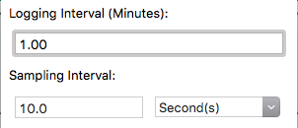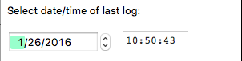Screen Shot 2016-02-26 at 10

‘**Manage Field Logging**’ is used to setup the SU-420 for the use in the field. When the SU-420 is supplied power from a USB power source it will log data which you can retrieve. Choose the interval the data is saved as well as the interval that data is sampled and the light source used. The shortest sampling interval is 1 second. The longest sampling or logging interval is 1440 minutes (1 day). Click ‘Load Settings’ to see current settings and ‘Save Setting’ to save the settings you want to the sensor. Note: If you don’t click save the sensor won’t change the settings.

Set the sampling interval in minutes or seconds. The sampling interval is how often a measurement is taken and logging interval is how often the data is saved. The logged data is the average of the samples. The logging interval must be evenly divided by the sampling interval. For example if the logging interval is 5 minutes and the sampling interval is 2 minutes it causes an error. But a sampling interval of 1 minute is acceptable.

Before clicking ‘Get Logged Data’ it is important to set the time of the last logged data point. This is used to back calculate the timestamps for the remaining data points. If you just unplugged the sensor and plugged it into the computer the preloaded day and time should be sufficient.

Click ‘**Get Logged Data**’ to save the data to your computer. You will be asked where you want to save the data.

Click ‘**Erase Data**’ to erase all the save data. This can’t be undone.

To use additional SU-422 devices, open additional ApogeeConnect software windows. The device serial number will display in the lower left hand corner of the corresponding software window. Devices may be selected by serial number in the tool bar.

### Maintenance and Recalibration

Moisture or debris on the sensor is a common cause of low readings. The sensor has a domed-shaped housing for improved self-cleaning from rainfall, but materials can accumulate on the photo-sensitive area (e.g., dust during periods of low rainfall, salt deposits from evaporation of sea spray or sprinkler irrigation water) and partially block the optical path. Dust or organic deposits are best removed using water, or window cleaner and a soft cloth or cotton swab. Salt deposits should be dissolved with vinegar and removed with a soft cloth or cotton swab. **Never use an abrasive material or cleaner on the sensor.**

The Clear Sky Calculator (www.clearskycalculator.com) determines total shortwave radiation or photosynthetic photon flux (PPF) incident on a horizontal surface at any time of day at any location in the world. It is most accurate when used near solar noon in spring and summer months, where accuracy over multiple clear and unpolluted days is estimated to be ± 4 % in all climates and locations around the world.

Although the Clear Sky Calculator does not specifically report an estimated value for UV radiation, it can still be used to help determine the need for UV sensor recalibration by approximating the ratio of UV to total shortwave or the ratio of UV to PPF. However, due to continuous changes in atmospheric conditions and their effect on UV radiation, the comparison of the UV sensor to the Clear Sky Calculator should only be made in the summer months near solar noon, and under completely clear skies.

To calculate a reference value of UV radiation in units of energy flux (W m-2), input site conditions into the calculator to determine the estimated total shortwave radiation. Then multiply the estimated total shortwave value by an approximated ratio value between 0.045 and 0.050 to convert the total shortwave radiation to total UV radiation.

To calculate a reference value of UV radiation in units of photon flux density (μmol m-2 s-1), input site conditions into the calculator to determine the estimated PPFD. Then multiply the estimated PPFD by an approximated ratio value between 0.070 and 0.075 to convert the PPFD to total UV radiation.

If UV sensor measurements over multiple days near solar noon are consistently different than calculated values (by more than 10 %), the sensor should be cleaned and re-leveled. If measurements are still different after a second test, email calibration@apogeeinstruments.com to discuss test results and possible return of sensor(s).

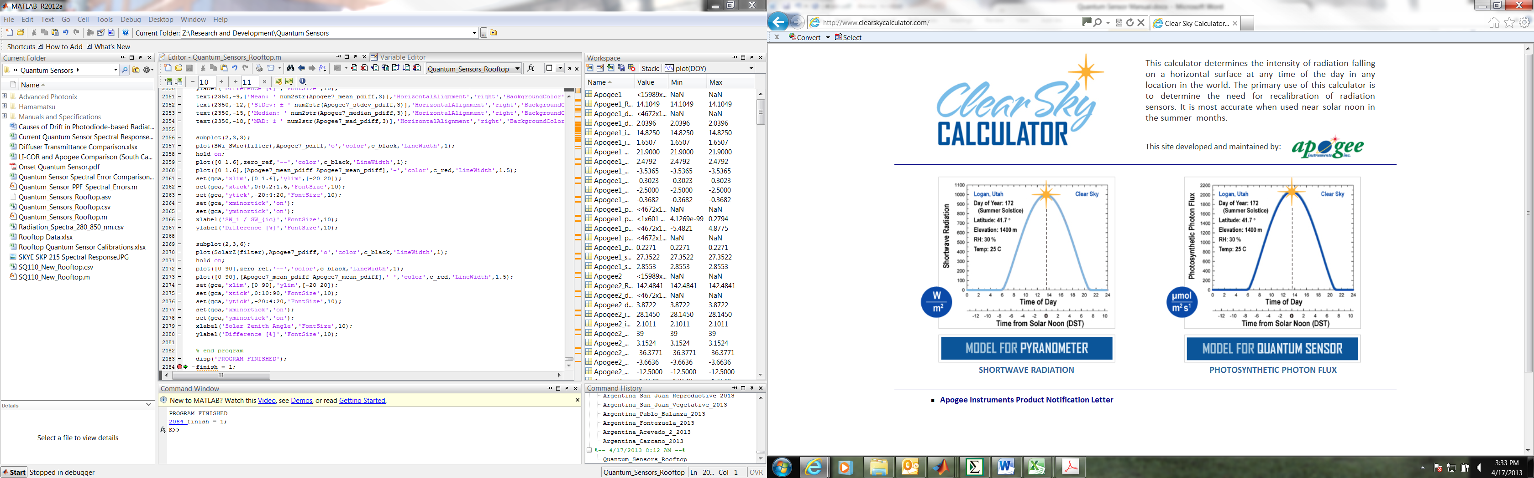

Homepage of the Clear Sky Calculator. Two calculators are available: One for pyranometers (total shortwave radiation) and one for quantum sensors (photosynthetic photon flux density).

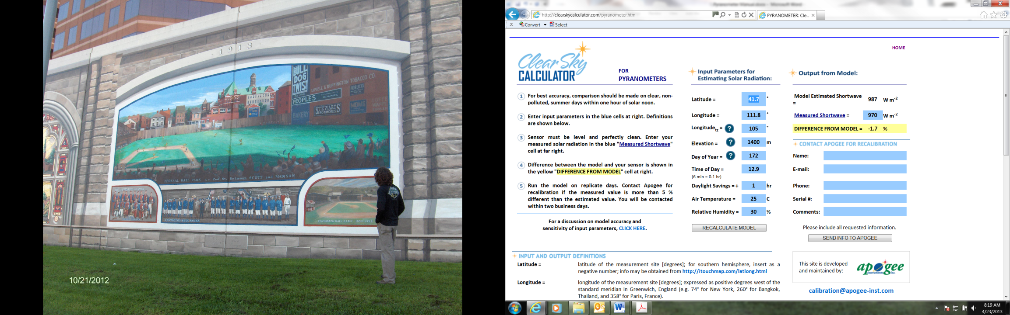

Clear Sky Calculator for pyranometers. Site data are input in blue cells in middle of page and an estimate of total shortwave radiation is returned on right-hand side of page.

### Troubleshooting and Customer Support

**Cable Length**

Fifteen feet is the maximum cable length that can be built into the sensor.

**Modifying Cable Length**

If you required a longer cable length an “active” USB extension cable is required. Please note, the connection between the cables must be made water tight.

### Return and Warranty Policy

RETURN POLICY

Apogee Instruments will accept returns within 30 days of purchase as long as the product is in new condition (to be determined by Apogee). Returns are subject to a 10 % restocking fee.

WARRANTY POLICY

**What is Covered**All products manufactured by Apogee Instruments are warranted to be free from defects in materials and craftsmanship for a period of four (4) years from the date of shipment from our factory. To be considered for warranty coverage an item must be evaluated either at our factory or by an authorized distributor.

Products not manufactured by Apogee (spectroradiometers, chlorophyll content meters) are covered for a period of one (1) year.

**What is Not Covered**The customer is responsible for all costs associated with the removal, reinstallation, and shipping of suspected warranty items to our factory.

The warranty does not cover equipment that has been damaged due to the following conditions:

1. Improper installation or abuse.

2. Operation of the instrument outside of its specified operating range.

3. Natural occurrences such as lightning, fire, etc. 5. Improper or unauthorized repair.

Please note that nominal accuracy drift is normal over time. Routine recalibration of sensors/meters is considered part of proper maintenance and is not covered under warranty.

**Who is Covered**This warranty covers the original purchaser of the product or other party who may own it during the warranty period.

**What We Will Do**At no charge we will:

1. Either repair or replace (at our discretion) the item under warranty.

2. Ship the item back to the customer by the carrier of our choice.

Different or expedited shipping methods will be at the customer’s expense.

**How To Return An Item**1. Please do not send any products back to Apogee Instruments until you have received a Return Merchandise Authorization (RMA) number from our technical support department by calling (435) 792-4700 or by submitting an online RMA form at www.apogeeinstruments.com/tech-support-recalibration-repairs/. We will use your RMA number for tracking of the service item.

2. Send all RMA sensors and meters back in the following condition: Clean the sensor’s exterior and cord. Do not modify the sensors or wires, including splicing, cutting wire leads, etc. If a connector has been attached to the cable end, please include the mating connector – otherwise the sensor connector will be removed in order to complete the repair/recalibration.

3. Please write the RMA number on the outside of the shipping container.

4. Return the item with freight pre-paid and fully insured to our factory address shown below. We are not responsible for any costs associated with the transportation of products across international borders.

5. Upon receipt, Apogee Instruments will determine the cause of failure. If the product is found to be defective in terms of operation to the published specifications due to a failure of product materials or craftsmanship, Apogee Instruments will repair or replace the items free of charge. If it is determined that your product is not covered under warranty, you will be informed and given an estimated repair/replacement cost.

**Apogee Instruments, Inc.   
721 West 1800 North Logan, UT  
84321, USA**

Other Terms

The available remedy of defects under this warranty is for the repair or replacement of the original product, and Apogee Instruments is not responsible for any direct, indirect, incidental, or consequential damages, including but not limited to loss of income, loss of revenue, loss of profit, loss of wages, loss of time, loss of sales, accruement of debts or expenses, injury to personal property, or injury to any person or any other type of damage or loss.

This limited warranty and any disputes arising out of or in connection with this limited warranty ("Disputes") shall be governed by the laws of the State of Utah, USA, excluding conflicts of law principles and excluding the Convention for the International Sale of Goods. The courts located in the State of Utah, USA, shall have exclusive jurisdiction over any Disputes.

This limited warranty gives you specific legal rights, and you may also have other rights, which vary from state to state and jurisdiction to jurisdiction, and which shall not be affected by this limited warranty. This warranty extends only to you and cannot by transferred or assigned. If any provision of this limited warranty is unlawful, void or unenforceable, that provision shall be deemed severable and shall not affect any remaining provisions. In case of any inconsistency between the English and other versions of this limited warranty, the English version shall prevail.

This warranty cannot be changed, assumed, or amended by any other person or agreement.

**APOGEE INSTRUMENTS, INC. |** 721 WEST 1800 NORTH, LOGAN, UTAH 84321, USA

TEL: (435) 792-4700 | FAX: (435) 787-8268 | WEB: APOGEEINSTRUMENTS.COM

*Copyright © 2016 Apogee Instruments, Inc.*