

# Owner’s Manual

Ultraviolet-A sensor

Models SU-200-SS  
Rev: 31-Mar-2022

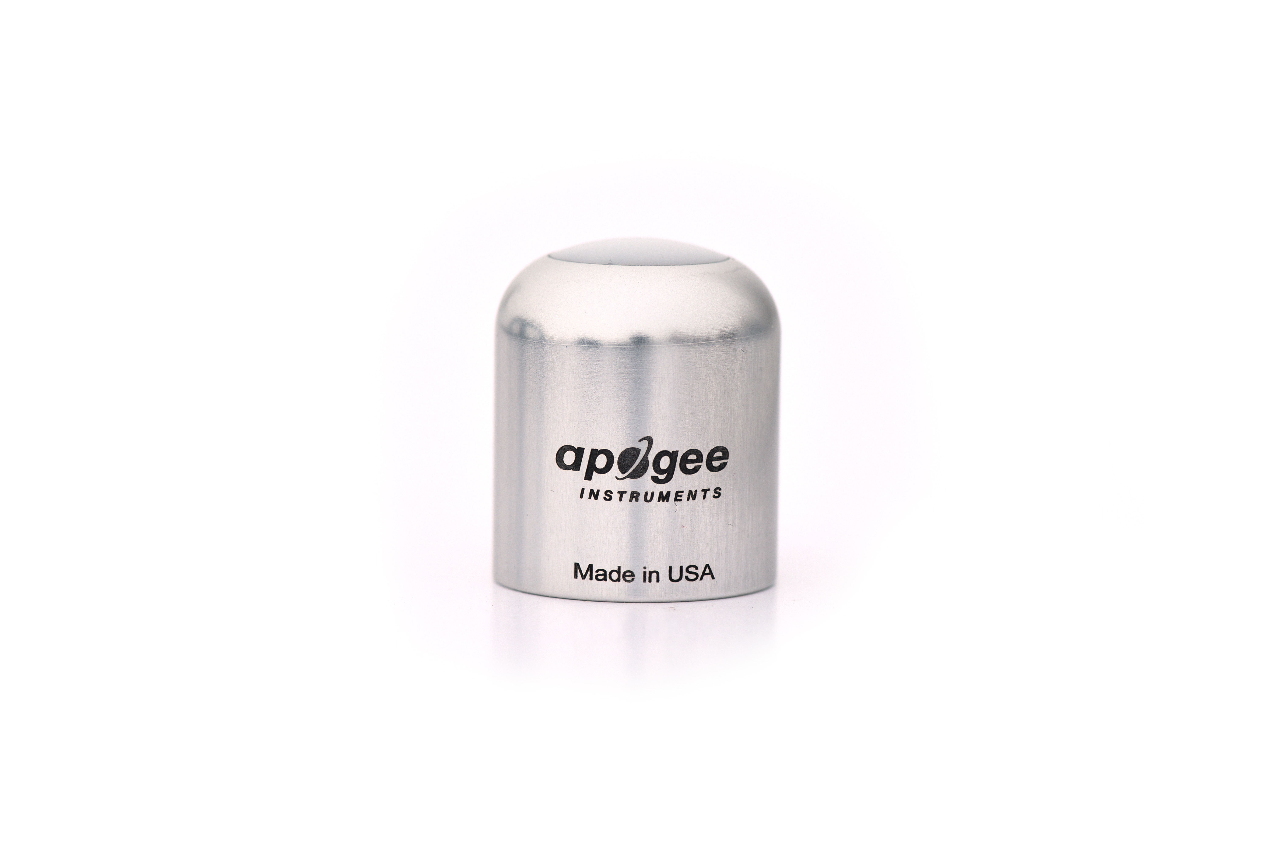

Table of Contents

Owner’s Manual 1

Certificate of Compliance 3

Introduction 4

Sensor Models 5

Specifications 6

Deployment and Installation 9

Cable Connectors 10

Operation and Measurement 11

Maintenance and Recalibration 14

Troubleshooting and Customer Support 15

Return and Warranty Policy 17

### Certificate of Compliance

**EU Declaration of Conformity**

This declaration of conformity is issued under the sole responsibility of the manufacturer:

Apogee Instruments, Inc.  
721 W 1800 N  
Logan, Utah 84321  
USA

for the following product(s):

Models: SU-200  
Type: Ultraviolet-A Sensor

The object of the declaration described above is in conformity with the relevant Union harmonization legislation:

2014/30/EU Electromagnetic Compatibility (EMC) Directive

2011/65/EU Restriction of Hazardous Substances (RoHS 2) Directive

2015/863/EU Amending Annex II to Directive 2011/65/EU (RoHS 3)

Standards referenced during compliance assessment:

EN 61326-1:2013 Electrical equipment for measurement, control, and laboratory use – EMC requirements

EN 50581:2012 Technical documentation for the assessment of electrical and electronic products with respect to the restriction of hazardous substances

Please be advised that based on the information available to us from our raw material suppliers, the products manufactured by us do not contain, as intentional additives, any of the restricted materials including lead (see note below), mercury, cadmium, hexavalent chromium, polybrominated biphenyls (PBB), polybrominated diphenyls (PBDE), bis (2-ethylhexyl) phthalate (DEHP), butyl benzyl phthalate (BBP), dibutyl phthalate (DBP), and diisobutyl phthalate (DIBP). However, please note that articles containing greater than 0.1 % lead concentration are RoHS 3 compliant using exemption 6c.

Further note that Apogee Instruments does not specifically run any analysis on our raw materials or end products for the presence of these substances, but we rely on the information provided to us by our material suppliers.

Signed for and on behalf of:

Apogee Instruments, March 2022



Bruce Bugbee  
President  
Apogee Instruments, Inc.

### Introduction

Ultraviolet (UV) radiation constitutes a portion of the electromagnetic spectrum from 100 to 400 nm and is further subdivided into three wavelength ranges: UV-A (315 to 400 nm), UV-B (280 to 315 nm), and UV-C (100 to 280 nm). Much of the UV-B and all of the UV-C wavelengths from the sun are absorbed by Earth’s atmosphere. There are also multiple artificial UV light sources available.

Most UV sensors designed for sunlight measurements are sensitive to UV radiation in the UV-A or UV-B ranges. Apogee Instruments SU-200 series UV-A sensors detect UV radiation from 300 to 400 nm and are calibrated in energy flux density units of watts per square meter (W m-2, equal to Joules per second per square meter). The output can also be expressed in photon flux density units of micromoles per square meter per second (µmol m-2 s-1).

Typical applications of UV sensors include incoming UV radiation measurement in outdoor environments or in laboratory use with artificial light sources (e.g., germicidal lamps).

Apogee Instruments SU-200 series UV-A sensors consist of a cast acrylic diffuser, photodiode, and signal processing circuitry mounted in an anodized aluminum housing and a cable to connect the sensor to a measurement device. SU-200 sensors are designed for continuous UV-A radiation measurement in indoor or outdoor environments. The SU-200 series outputs an analog voltage that is directly proportional to UV-A radiation incident on a planar surface (does not have to be horizontal) where the radiation emanates from all angles of a hemisphere.

### Sensor Models

This manual covers the unamplified model SU-200 UV-A sensor (listed below in bold). Additional models are covered in their respective manuals.

|  |  |
| --- | --- |
| Model | Signal |
| SU-200 | **0-10 mV** |
| SU-202 | 0- 2.5 V |
| SU-205 | 0- 5 V |
| SU-220 | USB |

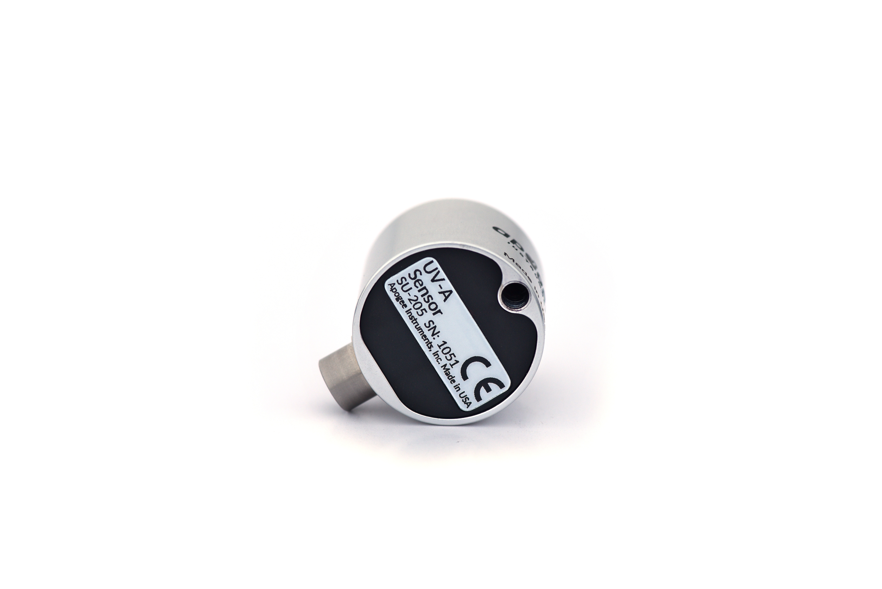

A sensor’s model number and serial number are located on the bottom of the sensor. If you need the manufacturing date of your sensor, please contact Apogee Instruments with the serial number of your sensor.

### Specifications­­

|  |  |
| --- | --- |
|  | **SU-200-SS** |
| Power Supply | Self-Powered |
| Output (sensitivity) | 0.1 mV per W m-2;  0.03 mV per µmol m⁻² s⁻¹ |
| Calibration Factor (reciprocal of sensitivity) | 10 W m-2 per mV;  30 µmol m⁻² s⁻¹ per mV |
| Calibration Uncertainty | ± 10 % |
| Output Range | 0 to 10 mV |
| Measurement Range | 0 to 100 W m-2 |
| Measurement Repeatability | Less than 0.5 % |
| Long-term Drift | Less than 2 % per year |
| Non-linearity | Less than 1 % |
| Response Time | Less than 1 ms |
| Field of View | 180° |
| Spectral Range | 300 to 400 nm (wavelengths where response is greater than 10 % of maximum; see Spectral Response below) |
| Directional (Cosine) Response | ± 2 % at 45°, ± 5 % at 70° |
| Temperature Response | Less than ­0.1 % per C |
| Operating Environment | -30 to 85 C; 0 to 100 % relative humidity |
| Dimension | 30.5 mm diameter, 37 mm height |
| Mass (5 m of cable) | 140 g |
| Cable | 5 m of shielded, twisted-pair wire; TPR jacket (high water resistance, high UV stability, flexibility in cold conditions); pigtail lead wires; stainless steel (316), M8 connector located 25 cm from sensor head |

**Calibration Traceability**

Apogee UV series sensors are calibrated through side-by-side comparison to the mean of four transfer standard UV sensors under UV-enhanced T5 fluorescent tubes. The transfer standard UV sensors are calibrated through side-by-side comparison to an Apogee model PS-300 spectroradiometer under sunlight (clear sky conditions) in Logan, Utah. The PS-300 is calibrated with a quartz halogen lamp traceable to the National Institute of Standards and Technology (NIST).

**Cosine Response**

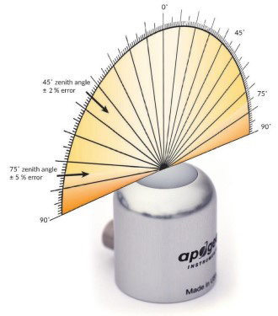

Directional, or cosine, response is defined as the measurement error at a specific angle of radiation incidence. Directional error for Apogee SU-200 series UV-A sensors is approximately ± 2 % and ± 5 % at solar zenith angles of 45° and 75°, respectively.

**Cosine Response Graph**

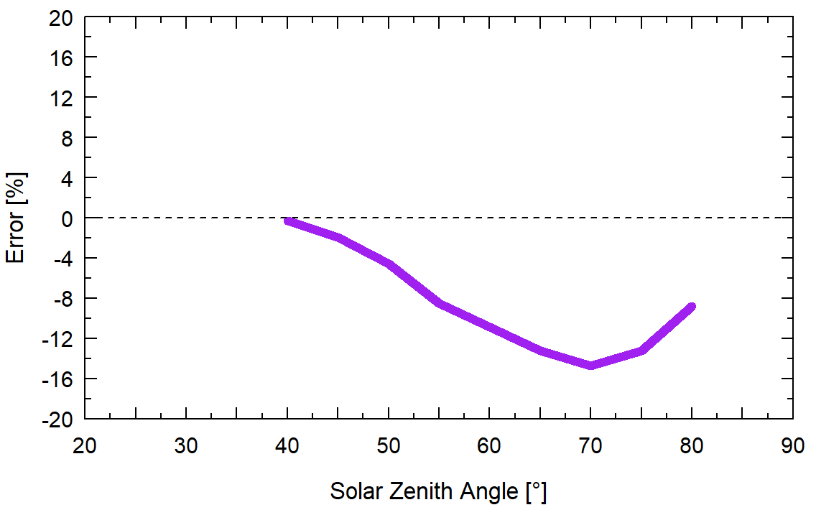

Mean cosine response of four Apogee UV-A sensors. Cosine response was calculated as the relative difference of UV-A sensors from the mean of replicate reference UV-A sensors deployed outdoors. These data are the average of the AM and PM response.

**Spectral Response**

Spectral response estimate of Apogee SU-200 UV-A sensors. Spectral response was modeled from sensitivity of the photodetector and transmittance of the diffuser.

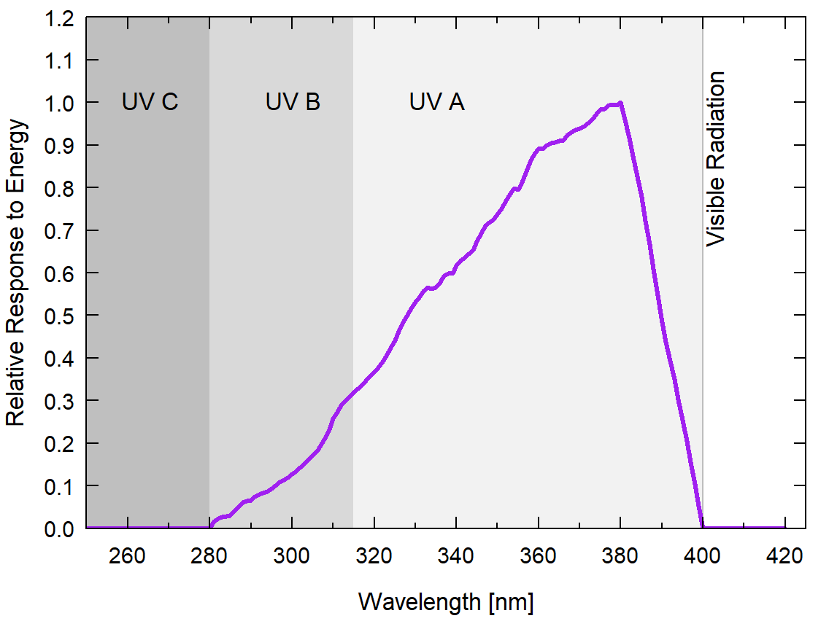

### Deployment and Installation

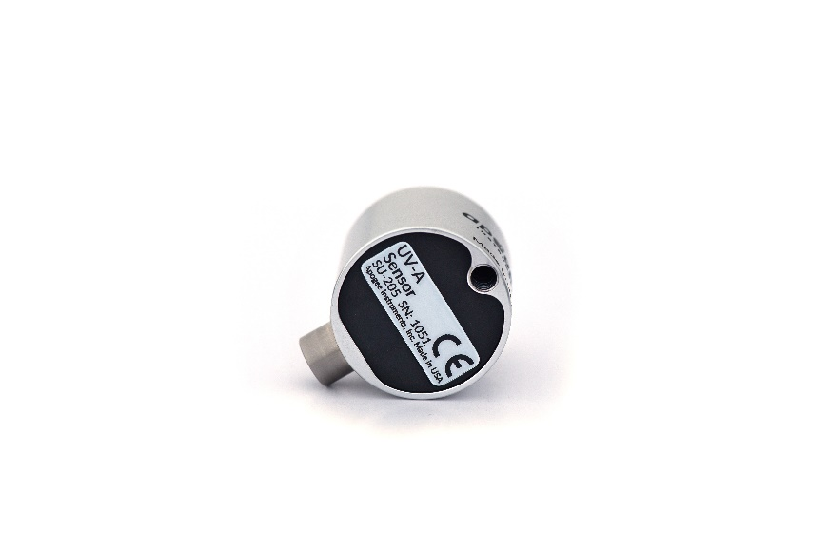Mount the sensor to a solid surface with the nylon mounting screw provided. To accurately measure UV-A incident on a horizontal surface, the sensor must be level. An Apogee Instruments model AL-100 Leveling Plate is recommended to level the sensor when used on a flat surface or being mounted to surfaces such as wood. To facilitate mounting on a mast or pipe, the Apogee Instruments model AL-120 Solar Mounting Bracket with Leveling Plate is recommended.

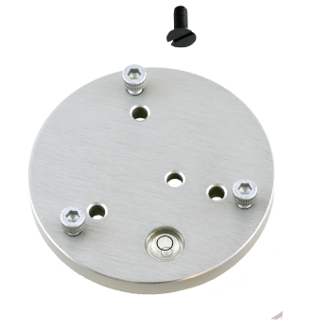

Nylon Screw: 10-32x3/8

Nylon Screw: 10-32x3/8

C:\Users\emyers\AppData\Local\Microsoft\Windows\INetCache\Content.Word\screw.png

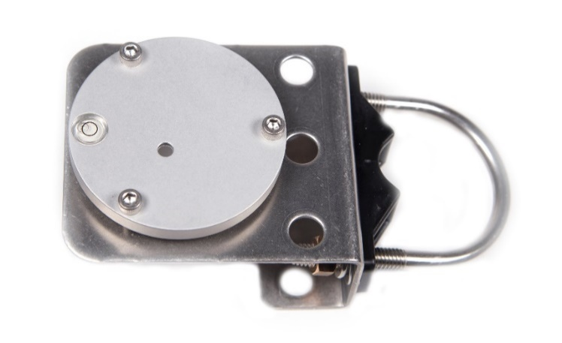

Model AL-120

Model AL-100

To minimize azimuth error, the sensor should be mounted with the cable pointing toward true north in the northern hemisphere or true south in the southern hemisphere. Azimuth error is typically less than 1 %, but it is easy to minimize by proper cable orientation.

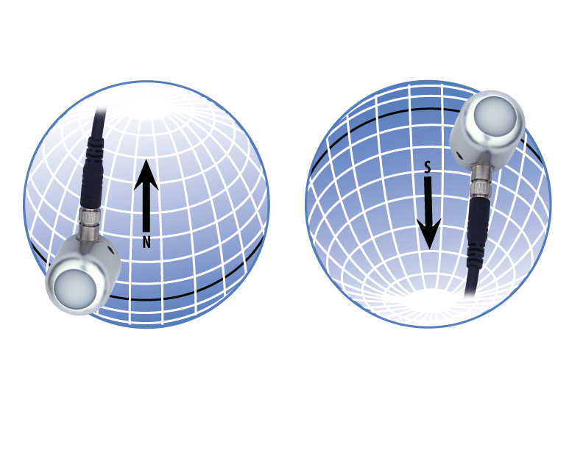

In addition to orienting the cable to point toward the nearest pole, the sensor should also be mounted such that obstructions (e.g., weather station tripod/tower or other instrumentation) do not shade the sensor. **Once mounted, the black cap should be removed from the sensor.** The black cap can be used as a protective covering for the sensor when it is not in use.

### Cable Connectors

|  |  |
| --- | --- |
| Apogee sensors offer cable connectors to simplify the process of removing sensors from weather stations for calibration (the entire cable does **not** have to be removed from the station and shipped with the sensor).  The ruggedized M8 connectors are rated IP68, made of corrosion-resistant marine-grade stainless-steel, and designed for extended use in harsh environmental conditions. | Inline cable connectors are installed 30 cm from the sensor head (pyranometer pictured). |

**Instructions**

|  |  |
| --- | --- |
| **Pins and Wiring Colors:** All Apogee connectors have six pins, but not all pins are used for every sensor. There may also be unused wire colors inside the cable. To simplify connection to a measurement device, the unused pigtail lead wire colors are removed.  If a replacement cable is required, please contact Apogee directly to ensure ordering the proper pigtail configuration.  **Alignment:** When reconnecting a sensor, arrows on the connector jacket and an aligning notch ensure proper orientation.  **Disconnection for extended periods:**  When disconnecting the sensor for an extended period of time from an installation, protect the remaining half of the connector still on the station from water and dirt with electrical tape or other method. | A reference notch inside the connector ensures  proper alignment before tightening.    When sending sensors back for recalibration, only send the section of cable that is hard-wired to the sensor. The section of cable with the pigtail is not required. |
| **Tightening:** Connectors are designed to be firmly finger-tightened only. There is an O-ring inside the connector that can be overly compressed if a wrench is used. Pay attention to thread alignment to avoid cross-threading. When fully tightened, one to two threads may still be visible.  **WARNING:** Do **not** tighten the connector by twisting the black cable, only twist the metal connector. | Finger-tighten firmly. |

### Operation and Measurement

Connect the sensor to a measurement device (meter, datalogger, controller) capable of measuring and displaying or recording a millivolt signal. An input measurement range of approximately 0-10 mV is required to cover the entire range of the SU-200 UV-A sensor. In order to maximize measurement resolution and signal-to-noise ratio, the input range of the measurement device should closely match the output range of the UV sensor. **DO NOT connect the sensor to a power source. The sensor is self-powered and applying voltage will damage the sensor.**

**Wiring for SU-200**

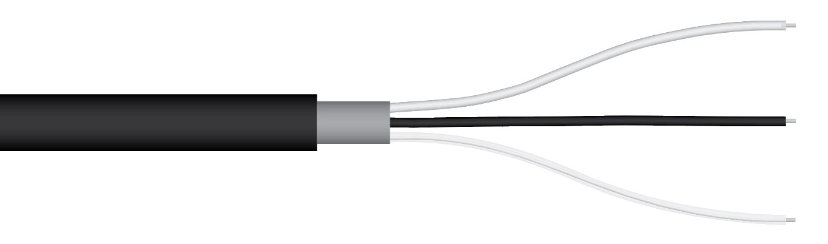

**White:** Output Signal

**Black:** Ground

**Clear:** Shield

**Sensor Calibration**

The SU-200 has a standard UV calibration factor of exactly:

**10.0 W m-2 per mV**

Multiply this calibration factor by the measured mV signal to convert sensor output to UV-A in units of W m-2:

**Calibration Factor (10 W m-2 per mV) * Sensor Output Signal (mV) = UV-A (W m-2)**

**10 W m-2 per mV * 6 mV = 60 W m-2**

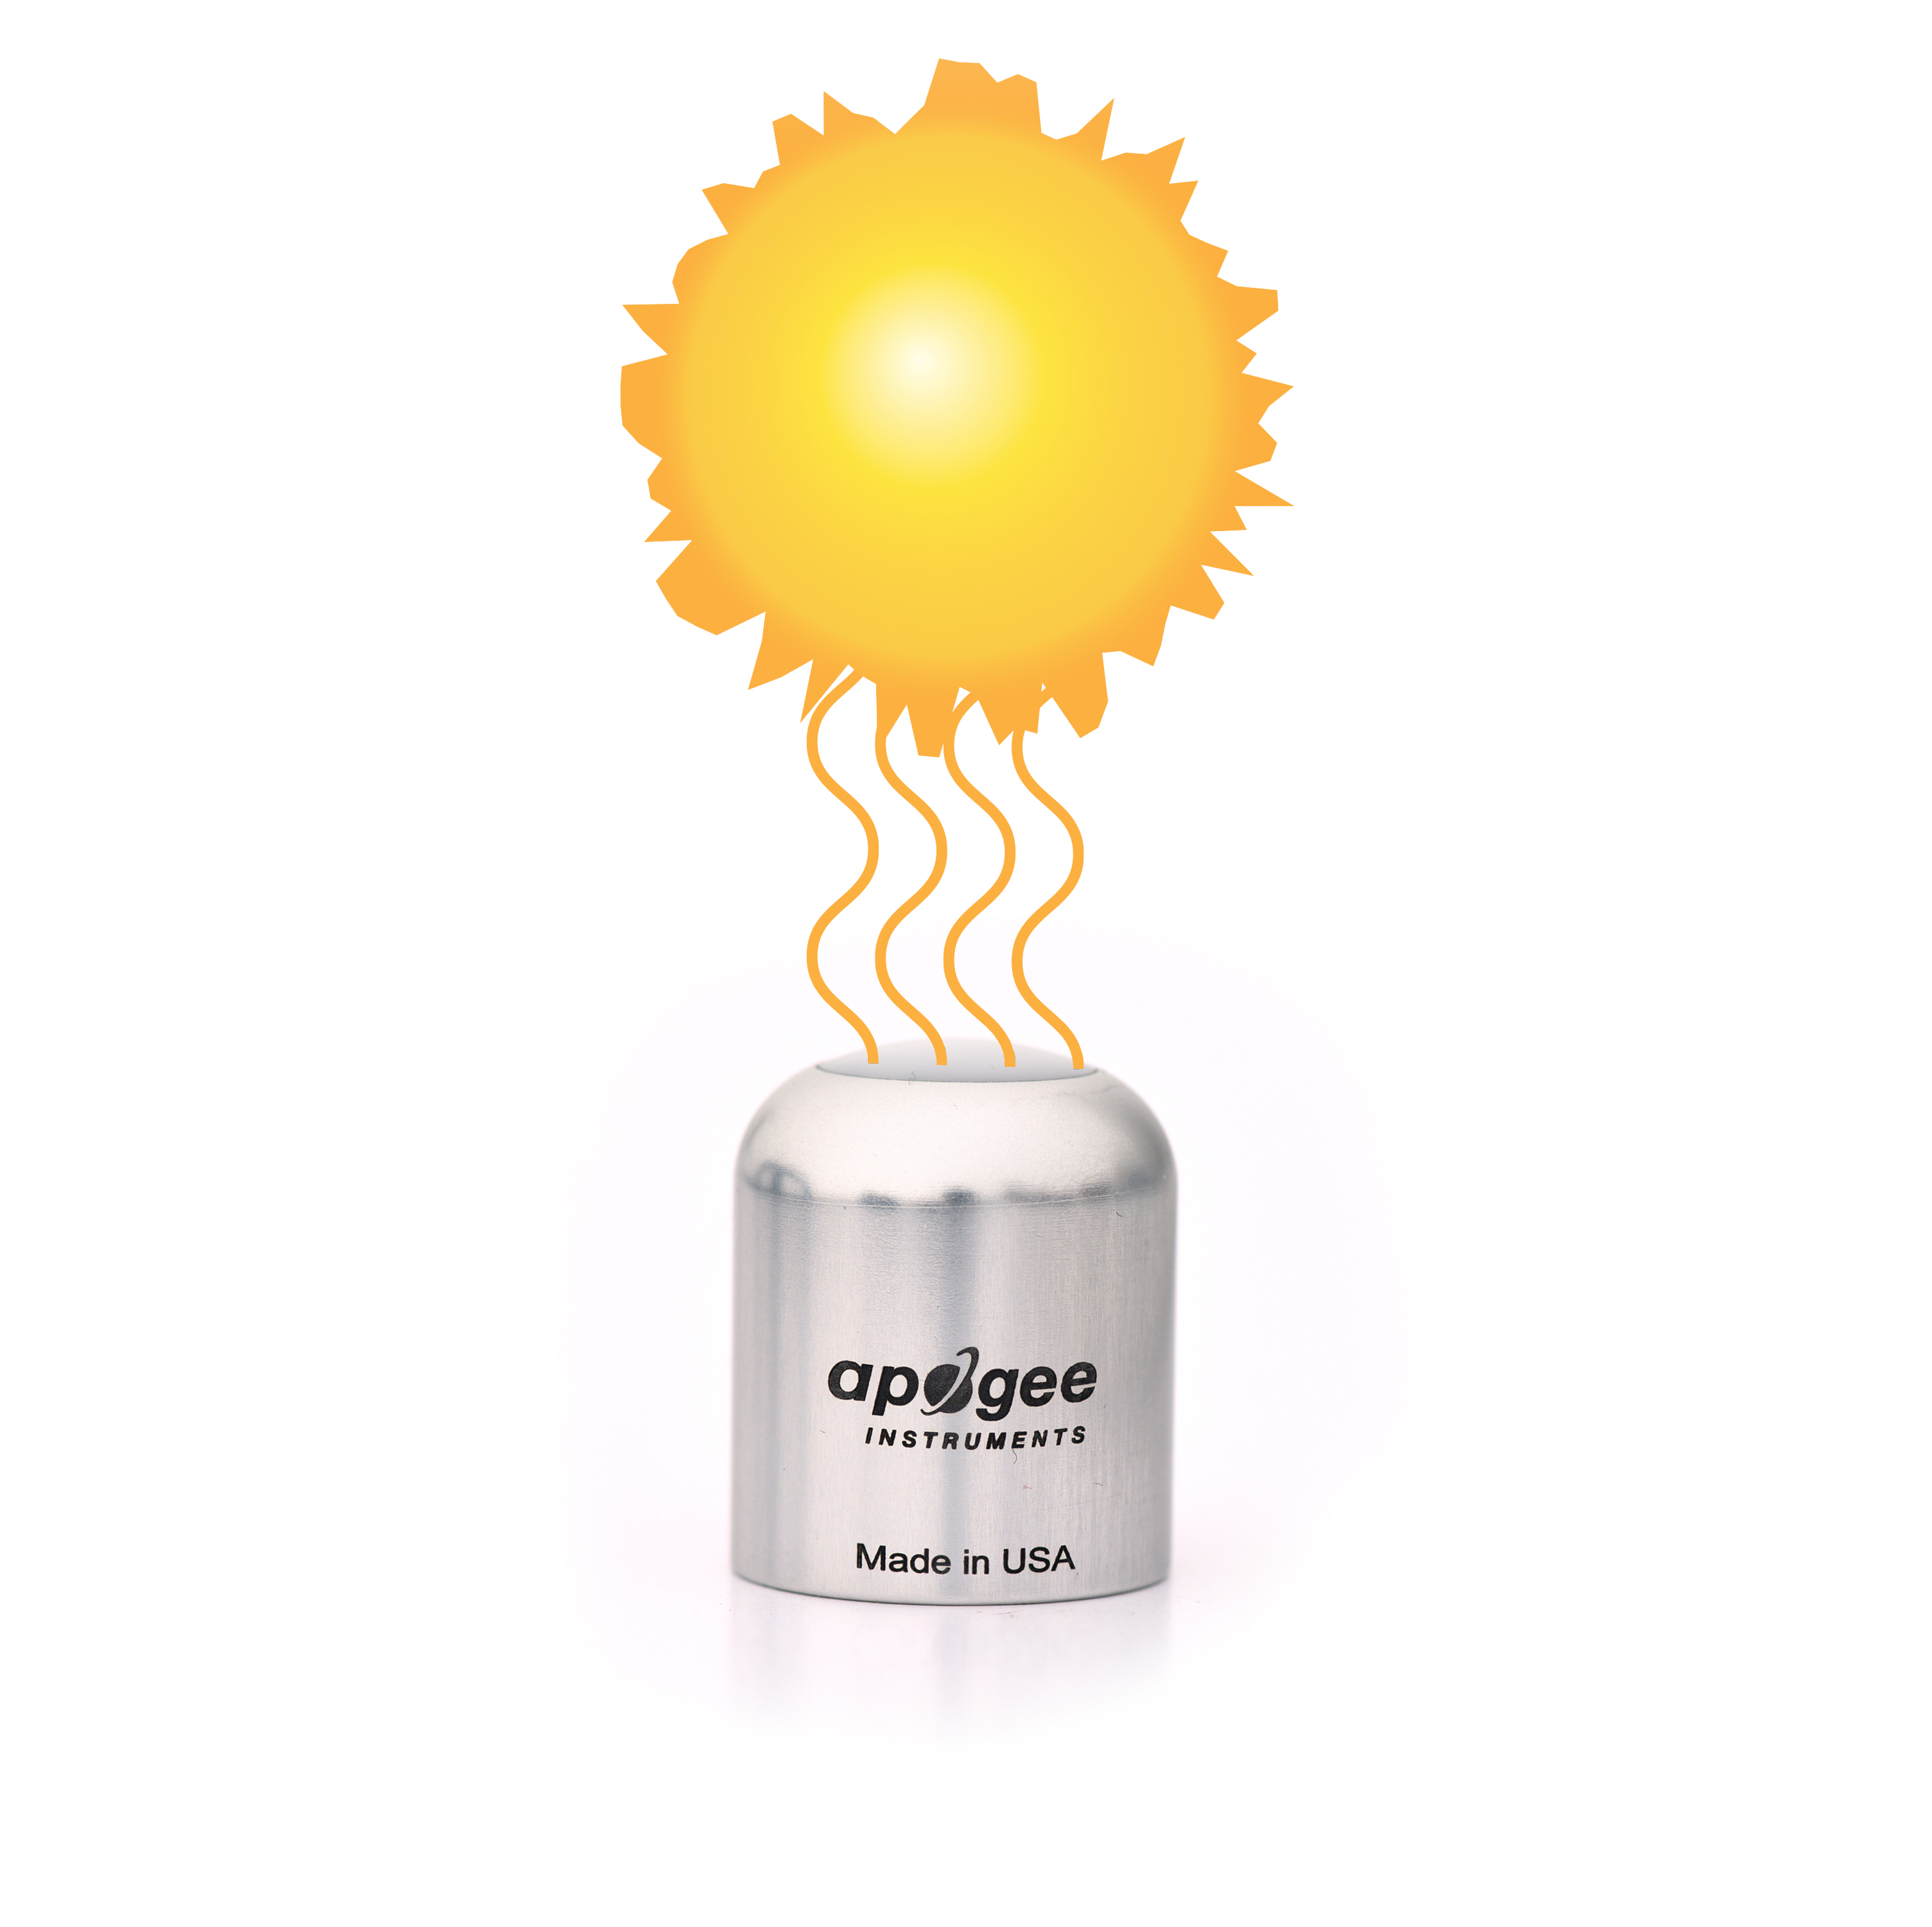

Full Sunlight

≈60 W m-2

UV-A

Example of UV-A measurement with an Apogee UV-A sensor. Full sunlight yields UV-A radiation on a horizontal plane at the Earth’s surface of approximately 60 W m-2. This yields an output signal of 6 mV. The signal is converted to UV-A radiation by multiplying by the calibration factor of 10 W m-2 per mV.

Sensor Output

6 mV

**­­­**

**UV-A Measurements and Spectral Errors**

Apogee Instruments model SU-200 UV-A sensors are calibrated to measure ultraviolet radiation from the sun between 315 and 400 nm in Watts per square meter. In addition to naturally occurring UV-A radiation from the sun, there are many electric light sources that emit UV-A radiation (e.g., cool white fluorescent, metal halide, mercury arc, and germicidal lamps). Although the relative wavelengths of UV-A radiation differ among sunlight and electric lights, the error estimates shown in the table below indicate the SU-200 provides reasonable estimates of UV-A radiation coming from electric lamps (table provides spectral error estimates for UV-A radiation measurements from radiation sources other than clear sky solar radiation). For most common lamps, the error is less than 10 %. The SU-200 is particularly useful for determining the UV-A filtering capacity of the transparent plastic and glass barriers that are commonly used below electric lamps.

|  |  |  |
| --- | --- | --- |
| Radiation Source (Error Calculated Relative to Sun, Clear Sky) | **Expected EFD Error [%]** | **Expected PFD Error [%]** |
| Clear Sky | 0.0 | 0.0 |
| Overcast | 0.0 | -1.1 |
| Direct Normal | -0.2 | -1.0 |
| Diffused Blue Light | 0.3 | 1.4 |
| CWF T5 | 8.2 | 9.2 |
| Metal Halide | 1.2 | -1.2 |
| Quartz Halogen | -2.3 | -3.8 |
| Mercury Arc | 16.2 | 16.9 |
| T12 Fluorescent UV-A Enhanced | 12.2 | 15.2 |
| UV-A LED (365 nm Peak) | 37.4 | 35.3 |
| UV-A LED (386 nm Peak) | 1.8 | -3.9 |
| UV-A LED (395 nm Peak) | -36.9 | -41.2 |

### Maintenance and Recalibration

Blocking of the optical path between the target and detector can cause low readings. Occasionally, accumulated materials on the diffuser of the SU-200 UV-A sensor can block the optical path in three common ways:

1. Moisture or debris build-up on the diffuser.
2. Dust during periods of low rainfall.
3. Salt deposit accumulation from evaporation of sea spray or sprinkler irrigation water.

SU-200 series sensors have a domed diffuser and housing for improved self-cleaning from rainfall, but active cleaning may be necessary. Dust or organic deposits are best removed using water, or window cleaner, and a soft cloth or cotton swab. Salt deposits should be dissolved with vinegar and removed with a cloth or cotton swab. **Never use solvents such as alcohol or acetone to clean the sensor.** Use only gentle pressure when cleaning the diffuser with a cotton swab or soft cloth, to avoid scratching the outer surface. The vinegar should be allowed to do the cleaning, not mechanical force. **Never use an abrasive material or cleaner on the diffuser**.

It is recommended that UV-A sensors be recalibrated every two years. See the Apogee webpage for details regarding return of sensors for recalibration (<http://www.apogeeinstruments.com/tech-support-recalibration-repairs/>).

### Troubleshooting and Customer Support

**Independent Verification of Functionality**

Apogee SU-200 sensors are self-powered devices and output a voltage signal proportional to incident UV-A radiation. A quick and easy check of sensor functionality can be determined using a voltmeter with millivolt resolution. Connect the positive lead of the voltmeter to the white wire from the sensor and the negative lead (or common) to the black wire from the sensor. Direct the sensor head toward the sun and verify the sensor provides a signal. Blocking all UV radiation from the sensor should force the sensor signal to zero.

**Compatible Measurement Devices (Dataloggers/Controllers/Meters)**

SU-200 UV-A sensors are calibrated with a standard calibration factor of 10.0 W m-2 per mV, yielding a sensitivity of 0.1 mV per W m-2. Thus, a compatible measurement device (e.g., datalogger or controller) should have resolution of at least 0.1 mV to provide a measurement resolution of 1 W m-2.

An example datalogger program for Campbell Scientific dataloggers can be found on the Apogee webpage at <http://www.apogeeinstruments.com/content/UV-Sensor.CR1>.

**Zero Offset Error**

With the use of certain dataloggers it is possible to measure a non-zero voltage (zero offset) when the sensor output should be zero (no UV irradiance incident on diffuser). This offset can be corrected by adding or subtracting the measured offset from the sensor output. However, if the offset is substantial, and your sensor is outputting unrealistic values then it may need to be recalibrated. In this case, contact Apogee customer support to recalibrate the sensor.

**Cable Length**

When the sensor is connected to a measurement device with high input impedance, sensor output signals are not changed by shortening the cable or splicing on additional cable in the field. Tests have shown that if the input impedance of the measurements device is greater than 1 mega-ohm there is negligible effect on the calibration, even after adding up to 100 m of cable. All Apogee sensors use shielded, twisted pair cable to minimize electromagnetic interference. For best measurements, the shield wire must be connected to an earth ground. This is particularly important when using the sensor with long lead lengths in electromagnetically noisy environments.

**Modifying Cable Length**

See Apogee webpage for details on how to extend sensor cable length at <http://www.apogeeinstruments.com/how-to-make-a-weatherproof-cable-splice/>.

**Unit Conversion**

SU-200 series UV-A sensors are calibrated in energy flux units of W m-2. It is possible to convert the energy flux value to photon flux units of µmol m-2 s-1 using a conversion factor. Below is an example of how to convert energy flux units to photon flux.

1. Calculate the sensor output in units of J m-2 s-1.
2. Multiply the energy flux units by the conversion factor. It’s important to note that each light source needs a specific conversion factor. The conversion factor used in the example equation is the sunlight conversion factor.

$$\frac{60 J/{m^{2}s}}{0.327 J/{μmol}}=183.5 \frac{μmol}{m^{2}s}$$

### Return and Warranty Policy

RETURN POLICY

Apogee Instruments will accept returns within 30 days of purchase as long as the product is in new condition (to be determined by Apogee). Returns are subject to a 10 % restocking fee.

WARRANTY POLICY

**What is Covered**All products manufactured by Apogee Instruments are warranted to be free from defects in materials and craftsmanship for a period of four (4) years from the date of shipment from our factory. To be considered for warranty coverage an item must be evaluated by Apogee.

Products not manufactured by Apogee (spectroradiometers, chlorophyll content meters, EE08-SS probes) are covered for a period of one (1) year.

**What is Not Covered**The customer is responsible for all costs associated with the removal, reinstallation, and shipping of suspected warranty items to our factory.

The warranty does not cover equipment that has been damaged due to the following conditions:

1. Improper installation, use, or abuse.

2. Operation of the instrument outside of its specified operating range.

3. Natural occurrences such as lightning, fire, etc.

4. Unauthorized modification.

5. Improper or unauthorized repair.

Please note that nominal accuracy drift is normal over time. Routine recalibration of sensors/meters is considered part of proper maintenance and is not covered under warranty.

**Who is Covered**This warranty covers the original purchaser of the product or other party who may own it during the warranty period.

**What Apogee Will Do**At no charge Apogee will:

1. Either repair or replace (at our discretion) the item under warranty.

2. Ship the item back to the customer by the carrier of our choice.

Different or expedited shipping methods will be at the customer’s expense.

**How To Return An Item**1. Please do not send any products back to Apogee Instruments until you have received a Return Merchandise Authorization (RMA) number from our technical support department by submitting an online RMA form at [www.apogeeinstruments.com/tech-support-recalibration-repairs/](http://www.apogeeinstruments.com/tech-support-recalibration-repairs/). We will use your RMA number for tracking of the service item. Call (435) 245-8012 or email techsupport@apogeeinstruments.com with questions.

2. For warranty evaluations, send all RMA sensors and meters back in the following condition: Clean the sensor’s exterior and cord. Do not modify the sensors or wires, including splicing, cutting wire leads, etc. If a connector has been attached to the cable end, please include the mating connector – otherwise the sensor connector will be removed in order to complete the repair/recalibration. ***Note:*** *When sending back sensors for routine calibration that have Apogee’s standard stainless-steel connectors, you only need to send the sensor with the 30 cm section of cable and one-half of the connector. We have mating connectors at our factory that can be used for calibrating the sensor.*

3. Please write the RMA number on the outside of the shipping container.

4. Return the item with freight pre-paid and fully insured to our factory address shown below. We are not responsible for any costs associated with the transportation of products across international borders.

**Apogee Instruments, Inc.   
721 West 1800 North Logan, UT  
84321, USA**

5. Upon receipt, Apogee Instruments will determine the cause of failure. If the product is found to be defective in terms of operation to the published specifications due to a failure of product materials or craftsmanship, Apogee Instruments will repair or replace the items free of charge. If it is determined that your product is not covered under warranty, you will be informed and given an estimated repair/replacement cost.

Products Beyond the Warranty Period

For issues with sensors beyond the warranty period, please contact Apogee at [techsupport@apogeeinstruments.com](mailto:techsupport@apogeeinstruments.com) to discuss repair or replacement options.

Other Terms

The available remedy of defects under this warranty is for the repair or replacement of the original product, and Apogee Instruments is not responsible for any direct, indirect, incidental, or consequential damages, including but not limited to loss of income, loss of revenue, loss of profit, loss of data, loss of wages, loss of time, loss of sales, accruement of debts or expenses, injury to personal property, or injury to any person or any other type of damage or loss.

This limited warranty and any disputes arising out of or in connection with this limited warranty ("Disputes") shall be governed by the laws of the State of Utah, USA, excluding conflicts of law principles and excluding the Convention for the International Sale of Goods. The courts located in the State of Utah, USA, shall have exclusive jurisdiction over any Disputes.

This limited warranty gives you specific legal rights, and you may also have other rights, which vary from state to state and jurisdiction to jurisdiction, and which shall not be affected by this limited warranty. This warranty extends only to you and cannot by transferred or assigned. If any provision of this limited warranty is unlawful, void, or unenforceable, that provision shall be deemed severable and shall not affect any remaining provisions. In case of any inconsistency between the English and other versions of this limited warranty, the English version shall prevail.

This warranty cannot be changed, assumed, or amended by any other person or agreement

**APOGEE INSTRUMENTS, INC. |** 721 WEST 1800 NORTH, LOGAN, UTAH 84321, USA

TEL: (435) 792-4700 | FAX: (435) 787-8268 | WEB: APOGEEINSTRUMENTS.COM

*Copyright © 2022 Apogee Instruments, Inc.*