

# Owner’s Manual

Ultraviolet sensor

Model SU-100  
(including SS model)

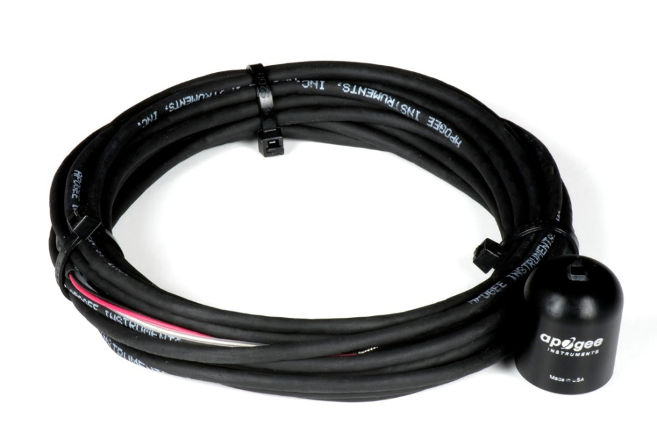

Table of Contents

Owner’s Manual 1

Certificate of Compliance 3

Introduction 4

Sensor Models 5

Specifications 6

Deployment and Installation 7

Cable Connectors 8

Operation and Measurement 9

Maintenance and Recalibration 12

Troubleshooting and Customer Support 14

Return and Warranty Policy 15

### Certificate of Compliance

**EU Declaration of Conformity**

This declaration of conformity is issued under the sole responsibility of the manufacturer:

Apogee Instruments, Inc.  
721 W 1800 N  
Logan, Utah 84321  
USA

for the following product(s):

Models: SU-100  
Type: Ultraviolet Sensor

The object of the declaration described above is in conformity with the relevant Union harmonization legislation:

2014/30/EU Electromagnetic Compatibility (EMC) Directive

2011/65/EU Restriction of Hazardous Substances (RoHS 2) Directive

2015/863/EU Amending Annex II to Directive 2011/65/EU (RoHS 3)

Standards referenced during compliance assessment:

EN 61326-1:2013 Electrical equipment for measurement, control and laboratory use – EMC requirements

EN 50581:2012 Technical documentation for the assessment of electrical and electronic products with respect to the restriction of hazardous substances

Please be advised that based on the information available to us from our raw material suppliers, the products manufactured by us do not contain, as intentional additives, any of the restricted materials including lead (see note below), mercury, cadmium, hexavalent chromium, polybrominated biphenyls (PBB), polybrominated diphenyls (PBDE), bis(2-ethylhexyl) phthalate (DEHP), butyl benzyl phthalate (BBP), dibutyl phthalate (DBP), and diisobutyl phthalate (DIBP). However, please note that articles containing greater than 0.1% lead concentration are RoHS 3 compliant using exemption 6c.

Further note that Apogee Instruments does not specifically run any analysis on our raw materials or end products for the presence of these substances, but rely on the information provided to us by our material suppliers.

Signed for and on behalf of:

Apogee Instruments, October 2019



Bruce Bugbee  
President  
Apogee Instruments, Inc.

### Introduction

Ultraviolet (UV) radiation constitutes a portion of the electromagnetic spectrum from 100 to 400 nm, and is further subdivided into three wavelength ranges: UV-A (315 to 400 nm), UV-B (280 to 315 nm) and UV-C (100 to 280 nm). Much of the UV-B and all of the UV-C wavelengths from the sun are absorbed by the Earth’s atmosphere. There are also many artificial UV light sources available that output a select wavelength range or offer a broadband UV radiation source.

Most UV sensors designed for sunlight measurements are sensitive to UV radiation in the UV-A and UV-B ranges. Apogee Instruments SU-100 UV sensors detect UV radiation from 250 to 400 nm and are calibrated in photon flux units of micromoles per square meter per second (µmol m-2 s-1). The output can also be expressed in energy flux units of watts per square meter (W m-2, equal to Joules per second per square meter).

Typical applications of UV sensors include incoming UV radiation measurement in outdoor environments (not recommended for continuous outdoor deployment) or in laboratory use with artificial light sources (e.g., germicidal lamps).

Apogee Instruments SU-100 UV sensors consist of a photodiode and signal processing circuitry mounted in an anodized aluminum housing, and a cable to connect the sensor to a measurement device. Sensors are potted solid with no internal air space, and are designed for UV radiation measurement in indoor or outdoor environments. The SU-100 outputs an analog voltage that is directly proportional to UV radiation incident on a planar surface (does not have to be horizontal), where the radiation emanates from all angles of a hemisphere.

### Sensor Models

The SU-100 UV sensor is the only stand-alone UV sensor offered by Apogee Instruments. Additional models are covered in their respective manuals.

|  |  |
| --- | --- |
| Model | Signal |
| SU-100 | **Self-powered** |
| SU-420 | USB |

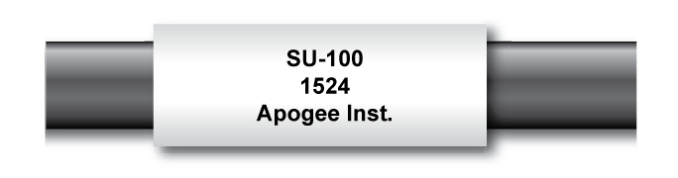

Sensor model number and serial number are located near the pigtail leads on the sensor cable. If you need the manufacturing date of your sensor, please contact Apogee Instruments with the serial number of your sensor.

### Specifications

|  |  |
| --- | --- |
|  | **SU-100** |
| Sensitivity | 0.2 mV per µmol m-2 s-1; 0.61 mV per W m-2 |
| Calibration Factor (reciprocal of sensitivity) | 5 µmol m-2 s-1 per mV; 1.65 W m-2 per mV |
| Calibration Uncertainty | ± 10 % (see Calibration Traceability below) |
| Measurement Repeatability | Less than 1 % |
| Non-stability  (Long-term Drift) | Less than 3 % per year |
| Non-linearity | Less than 1 % (up to 300 µmol m-2 s-1) |
| Response Time | Less than 1 ms |
| Field of View | 180º |
| Spectral Range | 250 nm to 400 nm (see Spectral Response below) |
| Directional (Cosine) Response | ± 10 % at 75º zenith angle |
| Temperature Response | Approximately 0.1 % per C |
| Operating Environment | -40 to 70 C; 0 to 100 % relative humidity |
| Dimension | 24 mm diameter; 28 mm height |
| Mass | 75 g (with 5 m of lead wire) |
| Cable | 5 m of two conductor, shielded, twisted-pair wire; additional cable available in multiples of 5 m; TPR jacket (high water resistance, high UV stability, flexibility in cold conditions); pigtail lead wires |

**Calibration Traceability**

Apogee SU-100 UV sensors are calibrated through side-by-side comparison to the mean of three Apogee model SU-100 transfer standard UV sensors under high intensity discharge metal halide lamps. The transfer standard UV sensors are calibrated through side-by-side comparison to an Apogee model PS-200 spectroradiometer under sunlight (clear sky conditions) in Logan, Utah. The PS-200 is calibrated with a LI-COR model 1800-02 Optical Radiation Calibrator using a 200 W quartz halogen lamp. The 1800-02 and quartz halogen lamp are traceable to the National Institute of Standards and Technology (NIST).

**Spectral Response**

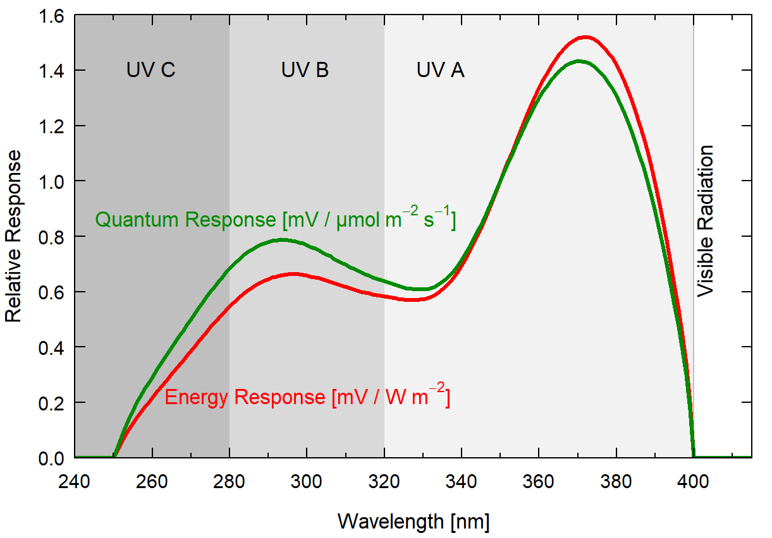

Spectral response estimate of Apogee SU-100 UV sensors. Spectral response measurements were made at 10 nm increments across a wavelength range of 200 to 450 nm in a monochromator with an attached electric light source. Measured spectral data were normalized at 350 nm.

### Deployment and Installation

Mount the sensor to a solid surface with the nylon mounting screw provided. To accurately measure PPFD incident on a horizontal surface, the sensor must be level. An Apogee Instruments model AL-100 Leveling Plate is recommended to level the sensor when used on a flat surface or being mounted to surfaces such as wood. To facilitate mounting on a mast or pipe, the Apogee Instruments model AL-120 Solar Mounting Bracket with Leveling Plate is recommended.

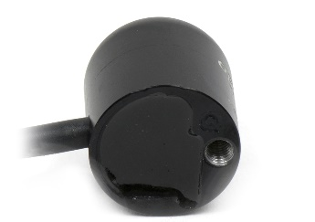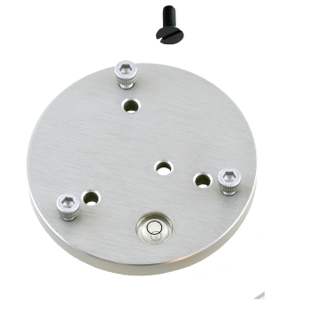C:\Users\emyers\AppData\Local\Microsoft\Windows\INetCache\Content.Word\screw.png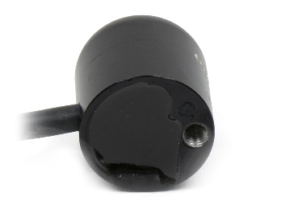

Nylon Screw: 10-32x3/8

Nylon Screw: 10-32x3/8

Model AL-100

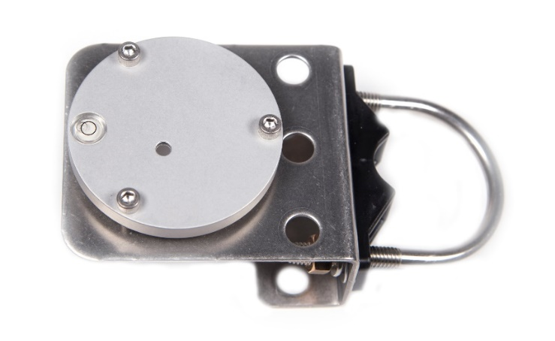

Model AL-120

****To minimize azimuth error, the sensor should be mounted with the cable pointing toward true north in the northern hemisphere or true south in the southern hemisphere. Azimuth error is typically less than 1 %, but it is easy to minimize by proper cable orientation.

In addition to orienting the cable to point toward the nearest pole, the sensor should also be mounted such that obstructions (e.g., weather station tripod/tower or other instrumentation) do not shade the sensor. **Once mounted, the green cap should be removed from the sensor.** The green cap can be used as a protective covering for the sensor when it is not in use.

### Cable Connectors

|  |  |
| --- | --- |
| Apogee started offering in-line cable connectors on some bare-lead sensors in March 2018 to simplify the process of removing sensors from weather stations for calibration (the entire cable does **not** have to be removed from the station and shipped with the sensor).  The ruggedized M8 connectors are rated IP68, made of corrosion-resistant marine-grade stainless-steel, and designed for extended use in harsh environmental conditions. | Inline cable connectors are installed 30 cm from the head  (pyranometer pictured) |

**Instructions**

|  |  |
| --- | --- |
| **Pins and Wiring Colors:** All Apogee connectors have six pins, but not all pins are used for every sensor. There may also be unused wire colors inside the cable. To simplify datalogger connection, we remove the unused pigtail lead colors at the datalogger end of the cable.  If you ever need a replacement cable, please contact us directly to ensure ordering the proper pigtail configuration.  **Alignment:** When reconnecting your sensor, arrows on the connector jacket and an aligning notch ensure proper orientation.  **Disconnection for extended periods:**  When disconnecting the sensor for an extended period of time from a station, protect the remaining half of the connector still on the station from water and dirt with electrical tape or other method. | A reference notch inside the connector ensures  proper alignment before tightening.    When sending sensors in for calibration, only send the short end of the cable and half the connector. |
| **Tightening:** Connectors are designed to be firmly finger-tightened only. There is an O-ring inside the connector that can be overly compressed if a wrench is used. Pay attention to thread alignment to avoid cross-threading. When fully tightened, 1-2 threads may still be visible. | Finger-tighten firmly |

### Operation and Measurement

Connect the sensor to a measurement device (meter, datalogger, controller) capable of measuring and displaying or recording a millivolt signal (an input measurement range of approximately 0-40 mV is required to cover the entire range of UV from the sun). In order to maximize measurement resolution and signal-to-noise ratio, the input range of the measurement device should closely match the output range of the UV sensor. **DO NOT connect the sensor to a power source. The sensor is self-powered and applying voltage will damage the sensor.**

**VERY IMPORTANT: Apogee changed all wiring colors of our bare-lead sensors in March 2018 in conjunction with the release of inline cable connectors on some sensors. To ensure proper connection to your data device, please note your serial number or if your sensor has a stainless-steel connector 30 cm from the sensor head then use the appropriate wiring configuration below.**

**Wiring for SU-100 Serial Numbers 2482 and above or with a cable connector**

Black: Negative (signal from sensor)

Clear: Shield/Ground

White: Positive (signal from sensor)

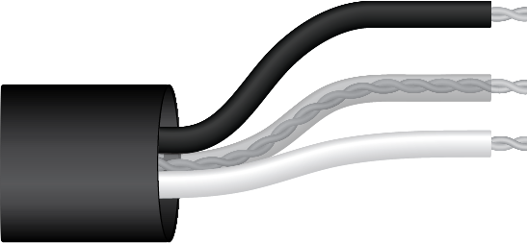

**Wiring for SU-100 Serial Numbers range 0-2481**

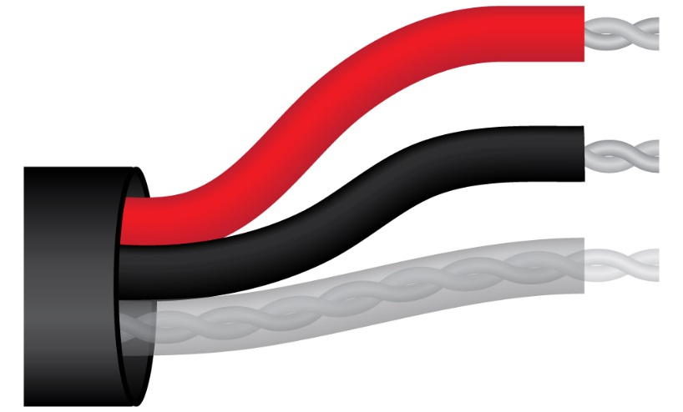

Red: Positive (signal from sensor)

Black: Negative (signal from sensor)

Clear: Shield/Ground

**Sensor Calibration**

The SU-100 has a standard UV calibration factor of exactly:

**5.0 µmol m-2 s-1 per mV**

Multiply this calibration factor by the measured mV signal to convert sensor output to UV in units of µmol m-2 s-1:

**Calibration Factor (5.0 µmol m-2 s-1 per mV) * Sensor Output Signal (mV) = UV (µmol m-2 s-1)**

**5.0 * 35 = 175**

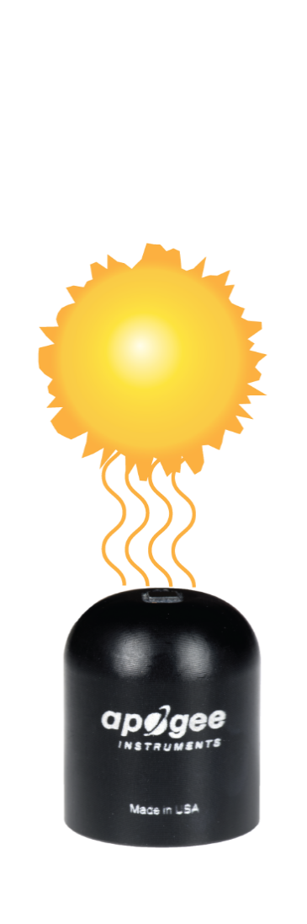

Sensor Output

35 mV

Example of UV measurement with an Apogee UV sensor. Full sunlight yields UV radiation on a horizontal plane at the Earth’s surface of approximately 175 µmol m-2 s-1. This yields an output signal of 35 mV. The signal is converted to UV radiation by multiplying by the calibration factor of 5.0 µmol m-2 s-1 per mV.

Full Sunlight

175 µmol m-2 s-1

**UV-B Measurements and Spectral Errors**

Apogee Instruments model SU-100 UV Sensors measure ultraviolet radiation between 250 and 400 nm in micromoles of photons per square meter per second. Although the UV radiation between 280 and 315 nm (UV-B) is critically important in photochemical and photobiological reactions, less than 3 % of the UV photons are in this range. Because only a small fraction of the photons are in the UV-B range, the SU-100 cannot be used to selectively measure UV-B radiation. The SU-100 is sensitive to UV-B radiation, but it is included with the UV-A radiation to provide a total measurement of UV radiation.

In addition to naturally occurring UV radiation from the sun, there are many electric light sources that emit UV radiation (e.g., cool white fluorescent, metal halide, mercury arc, and germicidal lamps). Although the relative wavelengths of UV radiation differ among sunlight and electric lights, the error estimates shown in the table below indicate that the SU-100 provides reasonable estimates of UV radiation coming from electric lamps (table provides spectral error estimates for UV radiation measurements from radiation sources other than clear sky solar radiation). For common lamps, the error is less than 10 %. The SU-100 is particularly useful for determining the UV filtering capacity of the transparent plastic and glass barriers that are commonly used below electric lamps.

**Spectral Errors for UV Radiation Measurements with Apogee SU-100 UV Sensors**

|  |  |
| --- | --- |
| **Radiation Source (Error Calculated Relative to Sun, Clear Sky)** | **Error [%]** |
| Sun (Clear Sky) | 0.0 |
| Sun (Cloudy Sky) | < 0.5 |
| Reflected from Grass Canopy | < 0.5 |
| Reflected from Deciduous Canopy | < 0.5 |
| Reflected from Conifer Canopy | < 0.5 |
| Reflected from Agricultural Soil | < 0.5 |
| Reflected from Forest Soil | < 0.5 |
| Reflected from Desert Soil | < 0.5 |
| Reflected from Water | < 0.5 |
| Reflected from Ice | < 0.5 |
| Reflected from Snow | < 0.5 |
| Cool White Fluorescent (T5) | 9.0 |
| Metal Halide | 2.8 |
| High Pressure Sodium | -1.7 |
| Incandescent | -3.3 |
| Mercury Arc | 17.8 |

### Maintenance and Recalibration

Moisture or debris on the sensor is a common cause of low readings. The sensor has a domed-shaped housing for improved self-cleaning from rainfall, but materials can accumulate on the photo-sensitive area (e.g., dust during periods of low rainfall, salt deposits from evaporation of sea spray or sprinkler irrigation water) and partially block the optical path. Dust or organic deposits are best removed using water, or window cleaner and a soft cloth or cotton swab. Salt deposits should be dissolved with vinegar and removed with a soft cloth or cotton swab. **Never use an abrasive material or cleaner on the sensor.**

Although Apogee sensors are very stable, nominal accuracy drift is normal for all research-grade sensors. To ensure maximum accuracy, we generally recommend sensors are sent in for recalibration every two years, although you can often wait longer according to your particular tolerances.

The Clear Sky Calculator (www.clearskycalculator.com) determines total shortwave radiation or photosynthetic photon flux (PPF) incident on a horizontal surface at any time of day at any location in the world. It is most accurate when used near solar noon in spring and summer months, where accuracy over multiple clear and unpolluted days is estimated to be ± 4 % in all climates and locations around the world.

Although the Clear Sky Calculator does not specifically report an estimated value for UV radiation, it can still be used to help determine the need for UV sensor recalibration by approximating the ratio of UV to total shortwave or the ratio of UV to PPF. However, due to continuous changes in atmospheric conditions and their effect on UV radiation, the comparison of the UV sensor to the Clear Sky Calculator should only be made in the summer months near solar noon, and under completely clear skies.

To calculate a reference value of UV radiation in units of energy flux (W m-2), input site conditions into the calculator to determine the estimated total shortwave radiation. Then multiply the estimated total shortwave value by an approximated ratio value between 0.05 and 0.06 to convert the total shortwave radiation to total UV radiation.

To calculate a reference value of UV radiation in units of photon flux density (μmol m-2 s-1), input site conditions into the calculator to determine the estimated PPFD. Then multiply the estimated PPFD by an approximated ratio value between 0.075 and 0.085 to convert the PPFD to total UV radiation.

If UV sensor measurements over multiple days near solar noon are consistently different than calculated values (by more than 10 %), the sensor should be cleaned and re-leveled. If measurements are still different after a second test, email calibration@apogeeinstruments.com to discuss test results and possible return of sensor(s).

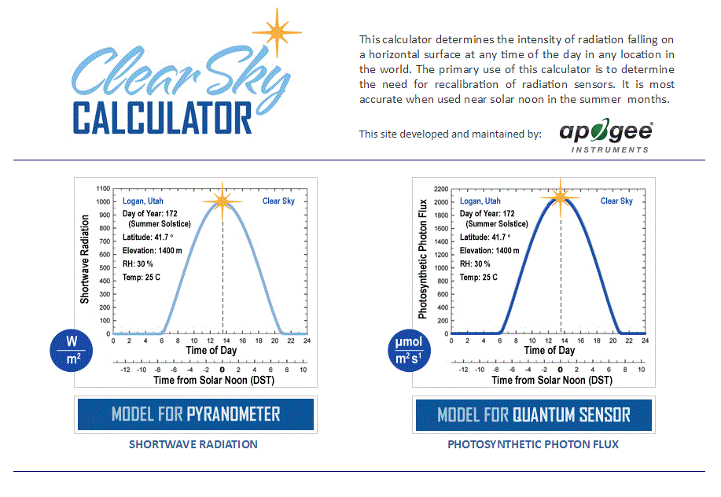

Homepage of the Clear Sky Calculator. Two calculators are available: One for pyranometers (total shortwave radiation) and one for quantum sensors (photosynthetic photon flux density).

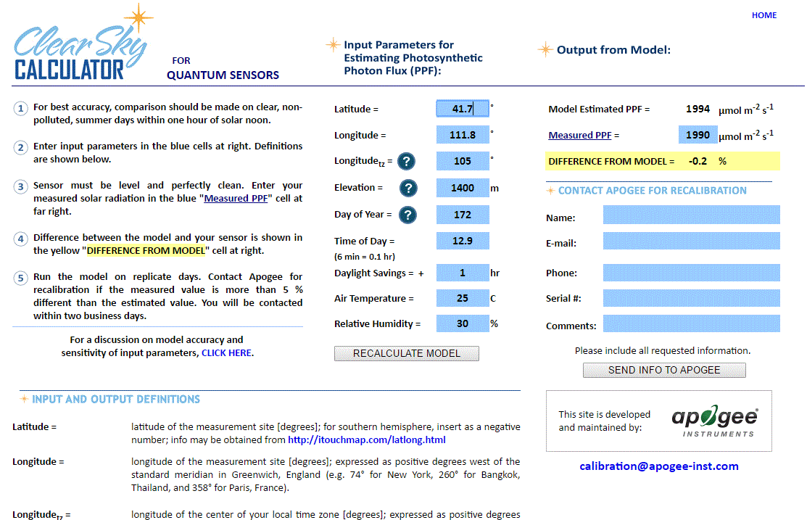

Clear Sky Calculator for pyranometers. Site data are input in blue cells in middle of page and an estimate of total shortwave radiation is returned on right-hand side of page.

### Troubleshooting and Customer Support

**Independent Verification of Functionality**

Apogee SU-100 sensors are self-powered devices and output a voltage signal proportional to incident UV radiation. A quick and easy check of sensor functionality can be determined using a voltmeter with millivolt resolution. Connect the positive lead of the voltmeter to the white wire from the sensor and the negative lead (or common) to the black wire from the sensor. Direct the sensor head toward the sun and verify the sensor provides a signal. Blocking all UV radiation from the sensor should force the sensor signal to zero.

**Compatible Measurement Devices (Dataloggers/Controllers/Meters)**

SU-100 UV sensors are calibrated with a standard calibration factor of 5.0 µmol m-2 s-1 per mV, yielding a sensitivity of 0.2 mV per µmol m-2 s-1. Thus, a compatible measurement device (e.g., datalogger or controller) should have resolution of at least 0.2 mV in order to provide a measurement resolution of 1 µmol m-2 s-1.

An example datalogger program for Campbell Scientific dataloggers can be found on the Apogee webpage at <http://www.apogeeinstruments.com/content/UV-Sensor.CR1>.

**Cable Length**

When the sensor is connected to a measurement device with high input impedance, sensor output signals are not changed by shortening the cable or splicing on additional cable in the field. Tests have shown that if the input impedance of the measurements device is greater than 1 mega-ohm there is negligible effect on the calibration, even after adding up to 100 m of cable. All Apogee sensors use shielded, twisted pair cable to minimize electromagnetic interference. For best measurements, the shield wire must be connected to an earth ground. This is particularly important when using the sensor with long lead lengths in electromagnetically noisy environments.

**Unit Conversion**

SU-100 UV sensors are calibrated in photon flux units of µmol m-2 s-1. It is possible to convert the photon flux value to energy flux units of W m-2. Example of this conversion can be found in the Knowledge Base of the Apogee website (http://www.apogeeinstruments.com/knowledge-base/; scroll down to UV Sensors section).

**Modifying Cable Length**

See Apogee webpage for details on how to extend sensor cable length: (http://www.apogeeinstruments.com/how-to-make-a-weatherproof-cable-splice/).

### Return and Warranty Policy

RETURN POLICY

Apogee Instruments will accept returns within 30 days of purchase as long as the product is in new condition (to be determined by Apogee). Returns are subject to a 10 % restocking fee.

WARRANTY POLICY

**What is Covered**All products manufactured by Apogee Instruments are warranted to be free from defects in materials and craftsmanship for a period of four (4) years from the date of shipment from our factory. To be considered for warranty coverage an item must be evaluated either at our factory or by an authorized distributor.

Products not manufactured by Apogee (spectroradiometers, chlorophyll content meters, EE08-SS probes) are covered for a period of one (1) year.

**What is Not Covered**The customer is responsible for all costs associated with the removal, reinstallation, and shipping of suspected warranty items to our factory.

The warranty does not cover equipment that has been damaged due to the following conditions:

1. Improper installation or abuse.

2. Operation of the instrument outside of its specified operating range.

3. Natural occurrences such as lightning, fire, etc.

4. Unauthorized modification.

5. Improper or unauthorized repair.

Please note that nominal accuracy drift is normal over time. Routine recalibration of sensors/meters is considered part of proper maintenance and is not covered under warranty.

**Who is Covered**This warranty covers the original purchaser of the product or other party who may own it during the warranty period.

**What We Will Do**At no charge we will:

1. Either repair or replace (at our discretion) the item under warranty.

2. Ship the item back to the customer by the carrier of our choice.

Different or expedited shipping methods will be at the customer’s expense.

**How To Return An Item**1. Please do not send any products back to Apogee Instruments until you have received a Return Merchandise Authorization (RMA) number from our technical support department by calling (435) 245-8012 or by submitting an online RMA form at www.apogeeinstruments.com/tech-support-recalibration-repairs/. We will use your RMA number for tracking of the service item.

2. Send all RMA sensors and meters back in the following condition: Clean the sensor’s exterior and cord. Do not modify the sensors or wires, including splicing, cutting wire leads, etc. If a connector has been attached to the cable end, please include the mating connector – otherwise the sensor connector will be removed in order to complete the repair/recalibration.

3. Please write the RMA number on the outside of the shipping container.

4. Return the item with freight pre-paid and fully insured to our factory address shown below. We are not responsible for any costs associated with the transportation of products across international borders.

5. Upon receipt, Apogee Instruments will determine the cause of failure. If the product is found to be defective in terms of operation to the published specifications due to a failure of product materials or craftsmanship, Apogee Instruments will repair or replace the items free of charge. If it is determined that your product is not covered under warranty, you will be informed and given an estimated repair/replacement cost.

**Apogee Instruments, Inc.   
721 West 1800 North Logan, UT  
84321, USA**

Products Beyond the Warranty Period

For issues with sensors beyond the warranty period, please contact Apogee at [techsupport@apogeeinstruments.com](mailto:techsupport@apogeeinstruments.com) to discuss repair or replacement options.

Other Terms

The available remedy of defects under this warranty is for the repair or replacement of the original product, and Apogee Instruments is not responsible for any direct, indirect, incidental, or consequential damages, including but not limited to loss of income, loss of revenue, loss of profit, loss of wages, loss of time, loss of sales, accruement of debts or expenses, injury to personal property, or injury to any person or any other type of damage or loss.

This limited warranty and any disputes arising out of or in connection with this limited warranty ("Disputes") shall be governed by the laws of the State of Utah, USA, excluding conflicts of law principles and excluding the Convention for the International Sale of Goods. The courts located in the State of Utah, USA, shall have exclusive jurisdiction over any Disputes.

This limited warranty gives you specific legal rights, and you may also have other rights, which vary from state to state and jurisdiction to jurisdiction, and which shall not be affected by this limited warranty. This warranty extends only to you and cannot by transferred or assigned. If any provision of this limited warranty is unlawful, void or unenforceable, that provision shall be deemed severable and shall not affect any remaining provisions. In case of any inconsistency between the English and other versions of this limited warranty, the English version shall prevail.

This warranty cannot be changed, assumed, or amended by any other person or agreement.

**APOGEE INSTRUMENTS, INC. |** 721 WEST 1800 NORTH, LOGAN, UTAH 84321, USA

TEL: (435) 792-4700 | FAX: (435) 787-8268 | WEB: APOGEEINSTRUMENTS.COM

*Copyright © 2019 Apogee Instruments, Inc.*