­

# Owner’s Manual

temperature Sensor­s

Models ST-150 and ST-300­

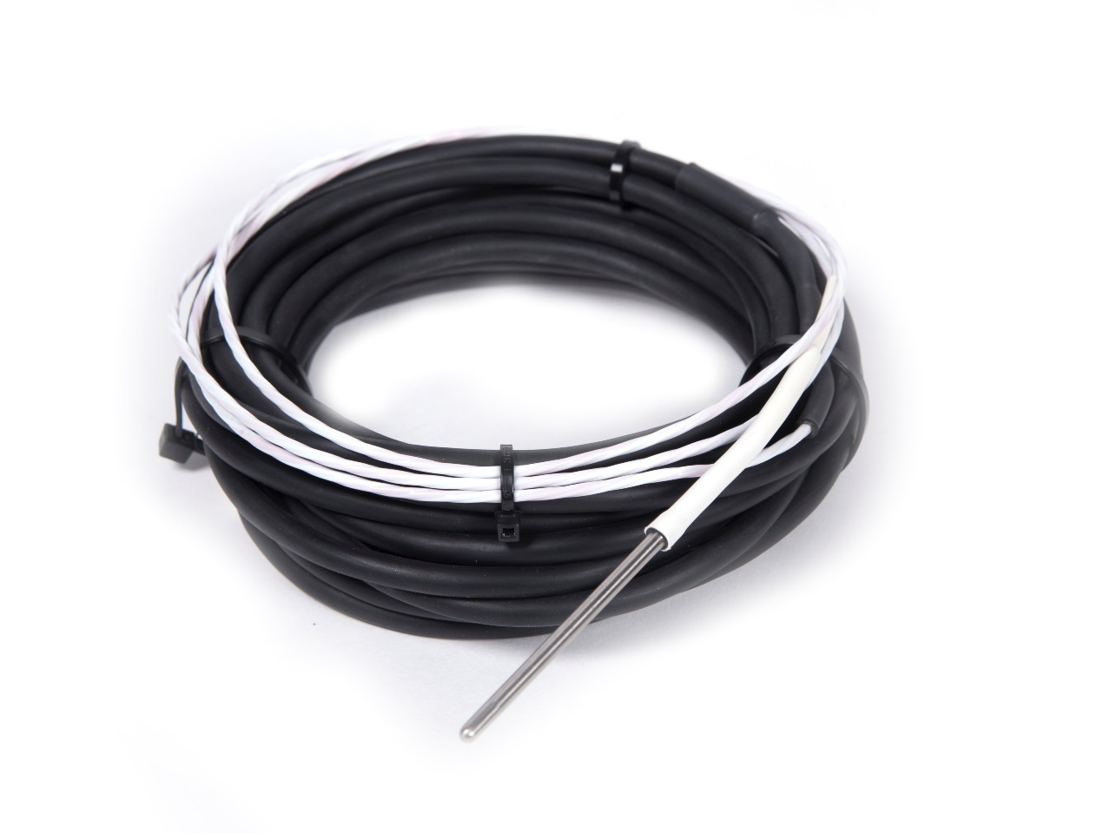

# Table of Contents

Owner’s Manual 1

Table of Contents 2

Certificate of Compliance 3

Introduction 4

Sensor Models 5

Specifications 6

Deployment and Installation 7

Operation and Measurement 8

Maintenance and Recalibration 11

Troubleshooting and Customer Support 12

Return and Warranty Policy 13

### Certificate of Compliance

**EU Declaration of Conformity**

This declaration of conformity is issued under the sole responsibility of the manufacturer:

Apogee Instruments, Inc.  
721 W 1800 N  
Logan, Utah 84321  
USA

for the following product(s):

Models: ST-150, ST-300   
Type: Temperature Sensor

The object of the declaration described above is in conformity with the relevant Union harmonization legislation:

2014/30/EU Electromagnetic Compatibility (EMC) Directive

2011/65/EU Restriction of Hazardous Substances (RoHS 2) Directive

Standards referenced during compliance assessment:

EN 61326-1:2013 Electrical equipment for measurement, control and laboratory use – EMC requirements

EN 50581:2012 Technical documentation for the assessment of electrical and electronic products with respect to the restriction of hazardous substances

Please be advised that based on the information available to us from our raw material suppliers, the products manufactured by us do not contain, as intentional additives, any of the restricted materials including cadmium, hexavalent chromium, lead, mercury, polybrominated biphenyls (PBB), polybrominated diphenyls (PBDE).

Further note that Apogee Instruments does not specifically run any analysis on our raw materials or end products for the presence of these substances, but rely on the information provided to us by our material suppliers.

Signed for and on behalf of:

Apogee Instruments, December 2018



Bruce Bugbee  
President  
Apogee Instruments, Inc.

### Introduction

Temperature is generally thought of as the relative degree of ‘hotness’ or ‘coldness’ of a specific object or material. In actuality, temperature is a measure of the average thermal energy (internal kinetic energy) of an object. Thermal energy is associated with the motion (kinetic energy) of the atoms and molecules making up the object/material. Higher temperatures correspond to higher thermal energies (faster motion of atoms and molecules), whereas colder temperatures correspond to lower thermal energies (slower motion of atoms and molecules).

Properties of materials and nearly all biological, chemical, and physical processes are temperature dependent. Temperature is also a fundamental weather variable. As a result, temperature is perhaps the most widely measured environmental variable.

Thermometers are sensors that measure temperature. Thermometers are often electronic, with multiple options available, such as platinum resistance thermometers (PRTs), thermistors, and thermocouples. Apogee Instruments ST-150 and ST-300 are PRTs, consisting of a platinum resistive element enclosed in a stainless steel sheath, and lead wires to connect the sensor to a measurement device. The sensors are weatherproof and is designed for continuous air temperature measurement when housed in the TS-100 aspirated radiation shield.

The ST-150 is designed to be used with dataloggers that have resistors built in.

### Sensor Models

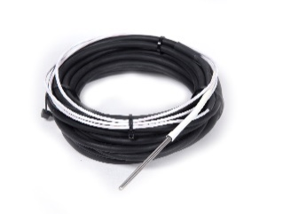The ST-150 PRT temperature sensor is an accurate and durable sensor for use in all applications, including air temperature measurements in the TS-100.

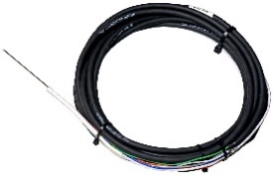

The ST-300 PRT temperature sensor is a highly accurate and durable sensor for use in all applications, including air temperature measurements in the TS-100.

Sensor model number and serial number are located on a label near the pigtail lead wires. If you need the manufacturing date of your sensor, please contact Apogee Instruments with the serial number of your sensor.

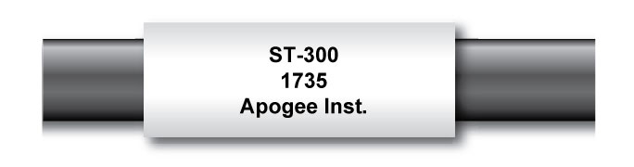

### Specifications

|  |  |  |
| --- | --- | --- |
|  | ST-150 | ST-300 |
| Measurement Range | -50 to 70 C | |
| Measurement Uncertainty | 0.3 C (from -50 to 70 C), Class A | 0.1 C (from -50 to 70 C), 1/10 DIN |
| Measurement Repeatability | less than 0.01 C | |
| Long-term Drift (Non-stability) | less than 0.05 C per year | |
| Equilibration Time | 15 s | |
| Self-Heating | less than 0.01 C (typical, assuming pulsed excitation of 2.1 V DC; 0.09 C at 5 C (maximum, assuming continuous input excitation of 2.1 V DC) | |
| Operating Environment | -50 to 70 C; 0 to 100 % relative humidity | |
| Input Voltage Requirement | Datalogger dependent | 2.1 V DC |
| Output Voltage Range | Datalogger dependent | 16 to 27 mV DC (assuming input excitation of 2.1 V DC) |
| Current Drain | Datalogger dependent | 0.21 mA DC (maximum, assuming continuous input excitation of 2.1 V DC) |
| Dimension | S | |
| Mass | 95 g | |
| Cable | 5 m of four conductor, shielded, twisted-pair wire; additional cable available in multiples of 5 m; TPR jacket (high water resistance, high UV stability, flexibility in cold conditions); pigtail lead wires | |

### Deployment and Installation

Apogee ST Series temperature sensors are designed to be mounted inside solar radiation shields, such as the model TS-100 fan aspirated radiation shield (see picture below). ST-150 and ST-300 sensors can also be buried in soil/porous media, or submerged in water.

The temperature measurement returned by a temperature sensor is the temperature for the sensor itself and not that of the environment the sensor is in, unless the sensor is in thermal equilibrium with the environment. In order to get representative temperature measurements, ST series sensors must be in thermal contact with the medium of interest. Accurate air temperature measurement requires a radiation shield (see picture below) to minimize the effects of shortwave radiation absorption (causes warming; occurs during the day) and longwave radiation emission (causes cooling; occurs on clear nights) by the sensor. Proper ventilation is also required to ensure coupling and thermal equilibrium with air. Condensation on air temperature sensors can pose a problem because it is a source of latent heat that can warm the sensor. When the condensed water evaporates, it cools the sensor via removal of latent heat (evaporational cooling).

During installation of ST-150 and ST-300 sensors in soil, care should be taken to minimize soil disturbance, which may potentially alter soil thermal properties.

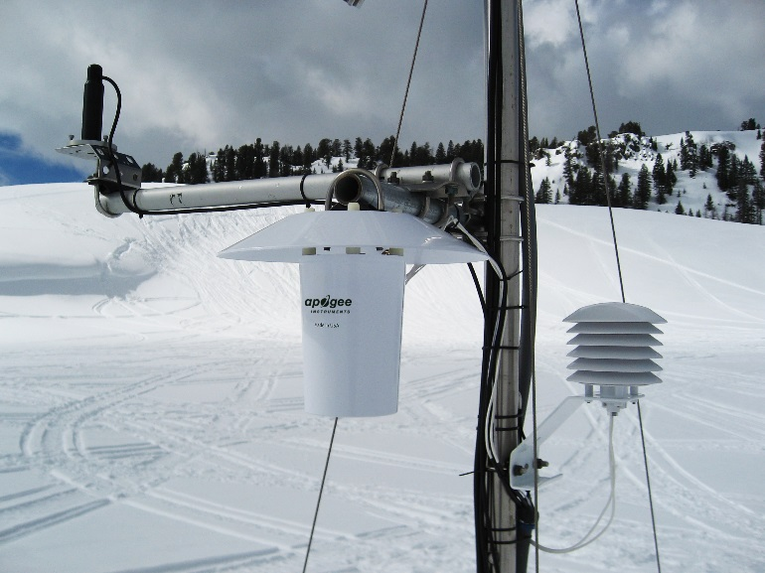

Top left: SP-230 Heated Pyranometer

Center: TS-100 Fan Aspirated Radiation Shield

Right: RM Young 41303 Static Solar Radiation Shield.

### Operation and Measurement

**ST-300**

Connect the sensor to a measurement device (meter, datalogger, controller) capable of inputting 2.1 V DC, and measuring and displaying or recording a millivolt (mV) signal (an input measurement range of 16 to 27 mV is required to cover the entire temperature range of the sensor). In order to maximize measurement resolution and signal-to-noise ratio, the input range of the measurement device should closely match the output range of the PRT.

Red: High Side of Differential Channel 2

Black: Low Side of Differential Channel 2

Blue: High Side of Differential Channel 1

Clear: Ground (shield wire)

White: Analog Ground

Green: Low Side of Differential Channel 1

Orange: PRT Excitation Channel

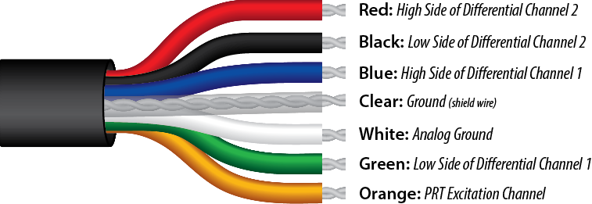

Measurement of PRT resistance is very similar to measurement of thermistor resistance, where a half-bridge measurement is used. An excitation voltage is input across the bridge resistor and an output voltage is measured across the PRT.

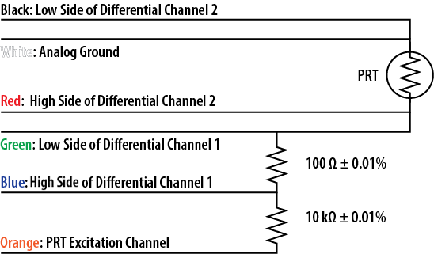

Note: as shown in the schematic, the 4-wire PRT can be directly measured without the bridge resistors. The black and white wires are electrically connected to one side of the PRT while the red and green wires are electrically connected to the other side of the PRT.

An excitation voltage of 2.1 V DC is recommended to minimize current drain, while still maintaining an adequate voltage signal. However, other excitation voltages can be used. Decreasing the excitation voltage will decrease current drain, but will also decrease output voltage. Increasing the excitation voltage will increase output voltage, but will also increase current draw.

**Conversion of PRT Resistance to Temperature**

The PRT is a resistive element, where resistance changes with temperature. PRT resistance (RPRT, in Ω) is measured with a half-bridge measurement, requiring a known excitation voltage input (VEX) and a measurement of output voltage (VOUT):

 (1)

where 100 Ω is resistance of the bridge resistor, V100Ω is the voltage measured across the 100 Ω bridge resistor, and VPRT is the voltage measured across the PRT. From resistance, temperature (TC, in Celsius) is calculated with:

 (2)

where A = 3.9083 x 10-3, B = 5.7750 x 10-7, and C = 4.1830 x 10-12.

**ST-150**

The ST-150 does not include bridge resistors and is therefore meant to be used with dataloggers or controllers that are capable of internally converting the measured resistance from the ST-150 into a temperature reading. Although the ST-150 can be used in a 2-wire or 3-wire measurement configuration, a 4-wire configuration is always preferred for best accuracy. If a half-bridge measurement is desired, the same wiring and bridge resistors detailed above in the ST-300 section can be used to achieve the measurement.

Red: High Side of Differential Channel 2

Black: Low Side of Differential Channel 2

Clear: Ground (shield wire)

White: Analog Ground

Green: Low Side of Differential Channel 1

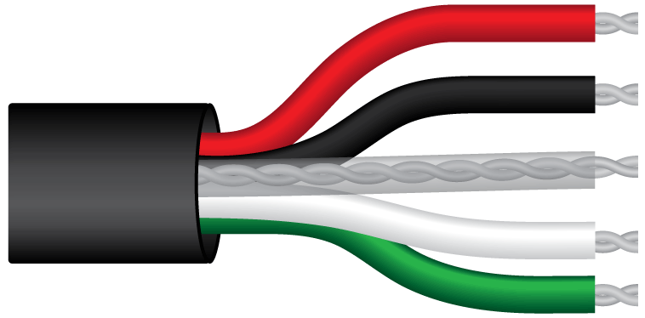

Note: as shown in the schematic, the 4-wire PRT can be directly measured. The black and white wires are electrically connected to one side of the PRT while the red and green wires are electronically connected to the other side of the PRT.

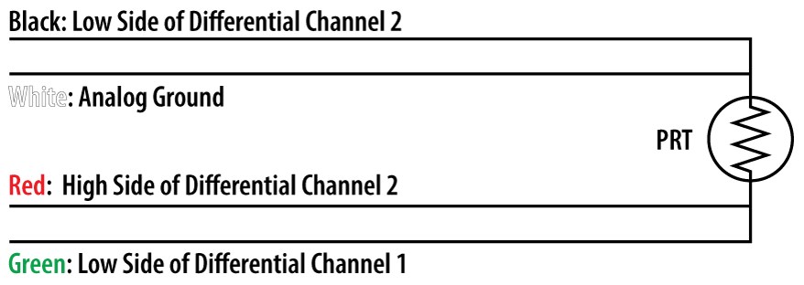

### Maintenance and Recalibration

When sensors are not in use, it is recommended that they be removed from the measurement environment, cleaned, and stored. ST series temperature sensors used to measure air temperature should be periodically cleaned to remove all dust and debris.

Apogee ST-150 and ST-300 temperature sensors are factory *verified* to ensure accuracy. Sensors are compared for absolute temperature against the mean of two reference PRTs in a constant temperature bath, over a range of approximately -35 to 60 C. The reference PRT calibrations are directly traceable to the NIST.

### Troubleshooting and Customer Support

**Independent Verification of Functionality**

Apogee ST-150 and ST-300 temperature sensors yield a resistance proportional to temperature. A quick and easy check of sensor functionality can be accomplished with an ohmmeter. Connect the lead wires of the ohmmeter to the white/black and red/green wires from the sensor. The resistance should read 100 Ω (0.1 kΩ) at 0 C. If the sensor temperature is less than 0 C, the resistance will be lower. If the sensor temperature is greater than 0 C, the resistance will be higher. The white and black wires are connected internally, without a resistor between them; continuity between white and black wires indicates both wires are functional. Similarly, the red and green wires are connected internally, without a resistor between them; continuity between red and green wires indicates both wires are functional. For the ST-300 connect the lead wires of the ohmmeter to the red/green and blue wires from the sensor. The resistance should read 100 Ω, and should not vary. Connect the lead wires of the ohmmeter to the blue and orange wires from the sensor. The resistance should read 10 kΩ, and should not vary. Connect the lead wires of the ohmmeter to the white/black and orange wires from the sensor. The resistance should be the sum of the resistances measured across the white/black and red/green wires wires, red/green and blue wires, and blue and orange wires (e.g., 100 Ω plus 100 Ω plus 10 kΩ at 0 C).

**Compatible Measurement Devices (Dataloggers/Controllers/Meters)**

Measurement of PRT requires an input excitation voltage, where 2.1 V DC is recommended. A compatible measurement device should have the capability to supply the necessary voltage.

The sensitivity (mV output from thermistor per C) of the temperature measurement varies with the excitation voltage, and varies as a function of temperature. With an excitation voltage of 2.1 V DC, the sensitivity is lowest near the ends of the measurement range, -50 and 70 C. A compatible measurement device (e.g., datalogger or controller) should have resolution of at least 0.6 mV, in order to produce temperature resolution of less than 0.1 C across the entire temperature measurement range (less than 0.05 C from -35 to 45 C).

The sensitivity (mV output from PRT per C) of the temperature measurement is approximately constant across the entire measurement range. With an excitation voltage of 2.1 V DC, a compatible measurement device should have resolution of at least 0.008 mV, in order to produce temperature resolution of less than 0.1 C across the entire temperature measurement range.

An example datalogger program for Campbell Scientific dataloggers can be found on the Apogee webpage at <http://www.apogeeinstruments.com/content/Thermistor-Temperature-Sensor.CR1>.

**Modifying Cable Length**

When the sensor is connected to a measurement device with high input impedance, sensor output signals are not changed by splicing on additional cable in the field. Tests have shown that if the input impedance of the measurements device is 1 mega-ohm or higher then there is negligible effect on ST series temperature sensors, even after adding up to 100 m of cable. See Apogee webpage for details on how to extend sensor cable length (<http://www.apogeeinstruments.com/how-to-make-a-weatherproof-cable-splice/>). For cable extensions, shielded, twisted pair cable is recommended, in order to minimize electromagnetic interference. This is particularly important for long lead lengths in electromagnetically noisy environments.

The precision bridge resistor is located at the pigtail end of the ST-300 cable. Thus, the ST-300 temperature sensor cables should not be shortened, otherwise the bridge resistor will be removed.

### Return and Warranty Policy

RETURN POLICY

Apogee Instruments will accept returns within 30 days of purchase as long as the product is in new condition (to be determined by Apogee). Returns are subject to a 10 % restocking fee.

WARRANTY POLICY

**What is Covered**All products manufactured by Apogee Instruments are warranted to be free from defects in materials and craftsmanship for a period of four (4) years from the date of shipment from our factory. To be considered for warranty coverage an item must be evaluated either at our factory or by an authorized distributor.

Products not manufactured by Apogee (spectroradiometers, chlorophyll content meters) are covered for a period of one (1) year.

**What is Not Covered**The customer is responsible for all costs associated with the removal, reinstallation, and shipping of suspected warranty items to our factory.

The warranty does not cover equipment that has been damaged due to the following conditions:

1. Improper installation or abuse.

2. Operation of the instrument outside of its specified operating range.

3. Natural occurrences such as lightning, fire, etc.

4. Unauthorized modification.

5. Improper or unauthorized repair.

Please note that nominal accuracy drift is normal over time. Routine recalibration of sensors/meters is considered part of proper maintenance and is not covered under warranty.

**Who is Covered**This warranty covers the original purchaser of the product or other party who may own it during the warranty period.

**What We Will Do**At no charge we will:

1. Either repair or replace (at our discretion) the item under warranty.

2. Ship the item back to the customer by the carrier of our choice.

Different or expedited shipping methods will be at the customer’s expense.

**How To Return An Item**1. Please do not send any products back to Apogee Instruments until you have received a Return Merchandise Authorization (RMA) number from our technical support department by calling (435) 792-4700 or by submitting an online RMA form at www.apogeeinstruments.com/tech-support-recalibration-repairs/. We will use your RMA number for tracking of the service item.

2. Send all RMA sensors and meters back in the following condition: Clean the sensor’s exterior and cord. Do not modify the sensors or wires, including splicing, cutting wire leads, etc. If a connector has been attached to the cable end, please include the mating connector – otherwise the sensor connector will be removed in order to complete the repair/recalibration.

3. Please write the RMA number on the outside of the shipping container.

4. Return the item with freight pre-paid and fully insured to our factory address shown below. We are not responsible for any costs associated with the transportation of products across international borders.

5. Upon receipt, Apogee Instruments will determine the cause of failure. If the product is found to be defective in terms of operation to the published specifications due to a failure of product materials or craftsmanship, Apogee Instruments will repair or replace the items free of charge. If it is determined that your product is not covered under warranty, you will be informed and given an estimated repair/replacement cost.

**Apogee Instruments, Inc.   
721 West 1800 North Logan, UT  
84321, USA**

Other Terms

The available remedy of defects under this warranty is for the repair or replacement of the original product, and Apogee Instruments is not responsible for any direct, indirect, incidental, or consequential damages, including but not limited to loss of income, loss of revenue, loss of profit, loss of wages, loss of time, loss of sales, accruement of debts or expenses, injury to personal property, or injury to any person or any other type of damage or loss.

This limited warranty and any disputes arising out of or in connection with this limited warranty ("Disputes") shall be governed by the laws of the State of Utah, USA, excluding conflicts of law principles and excluding the Convention for the International Sale of Goods. The courts located in the State of Utah, USA, shall have exclusive jurisdiction over any Disputes.

This limited warranty gives you specific legal rights, and you may also have other rights, which vary from state to state and jurisdiction to jurisdiction, and which shall not be affected by this limited warranty. This warranty extends only to you and cannot by transferred or assigned. If any provision of this limited warranty is unlawful, void or unenforceable, that provision shall be deemed severable and shall not affect any remaining provisions. In case of any inconsistency between the English and other versions of this limited warranty, the English version shall prevail.

This warranty cannot be changed, assumed, or amended by any other person or agreement.

**APOGEE INSTRUMENTS, INC. |** 721 WEST 1800 NORTH, LOGAN, UTAH 84321, USA

TEL: (435) 792-4700 | FAX: (435) 787-8268 WEB: APOGEEINSTRUMENTS.COM

*Copyright © 2018 Apogee Instruments, Inc.*