

# Owner’s Manual

Spectroradiometer

Models SS-110 and SS-120

Rev: 28-Oct-2020

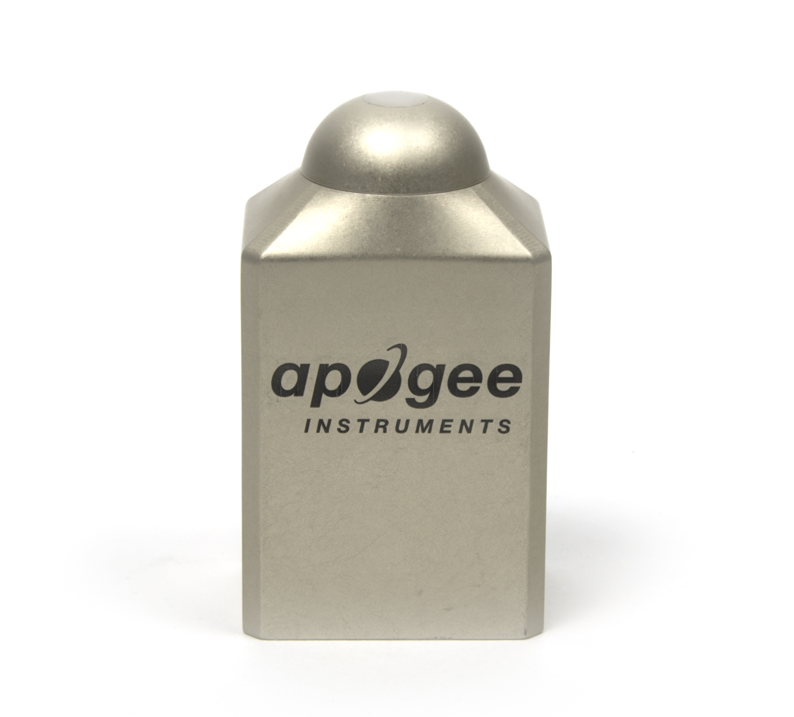

Table of Contents

Owner’s Manual 1

Certificate of Compliance 3

Introduction 4

Sensor Models 5

Specifications 6

Deployment and Installation 9

Operation and Measurement 12

Maintenance and Recalibration 17

Troubleshooting and Customer Support 18

Return and Warranty Policy 19

### Certificate of Compliance

**EU Declaration of Conformity**

This declaration of conformity is issued under the sole responsibility of the manufacturer:

Apogee Instruments, Inc.  
721 W 1800 N  
Logan, Utah 84321  
USA

for the following product(s):

Models: SS-110 and SS-120

Type: Spectroradiometer

The object of the declaration described above is in conformity with the relevant Union harmonization legislation:

2014/30/EU Electromagnetic Compatibility (EMC) Directive

2011/65/EU Restriction of Hazardous Substances (RoHS 2) Directive

2015/863/EU Amending Annex II to Directive 2011/65/EU (RoHS 3)

Standards referenced during compliance assessment:

EN 61326-1:2013 Electrical equipment for measurement, control and laboratory use – EMC requirements

EN 50581:2012 Technical documentation for the assessment of electrical and electronic products with respect to the restriction of hazardous substances

Please be advised that based on the information available to us from our raw material suppliers, the products manufactured by us do not contain, as intentional additives, any of the restricted materials including lead (see note below), mercury, cadmium, hexavalent chromium, polybrominated biphenyls (PBB), polybrominated diphenyls (PBDE), bis(2-ethylhexyl) phthalate (DEHP), butyl benzyl phthalate (BBP), dibutyl phthalate (DBP), and diisobutyl phthalate (DIBP). However, please note that articles containing greater than 0.1% lead concentration are RoHS 3 compliant using exemption 6c.

Further note that Apogee Instruments does not specifically run any analysis on our raw materials or end products for the presence of these substances, but rely on the information provided to us by our material suppliers.

Signed for and on behalf of:

Apogee Instruments, October 2020



Bruce Bugbee  
President  
Apogee Instruments, Inc.

### Introduction

Spectral (i.e., wavelength-dependent) radiation is intensity of output from a radiation source (e.g., sun, electric lamp, reflected radiation from a surface of interest) as a function of wavelength. Radiation spectra vary for different radiation sources and conditions. Radiation spectra can be used to characterize radiation sources.

Spectrometers measure relative spectral radiation over a specified wavelength range. Spectroradiometers are spectrometers calibrated to output spectral measurements in absolute units (e.g., energy flux density in W m-2 nm-1 or photon flux density in µmol m-2 s-1 nm-1).

Typical applications of spectroradiometers include measurement of spectral output from radiation sources used to grow plants, algae, and corals (e.g., in greenhouses, growth chambers, and aquariums), measurement of solar spectra with changing atmospheric conditions, and measurement of spectral reflectance on stationary (e.g., agricultural or ecological weather stations and flux towers) and mobile (e.g., plant phenotyping) platforms.

Apogee Instruments model SS-110 (340 to 820 nm measurement range) and SS-120 (635 to 1100 nm measurement range) spectroradiometers are small, lightweight units designed for laboratory and field use. Each spectroradiometer consists of a spectrometer (slit, diffraction grating, detector array), fiber optic, and diffuser mounted in an anodized aluminum housing. Each unit is calibrated to provide spectral measurements in absolute units. Onboard circuitry allows for output to a computer (via USB).

### Sensor Models

This manual covers Apogee model SS-110 (340 to 820 nm measurement range) and SS-120 (635 to 1100 nm measurement range) spectroradiometers.

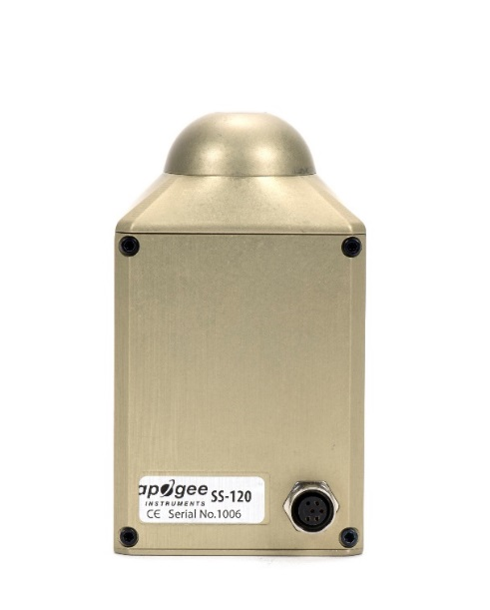

Sensor model number and serial number are located on the back of the sensor.

### Specifications

|  |  |  |  |
| --- | --- | --- | --- |
|  | **SS-110** | **SS-120** | |
| Wavelength Range | 340 to 820 nm | 635 to 1100 nm | |
| Wavelength Measurement Interval | 1.0 nm | | |
| Wavelength Resolution | 3.0 nm (full width half maximum) | | |
| Wavelength Accuracy | ± 0.5 nm | | |
| Wavelength Repeatability | ± 0.2 nm | | |
| Analog to Digital Resolution | 14 bit | | |
| Signal to Noise Ratio | 1500:1 (at maximum signal) | | |
| Stray Light | ≤ 0.25 % at 590 nm | | ≤ 0.25 % at 850 nm |
| Dark Noise | ≤ 3 counts | | |
| Integration Time Range | 10 ms to 10 s | | |
| Linearity | Less than 1 % | | |
| Measurement Sensitivity | Greater than 10 % of max sensitivity for wavelengths greater than 380 nm  (see Sensitivity graph below) | | Greater than 10 % of max sensitivity for wavelengths less than 1030 nm  (see Sensitivity graph below) |
| Measurement Repeatability | Less than 1.0 % (wavelengths greater than 400 nm) | | Less than 1.0 % (wavelengths less than 1020 nm) |
| Directional (Cosine) Response | ± 5 at 75º zenith angle | | |
| Fields of View | 180° (upward-facing); 25° or 150° (downward-facing) | | |
| Operating Environment | -20 to 70 C, 0 to 100 % relative humidity | | |
| Temperature Response | -0.1 ± 0.1 % per C | | |
| Irradiance Calibration Uncertainty (see Irradiance Calibration Traceability below) | ± 5 % | | |
| Current Draw | 190 mA during measurement and when idle (USB) | | |
| Power Requirement | 1 W (USB) | | |
| Interface Cable | 5 m PVC jacket with USB (for computer) | | |
| Software | Apogee Spectrovision (windows compatible, XP and later; Mac compatible, 10.9 and later) | | |
| Operating Environment | -20 to 70 C, 0 to 100 % relative humidity | | |
| Thread Size (for Mounting) | ¼”-20 | | |
| Dimensions | 89.3 mm height, 50.8 mm width, 38.1 mm depth | | |
| Mass | 300 g | | |
| Warranty | 1 year against defects in materials and workmanship | | |

**Irradiance Calibration Traceability**

Apogee SS series spectroradiometers are calibrated with a LI-COR model 1800-02 Optical Radiation Calibrator using a 200 W quartz halogen lamp. The 1800-02 and quartz halogen lamp are traceable to the National Institute of Standards and Technology (NIST).

**SS-110 Sensitivity**

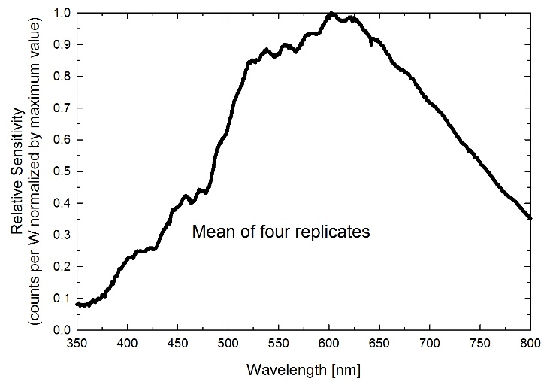

Sensitivity was determined by collecting spectra under a quartz halogen lamp with an NIST traceable calibration and calculating the ratio of counts measured with the spectrometer to energy flux density from the lamp. Maximum sensitivity of the SS-110 is near 600 nm. Sensitivity of the SS-110 is at least 10 % of the maximum value at all wavelengths greater than 380 nm.

**SS-120 Sensitivity**

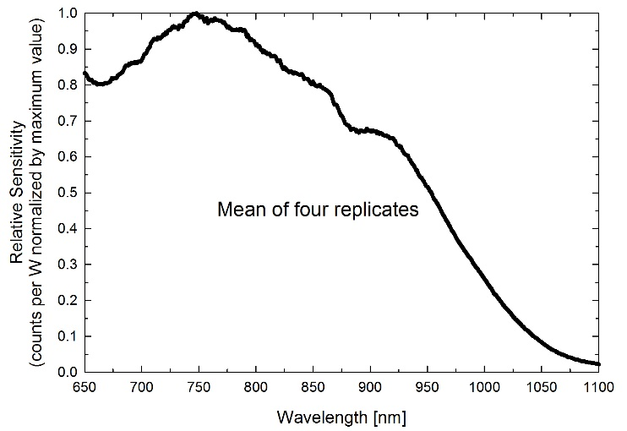

Sensitivity was determined by collecting spectra under a quartz halogen lamp with an NIST traceable calibration and calculating the ratio of counts measured with the spectrometer to energy flux density from the lamp. Maximum sensitivity of the SS-120 is near 750 nm. Sensitivity of the SS-120 is at least 10 % of the maximum value at all wavelengths less than 1030 nm.

**Dimensions**

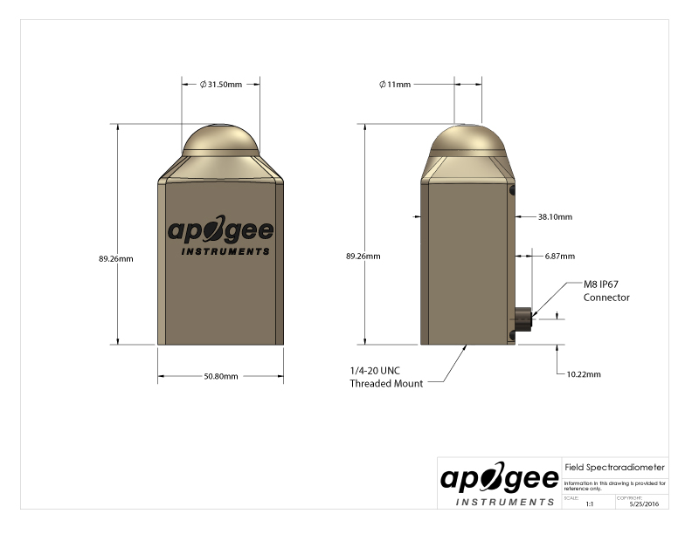

### Deployment and Installation

Mounting

**Upward-facing:** Mount the sensor to a solid surface with the nylon mounting screw provided. To accurately measure energy flux density or photon flux density incident on a horizontal surface, the sensor must be level. An Apogee Instruments model AL-200 leveling plate is recommended for this purpose. To facilitate mounting on a cross arm, an Apogee Instruments model AM-110 mounting bracket is recommended.

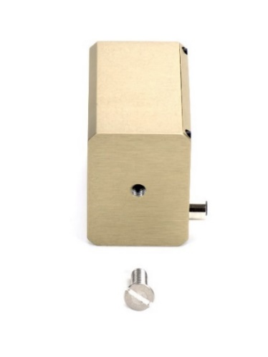

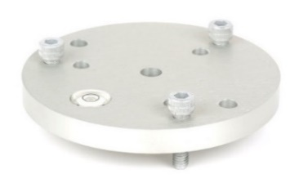

**Downward-facing:** To facilitate mounting on a cross arm, and Apogee Instruments model AM-210 mounting bracket is recommended.

To minimize azimuth error, the sensor should be mounted with the cable pointing toward true north in the northern hemisphere or true south in the southern hemisphere. Azimuth error is typically less than 1 %, but it is easy to minimize by proper cable orientation.

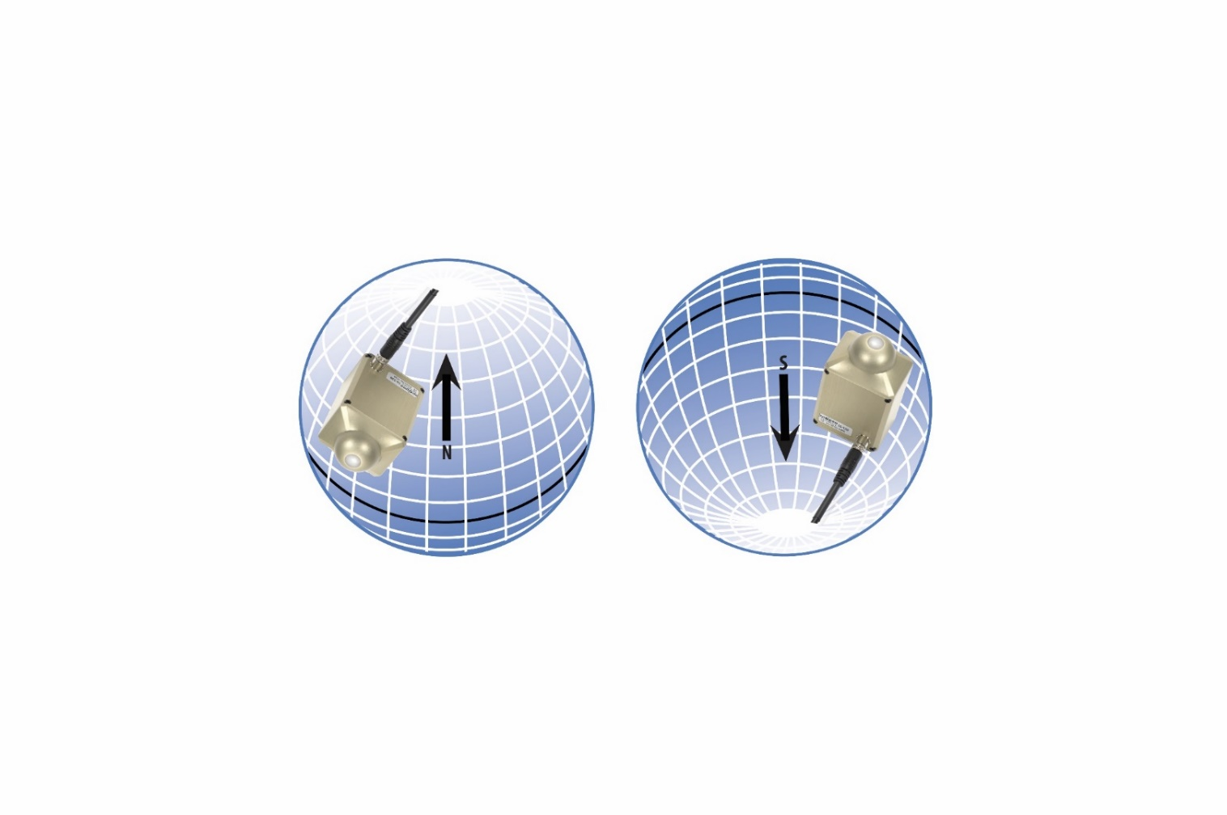

In addition to orienting the cable to point toward the nearest pole, the sensor should also be mounted such that obstructions (e.g., weather station tripod/tower or other instrumentation) do not shade the sensor. **Once mounted, the green cap should be removed from the sensor.** The green cap can be used as a protective covering for the sensor when it is not in use.

Software Installation (Required to Use with a Computer)

**The most recent version of ApogeeSpectrovision software can be downloaded at** [**http://www.apogeeinstruments.com/downloads/**](http://www.apogeeinstruments.com/downloads/)**.**

**Installing the software on a PC (Windows compatible, XP and later)**

1. 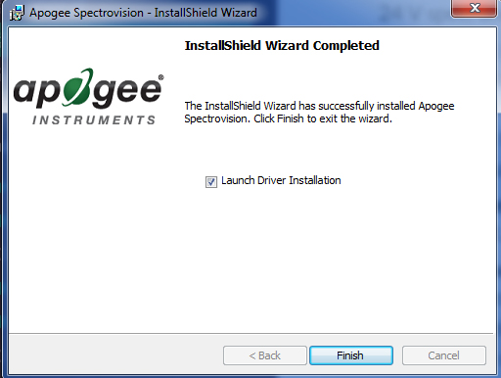P:\Marketing\Elisa\Photos\Spectroradiometer\Figures\software setup.jpg**Install Apogee Spectrovision software:** Double click the setup.exe file provided on the thumb drive (you may need to copy the file to your computer first). Run the downloaded setup file, following the prompts to complete software installation.

*Note: In the final setup window there will be a box checked that says “Launch Driver Installation”. This box must be checked.

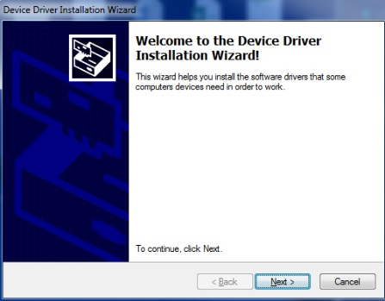

1. **Install Drivers:** You will be automatically prompted to install device software drivers (dpinst.exe). Click next to begin the installation process and follow the prompts.
2. **Plug sensor into computer** *Note: It may take up to 30 seconds for the computer to recognize the device each time it is plugged into the computer.
3. **Wait for 30-60 seconds while drivers associate with the device.** This will happen automatically.
4. **Open Apogee Spectrovision Software**
5. 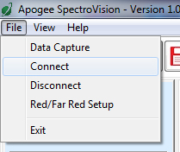**Connect Sensor:** In the “File Menu” click “Connect” to connect sensor. Sensor will now be visible in the “Tool Bar” and is ready for use.

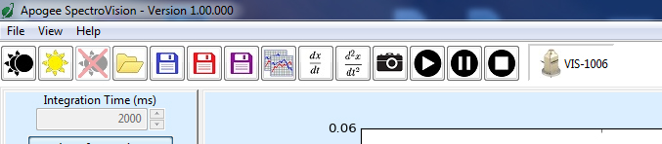

1. All of the available software buttons and controls are documented in the “Help Menu”, where information regarding uses and limitations of each button/control is provided.

**\*\*Note\*\*** Windows XP users may need to install additional language options for some of the characters to display properly in Apogee Spectrovision. To do this go to Control Panel->Regional and Language Options. Click the Languages tab. In the box labeled supplemental language support, install both options. *The software doesn’t care if these are installed or not; it’s simply user preference.*

**Installing the software on a Mac (Mac compatible, 10.10 and later)**

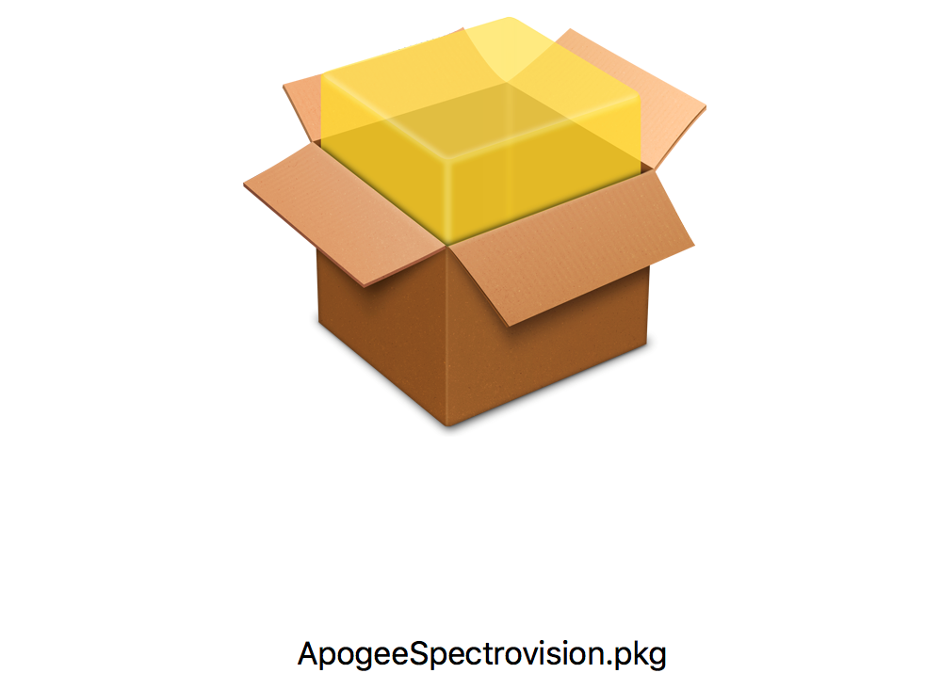

1. Double click on the installer package
2. On the ‘Introduction’ screen, please click ‘Continue’ to proceed.
3. Select ‘Continue’ on the ‘Read Me’ screen to continue. This screen contains a history of updates made to the ApogeeSpectrovision software versions.
4. Select ‘Continue’ on the ‘License’ screen to receive a prompt to agree to the terms of the software license agreement. Click ‘Agree’ to continue once you receive the prompt.
5. On the ‘Installation Type’ screen, click ‘Install’ to install the software. You can change the location the software installs to by clicking ‘Change Install Location…’. *Note: You may be prompted for an administrator password at this time. If you are, proceed by entering your respective password and clicking ‘Install Software’.
6. Once you receive the message “The installation was successful” on the ‘Summary’ screen click ‘Close’. Your software is now ready to be used.

### Operation and Measurement

SS-100 series spectroradiometers have onboard circuitry which allows for output to a computer (via USB).

##### Computer Output (via USB)

###### Menu Descriptions

File Menu

**Note:** Pressing the alt key while the application is open will display hot key values for menu bar options. For example, alt --> f --> c will select the Connect function in the File menu.

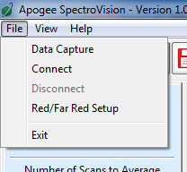

**Data Capture:** The data capture feature allows for a functional data logging environment. The user may choose a specific number of measurements to record or leave it open ended by leaving the default value of 0 in the spin control. The user may specify a waiting period between measurements or if left at zero, the device will take measurements as soon as data has been pulled from memory. If 'Save data to file' is checked, the user will be prompted to enter a file name. If a previously created file is chosen, the data capture function will append new data to the end of the file. A different file must be chosen for each sensor currently connected to Apogee Spectrovision. If 'Plot data to screen' is checked, the data capture function will plot the first ten measurements of the file specified during data capture setup. If multiple sensors are connected and there are less than ten measurements in the first file, the next file will be read from until a max of 10 measurements have been accumulated for plotting. The data capture mode may be canceled at any time by hitting the 'Cancel' button. Any measurements made before hitting the 'Cancel' button will still be saved in the files specified during setup.

**Connect:** This features connects to a sensor plugged in to the computers USB port. If more than one sensor is connected, the user will select which sensor to connect to from a dropdown menu.

**Disconnect:** Disconnect from the device chosen from the dropdown menu.

**Red/Far Red Setup:** Displays a window in which the user can specify the wavelength ranges of the Red and Far Red spectrums. The ratio R/RF (Red/Far Red) is displayed during Energy Flux Density and Photon Flux Density plot modes.

**Exit:** Close the application.

View Menu

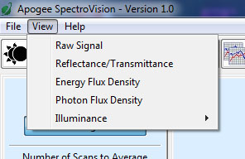Each option in this menu will switch the current plot mode to the one specified in the drop down menu. If continuous measurement mode is active, the next measurement taken will take on the new plot mode. Otherwise, a single measurement will be taken and plotted to the screen in the new plot mode.

Help Menu

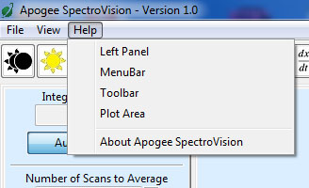

Jump to the help tab of the chosen subject.

Toolbar Descriptions

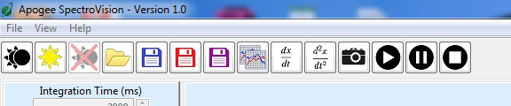

**Set dark reference:** During continuous measurement mode, this function will take the data from the last scan and save it as a dark reference to be used during both Relative and Reflectance/Transmittance plot modes. Otherwise, the application will take a new measurement to be used as the dark reference. If multiple devices are connected, the dark reference scan will apply only to the device selected in the toolbar.

**Set light reference:** During continuous measurement mode, this function will take the data from the last scan and save it as a light reference to be used during Reflectance/Transmittance plot mode. Otherwise, the application will take a new measurement to be used as the light reference. If multiple devices are connected, the light reference scan will apply only to the device selected in the toolbar.



**Clear dark reference:** Simply removes a saved dark reference scan from the selected device.



**Open:** Opens a previously saved *.dat or *.csv file for plotting. This function supports opening multiple files at a time; however, only ten scans may be plotted at a time. These files must be saved in the correct format to be compatible with Apogee Spectrovision.



**Save graph as image:** The current plot will be saved to an image file with the extension of your choice. Current supported extensions include *.pdf, *.jpg, *.png, *.ps, *.eps, and *.svg.



**Save graph data:** The data of the current plot will be saved to a file of type *.csv or *.dat. This function supports multi sensor plots as well.

 **Save graph data and image:** Combines the previous two buttons in one for ease of use.



**Copy graph to clipboard:** Copies the current plot to the system clipboard for pasting into other applications. The clipboard object is of type *.png.

**Plot the first derivative:** Plots the first derivative of the current plot data. This button is only active if a single device is connected.

**Plot the second derivative:** Plots the second derivative of the current plot data. This button is only active if a single device is connected.



**Take a single measurement:** The device will take a single measurement and plot the data to the screen. This is a convenience function for manipulating the plot without the data being updated at an inopportune time.



**Start continuous measurements:** The device will continually take measurements as soon as the data has been pulled from the previous scan. If multiple sensors are connected, measurements will wait until data has been pulled from all devices so that all measurements are taken at the same time.

 **Pause continuous measurements:** This simply pauses the continuous measurement mode. Use this function if you are worried about losing the data from the last scan but want to manipulate the currently displayed plot that may or may not represent the data from the last scan.

**Stop continuous measurements:** This completely stops continuous measurements without regard to data being left in the device's buffer.



**Sensor toggles:** When a device is connected, a new toggle button will be displayed on the toolbar representing the sensor. If the sensor is toggled, it is considered 'active' and all 'Set dark reference', 'Set light reference', and 'Clear dark reference' button clicks will apply only to the 'active' device. Right clicking on the device toggle button will display a pop up menu with options to rename the device or disconnect the device.

Left Panel/Status Bar

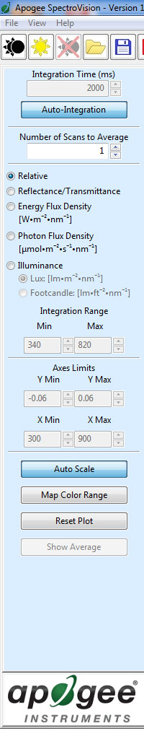 **Integration Time:** This specifies the time frame the sensor is to use for integrating the received radiation. A longer integration time will give a greater signal. If the auto-integration toggle button is pressed, the device will specify its own integration time based on the received light intensity. Auto-integration will max out at 2 sec. For integration times greater than 2 sec, toggle Auto-Integration off and enter the desired time in the spin ctrl box. The Apogee Visible and NIR sensors support 0.005 - 10 second integration times. The last scans integration time will be displayed in the status bar at the bottom of the screen.

 **Number of Scans to Average:** This tells the device how many measurements to average together before outputting data.

 **Relative:** Plots wavelength intensity as raw digital counts.

**Reflectance/Transmittance:** Plots the reflectance or transmittance of a material. First requires that both a dark and light reference have been saved.

 **Energy Flux Density:** Plots in units of Watts/m2 * nm. This mode will also display an integrated total over the given Integration Range from the left panel.

**Photon Flux Density:** Plots in units of µmol/m2*s*nm. This mode will also display an integrated total over the given Integration Range from the left panel, as well as YPF, PPF, and PPE values.

**Illuminance:** Plots a weighted data range in Lux or Footcandle according to user preference.

**Integration Range:** These spin controls become active during Energy Flux Density and Photon Flux Density plot modes and are used to specify a customized wavelength integration range for the Integrated Total displayed on the plot. The YPF, PPF, and PPE values remain unchanged regardless of the Integration Range values. These controls are inactive for the other plot modes.

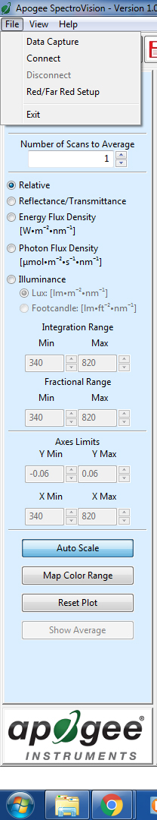**Fractional Range:** These spin controls become active during Energy Flux Density and Photon Flux Density modes. A 'Fractional' ratio is displayed on the graph. This ratio is the sum of the wavelengths specified in the Fractional Range spin controls divided by the sum of the wavelengths specified in the Integration Range spin controls.

 **Axes Limits:** These controls are inactive if the Auto Scale toggle button is active. The y axis has limits of (-16383, 16383) and the x axis has limits of (300, 1120). Any value in between may be specified with an accuracy of two decimal places.

**Auto Scale:** Automatically scales the plot to include all data points. Can be toggled on or off.

**Map Color Range:** Fills the area beneath the plot with the wavelength's corresponding color values. Can be toggled on or off. Keep toggled off to increase performance. This feature is disabled for multi-sensor/multi-line plots.

**Reset Plot:** Resets the plot to original data with a generalized zoom range. Derivative data will be cleared as well. If Auto Scale or Map Color Range toggles have changed since last plot, the new settings will be applied.

**Show Average:** This toggle button becomes active only if multiple lines are plotted at the same time either from a file, or from the Take a single measurement button in the toolbar. If this toggle is active, a thick black line will be plotted with the rest of the data representing the average.

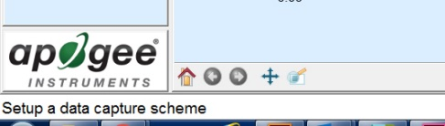

**Status Bar:** The first section on the far left displays tool tips when the cursor is over a menu bar option. The next section displays the currently active operation. The next section shows the active device's last integration time. The far right section of the status bar displays the current coordinates of the cursor in the plot area.

PlotView

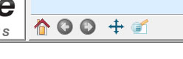

**Home:** Resets the plot zoom/pan position to the original position (before any other plot view button modifications).

**Back:** Goes back to the previous view.

**Forward:** Goes forward (if possible) to the next view.

**Pan:** The 'Pan' toggle button allows the user to left click and drag to pan the plot. If the right button is clicked, the plot will scale in the direction of the drag instead of pan.

**Zoom:** The zoom tool left click and drag will draw a zoom box in the plot area. Right click and drag will zoom out.

**Plot Area Controls:** A left click in the plot area will display the y-value of the plot near the data point and the corresponding x-value along the x-axis. A right click in the plot area will remove any labels displayed by a left-click. Scrolling in the plot area will zoom in or out depending on scroll direction.

### Maintenance and Recalibration

Maintenance

Moisture or debris on the diffuser is a common cause of low readings. The sensor has a domed diffuser and housing for improved self-cleaning from rainfall, but materials can accumulate on the diffuser (e.g., dust during periods of low rainfall, salt deposits from evaporation of sea spray or sprinkler irrigation water) and partially block the optical path. Dust or organic deposits are best removed using water, or window cleaner and a soft cloth or cotton swab. Salt deposits should be dissolved with vinegar and removed with a soft cloth or cotton swab. **Never use an abrasive material or cleaner on the diffuser.**

Although Apogee sensors are very stable, nominal accuracy drift is normal for all research-grade sensors. To ensure maximum accuracy, we generally recommend sensors are sent in for recalibration every two years, although you can often wait longer according to your particular tolerances.

Recalibration

The Clear Sky Calculator ([www.clearskycalculator.com](http://www.clearskycalculator.com)) can be used to determine the need for spectroradiometer recalibration when spectroradiometer is used in Photon Flux Density mode. It determines PPFD incident on a horizontal surface at any time of day at any location in the world. It is most accurate when used near solar noon in spring and summer months, where accuracy over multiple clear and unpolluted days is estimated to be ± 4 % in all climates and locations around the world. For best accuracy, the sky must be completely clear, as reflected radiation from clouds causes incoming radiation to increase above the value predicted by the clear sky calculator. Measured values of PPFD can exceed values predicted by the Clear Sky Calculator due to reflection from the sides and edges of clouds. This reflection increases the incoming radiation. The influence of high clouds typically shows up as spikes above clear sky values, not a constant offset greater than clear sky values.

To determine recalibration need, input site conditions into the calculator and compare PPFD measurements to calculated PPFD values for a clear sky. If sensor PPFD measurements over multiple days near solar noon are consistently different than calculated values (by more than 6 %), the sensor should be cleaned and re-leveled. If PPFD measurements are still different after a second test, email [calibration@apogeeinstruments.com](mailto:calibration@apogeeinstruments.com) to discuss test results and possible return of sensor(s) for recalibration.

### Troubleshooting and Customer Support

verification of functionality

The simplest way to verify functionality is to connect to the device with a computer. Once the software and drivers are installed, connect the USB cable to the spectroradiometer and to the computer, wait thirty to sixty seconds for the drivers to associate with the device, open the software, connect to the device (click Connect in the File menu), and push the play button on the toolbar. The spectrum displayed on the computer screen should now update automatically. This indicates the device is communicating with the computer and measuring a spectrum.

Compatible Measurement Devices

For use with a computer, USB 2.0 or later is required. Windows and Mac versions of Apogee Spectrovision software are available.

### Return and Warranty Policy

RETURN POLICY

Apogee Instruments will accept returns within 30 days of purchase as long as the product is in new condition (to be determined by Apogee). Returns are subject to a 10 % restocking fee.

WARRANTY POLICY

**What is Covered**All products manufactured by Apogee Instruments are warranted to be free from defects in materials and craftsmanship for a period of four (4) years from the date of shipment from our factory. To be considered for warranty coverage an item must be evaluated by Apogee.

Products not manufactured by Apogee (spectroradiometers, chlorophyll content meters, EE08-SS probes) are covered for a period of one (1) year.

**What is Not Covered**The customer is responsible for all costs associated with the removal, reinstallation, and shipping of suspected warranty items to our factory.

The warranty does not cover equipment that has been damaged due to the following conditions:

1. Improper installation or abuse.

2. Operation of the instrument outside of its specified operating range.

3. Natural occurrences such as lightning, fire, etc.

4. Unauthorized modification.

5. Improper or unauthorized repair.

Please note that nominal accuracy drift is normal over time. Routine recalibration of sensors/meters is considered part of proper maintenance and is not covered under warranty.

**Who is Covered**This warranty covers the original purchaser of the product or other party who may own it during the warranty period.

**What Apogee Will Do**At no charge Apogee will:

1. Either repair or replace (at our discretion) the item under warranty.

2. Ship the item back to the customer by the carrier of our choice.

Different or expedited shipping methods will be at the customer’s expense.

**How To Return An Item**1. Please do not send any products back to Apogee Instruments until you have received a Return Merchandise Authorization (RMA) number from our technical support department by submitting an online RMA form at [www.apogeeinstruments.com/tech-support-recalibration-repairs/](http://www.apogeeinstruments.com/tech-support-recalibration-repairs/). We will use your RMA number for tracking of the service item. Call (435) 245-8012 or email techsupport@apogeeinstruments.com with questions.

2. For warranty evaluations, send all RMA sensors and meters back in the following condition: Clean the sensor’s exterior and cord. Do not modify the sensors or wires, including splicing, cutting wire leads, etc. If a connector has been attached to the cable end, please include the mating connector – otherwise the sensor connector will be removed in order to complete the repair/recalibration. ***Note:*** *When sending back sensors for routine calibration that have Apogee’s standard stainless-steel connectors, you only need to send the sensor with the 30 cm section of cable and one-half of the connector. We have mating connectors at our factory that can be used for calibrating the sensor.*

3. Please write the RMA number on the outside of the shipping container.

4. Return the item with freight pre-paid and fully insured to our factory address shown below. We are not responsible for any costs associated with the transportation of products across international borders.

**Apogee Instruments, Inc.   
721 West 1800 North Logan, UT  
84321, USA**

5. Upon receipt, Apogee Instruments will determine the cause of failure. If the product is found to be defective in terms of operation to the published specifications due to a failure of product materials or craftsmanship, Apogee Instruments will repair or replace the items free of charge. If it is determined that your product is not covered under warranty, you will be informed and given an estimated repair/replacement cost.

Products Beyond the Warranty Period

For issues with sensors beyond the warranty period, please contact Apogee at [techsupport@apogeeinstruments.com](mailto:techsupport@apogeeinstruments.com) to discuss repair or replacement options.

Other Terms

The available remedy of defects under this warranty is for the repair or replacement of the original product, and Apogee Instruments is not responsible for any direct, indirect, incidental, or consequential damages, including but not limited to loss of income, loss of revenue, loss of profit, loss of data, loss of wages, loss of time, loss of sales, accruement of debts or expenses, injury to personal property, or injury to any person or any other type of damage or loss.

This limited warranty and any disputes arising out of or in connection with this limited warranty ("Disputes") shall be governed by the laws of the State of Utah, USA, excluding conflicts of law principles and excluding the Convention for the International Sale of Goods. The courts located in the State of Utah, USA, shall have exclusive jurisdiction over any Disputes.

This limited warranty gives you specific legal rights, and you may also have other rights, which vary from state to state and jurisdiction to jurisdiction, and which shall not be affected by this limited warranty. This warranty extends only to you and cannot by transferred or assigned. If any provision of this limited warranty is unlawful, void or unenforceable, that provision shall be deemed severable and shall not affect any remaining provisions. In case of any inconsistency between the English and other versions of this limited warranty, the English version shall prevail.

This warranty cannot be changed, assumed, or amended by any other person or agreement

**APOGEE INSTRUMENTS, INC. |** 721 WEST 1800 NORTH, LOGAN, UTAH 84321, USA

TEL: (435) 792-4700 | FAX: (435) 787-8268 | WEB: APOGEEINSTRUMENTS.COM

*Copyright © 2020 Apogee Instruments, Inc.*