

# Owner’s Manual

Quantum Light PolLution Sensor

Model SQ-646

Rev: 31-Mar-2022

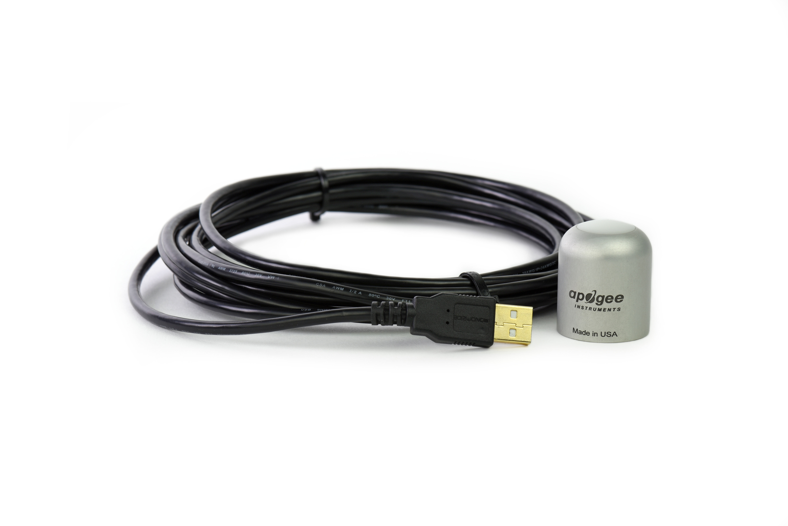

Table of Contents

Owner’s Manual 1

Certificate of Compliance 3

Introduction 4

Sensor Models 5

Specifications 6

Deployment and Installation 8

Software Installation 9

Operation and Measurement 10

Windows Software 11

Mac Software 16

Maintenance and Recalibration 22

Troubleshooting and Customer Support 23

Return and Warranty Policy 24

### Certificate of Compliance

**EU Declaration of Conformity**

This declaration of conformity is issued under the sole responsibility of the manufacturer:

Apogee Instruments, Inc.  
721 W 1800 N  
Logan, Utah 84321  
USA

for the following product(s):

Models: SQ-646  
Type: Quantum Light Pollution Sensor

The object of the declaration described above is in conformity with the relevant Union harmonization legislation:

2014/30/EU Electromagnetic Compatibility (EMC) Directive

2011/65/EU Restriction of Hazardous Substances (RoHS 2) Directive

2015/863/EU Amending Annex II to Directive 2011/65/EU (RoHS 3)

Standards referenced during compliance assessment:

EN 61326-1:2013 Electrical equipment for measurement, control, and laboratory use – EMC requirements

EN 50581:2012 Technical documentation for the assessment of electrical and electronic products with respect to the restriction of hazardous substances

Please be advised that based on the information available to us from our raw material suppliers, the products manufactured by us do not contain, as intentional additives, any of the restricted materials including lead (see note below), mercury, cadmium, hexavalent chromium, polybrominated biphenyls (PBB), polybrominated diphenyls (PBDE), bis (2-ethylhexyl) phthalate (DEHP), butyl benzyl phthalate (BBP), dibutyl phthalate (DBP), and diisobutyl phthalate (DIBP). However, please note that articles containing greater than 0.1 % lead concentration are RoHS 3 compliant using exemption 6c.

Further note that Apogee Instruments does not specifically run any analysis on our raw materials or end products for the presence of these substances, but we rely on the information provided to us by our material suppliers.

Signed for and on behalf of:

Apogee Instruments, March 2022



Bruce Bugbee  
President  
Apogee Instruments, Inc.

### Introduction

Radiation that drives photosynthesis is called photosynthetically active radiation (PAR) and is typically defined as total radiation across a range of 400 to 700 nm. PAR is almost universally quantified as photosynthetic photon flux density (PPFD) in units of micromoles per square meter per second (µmol m-2 s-1, equal to microEinsteins per square meter per second) summed from 400 to 700 nm (total number of photons from 400 to 700 nm). However, ultraviolet and far-red photons outside the defined PAR range of 400-700 nm can also contribute to photosynthesis and influence plant responses (e.g., flowering).

Sensors that measure PPFD are often called quantum sensors due to the quantized nature of radiation. A quantum refers to the minimum quantity of radiation, one photon, involved in physical interactions (e.g., absorption by photosynthetic pigments). In other words, one photon is a single quantum of radiation. Sensors that function like traditional quantum sensors but measure a wider range of wavelengths can be thought of as an ‘extended range’ quantum sensor.

Typical applications of traditional quantum sensors include incoming PPFD measurement over plant canopies in outdoor environments or in greenhouses and growth chambers and reflected or under-canopy (transmitted) PPFD measurement in the same environments. The Extended Range PFD Sensor detailed in this manual uses a detector that is sensitive to radiation up to about 1100 nm, well beyond the range of wavelengths that influence photosynthesis and plant responses. **This means this particular sensor should only be used for photon flux density measurements under LEDs.**

Apogee Instruments SQ-600 series Quantum Light Pollution Sensors consist of a cast acrylic diffuser (filter), photodiode, and signal processing circuitry mounted in an anodized aluminum housing, and a cable to connect the sensor to a measurement device. SQ-600 series sensors are designed for continuous photon flux density measurements in indoor environments under LEDs. The SQ-640 Quantum Light Pollution models output a voltage that is directly proportional to photon flux density.

### Sensor Models

This manual covers the USB Quantum Light Pollution sensor, model SQ-646 (listed in bold below). Additional models are covered in their respective manuals.

|  |  |
| --- | --- |
| Model | Signal |
| SQ-640 | Self-powered |
| SQ-642 | 0-2.5 V |
| SQ-644 | 4-20 mA |
| SQ-645 | 0-5 V |
| SQ-646 | **USB** |
| SQ-647 | SDI-12 |
| SQ-648 | Modbus |

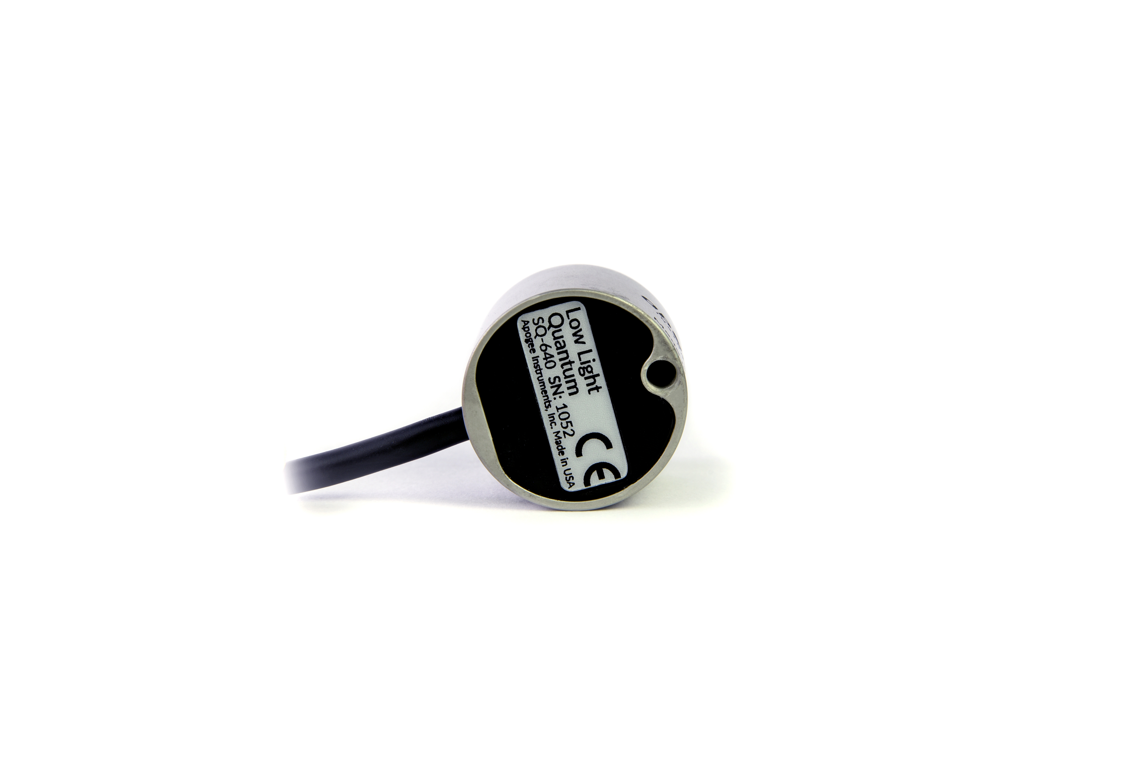

A sensor’s model number and serial number are located on the bottom of the sensor. If the manufacturing date of a specific sensor is required, please contact Apogee Instruments with the serial number of the sensor.

### Specifications

|  |  |
| --- | --- |
|  | **SQ-646** |
| Resolution | 0.1 µmol m-2 s-1 |
| Calibration Factor | Custom for each sensor and stored in the firmware |
| Calibration Uncertainty | ± 5 % (see calibration Traceability below) |
| Measurement Range | 0 to 200 µmol m-2 s-1 |
| Measurement Repeatability | Less than 0.5 % |
| Long-term Drift  (Non-stability) | Less than 2 % per year |
| Non-linearity | Less than 1 % (up to 200 µmol m-2 s-1) |
| Response Time | Software updates every second |
| Field of View | 180° |
| Spectral Range | 340 to 1040 nm ± 5 nm (wavelengths where response is greater than 50 %; see Spectral Response below) |
| Directional (Cosine) Response | ± 2 % at 45° zenith angle, ± 5 % at 75° zenith angle (see Cosine Response below) |
| Temperature Response | -0.11± 0.04 % per C |
| Azimuth Error | Less than 0.5 % |
| Tilt Error | Less than 0.5 % |
| Housing | Anodized aluminum body with acrylic diffuser |
| IP Rating | IP68 |
| Operating Environment | -40 to 70 C, 0 to 100 % relative humidity, can be submerged in water up to depths of 30 m |
| Dimensions | 30.5 mm diameter, 37 mm height |
| Mass (with 5 m of cable) | 140 g |
| USB Cable | 4.5 m (15 ft) |
| Current Draw (when Logging) | 61 mA |

**Calibration Traceability**

Apogee Instruments SQ-600 series quantum light pollution sensors are calibrated through side-by-side comparison to the mean of four transfer standard quantum light pollution sensors under a reference lamp. The transfer standard quantum light pollution sensors are recalibrated with a quartz halogen lamp traceable to the National Institute of Standards and Technology (NIST).

**Spectral Response**

Mean spectral response measurements of six replicate Apogee SQ-600 series Quantum Light Pollution Sensors. Spectral response measurements were made at 10 nm increments across a wavelength range of 300 to 1100 nm in a monochromator with an attached electric light source. Measured spectral data from each quantum light pollution sensor were normalized by the measured spectral response of the monochromator/electric light combination, which was measured with a spectroradiometer

Mean spectral response measurements of six replicate Apogee SQ-100 (original) and SQ-500 (full-spectrum) series quantum sensors. Spectral response measurements were made at 10 nm increments across a wavelength range of 300 to 800 nm with a monochromator and an attached electric light source. Measured spectral data from each quantum sensor were normalized by the measured spectral response of the monochromator/electric light combination, which was measured with a spectroradiometer.

Mean spectral response measurements of six replicate Apogee SQ-600 series Extended Range PFD Sensors. Spectral response measurements were made at 10 nm increments across a wavelength range of 300 to 1100 nm in a monochromator with an attached electric light source. Measured spectral data from each PFD sensor were normalized by the measured spectral response of the monochromator/electric light combination, which was measured with a spectroradiometer

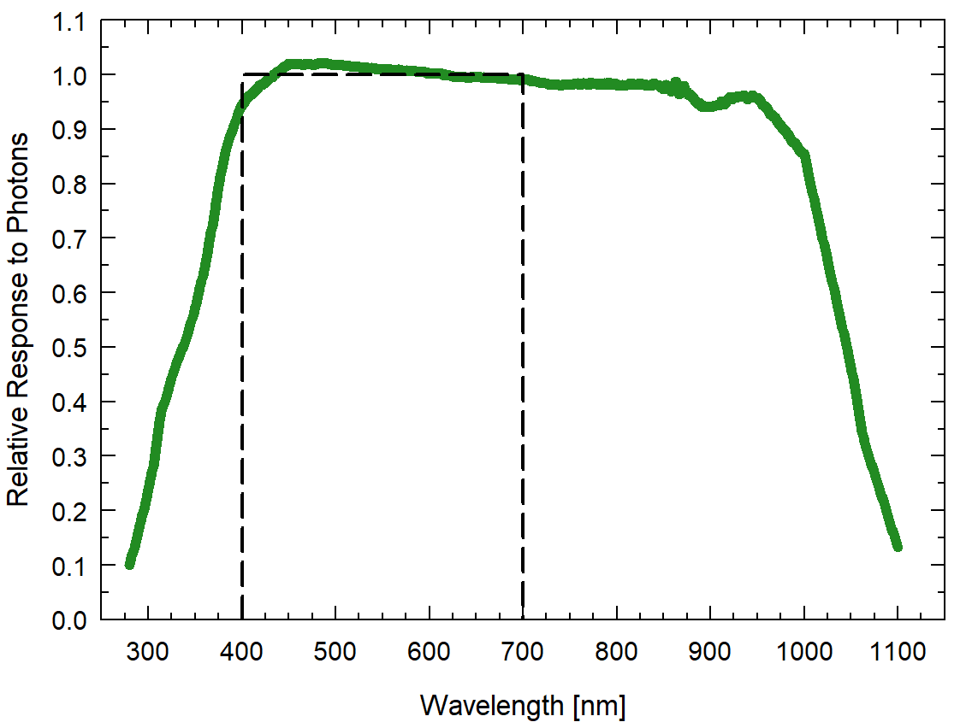

**Cosine Response**

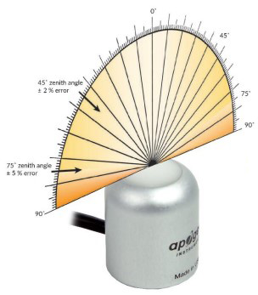

Directional, or cosine, response is defined as the measurement error at a specific angle of radiation incidence. Error for Apogee SQ-600 series Quantum Light Pollution Sensor is approximately ± 2 % and ± 5 % at solar zenith angles of 45° and 75°, respectively.

### Deployment and Installation

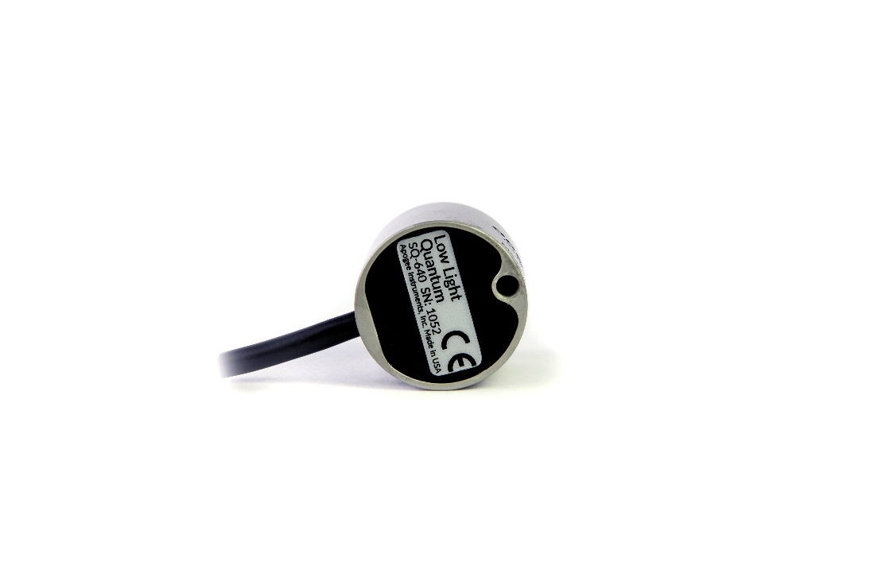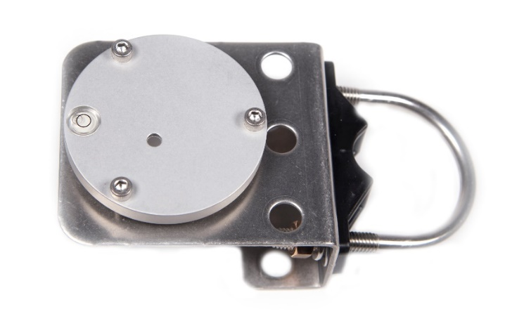Mount the sensor to a solid surface with the nylon mounting screw provided. To accurately measure photon flux density incident on a horizontal surface, the sensor must be level. An Apogee Instruments model AL-100 leveling plate is recommended for this purpose. To facilitate mounting on a cross arm, an Apogee Instruments model AL-120 mounting bracket is recommended.

Model: AL-100

Nylon Screw: 10-32 x 3/8

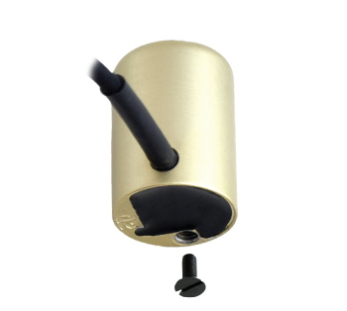

Nylon Screw: 10-32 x 3/8

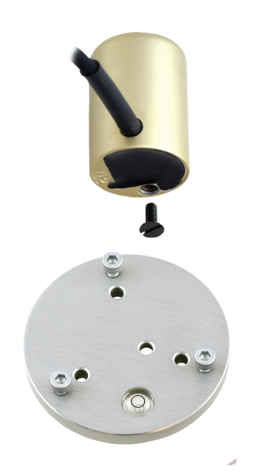

Model: AL-120

To minimize azimuth error, the sensor should be mounted with the cable pointing toward true north in the northern hemisphere or true south in the southern hemisphere. Azimuth error is typically less than 0.5 %, but it is easy to minimize by proper cable orientation.

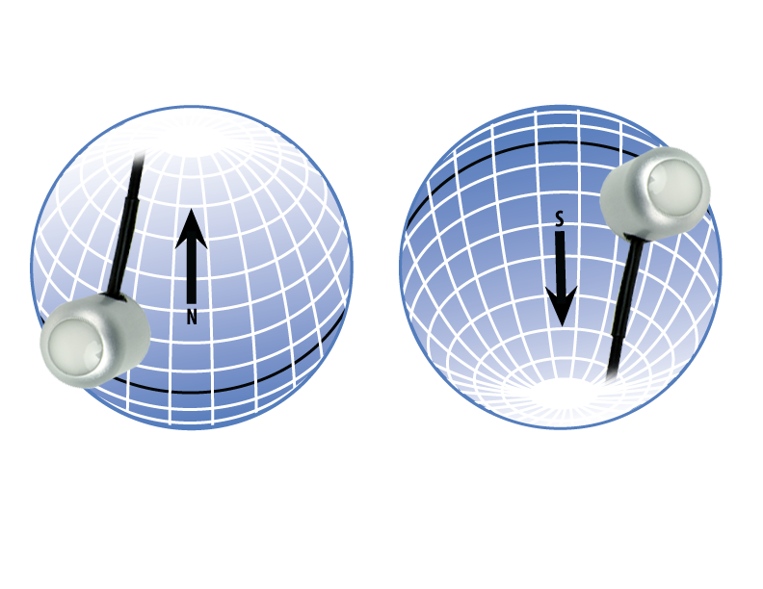

In addition to orienting the cable to point toward the nearest pole, the sensor should also be mounted such that obstructions (e.g., weather station tripod/tower or other instrumentation) do not shade the sensor. **Once mounted, the blue cap should be removed from the sensor.** The blue cap can be used as a protective covering for the sensor when it is not in use.

### Software Installation

**The most recent version of ApogeeConnect software can be downloaded at** [**http://www.apogeeinstruments.com/downloads/**](http://www.apogeeinstruments.com/downloads/)**.**

C:\Users\emyers\Desktop\apogee-connect.jpg**Installing the software on a PC (Windows compatible, XP and later)**

1. Double click on the installer package:
2. On the ‘Welcome’ screen, please click ‘Next’ to continue.
3. Select the radio button next to “I Agree” to the UELA… and click ‘Next’ to continue.
4. On the ‘Ready to Install the Program’ screen, click ‘Install’ to continue.
5. Click ‘Finish’ to complete the installation. There are shortcuts on your desktop and in your start bar.

**Installing the software on a Mac (Mac compatible, 10.10 and later)**

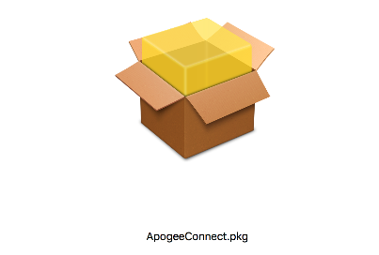

1. Double click on the installer package
2. On the ‘Introduction’ screen, please click ‘Continue’ to proceed.
3. Select ‘Continue’ on the ‘Read Me’ screen to continue, this screen contains a history of updates made to the ApogeeConnect software versions.
4. Select ‘Continue’ on the ‘License’ screen to receive a prompt to agree to the terms of the software license agreement. Click ‘Agree’ to continue once you receive the prompt.
5. On the ‘Installation Type’ screen, click ‘Install’ to install the software. You can change the location the software installs to by clicking ‘Change Install Location…’. *Note: You may be prompted for an administrator password at this time. If you are, proceed by entering your respective password and clicking ‘Install Software’.
6. Once you receive the message “The installation was successful.” on the ‘Summary’ screen click ‘Close’. Your software is now ready to be used.

### Operation and Measurement

**Low Light Measurements**

Accurate low light measurements are required in flowering and light pollution studies. Research indicates flowering can be triggered in some plants at photosynthetic and/or far-red photon flux densities less than 0.1 mol m-2 s-1. The threshold photon flux density at which flowering is triggered is variable among species. Two of the most light-sensitive species are Poinsettias and Cannabis. For reference, photon flux density of moonlight when the moon is full and near the minimum zenith angle is 0.005 mol m-2 s-1.

The model SQ-620 Extended Range Quantum Sensor can measure a photon flux density range of 0-4000 mol m-2 s-1. The model SQ-640 Quantum Light Pollution Sensor is designed for low light measurements and can only measure a photon flux density range of 0-200 mol m-2 s-1 (the sensor will output values beyond, 200 mol m-2 s-1, but these are beyond the linear range of the sensor) and is referred to as the low light version. The sensitivity of the SQ-640 is twenty times higher than the sensitivity of the SQ-620 (1 mV per mol m-2 s-1 versus 0.05 mV per mol m-2 s-1) to provide greater measurement resolution under low light conditions. For example, if the photon flux density were 0.1 mol m-2 s-1, the SQ-640 would output 0.1 mV, whereas the SQ-620 would output 0.005 mV.

### Windows Software

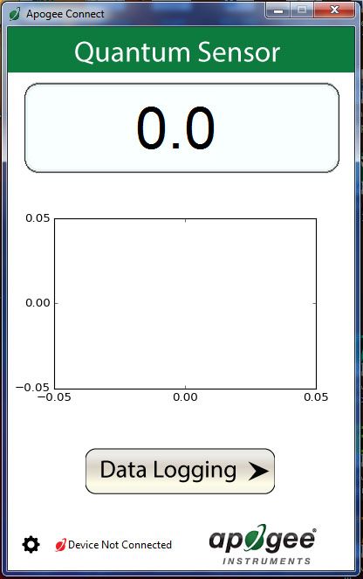

When the SQ-646 sensor is not plugged into the USB port, the software will display a message in the lower left corner, “Device Not Connected,” indicating it cannot establish communication with the sensor.

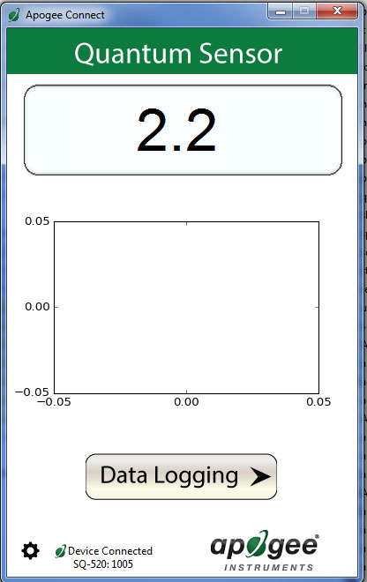

Plug the sensor into a USB port and allow some time for the sensor to automatically establish communication with the software. Once established, the message in the lower left corner will display “Device Connected-Model: SN ####” and real-time PFD readings will update on the screen. Moving the sensor closer to a light source should increase the readings, while blocking all light from the sensor should drop the reading to zero.

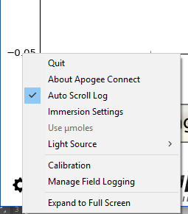

Click the ‘**Settings**’ icon to display the software options.

Note **‘Light Source’** is not a selectable option. This function is not necessary for the SQ-646. The function is designed to give increased accuracy for the SQ-420.

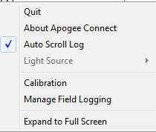

Note the **‘Immersion Setting’** function is not necessary for the SQ-646. This function automatically applies the SQ-520 immersion effect correction factor of 1.32 to the sensor measurements when the sensor is being used to take measurements underwater.

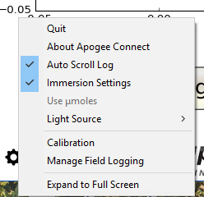

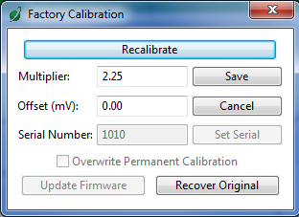

Clicking **‘Calibration’** will display the factory calibrated multiplier and offset values. These values are saved in firmware and can be recovered by clicking the ‘Recover Original’ button. Deriving a new calibration multiplier and offset is accomplished by clicking the ‘Recalibrate’ button. This is applicable if users want to calibrate the sensor to their own specific light source. Note that a reference PFD value of the light source is required to complete a recalibration.

After clicking the ‘Recalibate’ button the user will be prompted to cover the sensor. Place a dark cap over the sensor and wait for the real-time PFD reading to settle at zero. Click OK.

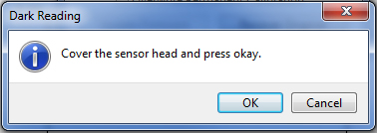

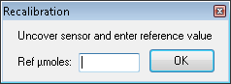

Uncover the sensor and wait for the PFD reading to settle ***before*** entering the reference value. Click OK.

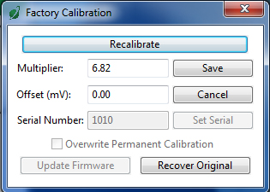

The multiplier and offset values will automatically calculate and update in the appropriate field. Be sure to click ‘Save’ to retain the new multiplier and offset.

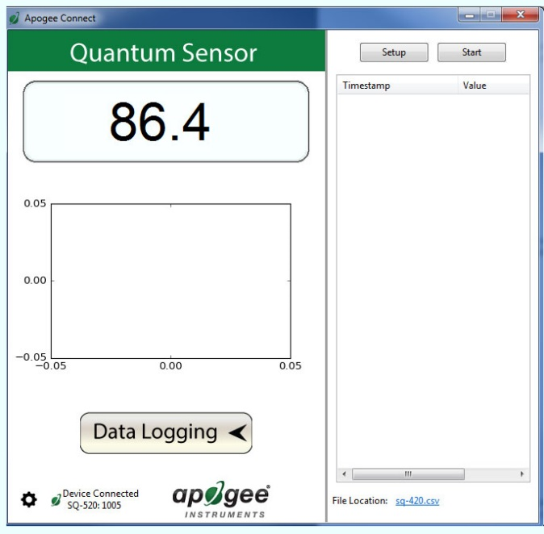

Clicking **‘Data Logging’** will allow the user to log interval measurements in a csv file while the software is open and communicating with the sensor.

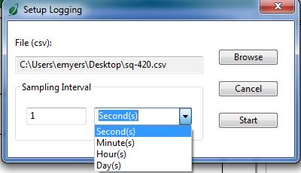

Click ‘Setup’ and the Setup Logging window appears. Click the ‘Browse’ button to create or select a csv file.

Select the desired sampling interval. Note that 1 second is the minimum interval allowed. Click ‘Start’.

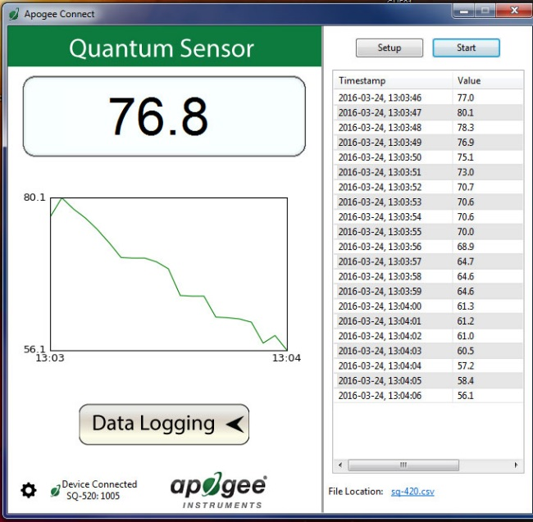

The data logging window will start to update at the specified sampling interval and display the Timestamp, Light Source, and Data Value. At the same time, data will be written to the csv file. Note that if the csv file is open in another program new data will not be saved to it.

The data logging window can be closed without affec­ting logged data by clicking the ‘Data Logging’ button. The ‘Stop’ button must be clicked to end data logging.

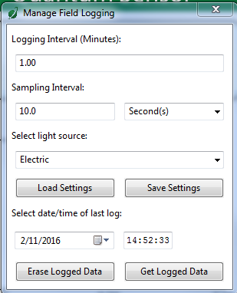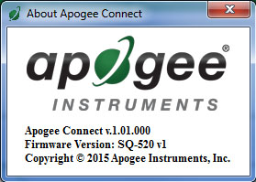

**‘Manage Field Logging’** is used to setup the SQ-646 for use in the field. When the SQ-646 is supplied power from a USB power source (plug or select batteries) it will log data which you can retrieve. Choose the interval that data is saved, as well as the interval that data is sampled and the light source used. The shortest sampling interval is 1 second. The longest sampling or logging interval is 1440 minutes (1 day). Click ‘Load Settings’ to see current settings and ‘Save Settings’ to save the settings you want to the sensor. Note: If you don’t click save the sensor won’t change the settings.

The about screen tells you the software and firmware versions. These can be used to help troubleshoot if problems arise.

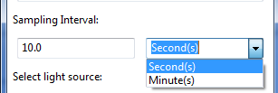

Set the sampling interval in minutes or seconds. The sampling interval is how often a measurement is taken and logging interval is how often the data is saved. The logged data is the average of the samples. The logging interval must be evenly divided by the sampling interval. For example, if the logging interval is 5 minutes and the sampling interval is 2 minutes it causes an error. But a sampling interval of 1 minute is acceptable.

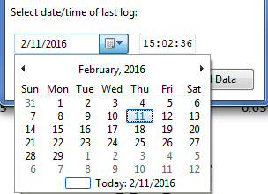C:\Users\emyers\Desktop\logged-data.PNG

When the software is open and logging data from the sensor, it will calculate daily light integral (DLI) in moles and Dark Hours in hours each day at 12:00 AM using PFD values collected during the previous 36 hours. The Dark Hours value is calculated using the “Darkness Threshold” setting. The number of continuously logged PFD values less than the Darkness Threshold are counted and multiplied by the logging interval to calculate the number of Dark Hours. This represents the longest continuous duration of darkness, not the total duration of darkness.

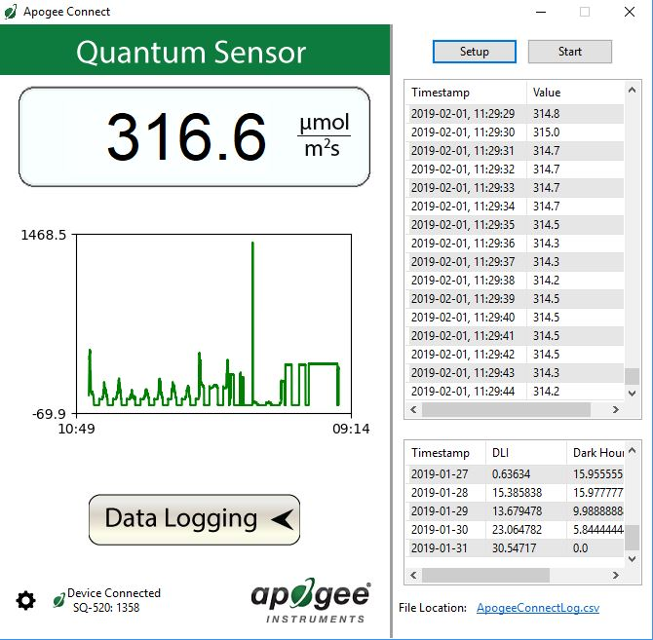

To use additional SQ-646 devices, open additional SQ-646 software windows. The device serial number will display in the lower left-hand corner of the corresponding software window. Devices may be selected by serial number in the tool bar.

Before clicking ‘Get Logged Data’ it is important to set the time of the last logged data point. This is used to back calculate the timestamps for the remaining data points. If you just unplugged the sensor and plugged it into the computer, the preloaded day and time should be sufficient.

Click **‘Get Logged Data’** to save the data to your computer. You will be asked where you want to save the data.

Click **‘Erase Data’** to erase all the saved data. This can’t be undone.

### **F:\Screen Shot 2016-03-08 at 9.40.56 AM.pngF:\Screen Shot 2016-03-08 at 9.40.32 AM.png**C:\Users\emyers\AppData\Local\Microsoft\Windows\Temporary Internet Files\Content.Outlook\XS3RXS83\Screen Shot 2016-02-26 at 10 48 01 AM (002).pngMac Software

Plug the sensor into a USB port and allow some time for the sensor to automatically establish communication with the software. Once established, the message in the lower left corner will display “Device Connected SN: ####” and real-time PFD readings will update on the screen. Moving the sensor closer to a light source should increase the readings, while blocking all light from the sensor should drop the reading to zero.

When the SQ-646 sensor is not plugged into the USB port, the software will display a message in the lower left corner, “Device Not Connected,” indicating it cannot establish communication with the sensor.

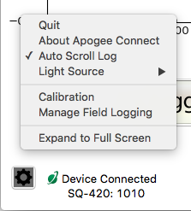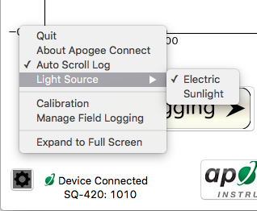**­­**

Note the **‘Immersion Setting’** function is not necessary for the SQ-646. This function automatically applies the SQ-520 immersion effect correction factor of 1.32 to the sensor measurements when the sensor is being used to take measurements underwater.

Note the **‘Light Source’** function is not necessary for the SQ-646. The function is designed to give increased accuracy for the SQ-420.

Click the **‘Settings’** icon to display the software options.

Clicking **‘Calibration’** will display the factory calibrated multiplier and offset values. These values are saved in firmware and can be recovered by clicking the ‘Recover Original’ button. Deriving a new calibration multiplier and offset is accomplished by clicking the ‘Recalibrate’ button. This is applicable if users want to calibrate the sensor to their own specific light source. Note that a reference PFD value of the light source is required to complete a recalibration.

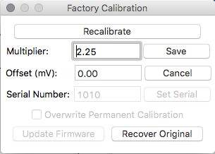

After clicking the ‘Recalibrate’ button the user will be prompted to cover the sensor. Place a dark cap over the sensor and wait for the real-time PFD reading to settle at zero. Click OK.

The multiplier and offset values will automatically calculate and update in the appropriate field. Be sure to click ‘Save’ to retain the new multiplier and offset.

Uncover the sensor and wait for the PFD reading to settle ***before*** entering the reference value. Click OK.

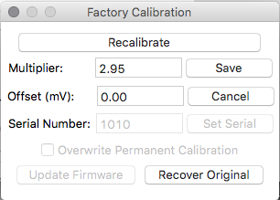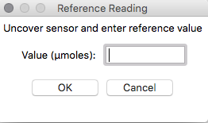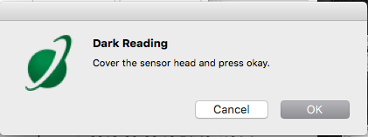

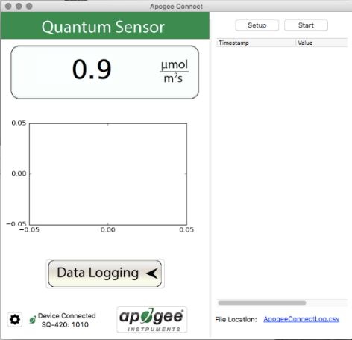

Clicking **‘Data Logging’** will allow the user to log interval measurements in a csv file while the software is open and communicating with the sensor.

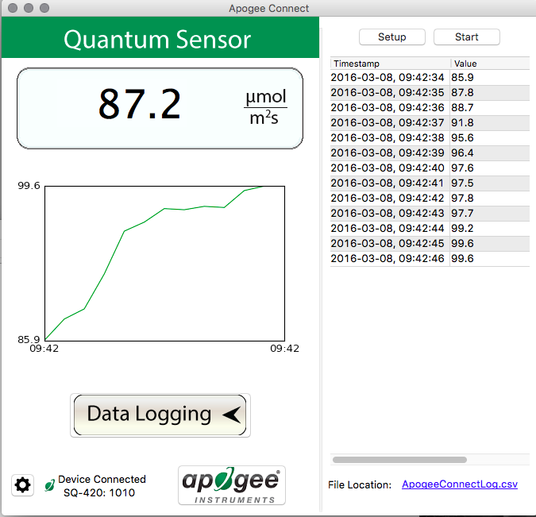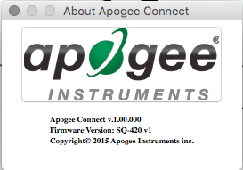

The about screen tells you the software and firmware versions. These can be used to help troubleshoot if problems arise.

The data logging window will start to update at the specified sampling interval and display the Timestamp, Light Source, and Data Value. At the same time, data will be written to the csv file. Note that if the csv file is open in another program new data will not be saved to it.

The data logging window can be closed without affecting logged data by clicking the ‘Exit’ button. The ‘Stop’ button must be clicked to end data logging.

Click ‘Setup’ and the Setup Logging window appears. Click the ‘Browse button to create or select a csv file.

Select the desired sampling interval. Note that 1 second is the minimum interval allowed. Click ‘Start’.

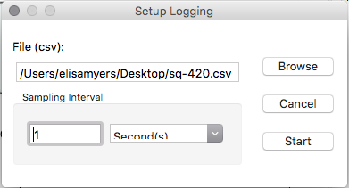

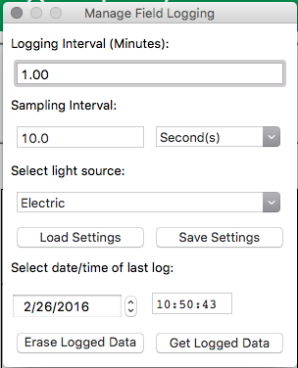

‘**Manage Field Logging**’ is used to setup the SQ-626 for the use in the field. When the SQ-626 is supplied power from a USB power source (plug or select batteries) it will log data which you can retrieve. Choose the interval the data is saved, as well as the interval that data is sampled and the light source used. The shortest sampling interval is 1 second. The longest sampling or logging interval is 1440 minutes (1 day). Click ‘Load Settings’ to see current settings and ‘Save Setting’ to save the settings you want to the sensor. Note: If you don’t click save the sensor won’t change the settings.

Set the sampling interval in minutes or seconds. The sampling interval is how often a measurement is taken and logging interval is how often the data is saved. The logged data is the average of the samples. The logging interval must be evenly divided by the sampling interval. For example, if the logging interval is 5 minutes and the sampling interval is 2 minutes it causes an error. But a sampling interval of 1 minute is acceptable.

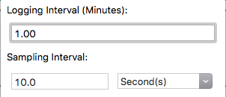

Before clicking ‘Get Logged Data’ it is important to set the time of the last logged data point. This is used to back calculate the timestamps for the remaining data points. If you just unplugged the sensor and plugged it into the computer, the preloaded day and time should be sufficient.

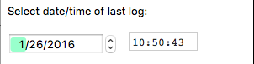

Screen Shot 2016-02-26 at 10

Click ‘**Get Logged Data**’ to save the data to your computer. You will be asked where you want to save the data.

Click ‘**Erase Data**’ to erase all the save data. This can’t be undone.



When the software is open and logging data from the sensor, it will calculate daily light integral (DLI) in moles and Dark Hours in hours each day at 12:00 AM using PFD values collected during the previous 36 hours. The Dark Hours value is calculated using the “Darkness Threshold” setting. The number of continuously logged PFD values less than the Darkness Threshold are counted and multiplied by the logging interval to calculate the number of Dark Hours. This represents the longest continuous duration of darkness, not the total duration of darkness.

To use additional SQ-646 devices, open additional SQ-646 software windows. The device serial number will display in the lower left-hand corner of the corresponding software window. Devices may be selected by serial number in the tool bar.

### Maintenance and Recalibration

Blocking of the optical path between the target and detector can cause low readings. Occasionally, accumulated materials on the diffuser of the upward-looking sensor can block the optical path in three common ways:

1. Moisture or debris on the diffuser.
2. Dust during periods of low rainfall.
3. Salt deposit accumulation from evaporation of sea spray or sprinkler irrigation water.

Apogee Instruments upward-looking sensors have a domed diffuser and housing for improved self-cleaning from rainfall, but active cleaning may be necessary. Dust or organic deposits are best removed using water, or window cleaner, and a soft cloth or cotton swab. Salt deposits should be dissolved with vinegar and removed with a cloth or cotton swab. **Salt deposits cannot be removed with solvents such as alcohol or acetone.** Use only gentle pressure when cleaning the diffuser with a cotton swab or soft cloth to avoid scratching the outer surface. The solvent should be allowed to do the cleaning, not mechanical force. **Never use abrasive material or cleaner on the diffuser.**

It is recommended that two-band radiometers be recalibrated every two years. See the Apogee webpage for details regarding return of sensors for recalibration (<http://www.apogeeinstruments.com/tech-support-recalibration-repairs/>).

### Troubleshooting and Customer Support

**Cable Length**

Fifteen feet is the maximum cable length that can be built into the sensor.

**Modifying Cable Length**

If you required a longer cable length an “active” USB extension cable is required. Please note, the connection between the cables must be made watertight prior to submersion.

### Return and Warranty Policy

RETURN POLICY

Apogee Instruments will accept returns within 30 days of purchase as long as the product is in new condition (to be determined by Apogee). Returns are subject to a 10 % restocking fee.

WARRANTY POLICY

**What is Covered**All products manufactured by Apogee Instruments are warranted to be free from defects in materials and craftsmanship for a period of four (4) years from the date of shipment from our factory. To be considered for warranty coverage an item must be evaluated by Apogee.

Products not manufactured by Apogee (spectroradiometers, chlorophyll content meters, EE08-SS probes) are covered for a period of one (1) year.

**What is Not Covered**The customer is responsible for all costs associated with the removal, reinstallation, and shipping of suspected warranty items to our factory.

The warranty does not cover equipment that has been damaged due to the following conditions:

1. Improper installation, use, or abuse.

2. Operation of the instrument outside of its specified operating range.

3. Natural occurrences such as lightning, fire, etc.

4. Unauthorized modification.

5. Improper or unauthorized repair.

Please note that nominal accuracy drift is normal over time. Routine recalibration of sensors/meters is considered part of proper maintenance and is not covered under warranty.

**Who is Covered**This warranty covers the original purchaser of the product or other party who may own it during the warranty period.

**What Apogee Will Do**At no charge Apogee will:

1. Either repair or replace (at our discretion) the item under warranty.

2. Ship the item back to the customer by the carrier of our choice.

Different or expedited shipping methods will be at the customer’s expense.

**How To Return An Item**1. Please do not send any products back to Apogee Instruments until you have received a Return Merchandise Authorization (RMA) number from our technical support department by submitting an online RMA form at [www.apogeeinstruments.com/tech-support-recalibration-repairs/](http://www.apogeeinstruments.com/tech-support-recalibration-repairs/). We will use your RMA number for tracking of the service item. Call (435) 245-8012 or email techsupport@apogeeinstruments.com with questions.

2. For warranty evaluations, send all RMA sensors and meters back in the following condition: Clean the sensor’s exterior and cord. Do not modify the sensors or wires, including splicing, cutting wire leads, etc. If a connector has been attached to the cable end, please include the mating connector – otherwise the sensor connector will be removed in order to complete the repair/recalibration. ***Note:*** *When sending back sensors for routine calibration that have Apogee’s standard stainless-steel connectors, you only need to send the sensor with the 30 cm section of cable and one-half of the connector. We have mating connectors at our factory that can be used for calibrating the sensor.*

3. Please write the RMA number on the outside of the shipping container.

4. Return the item with freight pre-paid and fully insured to our factory address shown below. We are not responsible for any costs associated with the transportation of products across international borders.

**Apogee Instruments, Inc.   
721 West 1800 North Logan, UT  
84321, USA**

5. Upon receipt, Apogee Instruments will determine the cause of failure. If the product is found to be defective in terms of operation to the published specifications due to a failure of product materials or craftsmanship, Apogee Instruments will repair or replace the items free of charge. If it is determined that your product is not covered under warranty, you will be informed and given an estimated repair/replacement cost.

Products Beyond the Warranty Period

For issues with sensors beyond the warranty period, please contact Apogee at [techsupport@apogeeinstruments.com](mailto:techsupport@apogeeinstruments.com) to discuss repair or replacement options.

Other Terms

The available remedy of defects under this warranty is for the repair or replacement of the original product, and Apogee Instruments is not responsible for any direct, indirect, incidental, or consequential damages, including but not limited to loss of income, loss of revenue, loss of profit, loss of data, loss of wages, loss of time, loss of sales, accruement of debts or expenses, injury to personal property, or injury to any person or any other type of damage or loss.

This limited warranty and any disputes arising out of or in connection with this limited warranty ("Disputes") shall be governed by the laws of the State of Utah, USA, excluding conflicts of law principles and excluding the Convention for the International Sale of Goods. The courts located in the State of Utah, USA, shall have exclusive jurisdiction over any Disputes.

This limited warranty gives you specific legal rights, and you may also have other rights, which vary from state to state and jurisdiction to jurisdiction, and which shall not be affected by this limited warranty. This warranty extends only to you and cannot by transferred or assigned. If any provision of this limited warranty is unlawful, void, or unenforceable, that provision shall be deemed severable and shall not affect any remaining provisions. In case of any inconsistency between the English and other versions of this limited warranty, the English version shall prevail.

This warranty cannot be changed, assumed, or amended by any other person or agreements

**APOGEE INSTRUMENTS, INC. |** 721 WEST 1800 NORTH, LOGAN, UTAH 84321, USA

TEL: (435) 792-4700 | FAX: (435) 787-8268 | WEB: APOGEEINSTRUMENTS.COM

*Copyright © 2022 Apogee Instruments, Inc.*