­­­­­­­

# Owner’s Manual

Quantum Light PolLution Sensor

Models SQ-644

Rev: 31-Mar-2022

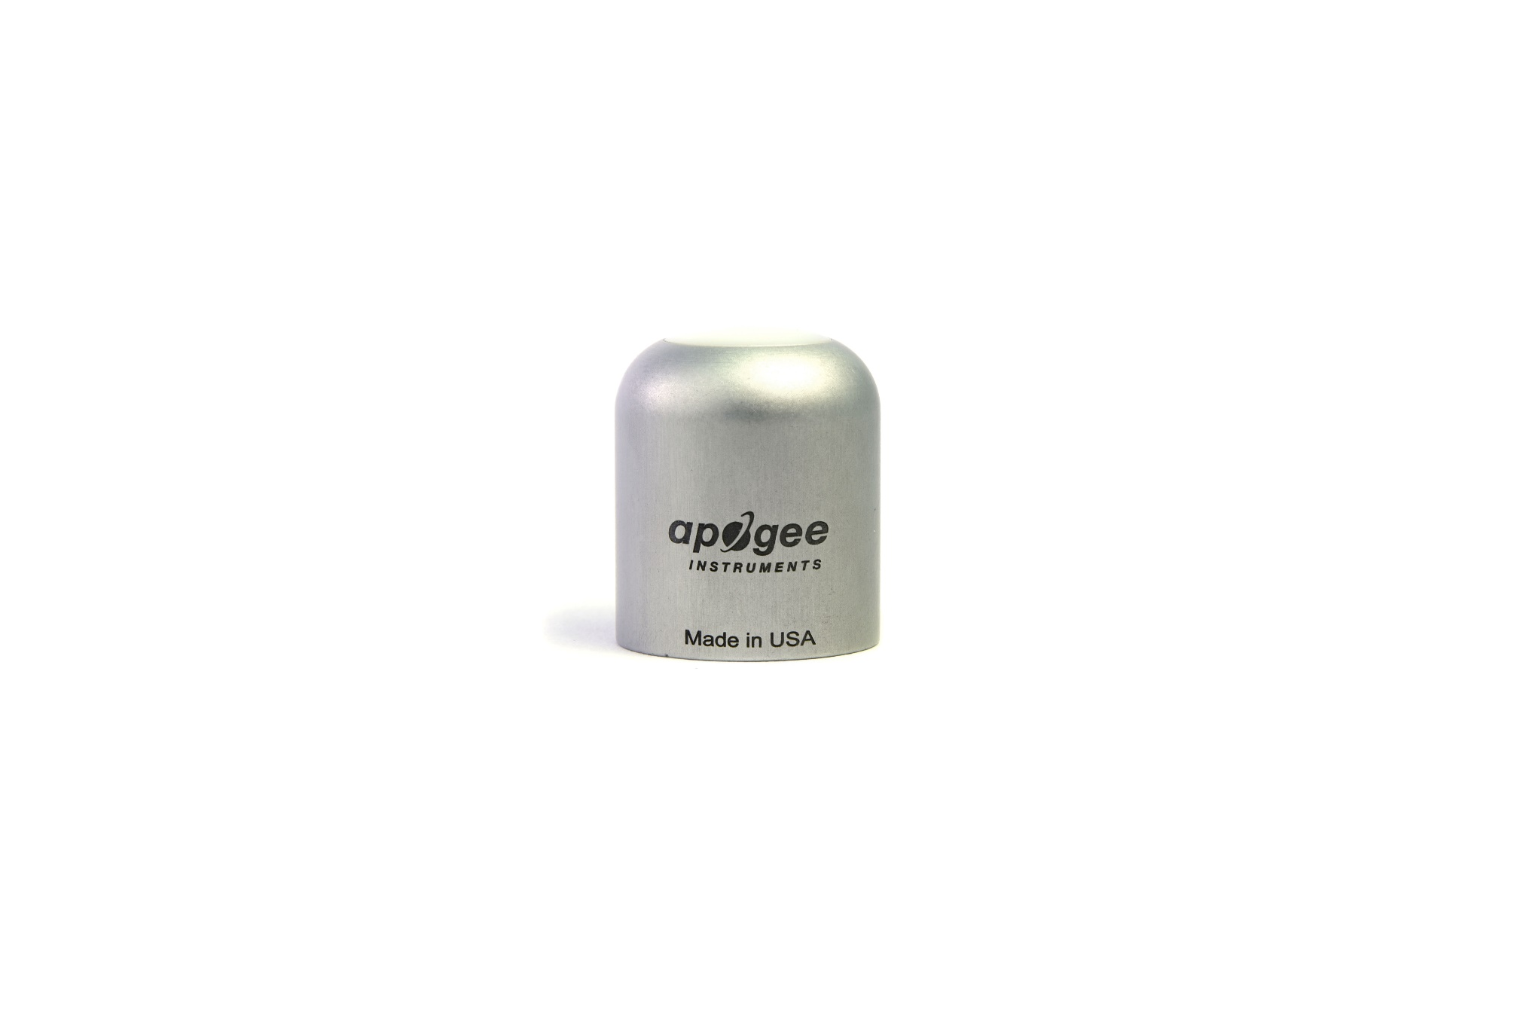

Table of Contents

[Owner’s Manual 1](#_Toc32225699)

[Certificate of Compliance 3](#_Toc32225700)

[Introduction 4](#_Toc32225701)

[Sensor Models 5](#_Toc32225702)

[Specifications 6](#_Toc32225703)

[Deployment and Installation 8](#_Toc32225704)

[Cable Connectors 9](#_Toc32225705)

[Operation and Measurement 10](#_Toc32225706)

[Maintenance and Recalibration 13](#_Toc32225707)

[Troubleshooting and Customer Support 14](#_Toc32225708)

[Return and Warranty Policy 15](#_Toc32225709)

### Certificate of Compliance

**EU Declaration of Conformity**

This declaration of conformity is issued under the sole responsibility of the manufacturer:

Apogee Instruments, Inc.  
721 W 1800 N  
Logan, Utah 84321  
USA

for the following product(s):

Models: SQ-644  
Type: Quantum Light Pollution Sensor

The object of the declaration described above is in conformity with the relevant Union harmonization legislation:

2014/30/EU Electromagnetic Compatibility (EMC) Directive

2011/65/EU Restriction of Hazardous Substances (RoHS 2) Directive

2015/863/EU Amending Annex II to Directive 2011/65/EU (RoHS 3)

Standards referenced during compliance assessment:

EN 61326-1:2013 Electrical equipment for measurement, control, and laboratory use – EMC requirements

EN 50581:2012 Technical documentation for the assessment of electrical and electronic products with respect to the restriction of hazardous substances

Please be advised that based on the information available to us from our raw material suppliers, the products manufactured by us do not contain, as intentional additives, any of the restricted materials including lead (see note below), mercury, cadmium, hexavalent chromium, polybrominated biphenyls (PBB), polybrominated diphenyls (PBDE), bis (2-ethylhexyl) phthalate (DEHP), butyl benzyl phthalate (BBP), dibutyl phthalate (DBP), and diisobutyl phthalate (DIBP). However, please note that articles containing greater than 0.1 % lead concentration are RoHS 3 compliant using exemption 6c.

Further note that Apogee Instruments does not specifically run any analysis on our raw materials or end products for the presence of these substances, but we rely on the information provided to us by our material suppliers.

Signed for and on behalf of:

Apogee Instruments, October 2021



Bruce Bugbee  
President  
Apogee Instruments, Inc.

### Introduction

Radiation that drives photosynthesis is called photosynthetically active radiation (PAR) and is typically defined as total radiation across a range of 400 to 700 nm. PAR is almost universally quantified as photosynthetic photon flux density (PPFD) in units of micromoles per square meter per second (µmol m-2 s-1, equal to microEinsteins per square meter per second) summed from 400 to 700 nm (total number of photons from 400 to 700 nm). However, ultraviolet and far-red photons outside the defined PAR range of 400-700 nm can also contribute to photosynthesis and influence plant responses (e.g., flowering).

Sensors that measure PPFD are often called quantum sensors due to the quantized nature of radiation. A quantum refers to the minimum quantity of radiation, one photon, involved in physical interactions (e.g., absorption by photosynthetic pigments). In other words, one photon is a single quantum of radiation. Sensors that function like traditional quantum sensors but measure a wider range of wavelengths can be thought of as an ‘extended range’ quantum sensor.

Typical applications of traditional quantum sensors include incoming PPFD measurement over plant canopies in outdoor environments or in greenhouses and growth chambers and reflected or under-canopy (transmitted) PPFD measurement in the same environments. The Extended Range PFD Sensor detailed in this manual uses a detector that is sensitive to radiation up to about 1100 nm, well beyond the range of wavelengths that influence photosynthesis and plant responses. **This means this particular sensor should only be used for photon flux density measurements under LEDs.**

Apogee Instruments SQ-600 series Quantum Light Pollution Sensors consist of a cast acrylic diffuser (filter), photodiode, and signal processing circuitry mounted in an anodized aluminum housing, and a cable to connect the sensor to a measurement device. SQ-600 series sensors are designed for continuous photon flux density measurements in indoor environments under LEDs. The SQ-640 Quantum Light Pollution models output a voltage that is directly proportional to photon flux density. The voltage output by the sensor is directly proportional to radiation incident on a planar surface (does not have to be horizontal), where the radiation emanates from all angles of a hemisphere.

### Sensor Models

This manual covers the amplified voltage output model SQ-644 Quantum Light Pollution Sensor (in bold below). Additional models are covered in their respective manuals.

|  |  |
| --- | --- |
| Model | Signal |
| SQ-640 | Self-powered |
| SQ-642 | 0-2.5 V |
| SQ-644 | **4-20 mA** |
| SQ-645 | 0-5 V |
| SQ-646 | USB |
| SQ-647 | SDI-12 |
| SQ-648 | Modbus |

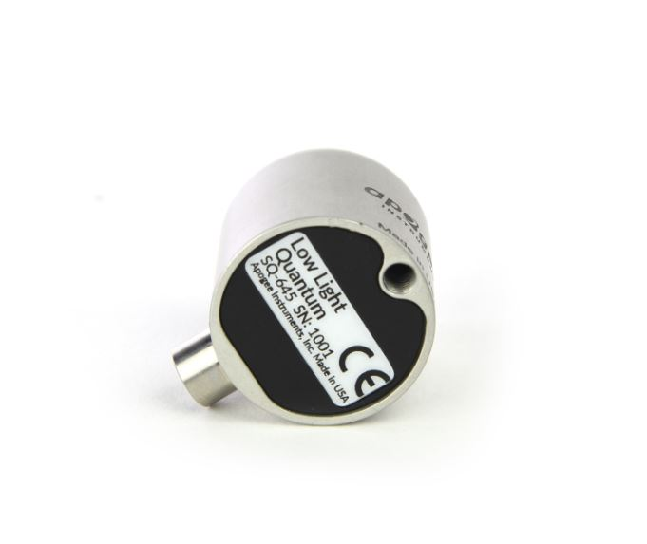

A sensor’s model number and serial number are located on the bottom of the sensor. If the manufacturing date of a specific sensor is required, please contact Apogee Instruments with the serial number of the sensor.

### Specifications

|  |  |
| --- | --- |
|  | **SQ-644-SS** |
| Power Supply | 12 to 24 V DC |
| Current Draw | Maximum of 20 mA |
| Sensitivity | 0.08 mA per µmol m-2 s-1 |
| Calibration Factor | 12.5 µmol m-2 s-1 per mA |
| Calibration Uncertainty | ± 5 % (see Calibration Traceability below) |
| Output Range | 4 to 20 mA |
| Measurement Range | 0 to 200 µmol m-2 s-1 |
| Measurement Repeatability | Less than 0.5 % |
| Long-term Drift  (Non-stability) | Less than 2 % per year |
| Non-linearity | Less than 1 % (up to 4000 µmol m-2 s-1) |
| Response Time | Less than 1 ms |
| Field of View | 180° |
| Spectral Range | 340 to 1040 nm ± 5 nm (wavelengths where response is greater than 50 %; see Spectral Response below) |
| Directional (Cosine) Response | ± 2 % at 45° zenith angle, ± 5 % at 75° zenith angle (see Directional Response below) |
| Azimuth Error | Less than 0.5 % |
| Tilt Error | Less than 0.5 % |
| Temperature Response | -0.11 ± 0.04 % per C |
| Uncertainty in Daily Total | Less than 5 % |
| Housing | Anodized aluminum body with acrylic diffuser |
| IP Rating | IP68 |
| Operating Environment | -40 to 70 C; 0 to 100 % relative humidity; can be submerged in water up to depths of 30 m |
| Dimensions | 30.5 mm diameter, 37 mm height |
| Mass (with 5 m of cable) | 140 g |
| Cable | 5 m of two conductor, shielded, twisted-pair wire; TPR jacket; pigtail lead wires; stainless steel (316), M8 connector |
| Warranty | 4 years against defects in materials and workmanship |

**Calibration Traceability**

Apogee Instruments SQ-600 series quantum light pollution sensors are calibrated through side-by-side comparison to the mean of four transfer standard quantum light pollution sensors under a reference lamp. The transfer standard quantum light pollution sensors are recalibrated with a quartz halogen lamp traceable to the National Institute of Standards and Technology (NIST).

**Spectral Response**

Mean spectral response measurements of six replicate Apogee SQ-600 series Quantum Light Pollution Sensors. Spectral response measurements were made at 10 nm increments across a wavelength range of 300 to 1100 nm in a monochromator with an attached electric light source. Measured spectral data from each quantum light pollution sensor were normalized by the measured spectral response of the monochromator/electric light combination, which was measured with a spectroradiometer

**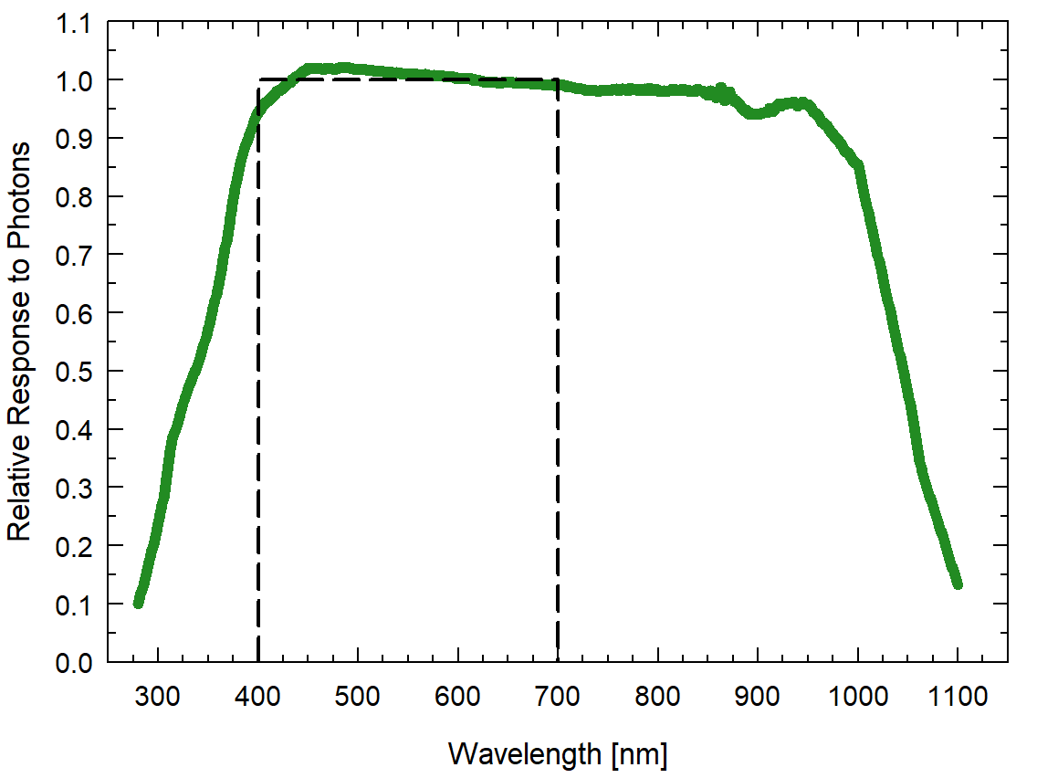**

**Cosine Response**

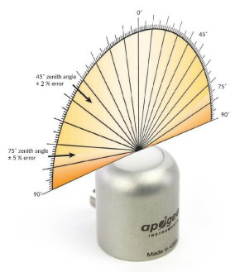

Directional, or cosine, response is defined as the measurement error at a specific angle of radiation incidence. Error for Apogee SQ-600 series Quantum Light Pollution Sensor is approximately ± 2 % and ± 5 % at solar zenith angles of 45° and 75°, respectively.

### Deployment and Installation

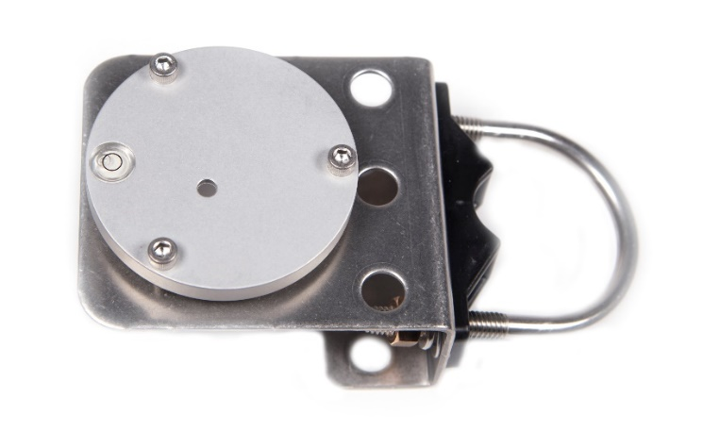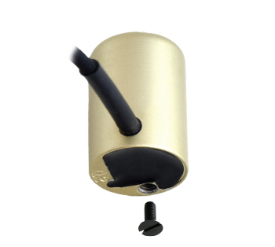Mount the sensor to a solid surface with the nylon mounting screw provided. To accurately measure photon flux density incident on a horizontal surface, the sensor must be level. An Apogee Instruments model AL-100 leveling plate is recommended for this purpose. To facilitate mounting on a cross arm, an Apogee Instruments model AL-120 mounting bracket is recommended.

Model: AL-110

Nylon Screw: 10-32 x 3/8

Nylon Screw: 10-32 x 3/8

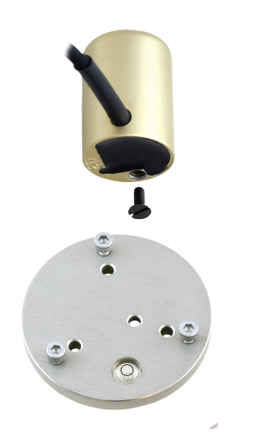

Model: AL-120

To minimize azimuth error, the sensor should be mounted with the cable pointing toward true north in the northern hemisphere or true south in the southern hemisphere. Azimuth error is typically less than 0.5 %, but it is easy to minimize by proper cable orientation.

**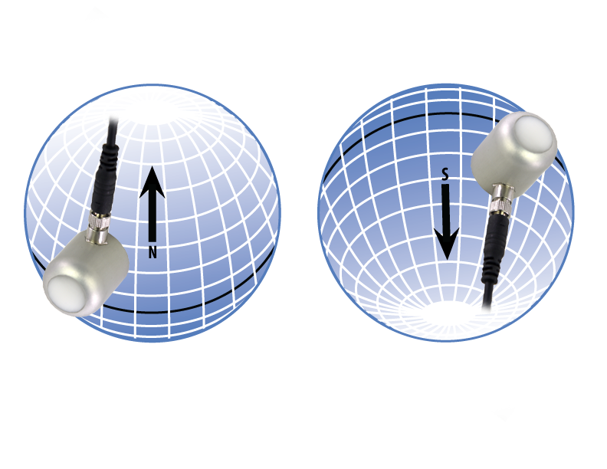**

In addition to orienting the cable to point toward the nearest pole, the sensor should also be mounted such that obstructions (e.g., weather station tripod/tower or other instrumentation) do not shade the sensor. **Once mounted, the blue cap should be removed from the sensor.** The blue cap can be used as a protective covering for the sensor when it is not in use.

### Cable Connectors

|  |  |
| --- | --- |
| Apogee started offering cable connectors on some bare-lead sensors in March 2018 to simplify the process of removing sensors from weather stations for calibration (the entire cable does **not** have to be removed from the station and shipped with the sensor).  The ruggedized M8 connectors are rated IP68, made of corrosion-resistant marine-grade stainless-steel, and designed for extended use in harsh environmental conditions. | DSC_2877  Cable connectors are attached directly to the head. |

**Instructions**

|  |  |
| --- | --- |
| **Pins and Wiring Colors:** All Apogee connectors have six pins, but not all pins are used for every sensor. There may also be unused wire colors inside the cable. To simplify datalogger connection, we remove the unused pigtail lead colors at the datalogger end of the cable.  If a replacement cable is required, please contact Apogee directly to ensure ordering the proper pigtail configuration.  **Alignment:** When reconnecting a sensor, arrows on the connector jacket and an aligning notch ensure proper orientation.  **Disconnection for extended periods:**  When disconnecting the sensor for an extended period of time from a station, protect the remaining half of the connector still on the station from water and dirt with electrical tape or other method. | A reference notch inside the connector ensures  proper alignment before tightening.  DSC_2876  When sending sensors in for calibration, only send the sensor head. |
| **Tightening:** Connectors are designed to be firmly finger-tightened only. There is an o-ring inside the connector that can be overly compressed if a wrench is used. Pay attention to thread alignment to avoid cross-threading. When fully tightened, 1-2 threads may still be visible.  **WARNING:** Do **not** tighten the connector by twisting the black cable or sensor head, only twist the metal connector (yellow arrows). | extended-warning  Finger-tighten firmly |

### Operation and Measurement

Connect the sensor to a measurement device (meter, datalogger, controller) capable of measuring and displaying a 4-20 mA signal. To maximize measurement resolution and signal-to-noise ratio, the input range of the measurement device should closely match the output range of the quantum sensor. **DO NOT connect the sensor to a power source greater than 24 V DC.**

**Wiring for SQ-644**

**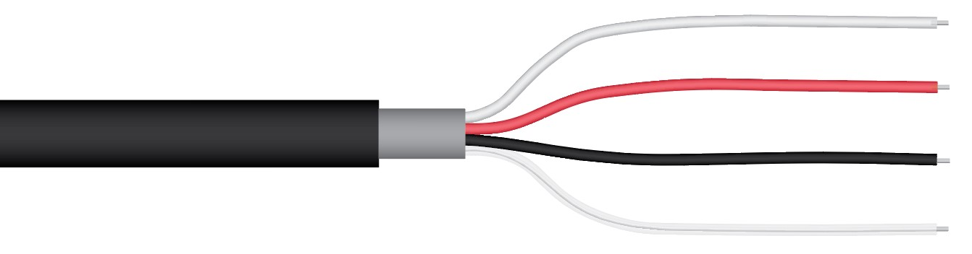**

**White**: 4-20 mA signal output

**Red**: Input power (7-24 V DC)

**Black**: Ground (for sensor signal and input power)

**Clear**: Shield/Ground

**Sensor Calibration**

Apogee SQ-644 Quantum Light Pollution Sensors have standard calibration factors of exactly:

**12.5 µmol m-2 s-1 per mA**

Multiply the calibration factor by the measured mV signal to convert sensor output to photon flux density in units of µmol m-2 s-1:

**Calibration Factor (12.5 µmol m-2 s-1 per mA) \* Sensor Output Signal (mA) = Photon Flux Density (µmol m-2 s-1)**

**12.5 \* (12 – 4) = 100**

Example of photon flux density measurement with an Apogee model SQ-644 Quantum Light Pollution Sensor. The LED in this example Full yields a photon flux density on a horizontal plane of 100 µmol m-2 s-1. This yields an output signal of 12 mA. This signal is converted to photon flux density by subtracting the 4.0 mA offset and then multiplying by the calibration factor of 12.5 mol m-2 s-1 / mA.

**LED Output**

**(100 µmol m-2s-1)**

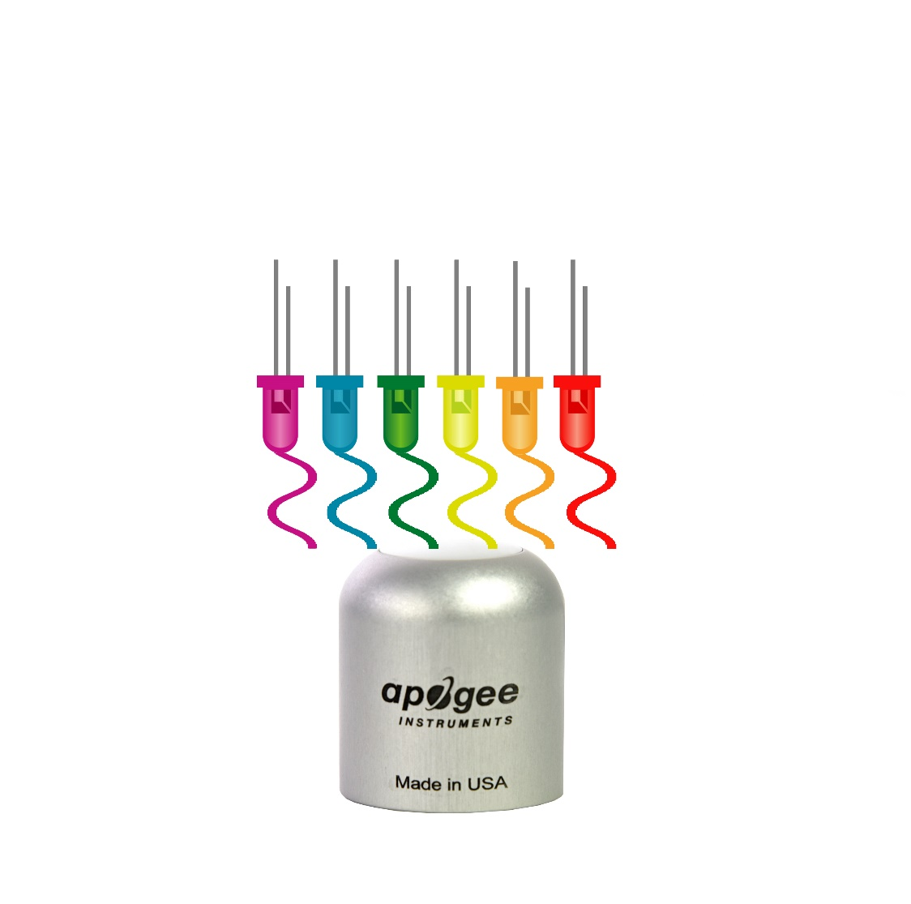

**Sensor Output**

**12 mA**

**Low Light Measurements**

Accurate low light measurements are required in flowering and light pollution studies. Research indicates flowering can be triggered in some plants at photosynthetic and/or far-red photon flux densities less than 0.1 mol m-2 s-1. The threshold photon flux density at which flowering is triggered is variable among species. Two of the most light-sensitive species are Poinsettias and Cannabis. For reference, photon flux density of moonlight when the moon is full and near the minimum zenith angle is 0.005 mol m-2 s-1.

The model SQ-620 Extended Range Quantum Sensor can measure a photon flux density range of 0-4000 mol m-2 s-1. The model SQ-640 Quantum Light Pollution Sensor is designed for low light measurements and can only measure a photon flux density range of 0-200 mol m-2 s-1 (the sensor will output values beyond, 200 mol m-2 s-1, but these are beyond the linear range of the sensor) and is referred to as the low light version. The sensitivity of the SQ-640 is twenty times higher than the sensitivity of the SQ-620 (1 mV per mol m-2 s-1 versus 0.05 mV per mol m-2 s-1) to provide greater measurement resolution under low light conditions. For example, if the photon flux density were 0.1 mol m-2 s-1, the SQ-640 would output 0.1 mV, whereas the SQ-620 would output 0.005 mV.

### Maintenance and Recalibration

Dust or organic deposits are best removed using water or window cleaner and a soft cloth or cotton swab. Salt deposits should be dissolved with vinegar and removed with a soft cloth or cotton swab.

Blocking of the optical path between the target and detector can cause low readings. Occasionally, accumulated materials on the diffuser of the upward-looking radiometer and in the apertures of the downward-looking radiometer can block the optical path in three common ways:

1. Moisture or debris on the diffuser (upward-looking) or in the apertures (downward-looking).
2. Dust during periods of low rainfall.
3. Salt deposit accumulation from evaporation of sea spray or sprinkler irrigation water.

Apogee Instruments upward-looking sensors have a domed diffuser and housing for improved self-cleaning from rainfall, but active cleaning may be necessary. Dust or organic deposits are best removed using water, or window cleaner, and a soft cloth or cotton swab. Salt deposits should be dissolved with vinegar and removed with a cloth or cotton swab. **Salt deposits cannot be removed with solvents such as alcohol or acetone.** Use only gentle pressure when cleaning the diffuser with a cotton swab or soft cloth, to avoid scratching the outer surface. The solvent should be allowed to do the cleaning, not mechanical force. **Never use an abrasive material or cleaner on the diffuser**.

It is recommended that two-band radiometers be recalibrated every two years. See the Apogee webpage for details regarding return of sensors for recalibration (<http://www.apogeeinstruments.com/tech-support-recalibration-repairs/>).

### Troubleshooting and Customer Support

**Independent Verification of Functionality**

Apogee SQ-644 Quantum Light Pollution Sensors provide a 4-20 mA output that is proportional to incident photon flux density for the 340-1040 nm wavelength range. A quick and easy check of sensor functionality can be determined using a DC power supply and an ammeter. Power the sensor with a DC voltage by connecting the positive voltage signal to the red wire from the sensor and the negative (or common) to the black wire from the sensor. Use the ammeter to measure across the white wire (signal output) and green wire (signal ground). Direct the sensor head toward a light source and verify the sensor provides a signal. Increase and decrease the distance from the sensor head to the light source to verify that the signal changes proportionally (decreasing signal with increasing distance and increasing signal with decreasing distance). Blocking all radiation from the sensor should force the sensor signal to 4 mA.

**Compatible Measurement Devices (Dataloggers/Controllers/Meters)**

SQ-644 Quantum Light Pollution Sensors are calibrated with a standard calibration factor of 12.5 µmol m-2 s-1 per mA, yielding a sensitivity of 0.08 mA per µmol m-2 s-1. Thus, a compatible measurement device (e.g., datalogger or controller) should have resolution of at least 0.08 mA in order to provide photon flux density resolution of 1 µmol m-2 s-1 and resolution of at least 0.008 mA in order provide photon flux density resolution of 0.1 µmol m-2 s-1.

An example datalogger program for Campbell Scientific dataloggers can be found on the Apogee webpage at <https://www.apogeeinstruments.com/downloads/#datalogger>.

**Cable Length**

Shortening or splicing on additional cable in the field is generally not a problem for the current output of the SQ-644. However, adding cable will result in a greater resistive load, which should be taken into consideration when determining the maximum resistive load that the sensor will drive (see section above on Compatible Measurement Devices). All Apogee sensors use shielded, twisted pair cable to minimize electromagnetic interference. For best measurements, the shield wire must be connected to an earth ground. This is particularly important when using the sensor with long lead lengths in electromagnetically noisy environments.

**Modifying Cable Length**

See Apogee webpage for details on how to extend sensor cable length: (<http://www.apogeeinstruments.com/how-to-make-a-weatherproof-cable-splice/>).

### Return and Warranty Policy

RETURN POLICY

Apogee Instruments will accept returns within 30 days of purchase as long as the product is in new condition (to be determined by Apogee). Returns are subject to a 10 % restocking fee.

WARRANTY POLICY

**What is Covered**All products manufactured by Apogee Instruments are warranted to be free from defects in materials and craftsmanship for a period of four (4) years from the date of shipment from our factory. To be considered for warranty coverage an item must be evaluated by Apogee.

Products not manufactured by Apogee (spectroradiometers, chlorophyll content meters, EE08-SS probes) are covered for a period of one (1) year.

**What is Not Covered**The customer is responsible for all costs associated with the removal, reinstallation, and shipping of suspected warranty items to our factory.

The warranty does not cover equipment that has been damaged due to the following conditions:

1. Improper installation, use, or abuse.

2. Operation of the instrument outside of its specified operating range.

3. Natural occurrences such as lightning, fire, etc.

4. Unauthorized modification.

5. Improper or unauthorized repair.

Please note that nominal accuracy drift is normal over time. Routine recalibration of sensors/meters is considered part of proper maintenance and is not covered under warranty.

**Who is Covered**This warranty covers the original purchaser of the product or other party who may own it during the warranty period.

**What Apogee Will Do**At no charge Apogee will:

1. Either repair or replace (at our discretion) the item under warranty.

2. Ship the item back to the customer by the carrier of our choice.

Different or expedited shipping methods will be at the customer’s expense.

**How To Return An Item**1. Please do not send any products back to Apogee Instruments until you have received a Return Merchandise Authorization (RMA) number from our technical support department by submitting an online RMA form at [www.apogeeinstruments.com/tech-support-recalibration-repairs/](http://www.apogeeinstruments.com/tech-support-recalibration-repairs/). We will use your RMA number for tracking of the service item. Call (435) 245-8012 or email techsupport@apogeeinstruments.com with questions.

2. For warranty evaluations, send all RMA sensors and meters back in the following condition: Clean the sensor’s exterior and cord. Do not modify the sensors or wires, including splicing, cutting wire leads, etc. If a connector has been attached to the cable end, please include the mating connector – otherwise the sensor connector will be removed in order to complete the repair/recalibration. ***Note:*** *When sending back sensors for routine calibration that have Apogee’s standard stainless-steel connectors, you only need to send the sensor with the 30 cm section of cable and one-half of the connector. We have mating connectors at our factory that can be used for calibrating the sensor.*

3. Please write the RMA number on the outside of the shipping container.

4. Return the item with freight pre-paid and fully insured to our factory address shown below. We are not responsible for any costs associated with the transportation of products across international borders.

**Apogee Instruments, Inc.   
721 West 1800 North Logan, UT  
84321, USA**

5. Upon receipt, Apogee Instruments will determine the cause of failure. If the product is found to be defective in terms of operation to the published specifications due to a failure of product materials or craftsmanship, Apogee Instruments will repair or replace the items free of charge. If it is determined that your product is not covered under warranty, you will be informed and given an estimated repair/replacement cost.

Products Beyond the Warranty Period

For issues with sensors beyond the warranty period, please contact Apogee at [techsupport@apogeeinstruments.com](mailto:techsupport@apogeeinstruments.com) to discuss repair or replacement options.

Other Terms

The available remedy of defects under this warranty is for the repair or replacement of the original product, and Apogee Instruments is not responsible for any direct, indirect, incidental, or consequential damages, including but not limited to loss of income, loss of revenue, loss of profit, loss of data, loss of wages, loss of time, loss of sales, accruement of debts or expenses, injury to personal property, or injury to any person or any other type of damage or loss.

This limited warranty and any disputes arising out of or in connection with this limited warranty ("Disputes") shall be governed by the laws of the State of Utah, USA, excluding conflicts of law principles and excluding the Convention for the International Sale of Goods. The courts located in the State of Utah, USA, shall have exclusive jurisdiction over any Disputes.

This limited warranty gives you specific legal rights, and you may also have other rights, which vary from state to state and jurisdiction to jurisdiction, and which shall not be affected by this limited warranty. This warranty extends only to you and cannot by transferred or assigned. If any provision of this limited warranty is unlawful, void, or unenforceable, that provision shall be deemed severable and shall not affect any remaining provisions. In case of any inconsistency between the English and other versions of this limited warranty, the English version shall prevail.

This warranty cannot be changed, assumed, or amended by any other person or agreement

**APOGEE INSTRUMENTS, INC. |** 721 WEST 1800 NORTH, LOGAN, UTAH 84321, USA

TEL: (435) 792-4700 | FAX: (435) 787-8268 | WEB: APOGEEINSTRUMENTS.COM

*Copyright © 2022 Apogee Instruments, Inc.*