

# Owner’s Manual

ePAR Sensor

Models SQ-614

Rev: 30-Mar-2022

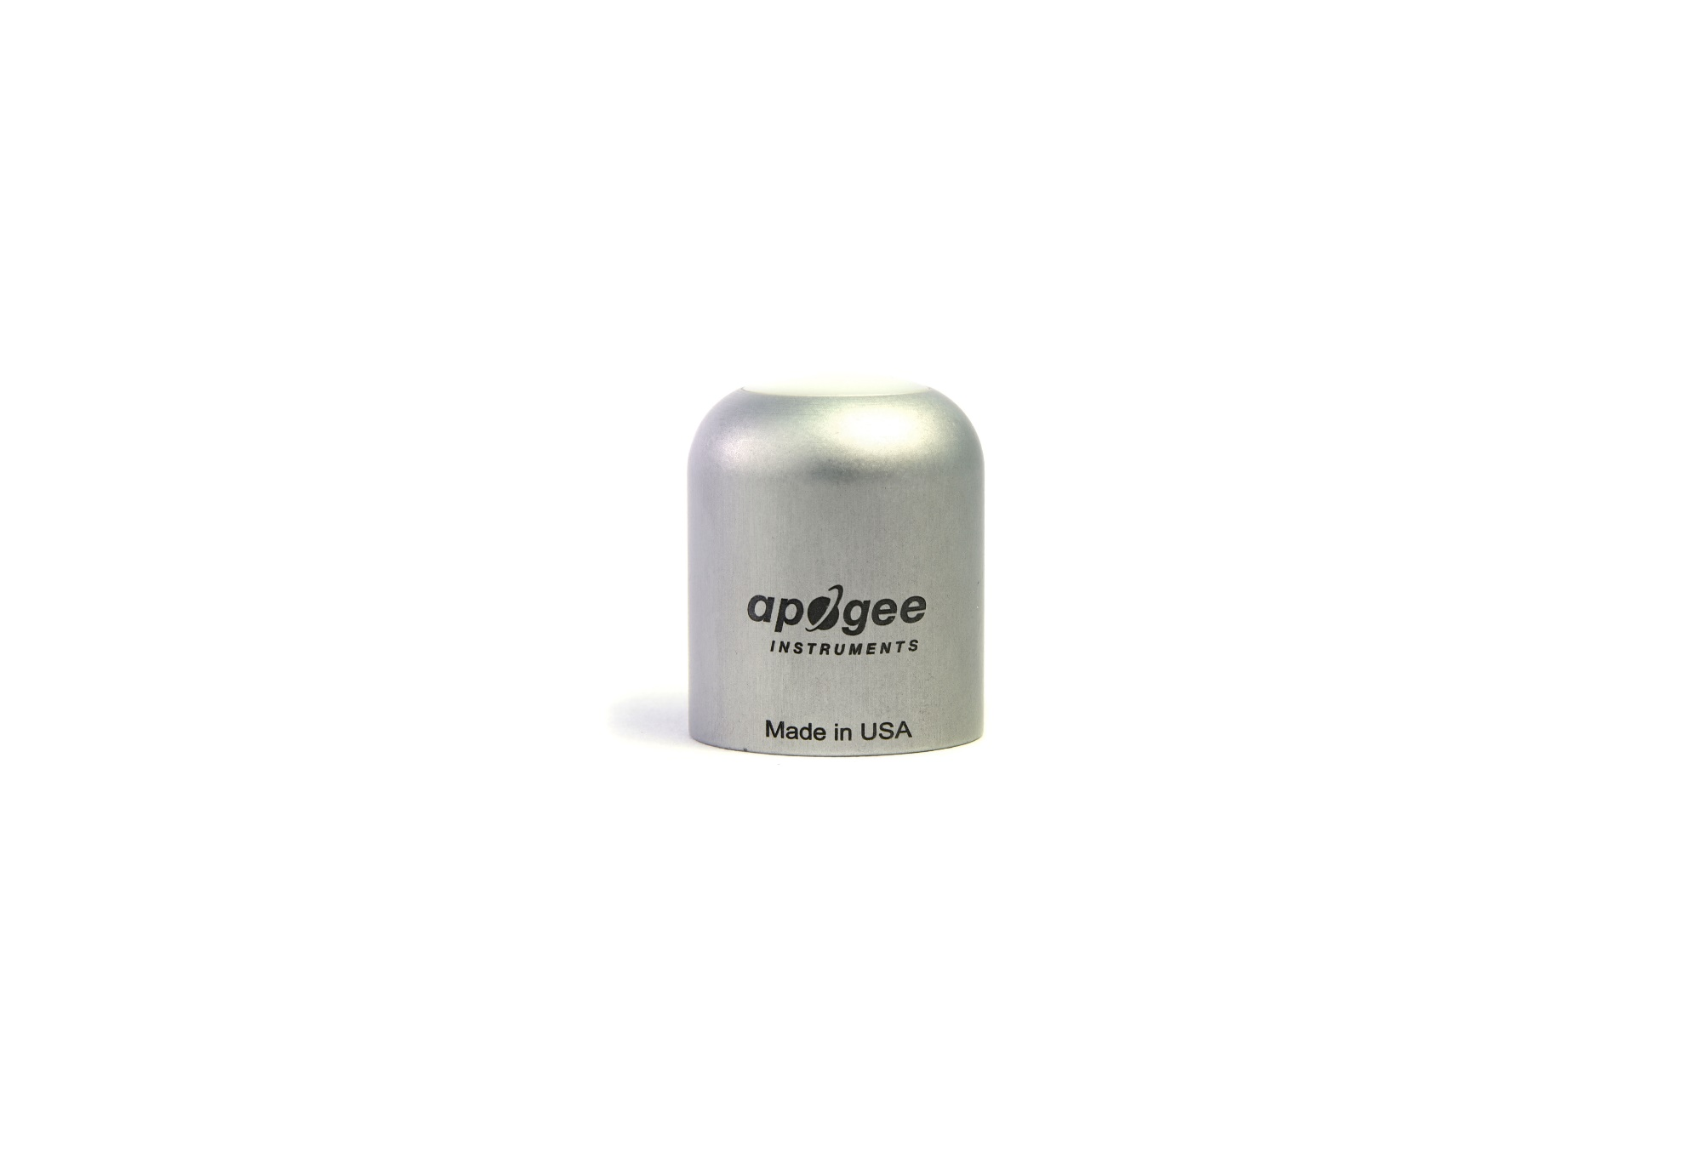

Table of Contents

[Owner’s Manual 1](#_Toc517081832)

[Certificate of Compliance 3](#_Toc517081833)

[Introduction 4](#_Toc517081834)

[Sensor Models 6](#_Toc517081835)

[Specifications 7](#_Toc517081836)

[Deployment and Installation 10](#_Toc517081837)

[Cable Connectors 11](#_Toc517081838)

[Operation and Measurement 11](#_Toc517081839)

[Maintenance and Recalibration 15](#_Toc517081840)

[Troubleshooting and Customer Support 16](#_Toc517081841)

[Return and Warranty Policy 17](#_Toc517081842)

### Certificate of Compliance

**EU Declaration of Conformity**

This declaration of conformity is issued under the sole responsibility of the manufacturer:

Apogee Instruments, Inc.  
721 W 1800 N  
Logan, Utah 84321  
USA

for the following product(s):

Models: SQ-614  
Type: ePAR Sensor

The object of the declaration described above is in conformity with the relevant Union harmonization legislation:

2014/30/EU Electromagnetic Compatibility (EMC) Directive

2011/65/EU Restriction of Hazardous Substances (RoHS 2) Directive

2015/863/EU Amending Annex II to Directive 2011/65/EU (RoHS 3)

Standards referenced during compliance assessment:

EN 61326-1:2013 Electrical equipment for measurement, control and laboratory use – EMC requirements

EN 50581:2012 Technical documentation for the assessment of electrical and electronic products with respect to the restriction of hazardous substances

Please be advised that based on the information available to us from our raw material suppliers, the products manufactured by us do not contain, as intentional additives, any of the restricted materials including lead (see note below), mercury, cadmium, hexavalent chromium, polybrominated biphenyls (PBB), polybrominated diphenyls (PBDE), bis (2-ethylhexyl) phthalate (DEHP), butyl benzyl phthalate (BBP), dibutyl phthalate (DBP), and diisobutyl phthalate (DIBP). However, please note that articles containing greater than 0.1 % lead concentration are RoHS 3 compliant using exemption 6c.

Further note that Apogee Instruments does not specifically run any analysis on our raw materials or end products for the presence of these substances, but we rely on the information provided to us by our material suppliers.

Signed for and on behalf of:

Apogee Instruments, March 2022



Bruce Bugbee  
President  
Apogee Instruments, Inc.

### Introduction

Radiation that drives photosynthesis is called photosynthetically active radiation (PAR) and, historically, is defined as total radiation across a range of 400 to 700 nm. PAR is almost universally quantified as photosynthetic photon flux density (PPFD) in units of micromoles per square meter per second (µmol m-2 s-1, equal to microEinsteins per square meter per second) summed from 400 to 700 nm (total number of photons from 400 to 700 nm). However, ultraviolet and far-red photons outside the defined PAR range of 400-700 nm can also contribute to photosynthesis and influence plant responses (e.g., flowering).

Data from recent studies indicate that far-red photons synergistically interact with photons in the historically defined PAR range of 400-700 nm to increase photochemical efficiency in leaves (Hogewoning et al., 2012; Murakami et al., 2018; Zhen and van Iersel, 2017; Zhen et al., 2019). Measurements from whole plants and plant canopies indicate adding far-red photons (using far-red LEDs with peaks near 735 nm and outputting photons across a range of about 700-750 nm) to radiation sources outputting photons in the 400-700 nm range increases canopy photosynthesis equal to the addition of the same number of photons in the 400-700 nm range for multiple species, and C3 and C4 photosynthetic pathways, but far-red photons alone are photosynthetically inefficient and result in minimal photosynthesis (Zhen and Bugbee, 2020a; Zhen and Bugbee, 2020b).

This research suggests that far-red photons drive canopy photosynthesis with similar efficiency as photons in the traditional PAR range when they are acting synergistically with photons in the 400-700 nm range, meaning when far-red photons are added to radiation sources outputting 400-700 nm photons. Thus, far-red photons need to be included in the definition of PAR (Zhen et al., 2021).

Sensors that measure PPFD are often called quantum sensors due to the quantized nature of radiation. A quantum refers to the minimum quantity of radiation, one photon, involved in physical interactions (e.g., absorption by photosynthetic pigments). In other words, one photon is a single quantum of radiation. Sensors that function like traditional quantum sensors but measure a wider range of wavelengths can be thought of as an ‘extended range’ quantum sensor.

Typical applications of traditional quantum sensors include incoming PPFD measurement over plant canopies in outdoor environments or in greenhouses and growth chambers and reflected or under-canopy (transmitted) PPFD measurement in the same environments. The extended photosynthetically active radiation (ePAR) sensor detailed in this manual uses a detector that is sensitive to radiation from 383-757 nm ± 5 nm, which allows it to measure photons from Far-red.

Apogee Instruments SQ-600 series ePAR sensors consist of a cast acrylic diffuser (filter), photodiode, and signal processing circuitry mounted in an anodized aluminum housing. A cable to connect the sensor to a measurement device is also included. SQ-600 series ePAR sensors are designed for continuous photon flux density measurements in indoor or outdoor environments. SQ-610 models output an analog signal that is directly proportional to photon flux density. The analog signal from the sensor is directly proportional to radiation incident on a planar surface (does not have to be horizontal), where the radiation emanates from all angles of a hemisphere.

Hogewoning et al. 2012. Photosynthetic Quantum Yield Dynamics: From Photosystems to Leaves. *The Plant Cell*, 24: 1921–1935.

Murakami et al. 2018. A Mathematical Model of Photosynthetic Electron Transport in Response to the Light Spectrum Based on Excitation Energy Distributed to Photosystems. *Plant Cell Physiology*. 59(8): 1643–1651.

Zhen and Van Iersel. 2017. Far-red light is needed for efficient photochemistry and photosynthesis. *Journal of Plant Physiology.* 209: 115–122.

Zhen et al. 2019. Far-red light enhances photochemical efficiency in a wavelength-dependent manner. *Physiologia Plantarum.* 167(1):21-33.

Zhen and Bugbee. 2020a. Far-red photons have equivalent efficiency to traditional photosynthetic photons: Implications for redefining photosynthetically active radiation. *Plant Cell and Environment*. 2020; 1–14.

Zhen and Bugbee. 2020b. Substituting Far-Red for Traditionally Defined Photosynthetic Photons Results in Equal Canopy Quantum Yield for CO2 Fixation and Increased Photon Capture During Long-Term Studies: Implications for Re-Defining PAR. *Frontiers in Plant Science.* 11:1-14.

Zhen et al. 2021. Why Far-Red Photons Should Be Included in the Definition of Photosynthetic Photons and the Measurement of Horticultural Fixture Efficacy. *Frontiers in Plant Science.* 12:1-4.

### Sensor Models

This manual covers the amplified voltage output model SQ-614 ePAR Sensor (in bold below). Additional models are covered in their respective manuals.

|  |  |
| --- | --- |
| Model | Signal |
| SQ-610 | Self-powered |
| SQ-612 | 0-2.5 V |
| SQ-614 | **4-20 mA** |
| SQ-615 | 0-5 V |
| SQ-616 | USB |
| SQ-617 | SDI-12 |
| SQ-618 | Modbus |

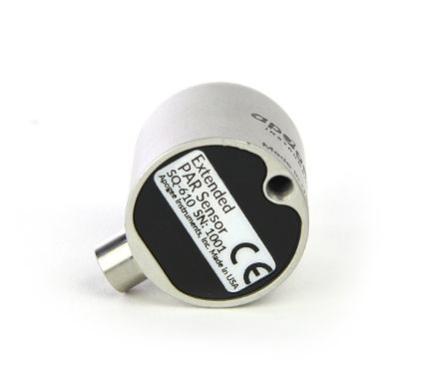

A sensor’s model number and serial number are located on the bottom of the sensor. If the manufacturing date of a specific sensor is required, please contact Apogee Instruments with the serial number of the sensor.

### Specifications

|  |  |
| --- | --- |
|  | **SQ-614-SS** |
| Power Supply | 12-24 V DC |
| Current Draw | Maximum of 20 mA |
| Sensitivity | 0.004 mA per µmol m-2 s-1 |
| Calibration Factor | 250 µmol m-2 s-1 per mA |
| Calibration Uncertainty | ± 5 % (see Calibration Traceability below) |
| Output Range | 4 to 20 mA |
| Measurement Range | 0 to 4000 µmol m-2 s-1 |
| Measurement Repeatability | Less than 0.5 % |
| Long-term Drift  (Non-stability) | Less than 2 % per year |
| Non-linearity | Less than 1 % (up to 4000 µmol m-2 s-1) |
| Response Time | Less than 1 ms |
| Field of View | 180° |
| Spectral Range | 383 to 757 nm ± 5 nm (wavelengths where response is greater than 50 %; see Spectral Response below) |
| Directional (Cosine) Response | ± 2 % at 45° zenith angle, ± 5 % at 75° zenith angle (see Directional Response below) |
| Azimuth Error | Less than 0.5 % |
| Tilt Error | Less than 0.5 % |
| Temperature Response | -0.11 ± 0.04 % per C |
| Uncertainty in Daily Total | Less than 5 % |
| Housing | Anodized aluminum body with acrylic diffuser |
| IP Rating | IP68 |
| Operating Environment | -40 to 70 C; 0 to 100 % relative humidity; can be submerged in water up to depths of 30 m |
| Dimensions | 30.5 mm diameter, 37 mm height |
| Mass (with 5 m of cable) | 140 g |
| Cable | 5 m of two conductor, shielded, twisted-pair wire; TPR jacket; pigtail lead wires; stainless steel (316), M8 connector |
| Warranty | 4 years against defects in materials and workmanship |

**Calibration Traceability**

Apogee Instruments SQ-600 series ePAR sensors are calibrated through side-by-side comparison to the mean of four transfer standard sensors under a reference lamp. The transfer standard sensors are recalibrated with a quartz halogen lamp traceable to the National Institute of Standards and Technology (NIST).

**Spectral Response**

Mean spectral response measurements of four replicate Apogee SQ-600 series ePAR Sensors. Incremental spectral response measurements were made at 10 nm increments across a wavelength range of 370 to 800 nm in a monochromator with an attached electric light source. Measured spectral data from each quantum sensor were refined and normalized by comparing measured spectral response of the monochromator/electric light combination to measured spectral differences from a quantum sensor reference.

****

**Cosine Response**

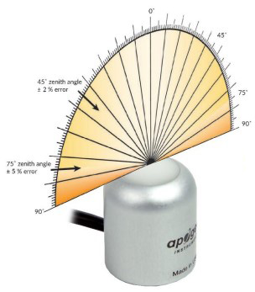

Directional, or cosine, response is defined as the measurement error at a specific angle of radiation incidence. Error for Apogee SQ-600 series ePAR Sensor is approximately ± 2 % and ± 5 % at solar zenith angles of 45° and 75°, respectively.

Mean directional (cosine) response of seven Apogee series quantum sensors. Directional response measurements were made on the rooftop of the Apogee building in Logan, Utah. Directional response was calculated as the relative difference of quantum sensors from the mean of replicate reference quantum sensors (LI-COR models LI-190 and LI-190R, Kipp & Zonen model PQS 1). Data were also collected in the laboratory using a reference lamp and positioning the sensor at varying angles.

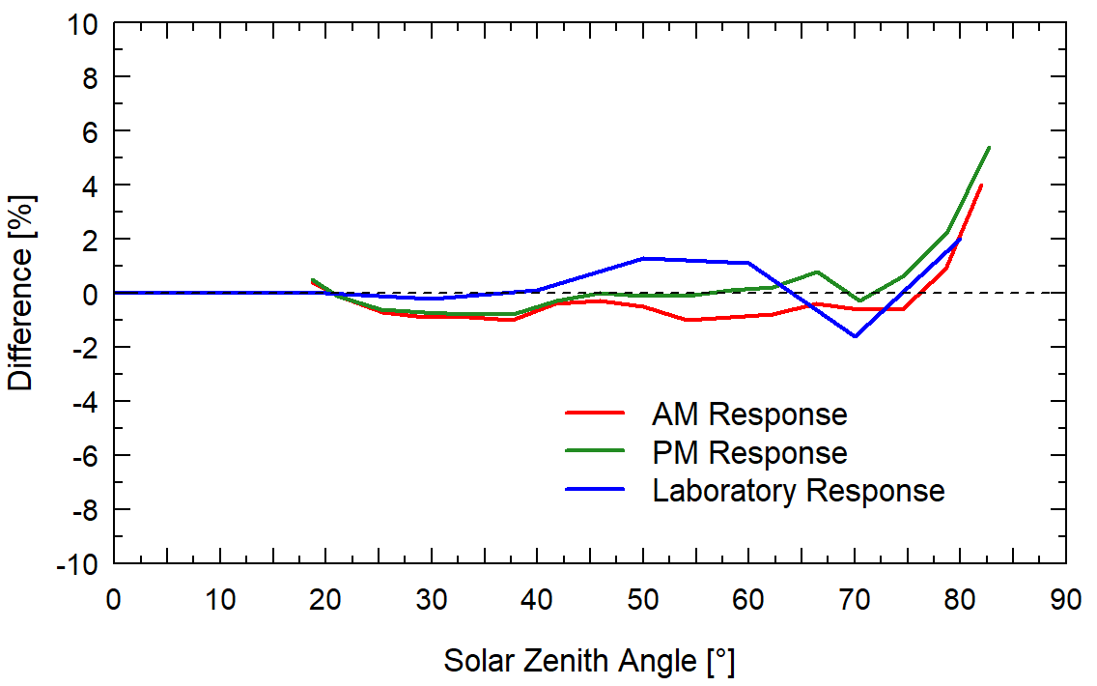

### Deployment and Installation

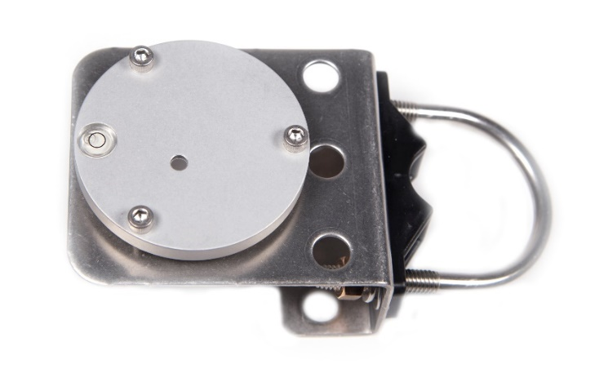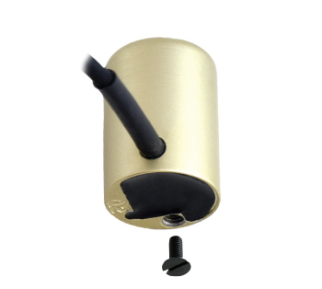Mount the sensor to a solid surface with the nylon mounting screw provided. To accurately measure photon flux density incident on a horizontal surface, the sensor must be level. An Apogee Instruments model AL-100 leveling plate is recommended for this purpose. To facilitate mounting on a cross arm, an Apogee Instruments model AL-120 mounting bracket is recommended.

Model: AL-110

Nylon Screw: 10-32 x 3/8

Nylon Screw: 10-32 x 3/8

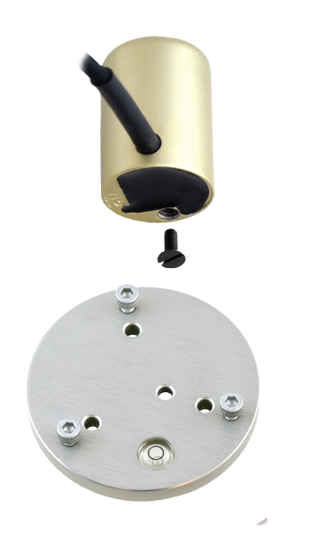

Model: AL-120

To minimize azimuth error, the sensor should be mounted with the cable pointing toward true north in the northern hemisphere or true south in the southern hemisphere. Azimuth error is typically less than 0.5 %, but it is easy to minimize by proper cable orientation.

**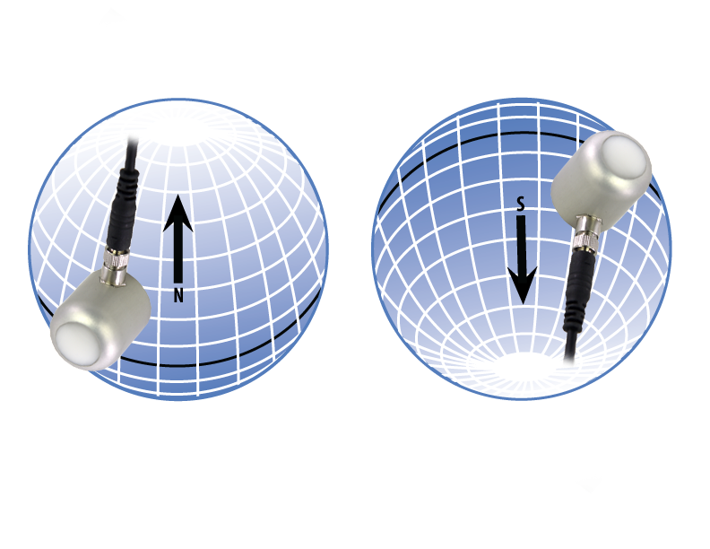**

In addition to orienting the cable to point toward the nearest pole, the sensor should also be mounted such that obstructions (e.g., weather station tripod/tower or other instrumentation) do not shade the sensor. **Once mounted, the blue cap should be removed from the sensor.** The blue cap can be used as a protective covering for the sensor when it is not in use.

### Cable Connectors

|  |  |
| --- | --- |
| Apogee offers cable connectors to simplify the process of removing sensors from weather stations for calibration (the entire cable does **not** have to be removed from the station and shipped with the sensor).  The ruggedized M8 connectors are rated IP68, made of corrosion-resistant marine-grade stainless-steel, and designed for extended use in harsh environmental conditions. | DSC_2877  Cable connectors are attached directly to the head. |

**Instructions**

|  |  |
| --- | --- |
| **Pins and Wiring Colors:** All Apogee connectors have six pins, but not all pins are used for every sensor. There may also be unused wire colors inside the cable. To simplify datalogger connection, we remove the unused pigtail lead colors at the datalogger end of the cable.  If a replacement cable is required, please contact Apogee directly to ensure ordering the proper pigtail configuration.  **Alignment:** When reconnecting a sensor, arrows on the connector jacket and an aligning notch ensure proper orientation.  **Disconnection for extended periods:**  When disconnecting the sensor for an extended period of time from a station, protect the remaining half of the connector still on the station from water and dirt with electrical tape or other method. | A reference notch inside the connector ensures  proper alignment before tightening.  DSC_2876  When sending sensors in for calibration, only send the sensor head. |
| **Tightening:** Connectors are designed to be firmly finger-tightened only. There is an o-ring inside the connector that can be overly compressed if a wrench is used. Pay attention to thread alignment to avoid cross-threading. When fully tightened, 1-2 threads may still be visible.  **WARNING:** Do **not** tighten the connector by twisting the black cable or sensor head, only twist the metal connector (yellow arrows). | extended-warning  Finger-tighten firmly |

### Operation and Measurement

Connect the sensor to a measurement device (meter, datalogger, controller) capable of measuring and displaying a 4-20 mA signal. To maximize measurement resolution and signal-to-noise ratio, the input range of the measurement device should closely match the output range of the quantum sensor. **DO NOT connect the sensor to a power source greater than 24 V DC.**

**Wiring for SQ-614**

**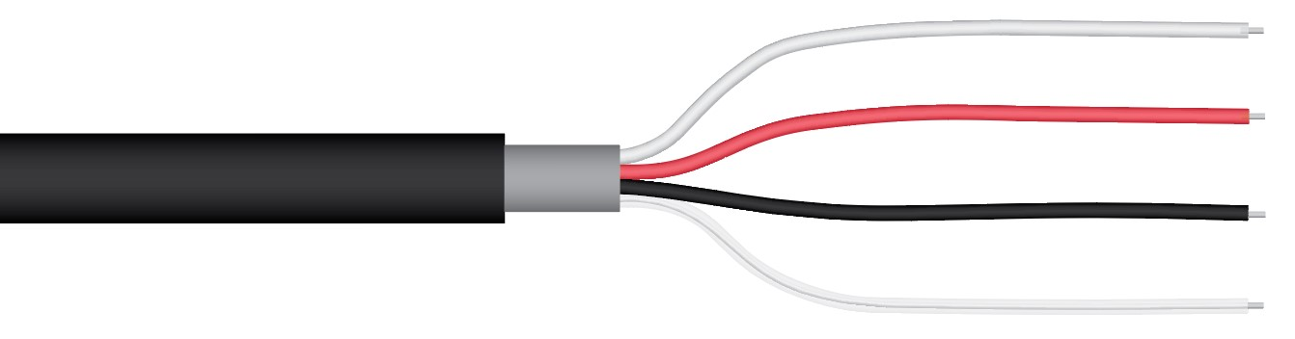**

**White**: 4-20 mA signal output

**Red**: Input power (7-24 V DC)

**Black**: Ground (for sensor signal and input power)

**Clear**: Shield/Ground

**Sensor Calibration**

Apogee SQ-614 ePAR Sensors have standard calibration factors of exactly:

**250 µmol m-2 s-1 per mA**

Multiply the calibration factor by the measured mA signal to convert sensor output to photon flux density in units of µmol m-2 s-1:

**Calibration Factor (250 µmol m-2 s-1 per mA) \* Sensor Output Signal (mA) = Photon Flux Density (µmol m-2 s-1)**

**250 \* (13.6 – 4) = 2400**

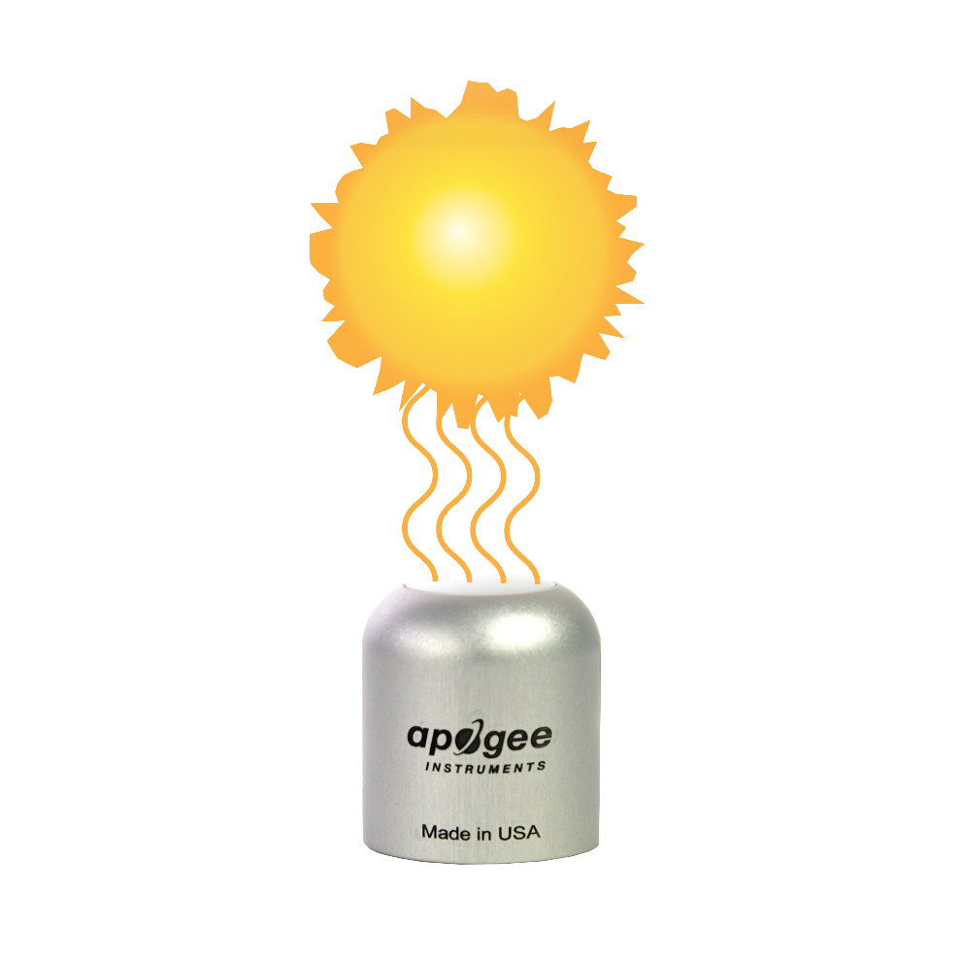

**Sensor Output**

**13.6 mA**

**Full Sunlight**

**(2400 µmol m-2s-1)**

Example of photon flux density measurement with an Apogee model SQ-610 ePAR Sensor. Full sunlight yields a photon flux density on a horizontal plane of approximately 2400 µmol m-2 s-1. This yields an output signal of 13.6 mA. This signal is converted to photon flux density by subtracting the 4.0 mA offset and then multiplying by the calibration factor of 250 mmol m-2 s-1 per mA.

**Spectral Error**

Quantum sensors are the most common instrument for measuring PPFD, because they are about an order of magnitude lower cost the spectroradiometers, but spectral errors must be considered. The spectral errors in the table below can be used as correction factors for individual radiation sources.

**Spectral Errors for PPFD Measurements with Apogee SQ-610 Series ePAR Sensors**

|  |  |
| --- | --- |
| **Radiation Source (Error Calculated Relative to Sun, Clear Sky)** | **SQ-610 Series**  **PPFD Error [%]** |
| Sun (Clear Sky) | 2.5 |
| Sun (Cloudy Sky) | 2.6 |
| Cool White Fluorescent (T5) | -0.5 |
| Metal Halide | 0.7 |
| Ceramic Metal Halide | 0.3 |
| Mogul Base HPS | 0.3 |
| Dual-ended HPS | 0.6 |
| Cool White LED | -1.0 |
| Warm White LED | -0.4 |
| Blue LED (442 nm) | -2.7 |
| Cyan LED (501 nm) | -0.7 |
| Green LED (529 nm) | -0.7 |
| Amber LED (598 nm) | -0.4 |
| Red LED (666 nm) | -0.3 |
| Far Red LED (737 nm) | 4.5 |

**Immersion Effect Correction Factor**

When a radiation sensor is submerged in water, more of the incident radiation is backscattered out of the diffuser than when the sensor is in air (Smith, 1969; Tyler and Smith, 1970). This phenomenon is caused by the difference in the refractive index for air (1.00) and water (1.33) and is called the immersion effect. Without correction for the immersion effect, radiation sensors calibrated in air can only provide relative values underwater (Smith, 1969; Tyler and Smith, 1970). Immersion effect correction factors can be derived by making measurements in air and at multiple water depths at a constant distance from a lamp in a controlled laboratory setting.

Apogee SQ-610 series ePAR sensors have an immersion effect correction factor of 1.25. This correction factor should be multiplied by PPFD measurements made underwater to yield accurate PPFD.

Further information on underwater measurements and the immersion effect can be found on the Apogee webpage (<http://www.apogeeinstruments.com/underwater-par-measurements/>).

Smith, R.C., 1969. An underwater spectral irradiance collector. Journal of Marine Research 27:341-351.

Tyler, J.E., and R.C. Smith, 1970. Measurements of Spectral Irradiance Underwater. Gordon and Breach, New York, New York. 103 pages.

### Maintenance and Recalibration

Dust or organic deposits are best removed using water or window cleaner and a soft cloth or cotton swab. Salt deposits should be dissolved with vinegar and removed with a soft cloth or cotton swab.

Blocking of the optical path between the target and detector can cause low readings. Occasionally, accumulated materials on the diffuser of the upward-looking radiometer and in the apertures of the downward-looking radiometer can block the optical path in three common ways:

1. Moisture or debris on the diffuser (upward-looking) or in the apertures (downward-looking).
2. Dust during periods of low rainfall.
3. Salt deposit accumulation from evaporation of sea spray or sprinkler irrigation water.

Apogee Instruments upward-looking sensors have a domed diffuser and housing for improved self-cleaning from rainfall, but active cleaning may be necessary. Dust or organic deposits are best removed using water, or window cleaner, and a soft cloth or cotton swab. Salt deposits should be dissolved with vinegar and removed with a cloth or cotton swab. **Salt deposits cannot be removed with solvents such as alcohol or acetone.** Use only gentle pressure when cleaning the diffuser with a cotton swab or soft cloth, to avoid scratching the outer surface. The solvent should be allowed to do the cleaning, not mechanical force. **Never use an abrasive material or cleaner on the diffuser**.

It is recommended that two-band radiometers be recalibrated every two years. See the Apogee webpage for details regarding return of sensors for recalibration (<http://www.apogeeinstruments.com/tech-support-recalibration-repairs/>).

### Troubleshooting and Customer Support

**Independent Verification of Functionality**

Apogee SQ-614 ePAR Sensors provide a 4-20 mA output that is proportional to extended photosynthetically active radiation for the 400-750 nm wavelength range. A quick and easy check of sensor functionality can be determined using a DC power supply and an ammeter. Power the sensor with a DC voltage by connecting the positive voltage signal to the red wire from the sensor and the negative (or common) to the black wire from the sensor. Use the ammeter to measure across the white wire (signal output) and green wire (signal ground). Direct the sensor head toward a light source and verify the sensor provides a signal. Increase and decrease the distance from the sensor head to the light source to verify that the signal changes proportionally (decreasing signal with increasing distance and increasing signal with decreasing distance). Blocking all radiation from the sensor should force the sensor signal to 4 mA.

**Compatible Measurement Devices (Dataloggers/Controllers/Meters)**

SQ-614 ePAR Sensors are calibrated with a standard calibration factor of 250 µmol m-2 s-1 per mA, yielding a sensitivity of 0.004 mA per µmol m-2 s-1. Thus, a compatible measurement device (e.g., datalogger or controller) should have resolution of at least 0.004 mA in order to provide photon flux density resolution of 1 µmol m-2 s-1.

The 4-20 mA circuit design allows the output to drive a resistive load (RL) to within 2 volts of the supply voltage to the sensor (VS), at 20 mA (0.02 A). The equation to calculate resistive load is RL = [VS – 2 V] / 0.02 A. For example, a sensor with a supply voltage of 12 V DC can drive a maximum load of 500 Ω (RL = [12 V – 2 V] / 0.02 A = 500 Ω). The output voltage from the sensor is calculated by adding the wire resistance to the input resistance of the data collection system, and then multiplying by 0.02 A.

An example datalogger program for Campbell Scientific dataloggers can be found on the Apogee webpage at <https://www.apogeeinstruments.com/downloads/#datalogger>.

**Cable Length**

Shortening or splicing on additional cable in the field is generally not a problem for the current output of the SQ-614. However, adding cable will result in a greater resistive load, which should be taken into consideration when determining the maximum resistive load that the sensor will drive (see section above on Compatible Measurement Devices). All Apogee sensors use shielded, twisted pair cable to minimize electromagnetic interference. For best measurements, the shield wire must be connected to an earth ground. This is particularly important when using the sensor with long lead lengths in electromagnetically noisy environments.

**Modifying Cable Length**

See Apogee webpage for details on how to extend sensor cable length: (<http://www.apogeeinstruments.com/how-to-make-a-weatherproof-cable-splice/>).

### Return and Warranty Policy

RETURN POLICY

Apogee Instruments will accept returns within 30 days of purchase as long as the product is in new condition (to be determined by Apogee). Returns are subject to a 10 % restocking fee.

WARRANTY POLICY

**What is Covered**All products manufactured by Apogee Instruments are warranted to be free from defects in materials and craftsmanship for a period of four (4) years from the date of shipment from our factory. To be considered for warranty coverage an item must be evaluated by Apogee.

Products not manufactured by Apogee (spectroradiometers, chlorophyll content meters, EE08-SS probes) are covered for a period of one (1) year.

**What is Not Covered**The customer is responsible for all costs associated with the removal, reinstallation, and shipping of suspected warranty items to our factory.

The warranty does not cover equipment that has been damaged due to the following conditions:

1. Improper installation, use, or abuse.

2. Operation of the instrument outside of its specified operating range.

3. Natural occurrences such as lightning, fire, etc.

4. Unauthorized modification.

5. Improper or unauthorized repair.

Please note that nominal accuracy drift is normal over time. Routine recalibration of sensors/meters is considered part of proper maintenance and is not covered under warranty.

**Who is Covered**This warranty covers the original purchaser of the product or another party who may own it during the warranty period.

**What Apogee Will Do**At no charge Apogee will:

1. Either repair or replace (at our discretion) the item under warranty.

2. Ship the item back to the customer by the carrier of our choice.

Different or expedited shipping methods will be at the customer’s expense.

**How To Return An Item**1. Please do not send any products back to Apogee Instruments until you have received a Return Merchandise Authorization (RMA) number from our technical support department by submitting an online RMA form at [www.apogeeinstruments.com/tech-support-recalibration-repairs/](http://www.apogeeinstruments.com/tech-support-recalibration-repairs/). We will use your RMA number for tracking of the service item. Call (435) 245-8012 or email techsupport@apogeeinstruments.com with questions.

2. For warranty evaluations, send all RMA sensors and meters back in the following condition: Clean the sensor’s exterior and cord. Do not modify the sensors or wires, including splicing, cutting wire leads, etc. If a connector has been attached to the cable end, please include the mating connector – otherwise the sensor connector will be removed in order to complete the repair/recalibration. ***Note:*** *When sending back sensors for routine calibration that have Apogee’s standard stainless-steel connectors, you only need to send the sensor with the 30 cm section of cable and one-half of the connector. We have mating connectors at our factory that can be used for calibrating the sensor.*

3. Please write the RMA number on the outside of the shipping container.

4. Return the item with freight pre-paid and fully insured to our factory address shown below. We are not responsible for any costs associated with the transportation of products across international borders.

**Apogee Instruments, Inc.   
721 West 1800 North Logan, UT  
84321, USA**

5. Upon receipt, Apogee Instruments will determine the cause of failure. If the product is found to be defective in terms of operation to the published specifications due to a failure of product materials or craftsmanship, Apogee Instruments will repair or replace the items free of charge. If it is determined that your product is not covered under warranty, you will be informed and given an estimated repair/replacement cost.

Products Beyond the Warranty Period

For issues with sensors beyond the warranty period, please contact Apogee at [techsupport@apogeeinstruments.com](mailto:techsupport@apogeeinstruments.com) to discuss repair or replacement options.

Other Terms

The available remedy of defects under this warranty is for the repair or replacement of the original product, and Apogee Instruments is not responsible for any direct, indirect, incidental, or consequential damages, including but not limited to loss of income, loss of revenue, loss of profit, loss of data, loss of wages, loss of time, loss of sales, accruement of debts or expenses, injury to personal property, or injury to any person or any other type of damage or loss.

This limited warranty and any disputes arising out of or in connection with this limited warranty ("Disputes") shall be governed by the laws of the State of Utah, USA, excluding conflicts of law principles and excluding the Convention for the International Sale of Goods. The courts located in the State of Utah, USA, shall have exclusive jurisdiction over any Disputes.

This limited warranty gives you specific legal rights, and you may also have other rights, which vary from state to state and jurisdiction to jurisdiction, and which shall not be affected by this limited warranty. This warranty extends only to you and cannot by transferred or assigned. If any provision of this limited warranty is unlawful, void, or unenforceable, that provision shall be deemed severable and shall not affect any remaining provisions. In case of any inconsistency between the English and other versions of this limited warranty, the English version shall prevail.

This warranty cannot be changed, assumed, or amended by any other person or agreement

**APOGEE INSTRUMENTS, INC. |** 721 WEST 1800 NORTH, LOGAN, UTAH 84321, USA

TEL: (435) 792-4700 | FAX: (435) 787-8268 | WEB: APOGEEINSTRUMENTS.COM

*Copyright © 2022 Apogee Instruments, Inc.*