

# Owner’s Manual

Quantum Sensor

Model SQ-421X  
Rev: 30-Mar-2022

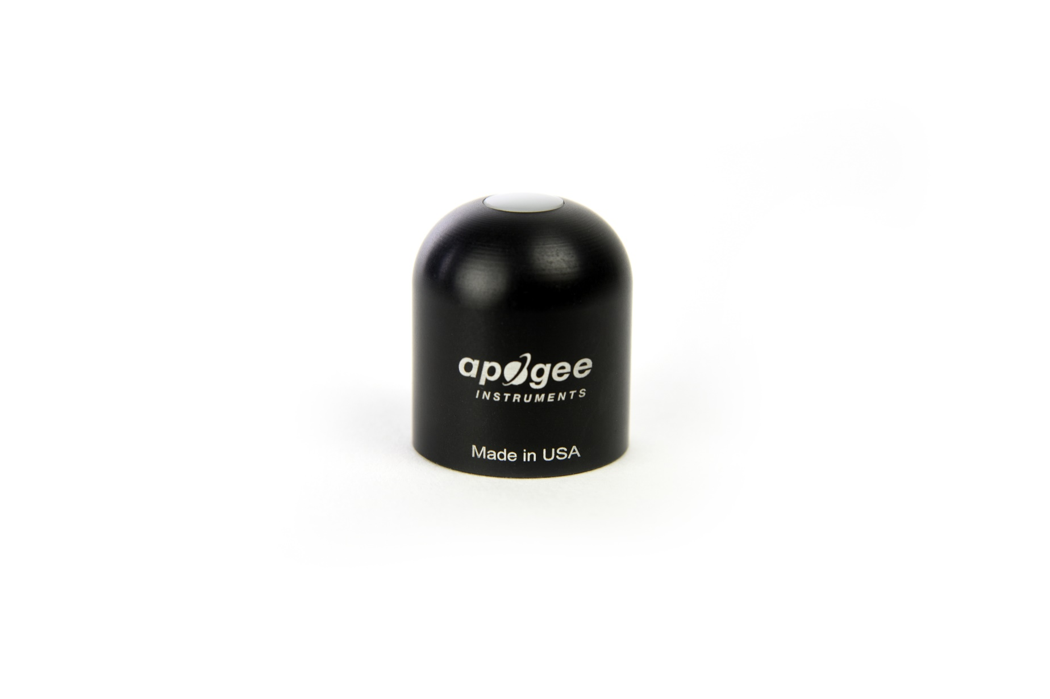

Table of Contents

[Owner’s Manual 1](#_Toc508805536)

[Certificate of Compliance 3](#_Toc508805537)

[Introduction 4](#_Toc508805538)

[Sensor Models 5](#_Toc508805539)

[Specifications 6](#_Toc508805540)

[Deployment and Installation 9](#_Toc508805541)

[Cable Connectors 10](#_Toc508805542)

[Operation and Measurement 10](#_Toc508805543)

[Maintenance and Recalibration 18](#_Toc508805544)

[Troubleshooting and Customer Support 20](#_Toc508805545)

[Return and Warranty Policy 21](#_Toc508805546)

### Certificate of Compliance

**EU Declaration of Conformity**

This declaration of conformity is issued under the sole responsibility of the manufacturer:

Apogee Instruments, Inc.  
721 W 1800 N  
Logan, Utah 84321  
USA

for the following product(s):

Models: SQ-421X

Type: Quantum Sensor

The object of the declaration described above is in conformity with the relevant Union harmonization legislation:

2014/30/EU Electromagnetic Compatibility (EMC) Directive

2011/65/EU Restriction of Hazardous Substances (RoHS 2) Directive

2015/863/EU Amending Annex II to Directive 2011/65/EU (RoHS 3)

Standards referenced during compliance assessment:

EN 61326-1:2013 Electrical equipment for measurement, control, and laboratory use – EMC requirements

EN 50581:2012 Technical documentation for the assessment of electrical and electronic products with respect to the restriction of hazardous substances

Please be advised that based on the information available to us from our raw material suppliers, the products manufactured by us do not contain, as intentional additives, any of the restricted materials including lead (see note below), mercury, cadmium, hexavalent chromium, polybrominated biphenyls (PBB), polybrominated diphenyls (PBDE), bis (2-ethylhexyl) phthalate (DEHP), butyl benzyl phthalate (BBP), dibutyl phthalate (DBP), and diisobutyl phthalate (DIBP). However, please note that articles containing greater than 0.1 % lead concentration are RoHS 3 compliant using exemption 6c.

Further note that Apogee Instruments does not specifically run any analysis on our raw materials or end products for the presence of these substances, but we rely on the information provided to us by our material suppliers.

Signed for and on behalf of:

Apogee Instruments, March 2022



Bruce Bugbee  
President  
Apogee Instruments, Inc.

### Introduction

Radiation that drives photosynthesis is called photosynthetically active radiation (PAR) and is typically defined as total radiation across a range of 400 to 700 nm. PAR is often expressed as photosynthetic photon flux density (PPFD): photon flux in units of micromoles per square meter per second (µmol m-2 s-1, equal to microEinsteins per square meter per second) summed from 400 to 700 nm (total number of photons from 400 to 700 nm). While Einsteins and micromoles are equal (one Einstein = one mole of photons), the Einstein is not an SI unit, so expressing PPFD as µmol m-2 s-1 is preferred.

The acronym PPF is also widely used and refers to the photosynthetic photon flux. The acronyms PPF and PPFD refer to the same variable. The two terms have co-evolved because there is not a universal definition of the term “flux”. Some physicists define flux as per unit area per unit time. Others define flux only as per unit time. We have used PPFD in this manual because we feel that it is better to be more complete and possibly redundant.

Sensors that measure PPFD are often called quantum sensors due to the quantized nature of radiation. A quantum refers to the minimum quantity of radiation, one photon, involved in physical interactions (e.g., absorption by photosynthetic pigments). In other words, one photon is a single quantum of radiation.

Typical applications of quantum sensors include incoming PPFD measurement over plant canopies in outdoor environments or in greenhouses and growth chambers and reflected or under-canopy (transmitted) PPFD measurement in the same environments.

Apogee Instruments SQ-421X-SS quantum sensors consist of a cast acrylic diffuser (filter), interference filter, photodiode, and signal processing circuitry mounted in an anodized aluminum housing, and a cable to connect the sensor to a measurement device. Sensors are potted solid with no internal air space and are designed for continuous PPFD measurement in indoor or outdoor environments. SQ-421X-SS model sensors output a digital signal using SDI-12 communication protocol.

### Sensor Models

This manual covers the SDI-12 communication protocol, quantum sensor model SQ-421X. Additional models are covered in their respective manuals.

|  |  |
| --- | --- |
| Model | Signal |
| SQ-421X | **SDI-12** |
| SQ-100X | Self-powered |
| SQ-202X | 0-2.5 V |
| SQ-204X | 4-20 mA |
| SQ-205X | 0-5 V |
| SQ-420X | USB |
| SQ-422X | ModBus |

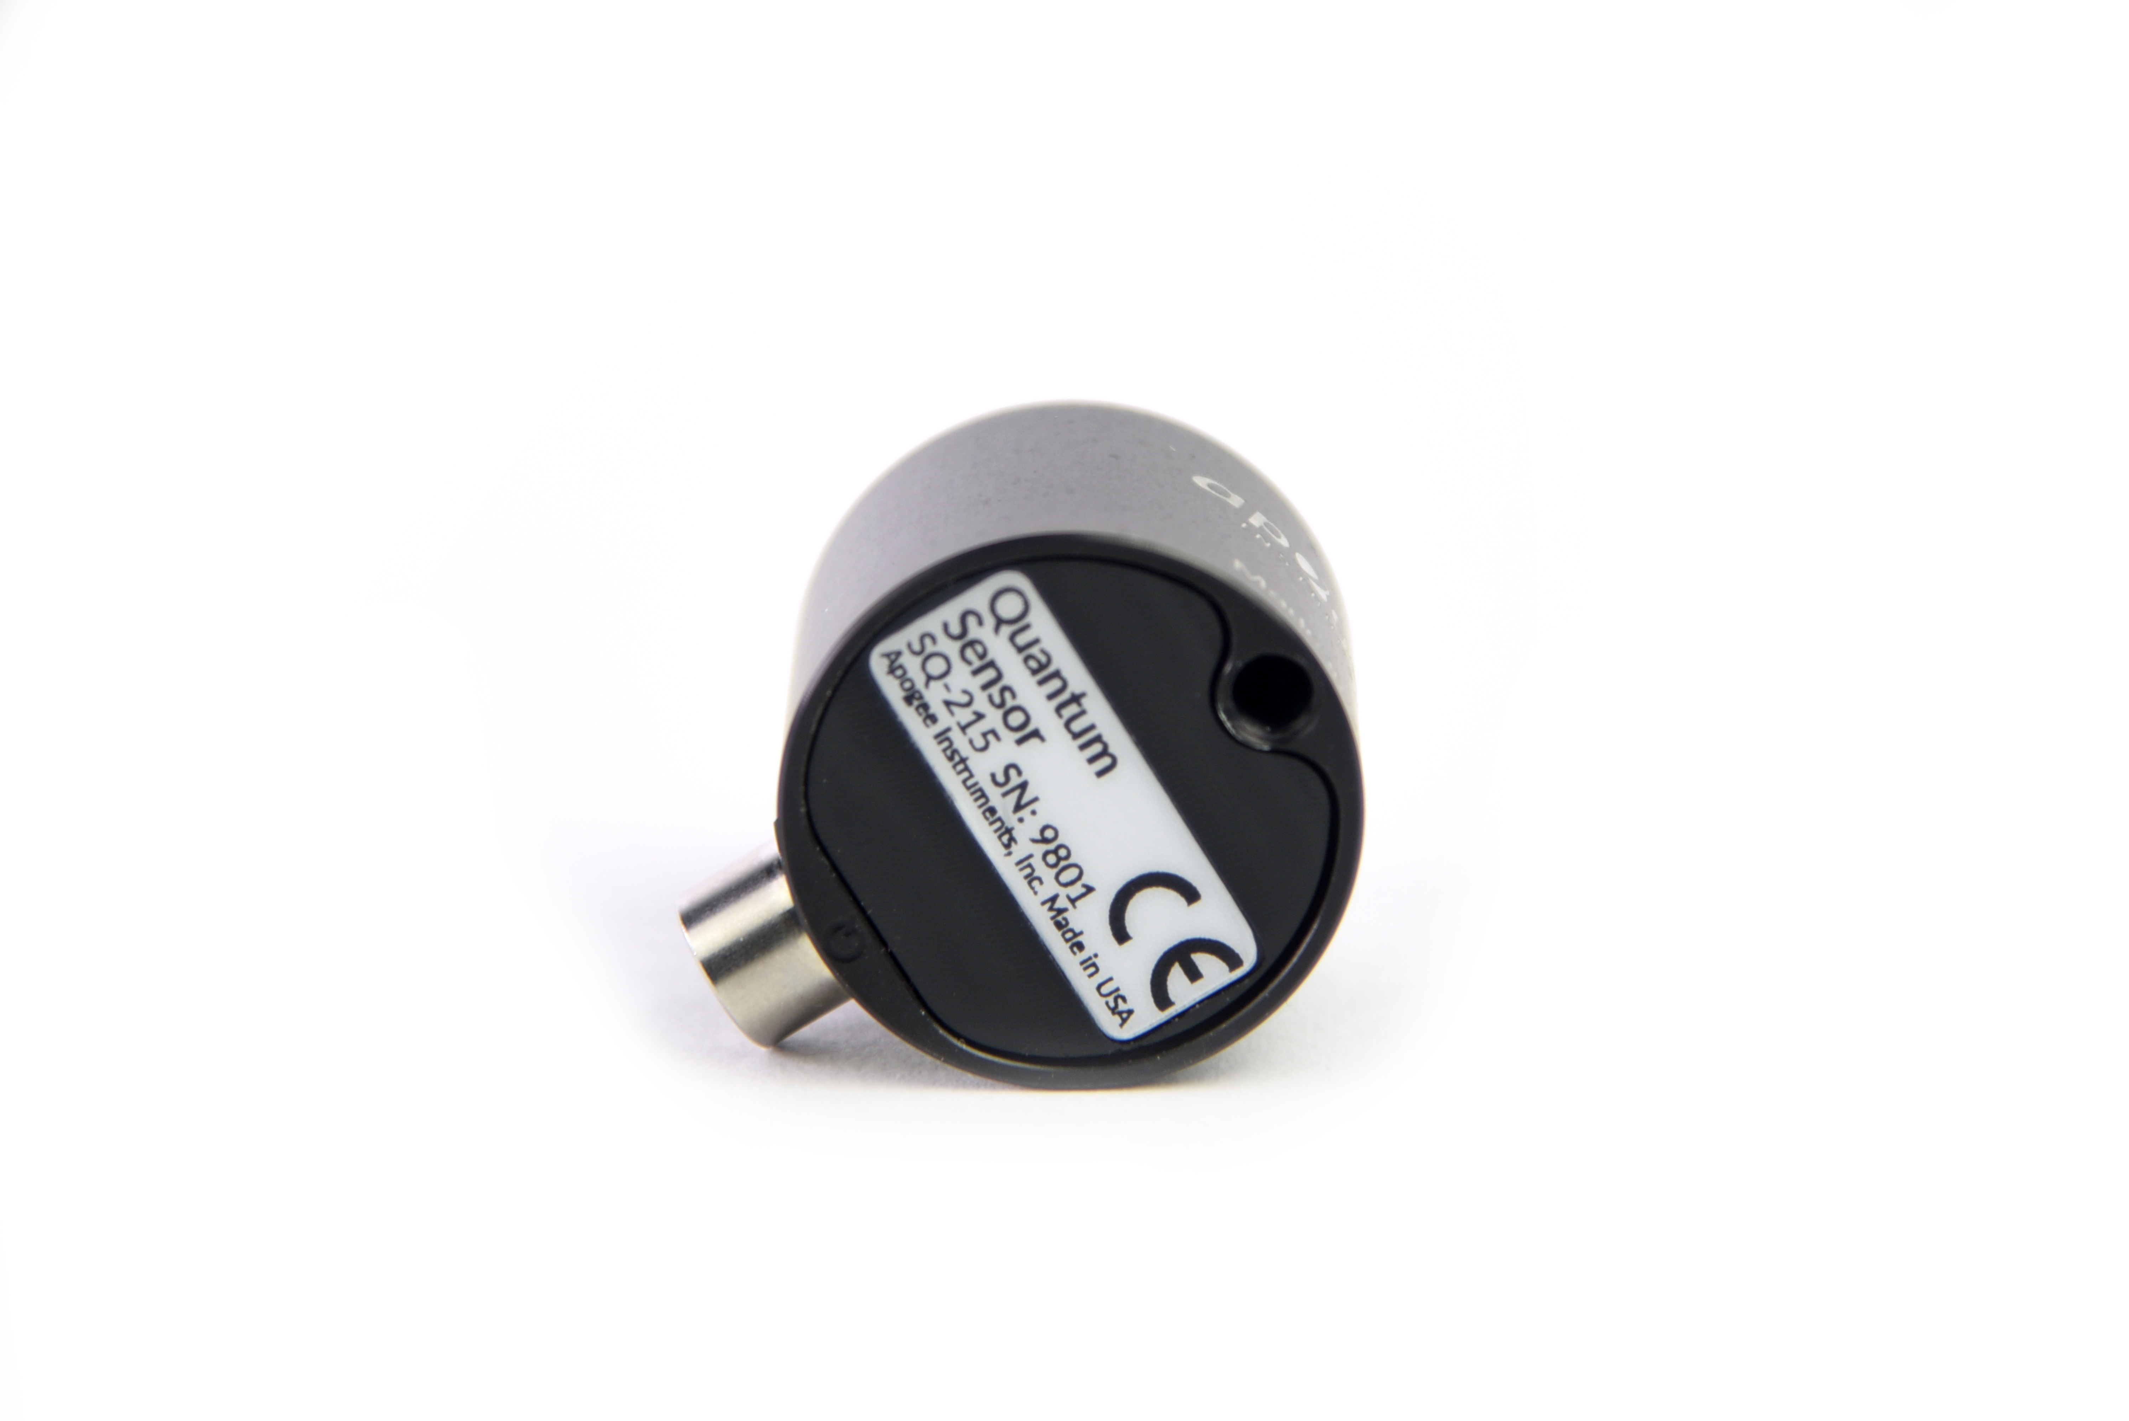

A sensor’s model number and serial number are located on the bottom of the sensor. If you need the manufacturing date of your sensor, please contact Apogee Instruments with the serial number of your sensor.

### Specifications

|  |  |
| --- | --- |
|  | **SQ-421X-SS** |
| Input Voltage Requirement | 5.5 to 24 V DC |
| Current Draw | 1.4 mA (quiescent), 1.8 mA (active) |
| Calibration Uncertainty | ± 5 % (see Calibration Traceability below) |
| Measurement Repeatability | Less than 1 % |
| Long-term Drift  (Non-stability) | Less than 2 % per year |
| Non-linearity | Less than 1 % (up to 2500 µmol m-2 s-1) |
| Response Time | 0.6 s, time for detector signal to reach 95 % following a step change; fastest data transmission rate for SDI-12 circuitry is 1 s |
| Field of View | 180° |
| Spectral Range | 370 to 650 nm (wavelengths where response is greater than 50 % of maximum; see Spectral Response below) |
| Directional (Cosine) Response | ± 5 % at 75° zenith angle (see Cosine Response below) |
| Temperature Response | 0.06 ± 0.06 % per C (see Temperature Response below) |
| Operating Environment | -40 to 70 C; 0 to 100 % relative humidity; can be submerged in water up to depths of 30 m |
| Dimensions | 30.5 mm diameter, 37 mm height |
| Mass (with 5 m cable) | 140 g |
| Cable | 5 m of two conductor, shielded, twisted-pair wire; TPR jacket (high water resistance, high UV stability, flexibility in cold conditions); pigtail lead wires; stainless steel (316), M8 connector |

**Calibration Traceability**

Apogee SQX series quantum sensors are calibrated through side-by-side comparison to the mean of transfer standard quantum sensors under a reference lamp. The reference quantum sensors are recalibrated with a 200 W quartz halogen lamp traceable to the National Institute of Standards and Technology (NIST).

**Spectral Response**

Mean spectral response of four SQ-100x series quantum sensors compared to PPFD weighting function. Spectral response measurements were made at 10 nm increments across a wavelength range of 350 to 800 nm in a monochromator with an attached electric light source. Measured spectral data from each quantum sensor were normalized by the measured spectral response of the monochromator/electric light combination, which was measured with a spectroradiometer.

**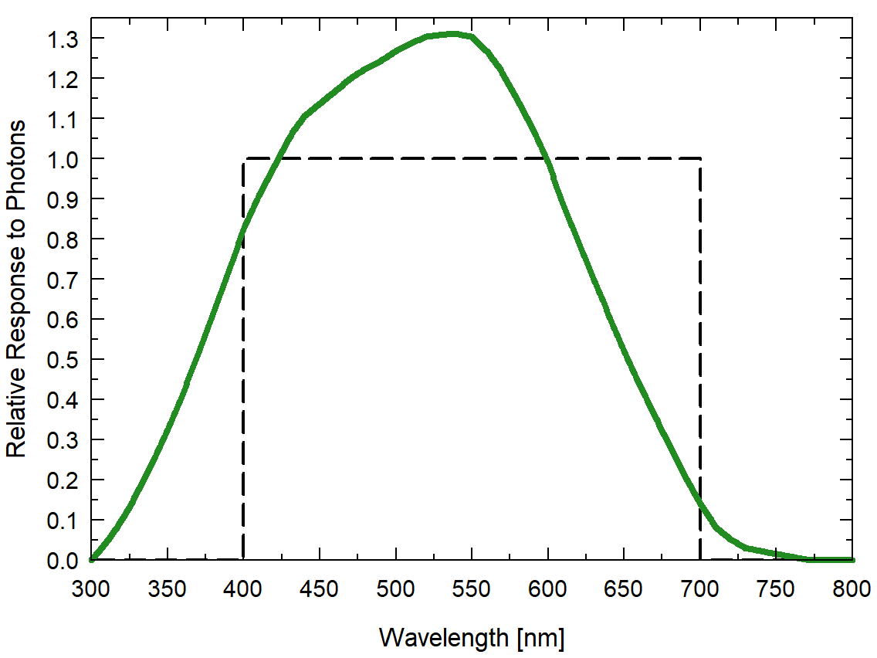**

**Cosine Response**

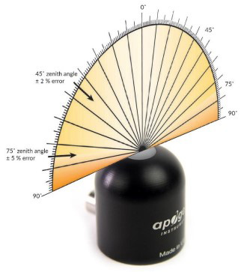

Directional (cosine) response is defined as the measurement error at a specific angle of radiation incidence. Error for Apogee SQ-100x series quantum sensors is approximately ± 2 % and ± 5 % at solar zenith angles of 45° and 75°, respectively.

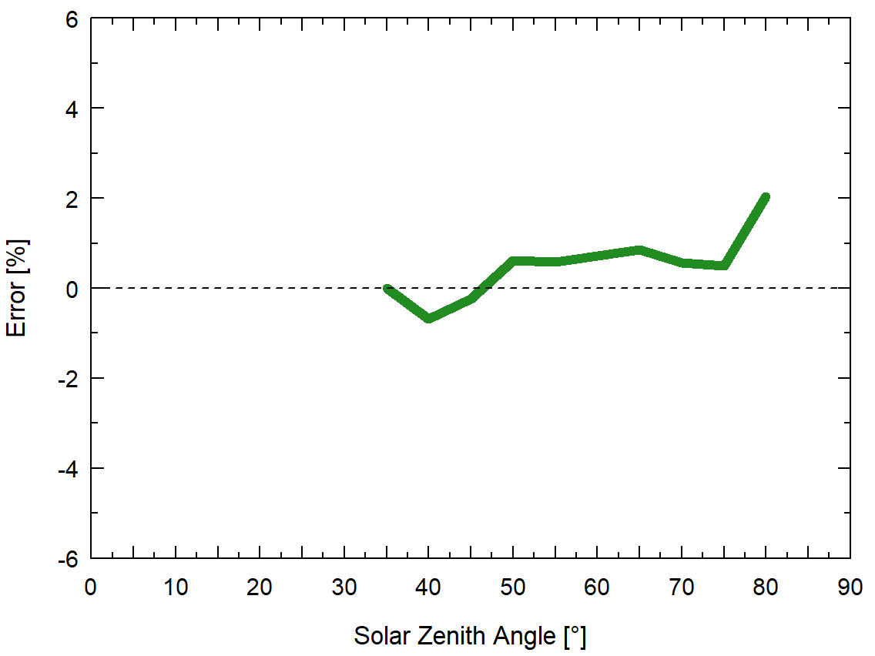

Mean cosine response of five SQ-100X series quantum sensors. Cosine response measurements were made by direct side-by-side comparison to the mean of seven reference SQ-500 quantum sensors.

### Deployment and Installation

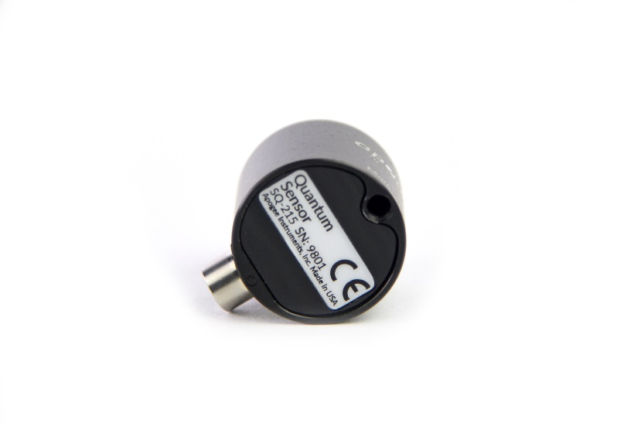 Mount the sensor to a solid surface with the nylon mounting screw provided. To accurately measure PPFD incident on a horizontal surface, the sensor must be level. An Apogee Instruments model AL-100 Leveling Plate is recommended to level the sensor when used on a flat surface or being mounted to surfaces such as wood. To facilitate mounting on a mast or pipe, the Apogee Instruments model AL-120 Solar Mounting Bracket with Leveling Plate is recommended.

C:\Users\emyers\AppData\Local\Microsoft\Windows\INetCache\Content.Word\screw.pngC:\Users\emyers\AppData\Local\Microsoft\Windows\INetCache\Content.Word\screw.png

Nylon Screw: 10-32 x 3/8

Nylon Screw: 10-32 x 3/8

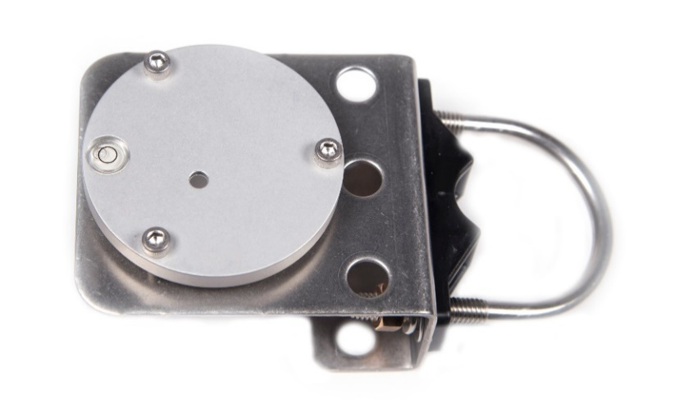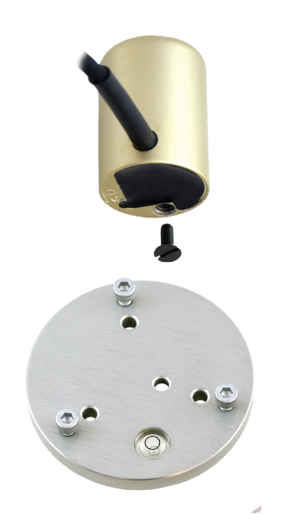

Model AL-120

Model AL-100

To minimize azimuth error, the sensor should be mounted with the cable pointing toward true north in the northern hemisphere or true south in the southern hemisphere. Azimuth error is typically less than 1 %, but it is easy to minimize by proper cable orientation.

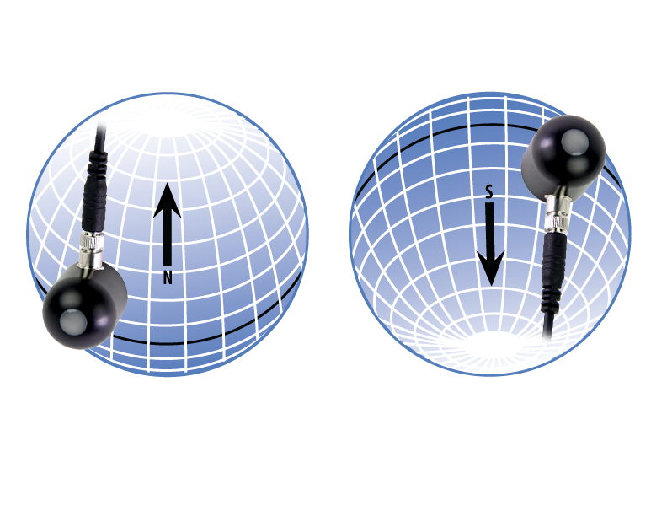

In addition to orienting the cable to point toward the nearest pole, the sensor should also be mounted such that obstructions (e.g., weather station tripod/tower or other instrumentation) do not shade the sensor. **Once mounted, the blue cap should be removed from the sensor.** The blue cap can be used as a protective covering for the sensor when it is not in use.

### Cable Connectors

|  |  |
| --- | --- |
| Apogee sensors offer cable connectors to simplify the process of removing sensors from weather stations for calibration (the entire cable does **not** have to be removed from the station and shipped with the sensor).  The ruggedized M8 connectors are rated IP68, made of corrosion-resistant marine-grade stainless-steel, and designed for extended use in harsh environmental conditions. | DSC_2828  Cable connectors are attached directly to the head. |

**Instructions**

|  |  |
| --- | --- |
| **Pins and Wiring Colors:** All Apogee connectors have six pins, but not all pins are used for every sensor. There may also be unused wire colors inside the cable. To simplify datalogger connection, we remove the unused pigtail lead colors at the datalogger end of the cable.  If a replacement cable is required, please contact Apogee directly to ensure ordering the proper pigtail configuration.  **Alignment:** When reconnecting a sensor, arrows on the connector jacket and an aligning notch ensure proper orientation.  **Disconnection for extended periods:**  When disconnecting the sensor for an extended period of time from a station, protect the remaining half of the connector still on the station from water and dirt with electrical tape or other method. | A reference notch inside the connector ensures  proper alignment before tightening.  DSC_3034  When sending sensors in for calibration, only send the sensor head. |
| **Tightening:** Connectors are designed to be firmly finger-tightened only. There is an o-ring inside the connector that can be overly compressed if a wrench is used. Pay attention to thread alignment to avoid cross-threading. When fully tightened, 1-2 threads may still be visible.  **WARNING:** Do **not** tighten the connector by twisting the black cable or sensor head, only twist the metal connector (blue arrows). | silicon-pyranometer-warning  Finger-tighten firmly |

### Operation and Measurement

The SQ-421X quantum sensor has a SDI-12 output, where shortwave radiation is returned in digital format. Measurement of SQ-421X quantum sensors requires a measurement device with SDI-12 functionality that includes the M or C command.

**Wiring for SQ-421X**

**White**: SDI-12 Data Line

**Red**: Power In (5.5-24 V DC)

**Black**: Ground

**Clear**: Shield/Ground

**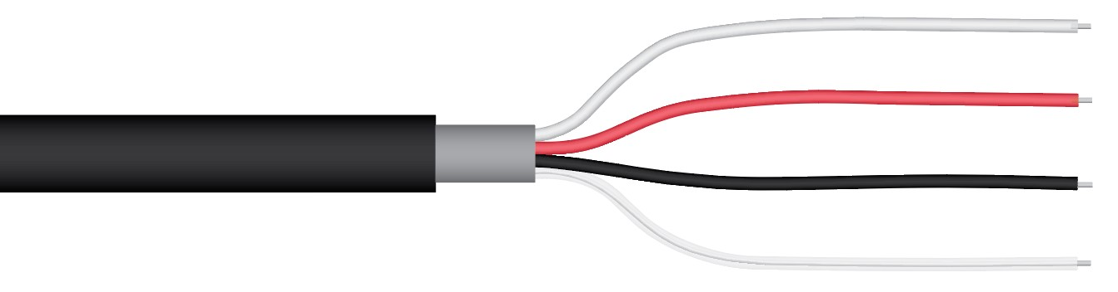**

**Sensor Calibration**

All Apogee SDI-12 quantum sensor models (SQ-400X series) have sensor-specific calibration coefficients determined during the custom calibration process. Coefficients are programmed into the microcontrollers at the factory.

**SDI-12 Interface**

The following is a brief explanation of the serial digital interface SDI-12 protocol instructions used in Apogee SQ-421X quantum sensors. For questions on the implementation of this protocol, please refer to the official version of the SDI-12 protocol: <http://www.sdi-12.org/specification.php> (version 1.4, August 10, 2016).

**Overview**

During normal communication, the data recorder sends a packet of data to the sensor that consists of an address and a command. Then, the sensor sends a response. In the following descriptions, SDI-12 commands and responses are enclosed in quotes. The SDI-12 address and the command/response terminators are defined as follows:

**Sensors come from the factory with the address of “0” for use in single sensor systems. Addresses “1 to 9” and “A to Z”, or “a to z”, can be used for additional sensors connected to the same SDI-12 bus.**

“!” is the last character of a command instruction. In order to be compliant with SDI-12 protocol, all commands must be terminated with a “!”. SDI-12 language supports a variety of commands. Supported commands for the Apogee Instruments SP-521 quantum sensors are listed in the following table (“a” is the sensor address. The following ASCII Characters are valid addresses: “0-9” or “A-Z”).

**Supported Commands for Apogee Instruments SQ-421X Quantum Sensors**

|  |  |  |
| --- | --- | --- |
| **Instruction Name** | **Instruction Syntax** | **Description** |
| Acknowledge Active Command | a! | Responds if the sensor with address a is on the line |
| Send Identification Command | aI! | Responds with sensor information |
| Measurement Command | aM! | Tells the sensor to take a measurement |
| Measurement Command w/ Check Character | aMC! | Tells the sensor to take a measurement and return it with a check character |
| Change Address Command | aAb! | Changes the sensor address from a to b |
| Concurrent Measurement Command | aC! | Used to take a measurement when more than one sensor is used on the same data line |
| Concurrent Measurement Command w/ Check Character | aCC! | Used to take a measurement when more than one sensor is used on the same data line. Data is returned with a check character. |
| Address Query Command | ?! | Used when the address is unknown to have the sensor identify its address, all sensors on data line respond |
| Get Data Command | aD0! | Retrieves the data from a sensor |
| Verification Command | aV! | Returns sensor coefficients as multiplier, offset, solar multiplier, and immersion effect correction factor |
| Running Average Command | aXAVG! | Returns or sets the running average for sensor measurements. |

**Make Measurement Command: M!**

The make measurement command signals a measurement sequence to be performed. Data values generated in response to this command are stored in the sensor's buffer for subsequent collection using “D” commands. Data will be retained in sensor storage until another “M”, “C”, or “V” command is

executed. M commands are shown in the following examples:

|  |  |  |
| --- | --- | --- |
| **Command** | **Response** | **Response to 0D0!** |
| aM! or aM0! | a0011<cr><If> | Returns µmol m-2 s-1 |
| aM1! | a0011<cr><If> | Returns millivolt output |
| aM2! | a0011<cr><If> | Returns µmol m-2 s-1 |
| aM3! | a0011<cr><If> | Returns immersed µmol m-2 s-1 for underwater measurements |
| aM4! | a0011<cr><If> | Returns angle offset from vertical in degrees. (0 degrees if pointed up, 180 degrees if pointed down.) Available in sensors with serial number 3033 or greater. |
| aMC! or aMC0! | a0011<cr><If> | Returns µmol m-2 s-1 w/CRC |
| aMC1! | a0011<cr><If> | Returns millivolt output w/ CRC |
| aMC2! | a0011<cr><If> | Returns µmol m-2 s-1 w/ CRC |
| aMC3! | a0011<cr><If> | Returns immersed µmol m-2 s-1 for underwater measurements w/ CRC |
| aMC4! | a0011<cr><If> | Returns angle offset from vertical in degrees w/CRC. (0 degrees if pointed up, 180 degrees if pointed down.) Available in sensors with serial numbers 3033 or greater. |

where a is the sensor address (“0-9”, “A-Z”, “a-z”) and M is an upper-case ASCII character.

The data values are separated by the sign “+”, as in the following example (0 is the address):

|  |  |  |
| --- | --- | --- |
| **Command** | **Sensor Response** | **Sensor Response when data is ready** |
| 0M0! | 00011<cr><lf> | 0<cr><lf> |
| 0D0! | 0+2000.0<cr><lf> |  |
| 0M1! | 00011<cr><lf> | 0<cr><lf> |
| 0D0! | 0+400.0<cr><lf> |  |
| 0M2! | 00011<cr><If> | 0<cr><If> |
| 0D0! | 0+2000.0<cr><If> |  |
| 0M3! | 00011<cr><If> | 0<cr><If> |
| 0D0! | 0+2000.0<cr><If> |  |
| 0M4! | a0011<cr><If> | 0<cr><lf> |
| 0D0! | 0+90.2<cr><lf> |  |

where 2000.0 is µmol m-2 s-1.

**Concurrent Measurement Command: aC!**

A concurrent measurement is one which occurs while other SDI-12 sensors on the bus are also making measurements. This command is similar to the “aM!” command, however, the nn field has an extra digit and the sensor does not issue a service request when it has completed the measurement. Communicating with other sensors will NOT abort a concurrent measurement. Data values generated in response to this command are stored in the sensor's buffer for subsequent collection using “D” commands. The data will be retained in the sensor until another “M”, “C”, or “V” command is executed:

|  |  |  |
| --- | --- | --- |
| **Command** | **Response** | **Response to 0D0!** |
| aC! or aC0! | a00101<cr><lf> | Returns µmol m-2 s-1 |
| aC1! | a00101<cr><lf> | Returns millivolt output |
| aC2! | a00101<cr><lf> | Returns µmol m-2 s-1 |
| aC3! | a00101<cr><lf> | Returns immersed µmol m-2 s-1 for underwater measurements |
| aC4! | a00101<cr><lf> | Returns angle offset from vertical in degrees. (0 degrees if pointed up, 180 degrees if pointed down.) Available in sensors with serial number 3033 or greater. |
| aCC! or aCC0! | a00101<cr><lf> | Returns µmol m-2 s-1 w/CRC |
| aCC1! | a00101<cr><lf> | Returns millivolt output w/ CRC |
| aCC2! | a00101<cr><lf> | Returns µmol m-2 s-1 w/ CRC |
| aCC3! | a00101<cr><lf> | Returns immersed µmol m-2 s-1 for underwater measurements w/ CRC |
| aCC4! | a00101<cr><lf> | Returns angle offset from vertical in degrees w/CRC. (0 degrees if pointed up, 180 degrees if pointed down.) Available in sensors with serial numbers 3033 or greater. |

where a is the sensor address (“0-9”, “A-Z”, “a-z”, “\*”, “?”) and C is an upper-case ASCII character.

For example (0 is the address):

|  |  |
| --- | --- |
| **Command** | **Sensor Response** |
| 0C0! | 000101<cr><lf> |
| 0D0! | 0+2000.0<cr><lf> |
| 0C1! | 000101<cr><If> |
| 0D0! | 0+400.0<cr><If> |
| 0C2! | 000101<cr><lf> |
| 0D0! | 0+2000.0<cr><lf> |
| 0C3! | 000101<cr><If> |
| 0D0! | 0+2000.0<cr><If> |
| 0C4! | 000101<cr><If> |
| 0D0! | 0+90.2<cr><lf> |

where 2000.0 is µmol m-2 s-1 and 400.0 is mV.

**Change Sensor Address: aAb!**

The change sensor address command allows the sensor address to be changed. If multiple SDI-12 devices are on the same bus, each device will require a unique SDI-12 address. For example, two SDI-12 sensors with the factory address of 0 requires changing the address on one of the sensors to a non-zero value in order for both sensors to communicate properly on the same channel:

|  |  |  |
| --- | --- | --- |
| **Command** | **Response** | **Description** |
| aAb! | b<cr><lf> | Change the address of the sensor |

where a is the current (old) sensor address (“0-9”, “A-Z”), A is an upper-case ASCII character denoting the instruction for changing the address, b is the new sensor address to be programmed (“0-9”, “A-Z”), and ! is the standard character to execute the command. If the address change is successful, the datalogger will respond with the new address and a <cr><lf>.

**Send Identification Command: aI!**

The send identification command responds with sensor vendor, model, and version data. Any measurement data in the sensor's buffer is not disturbed:

|  |  |  |
| --- | --- | --- |
| **Command** | **Response** | **Description** |
| "aI!" | a13Apogee SQ-421Xvvvxx…xx<cr><lf> | The sensor serial number and other identifying values are returned |

where a is the sensor address (“0-9”, “A-Z”, “a-z”, “\*”, “?”), 421X is the sensor model number, vvv is a three-character field specifying the sensor version number, and xx...xx is serial number.

**Running Average Command**

The running average command can be used to set or query the number of measurements that are averaged together before returning a value from a M! or MC! command. For example, if a user sends the command “0XAVG10!” to sensor with address 0, that sensor will average 10 measurements before sending the averaged value to the logger. To turn off averaging, the user should send the command “*a*XAVG1” to the sensor. To query the sensor to see how many measurements are being averaged, send the command “*a*XAVG!” and the sensor will return the number of measurements being averaged (see table below). The default for sensors is to have averaging turned off.

|  |  |  |  |
| --- | --- | --- | --- |
| **Command Name** | **Characters Sent** | **Response** | **Description** |
| Query running Average | *a*XAVG! | *an* | a = sensor address, *n* = number of measurements used in average calculation. Note: *n* may be multiple digits. |
| Set running Average | *a*XAVG*n!* | *a* | a = sensor address, *n* = number of measurements to be used in average calculation. Note: *n* may be any value from 1 to 100. |

**Spectral Errors**

Apogee SQ-100X series sensors can measure PPFD for sunlight and electric light with a single calibration factor. However, errors occur in various light sources due to changes in spectral output. If the light source spectrum is known, then errors can be estimated and used to adjust the measurements. The weighting function for PPFD is shown in the graph below, along with the spectral response of Apogee SQ-100X series quantum sensors. The closer the spectral response matches the defined PPFD spectral weighting functions, the smaller spectral errors will be. The table below provides spectral error estimates for PPFD measurements from light sources different than the calibration source. The method of Federer and Tanner (1966) was used to determine spectral errors based on the PPFD spectral weighting functions, measured sensor spectral response, and radiation source spectral outputs (measured with a spectroradiometer). This method calculates spectral error and does not consider calibration, cosine, and temperature errors.

Federer, C. A., and C. B. Tanner, 1966. Sensors for measuring light available for photosynthesis. Ecology 47:654-657.

McCree, K. J., 1972. The action spectrum, absorptance and quantum yield of photosynthesis in crop plants. Agricultural Meteorology 9:191-216.

**Spectral Errors for PPFD Measurements with Apogee SQ-100X Series Quantum Sensors**

|  |  |
| --- | --- |
| **Radiation Source (Error Calculated Relative to Sun, Clear Sky)** | **PPFD Error [%]** |
| Sun (Clear Sky) | 0.0 |
| Sun (Cloudy Sky) | 0.2 |
| Reflected from Grass Canopy | 5.0 |
| Reflected from Deciduous Canopy | 7.0 |
| Reflected from Conifer Canopy | 7.3 |
| Transmitted below Grass Canopy | 8.3 |
| Transmitted below Deciduous Canopy | 8.4 |
| Transmitted below Conifer Canopy | 10.1 |
| Cool White Fluorescent (T5) | 7.2 |
| Cool White Fluorescent (T12) | 8.3 |
| Metal Halide | 6.9 |
| Ceramic Metal Halide | -0.9 |
| High Pressure Sodium | 3.2 |
| Blue LED (448 nm peak, 20 nm full-width half-maximum) | 14.5 |
| Green LED (524 nm peak, 30 nm full-width half-maximum) | 29.6 |
| Red LED (635 nm peak, 20 nm full-width half-maximum) | -30.9 |
| Red, Blue LED Mixture (80 % Red, 20 % Blue) | -21.2 |
| Red, Green, Blue LED Mixture (70 % Red, 15 % Green, 15 % Blue) | -16.4 |
| Cool White Fluorescent LED | 7.3 |
| Neutral White Fluorescent LED | 1.1 |
| Warm White Fluorescent LED | -7.8 |

Quantum sensors can be a very practical means of measuring PPFD from multiple radiation sources, but spectral errors must be considered. The spectral errors in the table above can be used as correction factors for individual radiation sources.

**Underwater Measurements and Immersion Effect**

When a quantum sensor that was calibrated in air is used to make underwater measurements, the sensor reads low. This phenomenon is called the immersion effect and happens because the refractive index of water (1.33) is greater than air (1.00). The higher refractive index of water causes more light to be backscattered (or reflected) out of the sensor in water than in air (Smith,1969; Tyler and Smith,1970). As more light is reflected, less light is transmitted through the diffuser to the detector, which causes the sensor to read low. Without correcting for this effect, underwater measurements are only relative, which makes it difficult to compare light in different environments.

The SQ-100X series sensors have an immersion effect correction factor of 1.15. This correction factor should be multiplied to measurements made underwater.

Further information on underwater measurements and the immersion effect can be found at <http://www.apogeeinstruments.com/underwater-par-measurements/>

### Maintenance and Recalibration

Blocking of the optical path between the target and detector can cause low readings. Occasionally, accumulated materials on the diffuser of the upward-looking sensor can block the optical path in three common ways:

1. Moisture or debris on the diffuser.
2. Dust during periods of low rainfall.
3. Salt deposit accumulation from evaporation of sea spray or sprinkler irrigation water.

Apogee Instruments upward-looking sensors have a domed diffuser and housing for improved self-cleaning from rainfall, but active cleaning may be necessary. Dust or organic deposits are best removed using water, or window cleaner, and a soft cloth or cotton swab. Salt deposits should be dissolved with vinegar and removed with a cloth or cotton swab. **Salt deposits cannot be removed with solvents such as alcohol or acetone.** Use only gentle pressure when cleaning the diffuser with a cotton swab or soft cloth to avoid scratching the outer surface. The solvent should be allowed to do the cleaning, not mechanical force. **Never use abrasive material or cleaner on the diffuser.**

Although Apogee sensors are very stable, nominal calibration drift is normal for all research-grade sensors. To ensure maximum accuracy, recalibration every two years is recommended. Longer time periods between recalibration may be warranted depending on tolerances. See the Apogee webpage for details regarding return of sensors for recalibration (<http://www.apogeeinstruments.com/tech-support-recalibration-repairs/>).

To determine if your sensor needs recalibration, the Clear Sky Calculator ([www.clearskycalculator.com](http://www.clearskycalculator.com)) website and/or smartphone app can be used to indicate the PPFD incident on a horizontal surface at any time of day at any location in the world. It is most accurate when used near solar noon in spring and summer months, where accuracy over multiple clear and unpolluted days is estimated to be ± 4 % in all climates and locations around the world. For best accuracy, the sky must be completely clear, as reflected light from clouds causes PPFD to increase above the value predicted by the clear sky calculator. Measured values of PPFD can exceed values predicted by the Clear Sky Calculator due to reflection from thin, high clouds and edges of clouds, which enhances incoming PPFD. The influence of high clouds typically shows up as spikes above clear sky values, not a constant offset greater than clear sky values.

To determine recalibration need, input site conditions into the calculator and compare PPFD measurements to calculated values for a clear sky. If sensor PPFD measurements over multiple days near solar noon are consistently different than calculated values (by more than 6 %), the sensor should be cleaned and re-leveled. If measurements are still different after a second test, email [calibration@apogeeinstruments.com](mailto:calibration@apogeeinstruments.com) to discuss test results and possible return of sensor(s).

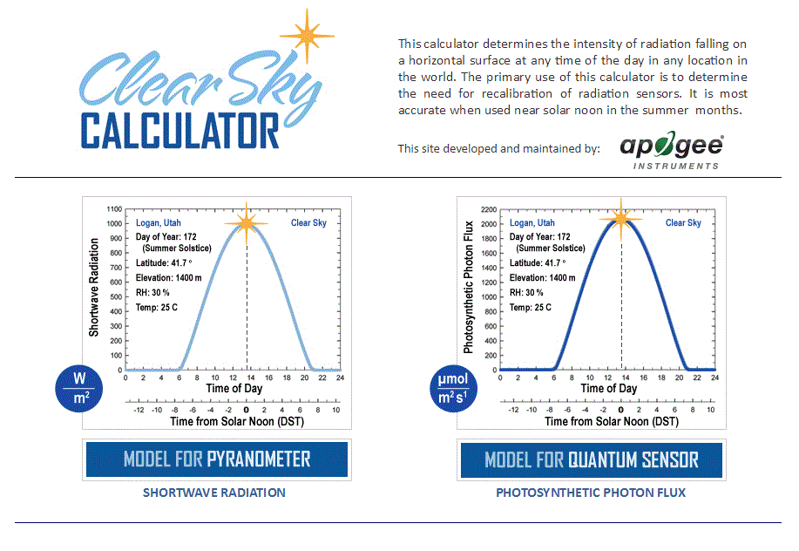

Homepage of the Clear Sky Calculator. Two calculators are available: one for quantum sensors (PPFD) and one for pyranometers (total shortwave radiation).

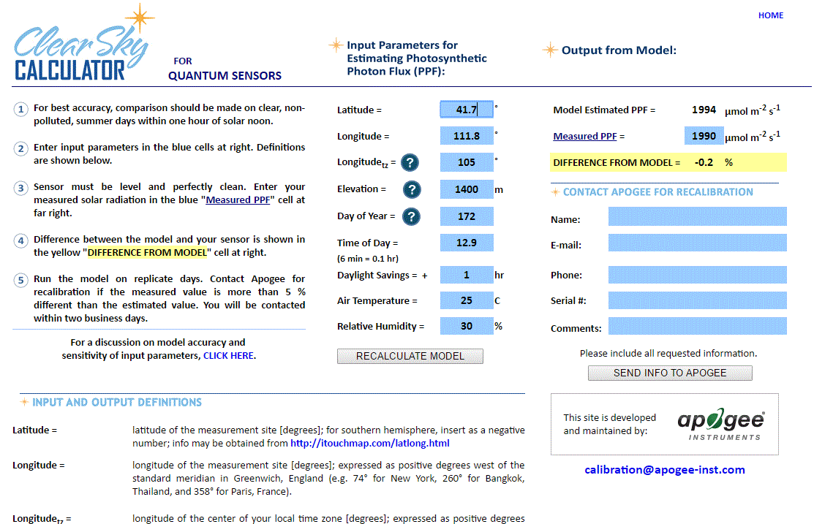

Clear Sky Calculator for quantum sensors. Site data are input in blue cells in middle of page and an estimate of PPFD is returned on right-hand side of page.

### Troubleshooting and Customer Support

**Independent Verification of Functionality**

If the sensor does not communicate with the datalogger, use an ammeter to check the current draw. It should be near 1.4 mA when the sensor is not communicating and spike to approximately 1.8 mA when the sensor is communicating. Any current draw greater than approximately 6 mA indicates a problem with power supply to the sensors, wiring of the sensor, or sensor electronics.

**Compatible Measurement Devices (Dataloggers/Controllers/Meters)**

Any datalogger or meter with SDI-12 functionality that includes the M or C command.

An example datalogger program for Campbell Scientific dataloggers can be found on the Apogee webpage at <https://www.apogeeinstruments.com/datalogger/#downloads>.

**Modifying Cable Length**

SDI-12 protocol limits cable length to 60 meters. For multiple sensors connected to the same data line, the maximum is 600 meters of total cable (e.g., ten sensors with 60 meters of cable per sensor). See Apogee webpage for details on how to extend sensor cable length (<http://www.apogeeinstruments.com/how-to-make-a-weatherproof-cable-splice/>).

**Unit Conversion Charts**

Apogee SQX series quantum sensors are calibrated to measure PPFD in units of µmol m-2 s-1. Units other than photon flux density (e.g., energy flux density, illuminance) may be required for certain applications. It is possible to convert the PPFD value from a quantum sensor to other units, but it requires spectral output of the radiation source of interest. Conversion factors for common radiation sources can be found in the Unit Conversions page of the Support Center on the Apogee website (<http://www.apogeeinstruments.com/unit-conversions/>). A spreadsheet to convert PPFD to energy flux density or illuminance is also provided in the in the Unit Conversions page of the Support Center on the Apogee website (<http://www.apogeeinstruments.com/content/PPFD-to-Illuminance-Calculator.xls>).

### Return and Warranty Policy

RETURN POLICY

Apogee Instruments will accept returns within 30 days of purchase as long as the product is in new condition (to be determined by Apogee). Returns are subject to a 10 % restocking fee.

WARRANTY POLICY

**What is Covered**All products manufactured by Apogee Instruments are warranted to be free from defects in materials and craftsmanship for a period of four (4) years from the date of shipment from our factory. To be considered for warranty coverage an item must be evaluated by Apogee.

Products not manufactured by Apogee (spectroradiometers, chlorophyll content meters, EE08-SS probes) are covered for a period of one (1) year.

**What is Not Covered**The customer is responsible for all costs associated with the removal, reinstallation, and shipping of suspected warranty items to our factory.

The warranty does not cover equipment that has been damaged due to the following conditions:

1. Improper installation, use, or abuse.

2. Operation of the instrument outside of its specified operating range.

3. Natural occurrences such as lightning, fire, etc.

4. Unauthorized modification.

5. Improper or unauthorized repair.

Please note that nominal accuracy drift is normal over time. Routine recalibration of sensors/meters is considered part of proper maintenance and is not covered under warranty.

**Who is Covered**This warranty covers the original purchaser of the product or other party who may own it during the warranty period.

**What Apogee Will Do**At no charge Apogee will:

1. Either repair or replace (at our discretion) the item under warranty.

2. Ship the item back to the customer by the carrier of our choice.

Different or expedited shipping methods will be at the customer’s expense.

**How To Return An Item**1. Please do not send any products back to Apogee Instruments until you have received a Return Merchandise Authorization (RMA) number from our technical support department by submitting an online RMA form at [www.apogeeinstruments.com/tech-support-recalibration-repairs/](http://www.apogeeinstruments.com/tech-support-recalibration-repairs/). We will use your RMA number for tracking of the service item. Call (435) 245-8012 or email techsupport@apogeeinstruments.com with questions.

2. For warranty evaluations, send all RMA sensors and meters back in the following condition: Clean the sensor’s exterior and cord. Do not modify the sensors or wires, including splicing, cutting wire leads, etc. If a connector has been attached to the cable end, please include the mating connector – otherwise the sensor connector will be removed in order to complete the repair/recalibration. ***Note:*** *When sending back sensors for routine calibration that have Apogee’s standard stainless-steel connectors, you only need to send the sensor with the 30 cm section of cable and one-half of the connector. We have mating connectors at our factory that can be used for calibrating the sensor.*

3. Please write the RMA number on the outside of the shipping container.

4. Return the item with freight pre-paid and fully insured to our factory address shown below. We are not responsible for any costs associated with the transportation of products across international borders.

**Apogee Instruments, Inc.   
721 West 1800 North Logan, UT  
84321, USA**

5. Upon receipt, Apogee Instruments will determine the cause of failure. If the product is found to be defective in terms of operation to the published specifications due to a failure of product materials or craftsmanship, Apogee Instruments will repair or replace the items free of charge. If it is determined that your product is not covered under warranty, you will be informed and given an estimated repair/replacement cost.

Products Beyond the Warranty Period

For issues with sensors beyond the warranty period, please contact Apogee at [techsupport@apogeeinstruments.com](mailto:techsupport@apogeeinstruments.com) to discuss repair or replacement options.

Other Terms

The available remedy of defects under this warranty is for the repair or replacement of the original product, and Apogee Instruments is not responsible for any direct, indirect, incidental, or consequential damages, including but not limited to loss of income, loss of revenue, loss of profit, loss of data, loss of wages, loss of time, loss of sales, accruement of debts or expenses, injury to personal property, or injury to any person or any other type of damage or loss.

This limited warranty and any disputes arising out of or in connection with this limited warranty ("Disputes") shall be governed by the laws of the State of Utah, USA, excluding conflicts of law principles and excluding the Convention for the International Sale of Goods. The courts located in the State of Utah, USA, shall have exclusive jurisdiction over any Disputes.

This limited warranty gives you specific legal rights, and you may also have other rights, which vary from state to state and jurisdiction to jurisdiction, and which shall not be affected by this limited warranty. This warranty extends only to you and cannot by transferred or assigned. If any provision of this limited warranty is unlawful, void, or unenforceable, that provision shall be deemed severable and shall not affect any remaining provisions. In case of any inconsistency between the English and other versions of this limited warranty, the English version shall prevail.

This warranty cannot be changed, assumed, or amended by any other person or agreement.

**APOGEE INSTRUMENTS, INC. |** 721 WEST 1800 NORTH, LOGAN, UTAH 84321, USA

TEL: (435) 792-4700 | FAX: (435) 787-8268 | WEB: APOGEEINSTRUMENTS.COM

*Copyright © 2022 Apogee Instruments, Inc.*