

# Owner’s Manual

USB quantum Sensor

Model SQ-420X

Rev: 30-Mar-2022

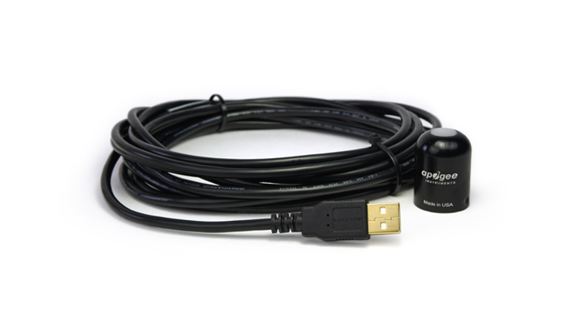

Table of Contents

Owner’s Manual 1

Certificate of Compliance 3

Introduction 4

Sensor Models 5

Specifications 6

Deployment and Installation 9

Software Installation 10

Operation and Measurement 11

Windows Software 13

Mac Software 18

Maintenance and Recalibration 24

Troubleshooting and Customer Support 26

Return and Warranty Policy 27

### Certificate of Compliance

**EU Declaration of Conformity**

This declaration of conformity is issued under the sole responsibility of the manufacturer:

Apogee Instruments, Inc.  
721 W 1800 N  
Logan, Utah 84321  
USA

for the following product(s):

Models: SQ-420X

Type: Quantum Sensor

The object of the declaration described above is in conformity with the relevant Union harmonization legislation:

2014/30/EU Electromagnetic Compatibility (EMC) Directive

2011/65/EU Restriction of Hazardous Substances (RoHS 2) Directive

2015/863/EU Amending Annex II to Directive 2011/65/EU (RoHS 3)

Standards referenced during compliance assessment:

EN 61326-1:2013 Electrical equipment for measurement, control, and laboratory use – EMC requirements

EN 50581:2012 Technical documentation for the assessment of electrical and electronic products with respect to the restriction of hazardous substances

Please be advised that based on the information available to us from our raw material suppliers, the products manufactured by us do not contain, as intentional additives, any of the restricted materials including lead (see note below), mercury, cadmium, hexavalent chromium, polybrominated biphenyls (PBB), polybrominated diphenyls (PBDE), bis (2-ethylhexyl) phthalate (DEHP), butyl benzyl phthalate (BBP), dibutyl phthalate (DBP), and diisobutyl phthalate (DIBP). However, please note that articles containing greater than 0.1 % lead concentration are RoHS 3 compliant using exemption 6c.

Further note that Apogee Instruments does not specifically run any analysis on our raw materials or end products for the presence of these substances, but we rely on the information provided to us by our material suppliers.

Signed for and on behalf of:

Apogee Instruments, March 2022



Bruce Bugbee  
President  
Apogee Instruments, Inc.

### Introduction

Radiation that drives photosynthesis is called photosynthetically active radiation (PAR) and is typically defined as total radiation across a range of 400 to 700 nm. PAR is often expressed as photosynthetic photon flux density (PPFD): photon flux in units of micromoles per square meter per second (µmol m-2 s-1, equal to microEinsteins per square meter per second) summed from 400 to 700 nm (total number of photons from 400 to 700 nm). While Einsteins and micromoles are equal (one Einstein = one mole of photons), the Einstein is not an SI unit, so expressing PPFD as µmol m-2 s-1 is preferred.

The acronym PPF is also widely used and refers to the photosynthetic photon flux. The acronyms PPF and PPFD refer to the same variable. The two terms have co-evolved because there is not a universal definition of the term “flux”. Some physicists define flux as per unit area per unit time. Others define flux only as per unit time. We have used PPFD in this manual because we feel that it is better to be more complete and possibly redundant.

Sensors that measure PPFD are often called quantum sensors due to the quantized nature of radiation. A quantum refers to the minimum quantity of radiation, one photon, involved in physical interactions (e.g., absorption by photosynthetic pigments). In other words, one photon is a single quantum of radiation.

Typical applications of quantum sensors include incoming PPFD measurement over plant canopies in outdoor environments or in greenhouses and growth chambers and reflected or under-canopy (transmitted) PPFD measurement in the same environments.

Apogee Instruments SQ-420X quantum sensors consist of a cast acrylic diffuser (filter), interference filter, photodiode, and signal processing circuitry mounted in an anodized aluminum housing, and a cable to connect the sensor to a measurement device. Sensors are potted solid with no internal air space and are designed for continuous PPFD measurement in indoor or outdoor environments. The signal from the sensor is directly proportional to radiation incident on a flat surface where the radiation comes from all angles of a hemisphere.

### Sensor Models

This manual covers the USB quantum sensor model SQ-420X. Additional models are covered in their respective manuals.

|  |  |
| --- | --- |
| Model | Signal |
| SQ-420X | **USB** |
| SQ-100X | Self-powered |
| SQ-202X | 0-2.5 V |
| SQ-204X | 4-20 mA |
| SQ-205X | 0-5 V |
| SQ-421X | SDI-12 |
| SQ-422X | Modbus |

A sensor’s model number and serial number are located near USB connector. If you need the manufacturing date of your sensor, please contact Apogee Instruments with the serial number of your sensor.

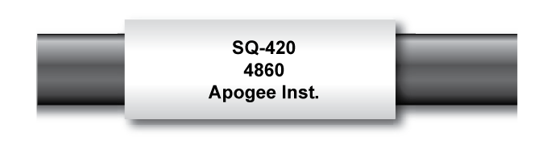

### Specifications

|  |  |
| --- | --- |
|  | **SQ-420X** |
| Resolution | 0.1 µmol m-2 s-1 |
| Calibration Factor | Custom for each sensor and stored in the firmware |
| Calibration Uncertainty | ± 5 % (see calibration Traceability below) |
| Measurement Repeatability | Less than 0.5 % |
| Long-term Drift  (Non-stability) | Less than 2 % per year |
| Non-linearity | Less than 1 % (up to 2500 µmol m-2 s-1) |
| Response Time | Software updates every second |
| Field of View | 180° |
| Spectral Range | 370 to 650 nm (wavelengths where response is greater than 50 % of maximum; see Spectral Response below) |
| Directional (Cosine) Response | ± 5 % at 75° zenith angle (see Cosine Response below) |
| Temperature Response | -0.04 % per C (see Temperature Response below) |
| Operating Environment | 10 to 60 C; 0 to 100 % relative humidity; can be submerged in water up to depths of 30 m |
| Dimensions | 24 mm diameter, 33 mm height |
| Mass | Sensor head weighs 90 g |
| USB Cable | 4.5 m (15 ft) |
| Current Draw (when Logging) | 61 mA |

**Calibration Traceability**

Apogee SQX series quantum sensors are calibrated through side-by-side comparison to the mean of transfer standard quantum sensors under a reference lamp. The reference quantum sensors are recalibrated with a 200 W quartz halogen lamp traceable to the National Institute of Standards and Technology (NIST).**Spectral Response**

Mean spectral response of four SQ-100x series quantum sensors compared to PPFD weighting function. Spectral response measurements were made at 10 nm increments across a wavelength range of 350 to 800 nm in a monochromator with an attached electric light source. Measured spectral data from each quantum sensor were normalized by the measured spectral response of the monochromator/electric light combination, which was measured with a spectroradiometer.

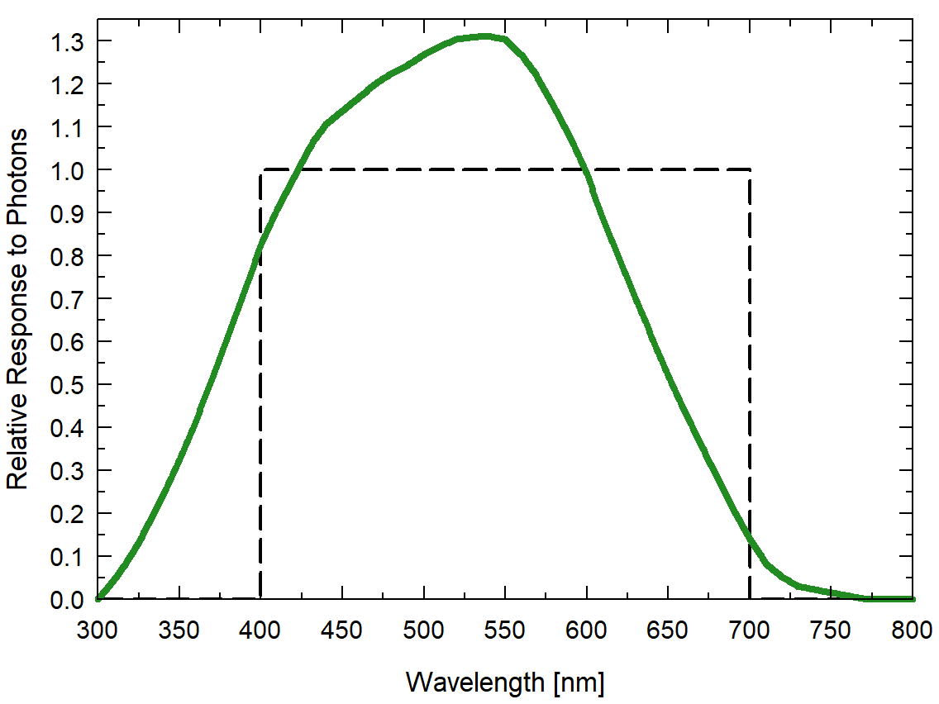

**Cosine Response**

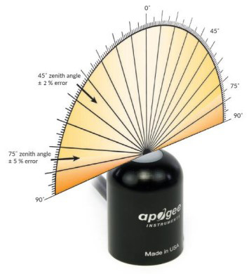

Directional, or cosine, response is defined as the measurement error at a specific angle of radiation incidence. Error for Apogee SQ-100X series quantum sensors is approximately ± 2 % and ± 5 % at solar zenith angles of 45° and 75°, respectively.

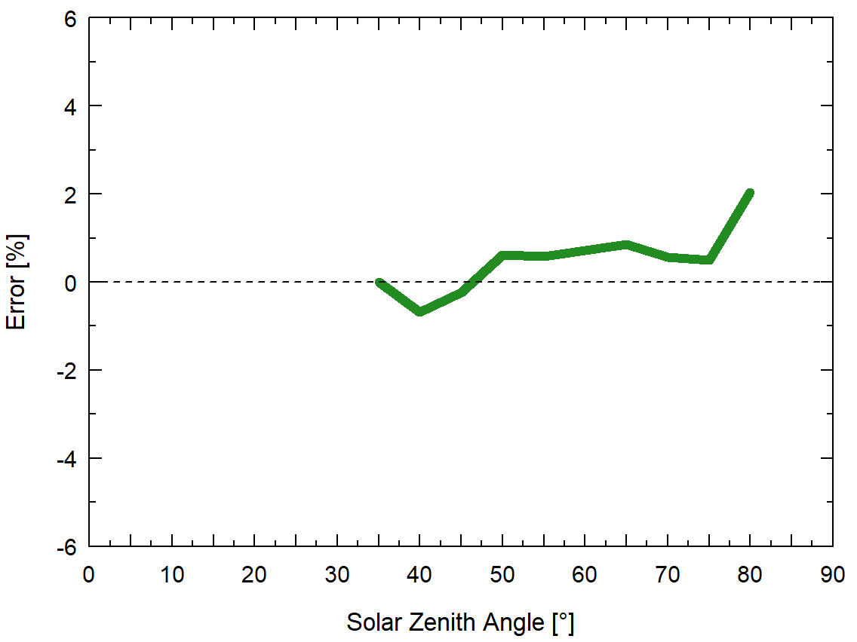

Mean cosine response of five SQ-100X series quantum sensors. Cosine response measurements were made by direct side-by-side comparison to the mean of seven reference SQ-500 quantum sensors.

### Deployment and Installation

Mount the sensor to a solid surface with the nylon mounting screw provided. To accurately measure PPFD incident on a horizontal surface, the sensor must be level. An Apogee Instruments model AL-100 Leveling Plate is recommended to level the sensor when used on a flat surface or being mounted to surfaces such as wood. To facilitate mounting on a mast or pipe, the Apogee Instruments model AL-120 Solar Mounting Bracket with Leveling Plate is recommended.

Important: Only use the nylon screw provided when mounting to insulate the non-anodized threads of the aluminum sensor head from the base to help prevent galvanic corrosion. For extended submersion applications, more insulation may be necessary. Contact Apogee tech support for details.

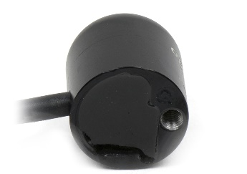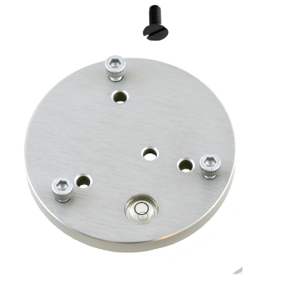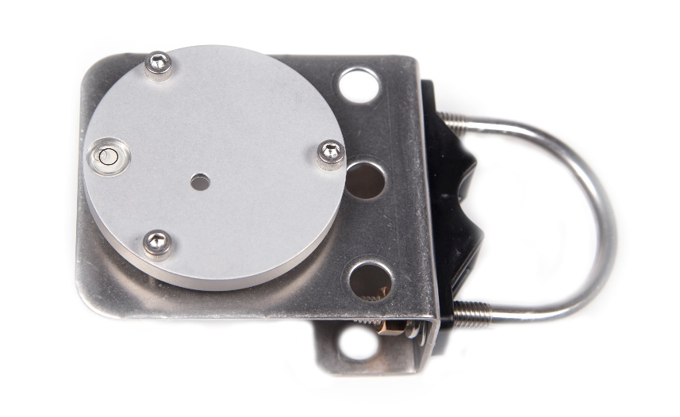C:\Users\emyers\AppData\Local\Microsoft\Windows\INetCache\Content.Word\screw.png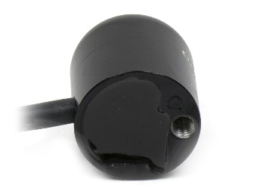

Nylon Screw: 10-32x3/8

Nylon Screw: 10-32x3/8

Model AL-120

Model AL-100

To minimize azimuth error, the sensor should be mounted with the cable pointing toward true north in the northern hemisphere or true south in the southern hemisphere. Azimuth error is typically less than 1 %, but it is easy to minimize by proper cable orientation.

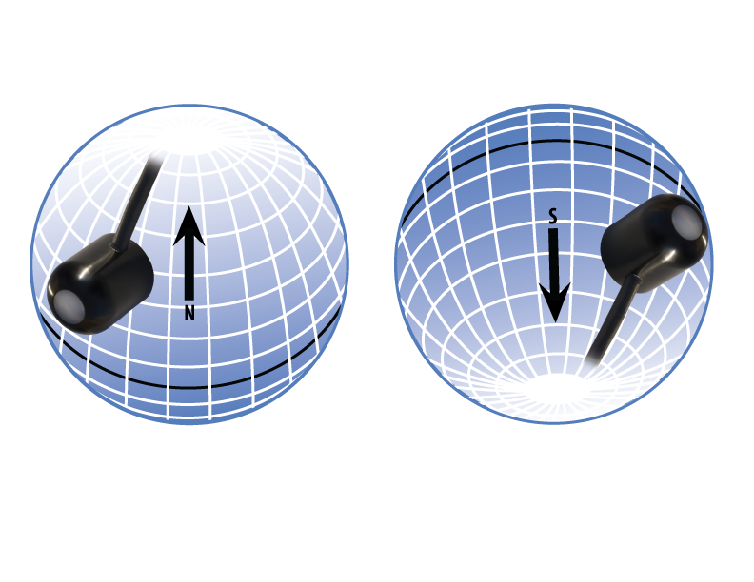

In addition to orienting the cable to point toward the nearest pole, the sensor should also be mounted such that obstructions (e.g., weather station tripod/tower or other instrumentation) do not shade the sensor. **Once mounted, the blue cap should be removed from the sensor.** The blue cap can be used as a protective covering for the sensor when it is not in use.

### Software Installation

**The most recent version of ApogeeConnect software can be downloaded at** [**http://www.apogeeinstruments.com/downloads/**](http://www.apogeeinstruments.com/downloads/)**.**

C:\Users\emyers\Desktop\apogee-connect.jpg**Installing the software on a PC (Windows compatible, XP and later)**

1. Double click on the installer package
2. On the ‘Welcome’ screen, please click ‘Next’ to continue.
3. Select the radio button next to “I Agree” to the UELA… and click ‘Next’ to continue.
4. On the ‘Ready to Install the Program’ screen, click ‘Install’ to continue.
5. Click ‘Finish’ to complete the installation. There are shortcuts on your desktop and in your start bar.

**Installing the software on a Mac (Mac compatible, 10.10 and later)**

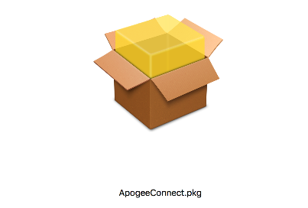

1. Double click on the installer package
2. On the ‘Introduction’ screen, please click ‘Continue’ to proceed.
3. Select ‘Continue’ on the ‘Read Me’ screen to continue, this screen contains a history of updates made to the ApogeeConnect software versions.
4. Select ‘Continue’ on the ‘License’ screen to receive a prompt to agree to the terms of the software license agreement. Click ‘Agree’ to continue once you receive the prompt.
5. On the ‘Installation Type’ screen, click ‘Install’ to install the software. You can change the location the software installs to by clicking ‘Change Install Location…’. *Note: You may be prompted for an administrator password at this time. If you are, proceed by entering your respective password and clicking ‘Install Software’.
6. Once you receive the message “The installation was successful.” on the ‘Summary’ screen click ‘Close’. Your software is now ready to be used.

### Operation and Measurement

**Spectral Errors**

Apogee SQ-100X series sensors can measure PPFD for sunlight and electric light with a single calibration factor. However, errors occur in various light sources due to changes in spectral output. If the light source spectrum is known, then errors can be estimated and used to adjust the measurements. The weighting function for PPFD is shown in the graph below, along with the spectral response of Apogee SQ-100X series quantum sensors. The closer the spectral response matches the defined PPFD spectral weighting functions, the smaller spectral errors will be. The table below provides spectral error estimates for PPFD measurements from light sources different than the calibration source. The method of Federer and Tanner (1966) was used to determine spectral errors based on the PPFD spectral weighting functions, measured sensor spectral response, and radiation source spectral outputs (measured with a spectroradiometer). This method calculates spectral error and does not consider calibration, cosine, and temperature errors.

Federer, C. A., and C. B. Tanner, 1966. Sensors for measuring light available for photosynthesis. Ecology 47:654-657.

McCree, K. J., 1972. The action spectrum, absorptance and quantum yield of photosynthesis in crop plants. Agricultural Meteorology 9:191-216.

**Underwater Measurements and Immersion Effect**

When a quantum sensor that was calibrated in air is used to make underwater measurements, the sensor reads low. This phenomenon is called the immersion effect and happens because the refractive index of water (1.33) is greater than air (1.00). The higher refractive index of water causes more light to be backscattered (or reflected) out of the sensor in water than in air (Smith,1969; Tyler and Smith,1970). As more light is reflected, less light is transmitted through the diffuser to the detector, which causes the sensor to read low. Without correcting for this effect, underwater measurements are only relative, which makes it difficult to compare light in different environments.

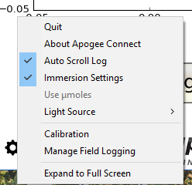The SQ-420X sensor has an immersion effect correction factor of 1.15. The immersion effect correction factor can be automatically applied to SQ-420X measurements by turning on the immersion setting in the settings option of the ApogeeConnect software, as pictured. Once you are finished making your underwater measurements simply uncheck the immersion setting in the software, to turn it off, and continue making measurements in air like normal.

When making underwater measurements, only the sensor and cable can go in the water. The USB connector is not waterproof and must not get wet.

Further information on underwater measurements and the immersion effect can be found at <http://www.apogeeinstruments.com/underwater-par-measurements/>.

### Windows Software

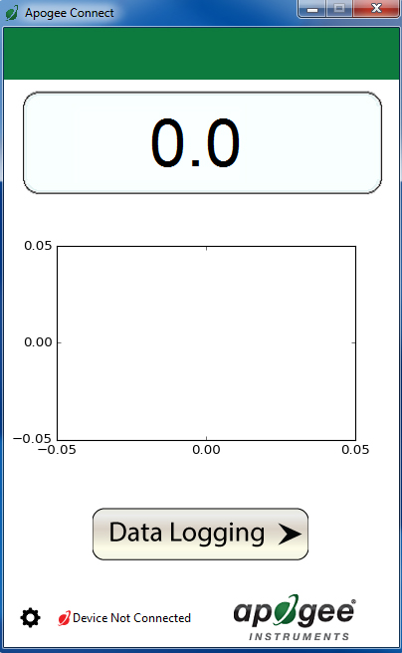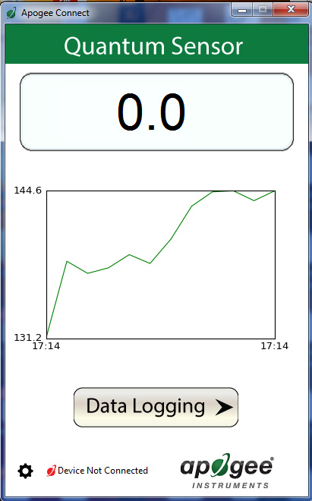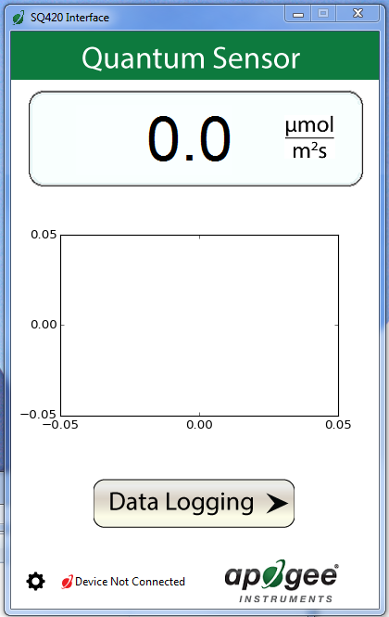

When the SQ-420X sensor is not plugged into the USB port, the software will display a message in the lower left corner, “Device Not Connected,” indicating it cannot establish communication with the sensor.

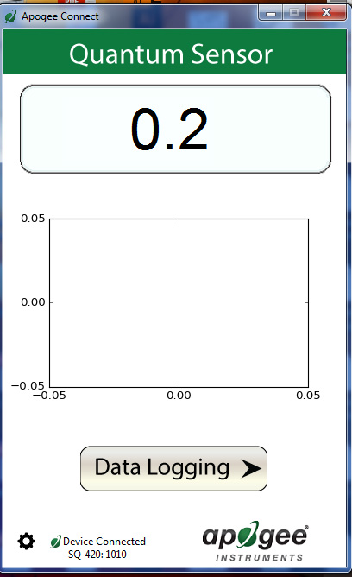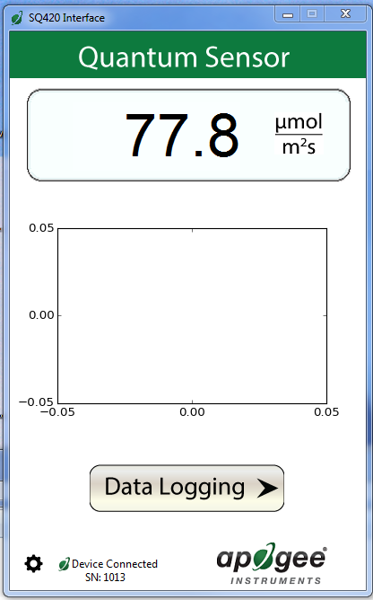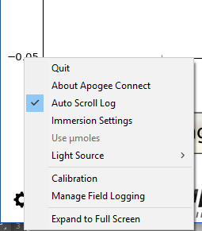

Plug the sensor into a USB port and allow some time for the sensor to automatically establish communication with the software. Once established, the message in the lower left corner will display “Device Connected SN: ####” and real-time PAR readings will update on the screen. Moving the sensor closer to a light source should increase the readings, while blocking all light from the sensor should drop the reading to zero.

Click the ‘**Settings**’ icon to display the software options.

Clicking **‘Immersion Setting’** will automatically apply the sensor’s immersion effect correction factor of 1.18 to the sensor measurements. This setting should be used when the sensor is being used to take measurements underwater.



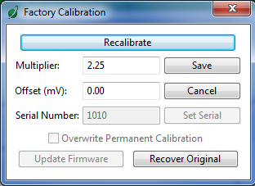

Clicking **‘Calibration’** will display the factory calibrated multiplier and offset values. These values are saved in firmware and can be recovered by clicking the ‘Recover Original’ button. Deriving a new calibration multiplier and offset is accomplished by clicking the ‘Recalibrate’ button. This is applicable if users want to calibrate the sensor to their own specific light source. Note that a reference PAR value of the light source is required to complete a recalibration.

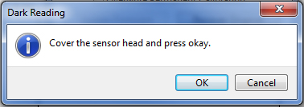

After clicking the ‘Recalibate’ button the user will be prompted to cover the sensor. Place a dark cap over the sensor and wait for the real-time PAR reading to settle at zero. Click OK.

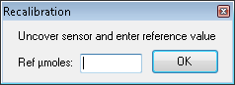

Uncover the sensor and wait for the PAR reading to settle ***before*** entering the reference value. Click OK.

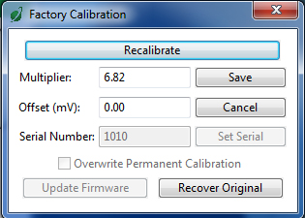

The multiplier and offset values will automatically calculate and update in the appropriate field. Be sure to click ‘Save’ to retain the new multiplier and offset.

Clicking **‘Data Logging’** will allow the user to log interval measurements in a csv file while the software is open and communicating with the sensor.

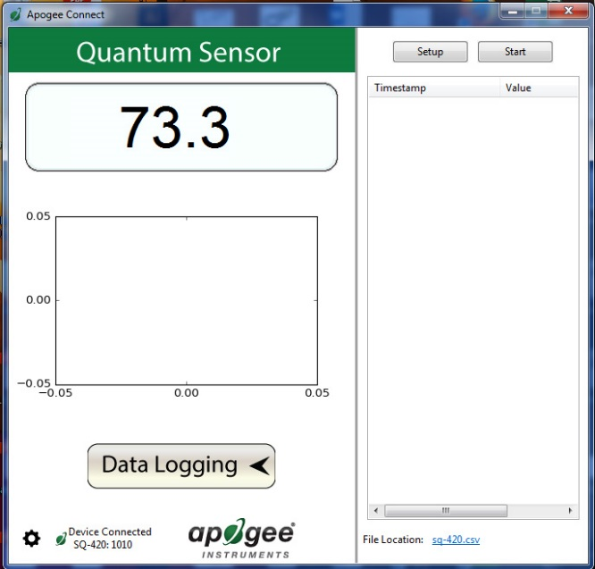

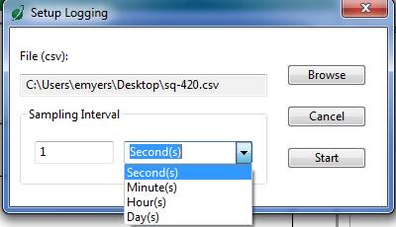

Click ‘Setup’ and the Setup Logging window appears. Click the ‘Browse’ button to create or select a csv file.

Select the desired sampling interval. Note that 1 second is the minimum interval allowed. Click ‘Start’.

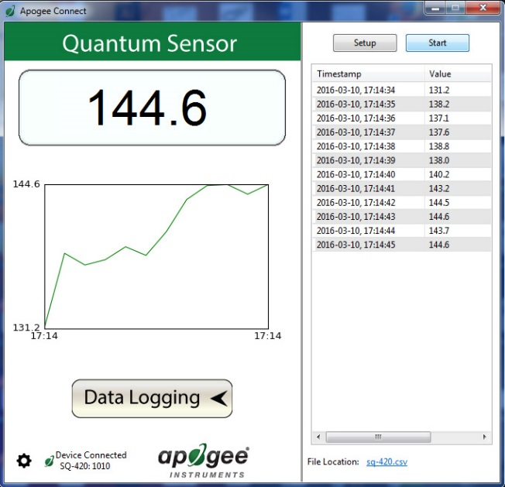

The data logging window will start to update at the specified sampling interval and display the Timestamp, Light Source, and Data Value. At the same time, data will be written to the csv file. Note that if the csv file is open in another program new data will not be saved to it.

The data logging window can be closed without affec­ting logged data by clicking the ‘Exit’ button. The ‘Stop’ button must be clicked to end data logging.

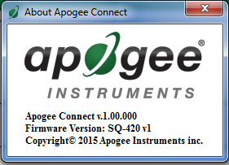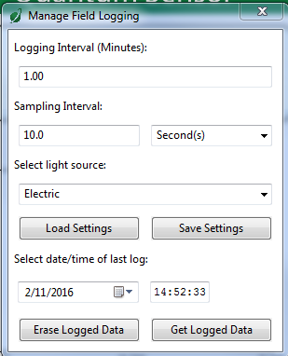

**‘Manage Field Logging’** is used to setup the SQ-420X for use in the field. When the SQ-420X is supplied power from a USB power source it will log data which you can retrieve. Choose the interval that data is saved, as well as the interval that data is sampled and the light source used. The shortest sampling interval is 1 second. The longest sampling or logging interval is 1440 minutes (1 day). Click ‘Load Settings’ to see current settings and ‘Save Settings’ to save the settings you want to the sensor. Note: If you don’t click save the sensor won’t change the settings.

The about screen tells you the software and firmware versions. These can be used to help troubleshoot if problems arise.

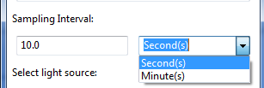

Set the sampling interval in minutes or seconds. The sampling interval is how often a measurement is taken and logging interval is how often the data is saved. The logged data is the average of the samples. The logging interval must be evenly divided by the sampling interval. For example, if the logging interval is 5 minutes and the sampling interval is 2 minutes it causes an error. But a sampling interval of 1 minute is acceptable.

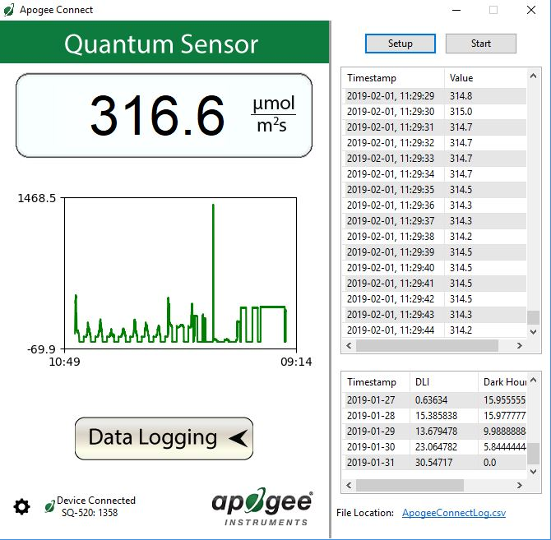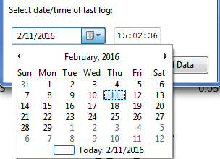C:\Users\emyers\Desktop\logged-data.PNG

When the software is open and logging data from sensor models SQ-420X and SQ-520, it will calculate daily light integral (DLI) in moles and Dark Hours in hours each day at 12:00 AM using PAR values collected during the previous 36 hours. The Dark Hours value is calculated using the “Darkness Threshold” setting. The number of continuously logged PAR values less than the Darkness Threshold are counted and multiplied by the logging interval to calculate the number of Dark Hours. This represents the longest continuous duration of darkness, not the total duration of darkness.

To use additional SQ-420X devices, open additional ApogeeConnect software windows. The device serial number will display in the lower left-hand corner of the corresponding software window. Devices may be selected by serial number in the tool bar.

Before clicking ‘Get Logged Data’ it is important to set the time of the last logged data point. This is used to back calculate the timestamps for the remaining data points. If you just unplugged the sensor and plugged it into the computer, the preloaded day and time should be sufficient.

Click **‘Get Logged Data’** to save the data to your computer. You will be asked where you want to save the data.

Click **‘Erase Data’** to erase all the saved data. This can’t be undone.

### **F:\Screen Shot 2016-03-08 at 9.40.32 AM.pngF:\Screen Shot 2016-03-08 at 9.40.56 AM.png**Mac Software

Plug the sensor into a USB port and allow some time for the sensor to automatically establish communication with the software. Once established, the message in the lower left corner will display “Device Connected Model: SN ####” and real-time PAR readings will update on the screen. Moving the sensor closer to a light source should increase the readings, while blocking all light from the sensor should drop the reading to zero.

When the SQ-420X sensor is not plugged into the USB port, the software will display a message in the lower left corner, “Device Not Connected,” indicating it cannot establish communication with the sensor.



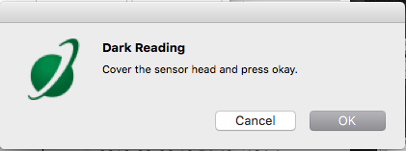

After clicking the ‘Recalibrate’ button the user will be prompted to cover the sensor. Place a dark cap over the sensor and wait for the real-time PAR reading to settle at zero. Click OK.

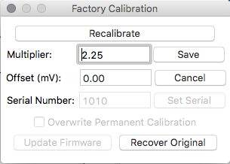

Clicking **‘Calibration’** will display the factory calibrated multiplier and offset values. These values are saved in firmware and can be recovered by clicking the ‘Recover Original’ button. Deriving a new calibration multiplier and offset is accomplished by clicking the ‘Recalibrate’ button. This is applicable if users want to calibrate the sensor to their own specific light source. Note that a reference PAR value of the light source is required to complete a recalibration.

Clicking **‘Immersion Setting’** will automatically apply the sensor’s immersion effect correction factor of 1.18 to the sensor measurements. This setting should be used when the sensor is being used to take measurements underwater.



Click the **‘Settings’** icon to display the software options.

Uncover the sensor and wait for the PAR reading to settle ***before*** entering the reference value. Click OK.

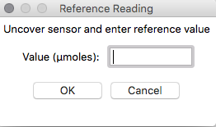

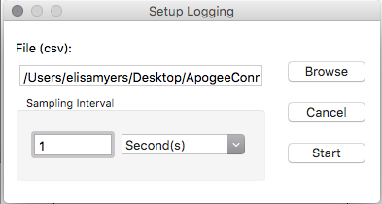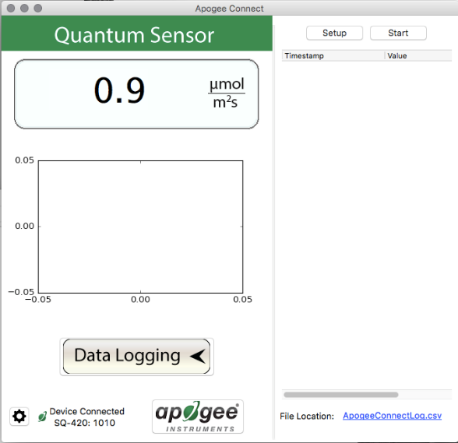

Click ‘Setup’ and the Setup Logging window appears. Click the ‘Browse button to create or select a csv file.

Select the desired sampling interval. Note that 1 second is the minimum interval allowed. Click ‘Start’.

Clicking **‘Data Logging’** will allow the user to log interval measurements in a csv file while the software is open and communicating with the sensor.

The multiplier and offset values will automatically calculate and update in the appropriate field. Be sure to click ‘Save’ to retain the new multiplier and offset.

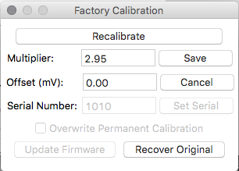

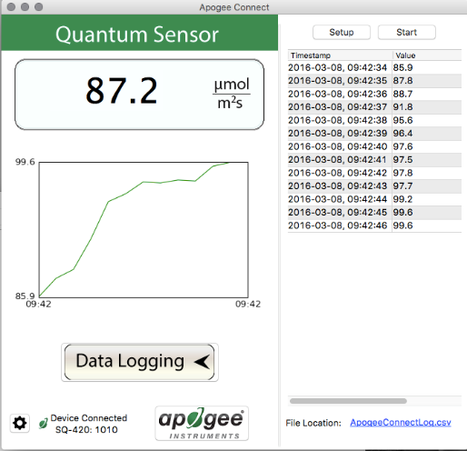

The data logging window will start to update at the specified sampling interval and display the Timestamp, Light Source, and Data Value. At the same time, data will be written to the csv file. Note that if the csv file is open in another program new data will not be saved to it.

The data logging window can be closed without affecting logged data by clicking the ‘Exit’ button. The ‘Stop’ button must be clicked to end data logging.

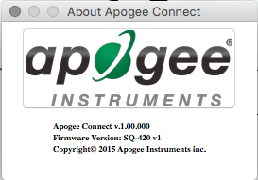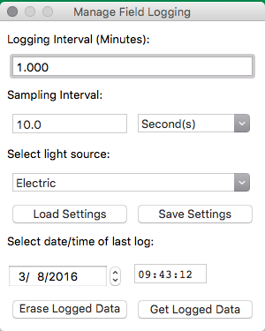

‘**Manage Field Logging**’ is used to setup the SQ-420X for the use in the field. When the SQ-420X is supplied power from a USB power source it will log data which you can retrieve. Choose the interval the data is saved, as well as the interval that data is sampled and the light source used. The shortest sampling interval is 1 second. The longest sampling or logging interval is 1440 minutes (1 day). Click ‘Load Settings’ to see current settings and ‘Save Setting’ to save the settings you want to the sensor. **Note:** If you don’t click save the sensor won’t change the settings.

The about screen tells you the software and firmware versions. These can be used to help troubleshoot if problems arise.

Set the sampling interval in minutes or seconds. The sampling interval is how often a measurement is taken and logging interval is how often the data is saved. The logged data is the average of the samples. The logging interval must be evenly divided by the sampling interval. For example, if the logging interval is 5 minutes and the sampling interval is 2 minutes it causes an error. But a sampling interval of 1 minute is acceptable.

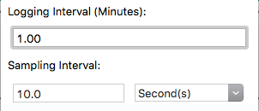



When the software is open and logging data from sensor models SQ-420X and SQ-520, it will calculate daily light integral (DLI) in moles and Dark Hours in hours each day at 12:00 AM using PAR values collected during the previous 36 hours. The Dark Hours value is calculated using the “Darkness Threshold” setting. The number of continuously logged PAR values less than the Darkness Threshold are counted and multiplied by the logging interval to calculate the number of Dark Hours. This represents the longest continuous duration of darkness, not the total duration of darkness.

To use additional SQ-420X devices, open additional ApogeeConnect software windows. The device serial number will display in the lower left-hand corner of the corresponding software window. Devices may be selected by serial number in the tool bar.



Click ‘**Get Logged Data**’ to save the data to your computer. You will be asked where you want to save the data.

Click ‘**Erase Data**’ to erase all the save data. This can’t be undone.

Before clicking ‘Get Logged Data’ it is important to set the time of the last logged data point. This is used to back calculate the timestamps for the remaining data points. If you just unplugged the sensor and plugged it into the computer, the preloaded day and time should be sufficient.

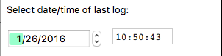

**Spectral Errors for PPFD Measurements with Apogee SQ-100X Series Quantum Sensors**

|  |  |
| --- | --- |
| **Radiation Source (Error Calculated Relative to Sun, Clear Sky)** | **PPFD Error [%]** |
| Sun (Clear Sky) | 0.0 |
| Sun (Cloudy Sky) | 0.2 |
| Reflected from Grass Canopy | 5.0 |
| Reflected from Deciduous Canopy | 7.0 |
| Reflected from Conifer Canopy | 7.3 |
| Transmitted below Grass Canopy | 8.3 |
| Transmitted below Deciduous Canopy | 8.4 |
| Transmitted below Conifer Canopy | 10.1 |
| Cool White Fluorescent (T5) | 7.2 |
| Cool White Fluorescent (T12) | 8.3 |
| Metal Halide | 6.9 |
| Ceramic Metal Halide | -0.9 |
| High Pressure Sodium | 3.2 |
| Blue LED (448 nm peak, 20 nm full-width half-maximum) | 14.5 |
| Green LED (524 nm peak, 30 nm full-width half-maximum) | 29.6 |
| Red LED (635 nm peak, 20 nm full-width half-maximum) | -30.9 |
| Red, Blue LED Mixture (80 % Red, 20 % Blue) | -21.2 |
| Red, Green, Blue LED Mixture (70 % Red, 15 % Green, 15 % Blue) | -16.4 |
| Cool White Fluorescent LED | 7.3 |
| Neutral White Fluorescent LED | 1.1 |
| Warm White Fluorescent LED | -7.8 |

Quantum sensors can be a very practical means of measuring PPFD from multiple radiation sources, but spectral errors must be considered. The spectral errors in the table above can be used as correction factors for individual radiation sources.

### Maintenance and Recalibration

Blocking of the optical path between the target and detector can cause low readings. Occasionally, accumulated materials on the diffuser of the upward-looking sensor can block the optical path in three common ways:

1. Moisture or debris on the diffuser.
2. Dust during periods of low rainfall.
3. Salt deposit accumulation from evaporation of sea spray or sprinkler irrigation water.

Apogee Instruments upward-looking sensors have a domed diffuser and housing for improved self-cleaning from rainfall, but active cleaning may be necessary. Dust or organic deposits are best removed using water, or window cleaner, and a soft cloth or cotton swab. Salt deposits should be dissolved with vinegar and removed with a cloth or cotton swab. **Salt deposits cannot be removed with solvents such as alcohol or acetone.** Use only gentle pressure when cleaning the diffuser with a cotton swab or soft cloth to avoid scratching the outer surface. The solvent should be allowed to do the cleaning, not mechanical force. **Never use abrasive material or cleaner on the diffuser.**

Although Apogee sensors are very stable, nominal calibration drift is normal for all research-grade sensors. To ensure maximum accuracy, recalibration every two years is recommended. Longer time periods between recalibration may be warranted depending on tolerances. See the Apogee webpage for details regarding return of sensors for recalibration (<http://www.apogeeinstruments.com/tech-support-recalibration-repairs/>).

To determine if your sensor needs recalibration, the Clear Sky Calculator ([www.clearskycalculator.com](http://www.clearskycalculator.com)) website and/or smartphone app can be used to indicate the PPFD incident on a horizontal surface at any time of day at any location in the world. It is most accurate when used near solar noon in spring and summer months, where accuracy over multiple clear and unpolluted days is estimated to be ± 4 % in all climates and locations around the world. For best accuracy, the sky must be completely clear, as reflected light from clouds causes PPFD to increase above the value predicted by the clear sky calculator. Measured values of PPFD can exceed values predicted by the Clear Sky Calculator due to reflection from thin, high clouds and edges of clouds, which enhances incoming PPFD. The influence of high clouds typically shows up as spikes above clear sky values, not a constant offset greater than clear sky values.

To determine recalibration need, input site conditions into the calculator and compare PPFD measurements to calculated values for a clear sky. If sensor PPFD measurements over multiple days near solar noon are consistently different than calculated values (by more than 6 %), the sensor should be cleaned and re-leveled. If measurements are still different after a second test, email [calibration@apogeeinstruments.com](mailto:calibration@apogeeinstruments.com) to discuss test results and possible return of sensor(s).

Homepage of the Clear Sky Calculator. Two calculators are available: one for quantum sensors (PPFD) and one for pyranometers (total shortwave radiation).

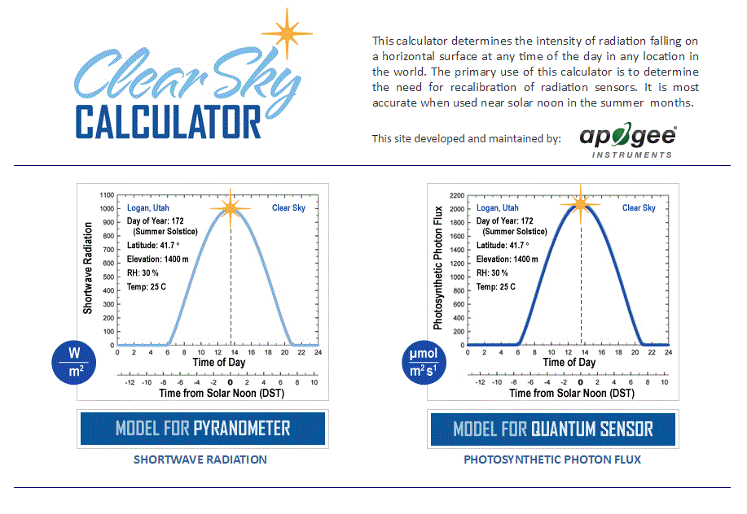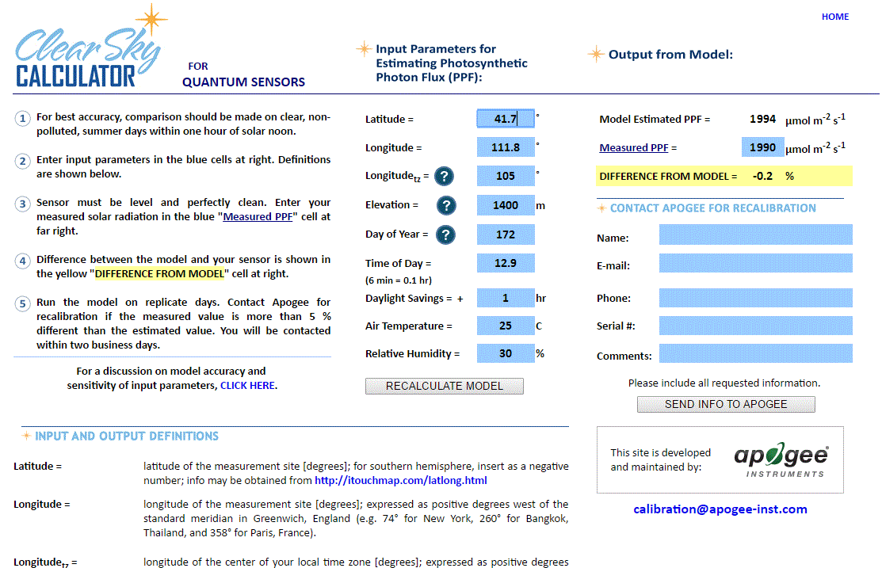

### Troubleshooting and Customer Support

Clear Sky Calculator for quantum sensors. Site data are input in blue cells in middle of page and an estimate of PPFD is returned on right-hand side of page.

**Cable Length**

Fifteen feet is the maximum cable length that can be built into the sensor.

**Modifying Cable Length**

If you required a longer cable length an “active” USB extension cable is required. Please note, the connection between the cables must be made watertight prior to submersion.

**Unit Conversion Charts**

Apogee SQX series quantum sensors are calibrated to measure PPFD in units of µmol m-2 s-1. Units other than photon flux density (e.g., energy flux density, illuminance) may be required for certain applications. It is possible to convert the PPFD value from a quantum sensor to other units, but it requires spectral output of the radiation source of interest. Conversion factors for common radiation sources can be found on the Unit Conversions page in the Support Center on the Apogee website (<http://www.apogeeinstruments.com/unit-conversions/>). A spreadsheet to convert PPFD to energy flux density or illuminance is also provided on the Unit Conversions page in the Support Center on the Apogee website (<http://www.apogeeinstruments.com/content/PPFD-to-Illuminance-Calculator.xls>).

### Return and Warranty Policy

RETURN POLICY

Apogee Instruments will accept returns within 30 days of purchase as long as the product is in new condition (to be determined by Apogee). Returns are subject to a 10 % restocking fee.

WARRANTY POLICY

**What is Covered**All products manufactured by Apogee Instruments are warranted to be free from defects in materials and craftsmanship for a period of four (4) years from the date of shipment from our factory. To be considered for warranty coverage an item must be evaluated by Apogee.

Products not manufactured by Apogee (spectroradiometers, chlorophyll content meters, EE08-SS probes) are covered for a period of one (1) year.

**What is Not Covered**The customer is responsible for all costs associated with the removal, reinstallation, and shipping of suspected warranty items to our factory.

The warranty does not cover equipment that has been damaged due to the following conditions:

1. Improper installation, use, or abuse.

2. Operation of the instrument outside of its specified operating range.

3. Natural occurrences such as lightning, fire, etc.

4. Unauthorized modification.

5. Improper or unauthorized repair.

Please note that nominal accuracy drift is normal over time. Routine recalibration of sensors/meters is considered part of proper maintenance and is not covered under warranty.

**Who is Covered**This warranty covers the original purchaser of the product or other party who may own it during the warranty period.

**What Apogee Will Do**At no charge Apogee will:

1. Either repair or replace (at our discretion) the item under warranty.

2. Ship the item back to the customer by the carrier of our choice.

Different or expedited shipping methods will be at the customer’s expense.

**How To Return An Item**1. Please do not send any products back to Apogee Instruments until you have received a Return Merchandise Authorization (RMA) number from our technical support department by submitting an online RMA form at [www.apogeeinstruments.com/tech-support-recalibration-repairs/](http://www.apogeeinstruments.com/tech-support-recalibration-repairs/). We will use your RMA number for tracking of the service item. Call (435) 245-8012 or email techsupport@apogeeinstruments.com with questions.

2. For warranty evaluations, send all RMA sensors and meters back in the following condition: Clean the sensor’s exterior and cord. Do not modify the sensors or wires, including splicing, cutting wire leads, etc. If a connector has been attached to the cable end, please include the mating connector – otherwise the sensor connector will be removed in order to complete the repair/recalibration. ***Note:*** *When sending back sensors for routine calibration that have Apogee’s standard stainless-steel connectors, you only need to send the sensor with the 30 cm section of cable and one-half of the connector. We have mating connectors at our factory that can be used for calibrating the sensor.*

3. Please write the RMA number on the outside of the shipping container.

4. Return the item with freight pre-paid and fully insured to our factory address shown below. We are not responsible for any costs associated with the transportation of products across international borders.

**Apogee Instruments, Inc.   
721 West 1800 North Logan, UT  
84321, USA**

5. Upon receipt, Apogee Instruments will determine the cause of failure. If the product is found to be defective in terms of operation to the published specifications due to a failure of product materials or craftsmanship, Apogee Instruments will repair or replace the items free of charge. If it is determined that your product is not covered under warranty, you will be informed and given an estimated repair/replacement cost.

Products Beyond the Warranty Period

For issues with sensors beyond the warranty period, please contact Apogee at [techsupport@apogeeinstruments.com](mailto:techsupport@apogeeinstruments.com) to discuss repair or replacement options.

Other Terms

The available remedy of defects under this warranty is for the repair or replacement of the original product, and Apogee Instruments is not responsible for any direct, indirect, incidental, or consequential damages, including but not limited to loss of income, loss of revenue, loss of profit, loss of data, loss of wages, loss of time, loss of sales, accruement of debts or expenses, injury to personal property, or injury to any person or any other type of damage or loss.

This limited warranty and any disputes arising out of or in connection with this limited warranty ("Disputes") shall be governed by the laws of the State of Utah, USA, excluding conflicts of law principles and excluding the Convention for the International Sale of Goods. The courts located in the State of Utah, USA, shall have exclusive jurisdiction over any Disputes.

This limited warranty gives you specific legal rights, and you may also have other rights, which vary from state to state and jurisdiction to jurisdiction, and which shall not be affected by this limited warranty. This warranty extends only to you and cannot by transferred or assigned. If any provision of this limited warranty is unlawful, void, or unenforceable, that provision shall be deemed severable and shall not affect any remaining provisions. In case of any inconsistency between the English and other versions of this limited warranty, the English version shall prevail.

This warranty cannot be changed, assumed, or amended by any other person or agreement.

**APOGEE INSTRUMENTS, INC. |** 721 WEST 1800 NORTH, LOGAN, UTAH 84321, USA

TEL: (435) 792-4700 | FAX: (435) 787-8268 | WEB: APOGEEINSTRUMENTS.COM

*Copyright © 2022 Apogee Instruments, Inc.*