

# Owner’s Manual

Quantum Sensor

Models SQ-100 and SQ-300 Series   
Rev: 30-Mar-2022

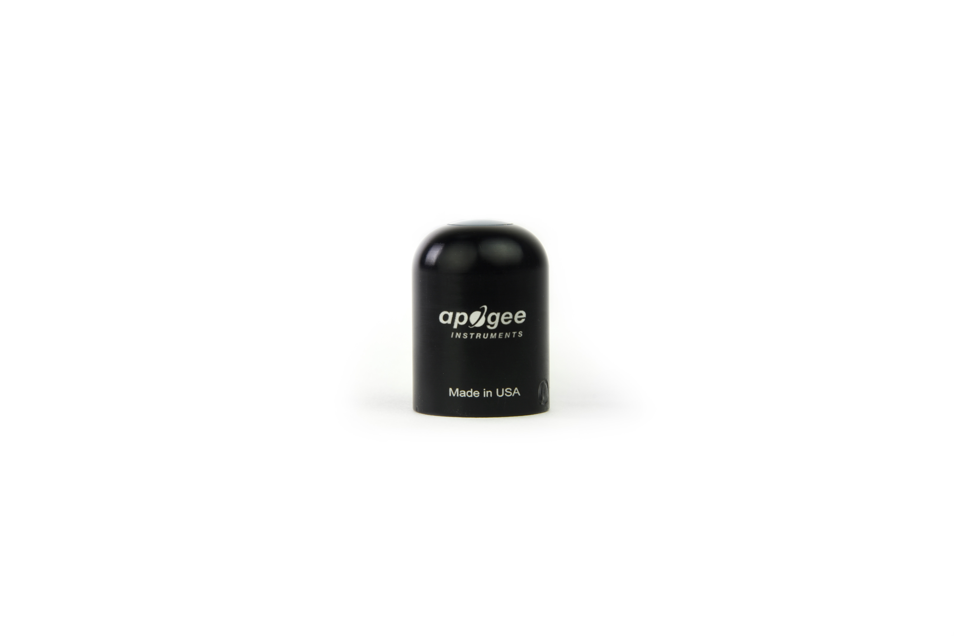

Table of Contents

Owner’s Manual 1

Certificate of Compliance 3

Introduction 4

Sensor Models 5

Specifications 6

Deployment and Installation 9

Cable Connectors 10

Operation and Measurement 11

Maintenance and Recalibration 15

Troubleshooting and Customer Support 17

Return and Warranty Policy 18

Appendix 20

### Certificate of Compliance

**EU Declaration of Conformity**

This declaration of conformity is issued under the sole responsibility of the manufacturer:

Apogee Instruments, Inc.  
721 W 1800 N  
Logan, Utah 84321  
USA

for the following product(s):

Models: SQ-110, SQ-120, SQ-301, SQ-303, SQ-306, SQ-321, SQ-323, SQ-326

Type: Quantum Sensor

The object of the declaration described above is in conformity with the relevant Union harmonization legislation:

2014/30/EU Electromagnetic Compatibility (EMC) Directive

2011/65/EU Restriction of Hazardous Substances (RoHS 2) Directive

2015/863/EU Amending Annex II to Directive 2011/65/EU (RoHS 3)

Standards referenced during compliance assessment:

EN 61326-1:2013 Electrical equipment for measurement, control, and laboratory use – EMC requirements

EN 50581:2012 Technical documentation for the assessment of electrical and electronic products with respect to the restriction of hazardous substances

Please be advised that based on the information available to us from our raw material suppliers, the products manufactured by us do not contain, as intentional additives, any of the restricted materials including lead (see note below), mercury, cadmium, hexavalent chromium, polybrominated biphenyls (PBB), polybrominated diphenyls (PBDE), bis (2-ethylhexyl) phthalate (DEHP), butyl benzyl phthalate (BBP), dibutyl phthalate (DBP), and diisobutyl phthalate (DIBP). However, please note that articles containing greater than 0.1 % lead concentration are RoHS 3 compliant using exemption 6c.

Further note that Apogee Instruments does not specifically run any analysis on our raw materials or end products for the presence of these substances, but we rely on the information provided to us by our material suppliers.

Signed for and on behalf of:

Apogee Instruments, March 2022



Bruce Bugbee  
President  
Apogee Instruments, Inc.

### Introduction

Radiation that drives photosynthesis is called photosynthetically active radiation (PAR) and is typically defined as total radiation across a range of 400 to 700 nm. PAR is often expressed as photosynthetic photon flux density (PPFD): photon flux in units of micromoles per square meter per second (µmol m-2 s-1, equal to microEinsteins per square meter per second) summed from 400 to 700 nm (total number of photons from 400 to 700 nm). While Einsteins and micromoles are equal (one Einstein = one mole of photons), the Einstein is not an SI unit, so expressing PPFD as µmol m-2 s-1 is preferred.

The acronym PPF is also widely used and refers to the photosynthetic photon flux. The acronyms PPF and PPFD refer to the same parameter. The two terms have co-evolved because there is not a universal definition of the term “flux”. Some physicists define flux as per unit area per unit time. Others define flux only as per unit time. We have used PPFD in this manual because we feel that it is better to be more complete and possibly redundant.

Sensors that measure PPFD are often called quantum sensors due to the quantized nature of radiation. A quantum refers to the minimum quantity of radiation, one photon, involved in physical interactions (e.g., absorption by photosynthetic pigments). In other words, one photon is a single quantum of radiation.

Typical applications of quantum sensors include incoming PPFD measurement over plant canopies in outdoor environments or in greenhouses and growth chambers and reflected or under-canopy (transmitted) PPFD measurement in the same environments.

Apogee Instruments SQ series quantum sensors consist of a cast acrylic diffuser (filter), photodiode, and signal processing circuitry mounted in an anodized aluminum housing, and a cable to connect the sensor to a measurement device. Sensors are potted solid with no internal air space and are designed for continuous PPFD measurement in indoor or outdoor environments. SQ series sensors output an analog voltage that is directly proportional to PPFD under sunlight (e.g., model SQ-110) or electric lights (e.g., model SQ-120). The voltage signal from the sensor is directly proportional to radiation incident on a planar surface (does not have to be horizontal), where the radiation emanates from all angles of a hemisphere.

### Sensor Models

This manual covers the unamplified models SQ-100 series and SQ-300 series. Additional models are covered in their respective manuals.

|  |  |  |
| --- | --- | --- |
| Model | Signal | Calibration |
| SQ-110 | **Self-powered** | **Sunlight** |
| SQ-120 | **Self-powered** | **Electric light** |
| SQ-311 | **Self-powered** | **Sunlight** |
| SQ-321 | **Self-powered** | **Electric light** |
| SQ-313 | **Self-powered** | **Sunlight** |
| SQ-323 | **Self-powered** | **Electric light** |
| SQ-316 | **Self-powered** | **Sunlight** |
| SQ-326 | **Self-powered** | **Electric light** |
| SQ-212 | 0-2.5 V | Sunlight |
| SQ-222 | 0-2.5 V | Electric light |
| SQ-214 | 4-20 mA | Sunlight |
| SQ-224 | 4-20 mA | Electric light |
| SQ-215 | 0-5 V | Sunlight |
| SQ-225 | 0-5 V | Electric light |
| SQ-420 | USB | Sunlight and Electric light |
| SQ-421 | SDI-12 | Sunlight and Electric light |
| SQ-422 | Modbus | Sunlight and Electric light |

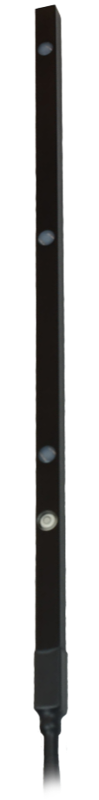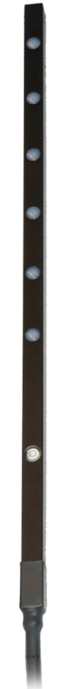Line quantum sensors, SQ-300 series, provide spatially averaged PPFD measurements. All sensors along the length of the line are connected in parallel, and as a result, Apogee line quantum sensors output a single voltage signal that is directly proportional to PPFD averaged from the location of the individual sensors.

Sensor model number and serial number are located near the pigtail leads on the sensor cable. If you need the manufacturing date of your sensor, please contact Apogee Instruments with the serial number of your sensor.

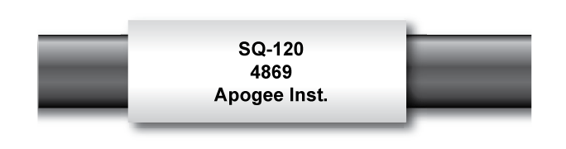

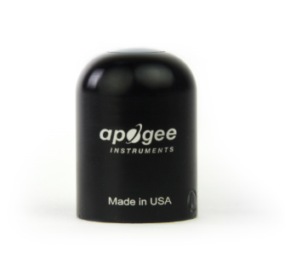

SQ-313-323

SQ-316/326

SQ-110/SQ-120

SQ-311/321

### Specifications

|  |  |  |  |
| --- | --- | --- | --- |
|  | **SQ-100-SS Series** | **SQ-313/316/323/326-SS\*** | **SQ-311/321-SS\*** |
| Power Supply | Self-powered | | |
| Sensitivity | 0.2 mV per µmol m-2 s-1 | | |
| Calibration Factor  (Reciprocal of Sensitivity) | 5 µmol m-2 s-1 per mV | | |
| Calibration Uncertainty | ± 5 % (see Calibration Traceability below) | | |
| Calibrated Output Range | 0 to 800 mV | | |
| Measurement Repeatability | Less than 0.5 % | | |
| Long-term Drift  (Non-stability) | Less than 2 % per year | | |
| Non-linearity | Less than 1 % (up to 4000 µmol m-2 s-1) | | |
| Response Time | Less than 1 ms | | |
| Field of View | 180° | | |
| Spectral Range | 410 to 655 nm (wavelengths where response is greater than 50 % of maximum; see Spectral Response below) | | |
| Spectral Selectivity | Less than 10 % from 469 to 655 nm | | |
| Directional (Cosine) Response | ± 5 % at 75° zenith angle (see Cosine Response below) | | |
| Temperature Response | 0.06 ± 0.06 % per C (see Temperature Response below) | | |
| Operating Environment | -40 to 70 C; 0 to 100 % relative humidity; can be submerged in water up to depths of 30 m | | |
| Dimensions | 24 mm diameter, 33 mm height | 500 mm length, 15 mm width,  15 mm height | 700 mm length, 15 mm width, 15 mm height |
| Mass | 90 g (with 5m of lead wire) | 275 g | 375 g |
| Cable | 5 m of two conductor, shielded, twisted-pair wire; TPR jacket (high water resistance, high UV stability, flexibility in cold conditions); pigtail lead wires; stainless steel (316), M8 connector located 25 cm from sensor head | | |
| *The spectral response of the SQ-300 series line quantum sensors changed in May 2021. Please see the appendix for updated spectral response and spectral errors. | | | |

**Calibration Traceability**

Apogee SQ series quantum sensors are calibrated through side-by-side comparison to the mean of transfer standard quantum sensors under a reference lamp. The reference quantum sensors are recalibrated with a 200 W quartz halogen lamp traceable to the National Institute of Standards and Technology (NIST).

**Spectral Response**

Mean spectral response of six SQ series quantum sensors (***error bars represent two standard deviations above and below mean***) compared to PPFD weighting function. Spectral response measurements were made at 10 nm increments across a wavelength range of 300 to 800 nm in a monochromator with an attached electric light source. Measured spectral data from each quantum sensor were normalized by the measured spectral response of the monochromator/electric light combination, which was measured with a spectroradiometer.



*The spectral response of the SQ-300 series line quantum sensors changed in May 2021. Please see the appendix for updated spectral response and spectral errors.

**Temperature Response**

Mean temperature response of eight SQ series quantum sensors (***errors bars represent two standard deviations above and below mean***). Temperature response measurements were made at 10 C intervals across a temperature range of approximately -10 to 40 C in a temperature-controlled chamber under a fixed, broad spectrum, electric lamp. At each temperature set point, a spectroradiometer was used to measure light intensity from the lamp and all quantum sensors were compared to the spectroradiometer. The spectroradiometer was mounted external to the temperature control chamber and remained at room temperature during the experiment.



**Cosine Response**

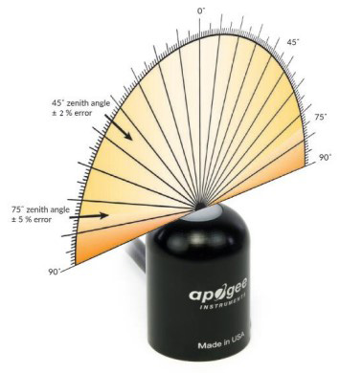

Directional, or cosine, response is defined as the measurement error at a specific angle of radiation incidence. Error for Apogee SQ series quantum sensors is approximately ± 2 % and ± 5 % at solar zenith angles of 45° and 75°, respectively.

Mean cosine response of twenty-three SQ series quantum sensors (***error bars represent two standard deviations above and below mean***). Cosine response measurements were made by direct side-by-side comparison to the mean of four reference thermopile pyranometers, with solar zenith angle-dependent factors applied to convert total shortwave radiation to PPFD. Blue points represent the AM response and red points represent the PM response.



### Deployment and Installation

Mount the sensor to a solid surface with the nylon mounting screw provided to prevent galvanic corrosion. To accurately measure PPFD incident on a horizontal surface, the sensor must be level. An Apogee Instruments model AL-100 Leveling Plate is recommended to level the sensor when used on a flat surface or being mounted to surfaces such as wood. To facilitate mounting on a mast or pipe, the Apogee Instruments model AL-120 Solar Mounting Bracket with Leveling Plate is recommended.

Important: Only use the nylon screw provided when mounting to insulate the non-anodized threads of the aluminum sensor head from the base to help prevent galvanic corrosion. For extended submersion applications, more insulation may be necessary. Contact Apogee tech support for details.

C:\Users\emyers\AppData\Local\Microsoft\Windows\INetCache\Content.Word\screw.png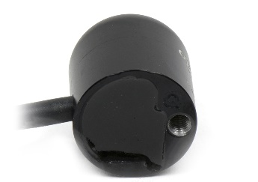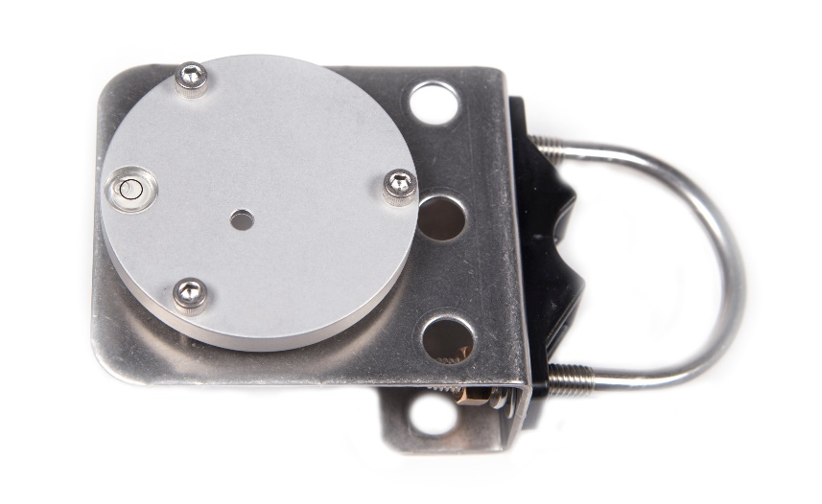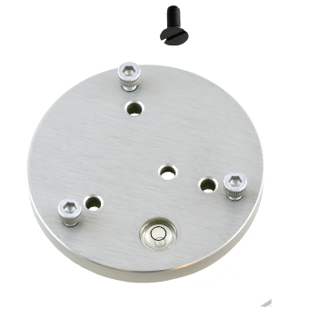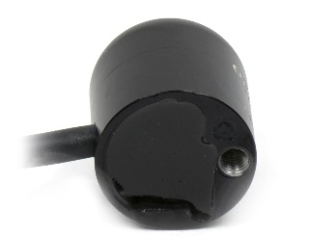

Nylon Screw: 10-32x3/8

Nylon Screw: 10-32x3/8

Model AL-120

Model AL-100

To minimize azimuth error, the sensor should be mounted with the cable pointing toward true north in the northern hemisphere or true south in the southern hemisphere. Azimuth error is typically less than 1 %, but it is easy to minimize by proper cable orientation.

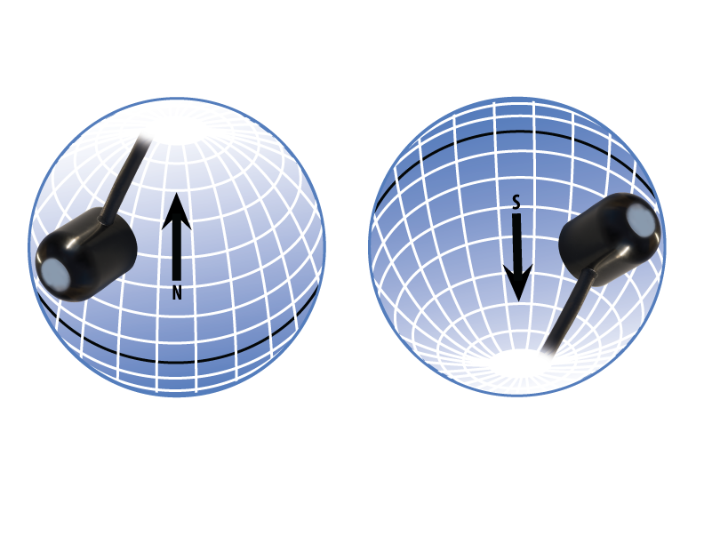

In addition to orienting the cable to point toward the nearest pole, the sensor should also be mounted such that obstructions (e.g., weather station tripod/tower or other instrumentation) do not shade the sensor. **Once mounted, the blue cap should be removed from the sensor.** The blue cap can be used as a protective covering for the sensor when it is not in use.

### Cable Connectors

|  |  |
| --- | --- |
| Apogee sensors offer cable connectors to simplify the process of removing sensors from weather stations for calibration (the entire cable does **not** have to be removed from the station and shipped with the sensor).  The ruggedized M8 connectors are rated IP68, made of corrosion-resistant marine-grade stainless-steel, and designed for extended use in harsh environmental conditions. | Inline cable connectors are installed 25 cm from the head |

**Instructions**

|  |  |
| --- | --- |
| **Pins and Wiring Colors:** All Apogee connectors have six pins, but not all pins are used for every sensor. There may also be unused wire colors inside the cable. To simplify datalogger connection, we remove the unused pigtail lead colors at the datalogger end of the cable.  If a replacement cable is required, please contact Apogee directly to ensure ordering the proper pigtail configuration.  **Alignment:** When reconnecting a sensor, arrows on the connector jacket and an aligning notch ensure proper orientation.  **Disconnection for extended periods:**  When disconnecting the sensor for an extended period of time from a station, protect the remaining half of the connector still on the station from water and dirt with electrical tape or other method. | A reference notch inside the connector ensures  proper alignment before tightening.    When sending sensors in for calibration, only send the short end of the cable and half the connector. |
| **Tightening:** Connectors are designed to be firmly finger-tightened only. There is an o-ring inside the connector that can be overly compressed if a wrench is used. Pay attention to thread alignment to avoid cross-threading. When fully tightened, 1-2 threads may still be visible. | Finger-tighten firmly |

### Operation and Measurement

Connect the sensor to a measurement device (meter, datalogger, controller) capable of measuring and displaying or recording a millivolt signal (an input measurement range of approximately 0-500 mV is required to cover the entire range of PPFD from the sun). In order to maximize measurement resolution and signal-to-noise ratio, the input range of the measurement device should closely match the output range of the quantum sensor. **DO NOT connect the sensor to a power source. The sensor is self-powered and applying voltage will damage the sensor.**

**VERY IMPORTANT: Apogee changed the wiring colors of all our bare-lead sensors in March 2018 in conjunction with the release of inline cable connectors on some sensors. To ensure proper connection to your data device, please note your serial number or if your sensor has a stainless-steel connector 30 cm from the sensor head then use the appropriate wiring configuration listed below. With the switch to connectors, we also changed to using cables that only have 4 or 7 internal wires. To make our various sensors easier to connect to your device, we clip off any unused wire colors at the end of the cable depending on the sensor. If you cut the cable or modify the original pigtail, you may find wires inside that are not used with your particular sensor. In this case, please disregard the extra wires and follow the color-coded wiring guide provided.**

|  |  |
| --- | --- |
| **Wiring for:** | **SQ-110 and SQ-120 Serial Numbers 25370 and above** |
|  | **SQ-313, SQ-323, SQ-316, SQ-326, SQ-311, SQ-311 Serial Number 3205 and above or with a connector** |

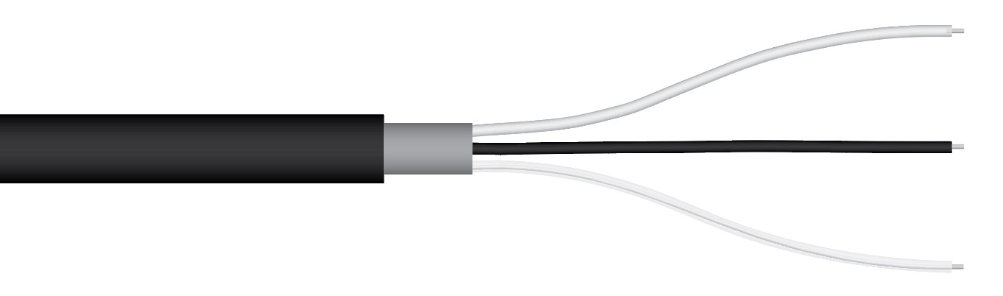

**White**: Positive (signal from sensor)

**Black**: Negative (signal from sensor)

**Clear:** Shield/Ground

|  |  |
| --- | --- |
| **Wiring for:** | **SQ-110 and SQ-120 Serial Numbers range 0-25369** |
|  | **SQ-313, SQ-323, SQ-316, SQ-326, SQ-311, SQ-311 Serial Numbers range 0-3204** |

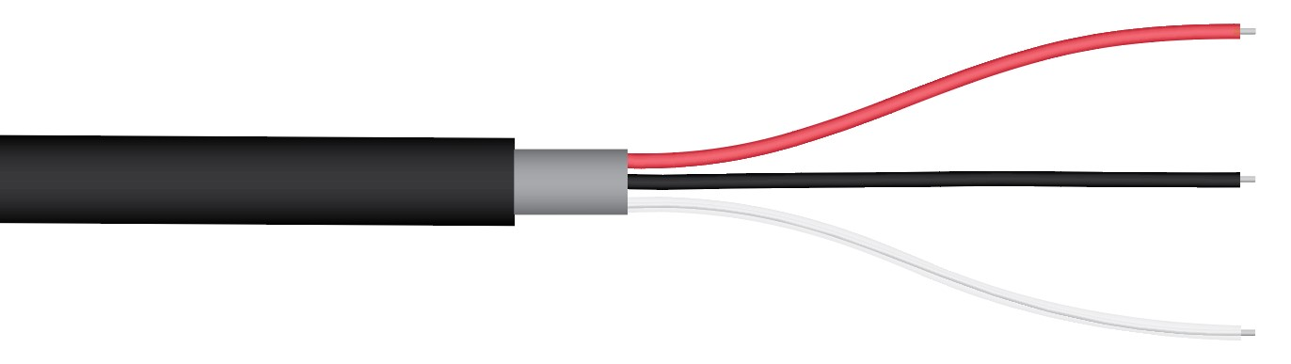

**Red:** Positive (signal from sensor)

**Black**: Negative (signal from sensor)

**Clear:** Shield/Ground

**Sensor Calibration**

All Apogee un-amplified quantum sensor models (SQ-100 and SQ-300 series) have a standard PPFD calibration factor of exactly:

**5.0 µmol m-2 s-1 per mV**

Multiply this calibration factor by the measured mV signal to convert sensor output to PPFD in units of µmol m-2 s-1:

**Calibration Factor (5.0 µmol m-2 s-1 per mV) * Sensor Output Signal (mV) = PPFD (µmol m-2 s-1)**

**5.0 * 400 = 2000**

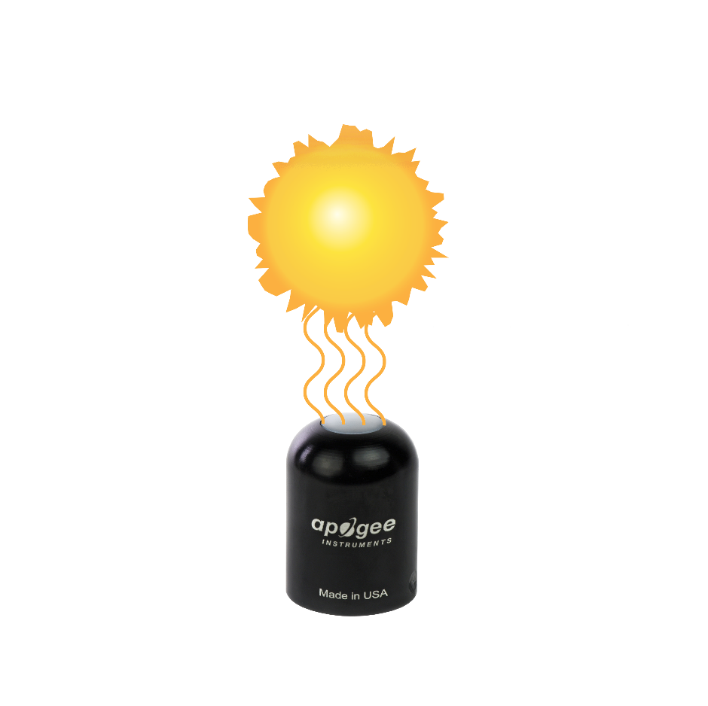

**Full Sunlight**

**(2000 µmol m-2 s-1)**

Example of PPFD measurement with an Apogee quantum sensor. Full sunlight yields a PPFD on a horizontal plane at the Earth’s surface of approximately 2000 µmol m-2 s-1. This yields an output signal of 400 mV. The signal is converted to PPFD by multiplying by the calibration factor of 5.00 µmol m-2 s-1 per mV.

**Sensor Output**

**400 mV**

**Spectral Errors and Yield Photon Flux Measurements**

Apogee quantum sensors are calibrated to measure PPFD for either sunlight or electric light. The difference between the calibrations is 12 %. A sensor calibrated for electric lights (calibration source is T5 cool white fluorescent lamps) will read approximately 12 % low in sunlight.

In addition to PPFD measurements, Apogee SQ series quantum sensors can also be used to measure yield photon flux density (YPFD): photon flux density weighted according to plant photosynthetic efficiency (McCree, 1972) and summed. YPFD is also expressed in units of µmol m-2 s-1, and is similar to PPFD, but has been reported to be more closely correlated to photosynthesis than PPFD in some studies. PPFD is usually measured and reported because the PPFD spectral weighting function (equal weight given to all photons between 400 and 700 nm; no weight given to photons outside this range) is easier to define and measure, and as a result, PPFD is widely accepted. The calibration factor for YPFD is 4.50 and 4.45 µmol m-2 s-1 per mV for sunlight and electric light measurements, respectively.

The weighting functions for PPFD and YPFD are shown in the graph below, along with the spectral response of Apogee SQ series quantum sensors. The closer the spectral response matches the defined PPFD or YPFD spectral weighting functions, the smaller spectral errors will be. The table below provides spectral error estimates for PPFD and YPFD measurements from light sources different than the calibration source. The method of Federer and Tanner (1966) was used to determine spectral errors based on the PPFD and YPFD spectral weighting functions, measured sensor spectral response, and radiation source spectral outputs (measured with a spectroradiometer). This method calculates spectral error and does not consider calibration, cosine, and temperature errors.

Federer, C. A., and C. B. Tanner, 1966. Sensors for measuring light available for photosynthesis. Ecology 47:654-657.

McCree, K. J., 1972. The action spectrum, absorptance and quantum yield of photosynthesis in crop plants. Agricultural Meteorology 9:191-216.



Radiation weighting factors for PPFD (defined plant response to radiation), YPFD (measured plant response to radiation), and Apogee SQ Series quantum sensors (sensor sensitivity to different wavelengths of radiation).

**Spectral Errors for PPFD and YPFD Measurements with Apogee SQ Series Quantum Sensors**

|  |  |  |
| --- | --- | --- |
| **Radiation Source (Error Calculated Relative to Sun, Clear Sky)** | **PPFD Error [%]** | **YPFD Error [%]** |
| Sun (Clear Sky) | 0.0 | 0.0 |
| Sun (Cloudy Sky) | 1.4 | 1.6 |
| Reflected from Grass Canopy | 5.7 | -6.3 |
| Reflected from Deciduous Canopy | 4.9 | -7.0 |
| Reflected from Conifer Canopy | 5.5 | -6.8 |
| Transmitted below Grass Canopy | 6.4 | -4.5 |
| Transmitted below Deciduous Canopy | 6.8 | -5.4 |
| Transmitted below Conifer Canopy | 5.3 | 2.6 |
| **Radiation Source (Error Calculated Relative to Cool White Fluorescent, T5)** |  |  |
| Cool White Fluorescent (T5) | 0.0 | 0.0 |
| Cool White Fluorescent (T8) | -0.3 | -1.2 |
| Cool White Fluorescent (T12) | -1.4 | -2.0 |
| Compact Fluorescent | -0.5 | -5.3 |
| Metal Halide | -3.7 | -3.7 |
| Ceramic Metal Halide | -6.0 | -6.4 |
| High Pressure Sodium | 0.8 | -7.2 |
| Blue LED (448 nm peak, 20 nm full-width half-maximum) | -12.7 | 8.0 |
| Green LED (524 nm peak, 30 nm full-width half-maximum) | 8.0 | 26.2 |
| Red LED (635 nm peak, 20 nm full-width half-maximum) | 4.8 | -6.2 |
| Red, Blue LED Mixture (85 % Red, 15 % Blue) | 2.4 | -4.4 |
| Red, Green, Blue LED Mixture (72 % Red, 16 % Green, 12 % Blue) | 3.4 | 0.2 |
| Cool White Fluorescent LED | -4.6 | -0.6 |
| Neutral White Fluorescent LED | -6.7 | -5.2 |
| Warm White Fluorescent LED | -10.9 | -13.0 |

Quantum sensors can be a very practical means of measuring PPFD and YPFD from multiple radiation sources, but spectral errors must be considered. The spectral errors in the table above can be used as correction factors for individual radiation sources.

**Underwater Measurements and Immersion Effect**

When a quantum sensor that was calibrated in air is used to make underwater measurements, the sensor reads low. This phenomenon is called the immersion effect and happens because the refractive index of water (1.33) is greater than air (1.00). The higher refractive index of water causes more light to be backscattered (or reflected) out of the sensor in water than in air (Smith,1969; Tyler and Smith,1970). As more light is reflected, less light is transmitted through the diffuser to the detector, which causes the sensor to read low. Without correcting for this effect, underwater measurements are only relative, which makes it difficult to compare light in different environments.

The SQ-100 and SQ-300 series sensors have an immersion effect correction factor of 1.08. This correction factor should be multiplied to measurements made underwater.

Further information on underwater measurements and the immersion effect can be found at <http://www.apogeeinstruments.com/underwater-par-measurements/>.

### Maintenance and Recalibration

Moisture or debris on the diffuser is a common cause of low readings. The sensor has a domed diffuser and housing for improved self-cleaning from rainfall, but materials can accumulate on the diffuser (e.g., dust during periods of low rainfall, salt deposits from evaporation of sea spray or sprinkler irrigation water) and partially block the optical path. Dust or organic deposits are best removed using water or window cleaner and a soft cloth or cotton swab. Salt deposits should be dissolved with vinegar and removed with a soft cloth or cotton swab. **Never use an abrasive material or cleaner on the diffuser.**

Although Apogee sensors are very stable, nominal accuracy drift is normal for all research-grade sensors. To ensure maximum accuracy, we generally recommend sensors are sent in for recalibration every two years, although you can often wait longer according to your particular tolerances.

To determine if your sensor needs recalibration, the Clear Sky Calculator ([www.clearskycalculator.com](http://www.clearskycalculator.com)) website and/or smartphone app can be used to indicate the total shortwave radiation incident on a horizontal surface at any time of day at any location in the world. It is most accurate when used near solar noon in spring and summer months, where accuracy over multiple clear and unpolluted days is estimated to be ± 4 % in all climates and locations around the world. For best accuracy, the sky must be completely clear, as reflected radiation from clouds causes incoming radiation to increase above the value predicted by the clear sky calculator. Measured values of total shortwave radiation can exceed values predicted by the Clear Sky Calculator due to reflection from thin, high clouds and edges of clouds, which enhances incoming shortwave radiation. The influence of high clouds typically shows up as spikes above clear sky values, not a constant offset greater than clear sky values.

To determine recalibration need, input site conditions into the calculator and compare total shortwave radiation measurements to calculated values for a clear sky. If sensor shortwave radiation measurements over multiple days near solar noon are consistently different than calculated values (by more than 6 %), the sensor should be cleaned and re-leveled. If measurements are still different after a second test, email [calibration@apogeeinstruments.com](mailto:calibration@apogeeinstruments.com) to discuss test results and possible return of sensor(s).

Homepage of the Clear Sky Calculator. Two calculators are available: one for quantum sensors (PPFD) and one for pyranometers (total shortwave radiation).

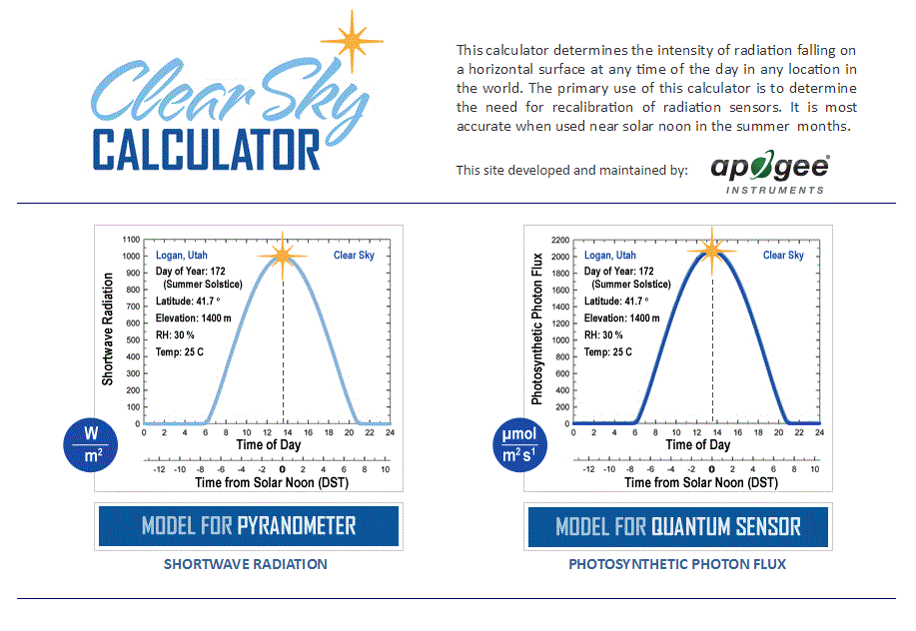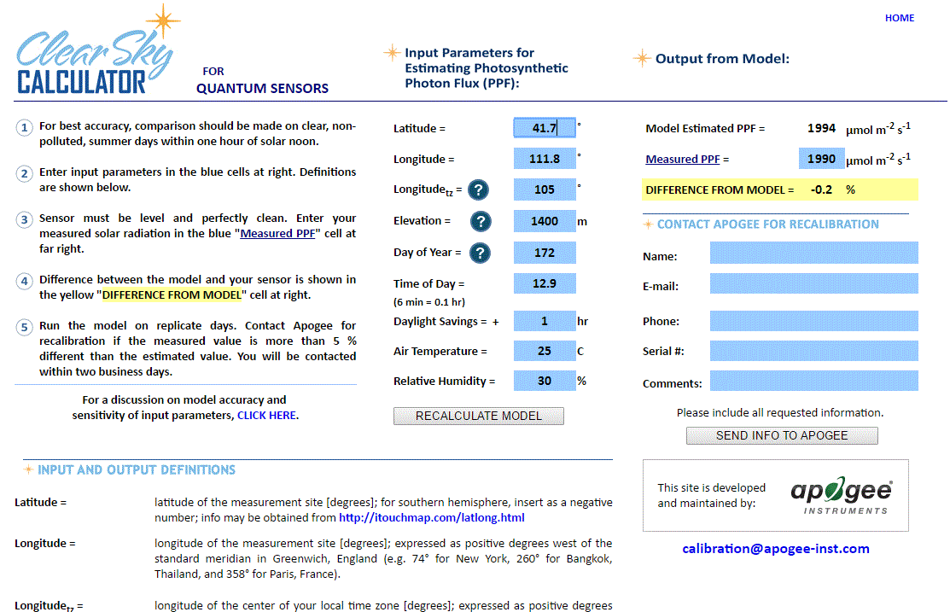

Clear Sky Calculator for quantum sensors. Site data are input in blue cells in middle of page and an estimate of PPFD is returned on right-hand side of page.

### Troubleshooting and Customer Support

**Independent Verification of Functionality**

Apogee SQ-100 and SQ-300 series quantum sensors are self-powered devices and output a voltage signal proportional to incident PPFD. A quick and easy check of sensor functionality can be determined using a voltmeter with millivolt resolution. Connect the positive lead wire from the voltmeter to the white wire from the sensor and the negative (or common) lead wire from the voltmeter to the black wire from the sensor. Direct the sensor head toward a light source and verify the sensor provides a signal. Increase and decrease the distance from the sensor head to the light source to verify that the signal changes proportionally (decreasing signal with increasing distance and increasing signal with decreasing distance). Blocking all radiation from the sensor should force the sensor signal to zero.

**Compatible Measurement Devices (Dataloggers/Controllers/Meters)**

SQ-100 and SQ-300 series quantum sensors are calibrated with a standard calibration factor of 5.0 µmol m-2 s-1 per mV, yielding a sensitivity of 0.2 mV per µmol m-2 s-1. Thus, a compatible measurement device (e.g., datalogger or controller) should have resolution of at least 0.2 mV in order to provide PPFD resolution of 1 µmol m-2 s-1.

An example datalogger program for Campbell Scientific dataloggers can be found on the Apogee webpage at <http://www.apogeeinstruments.com/content/Quantum-Sensor-Unamplified.CR1>.

**Cable Length**

When the sensor is connected to a measurement device with high input impedance, sensor output signals are not changed by shortening the cable or splicing on additional cable in the field. Tests have shown that if the input impedance of the measurements device is greater than 1 mega-ohm there is negligible effect on the calibration, even after adding up to 100 m of cable. All Apogee sensors use shielded, twisted pair cable to minimize electromagnetic interference. For best measurements, the shield wire must be connected to an earth ground. This is particularly important when using the sensor with long lead lengths in electromagnetically noisy environments.

**Modifying Cable Length**

See Apogee webpage for details on how to extend sensor cable length: (<http://www.apogeeinstruments.com/how-to-make-a-weatherproof-cable-splice/>).

**Unit Conversion Charts**

Apogee SQ series quantum sensors are calibrated to measure PPFD in units of µmol m-2 s-1. Units other than photon flux density (e.g., energy flux density, illuminance) may be required for certain applications. It is possible to convert the PPFD value from a quantum sensor to other units, but it requires spectral output of the radiation source of interest. Conversion factors for common radiation sources can be found on the Unit Conversions page in the Support Center on the Apogee website (<http://www.apogeeinstruments.com/unit-conversions/>; scroll down to Quantum Sensors section). A spreadsheet to convert PPFD to energy flux density or illuminance is also provided on the Unit Conversions page in the Support Center on the Apogee website (<http://www.apogeeinstruments.com/content/PPFD-to-Illuminance-Calculator.xls>).

### Return and Warranty Policy

RETURN POLICY

Apogee Instruments will accept returns within 30 days of purchase as long as the product is in new condition (to be determined by Apogee). Returns are subject to a 10 % restocking fee.

WARRANTY POLICY

**What is Covered**All products manufactured by Apogee Instruments are warranted to be free from defects in materials and craftsmanship for a period of four (4) years from the date of shipment from our factory. To be considered for warranty coverage an item must be evaluated by Apogee.

Products not manufactured by Apogee (spectroradiometers, chlorophyll content meters, EE08-SS probes) are covered for a period of one (1) year.

**What is Not Covered**The customer is responsible for all costs associated with the removal, reinstallation, and shipping of suspected warranty items to our factory.

The warranty does not cover equipment that has been damaged due to the following conditions:

1. Improper installation, use, or abuse.

2. Operation of the instrument outside of its specified operating range.

3. Natural occurrences such as lightning, fire, etc.

4. Unauthorized modification.

5. Improper or unauthorized repair.

Please note that nominal accuracy drift is normal over time. Routine recalibration of sensors/meters is considered part of proper maintenance and is not covered under warranty.

**Who is Covered**This warranty covers the original purchaser of the product or other party who may own it during the warranty period.

**What Apogee Will Do**At no charge Apogee will:

1. Either repair or replace (at our discretion) the item under warranty.

2. Ship the item back to the customer by the carrier of our choice.

Different or expedited shipping methods will be at the customer’s expense.

**How To Return An Item**1. Please do not send any products back to Apogee Instruments until you have received a Return Merchandise Authorization (RMA) number from our technical support department by submitting an online RMA form at [www.apogeeinstruments.com/tech-support-recalibration-repairs/](http://www.apogeeinstruments.com/tech-support-recalibration-repairs/). We will use your RMA number for tracking of the service item. Call (435) 245-8012 or email techsupport@apogeeinstruments.com with questions.

2. For warranty evaluations, send all RMA sensors and meters back in the following condition: Clean the sensor’s exterior and cord. Do not modify the sensors or wires, including splicing, cutting wire leads, etc. If a connector has been attached to the cable end, please include the mating connector – otherwise the sensor connector will be removed in order to complete the repair/recalibration. ***Note:*** *When sending back sensors for routine calibration that have Apogee’s standard stainless-steel connectors, you only need to send the sensor with the 30 cm section of cable and one-half of the connector. We have mating connectors at our factory that can be used for calibrating the sensor.*

3. Please write the RMA number on the outside of the shipping container.

4. Return the item with freight pre-paid and fully insured to our factory address shown below. We are not responsible for any costs associated with the transportation of products across international borders.

**Apogee Instruments, Inc.   
721 West 1800 North Logan, UT  
84321, USA**

5. Upon receipt, Apogee Instruments will determine the cause of failure. If the product is found to be defective in terms of operation to the published specifications due to a failure of product materials or craftsmanship, Apogee Instruments will repair or replace the items free of charge. If it is determined that your product is not covered under warranty, you will be informed and given an estimated repair/replacement cost.

Products Beyond the Warranty Period

For issues with sensors beyond the warranty period, please contact Apogee at [techsupport@apogeeinstruments.com](mailto:techsupport@apogeeinstruments.com) to discuss repair or replacement options.

Other Terms

The available remedy of defects under this warranty is for the repair or replacement of the original product, and Apogee Instruments is not responsible for any direct, indirect, incidental, or consequential damages, including but not limited to loss of income, loss of revenue, loss of profit, loss of data, loss of wages, loss of time, loss of sales, accruement of debts or expenses, injury to personal property, or injury to any person or any other type of damage or loss.

This limited warranty and any disputes arising out of or in connection with this limited warranty ("Disputes") shall be governed by the laws of the State of Utah, USA, excluding conflicts of law principles and excluding the Convention for the International Sale of Goods. The courts located in the State of Utah, USA, shall have exclusive jurisdiction over any Disputes.

This limited warranty gives you specific legal rights, and you may also have other rights, which vary from state to state and jurisdiction to jurisdiction, and which shall not be affected by this limited warranty. This warranty extends only to you and cannot by transferred or assigned. If any provision of this limited warranty is unlawful, void, or unenforceable, that provision shall be deemed severable and shall not affect any remaining provisions. In case of any inconsistency between the English and other versions of this limited warranty, the English version shall prevail.

This warranty cannot be changed, assumed, or amended by any other person or agreement.

**APOGEE INSTRUMENTS, INC. |** 721 WEST 1800 NORTH, LOGAN, UTAH 84321, USA

TEL: (435) 792-4700 | FAX: (435) 787-8268 | WEB: APOGEEINSTRUMENTS.COM

*Copyright © 2022 Apogee Instruments, Inc.*

### Appendix

**The spectral response of the SQ-300 series line quantum sensors changed in May 2021. Below is the updated information.**

**Serial Numbers**

The information below applies to these SQ-300 series sensors:

SQ-311 serial #’s 3557 and above

SQ-313 and SQ-316 serial #’s 3566 and above

**Spectral Response for SQ-300 series sensors: SQ-311 serial #’s 3557 and above, SQ-313 and SQ-316 serial #’s 3566 and above**

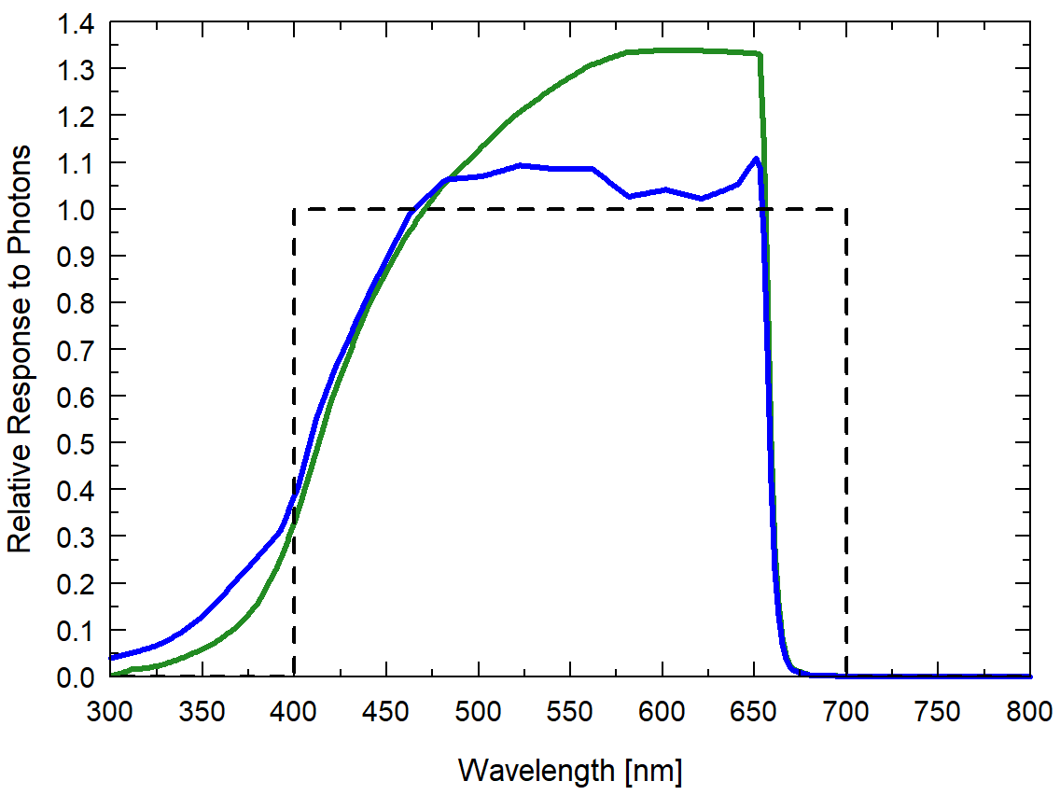

Spectral response of updated line quantum sensor spectral response graph (in green) vs. the original line quantum sensor response (in blue).

**Spectral Errors for PPFD and YPFD Measurements with Apogee SQ Series Quantum Sensors**

|  |  |  |  |
| --- | --- | --- | --- |
| **Radiation Source (Error Calculated Relative to Sun, Clear Sky)** | **\*SQ-300 Series** | **PPFD Error [%]** | **YPFD Error [%]** |
| Sun (Clear Sky) | 0.0 | 0.0 | 0.0 |
| Sun (Cloudy Sky) | 0.1 | 1.4 | 1.6 |
| Reflected from Grass Canopy | 7.4 | 5.7 | -6.3 |
| Reflected from Deciduous Canopy | 4.6 | 4.9 | -7.0 |
| Reflected from Conifer Canopy | 5.7 | 5.5 | -6.8 |
| Transmitted below Grass Canopy | 4.8 | 6.4 | -4.5 |
| Transmitted below Deciduous Canopy | 4.2 | 6.8 | -5.4 |
| Transmitted below Conifer Canopy | 3.8 | 5.3 | 2.6 |

Quantum sensors can be a very practical means of measuring PPFD and YPFD from multiple radiation sources, but spectral errors must be considered. The spectral errors in the table above can be used as correction factors for individual radiation sources.

*PPFD Error [%] for SQ-311 serial #’s 3557 and above, and SQ-313 and SQ-316 serial #’s 3566 and above.