

# Owner’s Manual

Pyranometer

Models SP-421  
Rev: 7-Sept-2021

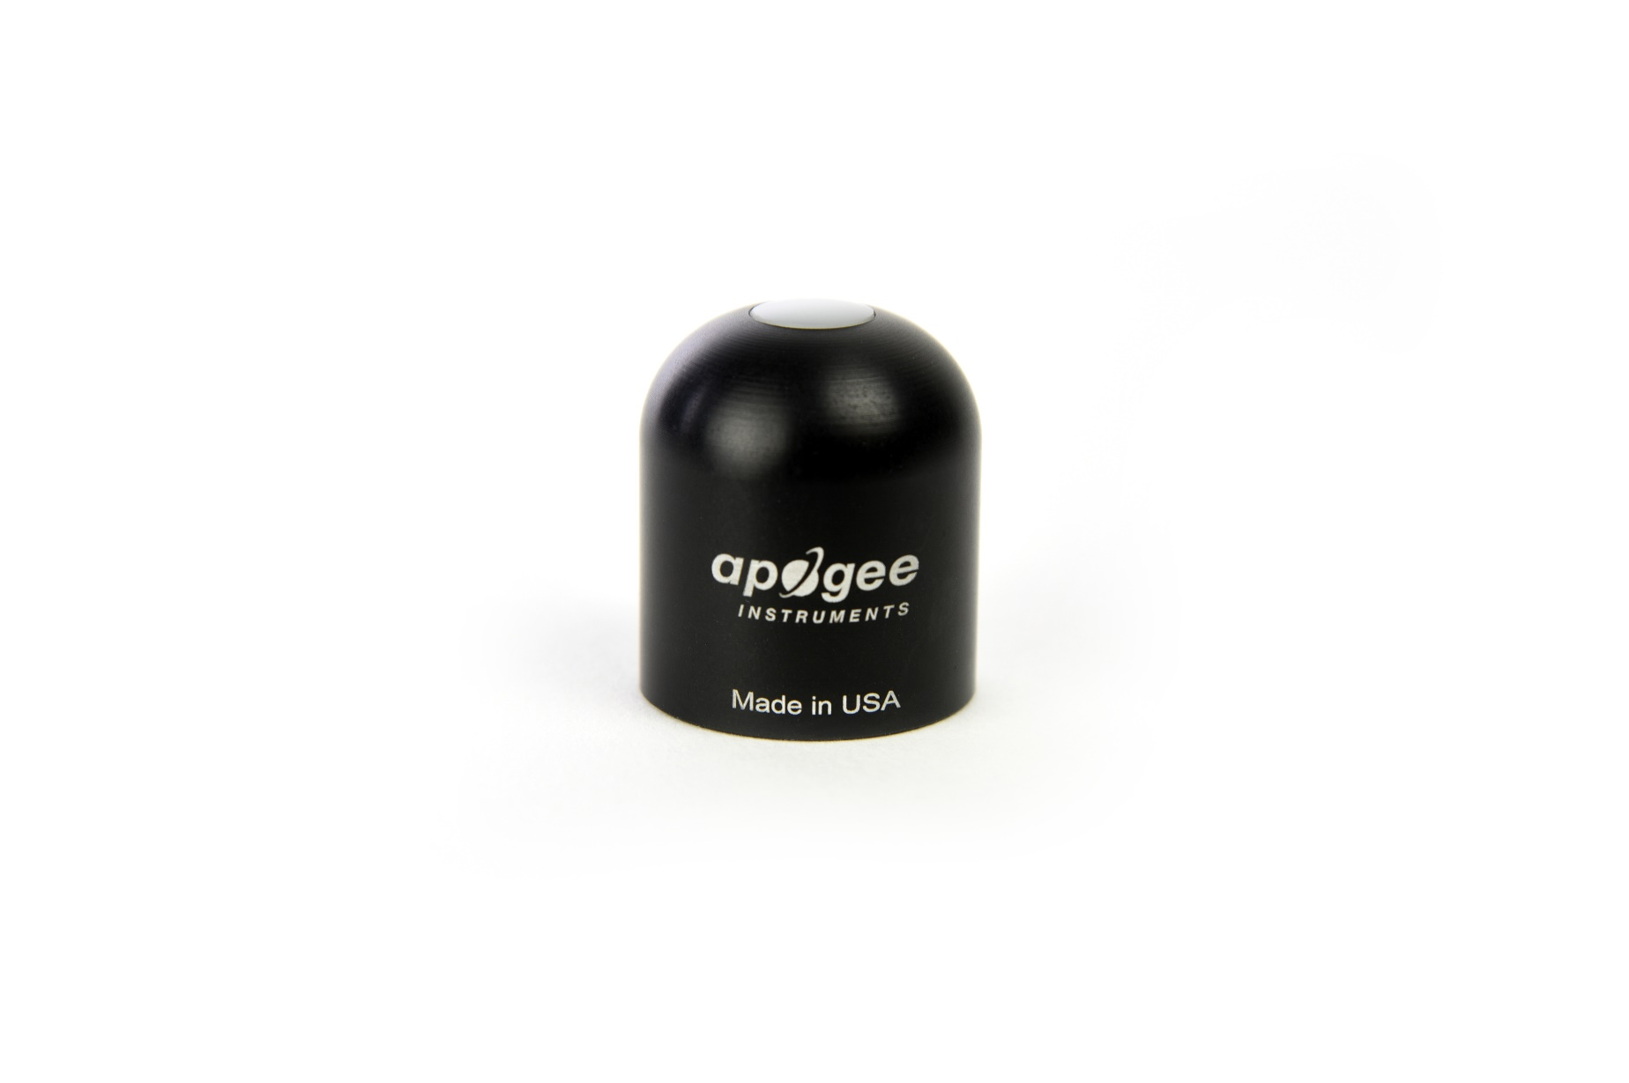

Table of Contents

Owner’s Manual 1

Certificate of Compliance 3

Introduction 4

Sensor Models 5

Specifications 6

Deployment and Installation 9

Cable Connectors 10

Operation and Measurement 11

Maintenace and Recalibration 19

Troubleshooting and Customer Support 21

Return and Warranty Policy 22

### Certificate of Compliance

**EU Declaration of Conformity**

This declaration of conformity is issued under the sole responsibility of the manufacturer:

Apogee Instruments, Inc.  
721 W 1800 N  
Logan, Utah 84321  
USA

for the following product(s):

Models: SP-421  
Type: Pyranometer

The object of the declaration described above is in conformity with the relevant Union harmonization legislation:

2014/30/EU Electromagnetic Compatibility (EMC) Directive

2011/65/EU Restriction of Hazardous Substances (RoHS 2) Directive

2015/863/EU Amending Annex II to Directive 2011/65/EU (RoHS 3)

Standards referenced during compliance assessment:

EN 61326-1:2013 Electrical equipment for measurement, control, and laboratory use – EMC requirements

EN 50581:2012 Technical documentation for the assessment of electrical and electronic products with respect to the restriction of hazardous substances

Please be advised that based on the information available to us from our raw material suppliers, the products manufactured by us do not contain, as intentional additives, any of the restricted materials including lead (see note below), mercury, cadmium, hexavalent chromium, polybrominated biphenyls (PBB), polybrominated diphenyls (PBDE), bis (2-ethylhexyl) phthalate (DEHP), butyl benzyl phthalate (BBP), dibutyl phthalate (DBP), and diisobutyl phthalate (DIBP). However, please note that articles containing greater than 0.1% lead concentration are RoHS 3 compliant using exemption 6c.

Further note that Apogee Instruments does not specifically run any analysis on our raw materials or end products for the presence of these substances, but we rely on the information provided to us by our material suppliers.

Signed for and on behalf of:

Apogee Instruments, September 2021



Bruce Bugbee  
President  
Apogee Instruments, Inc.

### Introduction

Solar radiation at Earth’s surface is typically defined as total radiation across a wavelength range of 280 to 4000 nm (shortwave radiation). Total solar radiation, direct beam and diffuse, incident on a horizontal surface is defined as global shortwave radiation, or shortwave irradiance (incident radiant flux), and is expressed in Watts per square meter (W m-2, equal to Joules per second per square meter).

Pyranometers are sensors that measure global shortwave radiation. Apogee SP series pyranometers are silicon-cell pyranometers and are only sensitive to a portion of the solar spectrum, approximately 350 to 1100 nm (approximately 80 % of total shortwave radiation is within this range). However, silicon-cell pyranometers are calibrated to estimate total shortwave radiation across the entire solar spectrum. Silicon-cell pyranometer specifications compare favorably to specifications for World Meteorological Organization (WMO) moderate and good quality classifications and specifications for International Organization of Standardization (ISO) Class C classification, but because of limited spectral sensitivity, they do not meet the spectral specification necessary for WMO certification.

Typical applications of silicon-cell pyranometers include incoming shortwave radiation measurement in agricultural, ecological, and hydrological weather networks, and solar panel arrays.

Apogee Instruments SP series pyranometers consist of a cast acrylic diffuser (filter), photodiode, and signal processing circuitry mounted in an anodized aluminum housing, and a cable to connect the sensor to a measurement device. Sensors are potted solid with no internal air space and are designed for continuous total shortwave radiation measurement on a planar surface in outdoor environments. SP series sensors output a digital signal using SDI-12 protocol.

### Sensor Models

|  |  |  |
| --- | --- | --- |
| Model | Signal | |
| SP-421 | **SDI-12** | |
| SP-110 | Self-powered |
| SP-230* | Self-powered |
| SP-212 | 0-2.5 V |
| SP-214 | 4-20 mA |
| SP-215 | 0-5 V |
| SP-420 | USB |
| SP-422 | Modbus |

This manual covers the SDI-12 protocol model SP-421 pyranometer sensor. Additional models are covered in their respective manuals.

*Pyranometer model SP-230 is similar to model SP-110, but includes internal heaters designed to keep the diffuser free of precipitation events such as dew or frost.

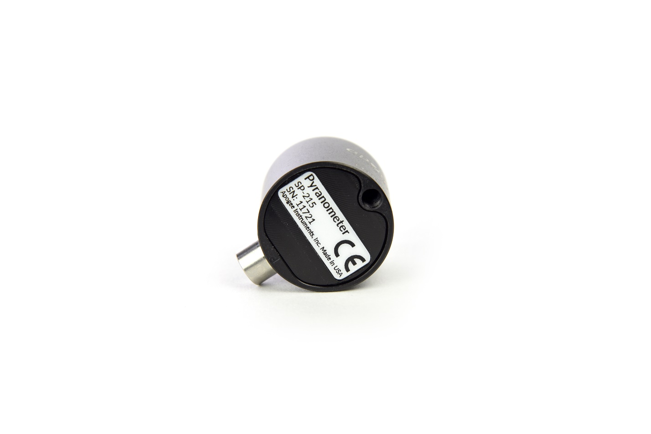

**Serial Numbers 1601 and above:** A sensor’s model number and serial number are located on the bottom of the sensor. If you need the manufacturing date of your sensor, please contact Apogee Instruments with the serial number of your sensor.

**Serial Number 0-1601:** A sensor’s model number and serial number are located near the pigtail leads on the sensor cable. If you need the manufacturing date of your sensor, please contact Apogee Instruments with the serial number of your sensor.

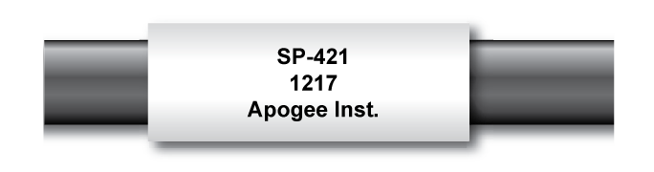

### Specifications

|  |  |
| --- | --- |
|  | **SP-421-SS** |
| ISO 9060:2018 | Class C (previously known as *second class*) |
| Input Voltage Requirement | 5.5 to 24 V DC |
| Current Draw | 1.5 mA (quiescent), 1.9 mA (active) |
| Output Range | 0 to 1750 W m-2 |
| Calibration Uncertainty at 1000 W m-2 | Less than 3 % (see Calibration Traceability below) |
| Measurement Repeatability | Less than 1 % |
| Long-term Drift  (Non-stability) | Less than 2 % per year |
| Non-linearity | Less than 1 % (up to 1750 W m-2) |
| Response Time | 0.6 s, time for detector signal to reach 95 % following a step change; fastest data transmission rate for SDI-12 circuitry is 1 s |
| Field of View | 180° |
| Spectral Range | 360 to 1120 nm (wavelengths where response is 10 % of maximum; see Spectral Response below) |
| Directional (Cosine) Response | ± 5 % at 75° zenith angle (see Cosine Response below) |
| Temperature Response | 0.04 ± 0.04 % per C (see Temperature Response below) |
| Operating Environment | -40 to 70 C; 0 to 100 % relative humidity; can be submerged in water up to depths of 30 m |
| Dimensions  Serial # 1601 and above | 30.5 mm diameter, 37 mm height |
| Dimensions  Serial # 0-1600 | 23.5 mm diameter, 44 mm height |
| Mass (with 5 m of cable)  Serial # 1601 and above | 140 g |
| Mass (with 5 m of cable)  Serial # 0-1600 | 177 g |
| Cable | 5 m of two conductor, shielded, twisted-pair wire, additional cable available in multiples of 5 m; TPR jacket (high water resistance, high UV stability, flexibility in cold conditions) |

**Calibration Traceability**

Apogee Instruments SP series pyranometers are calibrated through side-by-side comparison to the mean of four Apogee model SP-110 transfer standard pyranometers (shortwave radiation reference) under high intensity discharge metal halide lamps. The transfer standard pyranometers are calibrated through side-by-side comparison to the mean of at least two ISO-classified reference pyranometers under sunlight (clear sky conditions) in Logan, Utah. Each of four ISO-classified reference pyranometers are recalibrated on an alternating year schedule (two instruments each year) at the National Renewable Energy Laboratory (NREL) in Golden, Colorado. NREL reference standards are calibrated to the World Radiometric Reference (WRR) in Davos, Switzerland.

**Spectral Response**



Spectral response estimate of Apogee silicon-cell pyranometers. Spectral response was estimated by multiplying the spectral response of the photodiode, diffuser, and adhesive. Spectral response measurements of diffuser and adhesive were made with a spectrometer, and spectral response data for the photodiode were obtained from the manufacturer.

**Temperature Response**

Mean temperature response of four Apogee silicon-cell pyranometers. Temperature response measurements were made at approximately 10 C intervals across a temperature range of approximately -10 to 50 C under sunlight. Each pyranometer had an internal thermistor to measure temperature. At each temperature set point, a reference blackbody pyranometer was used to measure solar intensity.

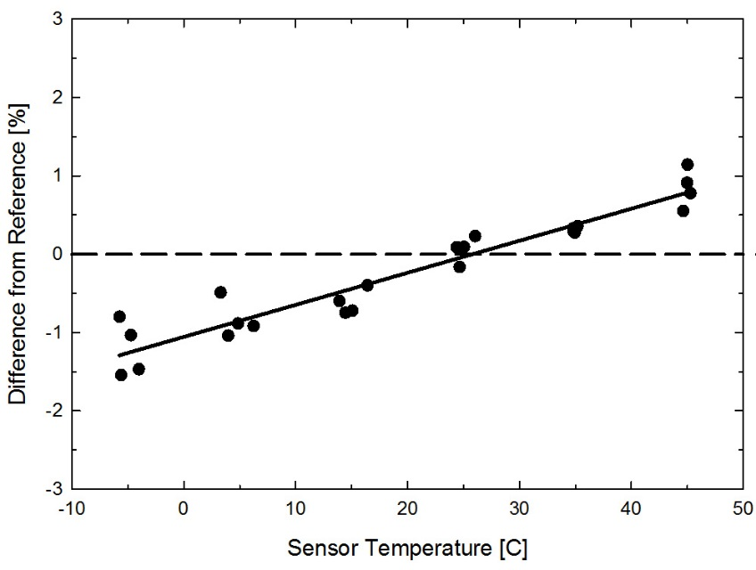

**Cosine Response**

**­**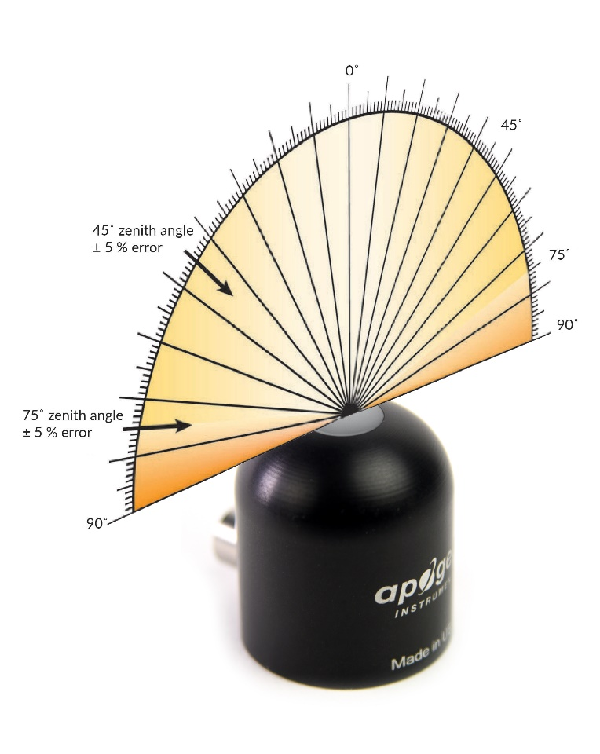

Directional, or cosine, response is defined as the measurement error at a specific angle of radiation incidence. Error for Apogee silicon-cell pyranometers is approximately ± 2 % and ± 5 % at solar zenith angles of 45° and 75°, respectively.

Mean cosine response of eleven Apogee silicon-cell pyranometers (***error bars represent two standard deviations above and below mean***). Cosine response measurements were made during broadband outdoor radiometer calibrations (BORCAL) performed during two different years at the National Renewable Energy Laboratory (NREL) in Golden, Colorado. Cosine response was calculated as the relative difference of pyranometer sensitivity at each solar zenith angle to sensitivity at 45° solar zenith angle. The blue symbols are AM measurements, the red symbols are PM measurements.



### Deployment and Installation

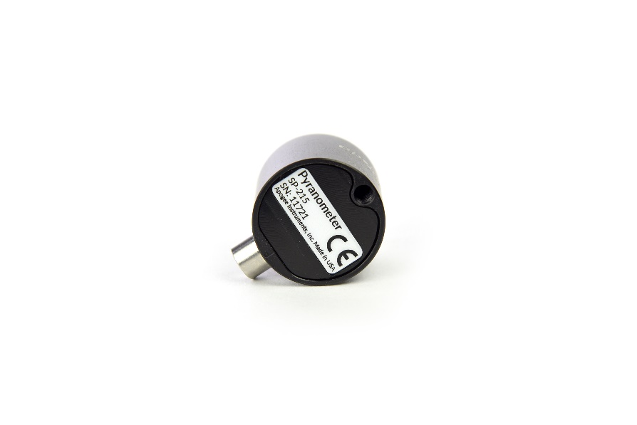Mount the sensor to a solid surface with the nylon mounting screw provided. To accurately measure PPFD incident on a horizontal surface, the sensor must be level. An Apogee Instruments model AL-100 Leveling Plate is recommended to level the sensor when used on a flat surface or being mounted to surfaces such as wood. To facilitate mounting on a mast or pipe, the Apogee Instruments model AL-120 Solar Mounting Bracket with Leveling Plate is recommended.

Important: Only use the nylon screw provided when mounting to insulate the non-anodized threads of the aluminum sensor head from the base to help prevent galvanic corrosion. For extended submersion applications, more insulation may be necessary. Contact Apogee tech support for details.

C:\Users\emyers\AppData\Local\Microsoft\Windows\INetCache\Content.Word\screw.png

Nylon Screw: 10-32x3/8

Nylon Screw: 10-32x3/8

C:\Users\emyers\AppData\Local\Microsoft\Windows\INetCache\Content.Word\screw.png

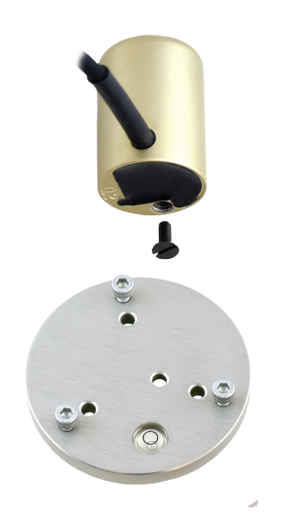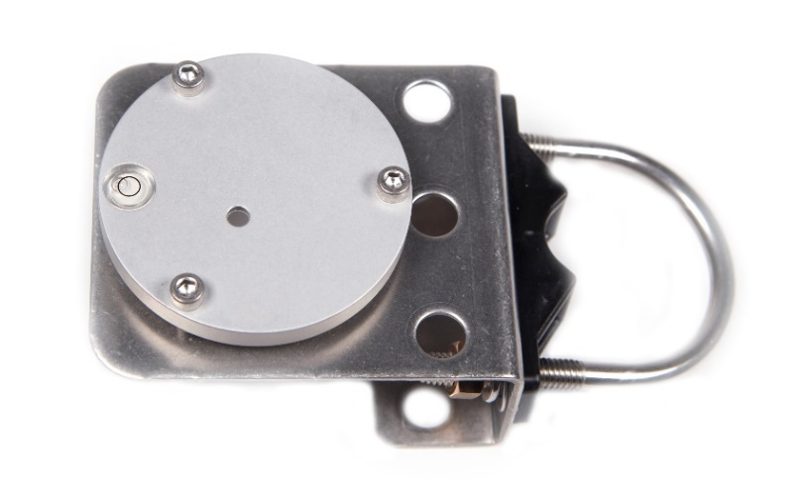

Model AL-100

Model AL-120

To minimize azimuth error, the sensor should be mounted with the cable pointing toward true north in the northern hemisphere or true south in the southern hemisphere. Azimuth error is typically less than 1 %, but it is easy to minimize by proper cable orientation.

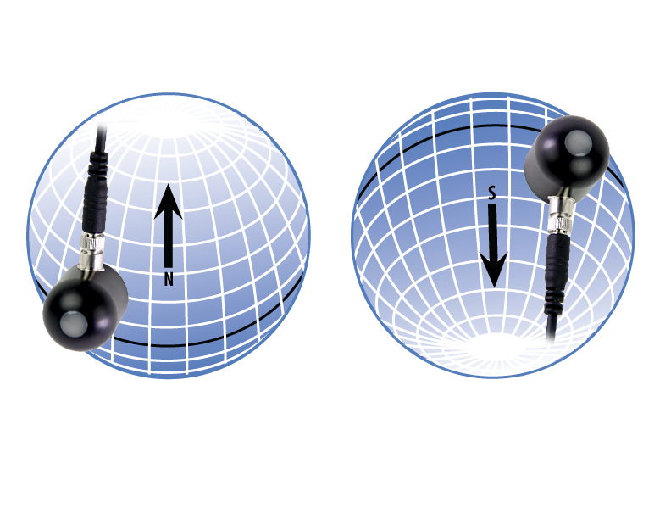

In addition to orienting the cable to point toward the nearest pole, the sensor should also be mounted such that obstructions (e.g., weather station tripod/tower or other instrumentation) do not shade the sensor. **Once mounted, the green cap should be removed from the sensor.** The green cap can be used as a protective covering for the sensor when it is not in use.

### Cable Connectors

|  |  |
| --- | --- |
| Apogee sensors offer cable connectors to simplify the process of removing sensors from weather stations for calibration (the entire cable does **not** have to be removed from the station and shipped with the sensor).  The ruggedized M8 connectors are rated IP68, made of corrosion-resistant marine-grade stainless-steel, and designed for extended use in harsh environmental conditions. | Cable connectors are attached directly to the head. |

**Instructions**

|  |  |
| --- | --- |
| **Pins and Wiring Colors:** All Apogee connectors have six pins, but not all pins are used for every sensor. There may also be unused wire colors inside the cable. To simplify datalogger connection, we remove the unused pigtail lead colors at the datalogger end of the cable.  If a replacement cable is required, please contact Apogee directly to ensure ordering the proper pigtail configuration.  **Alignment:** When reconnecting a sensor, arrows on the connector jacket and an aligning notch ensure proper orientation.  **Disconnection for extended periods:**  When disconnecting the sensor for an extended period of time from a station, protect the remaining half of the connector still on the station from water and dirt with electrical tape or other method. | A reference notch inside the connector ensures  proper alignment before tightening.    When sending sensors in for calibration, only send the sensor head. |
| **Tightening:** Connectors are designed to be firmly finger-tightened only. There is an  o-ring inside the connector that can be overly compressed if a wrench is used. Pay attention to thread alignment to avoid cross-threading. When fully tightened, 1-2 threads may still be visible.  **WARNING:** Do **not** tighten the connector by twisting the black cable or sensor head, only twist the metal connector (blue arrows). | Finger-tighten firmly |

### Operation and Measurement

The SP-421 pyranometer has a SDI-12 output, where shortwave radiation is returned in digital format. Measurement of SP-421 pyranometer requires a measurement device with SDI-12 functionality that includes the M or C command.

**VERY IMPORTANT: Apogee changed the wiring colors of all our bare-lead sensors in March 2018 in conjunction with the release of inline cable connectors on some sensors. To ensure proper connection to your data device, please note your serial number or if your sensor has a stainless-steel connector 30 cm from the sensor head then use the appropriate wiring configuration listed below. With the switch to connectors, we also changed to using cables that only have 4 or 7 internal wires. To make our various sensors easier to connect to your device, we clip off any unused wire colors at the end of the cable depending on the sensor. If you cut the cable or modify the original pigtail, you may find wires inside that are not used with your particular sensor. In this case, please disregard the extra wires and follow the color-coded wiring guide provided.**

**Wiring for SP-421 Serial Numbers 1174 and above or with a cable connector**

**White:** SDI-12 Data Line

**Red:** Power In (5.5-24 V DC)

**Black:** Ground

**Clear:** Shield/Ground

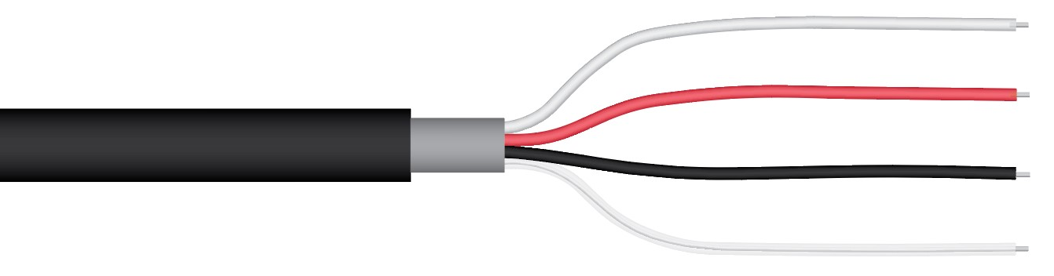

**Wiring for SP-421 Serial Numbers range 0-1173**

**Red:** Power In (4.5-24 V DC)

**Black:** SDI-12 Data Line

**Clear:** Ground (shield wire)

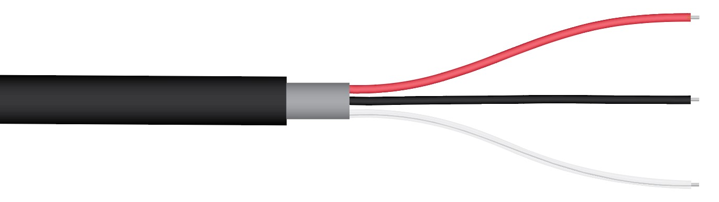

**Sensor Calibration**

The SP-421 pyranometer has sensor-specific calibration coefficients determined during the custom calibration process. Coefficients are programmed into the microcontrollers at the factory.

**SDI-12 Interface**

The following is a brief explanation of the serial digital interface SDI-12 protocol instructions used in Apogee SP-421 pyranometers. For questions on the implementation of this protocol, please refer to the official version of the SDI-12 protocol: <http://www.sdi-12.org/specification.php> (version 1.4, August 10, 2016).

**Overview**

During normal communication, the data recorder sends a packet of data to the sensor that consists of an address and a command. Then, the sensor sends a response. In the following descriptions, SDI-12 commands and responses are enclosed in quotes. The SDI-12 address and the command/response terminators are defined as follows:

**Sensors come from the factory with the address of “0” for use in single sensor systems. Addresses “1 to 9” and “A to Z”, or “a to z”, can be used for additional sensors connected to the same SDI-12 bus.**

“!” is the last character of a command instruction. In order to be compliant with SDI-12 protocol, all commands must be terminated with a “!”. SDI-12 language supports a variety of commands. Supported commands for the Apogee Instruments SP-421 pyranometers are listed in the following table (“a” is the sensor address. The following ASCII Characters are valid addresses: “0-9” or “A-Z”).

**Supported Commands for Apogee Instruments SP-421 Pyranometers**

|  |  |  |
| --- | --- | --- |
| **Instruction Name** | **Instruction Syntax** | **Description** |
| Send Identification Command | aI! | Send identification information |
| Measurement Command | aM! | Tells the sensor to take a measurement |
| Measurement Command w/ Check Character | aMC! | Tells the sensor to take a measurement and return it with a check character |
| Change Address Command | aAb! | Changes the address of the sensor from a to b |
| Concurrent Measurement Command | aC! | Used to take a measurement when more than one sensor is used on the same data line |
| Concurrent Measurement Command w/ Check Character | aCC! | Used to take a measurement when more than one sensor is used on the same data line. Data is returned with a check character. |
| Address Query Command | ?! | Used when the address is unknown to have the sensor identify its address |
| Get Data Command | aD0! | Retrieves the data from a sensor |
| Heater Commands | aXHxxx! | Turns heaters on and off |
| Running Average Command | aXAVG! | Returns or sets the running average for sensor measurements. |

**Make Measurement Command: M!**

The make measurement command signals a measurement sequence to be performed. Data values generated in response to this command are stored in the sensor's buffer for subsequent collection using “D” commands. Data will be retained in sensor storage until another “M”, “C”, or “V” command is

executed. M commands are shown in the following examples:

|  |  |  |
| --- | --- | --- |
| **Command** | **Response** | **Response to 0D0!** |
| aM! or aM0! | a0011<cr><lf> | Returns watts/m2 |
| aM1! | a0011<cr><lf> | Returns millivolt output |
| aM2! | a0011<cr><lf> | Returns angle offset from vertical in degrees. (0 degrees if pointed up, 180 degrees if pointed down.) Available in sensors with serial number 1601 or greater. |

where a is the sensor address (“0-9”, “A-Z”, “a-z”) and M is an upper-case ASCII character.

The data values are separated by the sign “+”, as in the following example (0 is the address):

|  |  |  |
| --- | --- | --- |
| **Command** | **Sensor Response** | **Sensor Response when data is ready** |
| 0M0! | 00011<cr><lf> | 0<cr><lf> |
| 0D0! | +1000.0<cr><lf> |  |
| 0M1! | 00011<cr><lf> | 0<cr><lf> |
| 0D0! | +200.0<cr><lf> |  |
| 0M2! | 00011<cr><lf> | 0<cr><lf> |
| 0D0! | 0+90.2<cr><lf> |  |

where 1000.0 is watts/m2 and 200 is mV.

**Concurrent Measurement Command: aC!**

A concurrent measurement is one which occurs while other SDI-12 sensors on the bus are also making measurements. This command is similar to the “aM!” command, however, the nn field has an extra digit and the sensor does not issue a service request when it has completed the measurement. Communicating with other sensors will NOT abort a concurrent measurement. Data values generated in response to this command are stored in the sensor's buffer for subsequent collection using “D” commands. The data will be retained in the sensor until another “M”, “C”, or “V” command is executed:

|  |  |  |
| --- | --- | --- |
| **Command** | **Response** | **Response to 0D0!** |
| aC! or aC0! | a00101<cr><lf> | Returns watts/m2 |
| aC1! | a00101<cr><lf> | Returns millivolt output |
| aC2! | a00101<cr><lf> | Returns angle offset from vertical in degrees. (0 degrees if pointed up, 180 degrees if pointed down.) Available in sensors with serial number 1601 or greater. |

where a is the sensor address (“0-9”, “A-Z”, “a-z”, “*”, “?”) and C is an upper-case ASCII character.

For example (0 is the address):

|  |  |
| --- | --- |
| **Command** | **Sensor Response** |
| 0C0! | 000101<cr><lf> |
| 0D0! | +1000.0<cr><lf> |
| 0C1! | 000101<cr><lf> |
| 0D0! | +200.0<cr><lf> |
| 0C2! | 000101<cr><lf> |
| 0D0! | 0+90.2<cr><lf> |

where 1000.0 is watts/m2 and 200 is mV.

**Change Sensor Address: aAn!**

The change sensor address command allows the sensor address to be changed. If multiple SDI-12 devices are on the same bus, each device will require a unique SDI-12 address. For example, two SDI-12 sensors with the factory address of 0 requires changing the address on one of the sensors to a non-zero value in order for both sensors to communicate properly on the same channel:

|  |  |  |
| --- | --- | --- |
| **Command** | **Response** | **Description** |
| aAb! | b<cr><lf> | Change the address of the sensor |

where a is the current (old) sensor address (“0-9”, “A-Z”), A is an upper-case ASCII character denoting the instruction for changing the address, b is the new sensor address to be programmed (“0-9”, “A-Z”), and ! is the standard character to execute the command. If the address change is successful, the datalogger will respond with the new address and a <cr><lf>.

**Send Identification Command: aI!**

The send identification command responds with sensor vendor, model, and version data. Any

measurement data in the sensor's buffer is not disturbed:

|  |  |  |
| --- | --- | --- |
| **Command** | **Response** | **Description** |
| "aI!" | a13Apogee SP-421vvvxx…xx<cr><lf> | The sensor serial number and other identifying values are returned |

where a is the sensor address (“0-9”, “A-Z”, “a-z”, “*”, “?”), 421 is the sensor model number, vvv is a three-character field specifying the sensor version number, and xx...xx is serial number.

**Heater Control**

The default is for the heater to be off. Heater use is recommended if deploying sensor in a cold environment where ice and dew may accumulate on the sensor head or if you need to save power. The heater can be turned on and off using the following extended commands.

|  |  |  |
| --- | --- | --- |
| **Command** | **Response** | **Description** |
| "aXHON!" | a<cr><lf> | Turns Heater on |
| "aXHOFF!" | a<cr><lf> | Turns Heater off |

where a is the sensor address (“0-9”, “A-Z”, “a-z”, “*”, “?”).

**Running Average Command**

The running average command can be used to set or query the number of measurements that are averaged together before returning a value from a M! or MC! command. For example, if a user sends the command “0XAVG10!” to sensor with address 0, that sensor will average 10 measurements before sending the averaged value to the logger. To turn off averaging, the user should send the command “*a*XAVG1” to the sensor. To query the sensor to see how many measurements are being averaged, send the command “*a*XAVG!” and the sensor will return the number of measurements being averaged (see table below). The default for sensors is to have averaging turned off.

|  |  |  |  |
| --- | --- | --- | --- |
| **Command Name** | **Characters Sent** | **Response** | **Description** |
| Query running Average | *a*XAVG! | *an* | a = sensor address, *n* = number of measurements used in average calculation. Note: *n* may be multiple digits. |
| Set running Average | *a*XAVG*n!* | *a* | a = sensor address, *n* = number of measurements to be used in average calculation. Note: *n* may be any value from 1 to 100. |

**Metadata Commands**

**Identify Measurement Commands**

The Identify Measurement Commands can be used to view the command response without making a measurement. The command response indicates the time it takes to make the measurement and the number of data values that it returns. It works with the Verification Command (aV!), Measurement Commands (aM!, aM1! … aM9!, aMC!, aMC1! … aMC9!), and Concurrent Measurement Commands (aC!, aC1! … aC9! , aCC!, aCC1! … aCC9!).

The format of the Identify Measurement Command is the address, the capital letter I, the measurement command, and the command terminator (“!”), as follows:

<address>I<command>!

The format of the response is the same as if the sensor is making a measurement. For the Verification Command and Measurement Commands, the response is atttn<CR><LF>. For the C Command, it is atttnn<CR><LF>. For the High-Volume Commands, it is atttnnn<CR><LF>. The address is indicated by a, the time in seconds to make the measurement is indicated by ttt, and the number of measurements is indicated by n, nn, and nnn. The response is terminated with a Carriage Return (<CR>) and Line Feed (<LF>).

Identify Measurement Command example:

|  |  |
| --- | --- |
| 3IMC2! | The Identify Measurement Command for sensor address 3, M2 command, requesting a CRC. |
| 30032<CR><LF> | The response from sensor addresses three indicating that the measurement will take three seconds and two data values will be returned. |

**Identify Measurement Parameter Commands**

The Measurement Parameter Commands can be used to retrieve information about each data value that a command returns. The first value returned is a Standard Hydrometeorological Exchange Format (SHEF) code. SHEF codes are published by the National Oceanic and Atmospheric Administration (NOAA). The SHEF code manual can be found at <http://www.nws.noaa.gov/oh/hrl/shef/indexshef.htm>. The second value is the units of the parameter. Additional fields with more information are optional.

The Measurement Parameter Commands work with the Verification Command (aV!), Measurement Commands (aM!, aM1! … aM9!, aMC!, aMC1! … aMC9!), and Concurrent Measurement Commands (aC!, aC1! … aC9! , aCC!, aCC1! … aCC9!).

The format of the Identify Measurement Parameter Command is the address, the capital letter I, the measurement command, the underscore character (“_”), a three-digit decimal number, and the command terminator (“!”). The three-digit decimal indicates which number of measurement that the command returns, starting with “001” and continuing to “002” and so on, up to the number of measurements that the command returns.

<address>I<command>_<three-digit decimal>!

The format of the response is comma delimited and terminated with a semicolon. The first value is the address. The second value is the SHEF code. The third value is the units. Other optional values may appear, such as a description of the data value. The response is terminated with a Carriage Return (<CR>) and Line Feed (<LF>).

a,<SHEF Code>,<units>;<CR><LF>

Identify Measurement Parameter Command example:

|  |  |
| --- | --- |
| 1IC_001! | The Identify Measurement Parameter Command for sensor address 1, C command, data value 1. |
| 1,RW,Watts/meter squared, incoming solar radiation;<CR><LF> | The response from sensor addresses 1, SHEF code RW, units of Watts/meter squared, and additional information of incoming solar radiation. |

**Spectral Errors for Measurements with Silicon-cell Pyranometers**

Apogee SP series pyranometers are calibrated under electric lamps in a calibration laboratory. The calibration procedure simulates calibration under clear sky conditions at a solar zenith angle of approximately 45°. However, due to the limited spectral sensitivity of silicon-cell pyranometers compared to the solar radiation spectrum (see graph below), spectral errors occur when measurements are made in conditions that differ from conditions the sensor was calibrated under (e.g., the solar spectrum differs in clear sky and cloudy conditions, thus, measurements in cloudy conditions result in spectral error because sensors are calibrated in clear sky conditions).



Spectral response of Apogee SP series pyranometers compared to solar radiation spectrum at Earth’s surface. Silicon-cell pyranometers, such as Apogee SP series, are only sensitive to the wavelength range of approximately 350-1100 nm and are not equally sensitive to all wavelengths within this range. As a result, when the spectral content of solar radiation is significantly different than the spectrum that silicon-cell pyranometers were calibrated to, spectral errors result.

Silicon-cell pyranometers can still be used to measure shortwave radiation in conditions other than clear sky or from radiation sources other than incoming sunlight, but spectral errors occur when measuring radiation with silicon-cell pyranometers in these conditions. The graphs below show spectral error estimates for Apogee silicon-cell pyranometers at varying solar zenith angles and varying atmospheric air mass. The diffuser is optimized to minimize directional errors, thus the cosine response graph in the Specifications section shows the actual directional errors in practice (which includes contributions from the spectral shift that occurs as solar zenith angle and atmospheric air mass change with time of day and time of year). The table below provides spectral error estimates for shortwave radiation measurements from shortwave radiation sources other than clear sky solar radiation.



Spectral error for Apogee SP series pyranometers as a function of solar zenith angle, assuming calibration at a zenith angle of 45°.



Spectral error for Apogee SP series pyranometers as a function of atmospheric air mass, assuming calibration at an air mass of 1.5.

**Spectral Errors for Shortwave Radiation Measurements with Apogee SP Series Pyranometers**

|  |  |
| --- | --- |
| **Radiation Source (Error Calculated Relative to Sun, Clear Sky)** | **Error [%]** |
| Sun (Clear Sky) | 0.0 |
| Sun (Cloudy Sky) | 9.6 |
| Reflected from Grass Canopy | 14.6 |
| Reflected from Deciduous Canopy | 16.0 |
| Reflected from Conifer Canopy | 19.2 |
| Reflected from Agricultural Soil | -12.1 |
| Reflected from Forest Soil | -4.1 |
| Reflected from Desert Soil | 3.0 |
| Reflected from Water | 6.6 |
| Reflected from Ice | 0.3 |
| Reflected from Snow | 13.7 |

### Maintenace and Recalibration

Moisture or debris on the diffuser is a common cause of low readings. The sensor has a domed diffuser and housing for improved self-cleaning from rainfall, but materials can accumulate on the diffuser (e.g., dust during periods of low rainfall, salt deposits from evaporation of sea spray or sprinkler irrigation water) and partially block the optical path. Dust or organic deposits are best removed using water or window cleaner and a soft cloth or cotton swab. Salt deposits should be dissolved with vinegar and removed with a soft cloth or cotton swab. **Never use an abrasive material or cleaner on the diffuser.**

Although Apogee sensors are very stable, nominal accuracy drift is normal for all research-grade sensors. To ensure maximum accuracy, we generally recommend sensors are sent in for recalibration every two years, although you can often wait longer according to your particular tolerances.

To determine if your sensor needs recalibration, the Clear Sky Calculator ([www.clearskycalculator.com](http://www.clearskycalculator.com)) website and/or smartphone app can be used to indicate the total shortwave radiation incident on a horizontal surface at any time of day at any location in the world. It is most accurate when used near solar noon in spring and summer months, where accuracy over multiple clear and unpolluted days is estimated to be ± 4 % in all climates and locations around the world. For best accuracy, the sky must be completely clear, as reflected radiation from clouds causes incoming radiation to increase above the value predicted by the clear sky calculator. Measured values of total shortwave radiation can exceed values predicted by the Clear Sky Calculator due to reflection from thin, high clouds and edges of clouds, which enhances incoming shortwave radiation. The influence of high clouds typically shows up as spikes above clear sky values, not a constant offset greater than clear sky values.

To determine recalibration need, input site conditions into the calculator and compare total shortwave radiation measurements to calculated values for a clear sky. If sensor shortwave radiation measurements over multiple days near solar noon are consistently different than calculated values (by more than 6 %), the sensor should be cleaned and re-leveled. If measurements are still different after a second test, email [calibration@apogeeinstruments.com](mailto:calibration@apogeeinstruments.com) to discuss test results and possible return of sensor(s).

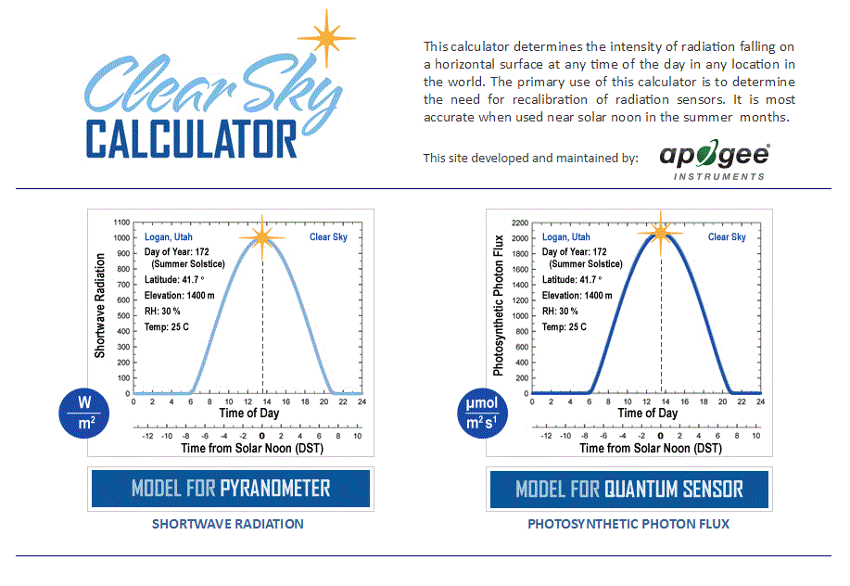

Homepage of the Clear Sky Calculator. Two calculators are available: One for pyranometers (total shortwave radiation) and one for quantum sensors (photosynthetic photon flux density).

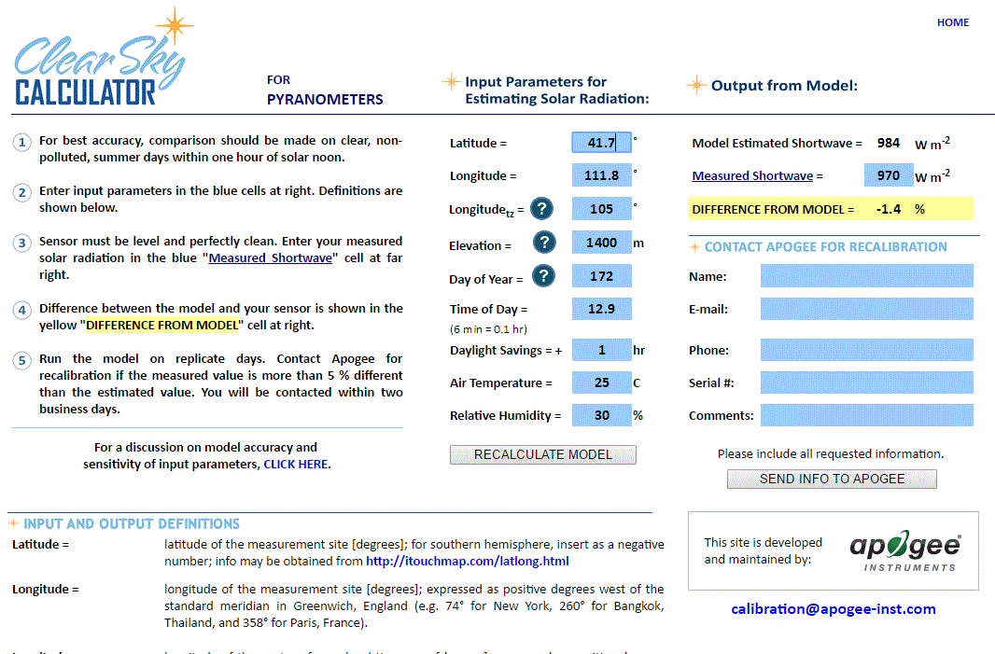

Clear Sky Calculator for pyranometers. Site data are input in blue cells in middle of page and an estimate of total shortwave radiation is returned on right-hand side of page.

### Troubleshooting and Customer Support

**Independent Verification of Functionality**

If the sensor does not communicate with the datalogger, use an ammeter to check the current draw. It should be near 1.5 mA when the sensor is not communicating and spike to approximately 1.9 mA when the sensor is communicating. Any current draw greater than approximately 6 mA indicates a problem with power supply to the sensors, wiring of the sensor, or sensor electronics.

**Compatible Measurement Devices (Dataloggers/Controllers/Meters)**

Any datalogger or meter with SDI-12 functionality that includes the M or C command.

An example datalogger program for Campbell Scientific dataloggers can be found on the Apogee webpage at <http://www.apogeeinstruments.com/content/Pyranometer-Digital.CR1>.

**Modifying Cable Length**

SDI-12 protocol limits cable length to 60 meters. For multiple sensors connected to the same data line, the maximum is 600 meters of total cable (e.g., ten sensors with 60 meters of cable per sensor). See Apogee webpage for details on how to extend sensor cable length (<http://www.apogeeinstruments.com/how-to-make-a-weatherproof-cable-splice/>).

### Return and Warranty Policy

RETURN POLICY

Apogee Instruments will accept returns within 30 days of purchase as long as the product is in new condition (to be determined by Apogee). Returns are subject to a 10 % restocking fee.

WARRANTY POLICY

**What is Covered**All products manufactured by Apogee Instruments are warranted to be free from defects in materials and craftsmanship for a period of four (4) years from the date of shipment from our factory. To be considered for warranty coverage an item must be evaluated by Apogee.

Products not manufactured by Apogee (spectroradiometers, chlorophyll content meters, EE08-SS probes) are covered for a period of one (1) year.

**What is Not Covered**The customer is responsible for all costs associated with the removal, reinstallation, and shipping of suspected warranty items to our factory.

The warranty does not cover equipment that has been damaged due to the following conditions:

1. Improper installation or abuse.

2. Operation of the instrument outside of its specified operating range.

3. Natural occurrences such as lightning, fire, etc.

4. Unauthorized modification.

5. Improper or unauthorized repair.

Please note that nominal accuracy drift is normal over time. Routine recalibration of sensors/meters is considered part of proper maintenance and is not covered under warranty.

**Who is Covered**This warranty covers the original purchaser of the product or other party who may own it during the warranty period.

**What Apogee Will Do**At no charge Apogee will:

1. Either repair or replace (at our discretion) the item under warranty.

2. Ship the item back to the customer by the carrier of our choice.

Different or expedited shipping methods will be at the customer’s expense.

**How To Return An Item**1. Please do not send any products back to Apogee Instruments until you have received a Return Merchandise Authorization (RMA) number from our technical support department by submitting an online RMA form at [www.apogeeinstruments.com/tech-support-recalibration-repairs/](http://www.apogeeinstruments.com/tech-support-recalibration-repairs/). We will use your RMA number for tracking of the service item. Call (435) 245-8012 or email techsupport@apogeeinstruments.com with questions.

2. For warranty evaluations, send all RMA sensors and meters back in the following condition: Clean the sensor’s exterior and cord. Do not modify the sensors or wires, including splicing, cutting wire leads, etc. If a connector has been attached to the cable end, please include the mating connector – otherwise the sensor connector will be removed in order to complete the repair/recalibration. ***Note:*** *When sending back sensors for routine calibration that have Apogee’s standard stainless-steel connectors, you only need to send the sensor with the 30 cm section of cable and one-half of the connector. We have mating connectors at our factory that can be used for calibrating the sensor.*

3. Please write the RMA number on the outside of the shipping container.

4. Return the item with freight pre-paid and fully insured to our factory address shown below. We are not responsible for any costs associated with the transportation of products across international borders.

**Apogee Instruments, Inc.   
721 West 1800 North Logan, UT  
84321, USA**

5. Upon receipt, Apogee Instruments will determine the cause of failure. If the product is found to be defective in terms of operation to the published specifications due to a failure of product materials or craftsmanship, Apogee Instruments will repair or replace the items free of charge. If it is determined that your product is not covered under warranty, you will be informed and given an estimated repair/replacement cost.

Products Beyond the Warranty Period

For issues with sensors beyond the warranty period, please contact Apogee at [techsupport@apogeeinstruments.com](mailto:techsupport@apogeeinstruments.com) to discuss repair or replacement options.

Other Terms

The available remedy of defects under this warranty is for the repair or replacement of the original product, and Apogee Instruments is not responsible for any direct, indirect, incidental, or consequential damages, including but not limited to loss of income, loss of revenue, loss of profit, loss of data, loss of wages, loss of time, loss of sales, accruement of debts or expenses, injury to personal property, or injury to any person or any other type of damage or loss.

This limited warranty and any disputes arising out of or in connection with this limited warranty ("Disputes") shall be governed by the laws of the State of Utah, USA, excluding conflicts of law principles and excluding the Convention for the International Sale of Goods. The courts located in the State of Utah, USA, shall have exclusive jurisdiction over any Disputes.

This limited warranty gives you specific legal rights, and you may also have other rights, which vary from state to state and jurisdiction to jurisdiction, and which shall not be affected by this limited warranty. This warranty extends only to you and cannot by transferred or assigned. If any provision of this limited warranty is unlawful, void, or unenforceable, that provision shall be deemed severable and shall not affect any remaining provisions. In case of any inconsistency between the English and other versions of this limited warranty, the English version shall prevail.

This warranty cannot be changed, assumed, or amended by any other person or agreement

**APOGEE INSTRUMENTS, INC. |** 721 WEST 1800 NORTH, LOGAN, UTAH 84321, USA

TEL: (435) 792-4700 | FAX: (435) 787-8268 | WEB: APOGEEINSTRUMENTS.COM

*Copyright © 2021 Apogee Instruments, Inc.*