

# Owner’s Manual

Pyranometer

Model SP-214

Rev: 7-Sept-2021

­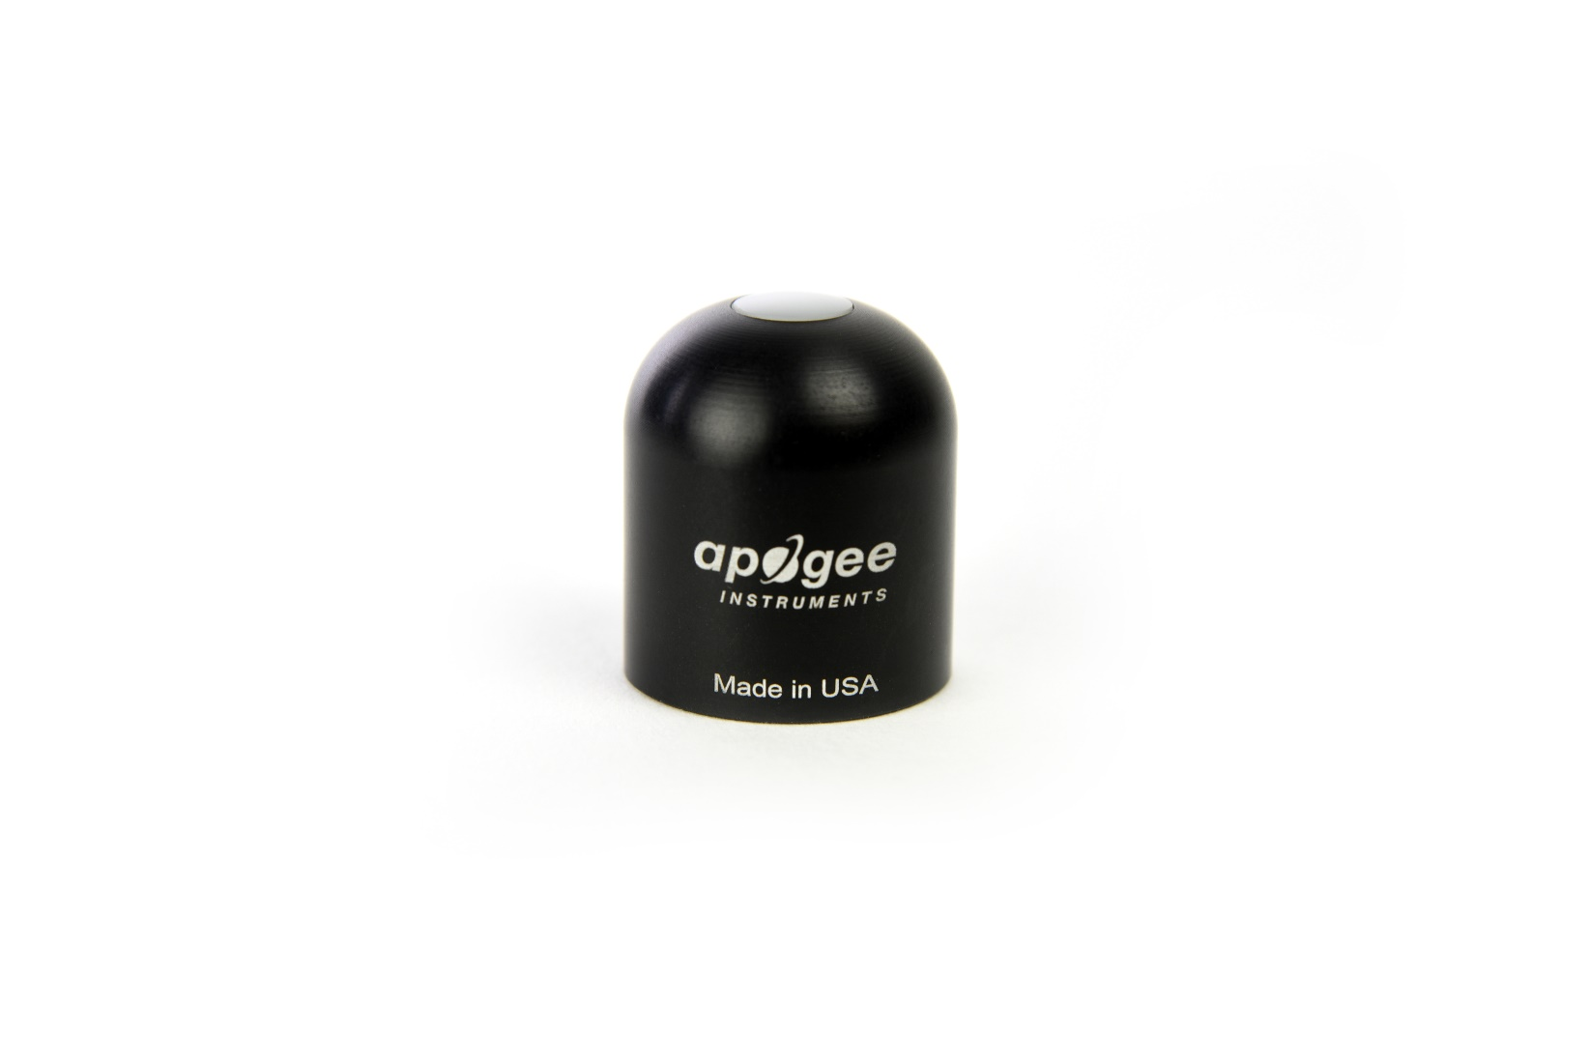

Table of Contents

Owner’s Manual 1

Certificate of Compliance 3

Introduction 4

Sensor Models 5

Specifications 6

Deployment and Installation 9

Cable Connectors 10

Operation and Measurement 11

Maintenance and Recalibration 15

Troubleshooting and Customer Support 17

Return and Warranty Policy 18

### Certificate of Compliance

**EU Declaration of Conformity**

This declaration of conformity is issued under the sole responsibility of the manufacturer:

Apogee Instruments, Inc.  
721 W 1800 N  
Logan, Utah 84321  
USA

for the following product(s):

Models: SP-214  
Type: Pyranometer

The object of the declaration described above is in conformity with the relevant Union harmonization legislation:

2014/30/EU Electromagnetic Compatibility (EMC) Directive

2011/65/EU Restriction of Hazardous Substances (RoHS 2) Directive

2015/863/EU Amending Annex II to Directive 2011/65/EU (RoHS 3)

Standards referenced during compliance assessment:

EN 61326-1:2013 Electrical equipment for measurement, control, and laboratory use – EMC requirements

EN 50581:2012 Technical documentation for the assessment of electrical and electronic products with respect to the restriction of hazardous substances

Please be advised that based on the information available to us from our raw material suppliers, the products manufactured by us do not contain, as intentional additives, any of the restricted materials including lead (see note below), mercury, cadmium, hexavalent chromium, polybrominated biphenyls (PBB), polybrominated diphenyls (PBDE), bis (2-ethylhexyl) phthalate (DEHP), butyl benzyl phthalate (BBP), dibutyl phthalate (DBP), and diisobutyl phthalate (DIBP). However, please note that articles containing greater than 0.1% lead concentration are RoHS 3 compliant using exemption 6c.

Further note that Apogee Instruments does not specifically run any analysis on our raw materials or end products for the presence of these substances, but we rely on the information provided to us by our material suppliers.

Signed for and on behalf of:

Apogee Instruments, September 2021



Bruce Bugbee  
President  
Apogee Instruments, Inc.

### Introduction

Solar radiation at Earth’s surface is typically defined as total radiation across a wavelength range of 280 to 4000 nm (shortwave radiation). Total solar radiation, direct beam and diffuse, incident on a horizontal surface is defined as global shortwave radiation, or shortwave irradiance (incident radiant flux), and is expressed in Watts per square meter (W m-2, equal to Joules per second per square meter).

Pyranometers are sensors that measure global shortwave radiation. Apogee SP series pyranometers are silicon-cell pyranometers and are only sensitive to a portion of the solar spectrum, approximately 350-1100 nm (approximately 80 % of total shortwave radiation is within this range). However, silicon-cell pyranometers are calibrated to estimate total shortwave radiation across the entire solar spectrum. Silicon-cell pyranometer specifications compare favorably to specifications for World Meteorological Organization (WMO) moderate and good quality classifications and specifications for International Organization of Standardization (ISO) Class C classifications, but because of limited spectral sensitivity, they do not meet the spectral specification necessary for WMO certification.

Typical applications of silicon-cell pyranometers include incoming shortwave radiation measurement in agricultural, ecological, and hydrological weather networks, and solar panel arrays.

Apogee Instruments SP series pyranometers consist of a cast acrylic diffuser (filter), photodiode, and signal processing circuitry mounted in an anodized aluminum housing, and a cable to connect the sensor to a measurement device. Sensors are potted solid with no internal air space and are designed for continuous total shortwave radiation measurement on a planar surface in outdoor environments. SP series sensors output an analog voltage that is directly proportional to total shortwave radiation from the sun. The voltage signal from the sensor is directly proportional to radiation incident on a planar surface (does not have to be horizontal), where the radiation emanates from all angles of a hemisphere.

### Sensor Models

This manual covers model SP-214 pyranometer sensors that provide a current output. Additional models are covered in their respective manuals.

|  |  |  |
| --- | --- | --- |
| Model | Signal | |
| SP-214 | **4-20 mA** |
| SP-110 | Self-powered |
| SP-212 | 0-2.5 V |
| SP-215 | 0-5 V |
| SP-230 | Self-powered |
| SP-420 | USB |
| SP-421 | SDI-12 |
| SP-422 | Modbus |

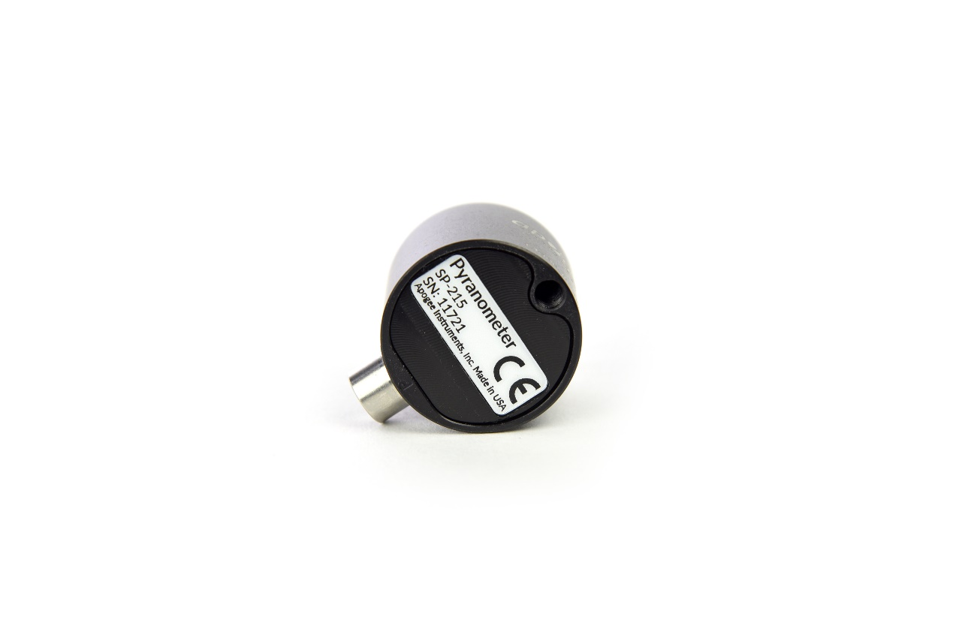

**Serial Numbers 11769 and above:** A sensor’s model number and serial number are located on the bottom of the sensor. If you need the manufacturing date of your sensor, please contact Apogee Instruments with the serial number of your sensor.

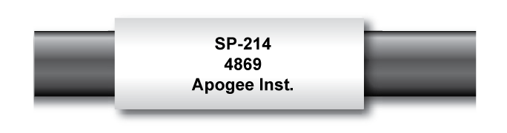

**Serial Number 0-11768:** A sensor’s model number and serial number are located near the pigtail leads on the sensor cable. If you need the manufacturing date of your sensor, please contact Apogee Instruments with the serial number of your sensor.

Located approximately 50 cm from the sensor head is a casing that houses the 4-20 mA transmitter. Separating the case from the sensor head will disconnect the pyranometer.

### Specifications

|  |  |
| --- | --- |
|  | **SP-214-SS** |
| ISO 9060:2018 | Class C (previously known as *second class*) |
| Power Supply | 7 to 24 V DC |
| Current Draw | Maximum of 22 mA (2 mA quiescent) |
| Sensitivity  Serial # 9997 and above | 0.008 mA per W m-2 |
| Sensitivity  Serial # 0-9996 | 0.0128 mA per W m-2 |
| Calibration Factor  Serial # 9997 and above | 125 W m-2 per mA (reciprocal of sensitivity) with an offset of 4 mA |
| Calibration Factor  Serial # 0-9996 | 78 W m-2 per mA (reciprocal of sensitivity) with an offset of 4 mA |
| Calibration Uncertainty at 1000 W m-2 | Less than 3 % (see calibration Traceability below) |
| Calibrated Output Range | 4 to 20 mA |
| Measurement Repeatability | Less than 1 % |
| Long-term Drift (Non-stability) | Less than 2 % per year |
| Non-linearity  Serial # 9997 and above | Less than 1 % (up to 2000 W m-2; maximum radiation measurement is 2000 W m-2) |
| Non-linearity  Serial # 0-9996 | Less than 1 % (up to 1250 W m-2; maximum radiation measurement is 1250 W m-2) |
| Response Time | Less than 1 ms |
| Field of View | 180° |
| Spectral Range | 360 to 1120 nm (wavelengths where response is 10 % of maximum; see Spectral Response below) |
| Directional (Cosine) Response | ± 5 % at 75° zenith angle (see Cosine Response below) |
| Temperature Response | 0.04 ± 0.04 % per C (see Temperature Response below) |
| Operating Environment | -40 to 70 C; 0 to 100 % relative humidity; can be submerged in water up to depths of 30 m |
| Dimensions  Serial # 11769 and above | 30.5 mm diameter, 37 mm height |
| Dimensions  Serial # 0-11768 | 24 mm diameter, 33 mm height |
| Mass (with 5 m cable)  Serial # 11769 and above | 140 g |
| Mass (with 5 m cable)  Serial # 0-11768 | 90 g |
| Cable | 5 m of four conductor, shielded, twisted-pair wire; TPR jacket; pigtail lead wires; stainless steel (316), M8 connector |

**Calibration Traceability**

Apogee Instruments SP series pyranometers are calibrated through side-by-side comparison to the mean of four Apogee model SP-110 transfer standard pyranometers (shortwave radiation reference) under high intensity discharge metal halide lamps. The transfer standard pyranometers are calibrated through side-by-side comparison to the mean of at least two ISO-classified reference pyranometers under sunlight (clear sky conditions) in Logan, Utah. Each of four ISO-classified reference pyranometers are recalibrated on an alternating year schedule (two instruments each year) at the National Renewable Energy Laboratory (NREL) in Golden, Colorado. NREL reference standards are calibrated to the World Radiometric Reference (WRR) in Davos, Switzerland.

**Spectral Response**



Spectral response estimate of Apogee silicon-cell pyranometers. Spectral response was estimated by multiplying the spectral response of the photodiode, diffuser, and adhesive. Spectral response measurements of diffuser and adhesive were made with a spectrometer, and spectral response data for the photodiode were obtained from the manufacturer.

**Temperature Response**

Mean temperature response of four Apogee silicon-cell pyranometers. Temperature response measurements were made at approximately 10 C intervals across a temperature range of approximately -10 to 50 C under sunlight. Each pyranometer had an internal thermistor to measure temperature. At each temperature set point, a reference blackbody pyranometer was used to measure solar intensity.

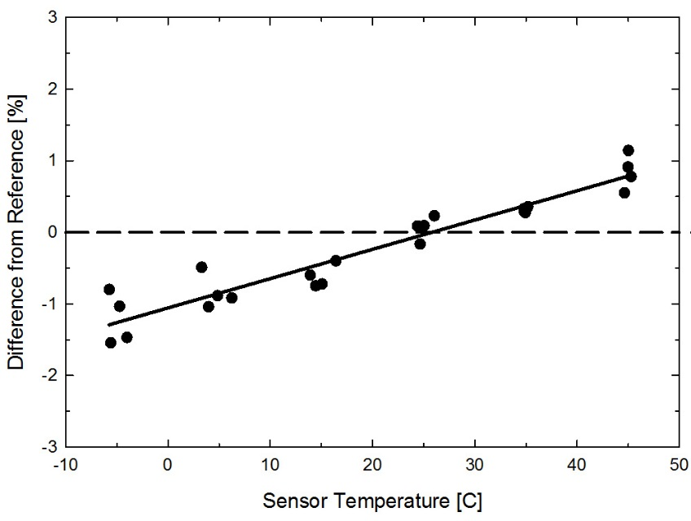

**Cosine Response**

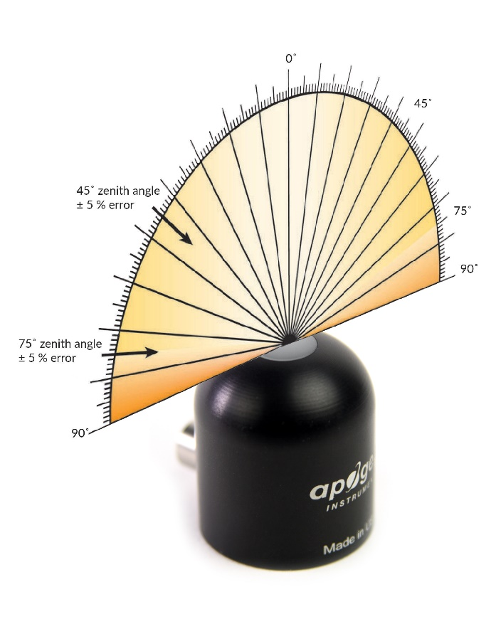

Directional, or cosine, response is defined as the measurement error at a specific angle of radiation incidence. Error for Apogee silicon-cell pyranometers is approximately ± 2 % and ± 5 % at solar zenith angles of 45° and 75°, respectively.

Mean cosine response of eleven Apogee silicon-cell pyranometers (***error bars represent two standard deviations above and below mean***). Cosine response measurements were made during broadband outdoor radiometer calibrations (BORCAL) performed during two different years at the National Renewable Energy Laboratory (NREL) in Golden, Colorado. Cosine response was calculated as the relative difference of pyranometer sensitivity at each solar zenith angle to sensitivity at 45° solar zenith angle. The blue symbols are AM measurements, the red symbols are PM measurements.



### Deployment and Installation

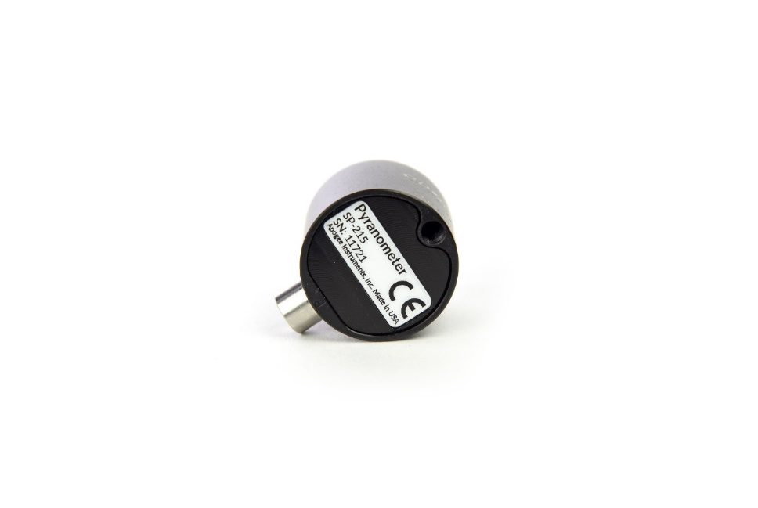Mount the sensor to a solid surface with the nylon mounting screw provided. To accurately measure PPFD incident on a horizontal surface, the sensor must be level. An Apogee Instruments model AL-100 Leveling Plate is recommended to level the sensor when used on a flat surface or being mounted to surfaces such as wood. To facilitate mounting on a mast or pipe, the Apogee Instruments model AL-120 Solar Mounting Bracket with Leveling Plate is recommended.

Important: Only use the nylon screw provided when mounting to insulate the non-anodized threads of the aluminum sensor head from the base to help prevent galvanic corrosion. For extended submersion applications, more insulation may be necessary. Contact Apogee tech support for details.

C:\Users\emyers\AppData\Local\Microsoft\Windows\INetCache\Content.Word\screw.png

Nylon Screw: 10-32x3/8

Nylon Screw: 10-32x3/8

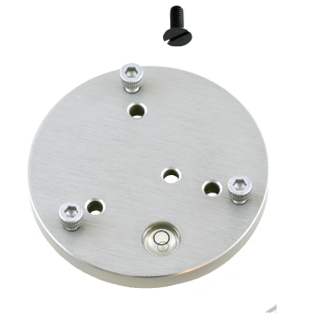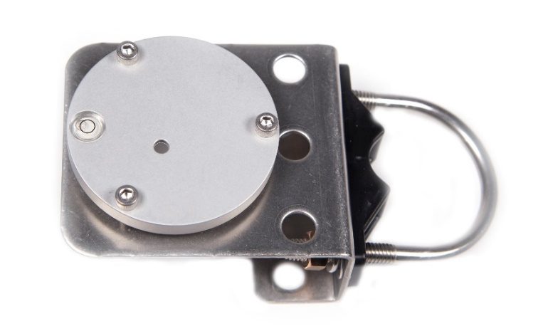

Model AL-100

Model AL-120

To minimize azimuth error, the sensor should be mounted with the cable pointing toward true north in the northern hemisphere or true south in the southern hemisphere. Azimuth error is typically less than 1 %, but it is easy to minimize by proper cable orientation.

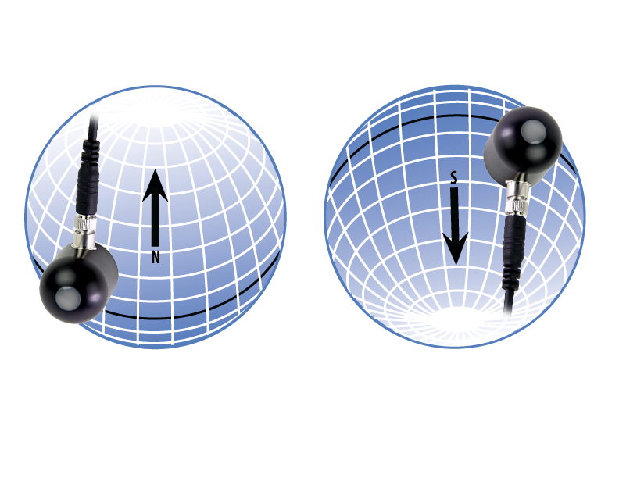

In addition to orienting the cable to point toward the nearest pole, the sensor should also be mounted such that obstructions (e.g., weather station tripod/tower or other instrumentation) do not shade the sensor. **Once mounted, the green cap should be removed from the sensor.** The green cap can be used as a protective covering for the sensor when it is not in use.

### Cable Connectors

|  |  |
| --- | --- |
| Apogee sensors offer cable connectors to simplify the process of removing sensors from weather stations for calibration (the entire cable does **not** have to be removed from the station and shipped with the sensor).  The ruggedized M8 connectors are rated IP68, made of corrosion-resistant marine-grade stainless-steel, and designed for extended use in harsh environmental conditions. | Cable connectors are attached directly to the head. |

**Instructions**

|  |  |
| --- | --- |
| **Pins and Wiring Colors:** All Apogee connectors have six pins, but not all pins are used for every sensor. There may also be unused wire colors inside the cable. To simplify datalogger connection, we remove the unused pigtail lead colors at the datalogger end of the cable.  If a replacement cable is required, please contact Apogee directly to ensure ordering the proper pigtail configuration.  **Alignment:** When reconnecting a sensor, arrows on the connector jacket and an aligning notch ensure proper orientation.  **Disconnection for extended periods:**  When disconnecting the sensor for an extended period of time from a station, protect the remaining half of the connector still on the station from water and dirt with electrical tape or other method. | A reference notch inside the connector ensures  proper alignment before tightening.    When sending sensors in for calibration, only send the sensor head. |
| **Tightening:** Connectors are designed to be firmly finger-tightened only. There is an  o-ring inside the connector that can be overly compressed if a wrench is used. Pay attention to thread alignment to avoid cross-threading. When fully tightened, 1-2 threads may still be visible.  **WARNING:** Do **not** tighten the connector by twisting the black cable or sensor head, only twist the metal connector (blue arrows). | Finger-tighten firmly |

### Operation and Measurement

Connect the sensor to a measurement device (meter, datalogger, controller) capable of measuring and displaying or recording a 4-20 mA signal. In order to maximize measurement resolution and signal-to-noise ratio, the input range of the measurement device should closely match the output range of the pyranometer. **DO NOT connect the sensor to a power source greater than 24 V DC.**

**VERY IMPORTANT: Apogee changed the wiring colors of all our bare-lead sensors in March 2018 in conjunction with the release of inline cable connectors on some sensors. To ensure proper connection to your data device, please note your serial number or if your sensor has a stainless-steel connector 30 cm from the sensor head then use the appropriate wiring configuration listed below. With the switch to connectors, we also changed to using cables that only have 4 or 7 internal wires. To make our various sensors easier to connect to your device, we clip off any unused wire colors at the end of the cable depending on the sensor. If you cut the cable or modify the original pigtail, you may find wires inside that are not used with your particular sensor. In this case, please disregard the extra wires and follow the color-coded wiring guide provided.**

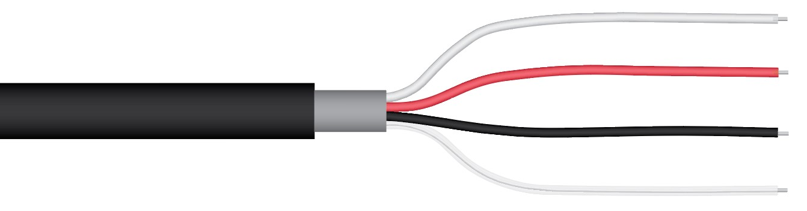**Wiring for SP-214 with Serial Numbers 9898 and above**

**White:** 4-20 mA signal output

**Red:** Input power (7-24 V DC)

**Black:** Ground (from sensor signal and output power)

**Clear:** Shield/Ground

**Wiring for SP-214 with Serial Numbers range 0-9897**

**White:** 4-20 mA signal output

**Green:** Signal ground

**Red:** Input power

**Black:** Input ground

**Clear:** Shield/ground

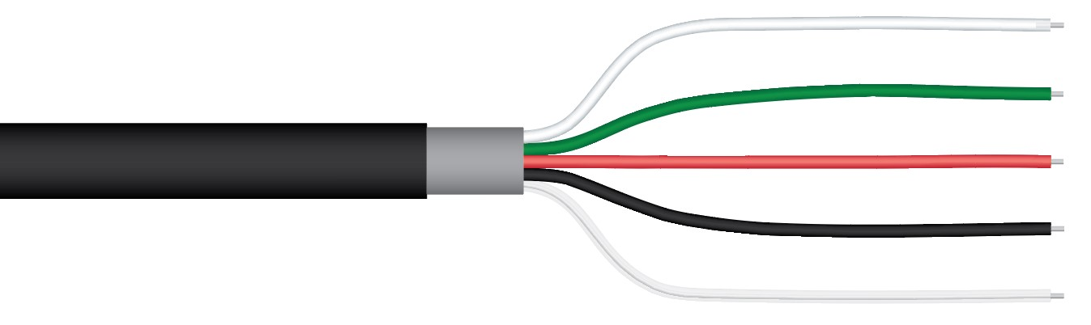

**Sensor Calibration**

**Serial Number Range 0-9996.** Apogee SP-214 pyranometer models have a standard calibration factor of exactly:

**78 W m-2 per mA with a 4.0 mA offset**

Multiply this calibration factor by the difference of the measured mA signal and the 4.0 mA offset to convert sensor output to total shortwave radiation in units of W m-2:

**Calibration Factor (78 W m-2 per mA) * [Sensor Output Signal (mA) – Offset (4.0 mA)] = Shortwave Radiation (W m-2)**

**78 * (16.8 – 4) = 1000**

**Serial Number Range 9997 and above.** Apogee SP-214 pyranometer models have a standard calibration factor of exactly:

**125 W m-2 per mA with a 4.0 mA offset**

Multiply this calibration factor by the difference of the measured mA signal and the 4.0 mA offset to convert sensor output to total shortwave radiation in units of W m-2:

**Calibration Factor (125 W m-2 per mA) * [Sensor Output Signal (mA) – Offset (4.0 mA)] = Shortwave Radiation (W m-2)**

**125 * (12.0 – 4) = 1000**

**Serial Numbers Range 0-9996.** Example of total shortwave radiation measurement with an Apogee SP-214 pyranometer. Full sunlight yields total shortwave radiation on a horizontal plane at the Earth’s surface of approximately 1000 W m-2. This yields an output signal of 16.82 mA. The signal is converted to shortwave radiation by subtracting the 4.0 mA offset and then multiplying by the calibration factor of 78 W m-2 per mA.

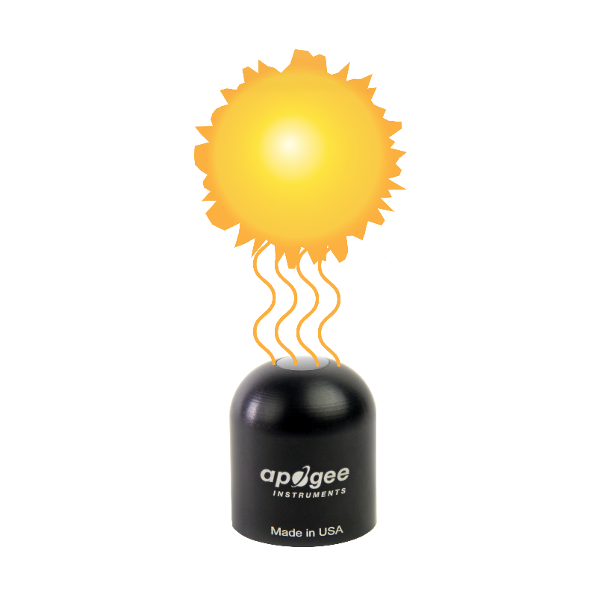

**Sensor Output**

**12.0 mA**

**Full Sunlight**

**(1000 W m-2)**

**Serial Numbers 9997 and above.** Example of total shortwave radiation measurement with an Apogee SP-214 pyranometer. Full sunlight yields total shortwave radiation on a horizontal plane at the Earth’s surface of approximately 1000 W m-2. This yields an output signal of 12.0 mA. The signal is converted to shortwave radiation by subtracting the 4.0 mA offset and then multiplying by the calibration factor of 125 W m-2 per mA.

**Spectral Errors for Measurements with Silicon-cell Pyranometers**

Apogee SP series pyranometers are calibrated under electric lamps in a calibration laboratory. The calibration procedure simulates calibration under clear sky conditions at a solar zenith angle of approximately 45°. However, due to the limited spectral sensitivity of silicon-cell pyranometers compared to the solar radiation spectrum (see graph below), spectral errors occur when measurements are made in conditions that differ from conditions the sensor was calibrated under (e.g., the solar spectrum differs in clear sky and cloudy conditions, thus measurements in cloudy conditions result in spectral error because sensors are calibrated in clear sky conditions).

Spectral response of Apogee SP series pyranometers compared to solar radiation spectrum at Earth’s surface. Silicon-cell pyranometers, such as Apogee SP series, are only sensitive to the wavelength range of approximately 350-1100 nm and are not equally sensitive to all wavelengths within this range. As a result, when the spectral content of solar radiation is significantly different than the spectrum that silicon-cell pyranometers were calibrated to, spectral errors result.



Silicon-cell pyranometers can still be used to measure shortwave radiation in conditions other than clear sky or from radiation sources other than incoming sunlight, but spectral errors occur when measuring radiation with silicon-cell pyranometers in these conditions. The graphs below show spectral error estimates for Apogee silicon-cell pyranometers at varying solar zenith angles and varying atmospheric air mass. The diffuser is optimized to minimize directional errors, thus the cosine response graph in the Specifications section shows the actual directional errors in practice (which includes contributions from the spectral shift that occurs as solar zenith angle and atmospheric air mass change with time of day and time of year). The table below provides spectral error estimates for shortwave radiation measurements from shortwave radiation sources other than clear sky solar radiation.



Spectral error for Apogee SP series pyranometers as a function of solar zenith angle, assuming calibration at a zenith angle of 45°.



Spectral error for Apogee SP series pyranometers as a function of atmospheric air mass, assuming calibration at an air mass of 1.5.

**Spectral Errors for Shortwave Radiation Measurements with Apogee SP Series Pyranometers**

|  |  |
| --- | --- |
| **Radiation Source (Error Calculated Relative to Sun, Clear Sky)** | **Error [%]** |
| Sun (Clear Sky) | 0.0 |
| Sun (Cloudy Sky) | 9.6 |
| Reflected from Grass Canopy | 14.6 |
| Reflected from Deciduous Canopy | 16.0 |
| Reflected from Conifer Canopy | 19.2 |
| Reflected from Agricultural Soil | -12.1 |
| Reflected from Forest Soil | -4.1 |
| Reflected from Desert Soil | 3.0 |
| Reflected from Water | 6.6 |
| Reflected from Ice | 0.3 |
| Reflected from Snow | 13.7 |

### Maintenance and Recalibration

Moisture or debris on the diffuser is a common cause of low readings. The sensor has a domed diffuser and housing for improved self-cleaning from rainfall, but materials can accumulate on the diffuser (e.g., dust during periods of low rainfall, salt deposits from evaporation of sea spray or sprinkler irrigation water) and partially block the optical path. Dust or organic deposits are best removed using water or window cleaner and a soft cloth or cotton swab. Salt deposits should be dissolved with vinegar and removed with a soft cloth or cotton swab. **Never use an abrasive material or cleaner on the diffuser.**

Although Apogee sensors are very stable, nominal accuracy drift is normal for all research-grade sensors. To ensure maximum accuracy, we generally recommend sensors are sent in for recalibration every two years, although you can often wait longer according to your particular tolerances.

To determine if your sensor needs recalibration, the Clear Sky Calculator ([www.clearskycalculator.com](http://www.clearskycalculator.com)) website and/or smartphone app can be used to indicate the total shortwave radiation incident on a horizontal surface at any time of day at any location in the world. It is most accurate when used near solar noon in spring and summer months, where accuracy over multiple clear and unpolluted days is estimated to be ± 4 % in all climates and locations around the world. For best accuracy, the sky must be completely clear, as reflected radiation from clouds causes incoming radiation to increase above the value predicted by the clear sky calculator. Measured values of total shortwave radiation can exceed values predicted by the Clear Sky Calculator due to reflection from thin, high clouds and edges of clouds, which enhances incoming shortwave radiation. The influence of high clouds typically shows up as spikes above clear sky values, not a constant offset greater than clear sky values.

To determine recalibration need, input site conditions into the calculator and compare total shortwave radiation measurements to calculated values for a clear sky. If sensor shortwave radiation measurements over multiple days near solar noon are consistently different than calculated values (by more than 6 %), the sensor should be cleaned and re-leveled. If measurements are still different after a second test, email [calibration@apogeeinstruments.com](mailto:calibration@apogeeinstruments.com) to discuss test results and possible return of sensor(s).

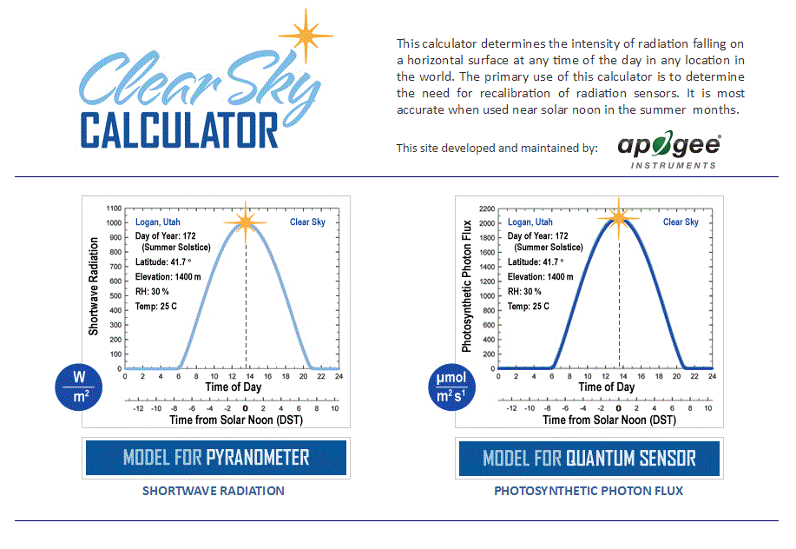

Homepage of the Clear Sky Calculator. Two calculators are available: One for pyranometers (total shortwave radiation) and one for quantum sensors (photosynthetic photon flux density).

Clear Sky Calculator for pyranometers. Site data are input in blue cells in middle of page and an estimate of total shortwave radiation is returned on right-hand side of page.

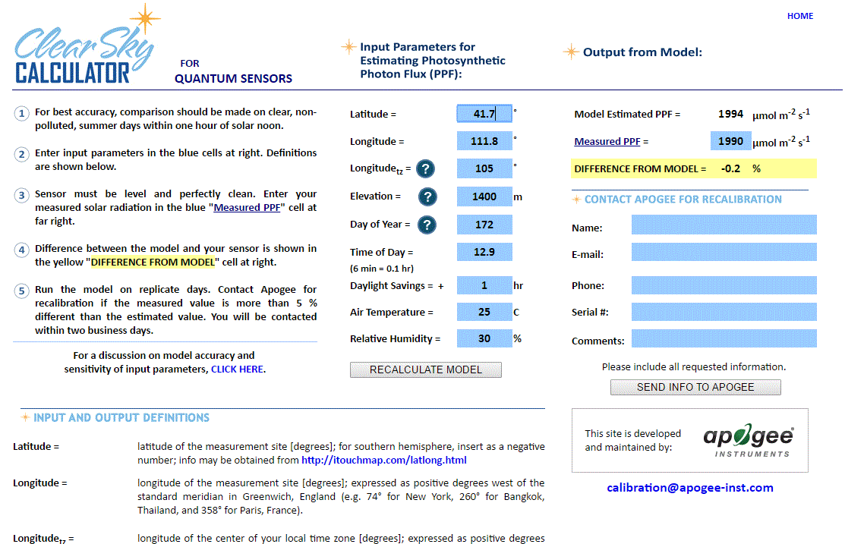

### Troubleshooting and Customer Support

**Independent Verification of Functionality**

Apogee model SP-214 pyranometers provide a 4-20 mA output that is proportional to incident total shortwave radiation. A quick and easy check of sensor functionality can be determined using a DC power supply and an ammeter. Power the sensor with a DC voltage by connecting the positive voltage signal to the red wire from the sensor and the negative (or common) to the black wire from the sensor. Use the ammeter to measure across the white wire (signal output) and black wire (signal ground). Direct the sensor head toward a light source and verify the sensor provides a signal. Increase and decrease the distance from the sensor head to the light source to verify that the signal changes proportionally (decreasing signal with increasing distance and increasing signal with decreasing distance). Blocking all radiation from the sensor should force the sensor signal to 4 mA.

**Compatible Measurement Devices (Dataloggers/Controllers/Meters)**

SP-214 pyranometers are calibrated with a standard calibration factor of 125 W m-2 per mA, yielding a sensitivity of 0.008 mA per W m-2. Thus, a compatible measurement device (e.g., datalogger or controller) should have resolution of at least 0.008 mA, in order to provide shortwave radiation resolution of 1 W m-2.

The 4-20 mA circuit design allows the output to drive a resistive load (RL) to within 2 volts of the supply voltage to the sensor (VS), at 20 mA (0.02 A). The equation to calculate resistive load is RL = [VS – 2 V] / 0.02 A. For example, a sensor with a supply voltage of 12 V DC can drive a maximum load of 500 Ω (RL = [12 V – 2 V] / 0.02 A = 500 Ω). The output voltage from the sensor is calculated by adding the wire resistance to the input resistance of the data collection system, and then multiplying by 0.02 A.

**Effect of Cable Length**

Shortening or splicing on additional cable in the field is generally not a problem for the current output of the SP-214. However, adding cable will result in a greater resistive load, which should be taken into consideration when determining the maximum resistive load that the sensor will drive (see section above on Compatible Measurement Devices). Apogee model SP series pyranometers use shielded, twisted pair cable, which minimizes electromagnetic interference. This is particularly important for long lead lengths in electromagnetically noisy environments.

**Modifying Cable Length**

See Apogee webpage for details on how to extend sensor cable length (<http://www.apogeeinstruments.com/how-to-make-a-weatherproof-cable-splice/>).

### return and Warranty Policy

RETURN POLICY

Apogee Instruments will accept returns within 30 days of purchase as long as the product is in new condition (to be determined by Apogee). Returns are subject to a 10 % restocking fee.

WARRANTY POLICY

**What is Covered**All products manufactured by Apogee Instruments are warranted to be free from defects in materials and craftsmanship for a period of four (4) years from the date of shipment from our factory. To be considered for warranty coverage an item must be evaluated by Apogee.

Products not manufactured by Apogee (spectroradiometers, chlorophyll content meters, EE08-SS probes) are covered for a period of one (1) year.

**What is Not Covered**The customer is responsible for all costs associated with the removal, reinstallation, and shipping of suspected warranty items to our factory.

The warranty does not cover equipment that has been damaged due to the following conditions:

1. Improper installation or abuse.

2. Operation of the instrument outside of its specified operating range.

3. Natural occurrences such as lightning, fire, etc.

4. Unauthorized modification.

5. Improper or unauthorized repair.

Please note that nominal accuracy drift is normal over time. Routine recalibration of sensors/meters is considered part of proper maintenance and is not covered under warranty.

**Who is Covered**This warranty covers the original purchaser of the product or other party who may own it during the warranty period.

**What Apogee Will Do**At no charge Apogee will:

1. Either repair or replace (at our discretion) the item under warranty.

2. Ship the item back to the customer by the carrier of our choice.

Different or expedited shipping methods will be at the customer’s expense.

**How To Return An Item**1. Please do not send any products back to Apogee Instruments until you have received a Return Merchandise Authorization (RMA) number from our technical support department by submitting an online RMA form at [www.apogeeinstruments.com/tech-support-recalibration-repairs/](http://www.apogeeinstruments.com/tech-support-recalibration-repairs/). We will use your RMA number for tracking of the service item. Call (435) 245-8012 or email techsupport@apogeeinstruments.com with questions.

2. For warranty evaluations, send all RMA sensors and meters back in the following condition: Clean the sensor’s exterior and cord. Do not modify the sensors or wires, including splicing, cutting wire leads, etc. If a connector has been attached to the cable end, please include the mating connector – otherwise the sensor connector will be removed in order to complete the repair/recalibration. ***Note:*** *When sending back sensors for routine calibration that have Apogee’s standard stainless-steel connectors, you only need to send the sensor with the 30 cm section of cable and one-half of the connector. We have mating connectors at our factory that can be used for calibrating the sensor.*

3. Please write the RMA number on the outside of the shipping container.

4. Return the item with freight pre-paid and fully insured to our factory address shown below. We are not responsible for any costs associated with the transportation of products across international borders.

**Apogee Instruments, Inc.   
721 West 1800 North Logan, UT  
84321, USA**

5. Upon receipt, Apogee Instruments will determine the cause of failure. If the product is found to be defective in terms of operation to the published specifications due to a failure of product materials or craftsmanship, Apogee Instruments will repair or replace the items free of charge. If it is determined that your product is not covered under warranty, you will be informed and given an estimated repair/replacement cost.

Products Beyond the Warranty Period

For issues with sensors beyond the warranty period, please contact Apogee at [techsupport@apogeeinstruments.com](mailto:techsupport@apogeeinstruments.com) to discuss repair or replacement options.

Other Terms

The available remedy of defects under this warranty is for the repair or replacement of the original product, and Apogee Instruments is not responsible for any direct, indirect, incidental, or consequential damages, including but not limited to loss of income, loss of revenue, loss of profit, loss of data, loss of wages, loss of time, loss of sales, accruement of debts or expenses, injury to personal property, or injury to any person or any other type of damage or loss.

This limited warranty and any disputes arising out of or in connection with this limited warranty ("Disputes") shall be governed by the laws of the State of Utah, USA, excluding conflicts of law principles and excluding the Convention for the International Sale of Goods. The courts located in the State of Utah, USA, shall have exclusive jurisdiction over any Disputes.

This limited warranty gives you specific legal rights, and you may also have other rights, which vary from state to state and jurisdiction to jurisdiction, and which shall not be affected by this limited warranty. This warranty extends only to you and cannot by transferred or assigned. If any provision of this limited warranty is unlawful, void, or unenforceable, that provision shall be deemed severable and shall not affect any remaining provisions. In case of any inconsistency between the English and other versions of this limited warranty, the English version shall prevail.

This warranty cannot be changed, assumed, or amended by any other person or agreement

**APOGEE INSTRUMENTS, INC. |** 721 WEST 1800 NORTH, LOGAN, UTAH 84321, USA

TEL: (435) 792-4700 | FAX: (435) 787-8268 | WEB: APOGEEINSTRUMENTS.COM

*Copyright © 2021 Apogee Instruments, Inc.*