

# Owner’s Manual

Net radiometer

Model SN-500-SS

Rev: 30-Nov-2020

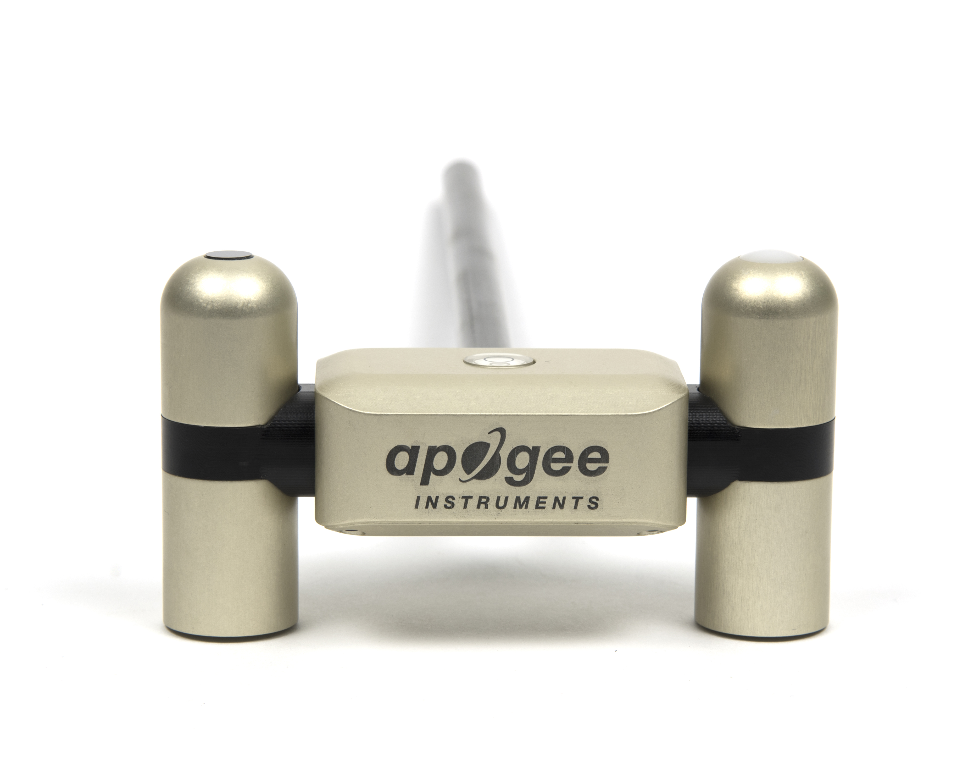

Table of contents

Owner’s Manual 1

Certificate of Compliance 3

Introduction 4

Sensor Models 5

Specifications 6

Deployment and Installation 8

Cable Connectors 9

Operation and Measurement 10

Maintenance and Recalibration 16

Troubleshooting and Customer Support 18

Return and Warranty Policy 19

### Certificate of Compliance

**EU Declaration of Conformity**

This declaration of conformity is issued under the sole responsibility of the manufacturer:

Apogee Instruments, Inc.  
721 W 1800 N  
Logan, Utah 84321  
USA

for the following product(s):

Models: SN-500

Type: Net Radiometer

The object of the declaration described above is in conformity with the relevant Union harmonization legislation:

2014/30/EU Electromagnetic Compatibility (EMC) Directive

2011/65/EU Restriction of Hazardous Substances (RoHS 2) Directive

2015/863/EU Amending Annex II to Directive 2011/65/EU (RoHS 3)

Standards referenced during compliance assessment:

EN 61326-1:2013 Electrical equipment for measurement, control and laboratory use – EMC requirements

EN 50581:2012 Technical documentation for the assessment of electrical and electronic products with respect to the restriction of hazardous substances

Please be advised that based on the information available to us from our raw material suppliers, the products manufactured by us do not contain, as intentional additives, any of the restricted materials including lead (see note below), mercury, cadmium, hexavalent chromium, polybrominated biphenyls (PBB), polybrominated diphenyls (PBDE), bis(2-ethylhexyl) phthalate (DEHP), butyl benzyl phthalate (BBP), dibutyl phthalate (DBP), and diisobutyl phthalate (DIBP). However, please note that articles containing greater than 0.1% lead concentration are RoHS 3 compliant using exemption 6c.

Further note that Apogee Instruments does not specifically run any analysis on our raw materials or end products for the presence of these substances, but rely on the information provided to us by our material suppliers.

Signed for and on behalf of:

Apogee Instruments, November 2020



Bruce Bugbee  
President  
Apogee Instruments, Inc.

### Introduction

Net radiation at Earth’s surface is the source of available energy that drives key processes, including surface and atmospheric heating, evaporation, sublimation, and transpiration. Shortwave radiation (approximately 280 to 4000 nm) is emitted by the sun, and a fraction incident at Earth’s surface is reflected. Longwave radiation (approximately 4000 to 100 000 nm) is emitted by molecules in the atmosphere and land surfaces. Net radiation is the difference between incoming (downwelling) and outgoing (upwelling) shortwave and longwave radiation. Net radiation at Earth’s surface is spatially and temporally variable due to changes in position of the sun with respect to Earth’s surface, changes in atmospheric conditions, and differences in land surface conditions. Shortwave radiation accounts for a larger proportion of net radiation during the day when the sun is shining. Longwave radiation contributes to net radiation during the day and at night.

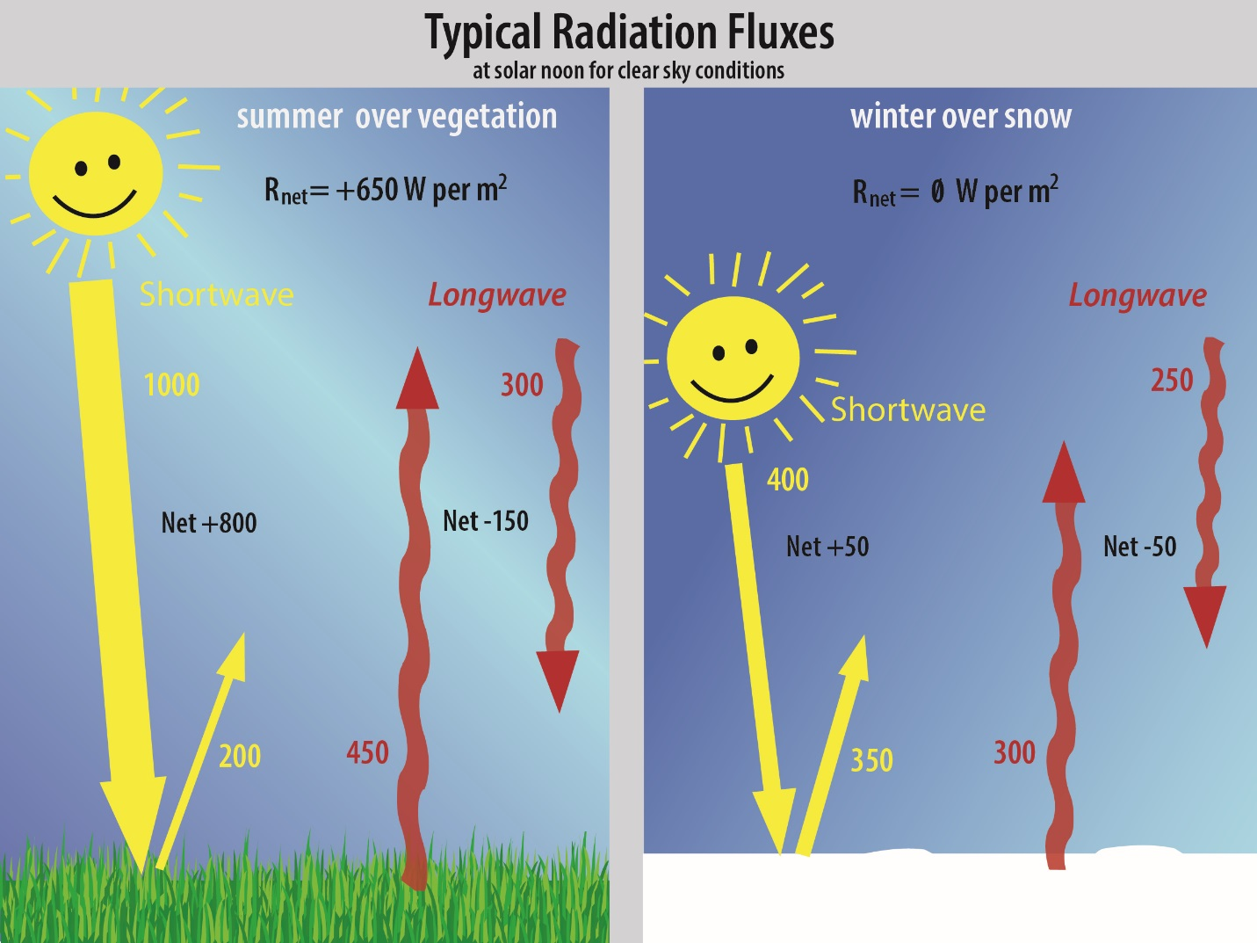Typical values of the four components of net radiation (Rnet) for a clear summer day near solar noon over vegetation and a clear winter day near solar noon over snow are shown in the figure below (all units are W m-2). Net shortwave radiation is the difference between incoming shortwave (from sun, SWi) and outgoing shortwave (reflected by surface, SWo). Net longwave radiation is the difference between incoming longwave (emitted by molecules in the atmosphere, LWi) and outgoing longwave (emitted by elements at the surface, LWo). Net radiation is the sum of net shortwave and net longwave radiation. Net radiation changes with solar zenith angle, atmospheric conditions (e.g., degree of cloudiness), and surface conditions (e.g., bare soil, plant cover, snow).

Net radiometers are instruments designed to measure net radiation. Typical applications of net radiometers include measurement of net radiation on surface flux towers and weather stations. Net radiation is a key variable in the surface energy balance and influences turbulent fluxes, including evapotranspiration.

Apogee Instruments model SN-500 net radiometers are four-component instruments, with individual upward- and downward-looking pyranometers and pyrgeometers. Each radiometer consists of a thermopile detector and filter mounted in an anodized aluminum housing. Each radiometer is heated to minimize the effects of dew, frost, snow, and ice on the filter and sensor head. Analog signals from each radiometer are measured with an onboard voltmeter and converted to SDI-12 outputs, eliminating the need for multiple analog datalogger channels to make the four-component measurement of net radiation. SN-500 net radiometers are small and lightweight to facilitate rapid and simple mounting.

### Sensor Models

This manual covers the SDI-12 communication protocol, net radiometer model SN-500 (in bold below). Additional models are covered in their respective manuals.

|  |  |
| --- | --- |
| Model | Signal |
| SN-500 | **SDI-12** |
| SN-522 | Modbus |

Apogee Instruments’ four-component net radiometer consists of an upward-looking (model SP-510) and downward-looking (model SP-610) pyranometer (to measure shortwave radiation), and an upward-looking (model SL-510) and downward-looking (model SL-610) pyrgeometer to measure longwave radiation). Each of the individual sensors are available as stand-alone sensors.

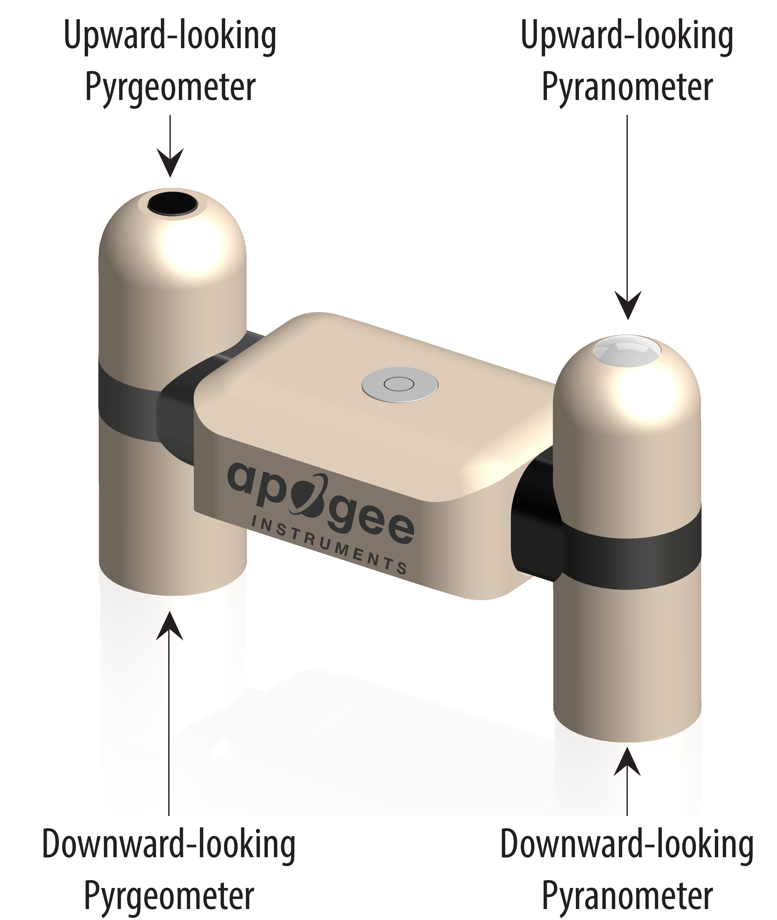

Sensor name and model number are located near the pigtail leads on the sensor cable.

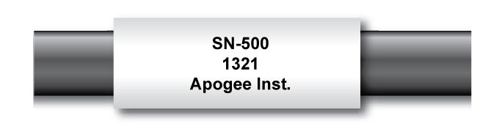

### Specifications

**Pyranometer (Shortwave Radiation) SP-510 and SP-610**

|  |  |  |  |
| --- | --- | --- | --- |
|  | **SP-510-SS (Upward-looking)** | **SP-610-SS (Downward-looking)** | |
| Sensitivity (variable from sensor to sensor, typical values listed) | 0.057 mV per W m-2 | 0.15 mV per W m-2 | |
| Calibration Factor (Reciprocal of Sensitivity) | 17.5 W m-2 per mV | 6.7 W m-2 per mV | |
| Calibration Uncertainty | ± 5 % (see Calibration Traceability below) | | |
| Output Range (Variable from sensor to sensor) | 0 to 114 mV | | 0 to 300 mV |
| Measurement Range | 0 to 2000 W m-2 (shortwave irradiance) | | |
| Measurement Repeatability | Less than 1 % | | |
| Long-term Drift (Non-stability) | Less than 2 % per year | | |
| Non-linearity | Less than 1 % | | |
| Detector Response Time | 0.5 seconds | | |
| Field of View | 180° | 150° | |
| Spectral Range (wavelengths where response is 50% of maximum) | 385 to 2105 nm | 295 to 2685 nm | |
| Directional (Cosine) Response | Less than 30 W m-2 at 80° solar zenith | | Less than 20% for angles between 0 and 60° |
| Temperature Response | Less than 5 % from -15 to 45 C | | |
| Zero Offset A | Less than 5 W m-2; Less than 10 W m-2 (heated) | | |
| Zero Offset B | Less than 5 W m-2 | | |
| Uncertainty in Daily Total | Less than 5 % | | |

**Calibration Traceability**

Apogee Instruments SP-510 and SP-610 pyranometers are calibrated through side-by-side comparison to the mean of four Apogee model SP-510 transfer standard pyranometers (shortwave radiation reference for upward-looking pyranometer on net radiometer) or to the mean of four Apogee model SP-610 transfer standard pyranometers (shortwave radiation reference for downward-looking pyranometer on net radiometer) under high intensity discharge metal halide lamps. The transfer standard pyranometers are calibrated through side-by-side comparison to the mean of at least two ISO-classified reference pyranometers under sunlight (clear sky conditions) in Logan, Utah. Each of four ISO-classified reference pyranometers are recalibrated on an alternating year schedule (two instruments each year) at the National Renewable Energy Laboratory (NREL) in Golden, Colorado. NREL reference standards are calibrated to the World Radiometric Reference (WRR).

**Pyrgeometers (Longwave Radiation) SL-510 and SL-610**

|  |  |  |
| --- | --- | --- |
|  | **SL-510-SS (upward-looking)** | **SL-610-SS (downward-looking)** |
| Sensitivity | 0.12 mV per W m-2 (variable from sensor to sensor, typical value listed) | |
| Calibration Factor  (Reciprocal of Sensitivity) | 8.5 W m-2 per mV (variable from sensor to sensor, typical value listed) | |
| Calibration Uncertainty | ± 5 % | |
| Measurement Range | -200 to 200 W m-2 (net longwave irradiance) | |
| Measurement Repeatability | Less than 1 % | |
| Long-term Drift (Non-stability) | Less than 2 % change in sensitivity per year | |
| Non-linearity | Less than 1 % | |
| Detector Response Time | Less than 0.5 seconds | |
| Field of View | 150° | |
| Spectral Range | 5 to 30 µm | |
| Temperature Response | Less than 5% from -15 to 45 C | |
| Window Heating Offset | Less than 10 W m-2 | |
| Zero Offset B | Less than 5 W m-2 | |
| Tilt Error | Less than 0.5 % | |
| Uncertainty in Daily Total | ± 5 % | |
| Temperature Sensor | 30 kΩ thermistor, ± 1 C tolerance at 25 C | |
| Output from Thermistor | 0 to 2500 mV (typical, other voltages can be used) | |
| Input Voltage Requirement for Thermistor | 2500 mV excitation (typical, other voltages can be used) | |

**Calibration Traceability**

Apogee SL-510 and SL-610 pyrgeometers are calibrated against the mean of at least two Apogee model SL-510 transfer standard pyrgeometers inside a custom blackbody cone held at multiple fixed temperatures over a range of radiometer (detector and sensor body) temperatures. The temperature of the blackbody cone is measured with replicate precision thermistors thermally bonded to the cone surface. The transfer standard pyrgeometers are calibrated against the mean of least two reference upward-looking pyrgeometers under all sky conditions in Logan, Utah. Each of the two reference pyrgeometers are recalibrated on an alternating year schedule (one instrument per year) at the National Renewable Energy Laboratory (NREL) in Golden, Colorado. NREL reference standards are calibrated to the World Infrared Standard Group (WISG) in Davos, Switzerland.

**Net Radiometer**

|  |  |
| --- | --- |
|  | SN-500-SS |
| Input voltage Range | 5.5 to 24 V DC (heaters are optimized to run at 12 V DC) |
| Current Draw (12 V DC Supply Voltage) | Heaters on, communication enabled: 63 mA;  Heaters off, communication enabled: 1.5 mA;  Heaters off; communication disabled: 0.6 mA |
| Response Time (using SDI-12 Protocol) | 1 s (SDI-12 data transfer rate; detector response times are 0.5 seconds) |
| Heaters ( 4 sensors individually heated) | 62 mA current draw and 740 mW power requirement at 12 V DC |
| Operating Environment | -50 to 80 C; 0 to 100 % relative humidity |
| Dimensions | 116 mm length, 45 mm width, 66 mm height |
| Mass | 320 g ( with mounting rod and 5 m of lead wire) |
| Cable | M8 connector (IP68 rating) to interface to sensor housing, 5 m of four conductor, shielded, twisted-pair wire, additional cable available in multiples of 5 m, TPR jacket (high water resistance, high UV stability, flexibility in cold conditions), pigtail lead wires |

### Deployment and Installation

An Apogee Instruments model AM-500 mounting bracket can be used to mount the net radiometer to a cross arm.

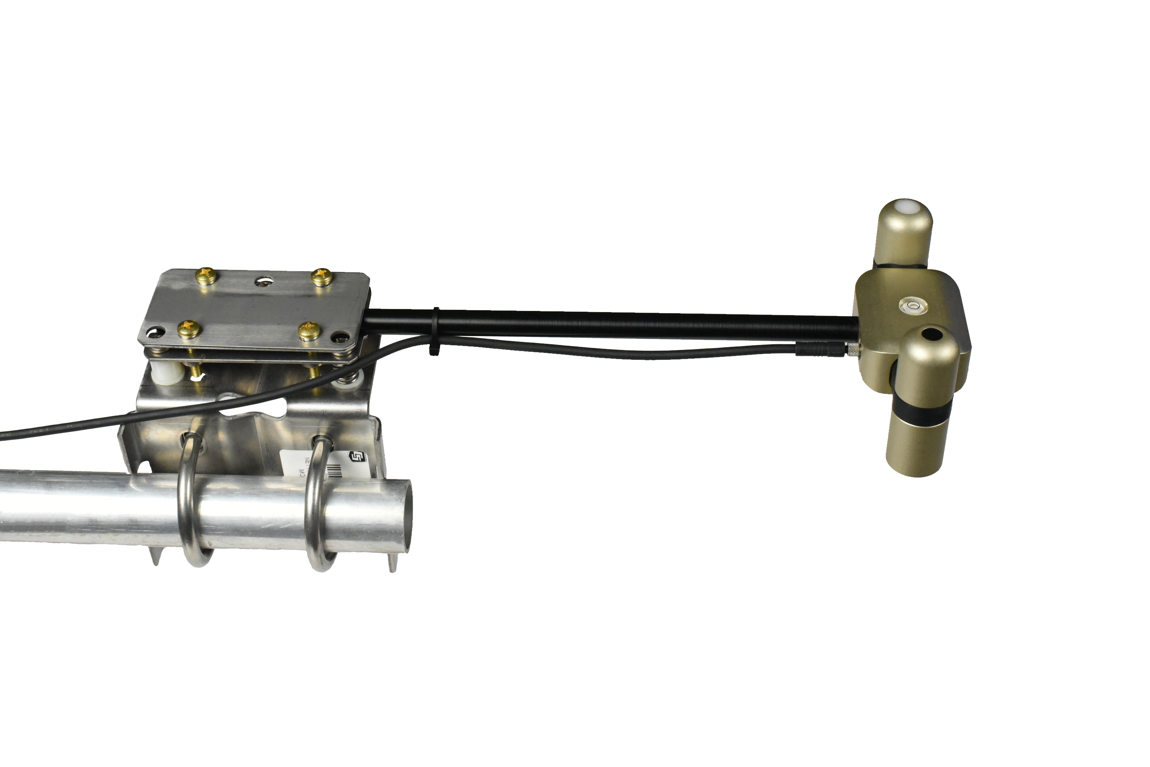

To minimize azimuth error, the sensor should be mounted with the cable pointing toward true north in the northern hemisphere or true south in the southern hemisphere. Azimuth error is typically less than 0.5 %, but it is easy to minimize by proper cable orientation.

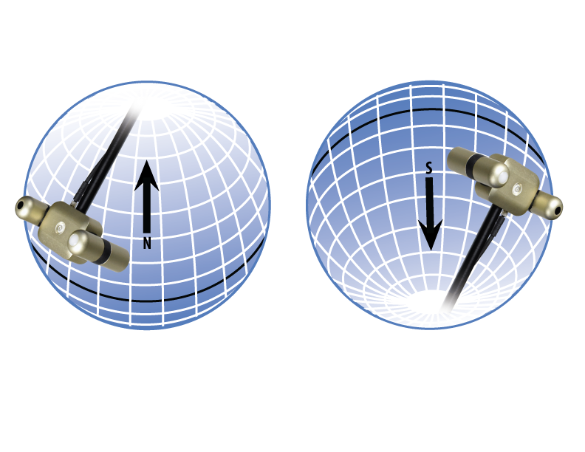

In addition to orienting the cable to point toward the nearest pole, the sensor should also be mounted such that obstructions (e.g., weather station tripod/tower or other instrumentation) do not shade the sensor. **Once mounted, the green caps should be removed from the sensor.** The green caps can be used as a protective covering for the sensor when it is not in use.

### Cable Connectors

|  |  |
| --- | --- |
| Apogee sensors offer cable connectors to simplify the process of removing sensors from weather stations for calibration (the entire cable does **not** have to be removed from the station and shipped with the sensor).  The ruggedized M8 connectors are rated IP68, made of corrosion-resistant marine-grade stainless-steel, and designed for extended use in harsh environmental conditions. | Cable connectors are attached directly to the head. |

**Instructions**

|  |  |
| --- | --- |
| **Pins and Wiring Colors:** All Apogee connectors have six pins, but not all pins are used for every sensor. There may also be unused wire colors inside the cable. To simplify datalogger connection, we remove the unused pigtail lead colors at the datalogger end of the cable.  If a replacement cable is required, please contact Apogee directly to ensure ordering the proper pigtail configuration.  **Alignment:** When reconnecting a sensor, arrows on the connector jacket and an aligning notch ensure proper orientation.  **Disconnection for extended periods:**  When disconnecting the sensor for an extended period of time from a station, protect the remaining half of the connector still on the station from water and dirt with electrical tape or other method. | A reference notch inside the connector ensures  proper alignment before tightening.      Finger-tighten firmly |
| **Tightening:** Connectors are designed to be firmly finger-tightened only. There is an o-ring inside the connector that can be overly compressed if a wrench is used. Pay attention to thread alignment to avoid cross-threading. When fully tightened, 1-2 threads may still be visible.  *NOTE: To avoid damaging the pins inside the connector, finger-tighten the connector by only turning the **metal** nut (see blue arrows). Do not tighten by turning the black cable. |  |

### Operation and Measurement

The SN-500 has an SDI-12 output, where the four components of net radiation, along with net values (net shortwave, net longwave, and net radiation), are returned in digital format. Measurement of the SN-500 net radiometer requires a measurement device with SDI-12 functionality that includes the M or C command.­­­

**VERY IMPORTANT: Apogee changed all wiring colors of our bare-lead sensors in March 2018. To ensure proper connection to your data device, please note your serial number then use the appropriate wiring configuration below.**

**Wiring for SN-500 with Serial Numbers 1086 and above**

White: SDI-12 Data Line

Red: Power In (4.5 -24 V DC)

Black: Ground

Clear: Shield Wire

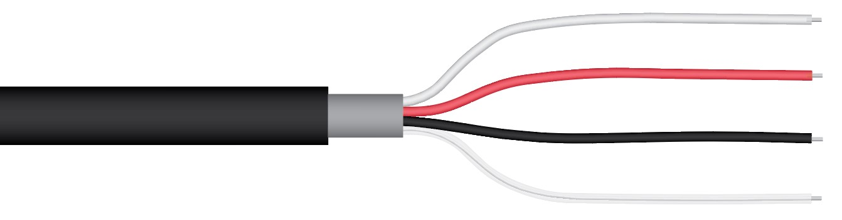

**Wiring for SN-500 with Serial Numbers range 0-1085**

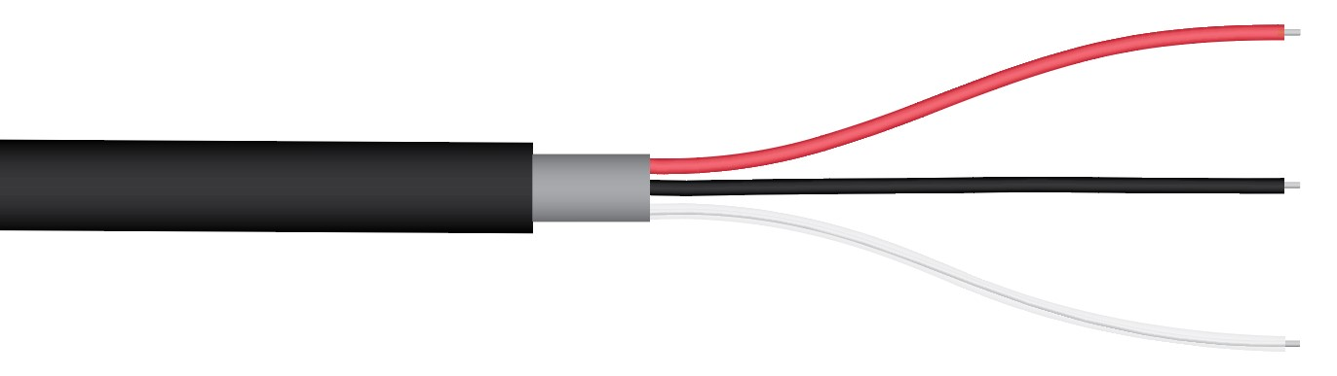

Red: Power In (4.5 -24 V DC)

Black: SDI-12 Data Line

Clear: Ground (shield wire)

**SDI-12 Interface**

The following is a brief explanation of the serial digital interface SDI-12 protocol instructions used in Apogee SN-500. For questions on the implementation of this protocol, please refer to the official version of the SDI-12 protocol: <http://www.sdi-12.org/specification.php> (version 1.4, August 10, 2016).

**Overview**

During normal communication, the data recorder sends a packet of data to the sensor that consists of an address and a command. Then, the sensor sends a response. In the following descriptions, SDI-12 commands and responses are enclosed in quotes. The SDI-12 address and the command/ response terminators are defined as follows:

**Sensors come from the factory with the address of “0” for use in single sensor systems. Addresses “1 to 9” and “A to Z”, or “a to z”, can be used for additional sensors connected to the same SDI-12 bus.**

“!” is the last character of a command instruction. In order to be compliant with SDI-12 protocol, all commands must be terminated with a “!”. SDI-12 language supports a variety of commands. Supported commands for the Apogee Instruments SN-500 are listed in the following table (“a” is the sensor address. The following ASCII Characters are valid addresses: “0-9” or “A-Z”).

**Supported Commands for Apogee Instruments SN-500 Net Radiometer**

|  |  |  |
| --- | --- | --- |
| **Instruction Name** | **Instruction Syntax** | **Description** |
| Send Identification Command | aI! | Send identification information |
| Measurement Command | aM! | Tells the sensor to take a measurement |
| Measurement Command w/ Check Character | aMC! | Tells the sensor to take a measurement and return it with a check character |
| Change Address Command | aAb! | Changes the address of the sensor from a to b |
| Concurrent Measurement Command | aC! | Used to take a measurement when more than one sensor is used on the same data line |
| Concurrent Measurement Command w/ Check Character | aCC! | Used to take a measurement when more than one sensor is used on the same data line. Data is returned with a check character. |
| Address Query Command | ?! | Used when the address is unknown to have the sensor identify its address |
| Get Data Command | aD0! | Retrieves the data from a sensor |
| Heater Commands | aXHxxx! | Turns heaters on and off |
| Running Average Command | aXAVG! | Returns or sets the running average for sensor measurements. |

**Make Measurement Command: M!**

The make measurement command signals a measurement sequence to be performed. Data values generated in response to this command are stored in the sensor's buffer for subsequent collection using “D” commands. Data will be retained in sensor storage until another “M”, “C”, or “V” command is executed. M commands are shown in the following examples:

|  |  |  |
| --- | --- | --- |
| **Command** | **Response** | **Response to aD0!** |
| aM! or aM0! | a0014<cr><lf> | Incoming SW, Outgoing SW, Incoming LW, Outgoing LW |
| aM1! | a0013<cr><lf> | Net SW, Net LW, Net Radiation |
| aM2! | a0012<cr><lf> | mV signal incoming SW, mV signal outgoing SW |
| aM3! | a0014<cr><lf> | mV signal incoming LW, sensor body temperature incoming LW, mV signal outgoing LW, sensor body temperature outgoing LW |
| aM4! | a0011<cr><lf> | Albedo |
| aMC! | a0014<cr><lf> | Incoming SW, Outgoing SW, Incoming LW, Outgoing LW w/ CRC |
| aMC1! | a0013<cr><lf> | Net SW, Net LW, Net Radiation w/ CRC |
| aMC2! | a0012<cr><lf> | mV signal incoming SW, mV signal outgoing SW w/ CRC |
| aMC3! | a0014<cr><lf> | mV signal incoming LW, sensor body temperature incoming LW,  mV signal outgoing LW, sensor body temperature outgoing LW w/ CRC |
| aMC4! | a0011<cr><lf> | Albedo w/CRC |

where a is the sensor address (“0-9”, “A-Z”, “a-z”) and M is an upper-case ASCII character.

The net radiation components are separated by the sign “+” or “-“, as in the following example (0 is the address):

|  |  |  |
| --- | --- | --- |
| **Command** | **Sensor Response** | **Sensor Response when data is ready** |
| 0M! | 00014<cr><lf> | 0<cr><lf> |
| 0D0! | 0+1000.0+200.0+300.0+450.0<cr><lf> |  |
| 0M1! | 00013<cr><lf> | 0<cr><lf> |
| 0D0! | 0+800.0-150.0+650.0<cr><lf> |  |

where 1000.0 is incoming shortwave radiation (W m-2), 200.0 is outgoing shortwave radiation (W -2), 300.0 is incoming longwave radiation (W m-2), 450.0 is outgoing longwave radiation (W m-2), 800.0 is net shortwave radiation (W m-2), -150.0 is net longwave radiation (W m-2), and 650.0 is net radiation (W m-2), 57.1 is incoming shortwave mV, and 149.2 is outgoing shortwave mV.

|  |  |  |
| --- | --- | --- |
| **Command** | **Sensor Response** | **Sensor Response when data is ready** |
| 0M2! | 00012<cr><lf> | 0<cr><lf> |
| 0D0! | 0+57.1+149.2<cr><lf> |  |
| 0M3! | 00014<cr><lf> | 0<cr><lf> |
| 0D0! | 0+1.0+25.0+1.3+27.0<cr><lf> |  |
| 0M4! | 00011<cr><lf> | 0<cr><lf> |
| 0D0! | 0+800.0<cr><lf> |  |

where 57.1 is incoming shortwave mV, 149.2 is outgoing shortwave mV, 1.0 is incoming longwave mV, 25.0 is incoming longwave sensor body temperature, 1.3 is outgoing longwave mV, 27.0 is longwave outgoing sensor body temperature, and 800.0 is albedo (W m-2).

**Concurrent Measurement Command: aC!**

A concurrent measurement is one which occurs while other SDI-12 sensors on the bus are also making measurements. This command is similar to the “aM!” command, however, the nn field has an extra digit and the sensor does not issue a service request when it has completed the measurement. Communicating with other sensors will NOT abort a concurrent measurement. Data values generated in response to this command are stored in the sensor's buffer for subsequent collection using “D” commands. The data will be retained in the sensor until another “M”, “C”, or “V” command is executed:

|  |  |  |
| --- | --- | --- |
| **Command** | **Response** | **Response to 0D0!** |
| aC! or aC0! | a00104<cr><lf> | Incoming SW, Outgoing SW, Incoming LW, Outgoing LW |
| aC1! | a00103<cr><lf> | Net SW, Net LW, Total Net Radiation |
| aC2! | a00102<cr><lf> | mV signal incoming SW, mV signal outgoing SW |
| aC3! | a00104<cr><lf> | mV signal incoming LW, sensor body temperature incoming LW, mV signal outgoing LW, sensor body temperature outgoing LW |
| aC4! | a00101<cr><lf> | Albedo |
| aCC! Or aCC0! | a00104<cr><lf> | Incoming SW, Outgoing SW, Incoming LW, Outgoing LW w/ CRC |
| aCC1! | a00103<cr><lf> | Net SW, Net LW, Net Radiation w/ CRC |
| aCC2! | a00102<cr><lf> | mV signal incoming SW, mV signal outgoing SW w/CRC |
| aCC3! | a00104<cr><lf> | mV signal incoming LW, sensor body temperature incoming LW, mV signal outgoing LW, sensor body temperature outgoing LW w/CRC |
| aCC4! | a00101<cr><lf> | Albedo w/CRC |

where a is the sensor address (“0-9”, “A-Z”, “a-z”) and M is an upper-case ASCII character.

The individual components of net radiation are separated by the sign “+” or “-“, as in the following example (0 is the address):

|  |  |
| --- | --- |
| **Command** | **Sensor Response** |
| 0C! | 000104<cr><lf> |
| 0D0! | 0+1000.0+200.0+300.0+450.0<cr><lf> |
| 0C1! | 000103<cr><lf> |
| 0D0! | 0+800.0-150.0+650.0<cr><lf> |

where 1000.0 is incoming shortwave radiation (W m-2), 200.0 is outgoing shortwave radiation (W m-2), 300.0 is incoming longwave radiation (W m-2), 450.0 is outgoing longwave radiation (W m-2), 800.0 is net shortwave radiation (W m-2), -150.0 is net longwave radiation (W m-2), and 650.0 is net radiation (W m-2).

**Change Sensor Address: aAb!**

The change sensor address command allows the sensor address to be changed. If multiple SDI-12 devices are on the same bus, each device will require a unique SDI-12 address. For example, two SDI-12 sensors with the factory address of 0 requires changing the address on one of the sensors to a non-zero value in order for both sensors to communicate properly on the same channel:

|  |  |  |
| --- | --- | --- |
| **Command** | **Response** | **Description** |
| aAb! | b<cr><lf> | Change the address of the sensor |

where a is the current (old) sensor address (“0-9”, “A-Z”), A is an upper-case ASCII character denoting the instruction for changing the address, b is the new sensor address to be programmed (“0-9”, “A-Z”), and ! is the standard character to execute the command. If the address change is successful, the datalogger will respond with the new address and a <cr><lf>.

**Send Identification Command: aI!**

The send identification command responds with sensor vendor, model, and version data. Any

measurement data in the sensor's buffer is not disturbed:

|  |  |  |
| --- | --- | --- |
| **Command** | **Response** | **Description** |
| "aI!" | a13Apogee SN-500vvvxx…xx<cr><lf> | The sensor serial number and other identifying values are returned |

where a is the sensor address (“0-9”, “A-Z”, “a-z”, “*”, “?”), vvv is a three character field specifying the sensor version number, and xx...xx is serial number.

**Heater Control**

The default is for the heater to be off. Heater use is recommended if deploying sensor in a cold environment where ice and dew may accumulate on the sensor heads or if you need to save power. The heater can be turned on and off using the following extended commands.

|  |  |  |
| --- | --- | --- |
| **Command** | **Response** | **Description** |
| "aXHON!" | a<cr><lf> | Turns Heater on |
| "aXHOFF!" | a<cr><lf> | Turns Heater off |

where a is the sensor address (“0-9”, “A-Z”, “a-z”, “*”, “?”).

**Running Average Command**

The running average command can be used to set or query the number of measurements that are averaged together before returning a value from a M! or MC! command. For example, if a user sends the command “0XAVG10!” to sensor with address 0, that sensor will average 10 measurements before sending the averaged value to the logger. To turn off averaging, the user should send the command “*a*XAVG1” to the sensor. To query the sensor to see how many measurements are being averaged, send the command “*a*XAVG!” and the sensor will return the number of measurements being averaged (see table below). The default for sensors is to have averaging turned off.

|  |  |  |  |
| --- | --- | --- | --- |
| **Command Name** | **Characters Sent** | **Response** | **Description** |
| Query running Average | *a*XAVG! | *an* | a = sensor address, *n* = number of measurements used in average calculation. Note: *n* may be multiple digits. |
| Set running Average | *a*XAVG*n!* | *a* | a = sensor address, *n* = number of measurements to be used in average calculation. Note: *n* may be any value from 1 to 100. |

**Metadata Commands**

**Identify Measurement Commands**

The Identify Measurement Commands can be used to view the command response without making a measurement. The command response indicates the time it takes to make the measurement and the number of data values that it returns. It works with the Verification Command (aV!), Measurement Commands (aM!, aM1! … aM9!, aMC!, aMC1! … aMC9!), and Concurrent Measurement Commands (aC!, aC1! … aC9! , aCC!, aCC1! … aCC9!).

The format of the Identify Measurement Command is the address, the capital letter I, the measurement command, and the command terminator (“!”), as follows:

<address>I<command>!

The format of the response is the same as if the sensor is making a measurement. For the Verification Command and Measurement Commands, the response is atttn<CR><LF>. For the C Command, it is atttnn<CR><LF>. For the High Volume Commands, it is atttnnn<CR><LF>. The address is indicated by a, the time in seconds to make the measurement is indicated by ttt, and the number of measurements is indicated by n, nn, and nnn. The response is terminated with a Carriage Return (<CR>) and Line Feed (<LF>).

Identify Measurement Command example:

|  |  |
| --- | --- |
| 3IMC2! | The Identify Measurement Command for sensor address 3, M2 command, requesting a CRC. |
| 30032<CR><LF> | The response from sensor address three indicating that the measurement will take three seconds and two data values will be returned. |

**Identify Measurement Parameter Commands**

The Measurement Parameter Commands can be used to retrieve information about each data value that a command returns. The first value returned is a Standard Hydrometeorological Exchange Format (SHEF) code. SHEF codes are published by the National Oceanic and Atmospheric Administration (NOAA). The SHEF code manual can be found at <http://www.nws.noaa.gov/oh/hrl/shef/indexshef.htm>. The second value is the units of the parameter. Additional fields with more information are optional.

The Measurement Parameter Commands work with the Verification Command (aV!), Measurement Commands (aM!, aM1! … aM9!, aMC!, aMC1! … aMC9!), and Concurrent Measurement Commands (aC!, aC1! … aC9! , aCC!, aCC1! … aCC9!).

The format of the Identify Measurement Parameter Command is the address, the capital letter I, the measurement command, the underscore character (“_”), a three-digit decimal number, and the command terminator (“!”). The three-digit decimal indicates which number of measurement that the command returns, starting with “001” and continuing to “002” and so on, up to the number of measurements that the command returns.

<address>I<command>_<three-digit decimal>!

The format of the response is comma delimited and terminated with a semicolon. The first value is the address. The second value is the SHEF code. The third value is the units. Other optional values may appear, such as a description of the data value. The response is terminated with a Carriage Return (<CR>) and Line Feed (<LF>).

a,<SHEF Code>,<units>;<CR><LF>

Identify Measurement Parameter Command example:

|  |  |
| --- | --- |
| 1IC_001! | The Identify Measurement Parameter Command for sensor address 1, C command, data value 1. |
| 1,RW,Watts/meter squared,incoming solar radiation;<CR><LF> | The response from sensor address 1, SHEF code RW, units of Watts/meter squared, and additional information of incoming solar radiation. |

### Maintenance and Recalibration

Moisture or debris on the filters (diffuser for upward-looking pyranometer, glass window for downward-looking pyranometer, silicon windows for pyrgeometers) is a common cause of errors. The upward-looking sensors have a domed housing for improved self-cleaning from rainfall, but materials can accumulate on the diffuser or window (e.g., dust during periods of low rainfall, salt deposits from evaporation of sea spray or sprinkler irrigation water) and partially block the optical path. Materials can also accumulate on the downward-looking detectors. Dust or organic deposits are best removed using water or window cleaner and a soft cloth or cotton swab. Salt deposits should be dissolved with vinegar and removed with a soft cloth or cotton swab. **Never use an abrasive material or cleaner on the diffuser.**

Although Apogee sensors are very stable, nominal accuracy drift is normal for all research-grade sensors. To ensure maximum accuracy, we generally recommend sensors are sent in for recalibration every two years, although you can often wait longer according to your particular tolerances.

**Upward-Looking Pyranometer (Shortwave Radiation)**

The Clear Sky Calculator ([www.clearskycalculator.com](http://www.clearskycalculator.com)) can be used to determine the need for pyranometer recalibration. It determines total shortwave radiation incident on a horizontal surface at any time of day at any location in the world. It is most accurate when used near solar noon in spring and summer months, where accuracy over multiple clear and unpolluted days is estimated to be ± 4 % in all climates and locations around the world. For best accuracy, the sky must be completely clear, as reflected radiation from clouds causes incoming radiation to increase above the value predicted by the clear sky calculator. Measured values of total shortwave radiation can exceed values predicted by the Clear Sky Calculator due to reflection from thin, high clouds and edges of clouds, which enhances incoming shortwave radiation. The influence of high clouds typically shows up as spikes above clear sky values, not a constant offset greater than clear sky values.

To determine recalibration need, input site conditions into the calculator and compare total shortwave radiation measurements to calculated values for a clear sky. If sensor shortwave radiation measurements over multiple days near solar noon are consistently different than calculated values (by more than 6 %), the sensor should be cleaned and re-leveled. If measurements are still different after a second test, email [calibration@apogeeinstruments.com](mailto:calibration@apogeeinstruments.com) to discuss test results and possible return of sensor(s).

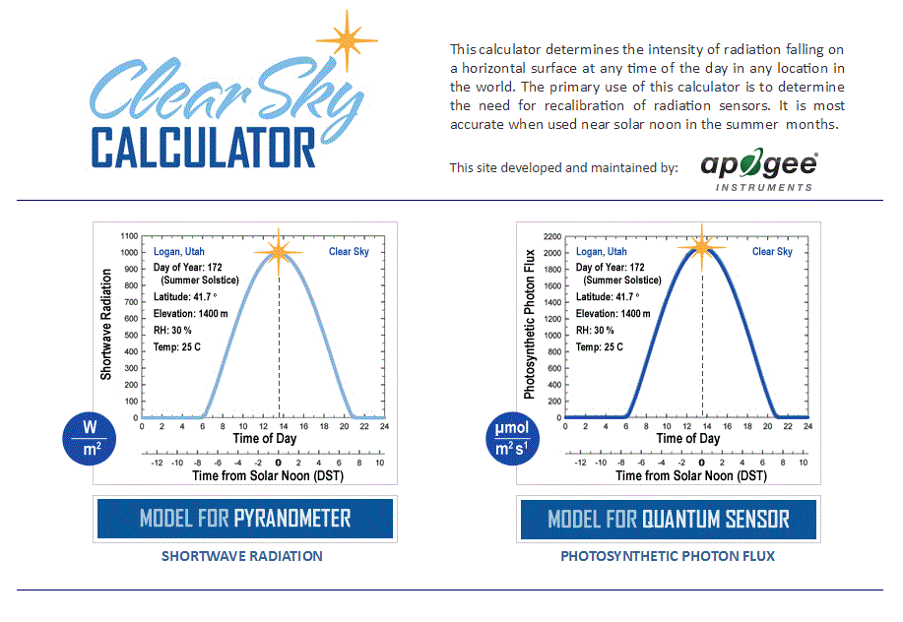

Homepage of the Clear Sky Calculator. Two calculators are available: One for pyranometers (total shortwave radiation) and one for quantum sensors (photosynthetic photon flux density).

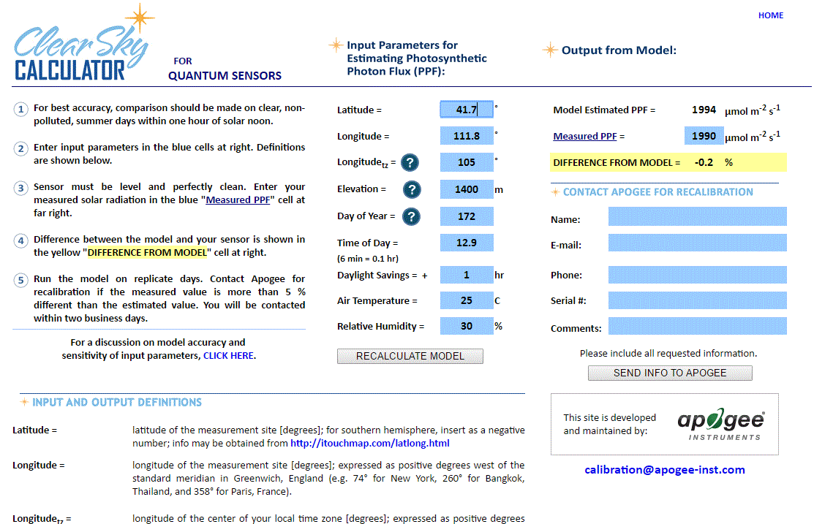

Clear Sky Calculator for pyranometers. Site data are input in blue cells in middle of page and an estimate of total shortwave radiation is returned on right-hand side of page.

### Troubleshooting and Customer Support

**Independent Verification of Functionality**

If the sensor does not communicate with the datalogger, use an ammeter to check the current drain. It should be near 0.6 mA when the sensor is not communicating and spike to approximately 1.3 mA when the sensor is communicating. Any current drain greater than approximately 6 mA indicates a problem with power supply to the sensors, wiring of the sensor, or sensor electronics.

**Compatible Measurement Devices (Dataloggers/Controllers/Meters)**

Any datalogger or meter with SDI-12 functionality that includes the M or C command.

An example datalogger program for Campbell Scientific dataloggers can be found on the Apogee webpage at <http://www.apogeeinstruments.com/content/Net-Radiometer-Digital.CR1>

**Modifying Cable Length**

SDI-12 protocol limits cable length to 60 meters. For multiple sensors connected to the same data line, the maximum is 600 meters of total cable (e.g., ten sensors with 60 meters of cable per sensor). See Apogee webpage for details on how to extend sensor cable length (<http://www.apogeeinstruments.com/how-to-make-a-weatherproof-cable-splice/>).

### Return and Warranty Policy

RETURN POLICY

Apogee Instruments will accept returns within 30 days of purchase as long as the product is in new condition (to be determined by Apogee). Returns are subject to a 10 % restocking fee.

WARRANTY POLICY

**What is Covered**All products manufactured by Apogee Instruments are warranted to be free from defects in materials and craftsmanship for a period of four (4) years from the date of shipment from our factory. To be considered for warranty coverage an item must be evaluated by Apogee.

Products not manufactured by Apogee (spectroradiometers, chlorophyll content meters, EE08-SS probes) are covered for a period of one (1) year.

**What is Not Covered**The customer is responsible for all costs associated with the removal, reinstallation, and shipping of suspected warranty items to our factory.

The warranty does not cover equipment that has been damaged due to the following conditions:

1. Improper installation or abuse.

2. Operation of the instrument outside of its specified operating range.

3. Natural occurrences such as lightning, fire, etc.

4. Unauthorized modification.

5. Improper or unauthorized repair.

Please note that nominal accuracy drift is normal over time. Routine recalibration of sensors/meters is considered part of proper maintenance and is not covered under warranty.

**Who is Covered**This warranty covers the original purchaser of the product or other party who may own it during the warranty period.

**What Apogee Will Do**At no charge Apogee will:

1. Either repair or replace (at our discretion) the item under warranty.

2. Ship the item back to the customer by the carrier of our choice.

Different or expedited shipping methods will be at the customer’s expense.

**How To Return An Item**1. Please do not send any products back to Apogee Instruments until you have received a Return Merchandise Authorization (RMA) number from our technical support department by submitting an online RMA form at [www.apogeeinstruments.com/tech-support-recalibration-repairs/](http://www.apogeeinstruments.com/tech-support-recalibration-repairs/). We will use your RMA number for tracking of the service item. Call (435) 245-8012 or email techsupport@apogeeinstruments.com with questions.

2. For warranty evaluations, send all RMA sensors and meters back in the following condition: Clean the sensor’s exterior and cord. Do not modify the sensors or wires, including splicing, cutting wire leads, etc. If a connector has been attached to the cable end, please include the mating connector – otherwise the sensor connector will be removed in order to complete the repair/recalibration. ***Note:*** *When sending back sensors for routine calibration that have Apogee’s standard stainless-steel connectors, you only need to send the sensor with the 30 cm section of cable and one-half of the connector. We have mating connectors at our factory that can be used for calibrating the sensor.*

3. Please write the RMA number on the outside of the shipping container.

4. Return the item with freight pre-paid and fully insured to our factory address shown below. We are not responsible for any costs associated with the transportation of products across international borders.

**Apogee Instruments, Inc.   
721 West 1800 North Logan, UT  
84321, USA**

5. Upon receipt, Apogee Instruments will determine the cause of failure. If the product is found to be defective in terms of operation to the published specifications due to a failure of product materials or craftsmanship, Apogee Instruments will repair or replace the items free of charge. If it is determined that your product is not covered under warranty, you will be informed and given an estimated repair/replacement cost.

Products Beyond the Warranty Period

For issues with sensors beyond the warranty period, please contact Apogee at [techsupport@apogeeinstruments.com](mailto:techsupport@apogeeinstruments.com) to discuss repair or replacement options.

Other Terms

The available remedy of defects under this warranty is for the repair or replacement of the original product, and Apogee Instruments is not responsible for any direct, indirect, incidental, or consequential damages, including but not limited to loss of income, loss of revenue, loss of profit, loss of data, loss of wages, loss of time, loss of sales, accruement of debts or expenses, injury to personal property, or injury to any person or any other type of damage or loss.

This limited warranty and any disputes arising out of or in connection with this limited warranty ("Disputes") shall be governed by the laws of the State of Utah, USA, excluding conflicts of law principles and excluding the Convention for the International Sale of Goods. The courts located in the State of Utah, USA, shall have exclusive jurisdiction over any Disputes.

This limited warranty gives you specific legal rights, and you may also have other rights, which vary from state to state and jurisdiction to jurisdiction, and which shall not be affected by this limited warranty. This warranty extends only to you and cannot by transferred or assigned. If any provision of this limited warranty is unlawful, void or unenforceable, that provision shall be deemed severable and shall not affect any remaining provisions. In case of any inconsistency between the English and other versions of this limited warranty, the English version shall prevail.

This warranty cannot be changed, assumed, or amended by any other person or agreement

**APOGEE INSTRUMENTS, INC. |** 721 WEST 1800 NORTH, LOGAN, UTAH 84321, USA

TEL: (435) 792-4700 | FAX: (435) 787-8268 | WEB: APOGEEINSTRUMENTS.COM

*Copyright © 2020 Apogee Instruments, Inc.*