

# Owner’s Manual

research-grade Infrared radiometer

Models SI-511, SI-521, SI-531, and SI-5H1  
Rev: 10-Dec-2020

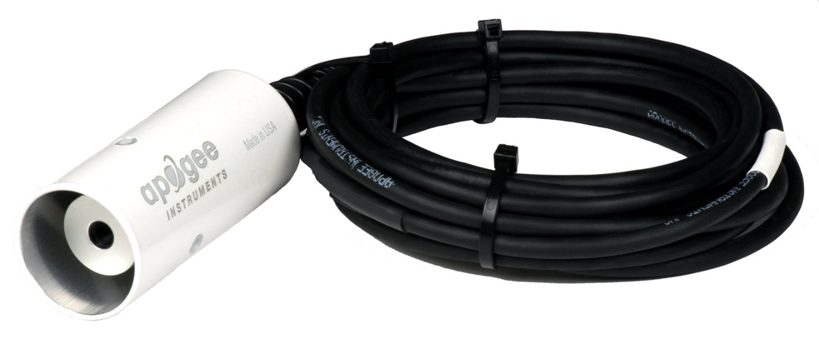

Table of Contents

Owner’s Manual 1

Declaration of Conformity 3

Introduction 4

Sensor Models 5

Specifications 6

Deployment and Installation 7

Cable Connectors 9

Operation and Measurement 10

Maintenance and Recalibration 18

Troubleshooting and Customer Support 19

Return and Warranty Policy 20

### Declaration of Conformity

**EU Declaration of Conformity**

This declaration of conformity is issued under the sole responsibility of the manufacturer:

Apogee Instruments, Inc.  
721 W 1800 N  
Logan, Utah 84321  
USA

for the following product(s):

Models: SI-511, SI-521, SI-531, SI-5H1  
Type: Infrared Radiometer

The object of the declaration described above is in conformity with the relevant Union harmonization legislation:

2014/30/EU Electromagnetic Compatibility (EMC) Directive

2011/65/EU Restriction of Hazardous Substances (RoHS 2) Directive

2015/863/EU Amending Annex II to Directive 2011/65/EU (RoHS 3)

Standards referenced during compliance assessment:

EN 61326-1:2013 Electrical equipment for measurement, control and laboratory use – EMC requirements

EN 50581:2012 Technical documentation for the assessment of electrical and electronic products with respect to the restriction of hazardous substances

Please be advised that based on the information available to us from our raw material suppliers, the products manufactured by us do not contain, as intentional additives, any of the restricted materials including lead (see note below), mercury, cadmium, hexavalent chromium, polybrominated biphenyls (PBB), polybrominated diphenyls (PBDE), bis(2-ethylhexyl) phthalate (DEHP), butyl benzyl phthalate (BBP), dibutyl phthalate (DBP), and diisobutyl phthalate (DIBP). However, please note that articles containing greater than 0.1% lead concentration are RoHS 3 compliant using exemption 6c.

Further note that Apogee Instruments does not specifically run any analysis on our raw materials or end products for the presence of these substances, but rely on the information provided to us by our material suppliers.

Signed for and on behalf of:

Apogee Instruments, December 2020



Bruce Bugbee  
President  
Apogee Instruments, Inc.

### Introduction

All objects with a temperature above absolute zero emit electromagnetic radiation. The wavelengths and intensity of radiation emitted are related to the temperature of the object. Terrestrial surfaces (e.g., soil, plant canopies, water, snow) emit radiation in the mid infrared portion of the electromagnetic spectrum (approximately 4-50 µm).

Infrared radiometers are sensors that measure infrared radiation, which is used to determine surface temperature without touching the surface (when using sensors that must be in contact with the surface, it can be difficult to maintain thermal equilibrium without altering surface temperature). Infrared radiometers are often called infrared thermometers because temperature is the desired quantity, even though the sensors detect radiation.

Typical applications of infrared radiometers include plant canopy temperature measurement for use in plant water status estimation, road surface temperature measurement for determination of icing conditions, and terrestrial surface (soil, vegetation, water, snow) temperature measurement in energy balance studies.

Apogee Instruments SI series research-grade infrared radiometers consist of a thermopile detector, germanium filter, precision thermistor (for detector reference temperature measurement), and signal processing circuitry mounted in an anodized aluminum housing, and a cable to connect the sensor to a measurement device. All radiometers also come with a radiation shield designed to minimize absorbed solar radiation, but still allowing natural ventilation. The radiation shield insulates the radiometer from rapid temperature changes and keeps the temperature of the radiometer closer to the target temperature. Sensors are potted solid with no internal air space and are designed for continuous temperature measurement of terrestrial surfaces in indoor and outdoor environments. SI-500 series sensors output a digital signal using Modbus RTU protocol over RS-232 or RS-485.

### Sensor Models

|  |  |  |
| --- | --- | --- |
| Model | Output | |
| SI-500 Series | **Modbus** |
| SI-400 Series | SDI-12 |
| SI-100 Series | Voltage |

Sensor model number and serial number are located on a label near the connector on the sensor cable. If you need the manufacturing date of your sensor, please contact Apogee Instruments with the serial number of your sensor.

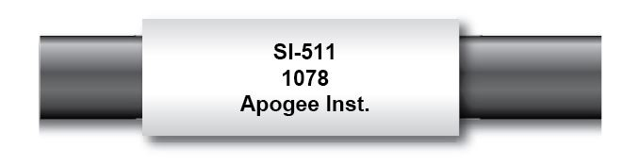

The four FOV options and associated model numbers are shown below:

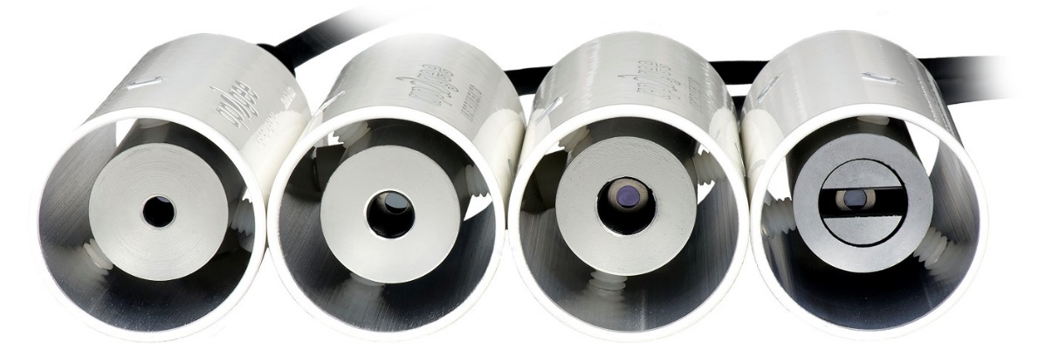

SI-531 SI-521 SI-511 SI-5H1

### Specifications

|  |  |  |  |  |
| --- | --- | --- | --- | --- |
|  | **SI-511-SS** | **SI-521-SS** | **SI-531-SS** | **SI-5H1-SS** |
| Input Voltage Requirement | 5.5 to 24 V DC | | | |
| Current Drain | RS-232 37 mA;  RS-485 quiescent 37, active 42 mA | | | |
| Calibration Uncertainty (-30 to 65 C), when target and detector temperature are within 20 C | 0.2 C | 0.2 C | 0.3 C | 0.2 C |
| Calibration Uncertainty (-40 to 80 C), when target and detector temperate are different by more than 20 C  (see Calibration Traceability below) | 0.5 C | 0.5 C | 0.6 C | 0.5 C |
| Measurement Repeatability | Less than 0.05 C | | | |
| Stability (Long-term Drift) | Less than 2 % change in slope per year when germanium filter is maintained in a clean condition (see Maintenance and Recalibration section below) | | | |
| Field of View | 22° half angle | 18° half angle | 14° half angle | 32° horizontal half angle; 13° vertical half angle |
| Spectral Range | 8 to 14 µm; atmospheric window (see Spectral Response below) | | | |
| Operating Environment | -50 to 80 C; 0 to 100 % relative humidity (non-condensing) | | | |
| Dimensions | 23 mm diameter; 60 mm length | | | |
| Mass | 190 g (with 5m of lead wire) | | | |
| Cable | 5 m of two conductor, shielded, twisted-pair wire; TPR jacket (high water resistance, high UV stability, flexibility in cold conditions); pigtail lead wires; stainless steel (316), M8 connector located 25 cm from sensor head | | | |

**Calibration Traceability**

Apogee SI series infrared radiometers are calibrated to the temperature of a custom blackbody cone held at multiple fixed temperatures over a range of radiometer (detector/sensor body) temperatures. The temperature of the blackbody cone is measured with replicate precision thermistors thermally bonded to the cone surface. The precision thermistors are calibrated for absolute temperature measurement against a platinum resistance thermometer (PRT) in a constant temperature bath. The PRT calibration is directly traceable to the NIST.

**Spectral Response**

Spectral response of SI series infrared radiometers. Spectral response (green line) is determined by the germanium filter and corresponds closely to the atmospheric window of 8-14 µm, minimizing interference from atmospheric absorption/emission bands (blue line) below 8 µm and above 14 µm. Typical terrestrial surfaces have temperatures that yield maximum radiation emission within the atmospheric window, as shown by the blackbody curve for a radiator at 28 C (red line).

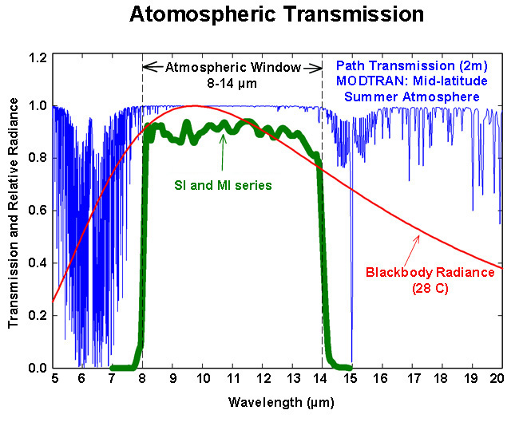

### Deployment and Installation

The mounting geometry (distance from target surface, angle of orientation relative to target surface) is determined by the desired area of surface to be measured. The field of view extends unbroken from the sensor to the target surface. Sensors must be carefully mounted in order to view the desired target and avoid including unwanted surfaces/objects in the field of view, thereby averaging unwanted temperatures with the target temperature (see Field of View below). **Once mounted, the green cap must be removed.** The green cap can be used as a protective covering for the sensor, when it is not in use.

An Apogee Instruments model AM-220 mounting bracket is recommended for mounting the sensor to a cross arm or pole. The AM-220 allows adjustment of the angle of the sensor with respect to the target and accommodates the radiation shield designed for all SI series infrared radiometers.

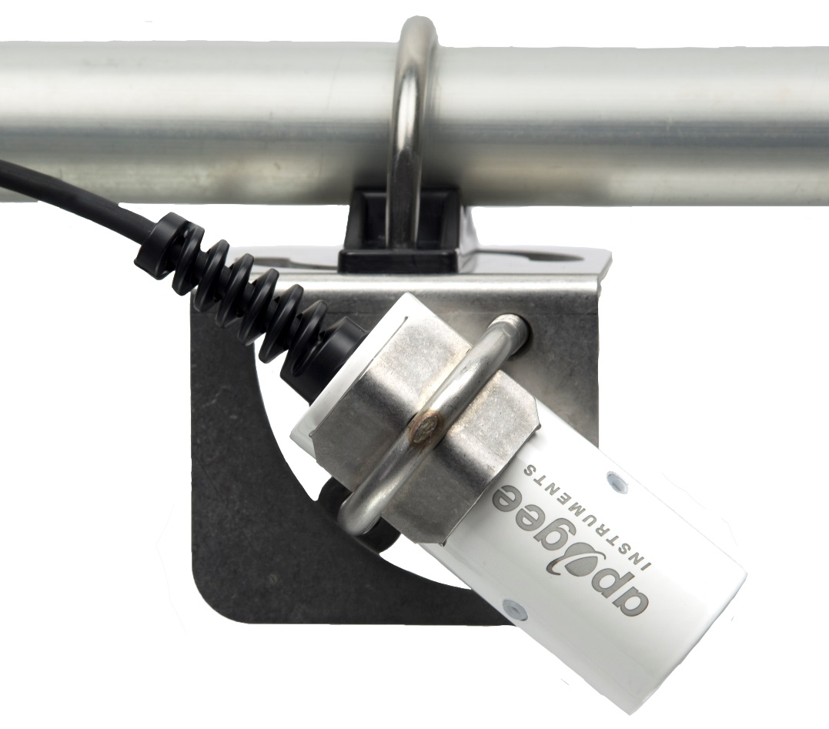

**Field of View**

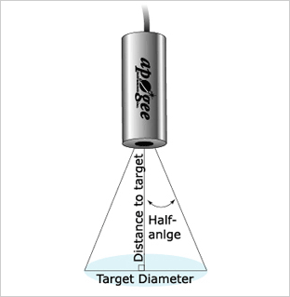The field of view (FOV) is reported as the half-angle of the apex of the cone formed by the target surface (cone base) and the detector (cone apex), as shown below, where the target is defined as a circle from which 98 % of the radiation detected by the radiometer is emitted.

Sensor FOV, distance to target, and sensor mounting angle in relation to the target will determine target area. Different mounting geometries (distance and angle combinations) produce different target shapes and areas, as shown below.

|  |  |  |  |  |  |  |  |  |  |  |  |  |
| --- | --- | --- | --- | --- | --- | --- | --- | --- | --- | --- | --- | --- |
| **CIRCULAR** | | | | | | **HORIZONTAL** | | | | | | |
|  | | | FOV Area (m²) | | |  | | Half Angle | | FOV Area (m²) | | |
| **Type** | **Model** | **Half Angle** | **0 Deg** | **45 Deg** | **60 Deg** | **Type** | **Model** | **Horizontal** | **Vertical** | **0 Deg** | **45 Deg** | **60 Deg** |
| Standard | SI-511 | 22° | 2.069 | 7.627 | 45.211 | Standard | SI-5H1 | 32° | 13° | 2.276 | 7.148 | 45.512 |
| IR-FOVNarrow | SI-521 | 18° | 1.337 | 4.461 | 18.865 | Narrow | SI-5HR | 16° | 5° | 0.403 | 1.15 | 3.341 |
| Ultra-Narrow | SI-531 | 14° | 0.787 | 2.447 | 8.544 |  |  |  |  |  |  |  |

-­­­

A simple FOV calculator for determining target dimensions based on infrared radiometer model, mounting height, and mounting angle, is available on the Apogee website: <https://www.apogeeinstruments.com/irr-calculators>.

### Cable Connectors

|  |  |
| --- | --- |
| Apogee sensors offer cable connectors to simplify the process of removing sensors from weather stations for calibration (the entire cable does **not** have to be removed from the station and shipped with the sensor).  The ruggedized M8 connectors are rated IP68, made of corrosion-resistant marine-grade stainless-steel, and designed for extended use in harsh environmental conditions. | Inline cable connectors are installed 30 cm from the head  (pyranometer pictured) |

**Instructions**

|  |  |
| --- | --- |
| **Pins and Wiring Colors:** All Apogee connectors have six pins, but not all pins are used for every sensor. There may also be unused wire colors inside the cable. To simplify datalogger connection, we remove the unused pigtail lead colors at the datalogger end of the cable.  If a replacement cable is required, please contact Apogee directly to ensure ordering the proper pigtail configuration.  **Alignment:** When reconnecting a sensor, arrows on the connector jacket and an aligning notch ensure proper orientation.  **Disconnection for extended periods:**  When disconnecting the sensor for an extended period of time from a station, protect the remaining half of the connector still on the station from water and dirt with electrical tape or other method. | A reference notch inside the connector ensures  proper alignment before tightening.    When sending sensors in for calibration, only send the short end of the cable and half the connector. |
| **Tightening:** Connectors are designed to be firmly finger-tightened only. There is an O-ring inside the connector that can be overly compressed if a wrench is used. Pay attention to thread alignment to avoid cross-threading. When fully tightened, 1-2 threads may still be visible. | Finger-tighten firmly |

### Operation and Measurement

All SI-500 series radiometers have a Modbus output, where target and detector temperatures are returned in digital format. Measurement of SI-500 series radiometers requires a measurement device with a Modbus interface that supports the Read Holding Registers (0x03) function.

**Wiring**

White: RS-232 RX / RS-485 Positive

Blue: RS-232 TX / RS-485 Negative

Green: Select (Switch between RS-232 and RS-485)

Black: Ground

Red: Power +12 V

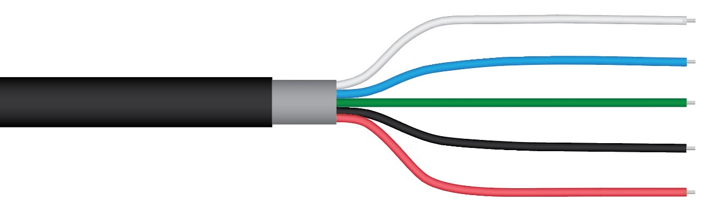

The Green wire should be connected to Ground to enable RS-485 communication, or it should be connected to 12 V power for RS-232 communication. Text for the White and Blue wires above refers to the port that the wires should be connected to.

**­**

**Sensor Calibration**

Apogee SI series infrared radiometers are calibrated in a temperature controlled chamber that houses a custom-built blackbody cone (target) for the radiation source. During calibration, infrared radiometers (detectors) are held in a fixture at the opening of the blackbody cone, but are thermally insulated from the cone. Detector and target temperature are controlled independently. At each calibration set point, detectors are held at a constant temperature while the blackbody cone is controlled at temperatures below (12 C), above (18 C), and equal to the detector temperature. The range of detector temperatures is -15 C to 45 C (set points at 10 C increments). Data are collected at each detector temperature set point, after detectors and target reach constant temperatures.

All Apogee modbus infrared radiometer models (SI-500 series) have sensor-specific calibration coefficients determined during the custom calibration process. Coefficients are programmed into the sensor at the factory. Calibration data for each sensor are provided on a calibration.

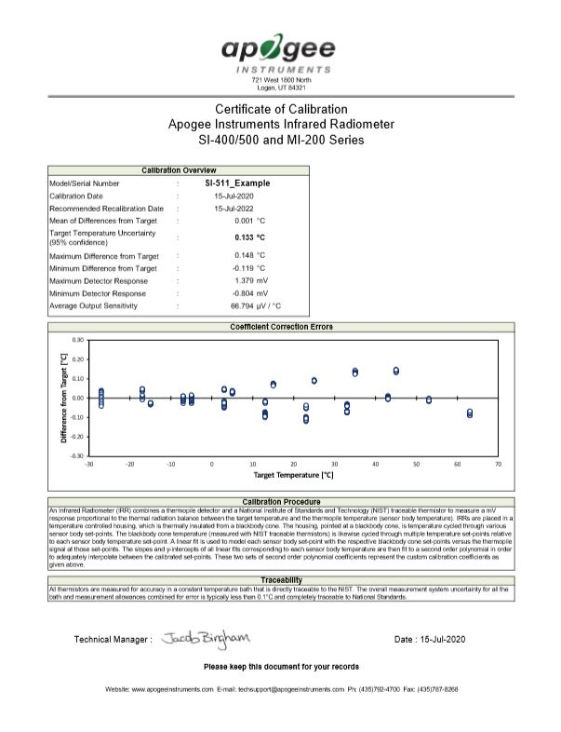

Calibration overview data are listed in box in upper left-hand corner, temperature errors are shown in graph, and calibration date is listed below descriptions of calibration procedure and traceability.

**Sensor Calibration**

All Apogee Modbus radiometers (model series SI-500) have sensor-specific calibration coefficients determined during the custom calibration process. Coefficients are programmed into the sensors at the factory.

**Modbus Interface**

The following is a brief explanation of the Modbus protocol instructions used in Apogee SI-500 series radiometers. For questions on the implementation of this protocol, please refer to the official serial line implementation of the Modbus protocol: <http://www.modbus.org/docs/Modbus_over_serial_line_V1_02.pdf> (2006) and the general Modbus protocol specification: <http://www.modbus.org/docs/Modbus_Application_Protocol_V1_1b3.pdf> (2012). Further information can be found at: <http://www.modbus.org/specs.php>

**Overview**

The primary idea of the Modbus interface is that each sensor exists at an address and appears as a table of values. These values are called Registers. Each value in the table has an associated index, and that index is used to identify which value in the table is being accessed.   
  
**Sensor addresses**

Each sensor is given an address from 1 to 247. Apogee sensors are shipped with a default address of 1. If using multiple sensors on the same Modbus line, the sensor’s address will have to be changed by writing the Slave Address register.

**Register Index**

Each register in a sensor represents a value in the sensor, such as a measurement or a configuration parameter. Some registers can only be read, some registers can only be written, and some can be both read and written. Each register exists at a specified index in the table for the sensor. Often this index is called an address, which is a separate address than the sensor address, but can be easily confused with the sensor address.

However, there are two different indexing schemes used for Modbus sensors, though translating between them is simple. One indexing scheme is called one-based numbering, where the first register is given the index of 1, and is thereby accessed by requesting access to register 1. The other indexing scheme is called zero-based numbering, where the first register is given the index 0, and is thereby accessed by requesting access to register 0. Apogee Sensors use zero-based numbering. However, if using the sensor in a system that uses one-based numbering, such as using a CR1000X logger, adding 1 to the zero-based address will produce the one-based address for the register.

**Register Format:**

According to the Modbus protocol specification, Holding Registers (the type registers Apogee sensors contain) are defined to be 16 bits wide. However, when making scientific measurements, it is desirable to obtain a more precise value than 16 bits allows. Thus, several Modbus implementations will use two 16-bit registers to act as one 32-bit register. Apogee Modbus sensors use this 32-bit implementation to provide measurement values as 32-bit IEEE 754 floating point numbers.

Apogee Modbus sensors also contain a redundant, duplicate set of registers that use 16-bit signed integers to represent values as decimal-shifted numbers. It is recommended to use the 32-bit values, if possible, as they contain more precise values.

**Communication Parameters:**

Apogee Sensors communicate using the Modbus RTU variant of the Modbus protocol. The default communication parameters are as follows:

Slave address: 1

Baudrate: 19200

Data bits: 8

Stop bits: 1

Parity: Even

Byte Order: Big-Endian (most significant byte sent first)

The baudrate and slave address are user configurable. **Valid slave addresses are 1 to 247. Since the address 0 is reserve as the broadcast address, setting the slave address to 0 will actually set the slave address to 1.** (This will also reset factory-calibrated values and should **NOT** be done by the user unless otherwise instructed.)

**Read only registers (function code 0x3).**

|  |  |
| --- | --- |
| **Float Registers** | |
| 0  1 | target temperature |
| 2  3 | sensor temperature |
| 4  5 | detector millivolts |
| 6  7 | thermistor millivolts |
| 8  9 | Reserved for Future Use |
| 10  11 | device status  (1 means device is busy, 0 otherwise) |
| 12  13 | firmware version |
| **Integer Registers** | |
| 50 | target temperature µmol (shifted one decimal point to the left) |
| 51 | sensor temperature µmol (shifted one decimal point to the left) |
| 52 | target millivolts (shifted three decimal points to the left) |
| 53 | sensor millivolts (shifted three decimal points to the left) |
| 54 | Reserved for Future Use |
| 55 | device status (1 means device is busy, 0 otherwise) |
| 56 | firmware version (shifted one decimal point to the left) |

**Read/Write registers (function codes 0x3 and 0x10).**

|  |  |
| --- | --- |
| **Float Registers** | |
| 20  21 | slave address |
| 22  23 | model number* |
| 24  25 | serial number* |
| 26  27 | baudrate (0 = 115200, 1 = 57600, 2 = 38400, 3 = 19200, 4 = 9600, any other number = 19200) |
| 28  29 | parity (0 = none, 1 = odd, 2 = even) |
| 30  31 | number of stopbits |
| 32  33 | MC0* |
| 34  35 | MC1* |
| 36  37 | MC2* |
| 38  39 | BC0* |
| 40  41 | BC1* |
| 42  43 | BC2* |
| 44  45 | running average |
| **Integer Registers** | |
| 60 | slave address |
| 61 | model number* |
| 62 | serial number* |
| 63 | baudrate (0 = 115200, 1 = 57600, 2 = 38400, 3 = 19200, 4 = 9600, any other number = 19200) |
| 64 | parity (0 = none, 1 = odd, 2 = even) |
| 65 | number of stopbits |
| 66 | MC0 |
| 67 | MC1 |
| 68 | MC2 |
| 69 | BC0 |
| 70 | BC1 |
| 71 | BC2 |
| 72 | running average |

**\*Registers marked with an asterisk (*) cannot be written to unless a specific procedure is followed. Contact Apogee Instruments to receive the procedure for writing these registers**

**Write only registers (function code 0x10).**

|  |  |
| --- | --- |
| **Integer Registers** | |
| 190 | Writing to this register resets Coefficients to firmware defaults. (NOT factory calibrated values!) Slave Address = 1, Model = 5X1, Serial = 1000, Baud = 3, Parity = 2, Stopbits = 1, running average = 1 |

**Packet Framing:**

Apogee sensors use Modbus RTU packets and tend to adhere to the following pattern:

Slave Address (1 byte), Function Code (1 byte), Starting Address (2 bytes), Number of Registers (2 bytes), Data Length (1 byte, optional) Data (n bytes, optional)

Modbus RTU packets use the zero-based address when addressing registers.

For information on Modbus RTU framing, see the official documentation at <http://www.modbus.org/docs/Modbus_Application_Protocol_V1_1b3.pdf>

**Example Packets:**

An example of a data packet sent from the controller to the sensor using function code 0x3 reading register address 0.Each pair of square brackets indicates one byte.

[Slave Address][Function][Starting Address High Byte][Starting Address Low Byte][No of Registers High Byte][No of Registers Low Byte][CRC High Byte][CRC Low Byte]

0x01 0x03 0x00 0x00 0x00 0x02 0xC4 0x0B

An example of a data packet sent from the controller to the sensor using function code 0x10 writing a 1 to register 26. Each pair of square brackets indicates one byte.

[Slave Address][Function][Starting Address High Byte][Starting Address Low Byte][No of Registers High Byte][No of Registers Low Byte][Byte Count][Data High Byte][Data Low Byte][Data High Byte][Data Low Byte][CRC High Byte][CRC Low Byte]

0x01 0x10 0x00 0x1A 0x00 0x02 0x04 0x3f 0x80 0x00 0x00 0x7f 0x20

**Target Temperature Measurement**

SI-500 series infrared radiometers communicate using the RS-232 or RS-485 protocol. The following equations and the custom calibration coefficients described in this section are programmed into the microcontroller. Target temperature is output directly in digital format.

The detector output from SI series radiometers follows the fundamental physics of the Stefan-Boltzmann Law, where radiation transfer is proportional to the fourth power of absolute temperature. A modified form of the Stefan-Boltzmann equation is used to calibrate sensors, and subsequently, calculate target temperature:

 (1)

where TT is target temperature [K], TD is detector temperature [K], SD is the millivolt signal from the detector, m is slope, and b is intercept. The mV signal from the detector is linearly proportional to the energy balance between the target and detector, analogous to energy emission being linearly proportional to the fourth power of temperature in the Stefan-Boltzmann Law.

During the calibration process, m and b are determined at each detector temperature set point (10 C increments across a -15 C to 45 C range) by plotting measurements of TT4 – TD4 versus mV. The derived m and b coefficients are then plotted as function of TD and second order polynomials are fitted to the results to produce equations that determine m and b at any TD:

 (2)

 (3)

Where C2, C1, and C0 are the custom calibration coefficients listed on the calibration certificate (shown above) that comes with each SI-100 series radiometer (there are two sets of polynomial coefficients, one set for m and one set for b). Note that TD is converted from Kelvin to Celsius (temperature in C equals temperature in K minus 273.15) before m and b are plotted versus TD.

To make measurements of target temperatures, Eq. (1) is rearranged to solve for TT [C], measured values of SD and TD are input, and predicted values of m and b are input:

 (4)

**Emissivity Correction**

Appropriate correction for surface emissivity is required for accurate surface temperature measurements. The simple (and commonly made) emissivity correction, dividing measured temperature by surface emissivity, is incorrect because it does not account for reflected infrared radiation.

The radiation detected by an infrared radiometer includes two components: 1. radiation directly emitted by the target surface, and 2. reflected radiation from the background. The second component is often neglected. The magnitude of the two components in the total radiation detected by the radiometer is estimated using the emissivity (ε) and reflectivity (1 - ε) of the target surface:

 (1)

where ESensor is radiance [W m-2 sr-1] detected by the radiometer, ETarget is radiance [W m-2 sr-1] emitted by the target surface, EBackground is radiance [W m-2 sr-1] emitted by the background (when the target surface is outdoors the background is generally the sky), and ε is the ratio of non-blackbody radiation emission (actual radiation emission) to blackbody radiation emission at the same temperature (theoretical maximum for radiation emission). Unless the target surface is a blackbody (ε = 1; emits and absorbs the theoretical maximum amount of energy based on temperature), Esensor will include a fraction (1 – ε) of reflected radiation from the background.

Since temperature, rather than energy, is the desired quantity, Eq. (1) can be written in terms of temperature using the Stefan-Boltzmann Law, E = σT4 (relates energy being emitted by an object to the fourth power of its absolute temperature):

 (2)

where TSensor [K] is temperature measured by the infrared radiometer (brightness temperature), TTarget [K] is actual temperature of the target surface, TBackground [K] is brightness temperature of the background (usually the sky), and σ is the Stefan-Boltzmann constant (5.67 x 10-8 W m-2 K-4). The power of 4 on the temperatures in Eq. (2) is valid for the entire blackbody spectrum.

Rearrangement of Eq. (2) to solve for TTarget yields the equation used to calculate the actual target surface temperature (i.e., measured brightness temperature corrected for emissivity effects):

. (3)

Equations (1)-(3) assume an infinite waveband for radiation emission and constant ε at all wavelengths. These assumptions are not valid because infrared radiometers do not have infinite wavebands, as most correspond to the atmospheric window of 8-14 µm, and ε varies with wavelength. Despite the violated assumptions, the errors for emissivity correction with Eq. (3) in environmental applications are typically negligible because a large proportion of the radiation emitted by terrestrial objects is in the 8-14 µm waveband (the power of 4 in Eqs. (2) and (3) is a reasonable approximation), ε for most terrestrial objects does not vary significantly in the 8-14 µm waveband, and the background radiation is a small fraction (1 – ε) of the measured radiation because most terrestrial surfaces have high emissivity (often between 0.9 and 1.0). To apply Eq. (3), the brightness temperature of the background (TBackground) must be measured or estimated with reasonable accuracy. If a radiometer is used to measure background temperature, the waveband it measures should be the same as the radiometer used to measure surface brightness temperature. Although the ε of a fully closed plant canopy can be 0.98-0.99, the lower ε of soils and other surfaces can result in substantial errors if ε effects are not accounted for.

### Maintenance and Recalibration

Blocking of the optical path between the target and detector, often due to moisture or debris on the filter, is a common cause of inaccurate measurements. The filter in SI series radiometers is inset in an aperture, but can become partially blocked in four ways:

1. Dew or frost formation on the filter.
2. Salt deposit accumulation on the filter, due to evaporating irrigation water or sea spray. This leaves a thin white film on the filter surface. Salt deposits can be removed with a dilute acid (e.g., vinegar). **Salt deposits cannot be removed with solvents such as alcohol or acetone.**
3. Dust and dirt deposition in the aperture and on the filter (usually a larger problem in windy environments). Dust and dirt are best removed with deionized water, rubbing alcohol, or in extreme cases, acetone.
4. Spiders/insects and/or nests in the aperture leading to the filter. If spiders/insects are a problem, repellent should be applied around the aperture entrance (not on the filter).

Clean inner threads of the aperture and the filter with a cotton swab dipped in the appropriate solvent. **Never use an abrasive material on the filter.** Use only gentle pressure when cleaning the filter with a cotton swab, to avoid scratching the outer surface. The solvent should be allowed to do the cleaning, not mechanical force.

It is recommended that infrared radiometers be recalibrated every two years. See the Apogee webpage for details regarding return of sensors for recalibration (<http://www.apogeeinstruments.com/tech-support-recalibration-repairs/>).

### Troubleshooting and Customer Support

**Independent Verification of Functionality**

If the sensor does not communicate with the datalogger, use an ammeter to check the current drain. It should be near 37 mA when the sensor is powered. Any current drain significantly greater than approximately 37 mA indicates a problem with power supply to the sensors, wiring of the sensor, or sensor electronics.

**Compatible Measurement Devices (Dataloggers/Controllers/Meters)**

Any datalogger or meter with RS-232/RS-485 that can read/write float or integer values.

An example datalogger program for Campbell Scientific dataloggers can be found on the Apogee webpage at <http://www.apogeeinstruments.com/downloads/#datalogger>.

**Cable Length**

All Apogee sensors use shielded cable to minimize electromagnetic interference. For best communication, the shield wire must be connected to an earth ground. This is particularly important when using the sensor with long lead lengths in electromagnetically noisy environments.

**RS-232 Cable Length**

If using an RS-232 serial interface, the cable length from the sensor to the controller should be kept short, no longer than 20 meters. For more information, see section 3.3.5 in this document: <http://www.modbus.org/docs/Modbus_over_serial_line_V1_02.pdf>  
  
**RS-485 Cable Length**

If using an RS-485 serial interface, longer cable lengths may be used. The trunk cable can be up to 1000 meters long. The length of cable from the sensor to a tap on the trunk should be short, no more than 20 meters. For more information, see section 3.4 in this document: <http://www.modbus.org/docs/Modbus_over_serial_line_V1_02.pdf>

**Troubleshooting Tips**

* Make sure to use the green wire to select between RS-232 and RS-485.
* Make sure that the sensor is wired correctly (refer to wiring diagram).
* Make sure the sensor is powered by a power supply with a sufficient output (e.g., 12 V).
* Make sure to use the appropriate kind of variable when reading Modbus registers. Use a float variable for float registers and an integer variable for integer registers.
* Make sure the baudrate, stop bits, parity, byte order, and protocols match between the control program and the sensor. Default values are:
  + Baudrate: 19200
  + Stop bits: 1
  + Parity: Even
  + Byte order: ABCD (Big-Endian/Most Significant Byte First)
  + Protocol: RS-232 or RS-485

### Return and Warranty Policy

RETURN POLICY

Apogee Instruments will accept returns within 30 days of purchase as long as the product is in new condition (to be determined by Apogee). Returns are subject to a 10 % restocking fee.

WARRANTY POLICY

**What is Covered**All products manufactured by Apogee Instruments are warranted to be free from defects in materials and craftsmanship for a period of four (4) years from the date of shipment from our factory. To be considered for warranty coverage an item must be evaluated by Apogee.

Products not manufactured by Apogee (spectroradiometers, chlorophyll content meters, EE08-SS probes) are covered for a period of one (1) year.

**What is Not Covered**The customer is responsible for all costs associated with the removal, reinstallation, and shipping of suspected warranty items to our factory.

The warranty does not cover equipment that has been damaged due to the following conditions:

1. Improper installation or abuse.

2. Operation of the instrument outside of its specified operating range.

3. Natural occurrences such as lightning, fire, etc.

4. Unauthorized modification.

5. Improper or unauthorized repair.

Please note that nominal accuracy drift is normal over time. Routine recalibration of sensors/meters is considered part of proper maintenance and is not covered under warranty.

**Who is Covered**This warranty covers the original purchaser of the product or other party who may own it during the warranty period.

**What Apogee Will Do**At no charge Apogee will:

1. Either repair or replace (at our discretion) the item under warranty.

2. Ship the item back to the customer by the carrier of our choice.

Different or expedited shipping methods will be at the customer’s expense.

**How To Return An Item**1. Please do not send any products back to Apogee Instruments until you have received a Return Merchandise Authorization (RMA) number from our technical support department by submitting an online RMA form at [www.apogeeinstruments.com/tech-support-recalibration-repairs/](http://www.apogeeinstruments.com/tech-support-recalibration-repairs/). We will use your RMA number for tracking of the service item. Call (435) 245-8012 or email techsupport@apogeeinstruments.com with questions.

2. For warranty evaluations, send all RMA sensors and meters back in the following condition: Clean the sensor’s exterior and cord. Do not modify the sensors or wires, including splicing, cutting wire leads, etc. If a connector has been attached to the cable end, please include the mating connector – otherwise the sensor connector will be removed in order to complete the repair/recalibration. ***Note:*** *When sending back sensors for routine calibration that have Apogee’s standard stainless-steel connectors, you only need to send the sensor with the 30 cm section of cable and one-half of the connector. We have mating connectors at our factory that can be used for calibrating the sensor.*

3. Please write the RMA number on the outside of the shipping container.

4. Return the item with freight pre-paid and fully insured to our factory address shown below. We are not responsible for any costs associated with the transportation of products across international borders.

**Apogee Instruments, Inc.   
721 West 1800 North Logan, UT  
84321, USA**

5. Upon receipt, Apogee Instruments will determine the cause of failure. If the product is found to be defective in terms of operation to the published specifications due to a failure of product materials or craftsmanship, Apogee Instruments will repair or replace the items free of charge. If it is determined that your product is not covered under warranty, you will be informed and given an estimated repair/replacement cost.

Products Beyond the Warranty Period

For issues with sensors beyond the warranty period, please contact Apogee at [techsupport@apogeeinstruments.com](mailto:techsupport@apogeeinstruments.com) to discuss repair or replacement options.

Other Terms

The available remedy of defects under this warranty is for the repair or replacement of the original product, and Apogee Instruments is not responsible for any direct, indirect, incidental, or consequential damages, including but not limited to loss of income, loss of revenue, loss of profit, loss of data, loss of wages, loss of time, loss of sales, accruement of debts or expenses, injury to personal property, or injury to any person or any other type of damage or loss.

This limited warranty and any disputes arising out of or in connection with this limited warranty ("Disputes") shall be governed by the laws of the State of Utah, USA, excluding conflicts of law principles and excluding the Convention for the International Sale of Goods. The courts located in the State of Utah, USA, shall have exclusive jurisdiction over any Disputes.

This limited warranty gives you specific legal rights, and you may also have other rights, which vary from state to state and jurisdiction to jurisdiction, and which shall not be affected by this limited warranty. This warranty extends only to you and cannot by transferred or assigned. If any provision of this limited warranty is unlawful, void or unenforceable, that provision shall be deemed severable and shall not affect any remaining provisions. In case of any inconsistency between the English and other versions of this limited warranty, the English version shall prevail.

This warranty cannot be changed, assumed, or amended by any other person or agreement

**APOGEE INSTRUMENTS, INC. |** 721 WEST 1800 NORTH, LOGAN, UTAH 84321, USA

TEL: (435) 792-4700 | FAX: (435) 787-8268 | WEB: APOGEEINSTRUMENTS.COM

*Copyright © 2020 Apogee Instruments, Inc.*