

# Owner’s Manual

Radiation frost detector

Model SF-421

Rev: 20-Jan-2022

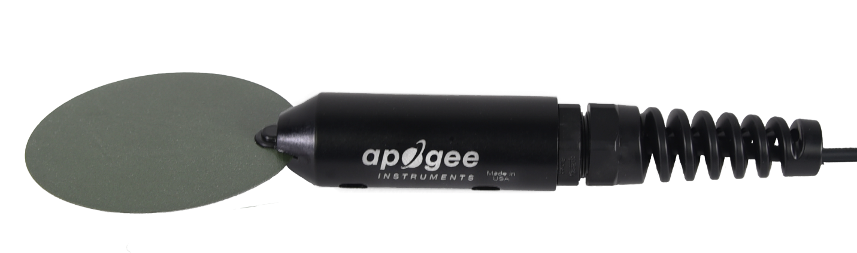

Table of Contents

Owner’s Manual 1

Certificate of Compliance 3

Introduction 4

Sensor Models 6

Specifications 7

Deployment and Installation 8

Cable Connectors 9

Operation and Measurement 10

Maintenance and Recalibration 16

Troubleshooting and Customer Support 17

Return and Warranty Policy 18

### Certificate of Compliance

**EU Declaration of Conformity**

This declaration of conformity is issued under the sole responsibility of the manufacturer:

Apogee Instruments, Inc.  
721 W 1800 N  
Logan, Utah 84321  
USA

for the following product(s):

Models: SF-421  
Type: Radiation Frost Detector

The object of the declaration described above is in conformity with the relevant Union harmonization legislation:

2014/30/EU Electromagnetic Compatibility (EMC) Directive

2011/65/EU Restriction of Hazardous Substances (RoHS 2) Directive

2015/863/EU Amending Annex II to Directive 2011/65/EU (RoHS 3)

Standards referenced during compliance assessment:

EN 61326-1:2013 Electrical equipment for measurement, control, and laboratory use – EMC requirements

EN 50581:2012 Technical documentation for the assessment of electrical and electronic products with respect to the restriction of hazardous substances

Please be advised that based on the information available to us from our raw material suppliers, the products manufactured by us do not contain, as intentional additives, any of the restricted materials including lead (see note below), mercury, cadmium, hexavalent chromium, polybrominated biphenyls (PBB), polybrominated diphenyls (PBDE), bis (2-ethylhexyl) phthalate (DEHP), butyl benzyl phthalate (BBP), dibutyl phthalate (DBP), and diisobutyl phthalate (DIBP). However, please note that articles containing greater than 0.1% lead concentration are RoHS 3 compliant using exemption 6c.

Further note that Apogee Instruments does not specifically run any analysis on our raw materials or end products for the presence of these substances, but we rely on the information provided to us by our material suppliers.

Signed for and on behalf of:

Apogee Instruments, January 2022



Bruce Bugbee  
President  
Apogee Instruments, Inc.

### Introduction

**In January 2022, the SF-110 (formerly called the leaf and bud temperature sensor) underwent a redesign to improve performance and ruggedness. As part of this redesign, the bud temperature sensor was removed, as it was determined the leaf measurement was most critical. The SF-110 was renamed the radiation frost detector.**

Frost damage to plants can have a large impact on crop yield and quality. Protection of crops during frost events is dependent on the accuracy of plant temperature predictions. Often, air temperature is not a reliable predictor of timing, duration, and severity of frost events because plant canopy temperatures can be significantly different than air temperature under certain environmental conditions.

On clear, calm nights, plant leaf temperature can drop below freezing even if air temperature remains above 0 C (see figure on page 5). This is called a radiation frost and is caused by the lack of air mixing (wind) near the surface and a negative net longwave radiation balance at the surface (more longwave radiation is being emitted from the surface than what the surface is absorbing from the clear sky). Under cloudy and/or windy conditions, radiation frost events do not occur.

Apogee model SF-421 radiation frost detectors are designed to approximate plant leaf temperatures for prediction of frost events. SF-421 radiation frost detectors are intended for applications in cropped fields and orchards when air temperatures will be near freezing and where air temperature measurements are not a good predictor of frost formation.

Apogee Instruments SF-421 radiation frost detectors consist of a precision thermistor combined with a simulated leaf. The sensor is designed to mimic a plant leaf. SF-421 radiation frost detectors provide close approximations of leaf temperature and can be used for prediction of frost on leaves. The detectors are weatherproof and are designed for continuous temperature measurement in the same environmental conditions to which plants are exposed. SF-421 detectors output the leaf temperatures in an SDI-12 format.



Simulated leaf (green trace in top panel) temperature from an Apogee model SF-110 compared to air temperature (black trace in top panel) and simulated bud (blue trace in top panel) temperature throughout a clear (net longwave radiation is plotted in middle panel), calm (wind speed is plotted in bottom panel) night during spring in Logan, Utah. Simulated leaf temperatures reached the freezing point approximately 5.5 hours before air temperature.

### Sensor Models

SF-421 radiation frost detectors use the same precision thermistors as Apogee ST series thermistor temperature sensors, but the thermistor is mounted into a simulated leaf. SF-421 detectors are rugged and weatherproof and are designed to be exposed to ambient environmental conditions.

A sensor’s model number and serial number are located on a label near the cable connector. If you need the manufacturing date of your sensor, please contact Apogee Instruments with the serial number of your sensor.

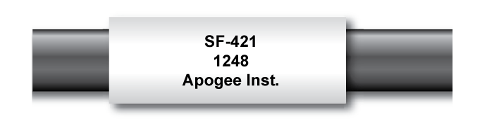

### Specifications

|  |  |
| --- | --- |
|  | SF-421 |
| Measurement Range | -50 to 70 C |
| Measurement Uncertainty | 0.1 C (from 0 to 70 C)  0.2 C (from -25 to 0 C)  0.4 C (from -50 to -25 C) |
| Measurement Repeatability | Less than 0.05 C |
| Long-term Drift  (Non-stability) | Less than 0.02 C per year (when used in non-condensing environments where the annual average temperature is less than 30 C; continuously high temperatures or continuously humid environments increase drift rate) |
| Equilibration Time | 10 s |
| Self-heating | Less than 0.01 C |
| Operating Environment | -50 to 70 C; 0 to 100 % relative humidity |
| Input Voltage Requirement | 5.5 to 24 V DC |
| Current Draw | 1.56 mA (quiescent), 1.93 mA (active) |
| Dimensions | 17.5 cm length, 2.2 cm pipe diameter, 6.0 cm disk diameter (see diagram below) |
| Mass | 75 g |
| Cable | 5 m of three conductor, shielded, twisted-pair wire; additional cable available in multiples of 5 m; TPR jacket (high water resistance, high UV stability, flexibility in cold conditions) |

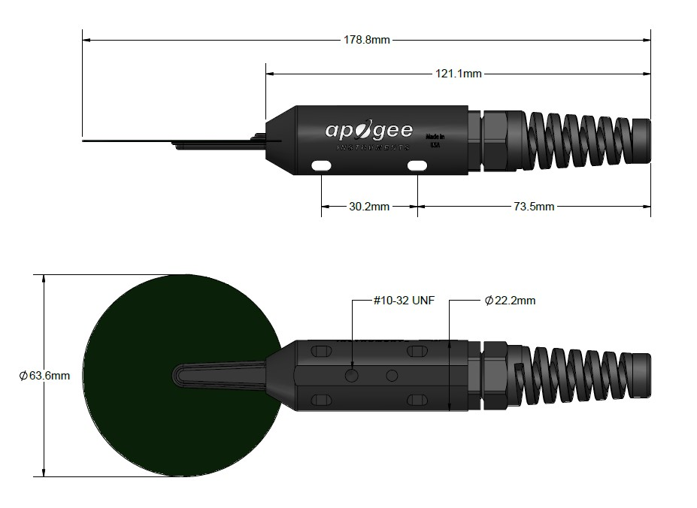

### Deployment and Installation

Apogee SF-421 radiation frost detectors should be mounted within—or very near—the plant canopy where frost detection is desired. This ensures the simulated leaf is in the same environment as the actual leaves.

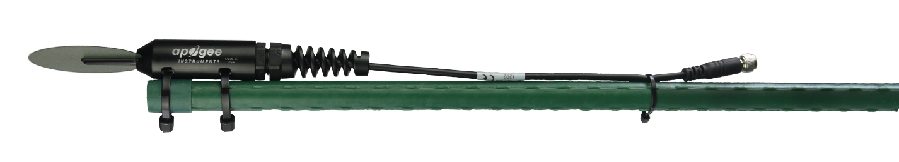

An Apogee Instruments model AM-210 mounting bracket can be used to mount the detector to a cross arm or pole. The AM-210 allows adjustment of the angle of the detector. Mounting the detector with a slight downward slope—or tilt to one side—is recommended to minimize moisture/debris build-up on the simulated leaf.

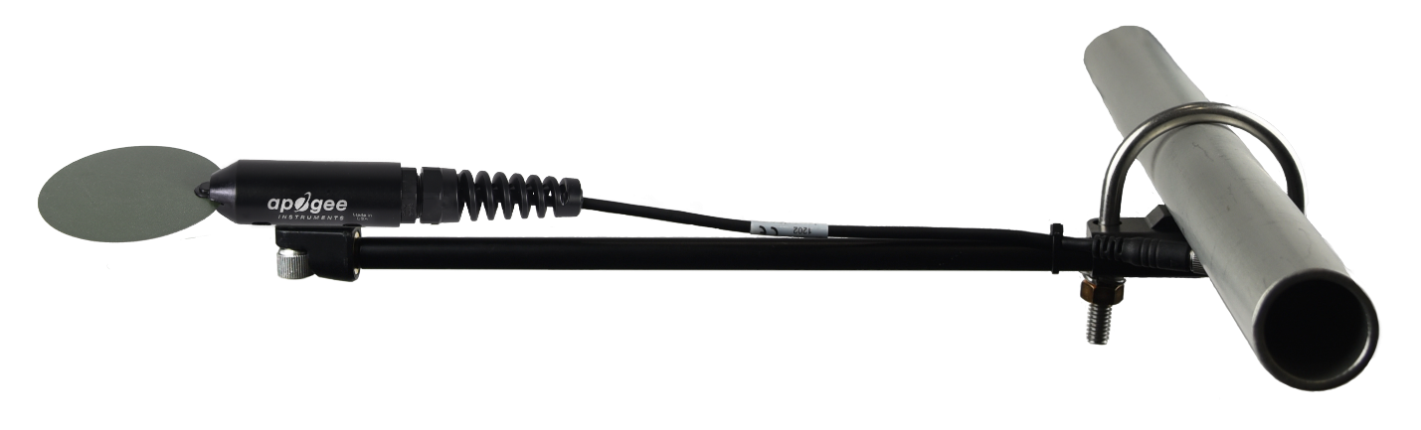

### Cable Connectors

|  |  |
| --- | --- |
| Apogee sensors offer cable connectors to simplify the process of removing sensors from weather stations for calibration (the entire cable does **not** have to be removed from the station and shipped with the sensor).  The ruggedized M8 connectors are rated IP67, made of corrosion-resistant marine-grade stainless-steel, and designed for extended use in harsh environmental conditions. | Inline cable connectors are installed 30 cm from the head (pyranometer pictured) |

**Instructions**

|  |  |
| --- | --- |
| **Pins and Wiring Colors:** All Apogee connectors have six pins, but not all pins are used for every sensor. There may also be unused wire colors inside the cable. To simplify datalogger connection, we remove the unused pigtail lead colors at the datalogger end of the cable.  If a replacement cable is required, please contact Apogee directly to ensure ordering the proper pigtail configuration.  **Alignment:** When reconnecting a sensor, arrows on the connector jacket and an aligning notch ensure proper orientation.  **Disconnection for extended periods:**  When disconnecting the sensor for an extended period from a station, protect the remaining half of the connector still on the station from water and dirt with electrical tape or other method. | A reference notch inside the connector ensures  proper alignment before tightening.    When sending sensors in for calibration, only send the short end of the cable and half the connector. |
| **Tightening:** Connectors are designed to be firmly finger-tightened only. There is an O-ring inside the connector that can be overly compressed if a wrench is used. Pay attention to thread alignment to avoid cross-threading. When fully tightened, 1-2 threads may still be visible. | Finger-tighten firmly |

### Operation and Measurement

The SF-421 has an SDI-12 output, where leaf temperatures are returned in digital format. Measurement of the SF-421 radiation frost detectors requires a measurement device with SDI-12 functionality that includes the M or C command.­­­

**VERY IMPORTANT: In January 2022, the SF-110 (formerly called the leaf and bud temperature sensor) underwent a redesign to improve performance and ruggedness. As part of this redesign, the bud temperature sensor was removed, as it was determined the leaf measurement was most critical. The SF-110 was renamed the radiation frost detector.**

**Radiation Frost Detector**

**Leaf and Bud Temperature Sensor**

**RADIATION FROST DETECTORS WIRING**

**Wiring for Radiation Frost Detectors (as of January 2022)**

**White**: SDI-12 Data Line

**Red**: Power Input (4.5-24 V DC)

**Black**: Ground (for sensor signal and input power)

**Clear**: Shield/Ground

**LEAF AND BUD TEMPERATURE SENSORS WIRING (OLD DESIGN)**

**VERY IMPORTANT: Apogee changed all wiring colors of our bare-lead sensors in March 2018. To ensure proper connection to your data device, please note your serial number and then use the appropriate wiring configuration below.**

**Wiring for SF-421 Serial Numbers 1014 and above**

**White**: SDI-12 Data Line

**Red**: Power Input (4.5-24 V DC)

**Black**: Ground (for sensor signal and input power)

**Clear**: Shield/Ground

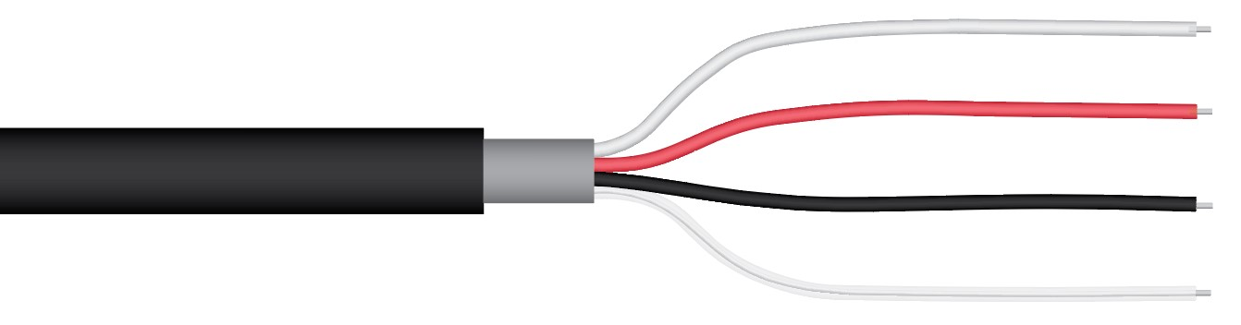

**Wiring for SF-421 Serial Numbers range 0-1013**

**Red**: Power In (4.5-24 V DC)

**Black**: SDI-12 Data Line

**Clear**: Ground (shield wire)

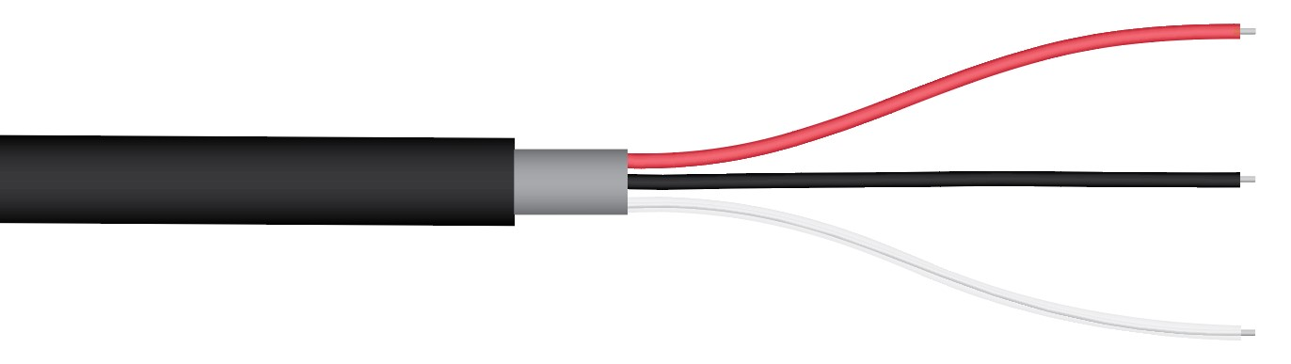

**SDI-12 Interface:**

The following is a brief explanation of the serial digital interface SDI-12 protocol instructions used in Apogee SF-421. For questions on the implementation of this protocol, please refer to the official version of the SDI-12 protocol: <http://www.sdi-12.org/specification.php> (version 1.3).

**Overview:**

During normal communication, the data recorder sends a packet of data to the sensor that consists of an address and a command. Then, the sensor sends a response. In the following descriptions, SDI-12 commands and responses are enclosed in quotes. The SDI-12 address and the command/response terminators are defined as follows:

**Sensors come from the factory with the address of “0” for use in single sensor systems. Addresses “1 to 9” and “A to Z”, or “a to z”, can be used for additional sensors connected to the same SDI-12 bus.**

“!” is the last character of a command instruction. To be compliant with SDI-12 protocol, all commands must be terminated with a “!”. SDI-12 language supports a variety of commands. Supported commands for the Apogee Instruments SF-421 are listed in the following table (“a” is the sensor address. The following ASCII Characters are valid addresses: “0-9” or “A-Z”).

**Supported Commands for Apogee Instruments SF-421 Radiation Frost Detectors**

|  |  |  |
| --- | --- | --- |
| **Instruction Name** | **Instruction Syntax** | **Description** |
| Send Identification Command | aI! | Send identification information |
| Measurement Command | aM! | Tells the sensor to take a measurement |
| Measurement Command w/ Check Character | aMC! | Tells the sensor to take a measurement and return it with a check character |
| Change Address Command | aAb! | Changes the address of the sensor from a to b |
| Concurrent Measurement Command | aC! | Used to take a measurement when more than one sensor is used on the same data line |
| Concurrent Measurement Command w/ Check Character | aCC! | Used to take a measurement when more than one sensor is used on the same data line. Data is returned with a check character. |
| Address Query Command | ?! | Used when the address is unknown to have the sensor identify its address |
| Get Data Command | aD0! | Retrieves the data from a sensor |
| Running Average Command | aXAVG! | Returns or sets the running average for sensor measurements. |

**Make Measurement Command: M!**

The make measurement command signals a measurement sequence to be performed. Data values generated in response to this command are stored in the sensor's buffer for subsequent collection using “D” commands. Data will be retained in sensor storage until another “M”, “C”, or “V” command is executed. M commands are shown in the following examples:

|  |  |  |
| --- | --- | --- |
| **Command** | **Response** | **Response to 0D0!** |
| aM! | a0012<cr><lf> | Leaf Temperature |
| aMC! | a0012<cr><lf> | Leaf Temperature w/ CRC |

where a is the sensor address (“0-9”, “A-Z”, “a-z”) and M is an upper-case ASCII character.

The address and leaf temperature are separated by the sign “+” or “-“, as in the following example (0 is the address):

|  |  |  |
| --- | --- | --- |
| **Command** | **Sensor Response** | **Sensor Response when data is ready** |
| 0M! | 00012<cr><lf> | 0<cr><lf> |
| 0D0! | 0+24.5678<cr><lf> |  |

where 24.5678 is leaf temperature.

**Concurrent Measurement Command: aC!**

A concurrent measurement is one that occurs while other SDI-12 sensors on the bus are also making measurements. This command is like the “aM!” command, however, the nn field has an extra digit and the sensor does not issue a service request when it has completed the measurement. Communicating with other sensors will NOT abort a concurrent measurement. Data values generated in response to this command are stored in the sensor's buffer for subsequent collection using “D” commands. The data will be retained in the sensor until another “M”, “C”, or “V” command is executed:

|  |  |  |
| --- | --- | --- |
| **Command** | **Response** | **Response to 0D0!** |
| aC! | a00102<cr><lf> | Leaf Temperatures |
| aCC! | a00102<cr><lf> | Leaf Temperatures w/ CRC |

where a is the sensor address (“0-9”, “A-Z”, “a-z”, “*”, “?”) and C is an upper-case ASCII character.

For example (0 is the address):

|  |  |
| --- | --- |
| **Command** | **Sensor Response** |
| 0C! | 000101<cr><lf> |
| 0D0! | 0+24.5678<cr><lf> |

where 24.5678 is leaf temperature.

**Change Sensor Address: aAb!**

The change sensor address command allows the sensor address to be changed. If multiple SDI-12 devices are on the same bus, each device will require a unique SDI-12 address. For example, two SDI-12 sensors with the factory address of 0 requires changing the address on one of the sensors to a non-zero value for both sensors to communicate properly on the same channel:

|  |  |  |
| --- | --- | --- |
| **Command** | **Response** | **Description** |
| aAb! | b<cr><lf> | Change the address of the sensor |

where a is the current (old) sensor address (“0-9”, “A-Z”), A is an upper-case ASCII character denoting the instruction for changing the address, b is the new sensor address to be programmed (“0-9”, “A-Z”), and ! is the standard character to execute the command. If the address change is successful, the datalogger will respond with the new address and a <cr><lf>.

**Send Identification Command: aI!**

The send identification command responds with sensor vendor, model, and version data. Any

measurement data in the sensor's buffer is not disturbed:

|  |  |  |
| --- | --- | --- |
| **Command** | **Response** | **Description** |
| "aI!" | a13Apogee SF-410vvvxx…xx<cr><lf> | The sensor serial number and other identifying values are returned |

where a is the sensor address (“0-9”, “A-Z”, “a-z”, “*”, “?”), vvv is a three-character field specifying the sensor version number, and xx...xx is serial number.

**Running Average Command**

The running average command can be used to set or query the number of measurements that are averaged together before returning a value from a M! or MC! command. For example, if a user sends the command “0XAVG10!” to sensor with address 0, that sensor will average 10 measurements before sending the averaged value to the logger. To turn off averaging, the user should send the command “*a*XAVG1” to the sensor. To query the sensor to see how many measurements are being averaged, send the command “*a*XAVG!” and the sensor will return the number of measurements being averaged (see table below). The default for sensors is to have averaging turned off.

|  |  |  |  |
| --- | --- | --- | --- |
| **Command Name** | **Characters Sent** | **Response** | **Description** |
| Query running Average | *a*XAVG! | *an* | a = sensor address, *n* = number of measurements used in average calculation. Note: *n* may be multiple digits. |
| Set running Average | *a*XAVG*n!* | *a* | a = sensor address, *n* = number of measurements to be used in average calculation. Note: *n* may be any value from 1 to 100. |

### Maintenance and Recalibration

Apogee SF-421 radiation frost detectors are weatherproof and are designed to be continuously deployed in outdoor conditions. When detectors are not is use, it is recommended that they be removed from the measurement environment, cleaned, and stored. SF-421 detectors deployed in the field should be periodically cleaned to remove all dust and debris.

The thermistor in SF-421 detectors is not factory calibrated, but it comes with a generic calibration. A custom calibration can be derived by comparing the temperature from the simulated leaf thermistors to a reference temperature measurement. Often, a simple offset can be used to make the measured temperature match the reference temperature.

### Troubleshooting and Customer Support

**Independent Verification of Functionality**

If the sensor does not communicate with the datalogger, use an ammeter to check the current drain. It should be near 0.6 mA when the sensor is not communicating and spike to approximately 1.3 mA when the sensor is communicating. Any current drain greater than approximately 6 mA indicates a problem with power supply to the sensors, wiring of the sensor, or sensor electronics.

**Compatible Measurement Devices (Dataloggers/Controllers/Meters)**

Any datalogger or meter with SDI-12 functionality that includes the M or C command.

An example datalogger program for Campbell Scientific dataloggers can be found on the Apogee webpage at <http://www.apogeeinstruments.com/downloads/>.

**Modifying Cable Length**

SDI-12 protocol limits cable length to 60 meters. For multiple sensors connected to the same data line, the maximum is 600 meters of total cable (e.g., ten sensors with 60 meters of cable per sensor). See Apogee webpage for details on how to extend sensor cable length ([http://www.apogeeinstruments.com/how-to-make-a-weatherproof-cable-splice](http://www.apogeeinstruments.com/how-to-make-a-weatherproof-cable-splice/)).

### Return and Warranty Policy

RETURN POLICY

Apogee Instruments will accept returns within 30 days of purchase as long as the product is in new condition (to be determined by Apogee). Returns are subject to a 10 % restocking fee.

WARRANTY POLICY

**What is Covered**All products manufactured by Apogee Instruments are warranted to be free from defects in materials and craftsmanship for a period of four (4) years from the date of shipment from our factory. To be considered for warranty coverage an item must be evaluated by Apogee.

Products not manufactured by Apogee (spectroradiometers, chlorophyll content meters, EE08-SS probes) are covered for a period of one (1) year.

**What is Not Covered**The customer is responsible for all costs associated with the removal, reinstallation, and shipping of suspected warranty items to our factory.

The warranty does not cover equipment that has been damaged due to the following conditions:

1. Improper installation or abuse.

2. Operation of the instrument outside of its specified operating range.

3. Natural occurrences such as lightning, fire, etc.

4. Unauthorized modification.

5. Improper or unauthorized repair.

Please note that nominal accuracy drift is normal over time. Routine recalibration of sensors/meters is considered part of proper maintenance and is not covered under warranty.

**Who is Covered**This warranty covers the original purchaser of the product or other party who may own it during the warranty period.

**What Apogee Will Do**At no charge Apogee will:

1. Either repair or replace (at our discretion) the item under warranty.

2. Ship the item back to the customer by the carrier of our choice.

Different or expedited shipping methods will be at the customer’s expense.

**How To Return An Item**1. Please do not send any products back to Apogee Instruments until you have received a Return Merchandise Authorization (RMA) number from our technical support department by submitting an online RMA form at [www.apogeeinstruments.com/tech-support-recalibration-repairs/](http://www.apogeeinstruments.com/tech-support-recalibration-repairs/). We will use your RMA number for tracking of the service item. Call (435) 245-8012 or email techsupport@apogeeinstruments.com with questions.

2. For warranty evaluations, send all RMA sensors and meters back in the following condition: Clean the sensor’s exterior and cord. Do not modify the sensors or wires, including splicing, cutting wire leads, etc. If a connector has been attached to the cable end, please include the mating connector – otherwise the sensor connector will be removed to complete the repair/recalibration. ***Note:*** *When sending back sensors for routine calibration that have Apogee’s standard stainless-steel connectors, you only need to send the sensor with the 30 cm section of cable and one-half of the connector. We have mating connectors at our factory that can be used for calibrating the sensor.*

3. Please write the RMA number on the outside of the shipping container.

4. Return the item with freight pre-paid and fully insured to our factory address shown below. We are not responsible for any costs associated with the transportation of products across international borders.

**Apogee Instruments, Inc.   
721 West 1800 North Logan, UT  
84321, USA**

5. Upon receipt, Apogee Instruments will determine the cause of failure. If the product is found to be defective in terms of operation to the published specifications due to a failure of product materials or craftsmanship, Apogee Instruments will repair or replace the items free of charge. If it is determined that your product is not covered under warranty, you will be informed and given an estimated repair/replacement cost.

Products Beyond the Warranty Period

For issues with sensors beyond the warranty period, please contact Apogee at [techsupport@apogeeinstruments.com](mailto:techsupport@apogeeinstruments.com) to discuss repair or replacement options.

Other Terms

The available remedy of defects under this warranty is for the repair or replacement of the original product, and Apogee Instruments is not responsible for any direct, indirect, incidental, or consequential damages, including but not limited to loss of income, loss of revenue, loss of profit, loss of data, loss of wages, loss of time, loss of sales, accruement of debts or expenses, injury to personal property, or injury to any person or any other type of damage or loss.

This limited warranty and any disputes arising out of or in connection with this limited warranty ("Disputes") shall be governed by the laws of the State of Utah, USA, excluding conflicts of law principles and excluding the Convention for the International Sale of Goods. The courts located in the State of Utah, USA, shall have exclusive jurisdiction over any Disputes.

This limited warranty gives you specific legal rights, and you may also have other rights, which vary from state to state and jurisdiction to jurisdiction, and which shall not be affected by this limited warranty. This warranty extends only to you and cannot by transferred or assigned. If any provision of this limited warranty is unlawful, void, or unenforceable, that provision shall be deemed severable and shall not affect any remaining provisions. In case of any inconsistency between the English and other versions of this limited warranty, the English version shall prevail.

This warranty cannot be changed, assumed, or amended by any other person or agreement

**APOGEE INSTRUMENTS, INC. |** 721 WEST 1800 NORTH, LOGAN, UTAH 84321, USA

TEL: (435) 792-4700 | FAX: (435) 787-8268 | WEB: APOGEEINSTRUMENTS.COM

*Copyright © 2022 Apogee Instruments, Inc.*