

# Owner’s Manual

Photometric Sensor

Model SE-100  
Rev: 28-Oct-2020

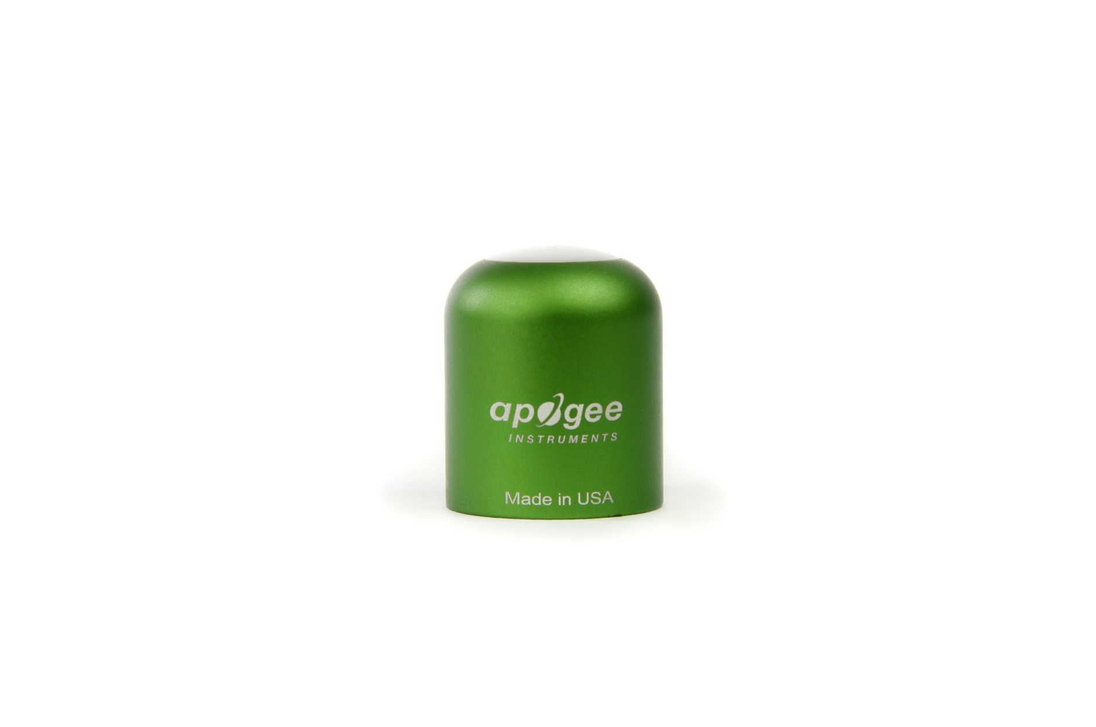

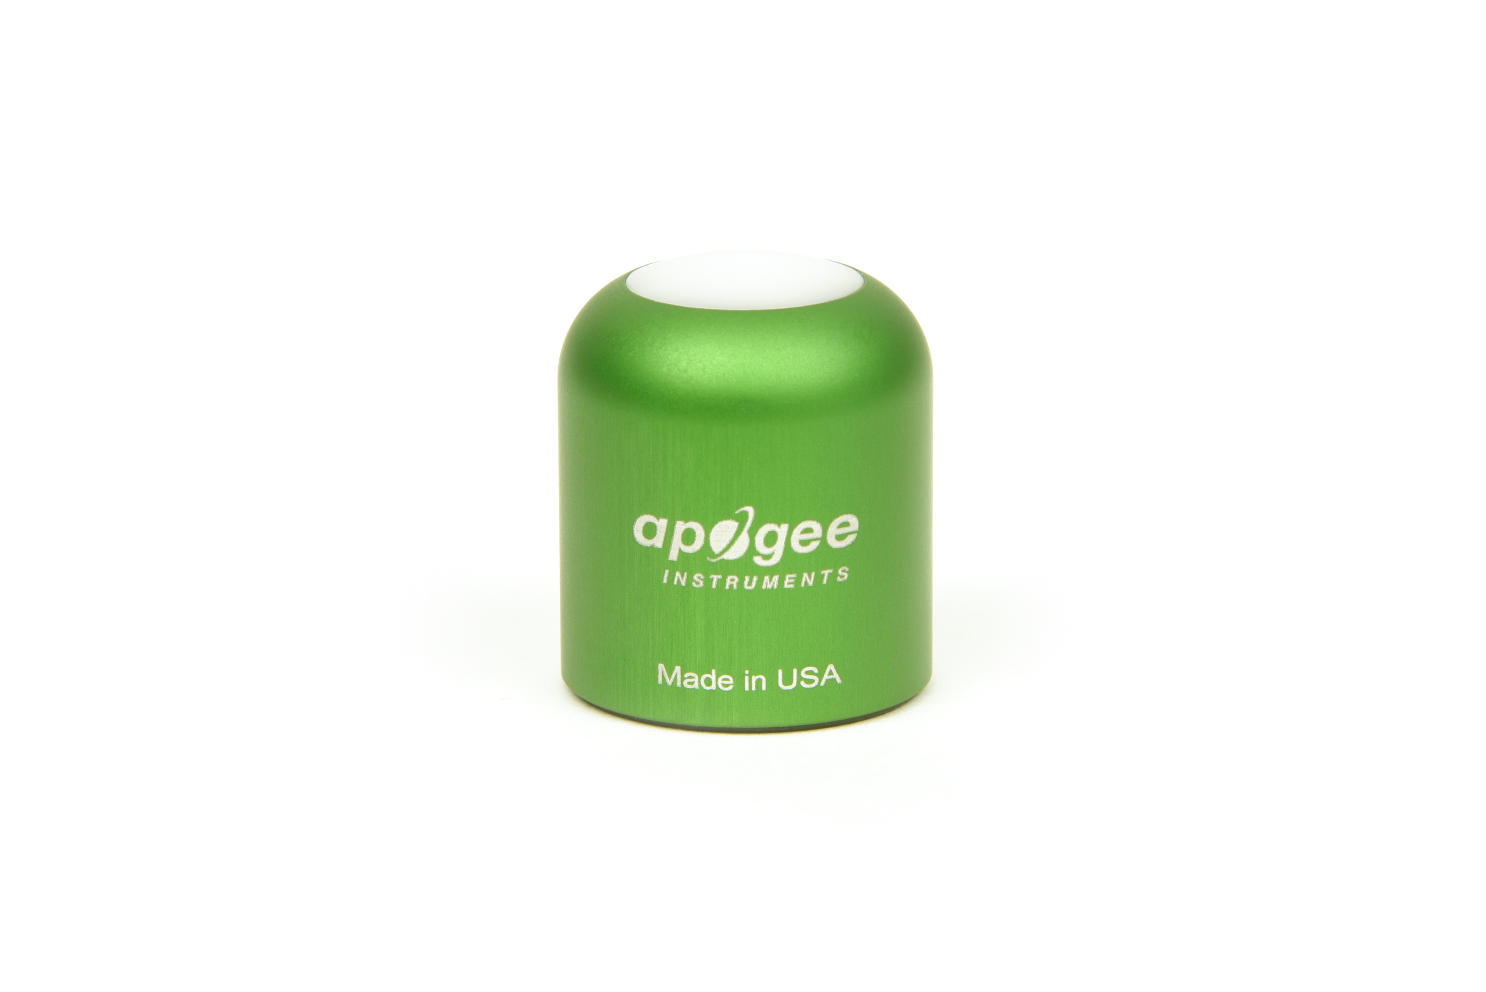

Table of Contents

Owner’s Manual 1

Certificate of Compliance 3

Introduction 4

Sensor Models 5

Specifications 6

Deployment and Installation 9

Cable Connectors 10

Operation and Measurement 11

Maintenance and Recalibration 14

Troubleshooting and Customer Support 15

Return and Warranty Policy 16

### Certificate of Compliance

**EU Declaration of Conformity**

This declaration of conformity is issued under the sole responsibility of the manufacturer:

Apogee Instruments, Inc.  
721 W 1800 N  
Logan, Utah 84321  
USA

for the following product(s):

Models: SE-100

Type: Photometric Sensors

The object of the declaration described above is in conformity with the relevant Union harmonization legislation:

2014/30/EU Electromagnetic Compatibility (EMC) Directive

2011/65/EU Restriction of Hazardous Substances (RoHS 2) Directive

2015/863/EU Amending Annex II to Directive 2011/65/EU (RoHS 3)

Standards referenced during compliance assessment:

EN 61326-1:2013 Electrical equipment for measurement, control and laboratory use – EMC requirements

EN 50581:2012 Technical documentation for the assessment of electrical and electronic products with respect to the restriction of hazardous substances

Please be advised that based on the information available to us from our raw material suppliers, the products manufactured by us do not contain, as intentional additives, any of the restricted materials including lead (see note below), mercury, cadmium, hexavalent chromium, polybrominated biphenyls (PBB), polybrominated diphenyls (PBDE), bis(2-ethylhexyl) phthalate (DEHP), butyl benzyl phthalate (BBP), dibutyl phthalate (DBP), and diisobutyl phthalate (DIBP). However, please note that articles containing greater than 0.1% lead concentration are RoHS 3 compliant using exemption 6c.

Further note that Apogee Instruments does not specifically run any analysis on our raw materials or end products for the presence of these substances, but rely on the information provided to us by our material suppliers.

Signed for and on behalf of:

Apogee Instruments, October 2020



Bruce Bugbee  
President  
Apogee Instruments, Inc.

### Introduction

The human eye is sensitive to radiation from about 380 to 780 nm but is most sensitive in the middle of this range near 555 nm. The photopic luminosity function (there are different versions, but the CIE 1931 standard is widely accepted and commonly used) describes the average sensitivity of the human eye, or the average human perception of brightness, in well-lit conditions. The scotopic luminosity function describes the average sensitivity of the human eye in dimly-lit conditions.

Illuminance is a measurement of radiant energy on a surface, weighted by the human eye response. Illuminance is quantified in units of lux or footcandles. Lux is luminous flux (radiant intensity weighted by the photopic luminosity function) incident on a surface in units of lumens per square meter [lm m-2] and footcandles is luminous flux incident on a surface in units of lumens per square foot [lm ft-2]. There are 10.7639 square feet in a square meter, so lux can be converted to footcandles by dividing by 10.7639. Sensors that measure illuminance are referred to by many names, including light sensors, photometric radiometers, photopic sensors, and lux sensors.

Typical applications of illuminance sensors include determination of optimum light levels in indoor environments and quantification of material/substance exposure to light.

Apogee Instruments SE series photometric sensors consist of a cast acrylic diffuser, optical filter, photodiode, and signal processing circuitry mounted in an anodized aluminum housing, and a cable to connect the sensor to a measurement device. Sensors are designed for continuous illuminance measurement in indoor and outdoor environments. SE-100 and SE-200 series sensors output an analog voltage that is directly proportional to illuminance incident on a planar surface (does not have to be horizontal), where the radiation emanates from all angles of a hemisphere.

### Sensor Models

This manual covers the unamplified model SE-100 (in bold below). Additional models are covered in their respective manuals.

|  |  |  |
| --- | --- | --- |
| Model | Signal | Measurement Range |
| SE-100 | **Self-powered** | **0-150000 lux** |
| SE-202 | 0-2.5 V | 0-5000 lux |
| SE-205 | 0-5 V | 0-5000 lux |
| SE-212 | 0-2.5 V | 0-150000 lux |
| SE-215 | 0-5 V | 0-150000 lux |

­

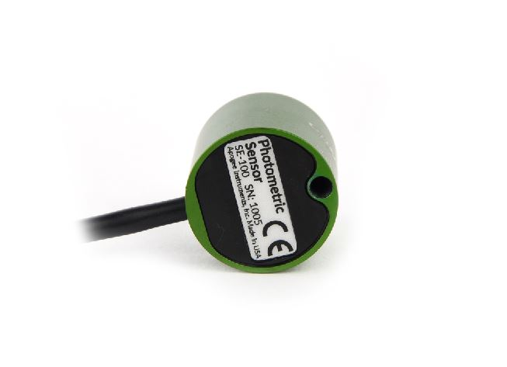

Sensor model number and serial number are located on the bottom of the sensor. If you need the manufacturing date of your sensor, please contact Apogee Instruments with the serial number of your sensor.

### Specifications

|  |  |
| --- | --- |
|  | **SE-100** |
| Output (sensitivity) | 0.001 mV per lux |
| Calibration Factor (Reciprocal of Sensitivity) | 1000 lux per mV |
| Calibration Uncertainty | ± 5 % |
| Output Range | 0 to 200 mV |
| Measurement Range | 0 to 150000 lux |
| Measurement Repeatability | Less than 0.5 % |
| Long-term Drift (Non-stability) | Less than 2 % per year |
| Non-linearity | Less than 1 % |
| Response Time | Less than 1 ms |
| Field of View | 180° |
| Spectral Range | CIE 1931 luminous efficiency function (see spectral response graph) |
| Directional (Cosine) Response | ± 2 % at 45°, ± 5 % at 75° |
| Temperature Response | Less than 0.1 % per C |
| Operating Environment | -40 to 70 C; 0 to 100 % relative humidity |
| Dimensions | 30.5 mm diameter, 37 mm height |
| Mass (with 5 m of cable) | 140 g |
| Cable | 5 m of shielded, twisted-pair wire; TPR jacket (high water resistance, high UV stability, flexibility in cold conditions); pigtail lead wires; stainless steel (316), M8 connector |

**Calibration Traceability**

Apogee SE series photometric sensors are calibrated through side-by-side comparison to the mean of four transfer standard SE-100 photometric sensors under a reference lamp. The transfer standard photometric sensors are calibrated through side-by-side comparison to the mean of at least two reference photometric sensors under a reference lamp. The reference photometric sensors are recalibrated on a biannual schedule with a quartz halogen lamp traceable to the National Institute of Standards and Technology (NIST).

**Spectral Response**

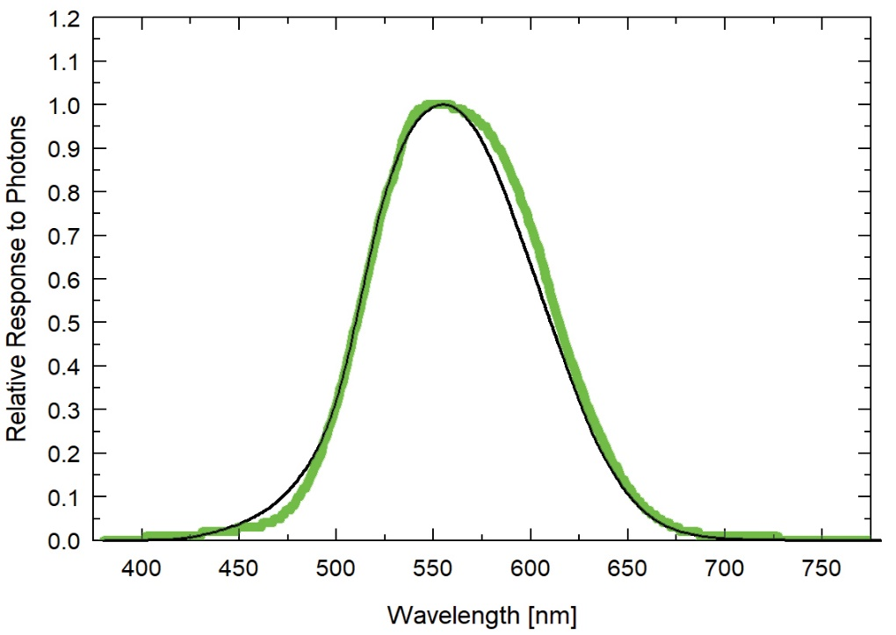

The mean relative spectral response of four SE-100 photometric radiometers (green) compared to CIE-1931 curve (dotted).

**Cosine Response**

Directional, or cosine, response is defined as the measurement error at a specific angle of radiation incidence. Error for Apogee SE series photometric sensors is approximately ± 2 % and ± 5 % at solar zenith angles of 45° and 75°, respectively.

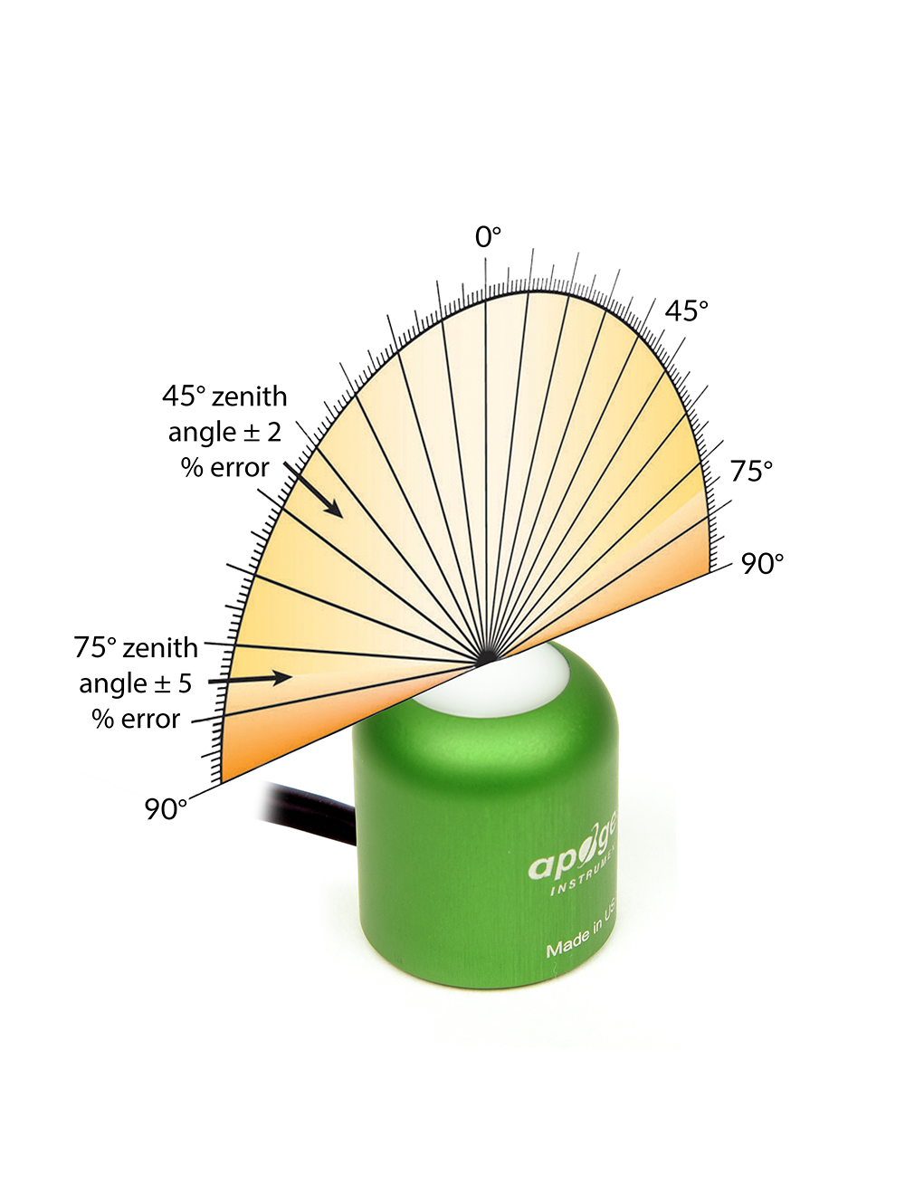

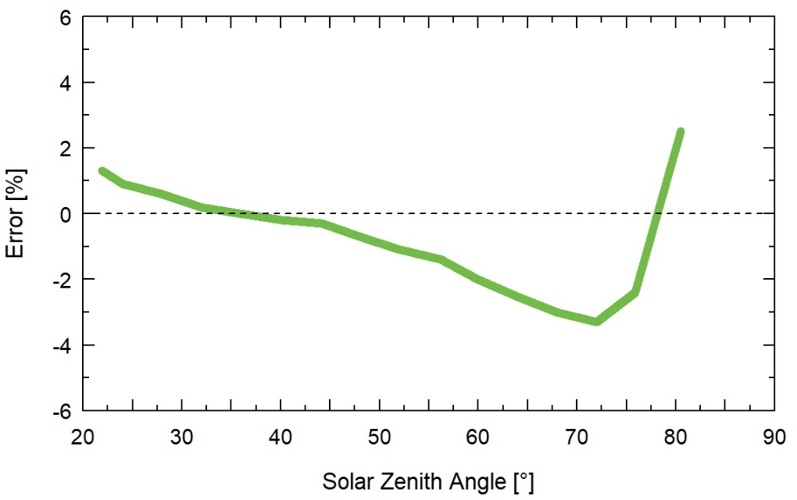

Cosine response measurements were made by direct side-by-side comparison to the mean of four reference SE-100 photometric sensors.

### Deployment and Installation

Mount the sensor to a solid surface with the nylon mounting screw provided to prevent galvanic corrosion. To accurately measure illuminance incident on a horizontal surface, the sensor must be level. An Apogee Instruments model AL-100 Leveling Plate is recommended to level the sensor when used on a flat surface or being mounted to surfaces such as wood. To facilitate mounting on a mast or pipe, the Apogee Instruments model AL-120 Solar Mounting Bracket with Leveling Plate is recommended.

Nylon Screw: 10-32x3/8

C:\Users\emyers\AppData\Local\Microsoft\Windows\INetCache\Content.Word\screw.png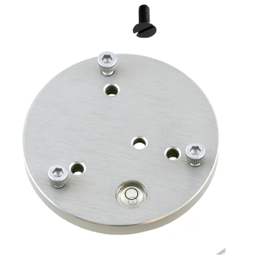

Nylon Screw: 10-32x3/8

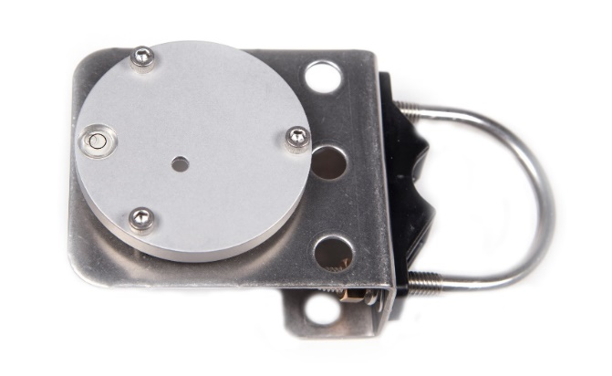

Model AL-120

Model AL-100

To minimize azimuth error, the sensor should be mounted with the cable pointing toward true north in the northern hemisphere or true south in the southern hemisphere. Azimuth error is typically less than 1 %, but it is easy to minimize by proper cable orientation.

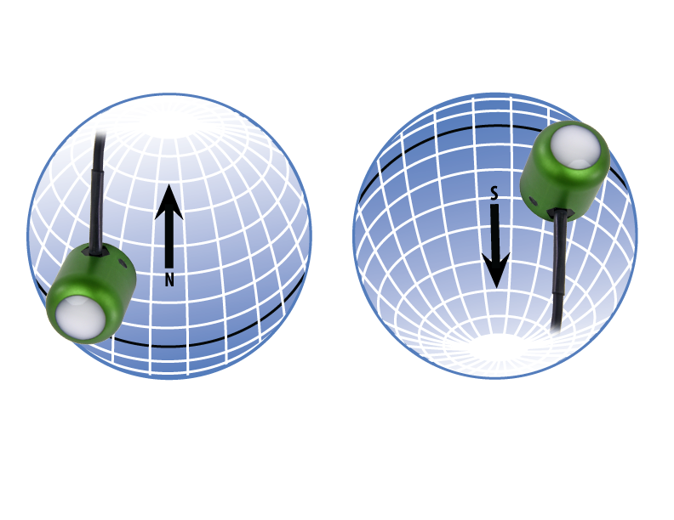

In addition to orienting the cable to point toward the nearest pole, the sensor should also be mounted such that obstructions (e.g., weather station tripod/tower or other instrumentation) do not shade the sensor. **Once mounted, the green cap should be removed from the sensor.** The green cap can be used as a protective covering for the sensor when it is not in use.

### Cable Connectors

|  |  |  |
| --- | --- | --- |
| Apogee sensors offer cable connectors to simplify the process of removing sensors from weather stations for calibration (the entire cable does not have to be removed from the station and shipped with the sensor).  The ruggedized M8 connectors are rated IP68, made of corrosion-resistant marine-grade stainless-steel, and designed for extended use in harsh environmental conditions. | | Inline cable connectors are installed 30 cm from the head |
| **Instructions**  **Pins and Wiring Colors:** All Apogee connectors have six pins, but not all pins are used for every sensor. There may also be unused wire colors inside the cable. To simplify datalogger connection, we remove the unused pigtail lead colors at the datalogger end of the cable.  If a replacement cable is required, please contact Apogee directly to ensure ordering the proper pigtail configuration.  **Alignment:** When reconnecting a sensor, arrows on the connector jacket and an aligning notch ensure proper orientation.  **Disconnection for extended periods:**  When disconnecting the sensor for an extended period of time from a station, protect the remaining half of the connector still on the station from water and dirt with electrical tape or other method. | A reference notch inside the connector ensures  proper alignment before tightening.    When sending sensors in for calibration, only send the  short end of the cable and half the connector. | |
| **Tightening:** Connectors are designed to be firmly finger-tightened only. There is an o-ring inside the connector that can be overly compressed if a wrench is used. Pay attention to thread alignment to avoid cross-threading. When fully tightened, 1-2 threads may still be visible.  **WARNING:** Do not tighten the connector by twisting the black cable or sensor head, only twist the metal connector . | Finger-tighten firmly | |

### Operation and Measurement

Connect the sensor to a measurement device (meter, datalogger, controller) capable of measuring and displaying or recording a millivolt signal (an input measurement range of approximately 0-150 mV is required to cover the entire range of illuminance from the sun). In order to maximize measurement resolution and signal-to-noise ratio, the input range of the measurement device should closely match the output range of the quantum sensor. **DO NOT connect the sensor to a power source. The sensor is self-powered and applying voltage will damage the sensor.**

**Wiring for SE-100**

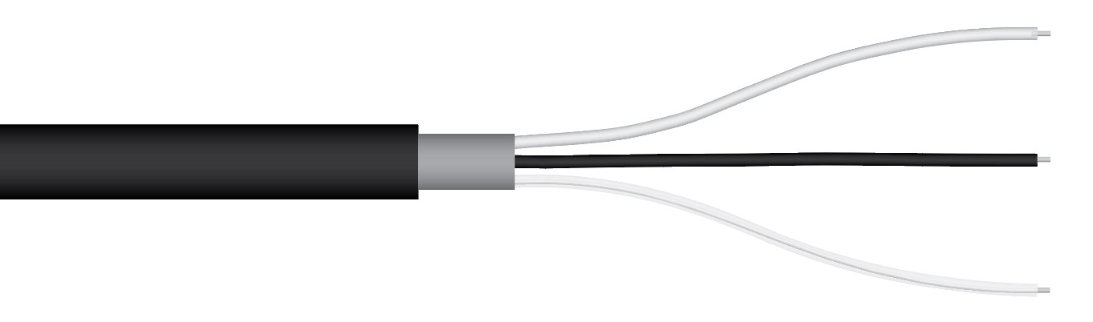

White: Output Signal

Black: Ground

Clear: Shield

**Sensor Calibration**

The Apogee unamplified photometric sensor model SE-100 has a standard illuminance (lux) calibration factor of exactly:

**1000 lux per mV**

Multiply this calibration factor by the measured mV signal to convert sensor output to illuminance in units of lux:

**Calibration Factor (1000 lux per mV) * Sensor Output Signal (mV) = lux (lm m-2)**

**1000 * 120 = 120000**

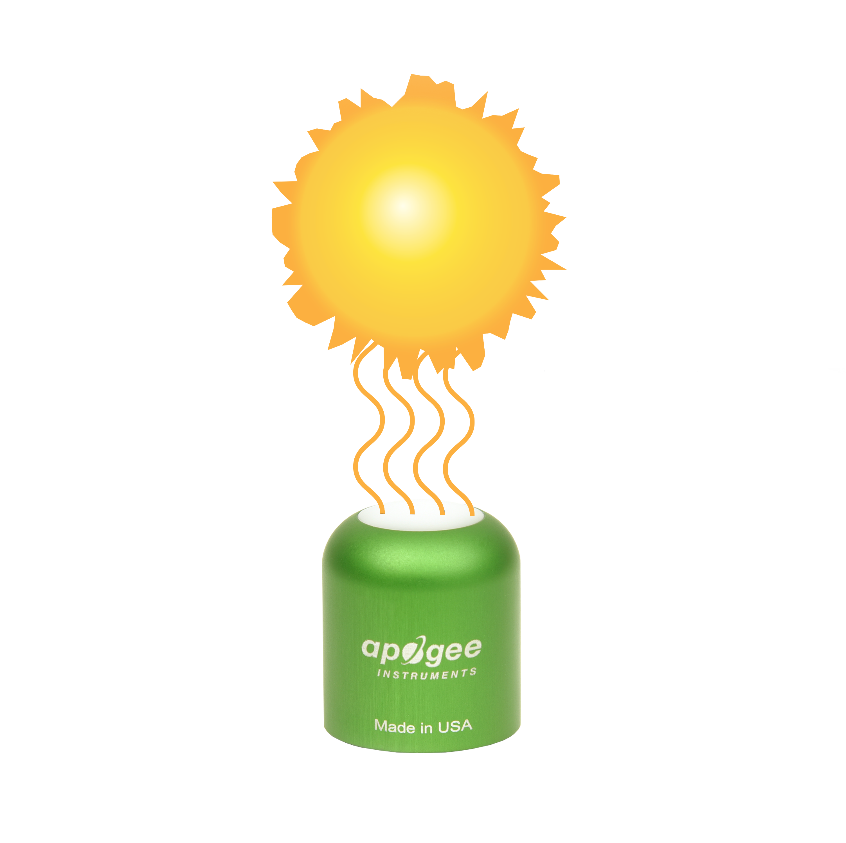

**Full Sunlight**

**(120000 lux)**

Example of illuminance measurement with an Apogee photometric sensor. Full sunlight yields an illuminance on a horizontal plane at the Earth’s surface of approximately 120000 lux. This yields an output signal of 120 mV. The signal is converted to illuminance by multiplying by the calibration factor of 1000 lux per mV.

**Sensor Output**

**120 mV**

**Spectral Errors**

The combination of the filter and photodiode in Apogee photometric radiometers is designed to provide a spectral response that matches the CIE 1931 photopic luminosity function. Mismatch between radiometer spectral response and the photopic luminosity function results in spectral errors for light sources that differ from the source used to calibrate the radiometer. The table below provides spectral error estimates for illuminance measurements with Apogee photometric radiometers under various light sources.

**Spectral Errors for Apogee SE-100 Series Photometric Radiometers**

|  |  |  |  |  |  |  |  |  |  |  |  |  |  |  |  |  |  |  |  |  |  |  |  |  |  |  |  |  |  |  |  |  |  |  |  |  |
| --- | --- | --- | --- | --- | --- | --- | --- | --- | --- | --- | --- | --- | --- | --- | --- | --- | --- | --- | --- | --- | --- | --- | --- | --- | --- | --- | --- | --- | --- | --- | --- | --- | --- | --- | --- | --- |
| |  |  | | --- | --- | | Radiation Source (Error Calculated Relative to Sun, Clear Sky) | **Error [%]** | | Sun (Clear Sky) | -2.2 | | Sun (Overcast) | -2.4 | | Cool White Fluorescent T12 | -0.9 | | Cool White Fluorescent T5 | -0.8 | | Metal Halide | -1.2 | | Ceramic Metal Halide | 0.0 | | Mogul Base HPS | 2.9 | | Dual-ended HPS | 2.0 | | Quartz Halogen | 0.0 | | Cool White | -2.1 | | Neutral White | -1.4 | | Warm White | -0.1 | | Blue (448 nm) | -32.9 | | Green (448 nm) | -5.3 | | Red (635 nm) | 7.3 | | Red (667 nm) | 9.8 | |  |  |

### Maintenance and Recalibration

Blocking of the optical path between the target and detector can cause low readings. Occasionally, accumulated materials on the diffuser of the upward-looking sensor and in the apertures of the downward-looking sensor can block the optical path in three common ways:

1. Moisture or debris on the diffuser (upward-looking) or in the apertures (downward-looking).
2. Dust during periods of low rainfall.
3. Salt deposit accumulation from evaporation of sea spray or sprinkler irrigation water.

Apogee Instruments upward-looking sensors have a domed diffuser and housing for improved self-cleaning from rainfall but active cleaning may be necessary. Dust or organic deposits are best removed using water, or window cleaner, and a soft cloth or cotton swab. Salt deposits should be dissolved with vinegar and removed with a cloth or cotton swab. **Salt deposits cannot be removed with solvents such as alcohol or acetone.** Use only gentle pressure when cleaning the diffuser with a cotton swab or soft cloth, to avoid scratching the outer surface. The solvent should be allowed to do the cleaning, not mechanical force. **Never use an abrasive material or cleaner on the diffuser**.

It is recommended that two-band sensors be recalibrated every two years. See the Apogee webpage for details regarding return of sensors for recalibration (<http://www.apogeeinstruments.com/tech-support-recalibration-repairs/>).

### Troubleshooting and Customer Support

**Independent Verification of Functionality**

Apogee SE-100 series photometric sensors are self-powered devices and output a voltage signal proportional to illuminance. A quick and easy check of sensor functionality can be determined using a voltmeter with millivolt resolution. Connect the positive lead wire from the voltmeter to the white wire from the sensor and the negative (or common) lead wire from the voltmeter to the black wire from the sensor. Direct the sensor head toward a light source and verify the sensor provides a signal. Increase and decrease the distance from the sensor head to the light source to verify that the signal changes proportionally (decreasing signal with increasing distance and increasing signal with decreasing distance). Blocking all radiation from the sensor should force the sensor signal to zero.

**Compatible Measurement Devices (Dataloggers/Controllers/Meters)**

SE-100 series photometric sensors are calibrated with a standard calibration factor of 1000 lux per mV, yielding a sensitivity of 0.001 mV per lux. Thus, a compatible measurement device (e.g., datalogger or controller) should have resolution of at least 0.001 mV in order to provide illuminance resolution of 1 lux.

An example datalogger program for Campbell Scientific dataloggers can be found on the Apogee webpage at <https://www.apogeeinstruments.com/content/Photometric-Unamplified.CR1>.

**Cable Length**

When the sensor is connected to a measurement device with high input impedance, sensor output signals are not changed by shortening the cable or splicing on additional cable in the field. Tests have shown that if the input impedance of the measurements device is greater than 1 mega-ohm there is negligible effect on the calibration, even after adding up to 100 m of cable. All Apogee sensors use shielded, twisted pair cable to minimize electromagnetic interference. For best measurements, the shield wire must be connected to an earth ground. This is particularly important when using the sensor with long lead lengths in electromagnetically noisy environments.

**Modifying Cable Length**

See Apogee webpage for details on how to extend sensor cable length: (<http://www.apogeeinstruments.com/how-to-make-a-weatherproof-cable-splice/>).

### Return and Warranty Policy

RETURN POLICY

Apogee Instruments will accept returns within 30 days of purchase as long as the product is in new condition (to be determined by Apogee). Returns are subject to a 10 % restocking fee.

WARRANTY POLICY

**What is Covered**All products manufactured by Apogee Instruments are warranted to be free from defects in materials and craftsmanship for a period of four (4) years from the date of shipment from our factory. To be considered for warranty coverage an item must be evaluated by Apogee.

Products not manufactured by Apogee (spectroradiometers, chlorophyll content meters, EE08-SS probes) are covered for a period of one (1) year.

**What is Not Covered**The customer is responsible for all costs associated with the removal, reinstallation, and shipping of suspected warranty items to our factory.

The warranty does not cover equipment that has been damaged due to the following conditions:

1. Improper installation or abuse.

2. Operation of the instrument outside of its specified operating range.

3. Natural occurrences such as lightning, fire, etc.

4. Unauthorized modification.

5. Improper or unauthorized repair.

Please note that nominal accuracy drift is normal over time. Routine recalibration of sensors/meters is considered part of proper maintenance and is not covered under warranty.

**Who is Covered**This warranty covers the original purchaser of the product or other party who may own it during the warranty period.

**What Apogee Will Do**At no charge Apogee will:

1. Either repair or replace (at our discretion) the item under warranty.

2. Ship the item back to the customer by the carrier of our choice.

Different or expedited shipping methods will be at the customer’s expense.

**How To Return An Item**1. Please do not send any products back to Apogee Instruments until you have received a Return Merchandise Authorization (RMA) number from our technical support department by submitting an online RMA form at [www.apogeeinstruments.com/tech-support-recalibration-repairs/](http://www.apogeeinstruments.com/tech-support-recalibration-repairs/). We will use your RMA number for tracking of the service item. Call (435) 245-8012 or email techsupport@apogeeinstruments.com with questions.

2. For warranty evaluations, send all RMA sensors and meters back in the following condition: Clean the sensor’s exterior and cord. Do not modify the sensors or wires, including splicing, cutting wire leads, etc. If a connector has been attached to the cable end, please include the mating connector – otherwise the sensor connector will be removed in order to complete the repair/recalibration. ***Note:*** *When sending back sensors for routine calibration that have Apogee’s standard stainless-steel connectors, you only need to send the sensor with the 30 cm section of cable and one-half of the connector. We have mating connectors at our factory that can be used for calibrating the sensor.*

3. Please write the RMA number on the outside of the shipping container.

4. Return the item with freight pre-paid and fully insured to our factory address shown below. We are not responsible for any costs associated with the transportation of products across international borders.

**Apogee Instruments, Inc.   
721 West 1800 North Logan, UT  
84321, USA**

5. Upon receipt, Apogee Instruments will determine the cause of failure. If the product is found to be defective in terms of operation to the published specifications due to a failure of product materials or craftsmanship, Apogee Instruments will repair or replace the items free of charge. If it is determined that your product is not covered under warranty, you will be informed and given an estimated repair/replacement cost.

Products Beyond the Warranty Period

For issues with sensors beyond the warranty period, please contact Apogee at [techsupport@apogeeinstruments.com](mailto:techsupport@apogeeinstruments.com) to discuss repair or replacement options.

Other Terms

The available remedy of defects under this warranty is for the repair or replacement of the original product, and Apogee Instruments is not responsible for any direct, indirect, incidental, or consequential damages, including but not limited to loss of income, loss of revenue, loss of profit, loss of data, loss of wages, loss of time, loss of sales, accruement of debts or expenses, injury to personal property, or injury to any person or any other type of damage or loss.

This limited warranty and any disputes arising out of or in connection with this limited warranty ("Disputes") shall be governed by the laws of the State of Utah, USA, excluding conflicts of law principles and excluding the Convention for the International Sale of Goods. The courts located in the State of Utah, USA, shall have exclusive jurisdiction over any Disputes.

This limited warranty gives you specific legal rights, and you may also have other rights, which vary from state to state and jurisdiction to jurisdiction, and which shall not be affected by this limited warranty. This warranty extends only to you and cannot by transferred or assigned. If any provision of this limited warranty is unlawful, void or unenforceable, that provision shall be deemed severable and shall not affect any remaining provisions. In case of any inconsistency between the English and other versions of this limited warranty, the English version shall prevail.

This warranty cannot be changed, assumed, or amended by any other person or agreement

**APOGEE INSTRUMENTS, INC. |** 721 WEST 1800 NORTH, LOGAN, UTAH 84321, USA

TEL: (435) 792-4700 | FAX: (435) 787-8268 | WEB: APOGEEINSTRUMENTS.COM

*Copyright © 2020 Apogee Instruments, Inc.*