

# Owner’s Manual

Barometric Pressure Sensor

Model SB-100

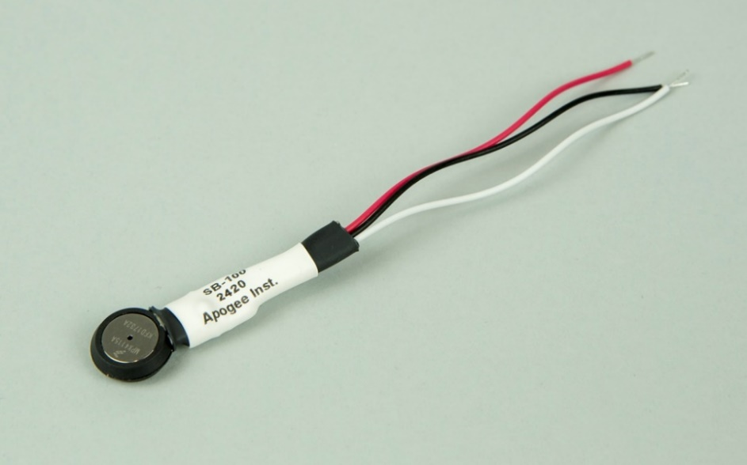Rev: 3-August-2021

Table of Contents

Owner’s Manual 1

Certificate of compliance 3

Introduction 4

Sensor Models 5

Specifications 6

Deployment and Installation 7

Operation and Measurement 8

Maintenance and Recalibration 11

Troubleshooting and Customer Support 12

Return and Warranty Policy 13

### Certificate of compliance

**CE and ROHS Certificate of Compliance**

**EU Declaration of Conformity**

This declaration of conformity is issued under the sole responsibility of the manufacturer:

Apogee Instruments, Inc.  
721 W 1800 N  
Logan, Utah 84321  
USA

for the following product(s):

Models: SB-100

Type: Barometric Pressure Sensor

The object of the declaration described above is in conformity with the relevant Union harmonization legislation:

2014/30/EU Electromagnetic Compatibility (EMC) Directive

2011/65/EU Restriction of Hazardous Substances (RoHS 2) Directive

2015/863/EU Amending Annex II to Directive 2011/65/EU (RoHS 3)

Standards referenced during compliance assessment:

EN 61326-1:2013 Electrical equipment for measurement, control and laboratory use – EMC requirements

EN 50581:2012 Technical documentation for the assessment of electrical and electronic products with respect to the restriction of hazardous substances

Please be advised that based on the information available to us from our raw material suppliers, the products manufactured by us do not contain, as intentional additives, any of the restricted materials including lead (see note below), mercury, cadmium, hexavalent chromium, polybrominated biphenyls (PBB), polybrominated diphenyls (PBDE), bis (2-ethylhexyl) phthalate (DEHP), butyl benzyl phthalate (BBP), dibutyl phthalate (DBP), and diisobutyl phthalate (DIBP). However, please note that articles containing greater than 0.1% lead concentration are RoHS 3 compliant using exemption 6c.

Further note that Apogee Instruments does not specifically run any analysis on our raw materials or end products for the presence of these substances, but we rely on the information provided to us by our material suppliers.

Signed for and on behalf of:

Apogee Instruments, August 2021



Bruce Bugbee  
President  
Apogee Instruments, Inc.

### Introduction

Pressure is defined as force per unit area applied to a surface in a direction perpendicular to the surface. Barometric pressure, or atmospheric pressure, is the force per unit area exerted on Earth’s surface by the mass of air overlying the surface. High pressure indicates more atmospheric air mass over a given area, whereas low pressure indicates less atmospheric air mass. Barometric pressure is strongly dependent on elevation, and decreases as elevation increases, due to less overlying air above the surface (shorter column of air) at higher elevations.

Barometers are sensors that measure barometric pressure. Aneroid (without liquid) barometers are often electronic and typically use capacitive elements to sense pressure, with the major advantage of capacitive sensing mechanisms being minimal temperature dependence. Capacitive sensing circuits output a voltage that is related to pressure via sensor-specific calibrations. Typical units for barometric pressure are kilopascals [kPa] and millibars [mb] (hectopascals [hPa], pounds per square inch [psi], and millimeters of mercury [mm Hg] or inches of mercury [in Hg] have also been used).

Barometric pressure is a fundamental weather variable. Typical applications of barometers include barometric pressure measurement in weather networks, often for weather forecasting. Barometric pressure is also an input variable required for calculation of evapotranspiration. Additionally, barometric pressure measurements are used to correct the output of sensors that are sensitive to pressure fluctuations (e.g., Apogee Instruments oxygen sensors).

Apogee Instruments SB-100 barometric pressure sensors consist of a silicon capacitive sensing element and signal processing circuitry mounted in a compact epoxy plastic/stainless steel housing, and lead wires to connect the sensor to a measurement device. Sensors are weather resistant and are designed for continuous barometric pressure measurement when housed inside the same enclosure as the measurement device (e.g., datalogger or controller). SB-100 pressure sensors output an analog voltage that is directly proportional to barometric pressure.

### Sensor Models

The SB-100 barometric pressure sensor is the only pressure sensor model offered by Apogee Instruments.

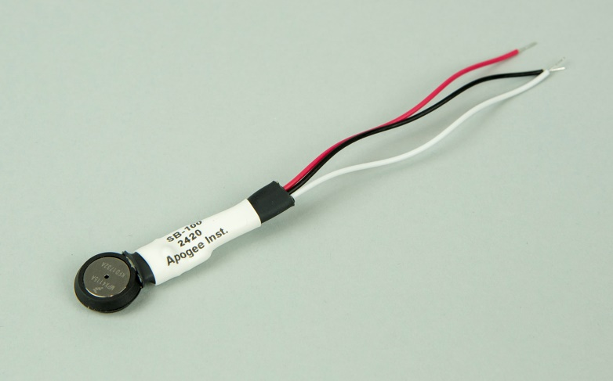

Sensor model number, serial number, and production date are located on a label between the sensor and pigtail lead wires.

### Specifications

|  |  |
| --- | --- |
|  | **SB-100** |
| Measurement Range | 15 to 115 kPa (approximate) |
| Maximum Pressure Exposure | 400 kPa (exposure beyond this limit may cause permanent damage to sensor) |
| Sensitivity | 45.9 mV per kPa; 0.459 mV per 0.01 kPa (approximate) |
| Calibration Factor | 0.0218 kPa per mV (generic slope; reciprocal of sensitivity) and 11.4 kPa (generic intercept) |
| Measurement Uncertainty | ± 1.5 kPa (with generic calibration coefficients) |
| Measurement Repeatability | Less than 0.1 % |
| Long-term Drift  (Non-stability) | Less than 1 % per year |
| Non-linearity | Less than 1 % |
| Warm-up Time | 20 ms |
| Response Time | 1 ms |
| Temperature Response | Less than 0.002 % per C for temperatures greater than 0 C, -0.015 % per C for temperatures less than 0 C |
| Operating Environment | -40 to 80 C; 0 to 100 % relative humidity (non-condensing) |
| Input Voltage Requirement | 5 V DC |
| Output Voltage Requirement | 0 to 5 V DC |
| Current Draw | 7 mA DC |
| Dimensions | 1.6 cm diameter |
| Mass | 5 g |
| Cable | 12 cm pigtail |

### Deployment and Installation

Apogee SB-100 barometric pressures sensors are designed to be mounted inside the datalogger enclosure, where they are protected from the elements, specifically, precipitation, condensation, and dynamic pressure caused by wind. Lead wires are short and allow the sensor to remain near the datalogger wiring panel (as shown below). The datalogger enclosure should not be air tight, as the pressure sensor must be exposed to an environment where the pressure varies with ambient pressure. As a result, vent holes in the enclosure are required and should be in the bottom of the enclosure to minimize the impact of dynamic pressure caused by wind.



### Operation and Measurement

Connect the sensor to a measurement device (meter, datalogger, controller) capable of inputting 5 V DC, and measuring and displaying or recording a millivolt (mV) signal (an input measurement range of approximately 100-4800 mV is required to cover the entire pressure range of the sensor). In order to maximize measurement resolution and signal-to-noise ratio, the input range of the measurement device should closely match the output range of the barometric pressure sensor. **DO NOT connect the black wire to a power source; applying voltage may damage the sensor.**

**VERY IMPORTANT: Apogee changed all wiring colors of our bare-lead sensors in March 2018. To ensure proper connection to your data device, please note your serial number and then use the appropriate wiring configuration below.**

**Wiring for SB-100 Serial Numbers 2405 and above**

White: Signal output; connect to single-ended channel

Red: Power input; connect to 5 V

Black: Ground for signal output; connect to analog ground

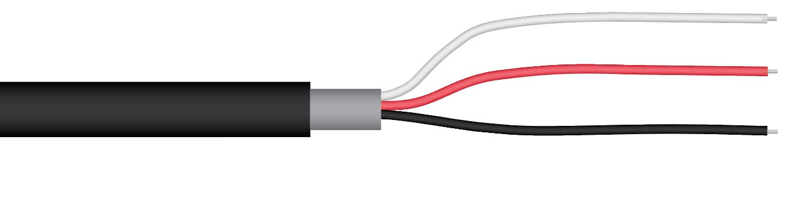

**Old Wiring for SB-100 Serial Numbers range 0-2404**

Red: Power input; connect to 5 V

Black: Signal output; connect to single-ended channel

Green: Ground for signal output; connect to analog ground

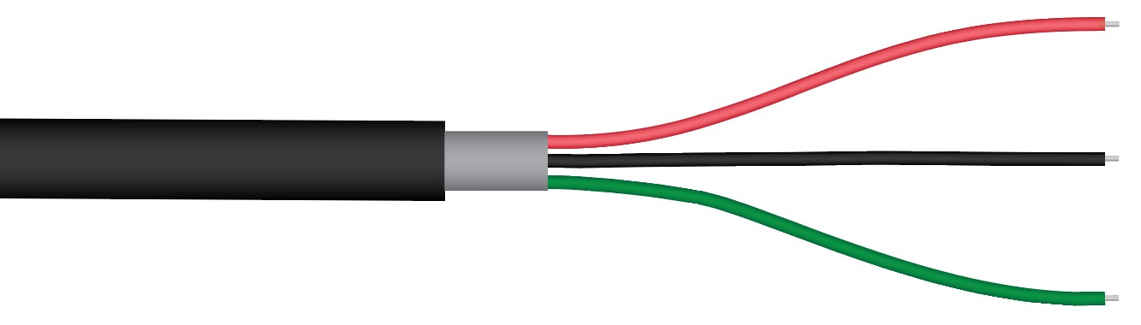

**Sensor Calibration**

All Apogee SB-100 barometric pressure sensors have a generic calibration factor (slope):

**0.0218 kPa per mV**

and generic offset (intercept):

**11.4 kPa**

Multiply this calibration factor by the measured voltage signal, and then add the offset, to convert sensor voltage output to barometric pressure (in units of kilopascals, kPa):

**Calibration Factor (0.0218 kPa per mV) * Sensor Output Signal (mV) + Offset (kPa) = Barometric Pressure (kPa)**

**0.0218 * 4125 + 11.4 = 101.325**

The calibration factor and offset are variable from sensor to sensor, and a sensor-specific calibration factor and offset can be derived by plotting measured pressure (from a reference) against the measured voltage signal, and then fitting a linear equation to the results (see Maintenance and Recalibration section below).

The generic calibration coefficients given above yield barometric pressure in units of kilopascals [kPa], but multiple units are available and used to report barometric pressure measurements. The following tables provide calibration factors and offsets in other common pressure units and conversion of kPa to other common units.

**Generic Calibration Factors and Offsets for Common Pressure Units**

|  |  |  |
| --- | --- | --- |
| **Units** | **Calibration Factor (Slope)** | **Offset (Intercept)** |
| kilopascals [kPa] | 0.0218 | 11.4 |
| hectopascals [hPa] | 0.218 | 114 |
| millibars [mb] | 0.218 | 114 |
| pounds per square inch [psi] | 0.00316 | 1.65 |
| millimeters of mercury [mm Hg] | 0.164 | 85.5 |
| inches of mercury [in Hg] | 0.00643 | 3.36 |

**Standard Atmospheric Pressure in Various Units and Conversion Factors for Pressure Units (Relative to Pressure in Kilopascals)**

|  |  |  |  |  |  |
| --- | --- | --- | --- | --- | --- |
| **kilopascals [kPa]** | **hectopascals [hPa]** | **millibars [mb]** | **pounds per square inch [psi]** | **millimeters of mercury [mm Hg]** | **inches of mercury [in Hg]** |
| 101.325 | 1013.25 | 1013.25 | 14.70 | 760.0 | 29.92 |
| **Conversion Factor** |  |  |  |  |  |
| 1 | 10 | 10 | 0.145 | 7.50 | 0.295 |

**Normalizing to Sea Level**

Before reporting, barometric pressure is often normalized to sea level (common reference pressure). A simple equation can be used to calculate the difference in barometric pressure (ΔP, in kPa) at a given elevation and the equivalent pressure at sea level:



where E is elevation is meters. To normalize measured barometric pressure to sea level pressure, the pressure difference (ΔP) from the above equation should be added to the measured pressure.

### Maintenance and Recalibration

To maintain proper sensor function, the small ports (holes) on each side of the sensor housing (one port in the epoxy plastic and one port in the stainless steel plate) should be kept unobstructed.

Apogee SB-100 barometric pressure sensors are weather resistant, but not weatherproof. They should be housed in a weatherproof enclosure, where water does not condense. Desiccant can be used to keep water from condensing inside the enclosure. The enclosure must have vents, so the internal air remains in equilibrium with the atmosphere, otherwise the pressure inside the enclosure will not be representative of ambient conditions.

Apogee SB-100 barometric pressure sensors are not factory calibrated, but come with a generic calibration. A custom calibration can be derived by plotting pressure measurements from a reference barometric pressure sensor versus the measured voltage output from an SB-100, then fitting a linear equation to the data. The slope of the linear equation is the calibration factor and the intercept is the offset.

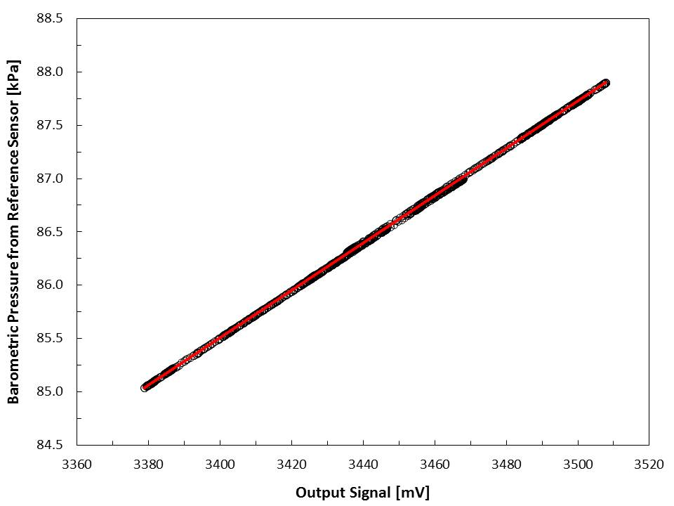

Example of SB-100 barometric pressure sensor calibration. Barometric pressure measurements from a reference sensor are plotted against the output signal voltage from the SB-100. A linear equation fitted to the data yields the calibration factor and offset, 0.0222 and 9.93, respectively, for this example.

Calibration Equation:

Pressure = 0.0222 * mV + 9.93

### Troubleshooting and Customer Support

**Independent Verification of Functionality**

Apogee SB-100 barometric pressure sensors require 5 V DC input for operation. A quick and easy check of sensor functionality can be determined using a DC power supply and a voltmeter. Power the sensor with 5 V DC by connecting the positive voltage signal to the red wire from the sensor and the negative (or common) to the black wire from the sensor. Use the voltmeter to measure across the white wire (output signal) and black wire. The sensor should read approximately 4100 mV at sea level, with the voltage output decreasing by approximately 50 mV per 100 meters above sea level.

**Compatible Measurement Devices (Dataloggers/Controllers/Meters)**

SB-100 barometric pressure sensors have a calibration factor of approximately 0.0218 kPa per mV, yielding a sensitivity of approximately 0.459 mV per 0.01 kPa. Thus, a compatible measurement device (e.g., datalogger or controller) should have resolution of at least 0.459 mV, in order to provide pressure resolution of 0.01 kPa.

The signal output range of SB-100 sensors is approximately 100 to 4800 mV. A compatible measurement device should also have a full scale range spanning the sensor signal output range.

An example datalogger program for Campbell Scientific dataloggers can be found on the Apogee webpage at <http://www.apogeeinstruments.com/content/Barometric-Pressure-Sensor.CR1>.

**Modifying Cable Length**

When the sensor is connected to a measurement device with high input impedance, sensor output signals are not changed by splicing on additional cable in the field. Tests have shown that if the input impedance of the measurement device is 1 mega-ohm or higher then there is negligible effect on the SB-100 pressure sensor calibration, even after adding up to 100 m of cable. See Apogee webpage for details on how to extend sensor cable length (<http://www.apogeeinstruments.com/how-to-make-a-weatherproof-cable-splice/>). For cable extensions, shielded, twisted pair cable is recommended, in order to minimize electromagnetic interference. This is particularly important for long lead lengths in electromagnetically noisy environments.

### Return and Warranty Policy

RETURN POLICY

Apogee Instruments will accept returns within 30 days of purchase as long as the product is in new condition (to be determined by Apogee). Returns are subject to a 10 % restocking fee.

WARRANTY POLICY

**What is Covered**All products manufactured by Apogee Instruments are warranted to be free from defects in materials and craftsmanship for a period of four (4) years from the date of shipment from our factory. To be considered for warranty coverage an item must be evaluated by Apogee.

Products not manufactured by Apogee (spectroradiometers, chlorophyll content meters, EE08-SS probes) are covered for a period of one (1) year.

**What is Not Covered**The customer is responsible for all costs associated with the removal, reinstallation, and shipping of suspected warranty items to our factory.

The warranty does not cover equipment that has been damaged due to the following conditions:

1. Improper installation or abuse.

2. Operation of the instrument outside of its specified operating range.

3. Natural occurrences such as lightning, fire, etc.

4. Unauthorized modification.

5. Improper or unauthorized repair.

Please note that nominal accuracy drift is normal over time. Routine recalibration of sensors/meters is considered part of proper maintenance and is not covered under warranty.

**Who is Covered**This warranty covers the original purchaser of the product or other party who may own it during the warranty period.

**What Apogee Will Do**At no charge Apogee will:

1. Either repair or replace (at our discretion) the item under warranty.

2. Ship the item back to the customer by the carrier of our choice.

Different or expedited shipping methods will be at the customer’s expense.

**How To Return An Item**1. Please do not send any products back to Apogee Instruments until you have received a Return Merchandise Authorization (RMA) number from our technical support department by submitting an online RMA form at [www.apogeeinstruments.com/tech-support-recalibration-repairs/](http://www.apogeeinstruments.com/tech-support-recalibration-repairs/). We will use your RMA number for tracking of the service item. Call (435) 245-8012 or email [techsupport@apogeeinstruments.com](mailto:techsupport@apogeeinstruments.com) with questions.

2. For warranty evaluations, send all RMA sensors and meters back in the following condition: Clean the sensor’s exterior and cord. Do not modify the sensors or wires, including splicing, cutting wire leads, etc. If a connector has been attached to the cable end, please include the mating connector – otherwise the sensor connector will be removed in order to complete the repair/recalibration. ***Note:*** *When sending back sensors for routine calibration that have Apogee’s standard stainless-steel connectors, you only need to send the sensor with the 30 cm section of cable and one-half of the connector. We have mating connectors at our factory that can be used for calibrating the sensor.*

3. Please write the RMA number on the outside of the shipping container.

4. Return the item with freight pre-paid and fully insured to our factory address shown below. We are not responsible for any costs associated with the transportation of products across international borders.

**Apogee Instruments, Inc.   
721 West 1800 North Logan, UT  
84321, USA**

5. Upon receipt, Apogee Instruments will determine the cause of failure. If the product is found to be defective in terms of operation to the published specifications due to a failure of product materials or craftsmanship, Apogee Instruments will repair or replace the items free of charge. If it is determined that your product is not covered under warranty, you will be informed and given an estimated repair/replacement cost.

Products Beyond the Warranty Period

For issues with sensors beyond the warranty period, please contact Apogee at [techsupport@apogeeinstruments.com](mailto:techsupport@apogeeinstruments.com) to discuss repair or replacement options.

Other Terms

The available remedy of defects under this warranty is for the repair or replacement of the original product, and Apogee Instruments is not responsible for any direct, indirect, incidental, or consequential damages, including but not limited to loss of income, loss of revenue, loss of profit, loss of data, loss of wages, loss of time, loss of sales, accruement of debts or expenses, injury to personal property, or injury to any person or any other type of damage or loss.

This limited warranty and any disputes arising out of or in connection with this limited warranty ("Disputes") shall be governed by the laws of the State of Utah, USA, excluding conflicts of law principles and excluding the Convention for the International Sale of Goods. The courts located in the State of Utah, USA, shall have exclusive jurisdiction over any Disputes.

This limited warranty gives you specific legal rights, and you may also have other rights, which vary from state to state and jurisdiction to jurisdiction, and which shall not be affected by this limited warranty. This warranty extends only to you and cannot by transferred or assigned. If any provision of this limited warranty is unlawful, void or unenforceable, that provision shall be deemed severable and shall not affect any remaining provisions. In case of any inconsistency between the English and other versions of this limited warranty, the English version shall prevail.

This warranty cannot be changed, assumed, or amended by any other person or agreement.

**APOGEE INSTRUMENTS, INC. |** 721 WEST 1800 NORTH, LOGAN, UTAH 84321, USA

TEL: (435) 792-4700 | FAX: (435) 787-8268 | WEB: APOGEEINSTRUMENTS.COM

*Copyright © 2021 Apogee Instruments, Inc.*