

# Owner’s Manual

PAR-Far Sensor

Models S2-441  
Rev: 31-Mar-2022

­­

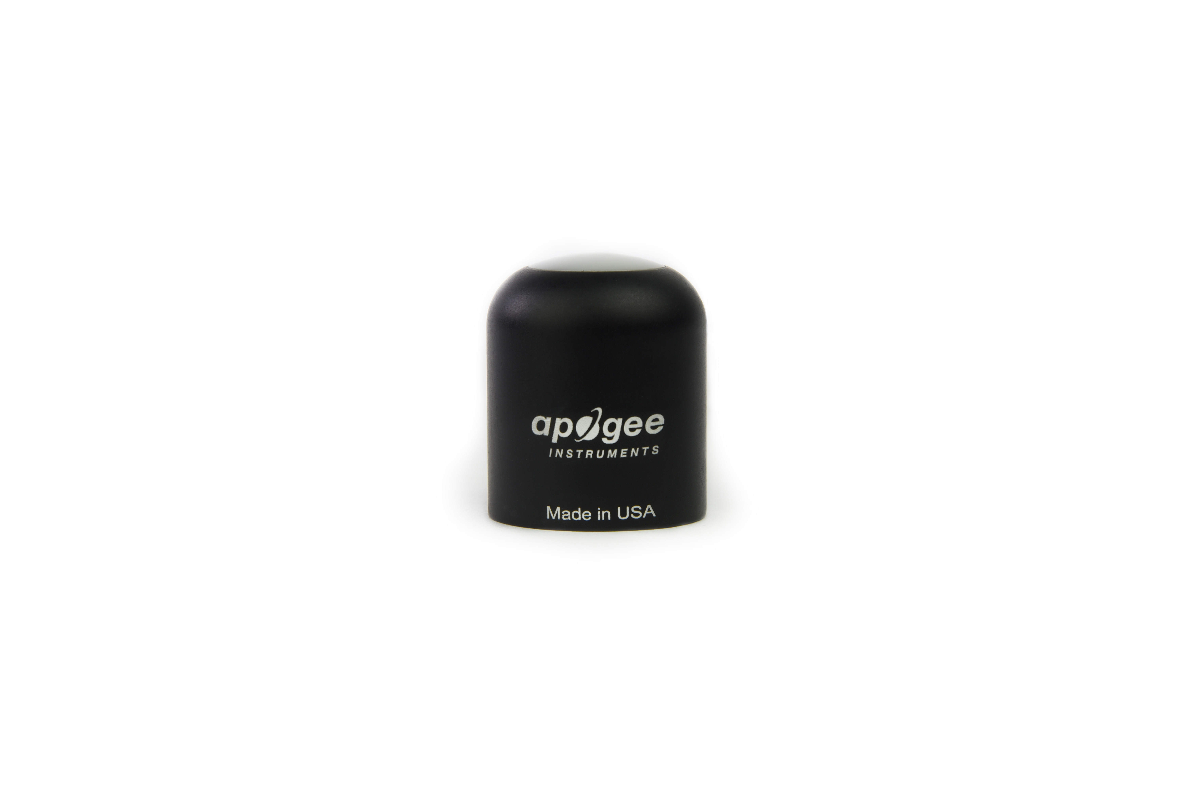

Table of Contents

[Owner’s Manual 1](#_Toc12273863)

[Certificate of Compliance 3](#_Toc12273864)

[Introduction 4](#_Toc12273865)

[Sensor Models 5](#_Toc12273866)

[Specifications 6](#_Toc12273867)

[Deployment and Installation 9](#_Toc12273868)

[Cable Connectors 10](#_Toc12273869)

[Operation and Measurement 11](#_Toc12273870)

[Maintenance and Recalibration 15](#_Toc12273871)

[Troubleshooting and Customer Support 16](#_Toc12273872)

[Return and Warranty Policy 17](#_Toc12273873)

### Certificate of Compliance

**EU Declaration of Conformity**

This declaration of conformity is issued under the sole responsibility of the manufacturer:

Apogee Instruments, Inc.  
721 W 1800 N  
Logan, Utah 84321  
USA

for the following product(s):

Models: S2-441  
Type: PAR-FAR Sensor

The object of the declaration described above is in conformity with the relevant Union harmonization legislation:

2014/30/EU Electromagnetic Compatibility (EMC) Directive

2011/65/EU Restriction of Hazardous Substances (RoHS 2) Directive

2015/863/EU Amending Annex II to Directive 2011/65/EU (RoHS 3)

Standards referenced during compliance assessment:

EN 61326-1:2013 Electrical equipment for measurement, control and laboratory use – EMC requirements

EN 50581:2012 Technical documentation for the assessment of electrical and electronic products with respect to the restriction of hazardous substances

Please be advised that based on the information available to us from our raw material suppliers, the products manufactured by us do not contain, as intentional additives, any of the restricted materials including lead (see note below), mercury, cadmium, hexavalent chromium, polybrominated biphenyls (PBB), polybrominated diphenyls (PBDE), bis (2-ethylhexyl) phthalate (DEHP), butyl benzyl phthalate (BBP), dibutyl phthalate (DBP), and diisobutyl phthalate (DIBP). However, please note that articles containing greater than 0.1 % lead concentration are RoHS 3 compliant using exemption 6c.

Further note that Apogee Instruments does not specifically run any analysis on our raw materials or end products for the presence of these substances, but we rely on the information provided to us by our material suppliers.

Signed for and on behalf of:

Apogee Instruments, March 2022



Bruce Bugbee  
President  
Apogee Instruments, Inc.

### Introduction

Specific wavelengths of radiation trigger distinct plant responses. Radiation that drives photosynthesis is called photosynthetically active radiation (PAR) and is typically defined as total radiation across a wavelength range of 400 to 700 nm. PAR is almost universally quantified as photosynthetic photon flux density (PPFD), the sum of photons from 400 to 700 nm in units of micromoles per square meter per second (µmol m-2 s-1, equal to microEinsteins m-2 s-1). While microEinsteins and micromoles are equal (one Einstein = one mole of photons), the Einstein is not an SI unit, so expressing PPFD as µmol m-2 s-1 is preferred. Daily total PPFD is typically reported in units of moles of photons per square meter per day (mol m-2 d-1) and is often called daily light integral (DLI).

The acronym PPF is also used and refers to the photosynthetic photon flux. The acronyms PPF and PPFD refer to the same variable. Both terms are used because there is not a universal definition of the term flux. Flux is sometimes defined as per unit area per unit time and sometimes defined as per unit time only. PPFD is used in this manual.

In addition to wavelengths within the PAR range, far-red wavelengths (those just beyond 700 nm) are of particular interest because they influence plant photosynthetic and morphogenic activity. Phytochrome pigments sensitive to varying ratios of red and far-red light provide information to the plant about the light environment, and therefore, influence growth patterns. Increasing the fraction of PAR, and specifically red radiation, relative to far-red radiation indicates less shading and generally results in more conservative vertical growth patterns. Increasing far-red radiation relative to PAR indicates more shading and results in more aggressive vertical growth patterns.

Sensors that measure PPFD are often called quantum sensors because they measure the number of incident photosynthetic photons and one photon is a single quantum of radiation. Far-red sensors are similar in that they measure incident photons, but the wavelength range is different. Far-red sensors can be thought of as quantum sensors that measure radiation just beyond 700 nm. Sensors that pair detectors to measure both PPFD and far-red photon flux density can be called PAR-FAR sensors.

The primary application of PAR-FAR sensors is monitoring plant light environments, including calculation of the far-red fraction (far-red photon flux density / sum of PPFD and far-red photon flux density), in photobiology studies (e.g., researching plant morphogenic activity).

Apogee Instruments S2 series PAR-FAR sensors consist of a cast acrylic diffuser, pair of photodetectors that measure PAR and far-red wavelength ranges (400-700 nm for PAR, 700-760 nm for far-red), and signal processing circuitry mounted in an anodized aluminum housing. A cable to connect the radiometer measurement device is also included. Sensors are designed for continuous measurement in indoor and outdoor environments. S2-100 series sensors output two voltage signals, one from each photodetector, that are directly proportional to the radiation incident on a planar surface (does not have to be horizontal), where the radiation emanates from all angles of a hemisphere.

### Sensor Models

This manual covers the SDI-12 model S2-441 (in bold below). Additional models are covered in their respective manuals.

|  |  |
| --- | --- |
| Model | Signal |
| S2-141 | Voltage |
| S2-441 | **SDI-12** |
| S2-442 | Modbus |

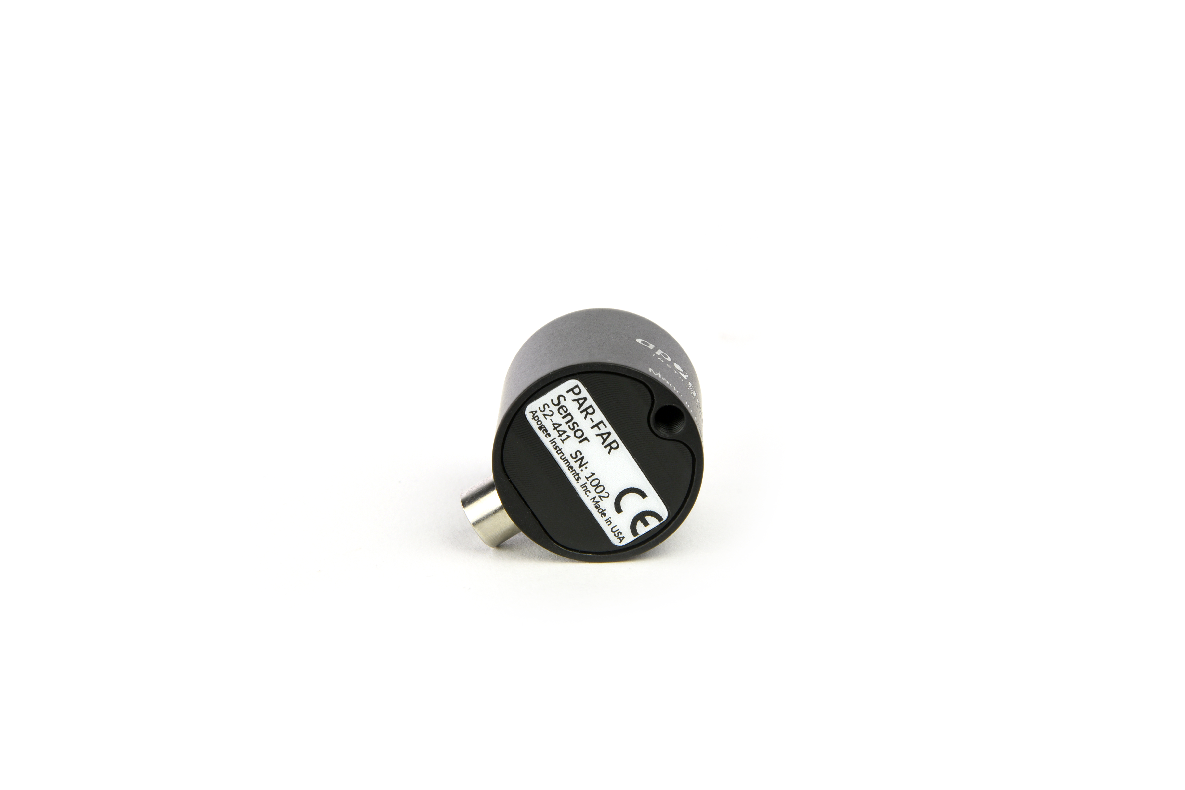

A sensor’s model number and serial number are located on the bottom of the sensor. If you need the manufacturing date of your sensor, please contact Apogee Instruments with the serial number of your sensor.

### Specifications

|  |  |
| --- | --- |
|  | **S2-441** |
| Power Supply | 5.5 to 24 V DC |
| Current Draw | 1.4 mA (quiescent), 1.8 mA (active) |
| Calibration Factor (reciprocal of sensitivity) | Custom for each sensor and stored in firmware |
| Calibration Uncertainty | ± 5 % |
| Output Range | SDI-12 |
| Measurement Repeatability | Less than 1 % |
| Long-term Drift | Less than 2 % per year |
| Non-linearity | Less than 1 % (up to 4000 µmol m⁻² s⁻¹) (PAR)  Less than 1 % (up to 1000 µmol m⁻² s⁻¹) (Far-red) |
| Response Time | 0.6 s, time for detector signal to reach 95 % following a step change; fastest data transmission rate for SDI-12 circuitry is 1 s |
| Field of View | 180° |
| Spectral Ranges | 389 to 692 nm ± 5 nm (PAR)  702 to 761 nm ± 5 nm (Far-red) |
| Directional (Cosine) Response | ± 2 % at 45°; ± 5 % at 75° zenith angle |
| Temperature Response | Less than 0.1 % per C |
| Housing | Anodized aluminum body with acrylic diffuser |
| IP Rating | IP68 |
| Operating Environment | -40 to 70 C; 0 to 100 % relative humidity |
| Dimensions | 30.5 mm diameter, 37 mm height |
| Mass (with 5 m of cable) | 140 g |
| Cable | 5 m of shielded, twisted-pair wire; TPR jacket (high water resistance, high UV stability, flexibility in cold conditions); pigtail lead wires; stainless steel (316), M8 connector |

**Calibration Traceability**

The PAR sensor in Apogee S2 series PAR-FAR sensors are calibrated through side-by-side comparison to the mean of four transfer standard quantum sensors under a reference lamp. The transfer standard quantum sensors are calibrated with a quartz halogen lamp traceable to the National Institute of Standards and Technology (NIST).

The far-red sensor in Apogee S2 series PAR-FAR sensors are calibrated through side-by-side comparison to the mean photon flux density of four transfer standard far-red radiometers under far-red LEDs (735 nm peak, 710-760 nm range). The transfer standard far-red sensors are calibrated against a spectroradiometer (Apogee Instruments model PS-300) under the same far-red LEDs. The spectroradiometer is calibrated with a quartz halogen lamp traceable to the National Institute of Standards and Technology (NIST).

**Cosine Response**

**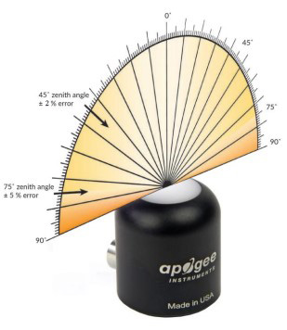**

Directional, or cosine, response is defined as the measurement error at a specific angle of radiation incidence. Error for Apogee S2 series PAR-FAR sensors is approximately ± 2 % and ± 5 % at solar zenith angles of 45° and 75°, respectively.

Mean directional (cosine) response of seven apogee PAR-FAR sensors. Directional response measurements were made on the rooftop of the Apogee building in Logan, Utah. Directional response was calculated as the relative difference of PAR-FAR sensors from the mean of replicate PAR detectors (LI-COR models LI-190 and LI-190R, Kipp & Zonen model PQS 1). Data were also collected in the laboratory using a reference lamp and positioning the sensor at varying angles.

**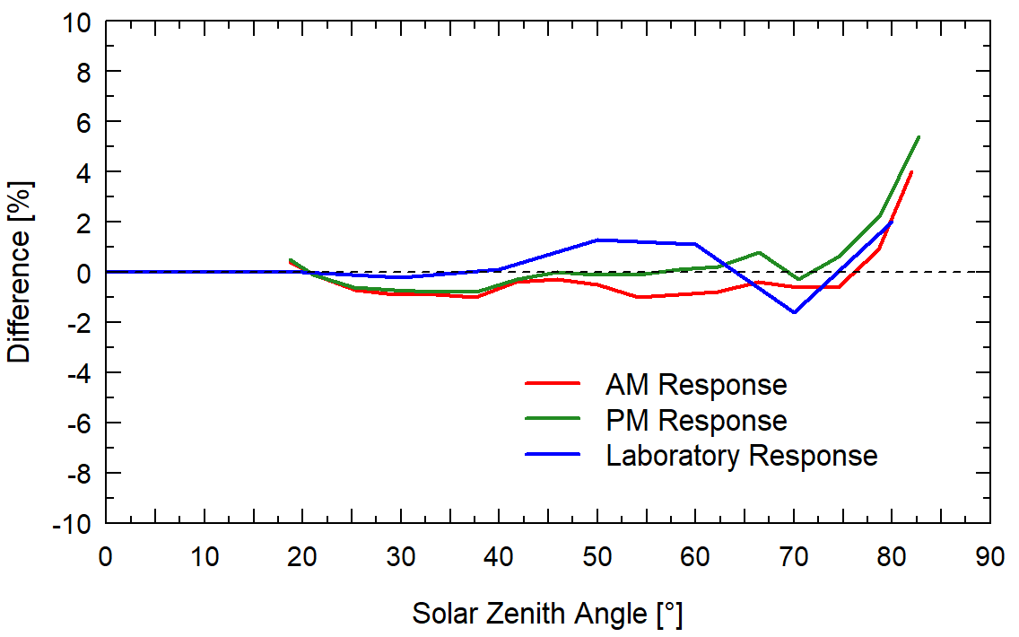**

**Spectral Response**

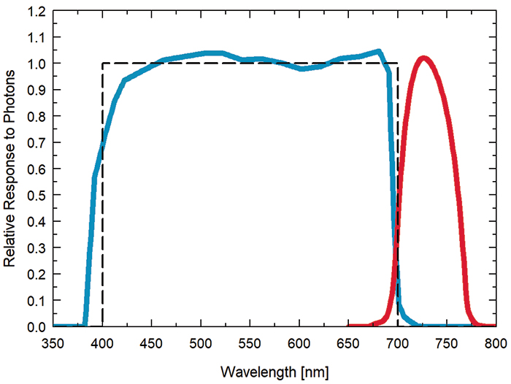

Spectral response of PAR detector (blue) and Far-red detector (red) compared to the defined response of plants to radiation (dashed).

### Deployment and Installation

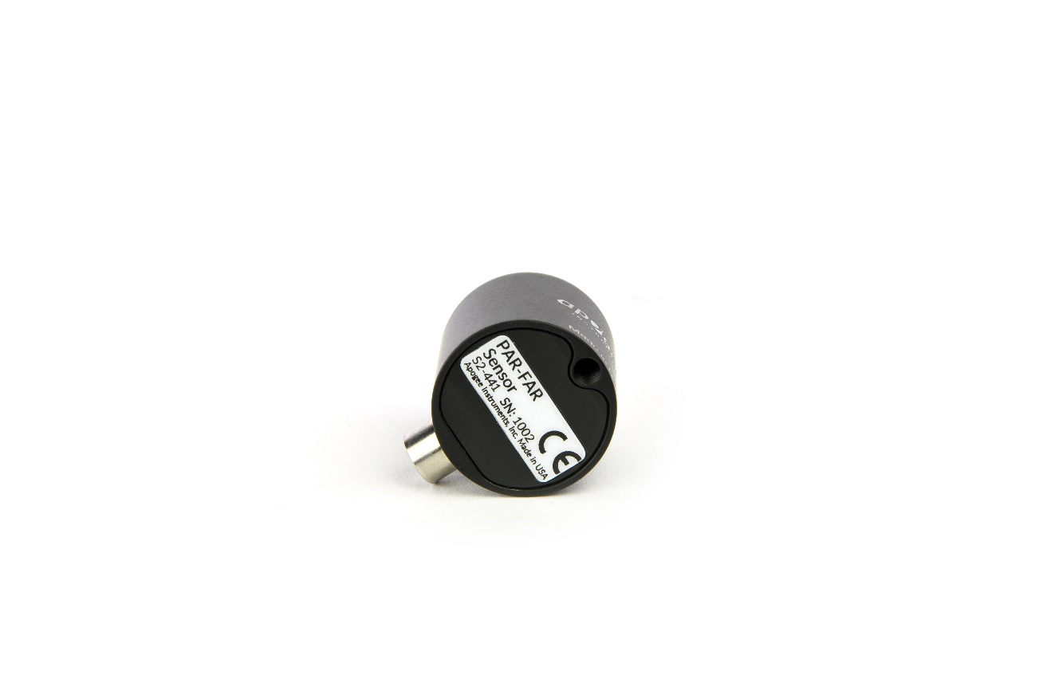Mount the sensor to a solid surface with the nylon mounting screw provided. To accurately measure PPFD incident on a horizontal surface, the sensor must be level. An Apogee Instruments model AL-100 leveling plate is recommended for this purpose. To facilitate mounting on a cross arm, an Apogee Instruments model AM-110 mounting bracket is recommended.

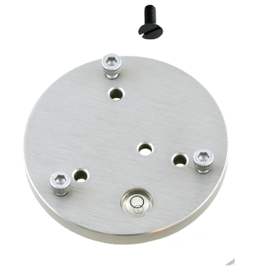

Nylon Screw: 10-32 x 3/8

Nylon Screw: 10-32 x 3/8

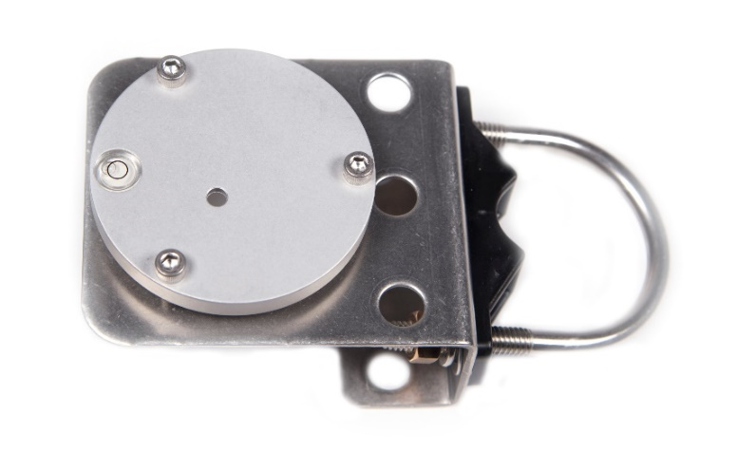C:\Users\emyers\AppData\Local\Microsoft\Windows\INetCache\Content.Word\screw.png

Model: AL-120

Model: AL-110

To minimize azimuth error, the sensor should be mounted with the cable pointing toward true north in the northern hemisphere or true south in the southern hemisphere. Azimuth error is typically less than 0.5 %, but it is easy to minimize by proper cable orientation.

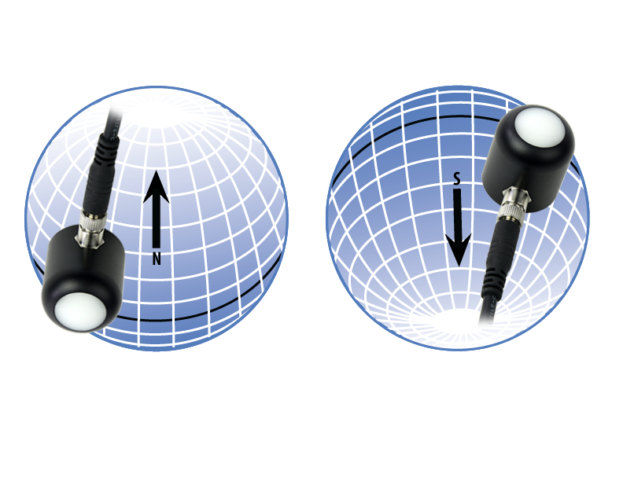

In addition to orienting the cable to point toward the nearest pole, the sensor should also be mounted such that obstructions (e.g., weather station tripod/tower or other instrumentation) do not shade the sensor. **Once mounted, the green cap should be removed from the sensor.** The green cap can be used as a protective covering for the sensor when it is not in use.

### Cable Connectors

|  |  |
| --- | --- |
| Apogee sensors offer cable connectors to simplify the process of removing sensors from weather stations for calibration (the entire cable does **not** have to be removed from the station and shipped with the sensor).  The ruggedized M8 connectors are rated IP68, made of corrosion-resistant marine-grade stainless-steel, and designed for extended use in harsh environmental conditions. | Cable connectors are attached directly to the head. |

**Instructions**

|  |  |
| --- | --- |
| **Pins and Wiring Colors:** All Apogee connectors have six pins, but not all pins are used for every sensor. There may also be unused wire colors inside the cable. To simplify datalogger connection, we remove the unused pigtail lead colors at the datalogger end of the cable.  If a replacement cable is required, please contact Apogee directly to ensure ordering the proper pigtail configuration.  **Alignment:** When reconnecting a sensor, arrows on the connector jacket and an aligning notch ensure proper orientation.  **Disconnection for extended periods:**  When disconnecting the sensor for an extended period of time from a station, protect the remaining half of the connector still on the station from water and dirt with electrical tape or other method. | A reference notch inside the connector ensures  proper alignment before tightening.  C:\Users\sadie.webster\AppData\Local\Microsoft\Windows\INetCache\Content.Word\DSC_1436.jpg  When sending sensors in for calibration, only send the sensor head. |
| **Tightening:** Connectors are designed to be firmly finger-tightened only. There is an o-ring inside the connector that can be overly compressed if a wrench is used. Pay attention to thread alignment to avoid cross-threading. When fully tightened, 1-2 threads may still be visible.  **WARNING:** Do **not** tighten the connector by twisting the black cable or sensor head, only twist the metal connector (blue arrows). | Finger-tighten firmly |

### Operation and Measurement

The S2-441 PAR-FAR sensor has a SDI-12 output, where PPFD and far-red photon flux density are returned in digital format. Measurement of S2-441 PAR-FAR sensors requires a measurement device with SDI-12 functionality that includes the M or C command.

**Wiring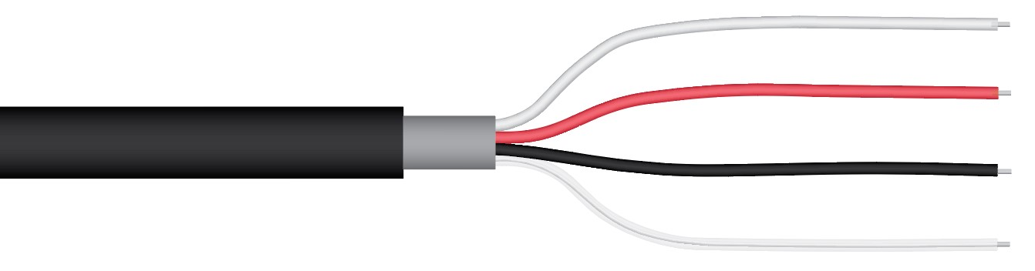**

**White:** Positive (signal from sensor)

**Red:** Input Power

**Black:** Ground (from sensor signal and output power)

**Clear:** Shield/Ground

**Sensor Calibration**

All Apogee SDI-12 S2 sensor models have sensor-specific calibration coefficients determined during the custom calibration process. Coefficients are programmed into sensor microcontrollers at the factory.

**SDI-12 Interface**

The following is a brief explanation of the serial digital interface SDI-12 protocol instructions used in Apogee S2-400 series PAR-FAR sensors. For questions on the implementation of this protocol, please refer to the official version of the SDI-12 protocol: <http://www.sdi-12.org/specification.php> (version 1.4, August 10, 2016).

**Overview**

During normal communication, the data recorder sends a packet of data to the sensor that consists of an address and a command. Then, the sensor sends a response. In the following descriptions, SDI-12 commands and responses are enclosed in quotes. The SDI-12 address and the command/response terminators are defined as follows:

**Sensors come from the factory with the address of “0” for use in single sensor systems. Addresses “1 to 9” and “A to Z”, or “a to z”, can be used for additional sensors connected to the same SDI-12 bus.**

“!” is the last character of a command instruction. In order to be compliant with SDI-12 protocol, all commands must be terminated with a “!”. SDI-12 language supports a variety of commands. Supported commands for the Apogee Instruments SQ-400 series two-band radiometers are listed in the following table (“a” is the sensor address. The following ASCII Characters are valid addresses: “0-9” or “A-Z”). Please note that SDI-12 commands are case-sensitive.

**Supported Commands for Apogee Instruments S2-400 Series PAR-FAR Sensors**

|  |  |  |
| --- | --- | --- |
| **Instruction Name** | **Instruction Syntax** | **Description** |
| Address Query Command | ?! | Used when the address is unknown to have the sensor identify its address, all sensors on data line respond |
| Change Address Command | aAb! | Changes the sensor address from a to b |
| Acknowledge Active Command | a! | Responds if the sensor with address a is on the line |
| Send Identification Command (“I” command) | aI! | Responds with sensor information |
| Calibration Verification (“V” command) | aV! | Retrieves calibration coefficients |
| Measurement Command (“M” command) | aM! | Tells the sensor to take a measurement |
| Measurement Command w/ Check Character (“M” command) | aMC! | Tells the sensor to take a measurement and return it with a check character |
| Concurrent Measurement Command (“C” command) | aC! | Used to take a measurement when more than one sensor is used on the same data line |
| Concurrent Measurement Command w/ Check Character (“C” command) | aCC! | Used to take a measurement when more than one sensor is used on the same data line. Data is returned with a check character. |
| Get Data Command (“D” command) | aD0! | Retrieves the data from a sensor |
| Running Average Command | aXAVG! | Returns or sets the running average for sensor measurements. |

**Make Measurement Command: M!**

The make measurement command signals a measurement sequence to be performed. Data values generated in response to this command are stored in the sensor's buffer for subsequent collection using “D” commands. Data will be retained in sensor storage until another “M”, “C”, or “V” command is executed. M commands are shown in the following examples:

|  |  |  |
| --- | --- | --- |
| **Command** | **Response** | **Response to 0D0!** |
| aM! or aM0! | a0011<cr><If> | Returns Ratio (PAR / Far-red), Far-red Percentage ((FR / total) x 100) values |
| aM1! | a0012<cr><If> | Returns calibrated lower wavelength output and calibrated upper wavelength output in µmol m⁻² s⁻¹ |
| aM2! | a0012<cr><If> | Returns lower wavelength detector millivolts and upper wavelength detector millivolts |
| aM3! | a0013<cr><If> | Returns angle offset from vertical in degrees. (0 degrees if pointed up, 180 degrees if pointed down.) |
| aMC0! | a0011<cr><If> | Returns Ratio (PAR / Far-red), Far-red Percentage ((FR / total) x 100) values w/CRC |
| aMC1! | a0012<cr><If> | Returns calibrated lower wavelength output and calibrated upper wavelength output in µmol m⁻² s⁻¹ w/ CRC |
| aMC2! | a0012<cr><If> | Returns lower wavelength detector millivolts and upper wavelength detector millivolts w/ CRC |
| aMC3! | A0013<cr><If> | Returns angle offset from vertical in degrees. (0 degrees if pointed up, 180 degrees if pointed down.) w/ CRC |

“<cf>” is a carriage return and “<lf>” is line feed

where a is the sensor address (“0-9”, “A-Z”, “a-z”) and M is an upper-case ASCII character.

The data values are separated by the sign “+”, as in the following example (0 is the address):

|  |  |  |
| --- | --- | --- |
| **Command** | **Sensor Response** | **Sensor Response when data is ready** |
| 0M0! | 00011<cr><lf> | 0<cr><lf> |
| 0D0! | 0+2.0+20.0<cr><lf> |  |
| 0M1! | 00012<cr><lf> | 0<cr><lf> |
| 0D0! | 0+400.0+20.0<cr><lf> |  |
| 0M2! | 00012<cr><If> | 0<cr><If> |
| 0D0! | 0+40.0+2.0<cr><If> |  |
| 0M3! | 00013<cr><If> | 0<cr><If> |
| 0D0! | 0+35.2<cr><If> |  |

Where M1! output is in µmol m-2 s-1.

**Concurrent Measurement Command: aC!**

A concurrent measurement is one which occurs while other SDI-12 sensors on the bus are also making measurements. This command is similar to the “aM!” command, however, the nn field has an extra digit and the sensor does not issue a service request when it has completed the measurement. Communicating with other sensors will NOT abort a concurrent measurement. Data values generated in response to this command are stored in the sensor's buffer for subsequent collection using “D” commands. The data will be retained in the sensor until another “M”, “C”, or “V” command is executed:

|  |  |  |
| --- | --- | --- |
| **Command** | **Response** | **Response to 0D0!** |
| aC! or aC0! | a00101<cr><lf> | Returns Ratio (PAR / Far-red), Far-red Percentage ((FR / total) x 100) values |
| aC1! | a00102<cr><lf> | Returns calibrated lower wavelength output and calibrated upper wavelength output in µmol m⁻² s⁻¹ |
| aC2! | a00102<cr><lf> | Returns lower wavelength detector millivolts and upper wavelength detector millivolts |
| aC3! | a00103<cr><lf> | Returns angle offset from vertical in degrees. (0 degrees if pointed up, 180 degrees if pointed down.) |
| aCC! or aCC0! | a00101<cr><lf> | Returns Ratio (PAR / Far-red), Far-red Percentage ((FR / total) x 100) values w/CRC |
| aCC1! | a00102<cr><lf> | Returns calibrated lower wavelength output and calibrated upper wavelength output in µmol m⁻² s⁻¹w/CRC |
| aCC2! | a00102<cr><lf> | Returns lower wavelength detector millivolts and upper wavelength detector millivolts w/CRC |
| aCC3! | a00103<cr><lf> | Returns angle offset from vertical in degrees. (0 degrees if pointed up, 180 degrees if pointed down.) w/CRC |

where a is the sensor address (“0-9”, “A-Z”, “a-z”, “\*”, “?”) and C is an upper-case ASCII character.

For example (0 is the address):

|  |  |
| --- | --- |
| **Command** | **Sensor Response** |
| 0C0! | 000101<cr><lf> |
| 0D0! | 0+2.0+20.0<cr><lf> |
| 0C1! | 000102<cr><If> |
| 0D0! | 0+400.0+20.0<cr><lf> |
| 0C2! | 000102<cr><lf> |
| 0D0! | 0+40.0+2.0<cr><If> |
| 0C3! | 000103<cr><If> |
| 0D0! | 0+35.2<cr><If> |

Where C1! output is in µmol m-2 s-1.

**Change Sensor Address: aAb!**

The change sensor address command allows the sensor address to be changed. If multiple SDI-12 devices are on the same bus, each device will require a unique SDI-12 address. For example, two SDI-12 sensors with the factory address of 0 requires changing the address on one of the sensors to a non-zero value in order for both sensors to communicate properly on the same channel:

|  |  |  |
| --- | --- | --- |
| **Command** | **Response** | **Description** |
| aAb! | b<cr><lf> | Change the address of the sensor |

where a is the current (old) sensor address (“0-9”, “A-Z”), A is an upper-case ASCII character denoting the instruction for changing the address, b is the new sensor address to be programmed (“0-9”, “A-Z”), and ! is the standard character to execute the command. If the address change is successful, the datalogger will respond with the new address and a <cr><lf>.

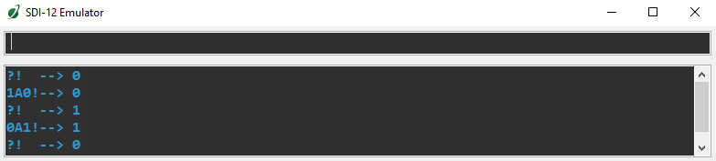

**Send Identification Command: aI!**

The send identification command responds with sensor vendor, model, and version data. Any measurement data in the sensor's buffer is not disturbed:

|  |  |  |
| --- | --- | --- |
| **Command** | **Response** | **Description** |
| "aI!" | a13Apogee S2-441vvvxx…xx<cr><lf> | The sensor serial number and other identifying values are returned |

where a is the sensor address (“0-9”, “A-Z”, “a-z”, “\*”, “?”), 441 is the sensor model number, vvv is a three character field specifying the sensor version number, and xx...xx is serial number.

**Running Average Command**

The running average command can be used to set or query the number of measurements that are averaged together before returning a value from a M! or MC! command. For example, if a user sends the command “0XAVG10!” to sensor with address 0, that sensor will average 10 measurements before sending the averaged value to the logger. To turn off averaging, the user should send the command “*a*XAVG1” to the sensor. To query the sensor to see how many measurements are being averaged, send the command “*a*XAVG!” and the sensor will return the number of measurements being averaged (see table below). The default for sensors is to have averaging turned off.

|  |  |  |  |
| --- | --- | --- | --- |
| **Command Name** | **Characters Sent** | **Response** | **Description** |
| Query running Average | *a*XAVG! | *an* | a = sensor address, *n* = number of measurements used in average calculation. Note: *n* may be multiple digits. |
| Set running Average | *a*XAVG*n!* | *a* | a = sensor address, *n* = number of measurements to be used in average calculation. Note: *n* may be any value from 1 to 100. |

### Maintenance and Recalibration

Blocking of the optical path between the target and detector can cause low readings. Occasionally, accumulated materials on the diffuser can block the optical path in three common ways:

1. Moisture or debris on the diffuser.
2. Dust during periods of low rainfall.
3. Salt deposit accumulation from evaporation of sea spray or sprinkler irrigation water.

Apogee Instruments PAR-FAR sensors have a domed diffuser and housing for improved self-cleaning from rainfall but active cleaning may be necessary. Dust or organic deposits are best removed using water, or window cleaner, and a soft cloth or cotton swab. Salt deposits should be dissolved with vinegar and removed with a cloth or cotton swab. **Salt deposits cannot be removed with solvents such as alcohol or acetone.** Use only gentle pressure when cleaning the diffuser with a cotton swab or soft cloth, to avoid scratching the outer surface. The solvent should be allowed to do the cleaning, not mechanical force. **Never use an abrasive material or cleaner on the diffuser**.

It is recommended that PAR-FAR sensors be recalibrated every two years. See the Apogee webpage for details regarding return of sensors for recalibration (<http://www.apogeeinstruments.com/tech-support-recalibration-repairs/>).

### Troubleshooting and Customer Support

**Independent Verification of Functionality**

If the sensor does not communicate with the datalogger, use an ammeter to check the current drain. It should be near 1.4 mA when the sensor is not communicating and spike to approximately 1.8 mA when the sensor is communicating. Any current drain greater than approximately 6 mA indicates a problem with power supply to the sensors, wiring of the sensor, or sensor electronics.

**Compatible Measurement Devices (Dataloggers/Controllers/Meters)**

Any datalogger or meter with SDI-12 functionality that includes the M or C command.

An example datalogger program for Campbell Scientific dataloggers can be found on the Apogee webpage at <http://www.apogeeinstruments.com/downloads/#datalogger>.

**Modifying Cable Length**

SDI-12 protocol limits cable length to 60 meters. For multiple sensors connected to the same data line, the maximum is 600 meters of total cable (e.g., ten sensors with 60 meters of cable per sensor). See Apogee webpage for details on how to extend sensor cable length (<http://www.apogeeinstruments.com/how-to-make-a-weatherproof-cable-splice/>).

### Return and Warranty Policy

RETURN POLICY

Apogee Instruments will accept returns within 30 days of purchase as long as the product is in new condition (to be determined by Apogee). Returns are subject to a 10 % restocking fee.

WARRANTY POLICY

**What is Covered**All products manufactured by Apogee Instruments are warranted to be free from defects in materials and craftsmanship for a period of four (4) years from the date of shipment from our factory. To be considered for warranty coverage an item must be evaluated by Apogee.

Products not manufactured by Apogee (spectroradiometers, chlorophyll content meters, EE08-SS probes) are covered for a period of one (1) year.

**What is Not Covered**The customer is responsible for all costs associated with the removal, reinstallation, and shipping of suspected warranty items to our factory.

The warranty does not cover equipment that has been damaged due to the following conditions:

1. Improper installation, use, or abuse.

2. Operation of the instrument outside of its specified operating range.

3. Natural occurrences such as lightning, fire, etc.

4. Unauthorized modification.

5. Improper or unauthorized repair.

Please note that nominal accuracy drift is normal over time. Routine recalibration of sensors/meters is considered part of proper maintenance and is not covered under warranty.

**Who is Covered**This warranty covers the original purchaser of the product or other party who may own it during the warranty period.

**What Apogee Will Do**At no charge Apogee will:

1. Either repair or replace (at our discretion) the item under warranty.

2. Ship the item back to the customer by the carrier of our choice.

Different or expedited shipping methods will be at the customer’s expense.

**How To Return An Item**1. Please do not send any products back to Apogee Instruments until you have received a Return Merchandise Authorization (RMA) number from our technical support department by submitting an online RMA form at [www.apogeeinstruments.com/tech-support-recalibration-repairs/](http://www.apogeeinstruments.com/tech-support-recalibration-repairs/). We will use your RMA number for tracking of the service item. Call (435) 245-8012 or email techsupport@apogeeinstruments.com with questions.

2. For warranty evaluations, send all RMA sensors and meters back in the following condition: Clean the sensor’s exterior and cord. Do not modify the sensors or wires, including splicing, cutting wire leads, etc. If a connector has been attached to the cable end, please include the mating connector – otherwise the sensor connector will be removed in order to complete the repair/recalibration. ***Note:*** *When sending back sensors for routine calibration that have Apogee’s standard stainless-steel connectors, you only need to send the sensor with the 30 cm section of cable and one-half of the connector. We have mating connectors at our factory that can be used for calibrating the sensor.*

3. Please write the RMA number on the outside of the shipping container.

4. Return the item with freight pre-paid and fully insured to our factory address shown below. We are not responsible for any costs associated with the transportation of products across international borders.

**Apogee Instruments, Inc.   
721 West 1800 North Logan, UT  
84321, USA**

5. Upon receipt, Apogee Instruments will determine the cause of failure. If the product is found to be defective in terms of operation to the published specifications due to a failure of product materials or craftsmanship, Apogee Instruments will repair or replace the items free of charge. If it is determined that your product is not covered under warranty, you will be informed and given an estimated repair/replacement cost.

Products Beyond the Warranty Period

For issues with sensors beyond the warranty period, please contact Apogee at [techsupport@apogeeinstruments.com](mailto:techsupport@apogeeinstruments.com) to discuss repair or replacement options.

Other Terms

The available remedy of defects under this warranty is for the repair or replacement of the original product, and Apogee Instruments is not responsible for any direct, indirect, incidental, or consequential damages, including but not limited to loss of income, loss of revenue, loss of profit, loss of data, loss of wages, loss of time, loss of sales, accruement of debts or expenses, injury to personal property, or injury to any person or any other type of damage or loss.

This limited warranty and any disputes arising out of or in connection with this limited warranty ("Disputes") shall be governed by the laws of the State of Utah, USA, excluding conflicts of law principles and excluding the Convention for the International Sale of Goods. The courts located in the State of Utah, USA, shall have exclusive jurisdiction over any Disputes.

This limited warranty gives you specific legal rights, and you may also have other rights, which vary from state to state and jurisdiction to jurisdiction, and which shall not be affected by this limited warranty. This warranty extends only to you and cannot by transferred or assigned. If any provision of this limited warranty is unlawful, void, or unenforceable, that provision shall be deemed severable and shall not affect any remaining provisions. In case of any inconsistency between the English and other versions of this limited warranty, the English version shall prevail.

This warranty cannot be changed, assumed, or amended by any other person or agreement

**APOGEE INSTRUMENTS, INC. |** 721 WEST 1800 NORTH, LOGAN, UTAH 84321, USA

TEL: (435) 792-4700 | FAX: (435) 787-8268 | WEB: APOGEEINSTRUMENTS.COM

*Copyright © 2022 Apogee Instruments, Inc.*