

# Owner’s Manual

Red - Far-Red sensors

Models S2-432  
Rev: 31-Mar-2022

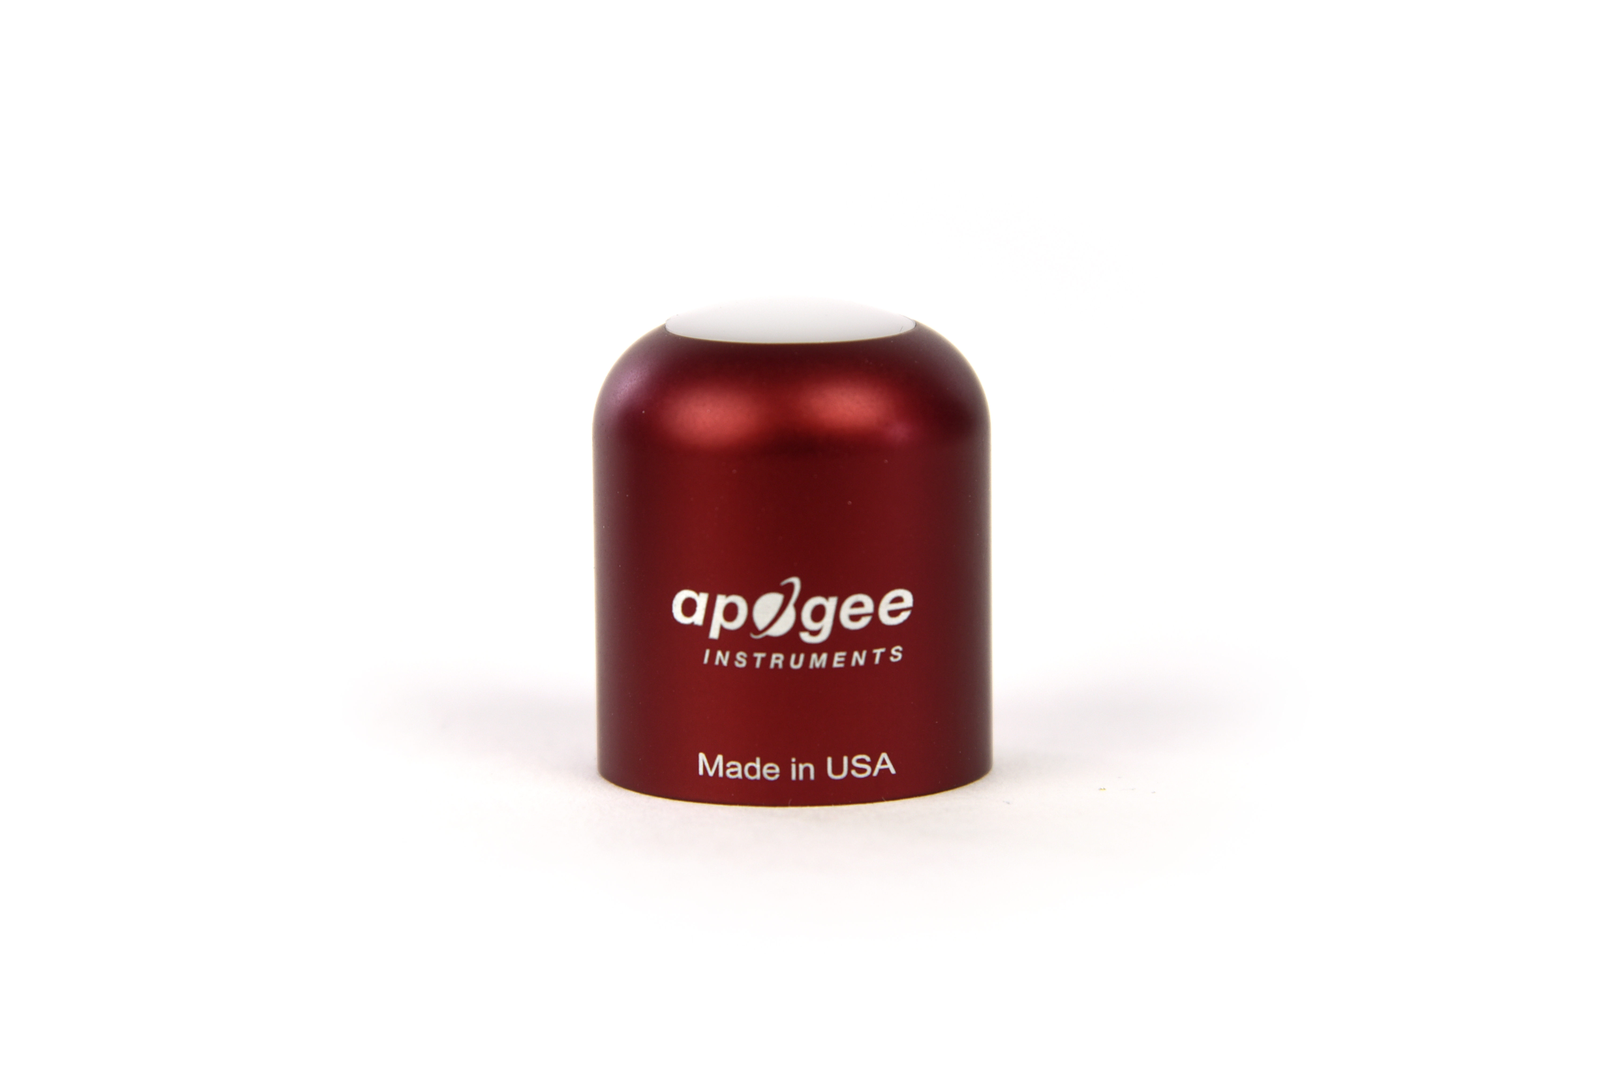

Table of Contents

Owner’s Manual 1

Certificate of Compliance 3

Introduction 4

Sensor Models 5

Specifications 6

Deployment and Installation 8

Cable Connectors 9

Operation and Measurement 10

Maintenance and Recalibration 10

Troubleshooting and Customer Support 16

Return and Warranty Policy 17

### Certificate of Compliance

**EU Declaration of Conformity**

This declaration of conformity is issued under the sole responsibility of the manufacturer:

Apogee Instruments, Inc.  
721 W 1800 N  
Logan, Utah 84321  
USA

for the following product(s):

Models: S2-432

Type: Red - Far-red Sensors

The object of the declaration described above is in conformity with the relevant Union harmonization legislation:

2014/30/EU Electromagnetic Compatibility (EMC) Directive

2011/65/EU Restriction of Hazardous Substances (RoHS 2) Directive

2015/863/EU Amending Annex II to Directive 2011/65/EU (RoHS 3)

Standards referenced during compliance assessment:

EN 61326-1:2013 Electrical equipment for measurement, control and laboratory use – EMC requirements

EN 50581:2012 Technical documentation for the assessment of electrical and electronic products with respect to the restriction of hazardous substances

Please be advised that based on the information available to us from our raw material suppliers, the products manufactured by us do not contain, as intentional additives, any of the restricted materials including lead (see note below), mercury, cadmium, hexavalent chromium, polybrominated biphenyls (PBB), polybrominated diphenyls (PBDE), bis (2-ethylhexyl) phthalate (DEHP), butyl benzyl phthalate (BBP), dibutyl phthalate (DBP), and diisobutyl phthalate (DIBP). However, please note that articles containing greater than 0.1 % lead concentration are RoHS 3 compliant using exemption 6c.

Further note that Apogee Instruments does not specifically run any analysis on our raw materials or end products for the presence of these substances, but we rely on the information provided to us by our material suppliers.

Signed for and on behalf of:

Apogee Instruments, March 2022



Bruce Bugbee  
President  
Apogee Instruments, Inc.

### Introduction

Specific wavelengths of radiation trigger distinct responses in plants. Red and far-red wavelengths are of particular interest because they influence photosynthetic and morphogenic activity. Phytochrome pigments in plants are sensitive to varying ratios of red and far-red radiation, providing information to the plant about the light environment, and therefore, optimal growth patterns. Increasing the fraction of red radiation indicates less shading and generally results in more conservative vertical growth patterns, while increasing the far-red radiation fraction indicates more shading and results in more aggressive vertical growth patterns.

Red - far-red sensors are designed to have spectral sensitivities that approximate the phytochrome absorption spectrum. Red - far-red sensors quantify properties of radiation sources, not plant responses. However, inferences of plant responses can be made from measurements of the lighting/shading environment, so it is important that red - far-red sensors have high sensitivity in the wavelength ranges where plants are most sensitive (i.e., the wavelength ranges that drive the strongest responses in plants), hence red - far-red sensor spectral responses should approximate the phytochrome absorption spectrum.

The primary application of red - far-red sensors is monitoring plant light environments, including calculation of the red to far-red ratio (red photon flux density / far-red photon flux density) and far-red fraction (far-red photon flux density / sum of red and far-red photon flux densities), in photobiology studies (e.g., researching plant morphogenic activities).

Apogee Instruments S2 series Red - Far-red sensors consist of a cast acrylic diffuser, pair of photodiodes that measure specific wavelength ranges, and signal processing circuitry mounted in an anodized aluminum housing, and a cable to connect the radiometer to a measurement device. Sensors are potted solid with no internal airspace and are designed for continuous measurement in indoor and outdoor environments. S2-100 series sensors output two analog voltages, one for each photodetector, that are directly proportional to red and far-red radiation incident on a planar surface (does not have to be horizontal), where the radiation emanates from all angles of a hemisphere. The S2-432 model outputs a digital signal using Modbus RTU communication protocol over RS-232 or RS-485.

### Sensor Models

This manual covers the Modbus RTU communication protocol, Red - Far-red model S2-432 (in bold below). Additional models are covered in their respective manuals.

|  |  |
| --- | --- |
| Model | Signal |
| S2-131 | Self-powered |
| S2-431 | SDI-12 |
| S2-432 | **Modbus** |

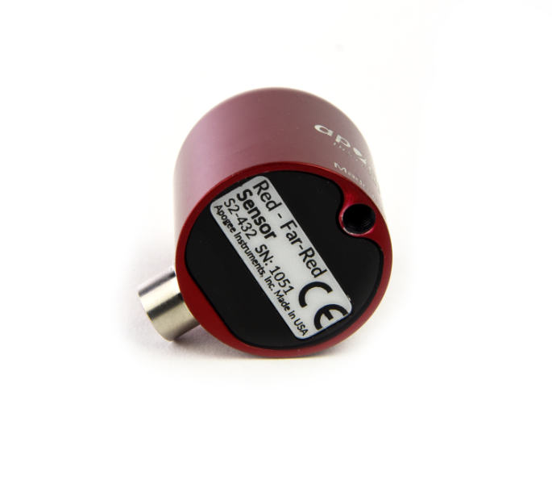

A sensor’s model number and serial number are located on the bottom of the sensor. If you need the manufacturing date of your sensor, please contact Apogee Instruments with the serial number of your sensor.

.

### Specifications

|  |  |  |
| --- | --- | --- |
|  | **S2-432** | |
| Power Supply | 5.5 to 24 V DC | |
| Average Max Current Draw | RS-232 37 mA;  RS-485 quiescent 37 mA, active 42 mA | |
| Calibration Factor (reciprocal of sensitivity) | Custom for each sensor and stored in firmware | |
| Calibration Uncertainty | ± 5 % | |
| Output Range | Modbus | |
| Measurement Repeatability | Less than 1 % | |
| Long-term Drift | Less than 2 % per year | |
| Non-linearity | Less than 1 % (up to 400 µmol m⁻² s⁻¹) | |
| Field of View | 180° | |
| Wavelength Ranges | 645 to 665 nm ± 5 nm (Red)  720 to 740 nm ± 5 nm (Far-red) | |
| Directional (Cosine) Response | ± 2 % at 45°; ± 5 % at 75° zenith angle | |
| Temperature Response | | Less than 0.1 % per C |
| Housing | Anodized aluminum body with acrylic diffuser | |
| IP Rating | IP68 | |
| Operating Environment | -40 to 70 C; 0 to 100 % relative humidity | |
| Dimensions | 30.5 mm diameter, 37 mm height | |
| Mass (with 5 m of cable) | 140 g | |
| Cable | 5 m of shielded, twisted-pair wire; TPR jacket (high water resistance, high UV stability, flexibility in cold conditions); pigtail lead wires; stainless steel (316), M8 connector | |

**Calibration Traceability**

Apogee S2 series Red - Far-red sensors are calibrated through side-by-side comparison to the mean of three transfer standard sensors under a quartz halogen lamp. The transfer standard sensors are calibrated through side-by-side comparison to red and far-red photon flux density calculated from solar spectra collected in Logan, Utah, using an Apogee model PS-300 spectroradiometer. The PS-300 spectroradiometer is calibrated with a quartz halogen lamp traceable to the National Institute of Standards and Technology (NIST).

**Cosine Response**

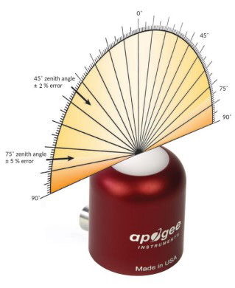

Directional, or cosine, response is defined as the measurement error at a specific angle of radiation incidence. Directional error for Apogee S2 series Red - Far-red sensors is approximately ± 2 % and ± 5 % at solar zenith angles of 45° and 75°, respectively.

**Spectral Response**

Mean spectral response measurements of six replicate red - far-red sensors (red sensor is centered near 655 nm, far-red sensor is centered near 730 nm). Spectral response measurements were made at 2 nm increments across a wavelength range of 600 to 800 nm in a monochromator with an attached electric light source. Measured spectral data from each sensor were normalized by the measured spectral response of the monochromator/electric light combination, which was measured with a spectroradiometer.

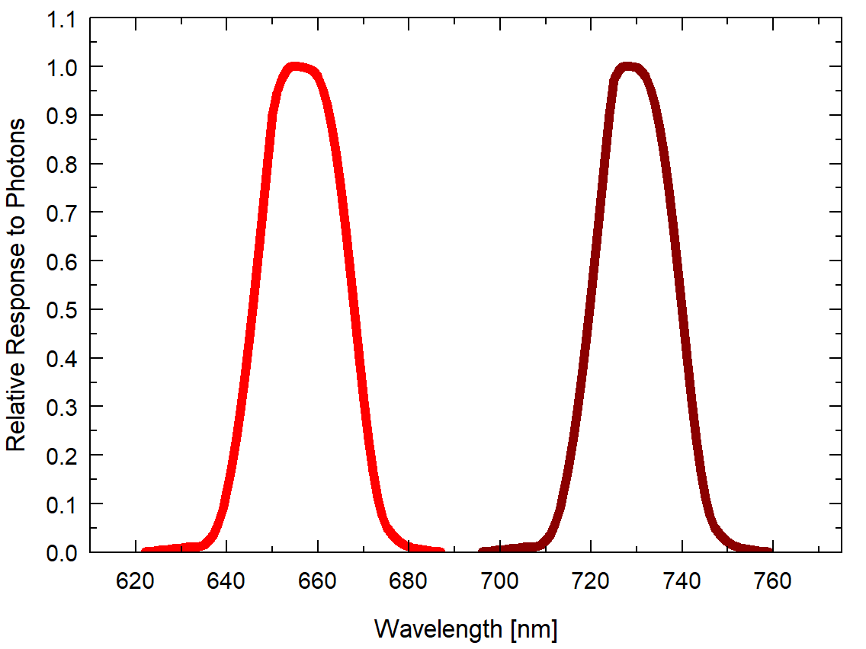

### Deployment and Installation

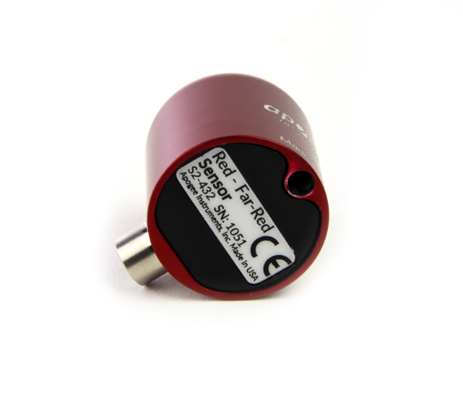Mount the sensor to a solid surface with the nylon mounting screw provided to prevent galvanic corrosion. To accurately measure red and far-red photon flux density incident on a horizontal surface, the sensor must be level. An Apogee Instruments model AL-100 Leveling Plate is recommended to level the sensor when used on a flat surface or being mounted to surfaces such as wood. To facilitate mounting on a mast or pipe, the Apogee Instruments model AL-120 Solar Mounting Bracket with Leveling Plate is recommended.

C:\Users\emyers\AppData\Local\Microsoft\Windows\INetCache\Content.Word\screw.png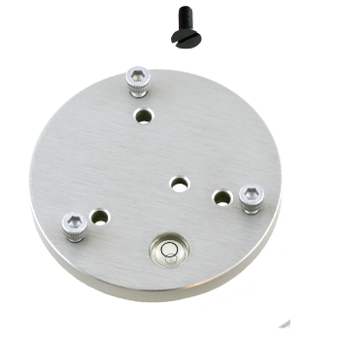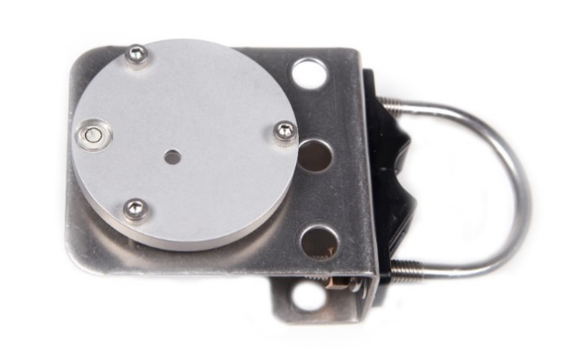

Nylon Screw: 10-32x3/8

Nylon Screw: 10-32x3/8

Model AL-120

Model AL-100

To minimize azimuth error, the sensor should be mounted with the cable pointing toward true north in the northern hemisphere or true south in the southern hemisphere. Azimuth error is typically less than 1 %, but it is easy to minimize by proper cable orientation.

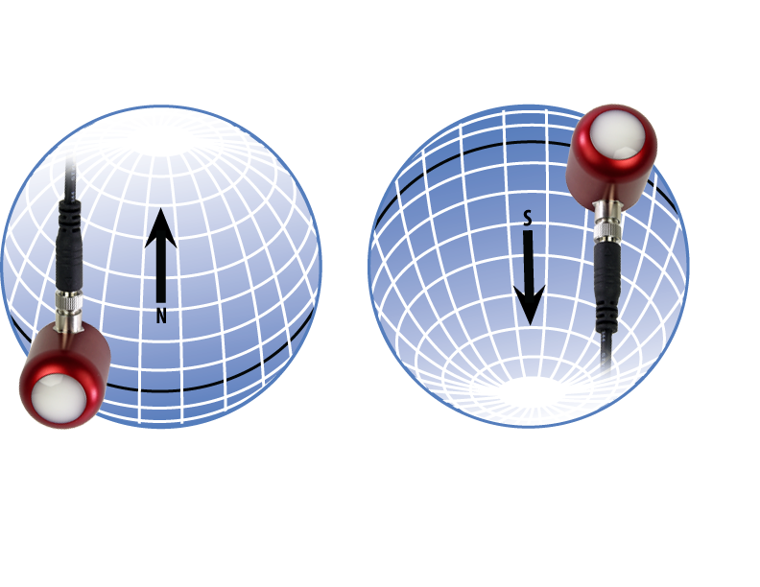

In addition to orienting the cable to point toward the nearest pole, the sensor should also be mounted such that obstructions (e.g., weather station tripod/tower or other instrumentation) do not shade the sensor. **Once mounted, the black cap should be removed from the sensor.** The black cap can be used as a protective covering for the sensor when it is not in use.

### Cable Connectors

|  |  |
| --- | --- |
| Apogee sensors offer cable connectors to simplify the process of removing sensors from weather stations for calibration (the entire cable does **not** have to be removed from the station and shipped with the sensor).  The ruggedized M8 connectors are rated IP68, made of corrosion-resistant marine-grade stainless-steel, and designed for extended use in harsh environmental conditions. | Cable connectors are attached directly to the head. |

**Instructions**

|  |  |
| --- | --- |
| **Pins and Wiring Colors:** All Apogee connectors have six pins, but not all pins are used for every sensor. There may also be unused wire colors inside the cable. To simplify datalogger connection, we remove the unused pigtail lead colors at the datalogger end of the cable.  If a replacement cable is required, please contact Apogee directly to ensure ordering the proper pigtail configuration.  **Alignment:** When reconnecting a sensor, arrows on the connector jacket and an aligning notch ensure proper orientation.  **Disconnection for extended periods:**  When disconnecting the sensor for an extended period of time from a station, protect the remaining half of the connector still on the station from water and dirt with electrical tape or other method. | A reference notch inside the connector ensures  proper alignment before tightening.  When sending sensors in for calibration, only send the sensor head. |
| **Tightening:** Connectors are designed to be firmly finger-tightened only. There is an o-ring inside the connector that can be overly compressed if a wrench is used. Pay attention to thread alignment to avoid cross-threading. When fully tightened, 1-2 threads may still be visible.  **WARNING:** Do **not** tighten the connector by twisting the black cable or sensor head, only twist the metal connector (blue arrows). | Finger-tighten firmly |

### Operation and Measurement

The S2-432 Red - Far-red sensor has a Modbus output, where red and far-red photon flux density are returned in digital format. Measurement of S2-432 Red - Far-red sensors requires a measurement device with a Modbus interface that supports the Read Holding Registers (0x03) function.

**Wiring**

**White:** RS-232 RX / RS-485 Positive

**Blue:** RS-232 TX / RS-485 Negative

**Green:** Select (Switch between RS-232 and RS-485)

**Black:** Ground

**Red:** Power +12 V

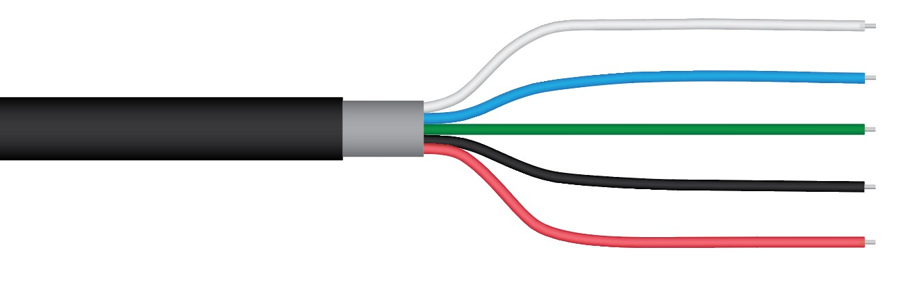

The Green wire should be connected to Ground to enable RS-485 communication, or it should be connected to 12 V power for RS-232 communication. Text for the White and Blue wires above refers to the port that the wires should be connected to.

**Sensor Calibration**

All Apogee Modbus Red - Far-red sensors (model S2-432) have sensor-specific calibration coefficients determined during the custom calibration process. Coefficients are programmed into the sensors at the factory.

**Modbus Interface**

The following is a brief explanation of the Modbus protocol instructions used in Apogee S2-432 Red - Far-red sensors. For questions on the implementation of this protocol, please refer to the official serial line implementation of the Modbus protocol: <http://www.modbus.org/docs/Modbus_over_serial_line_V1_02.pdf> (2006) and the general Modbus protocol specification: <http://www.modbus.org/docs/Modbus_Application_Protocol_V1_1b3.pdf> (2012). Further information can be found at: <http://www.modbus.org/specs.php>

**Overview**

The primary idea of the Modbus interface is that each sensor exists at an address and appears as a table of values. These values are called Registers. Each value in the table has an associated index, and that index is used to identify which value in the table is being accessed.   
  
**Sensor addresses**

Each sensor is given an address from 1 to 247. Apogee sensors are shipped with a default address of 1. If using multiple sensors on the same Modbus line, the sensor’s address will have to be changed by writing the Slave Address register.

**Register Index**

Each register in a sensor represents a value in the sensor, such as a measurement or a configuration parameter. Some registers can only be read, some registers can only be written, and some can be both read and written. Each register exists at a specified index in the table for the sensor. Often this index is called an address, which is a separate address than the sensor address, but can be easily confused with the sensor address.

However, there are two different indexing schemes used for Modbus sensors, though translating between them is simple. One indexing scheme is called one-based numbering, where the first register is given the index of 1, and is thereby accessed by requesting access to register 1. The other indexing scheme is called zero-based numbering, where the first register is given the index 0, and is thereby accessed by requesting access to register 0. Apogee Sensors use zero-based numbering. However, if using the sensor in a system that uses one-based numbering, such as using a CR1000X logger, adding 1 to the zero-based address will produce the one-based address for the register.

**Register Format:**

According to the Modbus protocol specification, Holding Registers (the type registers Apogee sensors contain) are defined to be 16 bits wide. However, when making scientific measurements, it is desirable to obtain a more precise value than 16 bits allows. Thus, several Modbus implementations will use two 16-bit registers to act as one 32-bit register. Apogee Modbus sensors use this 32-bit implementation to provide measurement values as 32-bit IEEE 754 floating point numbers.

Apogee Modbus sensors also contain a redundant, duplicate set of registers that use 16-bit signed integers to represent values as decimal-shifted numbers. It is recommended to use the 32-bit values, if possible, as they contain more precise values.

**Communication Parameters:**

Apogee Sensors communicate using the Modbus RTU variant of the Modbus protocol. The default communication parameters are as follows:

Slave address: 1

Baudrate: 19200

Data bits: 8

Stop bits: 1

Parity: Even

Byte Order: Big-Endian (most significant byte sent first)

The baudrate and slave address are user configurable. **Valid slave addresses are 1 to 247. Since the address 0 is reserve as the broadcast address, setting the slave address to 0 will actually set the slave address to 1.** (This will also reset factory-calibrated values and should **NOT** be done by the user unless otherwise instructed.)

**Read only registers (function code 0x3).**

|  |  |
| --- | --- |
| **Float Registers** | |
| 0  1 | Red calibrated output µmol |
| 2  3 | Far-red calibrated output µmol |
| 4  5 | Red detector millivolts |
| 6  7 | Far-red detector millivolts |
| 8  9 | Ratio |
| 10  11 | Percentage Far-red |
| 12  13 | Reserved for Future Use |
| 14  15 | device status  (1 means device is busy, 0 otherwise) |
| 16  17 | firmware version |
| **Integer Registers** | |
| 44 | Red calibrated output µmol (shifted one decimal point to the left) |
| 45 | Far-red calibrated µmol (shifted one decimal point to the left) |
| 46 | Red detector millivolts (shifted three decimal points to the left) |
| 47 | Far-red detector millivolts (shifted three decimal points to the left) |
| 48 | Ratio (shifted one decimal point to the left) |
| 49 | Percentage Far-red (shifted one decimal point to the left) |
| 50 | Reserved for Future Use |
| 51 | device status  (1 means device is busy, 0 otherwise) |
| 52 | Firmware version (shifted one decimal point to the left) |

**Read/Write registers (function codes 0x3 and 0x10).**

|  |  |
| --- | --- |
| **Float Registers** | |
| 20  21 | slave address |
| 22  23 | model number* |
| 24  25 | serial number* |
| 26  27 | baudrate (0 = 115200, 1 = 57600, 2 = 38400, 3 = 19200, 4 = 9600, any other number = 19200) |
| 28  29 | parity (0 = none, 1 = odd, 2 = even) |
| 30  31 | number of stopbits |
| 32  33 | Red multiplier* |
| 34  35 | Red offset* |
| 36  37 | Far-red multiplier* |
| 38  39 | Far-red offset* |
| 40  41 | running average |
| 42  43 | heater status |
| **Integer Registers** | |
| 54 | slave address |
| 55 | model number* |
| 56 | serial number* |
| 57 | baudrate (0 = 115200, 1 = 57600, 2 = 38400, 3 = 19200, 4 = 9600, any other number = 19200) |
| 58 | parity (0 = none, 1 = odd, 2 = even) |
| 59 | number of stopbits |
| 60 | Red multiplier (shifted two decimal points to the left)* |
| 61 | Red mV offset (shifted four decimal points to the left)* |
| 62 | Far-red multiplier (shifted two decimal points to the left)* |
| 63 | Far-red mV offset (shifted four decimal points to the left)* |
| 64 | running average |
| 65 | heater status |

**\*Registers marked with an asterisk (*) cannot be written to unless a specific procedure is followed. Contact Apogee Instruments to receive the procedure for writing these registers.**

**Packet Framing:**

Apogee sensors use Modbus RTU packets and tend to adhere to the following pattern:

Slave Address (1 byte), Function Code (1 byte), Starting Address (2 bytes), Number of Registers (2 bytes), Data Length (1 byte, optional) Data (n bytes, optional)

Modbus RTU packets use the zero-based address when addressing registers.

For information on Modbus RTU framing, see the official documentation at <http://www.modbus.org/docs/Modbus_Application_Protocol_V1_1b3.pdf>

**Example Packets:**

An example of a data packet sent from the controller to the sensor using function code 0x3 reading register address 0.Each pair of square brackets indicates one byte.

[Slave Address][Function][Starting Address High Byte][Starting Address Low Byte][No of Registers High Byte][No of Registers Low Byte][CRC High Byte][CRC Low Byte]

0x01 0x03 0x00 0x00 0x00 0x02 0xC4 0x0B

An example of a data packet sent from the controller to the sensor using function code 0x10 writing a 1 to register 26. Each pair of square brackets indicates one byte.

[Slave Address][Function][Starting Address High Byte][Starting Address Low Byte][No of Registers High Byte][No of Registers Low Byte][Byte Count][Data High Byte][Data Low Byte][Data High Byte][Data Low Byte][CRC High Byte][CRC Low Byte]

0x01 0x10 0x00 0x1A 0x00 0x02 0x04 0x3f 0x80 0x00 0x00 0x7f 0x20.

### Maintenance and Recalibration

Blocking of the optical path between the target and detector can cause low readings. Occasionally, accumulated materials on the diffuser can block the optical path in three common ways:

1. Moisture or debris on the diffuser.
2. Dust during periods of low rainfall.
3. Salt deposit accumulation from evaporation of sea spray or sprinkler irrigation water.

Apogee Instruments Red - Far-red sensors have a domed diffuser and housing for improved self-cleaning from rainfall but active cleaning may be necessary. Dust or organic deposits are best removed using water, or window cleaner, and a soft cloth or cotton swab. Salt deposits should be dissolved with vinegar and removed with a cloth or cotton swab. **Salt deposits cannot be removed with solvents such as alcohol or acetone.** Use only gentle pressure when cleaning the diffuser with a cotton swab or soft cloth, to avoid scratching the outer surface. The solvent should be allowed to do the cleaning, not mechanical force. **Never use an abrasive material or cleaner on the diffuser**.

It is recommended that Red - Far-red sensors be recalibrated every two years. See the Apogee webpage for details regarding return of sensors for recalibration (<http://www.apogeeinstruments.com/tech-support-recalibration-repairs/>).

### Troubleshooting and Customer Support

**Independent Verification of Functionality**

If the sensor does not communicate with the datalogger, use an ammeter to check the current drain. It should be near 37 mA when the sensor is powered. Any current drain significantly greater than approximately 37 mA indicates a problem with power supply to the sensors, wiring of the sensor, or sensor electronics.

**Compatible Measurement Devices (Dataloggers/Controllers/Meters)**

Any datalogger or meter with RS-232/RS-485 that can read/write float or integer values.

An example datalogger program for Campbell Scientific dataloggers can be found at https://www.apogeeinstruments.com/content/Red-Far-Red-Sensor-Modbus.CR1.

**Cable Length**

All Apogee sensors use shielded cable to minimize electromagnetic interference. For best communication, the shield wire must be connected to an earth ground. This is particularly important when using the sensor with long lead lengths in electromagnetically noisy environments.

**RS-232 Cable Length**

If using an RS-232 serial interface, the cable length from the sensor to the controller should be kept short, no longer than 20 meters. For more information, see section 3.3.5 in this document: <http://www.modbus.org/docs/Modbus_over_serial_line_V1_02.pdf>  
  
**RS-485 Cable Length**

If using an RS-485 serial interface, longer cable lengths may be used. The trunk cable can be up to 1000 meters long. The length of cable from the sensor to a tap on the trunk should be short, no more than 20 meters. For more information, see section 3.4 in this document: <http://www.modbus.org/docs/Modbus_over_serial_line_V1_02.pdf>

**Troubleshooting Tips**

* Make sure to use the green wire to select between RS-232 and RS-485.
* Make sure that the sensor is wired correctly (refer to wiring diagram).
* Make sure the sensor is powered by a power supply with a sufficient output (e.g., 12 V).
* Make sure to use the appropriate kind of variable when reading Modbus registers. Use a float variable for float registers and an integer variable for integer registers.
* Make sure the baudrate, stop bits, parity, byte order, and protocols match between the control program and the sensor. Default values are:
  + Baudrate: 19200
  + Stop bits: 1
  + Parity: Even
  + Byte order: ABCD (Big-Endian/Most Significant Byte First)
  + Protocol: RS-232 or RS-485

### Return and Warranty Policy

RETURN POLICY

Apogee Instruments will accept returns within 30 days of purchase as long as the product is in new condition (to be determined by Apogee). Returns are subject to a 10 % restocking fee.

WARRANTY POLICY

**What is Covered**All products manufactured by Apogee Instruments are warranted to be free from defects in materials and craftsmanship for a period of four (4) years from the date of shipment from our factory. To be considered for warranty coverage an item must be evaluated by Apogee.

Products not manufactured by Apogee (spectroradiometers, chlorophyll content meters, EE08-SS probes) are covered for a period of one (1) year.

**What is Not Covered**The customer is responsible for all costs associated with the removal, reinstallation, and shipping of suspected warranty items to our factory.

The warranty does not cover equipment that has been damaged due to the following conditions:

1. Improper installation, use, or abuse.

2. Operation of the instrument outside of its specified operating range.

3. Natural occurrences such as lightning, fire, etc.

4. Unauthorized modification.

5. Improper or unauthorized repair.

Please note that nominal accuracy drift is normal over time. Routine recalibration of sensors/meters is considered part of proper maintenance and is not covered under warranty.

**Who is Covered**This warranty covers the original purchaser of the product or other party who may own it during the warranty period.

**What Apogee Will Do**At no charge Apogee will:

1. Either repair or replace (at our discretion) the item under warranty.

2. Ship the item back to the customer by the carrier of our choice.

Different or expedited shipping methods will be at the customer’s expense.

**How To Return An Item**1. Please do not send any products back to Apogee Instruments until you have received a Return Merchandise Authorization (RMA) number from our technical support department by submitting an online RMA form at [www.apogeeinstruments.com/tech-support-recalibration-repairs/](http://www.apogeeinstruments.com/tech-support-recalibration-repairs/). We will use your RMA number for tracking of the service item. Call (435) 245-8012 or email techsupport@apogeeinstruments.com with questions.

2. For warranty evaluations, send all RMA sensors and meters back in the following condition: Clean the sensor’s exterior and cord. Do not modify the sensors or wires, including splicing, cutting wire leads, etc. If a connector has been attached to the cable end, please include the mating connector – otherwise the sensor connector will be removed in order to complete the repair/recalibration. ***Note:*** *When sending back sensors for routine calibration that have Apogee’s standard stainless-steel connectors, you only need to send the sensor with the 30 cm section of cable and one-half of the connector. We have mating connectors at our factory that can be used for calibrating the sensor.*

3. Please write the RMA number on the outside of the shipping container.

4. Return the item with freight pre-paid and fully insured to our factory address shown below. We are not responsible for any costs associated with the transportation of products across international borders.

**Apogee Instruments, Inc.   
721 West 1800 North Logan, UT  
84321, USA**

5. Upon receipt, Apogee Instruments will determine the cause of failure. If the product is found to be defective in terms of operation to the published specifications due to a failure of product materials or craftsmanship, Apogee Instruments will repair or replace the items free of charge. If it is determined that your product is not covered under warranty, you will be informed and given an estimated repair/replacement cost.

Products Beyond the Warranty Period

For issues with sensors beyond the warranty period, please contact Apogee at [techsupport@apogeeinstruments.com](mailto:techsupport@apogeeinstruments.com) to discuss repair or replacement options.

Other Terms

The available remedy of defects under this warranty is for the repair or replacement of the original product, and Apogee Instruments is not responsible for any direct, indirect, incidental, or consequential damages, including but not limited to loss of income, loss of revenue, loss of profit, loss of data, loss of wages, loss of time, loss of sales, accruement of debts or expenses, injury to personal property, or injury to any person or any other type of damage or loss.

This limited warranty and any disputes arising out of or in connection with this limited warranty ("Disputes") shall be governed by the laws of the State of Utah, USA, excluding conflicts of law principles and excluding the Convention for the International Sale of Goods. The courts located in the State of Utah, USA, shall have exclusive jurisdiction over any Disputes.

This limited warranty gives you specific legal rights, and you may also have other rights, which vary from state to state and jurisdiction to jurisdiction, and which shall not be affected by this limited warranty. This warranty extends only to you and cannot by transferred or assigned. If any provision of this limited warranty is unlawful, void, or unenforceable, that provision shall be deemed severable and shall not affect any remaining provisions. In case of any inconsistency between the English and other versions of this limited warranty, the English version shall prevail.

This warranty cannot be changed, assumed, or amended by any other person or agreement

**APOGEE INSTRUMENTS, INC. |** 721 WEST 1800 NORTH, LOGAN, UTAH 84321, USA

TEL: (435) 792-4700 | FAX: (435) 787-8268 | WEB: APOGEEINSTRUMENTS.COM

*Copyright © 2022 Apogee Instruments, Inc.*