

# Owner’s Manual

PRI Sensors

Models S2-421 and S2-422  
Rev: 5-Nov-2020

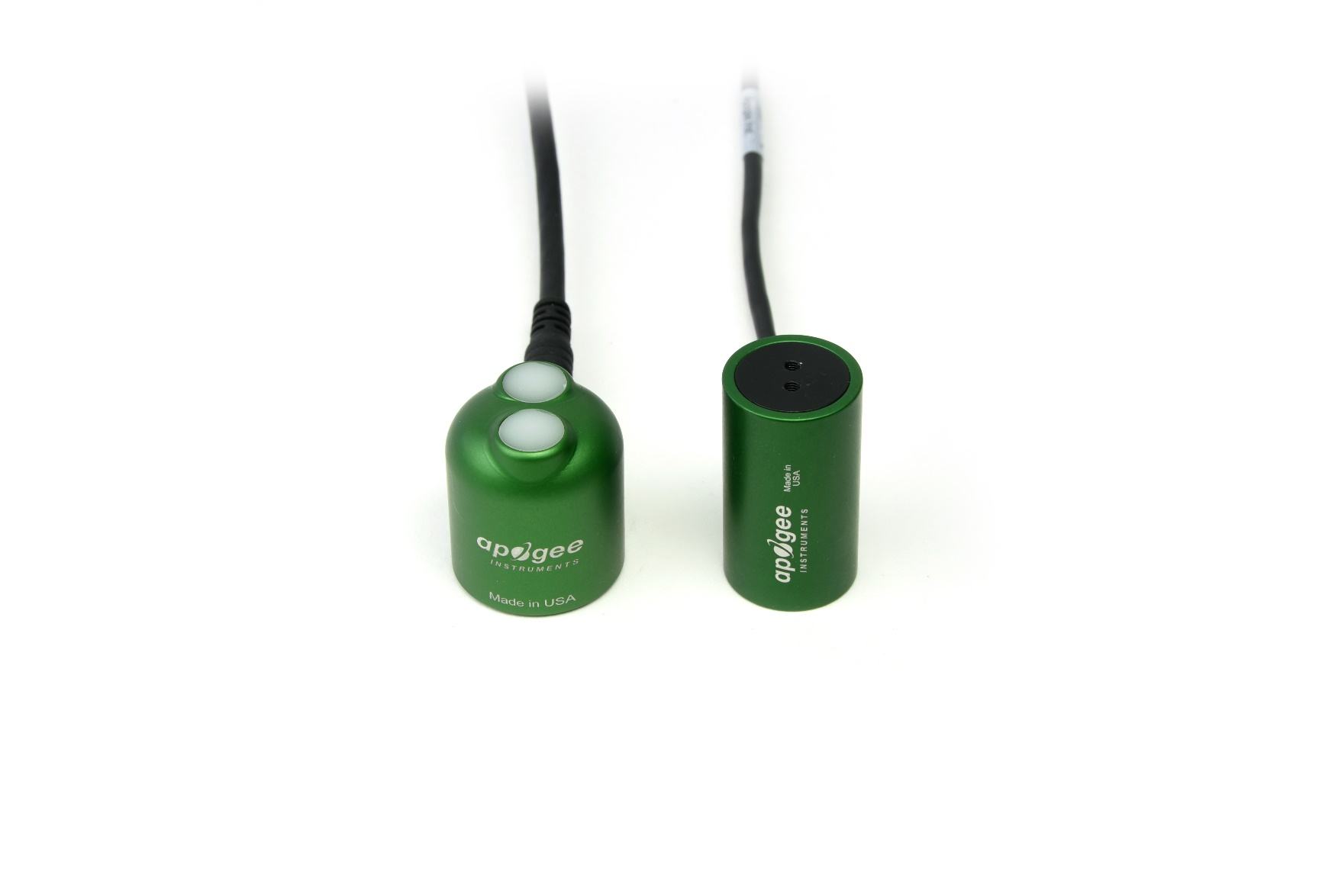

Downward (model S2-422)

Upward (model S2-421)

Table of Contents

[Owner’s Manual 1](#_Toc12355280)

[Certificate of Compliance 3](#_Toc12355281)

[Introduction 4](#_Toc12355282)

[Sensor Models 5](#_Toc12355283)

[Specifications 6](#_Toc12355284)

[Deployment and Installation 9](#_Toc12355285)

[Cable Connectors 11](#_Toc12355286)

[Operation and Measurement 12](#_Toc12355287)

[Maintenance and Recalibration 17](#_Toc12355288)

[Troubleshooting and Customer Support 18](#_Toc12355289)

[Return and Warranty Policy 19](#_Toc12355290)

### Certificate of Compliance

**EU Declaration of Conformity**

This declaration of conformity is issued under the sole responsibility of the manufacturer:

Apogee Instruments, Inc.  
721 W 1800 N  
Logan, Utah 84321  
USA

for the following product(s):

Models: S2-421, S2-422

Type: PRI Sensors

The object of the declaration described above is in conformity with the relevant Union harmonization legislation:

2014/30/EU Electromagnetic Compatibility (EMC) Directive

2011/65/EU Restriction of Hazardous Substances (RoHS 2) Directive

2015/863/EU Amending Annex II to Directive 2011/65/EU (RoHS 3)

Standards referenced during compliance assessment:

EN 61326-1:2013 Electrical equipment for measurement, control and laboratory use – EMC requirements

EN 50581:2012 Technical documentation for the assessment of electrical and electronic products with respect to the restriction of hazardous substances

Please be advised that based on the information available to us from our raw material suppliers, the products manufactured by us do not contain, as intentional additives, any of the restricted materials including lead (see note below), mercury, cadmium, hexavalent chromium, polybrominated biphenyls (PBB), polybrominated diphenyls (PBDE), bis(2-ethylhexyl) phthalate (DEHP), butyl benzyl phthalate (BBP), dibutyl phthalate (DBP), and diisobutyl phthalate (DIBP). However, please note that articles containing greater than 0.1% lead concentration are RoHS 3 compliant using exemption 6c.

Further note that Apogee Instruments does not specifically run any analysis on our raw materials or end products for the presence of these substances, but rely on the information provided to us by our material suppliers.

Signed for and on behalf of:

Apogee Instruments, November 2020



Bruce Bugbee  
President  
Apogee Instruments, Inc.

### Introduction

Radiation reflected from surfaces (e.g., plant canopies, soil) provides information about the state of the surface. Reflectance is the ratio of radiation reflected by the surface to radiation incident on the surface.

A common index calculated from reflectance measurements is photochemical reflectance index (PRI). PRI is calculated from reflectance at 531 nm (green) and 570 nm (yellow) and provides an indication of canopy photosynthetic activity.

The typical application of PRI sensors is monitoring plant canopies. PRI is related to plant canopy light use efficiency and is often used in studies of canopy photosynthesis and response to stress.

Apogee Instruments S2 series two-band sensors consist of a cast acrylic diffuser (upward-looking sensor) or acrylic window (downward-looking sensor), pair of photodiodes that measure specific wavelength ranges, signal processing circuitry mounted in an anodized aluminum housing, and a cable to connect the sensor to a measurement device. S2 series sensors are designed for continuous irradiance (upward-looking sensor) or radiance (downward-looking sensor) measurements in indoor and outdoor environments. Reflectance derived from paired upward-looking and downward-looking sensors can be used to calculate PRI.

### Sensor Models

This manual covers SDI-12 output models S2-421 and S2-422 (in bold below). Additional models are covered in their respective manuals.

|  |  |  |
| --- | --- | --- |
| Model | Signal | Description |
| S2-121 | Voltage | Measures green and yellow irradiance (upward- looking ) for PRI |
| S2-122 | Voltage | Measures green and yellow irradiance (downward- looking ) for PRI |
| S2-421 | **SDI-12** | **Measures green and yellow irradiance (upward- looking ) for PRI** |
| S2-422 | **SDI-12** | **Measures green and yellow irradiance (downward- looking ) for PRI** |

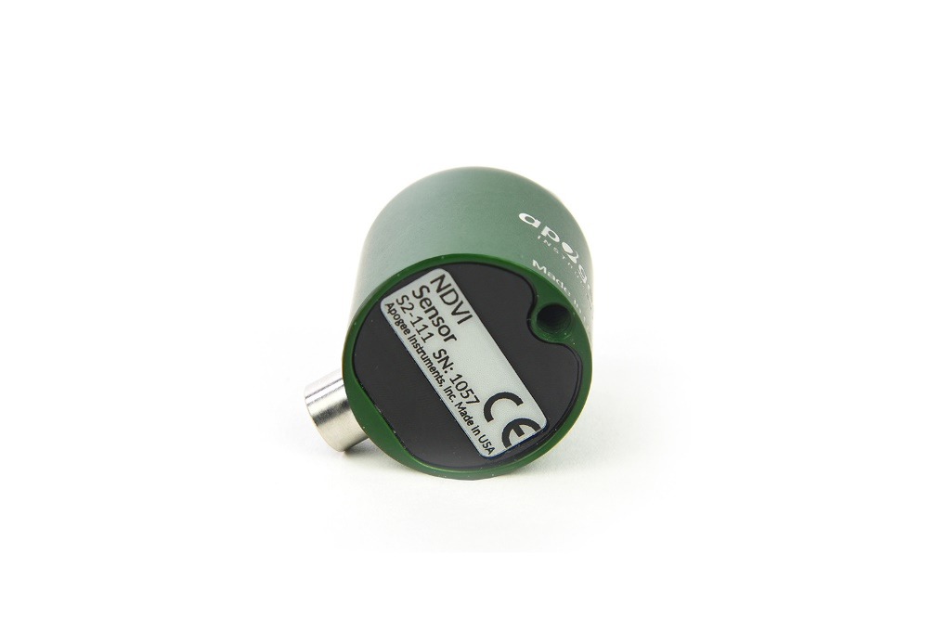

.

Upward-looking (S2-421) sensor model number and serial number are located on the bottom of the sensor. If you need the manufacturing date of your sensor, please contact Apogee Instruments with the serial number of your sensor.

Downward-looking (S2-422) sensor model number and serial number are located near the connector on the sensor cable. If you need the manufacturing date of your sensor, please contact Apogee Instruments with the serial number of your sensor.

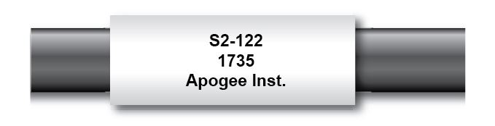

### Specifications

|  |  |  |
| --- | --- | --- |
|  | **PRI** | |
|  | **S2-421-SS**  **(upward-looking)** | **S2-422-SS**  **(downward-looking)** |
| Calibration Factor (reciprocal of sensitivity)\*\* | Custom for each sensor and stored in firmware | |
| Calibration Uncertainty | ± 5 % | |
| Output Range\*\* | SDI-12 | |
| Power Supply | 5.5 to 24 V DC | |
| Wavelength Ranges | Green detector = 532 nm with 10 nm FWHM\*  Yellow detector = 570 nm with 10 nm FWHM\* | |
| Measurement Range | 2x full sunlight | |
| Measurement Repeatability | Less than 1 % | |
| Long-term Drift | Less than 2 % per year | |
| Response Time | Less than 0.6 s | |
| Field of View | 180° | 35° |
| Directional (Cosine) Response | ± 2 % at 45°, ± 5 % at 75° zenith angle | |
| Temperature Response | Less than 0.1 % per C | |
| Housing | Anodized aluminum body with acrylic diffuser | |
| IP Rating | IP68 | |
| Operating Environment | -40 to 70 C; 0 to 100 % relative humidity | |
| Dimensions | 30.5 mm diameter, 37 mm height | 23.5 mm diameter,  43 mm height |
| Mass (with 5 m of cable) | 140 g | 110 g |
| Cable | 5 m of shielded, twisted-pair wire; TPR jacket (high water resistance, high UV stability, flexibility in cold conditions); pigtail lead wires; stainless steel (316), M8 connector | |
| \*FWHM = full-width half-maximum | | |
| \*\* The Calibration Factor (reciprocal of sensitivity) and Output Range are all approximations and variable from sensor to sensor | | |

**Calibration Traceability**

Apogee S2 series PRI sensors are calibrated through side-by-side comparison to the mean of three transfer standard sensors under a quartz halogen lamp. The transfer standard PRI sensors are calibrated through side-by-side comparison to the mean of six replicate direct and diffuse solar spectra collected in Logan, Utah, using an Apogee PS-300 spectroradiometer. The Apogee PS-300 spectroradiometer is calibrated with a quartz halogen lamp traceable to the National Institute of Standards and Technology (NIST).

**Cosine Response**

**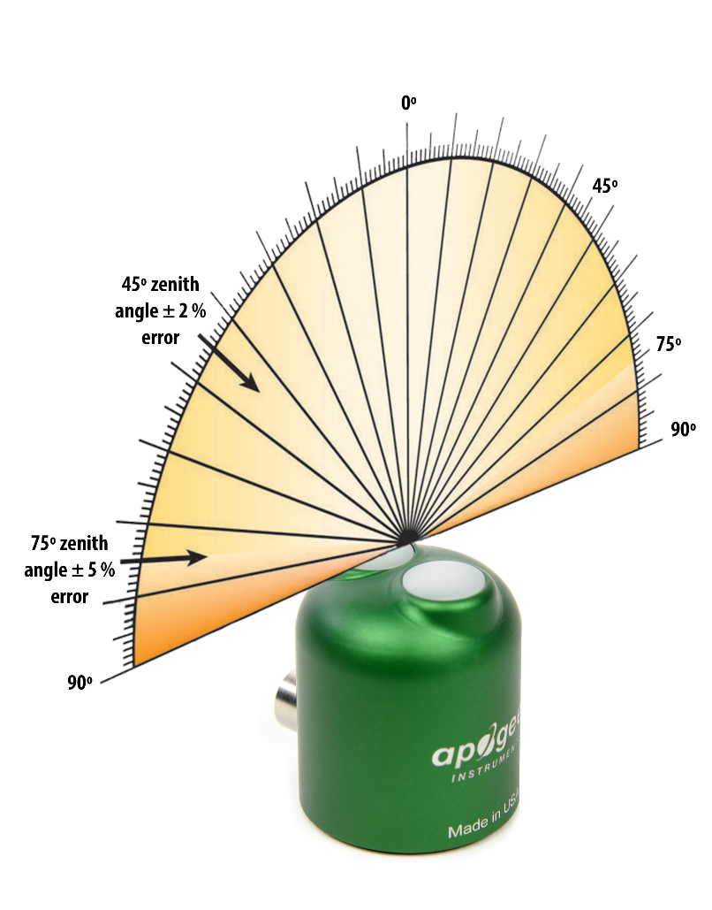**

Directional, or cosine, response is defined as the measurement error at a specific angle of radiation incidence. Error for Apogee S2 series PRI sensors is approximately ± 2 % and ± 5 % at solar zenith angles of 45° and 75°, respectively.

**Upward- and Downward-looking Two-band Sensors**

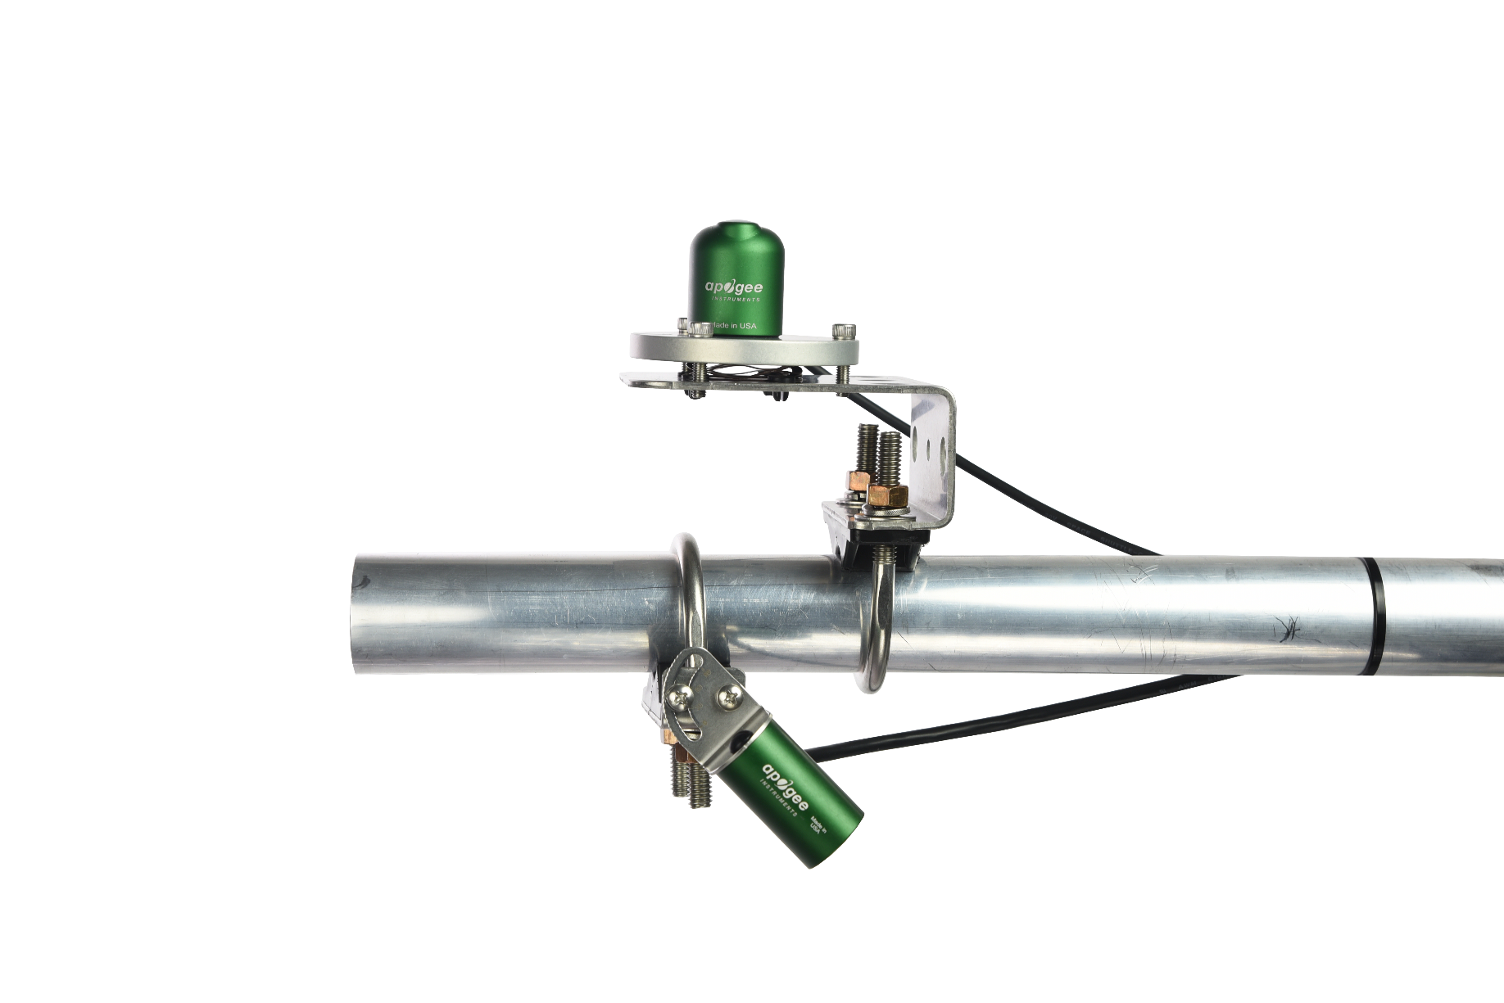

Upward (model S2-421)

Downward (model S2-422)

**Spectral Response Graph of PRI**

**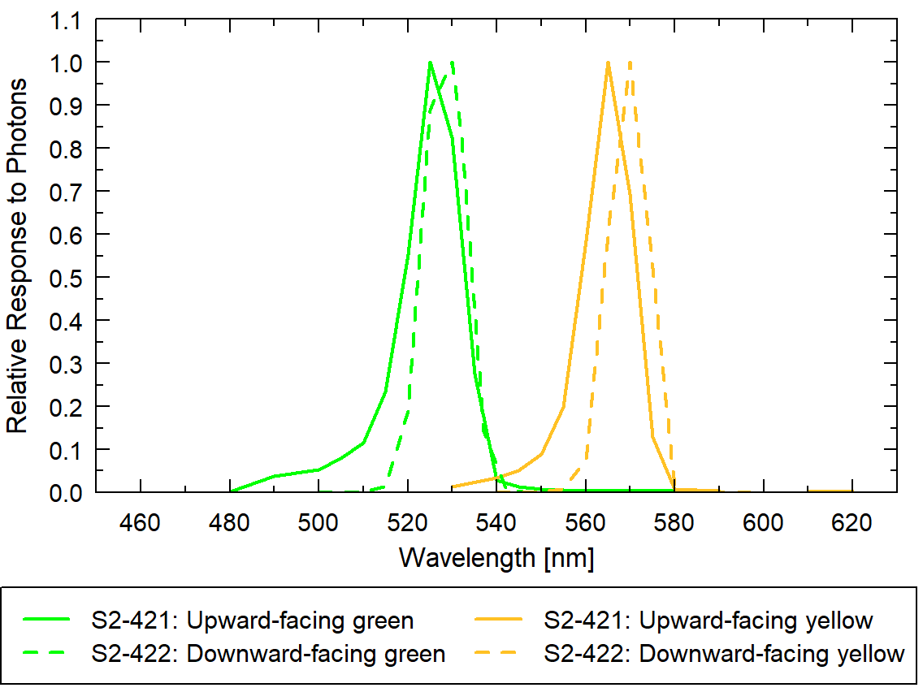**

The PRI sensors have the spectral ranges of 532 nm with 10 nm full-width half-maximum (Green) and 570 nm with 10 nm full-width half-maximum (Yellow). The spectral responses can be seen in the graph to the left.

### Deployment and Installation

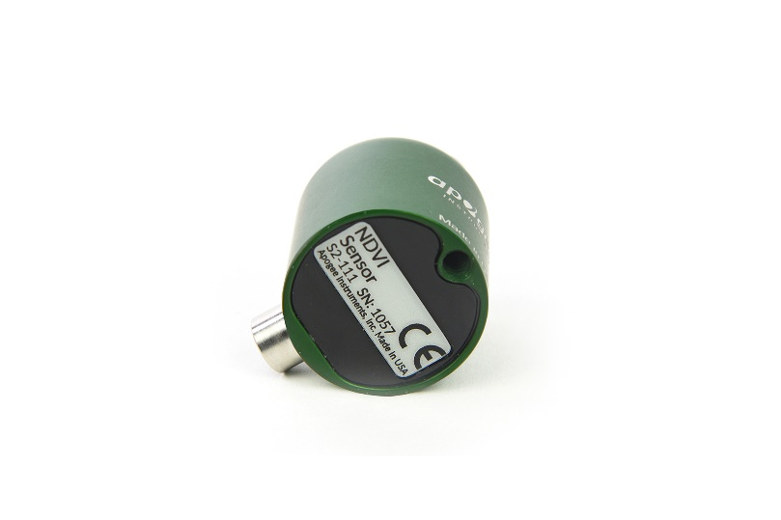Mount the upward-looking sensor to a solid surface with the nylon mounting screw provided to prevent galvanic corrosion. To accurately measure irradiance incident on a horizontal surface, the sensor must be level. An Apogee Instruments model AL-100 Leveling Plate is recommended to level the sensor when used on a flat surface or being mounted to surfaces such as wood. To facilitate mounting on a mast or pipe, the Apogee Instruments model AL-120 Solar Mounting Bracket with AL-100 Leveling Plate is recommended.

C:\Users\emyers\AppData\Local\Microsoft\Windows\INetCache\Content.Word\screw.png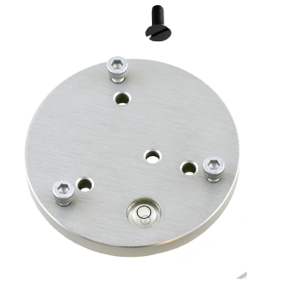

Nylon Screw: 10-32x3/8

Nylon Screw: 10-32x3/8

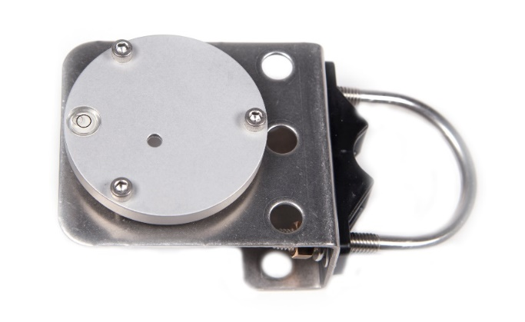

Model AL-120

Model AL-100

To minimize azimuth error, the sensor should be mounted with the cable pointing toward true north in the northern hemisphere or true south in the southern hemisphere. Azimuth error is typically less than 1 %, but it is easy to minimize by proper cable orientation.

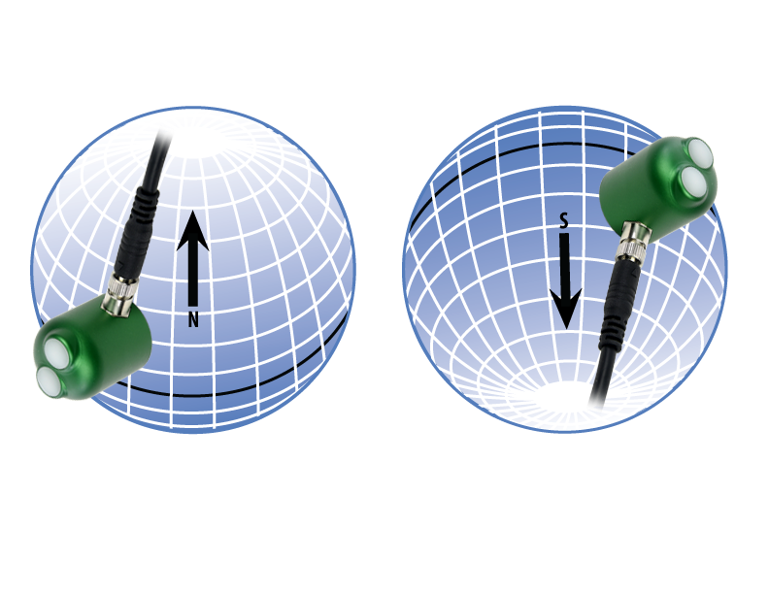

In addition to orienting the cable to point toward the nearest pole, the sensor should also be mounted such that obstructions (e.g., weather station tripod/tower or other instrumentation) do not shade the sensor. **Once mounted, the black cap should be removed from the sensor.** The green cap can be used as a protective covering for the sensor when it is not in use.

**Downward-looking sensor mounting**

Mount the sensor to a solid surface with the nylon mounting screw provided to prevent galvanic corrosion. To facilitate mounting on a mast or pipe, the Apogee Instruments model SM-400 Two Band Radiometer Downward-looking Mounting Bracket is recommended.

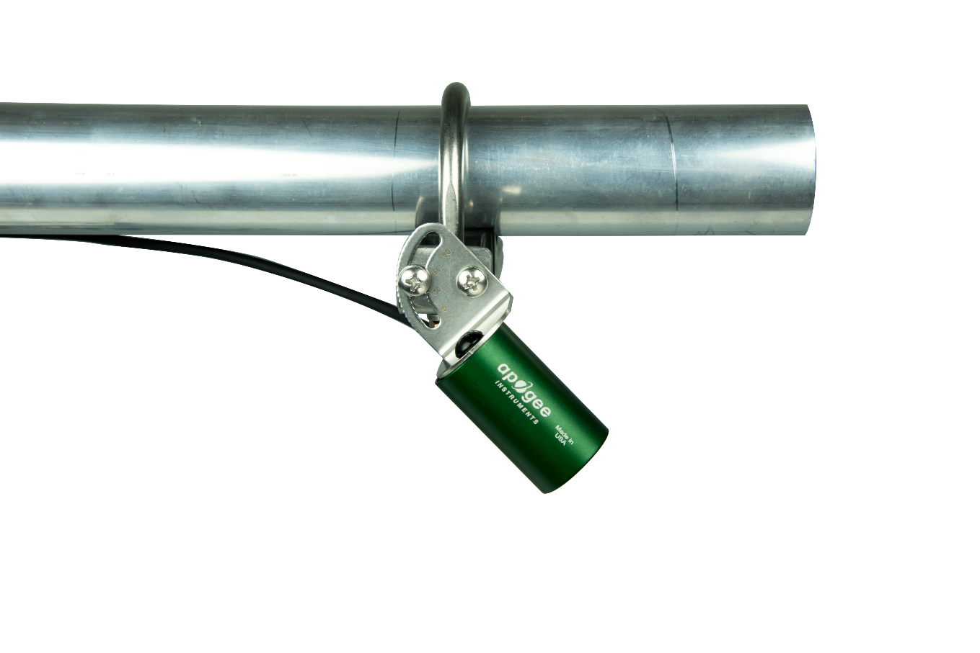

### Cable Connectors

|  |  |
| --- | --- |
| Apogee sensors offer cable connectors to simplify the process of removing sensors from weather stations for calibration (the entire cable does **not** have to be removed from the station and shipped with the sensor).  The ruggedized M8 connectors are rated IP68, made of corrosion-resistant marine-grade stainless-steel, and designed for extended use in harsh environmental conditions. | C:\Users\sadie.webster\AppData\Local\Microsoft\Windows\INetCache\Content.Word\DSC_1460.jpg  Cable connectors are attached directly to the head. |

**Instructions**

|  |  |
| --- | --- |
| **Pins and Wiring Colors:** All Apogee connectors have six pins, but not all pins are used for every sensor. There may also be unused wire colors inside the cable. To simplify datalogger connection, we remove the unused pigtail lead colors at the datalogger end of the cable.  If a replacement cable is required, please contact Apogee directly to ensure ordering the proper pigtail configuration.  **Alignment:** When reconnecting a sensor, arrows on the connector jacket and an aligning notch ensure proper orientation.  **Disconnection for extended periods:**  When disconnecting the sensor for an extended period of time from a station, protect the remaining half of the connector still on the station from water and dirt with electrical tape or other method. | A reference notch inside the connector ensures  proper alignment before tightening.C:\Users\sadie.webster\AppData\Local\Microsoft\Windows\INetCache\Content.Word\DSC_1455.jpg  When sending sensors in for calibration, only send the sensor head. |
| **Tightening:** Connectors are designed to be firmly finger-tightened only. There is an o-ring inside the connector that can be overly compressed if a wrench is used. Pay attention to thread alignment to avoid cross-threading. When fully tightened, 1-2 threads may still be visible.  **WARNING:** Do not tighten the connector by twisting the black cable or sensor head, only twist the metal connector (blue arrows). | C:\Users\sadie.webster\AppData\Local\Microsoft\Windows\INetCache\Content.Word\ndvi-warning.jpg  Finger-tighten firmly |

### Operation and Measurement

The S2-400 series two-band sensors have an SDI-12 output, where irradiance or radiance is returned in digital format. Measurement of S2-400 series two-band sensors requires a measurement device with SDI-12 functionality that includes the M or C command.

**Wiring for S2-400 series**

White: Output Signal

Red: Power in (4.5-24 V DC)

Black: Ground

Clear: Shield

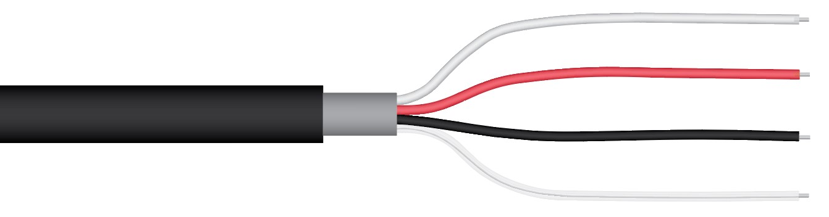

**Reflectance and Reflectance Indices (PRI)**

Reflectance (ρ) is the ratio of radiance, the calibrated signal returned by the downward-looking sensor, to irradiance, the calibrated signal returned by the upward-looking sensor, for a specific wavelength range:

** = radiance reflected from the surface / irradiance incident on the surface

Typically, a measurement of radiance is used in the numerator of the equation above to determine reflectance. Theoretically, when ρ is determined from radiance reflected from the surface it is called directional reflectance, which approximates the bidirectional reflectance factor. When ρ is determined from irradiance reflected from the surface it is called hemispherical reflectance. Both terms are referred to as reflectance herein.

PRI is calculated as the difference between reflectance at 532 nm (green) and reflectance at 570 (yellow) divided by the sum of these reflectances:

$$PRI=\frac{ρ_{Green}-ρ_{Yellow}}{ρ_{Green}+ρ_{Yellow}}$$

It is important to ensure that paired upward-looing and downward-looking sensors make measurements at the same time, otherwise temporal changes in sky conditions can result in errors in reflectance and calculated PRI values.

A single upward-looking sensor can be deployed with multiple downward-looking sensors, and irradiance from the single upward-looking sensor can be used to calculate PRI at the location of all the downward-looking sensors, if the downward-looking sensors are in close proximity to each other (e.g., within a research plot).

An approximation of PRI can also be made using only measured radiances and a value of , but this is not recommended because the difference between green and yellow radiances is small, resulting in high sensitivity of the PRI approximation to the value of .

**Sensor Calibration**

All Apogee SDI-12 S2 sensor models have sensor-specific calibration coefficients determined during the custom calibration process. Coefficients are programmed into sensor microcontrollers at the factory.

**SDI-12 Interface**

The following is a brief explanation of the serial digital interface SDI-12 protocol instructions used in Apogee S2-400 series PRI sensors. For questions on the implementation of this protocol, please refer to the official version of the SDI-12 protocol: <http://www.sdi-12.org/specification.php> (version 1.4, August 10, 2016).

**Overview**

During normal communication, the data recorder sends a packet of data to the sensor that consists of an address and a command. Then, the sensor sends a response. In the following descriptions, SDI-12 commands and responses are enclosed in quotes. The SDI-12 address and the command/response terminators are defined as follows:

**Sensors come from the factory with the address of “0” for use in single sensor systems. Address “1 to 9” and “A to Z,” or “a to z,” can be used for additional sensors connected to the same SDI-12 bus.**

“!” is the last character of a command instruction. In order to be compliant with SDI-12 protocol, all commands must be terminated with a “!”. SDI-12 language supports a variety of commands. Supported commands for the Apogee Instruments S2-400 series two-band radiometers are listed in the following table (“a” is the sensor address. The following ASCII Characters are valid addresses: “0-9” or “A-Z”). Please note that SDI-12 commands are case-sensitive.

**Supported Commands for Apogee Instruments S2-400 Series PRI Sensors**

|  |  |  |
| --- | --- | --- |
| **Instruction Name** | **Instruction Syntax** | **Description** |
| Address Query Command | ?! | Used when the address is unknown to have the sensor identify its address, all sensors on data line respond |
| Change Address Command | aAb! | Changes the sensor address from a to b |
| Acknowledge Active Command | a! | Responds if the sensor with address a is on the line |
| Send Identification Command (“I” command) | aI! | Responds with sensor information |
| Calibration Verification (“V” command) | aV! | Retrieves calibration coefficients |
| Measurement Command (“M” command) | aM! | Tells the sensor to take a measurement |
| Measurement Command w/ Check Character (“M” command) | aMC! | Tells the sensor to take a measurement and return it with a check character |
| Concurrent Measurement Command (“C” command) | aC! | Used to take a measurement when more than one sensor is used on the same data line |
| Concurrent Measurement Command w/ Check Character (“C” command) | aCC! | Used to take a measurement when more than one sensor is used on the same data line. Data is returned with a check character. |
| Get Data Command (“D” command) | aD0! | Retrieves the data from a sensor |

**Make Measurement Command: M!**

The make measurement command signals a measurement sequence to be performed. Data values generated in response to this command are stored in the sensor's buffer for subsequent collection using “D” commands. Data will be retained in sensor storage until another “M”, “C”, or “V” command is executed. M commands are shown in the following examples:

|  |  |  |
| --- | --- | --- |
| **Command** | **Response** | **Response to 0D0!** |
| aM! or aM0! | a0012<cr><If> | Returns calibrated lower wavelength output and calibrated upper wavelength output in Watts m⁻² |
| aM1! | a0012<cr><If> | Returns lower wavelength detector millivolts and upper wavelength detector millivolts |
| aM2! | a0011<cr><If> | Returns estimated PRI value from a downward-looking sensor. Returns an invalid estimated PRI value from an upward-looking sensor. (Note: this estimation is often inaccurate, therefore use of this value is discouraged. See “Get/Set Alpha Command” section for more details.) |
| aM3! | a0013<cr><If> | Returns angle offset from vertical in degrees. (0 degrees if pointed up, 180 degrees if pointed down.) |
| aMC0! | a0012<cr><If> | Returns calibrated lower wavelength output and calibrated upper wavelength output in Watts m⁻² w/ CRC |
| aMC1! | a0012<cr><If> | Returns lower wavelength detector millivolts and upper wavelength detector millivolts w/ CRC |
| aMC2! | a0011<cr><If> | Returns estimated PRI value w/CRC from a downward-looking sensor. Returns an invalid estimated PRI value w/CRC from an upward-looking sensor. (Note: this estimation is often inaccurate, therefore use of this value is discouraged. See “Get/Set Alpha Command” section for more details.) |
| aMC3! | a0013<cr><If> | Returns angle offset from vertical in degrees. (0 degrees if pointed up, 180 degrees if pointed down.) |

“<cf>” is a carriage return and “<lf>” is line feed

where a is the sensor address (“0-9”, “A-Z”, “a-z”) and M is an upper-case ASCII character.

The data values are separated by the sign “+”, as in the following example (0 is the address):

|  |  |  |
| --- | --- | --- |
| **Command** | **Sensor Response** | **Sensor Response when data is ready** |
| 0M0! | 00012<cr><lf> | 0<cr><lf> |
| 0D0! | 0+0.010+0.109<cr><lf> |  |
| 0M1! | 00012<cr><If> | 0<cr><lf> |
| 0D0! | 0+0.2858+3.3905<cr><If> |  |
| 0M2! | 00011<cr><lf> | 0<cr><lf> |
| 0D0! | 0+0.8445<cr><lf> |  |
| 0M3! | 00013<cr><If> | 0<cr><If> |
| 0D0! | 0+35.2<cr><If> |  |

where 0.010 and 0.109 are the two Watts m⁻² measurements for lower and upper wavelengths respectively, 0.2858 and 3.3905 are the two mV signals, and 0.8445 is the PRI value.

**Concurrent Measurement Command: aC!**

A concurrent measurement is one which occurs while other SDI-12 sensors on the bus are also making measurements. This command is similar to the “aM!” command, however, the nn field has an extra digit and the sensor does not issue a service request when it has completed the measurement. Communicating with other sensors will NOT abort a concurrent measurement. Data values generated in response to this command are stored in the sensor's buffer for subsequent collection using “D” commands. The data will be retained in the sensor until another “M”, “C”, or “V” command is executed:

|  |  |  |
| --- | --- | --- |
| **Command** | **Response** | **Response to 0D0!** |
| aC! or aC0! | a00102<cr><lf> | Returns calibrated lower wavelength output and calibrated upper wavelength output in Watts m⁻² |
| aC1! | a00102<cr><lf> | Returns lower wavelength detector millivolts and upper wavelength detector millivolts |
| aC2! | a00101<cr><lf> | Returns estimated PRI value from a downward-looking sensor. Returns an invalid estimated PRI value from an upward-looking sensor. (Note: this estimation is often inaccurate, therefore use of this value is discouraged. See “Get/Set Alpha Command” section for more details.) |
| aC3! | a00103<cr><lf> | Returns angle offset from vertical in degrees. (0 degrees if pointed up, 180 degrees if pointed down.) |
| aCC! or aCC0! | a00102<cr><lf> | Returns calibrated lower wavelength output and calibrated upper wavelength output in W m-2 w/CRC |
| aCC1! | a00102<cr><lf> | Returns lower wavelength detector millivolts and upper wavelength detector millivolts w/CRC |
| aCC2! | a00101<cr><lf> | Returns estimated PRI value w/CRC from a downward-looking sensor. Returns an invalid estimated PRI value w/CRC from an upward-looking sensor. (Note: this estimation is often inaccurate, therefore use of this value is discouraged. See “Get/Set Alpha Command” section for more details.) |
| aCC3! | a00103<cr><lf> | Returns angle offset from vertical in degrees. (0 degrees if pointed up, 180 degrees if pointed down.) w/CRC |

where a is the sensor address (“0-9”, “A-Z”, “a-z”, “\*”, “?”) and C is an upper-case ASCII character.

For example (0 is the address):

|  |  |
| --- | --- |
| **Command** | **Sensor Response** |
| 0C0! | 000102<cr><If> |
| 0D0! | 0+0.010+0.109<cr><If> |
| 0C1! | 000102<cr><lf> |
| 0D0! | 0+0.2858+3.3905<cr><lf> |
| 0C2! | 000101<cr><lf> |
| 0D0! | 0+0.8445<cr><lf> |
| 0C3! | 000103<cr><If> |
| 0D0! | 0+35.2<cr><If> |

Where 0.010 and 0.109 are the two Watts m⁻² measurements for lower and upper wavelengths respectively, 0.2858 and 3.3905 are the two mV signals, and 0.8445 is the PRI value.

**Change Sensor Address: aAb!**

The change sensor address command allows the sensor address to be changed. If multiple SDI-12 devices are on the same bus, each device will require a unique SDI-12 address. For example, two SDI-12 sensors with the factory address of 0 requires changing the address on one of the sensors to a non-zero value in order for both sensors to communicate properly on the same channel:

|  |  |  |
| --- | --- | --- |
| **Command** | **Response** | **Description** |
| aAb! | b<cr><lf> | Change the address of the sensor (see example below) |

where a is the current (old) sensor address (“0-9”, “A-Z”), A is an upper-case ASCII character denoting the instruction for changing the address, b is the new sensor address to be programmed (“0-9”, “A-Z”), and ! is the standard character to execute the command. If the address change is successful, the datalogger will respond with the new address and a <cr><lf>.

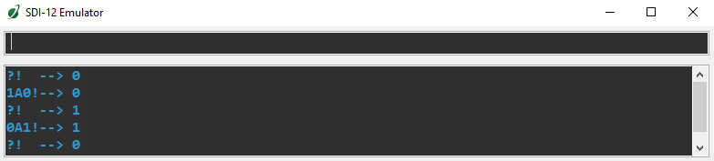

**Send Identification Command: aI!**

The send identification command responds with sensor vendor, model, and version data. Any measurement data in the sensor's buffer is not disturbed:

|  |  |  |
| --- | --- | --- |
| **Command** | **Response** | **Description** |
| "aI!" | a14Apogee S2-421vvvxx…xx<cr><lf> | The sensor serial number and other identifying values are returned |

where a is the sensor address (“0-9”, “A-Z”, “a-z”, “\*”, “?”), 421 is the sensor model number, vvv is a three character field specifying the sensor version number, and xx...xx is serial number.

**Get/Set Alpha Command: aXALPHA! and aXALPHA+<alpha>!**

The get/set alpha ( command is used to get or set  the estimated ratio of incoming yellow to green irradiance. This ratio is used in the “aM2!” command to provide an estimated PRI value from downward-facing PRI measurements alone (see “Reflectance and Reflectance Indices (PRI)” section above). The alpha value can substitute for direct measurements of incoming yellow and green irradiance when an upward-facing sensor is not available. This value is usually about 0.95 under clear sky conditions, but there is some variability with solar zenith angle. The alpha value declines as cloudiness increases. The default alpha value from the factory is 1.35. The alpha value and the “aM2!” command provide an estimated PRI value, but the estimation is dependent on an accurate value for . Small changes in  can produce large swings in estimated PRI. For the most precise PRI measurements paired upward and downward-facing sensors should be used to directly measure both incoming irradiance values and reflected radiance values.

|  |  |  |
| --- | --- | --- |
| **Command** | **Response** | **Description** |
| "aXALPHA!" | a<alpha value><cr><lf> | The current alpha value used for estimating PRI is returned. |
| "aXALPHA+<alpha>!" | a<cr><lf> | Sets the current alpha value used for estimating PRI. |

s

### Maintenance and Recalibration

Blocking of the optical path between the target and detector can cause low readings. Occasionally, accumulated materials on the diffuser of the upward-looking sensor and in the apertures of the downward-looking sensor can block the optical path in three common ways:

1. Moisture or debris on the diffuser (upward-looking) or in the apertures (downward-looking).
2. Dust during periods of low rainfall.
3. Salt deposit accumulation from evaporation of sea spray or sprinkler irrigation water.

Apogee Instruments upward-looking sensors have a domed diffuser and housing for improved self-cleaning from rainfall but active cleaning may be necessary. Dust or organic deposits are best removed using water, or window cleaner, and a soft cloth or cotton swab. Salt deposits should be dissolved with vinegar and removed with a cloth or cotton swab. **Salt deposits cannot be removed with solvents such as alcohol or acetone.** Use only gentle pressure when cleaning the diffuser with a cotton swab or soft cloth, to avoid scratching the outer surface. The solvent should be allowed to do the cleaning, not mechanical force. **Never use an abrasive material or cleaner on the diffuser**.

It is recommended that two-band sensors be recalibrated every two years. See the Apogee webpage for details regarding return of sensors for recalibration (<http://www.apogeeinstruments.com/tech-support-recalibration-repairs/>).

### Troubleshooting and Customer Support

**Independent Verification of Functionality**

The simplest way to check sensor functionality is the aM2! command. This command returns calibrated outputs from each detector. Detector temperature should read very near room temperature. When the diffuser or aperture of the sensor is covered (no incident radiation), the outputs should read very near 0 Watts m⁻² nm-1 (irradiance) or 0 Watts m⁻² nm-1 sr-1 (radiance). When illuminated, the sensors should return positive values, with irradiance near 1 Watts m⁻² nm-1 for sunlight on a clear day.

If the sensor does not communicate with the datalogger, use an ammeter to check the current draw. It should be near 1.5 mA when the sensor is not communicating and spike to approximately 2 mA when the sensor is communicating. Any current draw greater than approximately 6 mA indicates a problem with power supply to the sensors, wiring of the sensor, or sensor electronics.

**Compatible Measurement Devices (Dataloggers/Controllers/Meters)**

Any datalogger or meter with SDI-12 functionality that includes the M or C command.

Example datalogger programs for Campbell Scientific dataloggers can be found on the Apogee webpage at: <https://www.apogeeinstruments.com/content/PRI-Digital.CR1>

**Modifying Cable Length**

SDI-12 protocol limits cable length to 60 meters. For multiple sensors connected to the same data line, the maximum is 600 meters of total cable (e.g., ten sensors with 60 meters of cable per sensor). See Apogee webpage for details on how to extend sensor cable length at <https://www.apogeeinstruments.com/how-to-make-a-weatherproof-cable-splice/>.

### Return and Warranty Policy

RETURN POLICY

Apogee Instruments will accept returns within 30 days of purchase as long as the product is in new condition (to be determined by Apogee). Returns are subject to a 10 % restocking fee.

WARRANTY POLICY

**What is Covered**All products manufactured by Apogee Instruments are warranted to be free from defects in materials and craftsmanship for a period of four (4) years from the date of shipment from our factory. To be considered for warranty coverage an item must be evaluated by Apogee.

Products not manufactured by Apogee (spectroradiometers, chlorophyll content meters, EE08-SS probes) are covered for a period of one (1) year.

**What is Not Covered**The customer is responsible for all costs associated with the removal, reinstallation, and shipping of suspected warranty items to our factory.

The warranty does not cover equipment that has been damaged due to the following conditions:

1. Improper installation or abuse.

2. Operation of the instrument outside of its specified operating range.

3. Natural occurrences such as lightning, fire, etc.

4. Unauthorized modification.

5. Improper or unauthorized repair.

Please note that nominal accuracy drift is normal over time. Routine recalibration of sensors/meters is considered part of proper maintenance and is not covered under warranty.

**Who is Covered**This warranty covers the original purchaser of the product or other party who may own it during the warranty period.

**What Apogee Will Do**At no charge Apogee will:

1. Either repair or replace (at our discretion) the item under warranty.

2. Ship the item back to the customer by the carrier of our choice.

Different or expedited shipping methods will be at the customer’s expense.

**How To Return An Item**1. Please do not send any products back to Apogee Instruments until you have received a Return Merchandise Authorization (RMA) number from our technical support department by submitting an online RMA form at [www.apogeeinstruments.com/tech-support-recalibration-repairs/](http://www.apogeeinstruments.com/tech-support-recalibration-repairs/). We will use your RMA number for tracking of the service item. Call (435) 245-8012 or email techsupport@apogeeinstruments.com with questions.

2. For warranty evaluations, send all RMA sensors and meters back in the following condition: Clean the sensor’s exterior and cord. Do not modify the sensors or wires, including splicing, cutting wire leads, etc. If a connector has been attached to the cable end, please include the mating connector – otherwise the sensor connector will be removed in order to complete the repair/recalibration. ***Note:*** *When sending back sensors for routine calibration that have Apogee’s standard stainless-steel connectors, you only need to send the sensor with the 30 cm section of cable and one-half of the connector. We have mating connectors at our factory that can be used for calibrating the sensor.*

3. Please write the RMA number on the outside of the shipping container.

4. Return the item with freight pre-paid and fully insured to our factory address shown below. We are not responsible for any costs associated with the transportation of products across international borders.

**Apogee Instruments, Inc.   
721 West 1800 North Logan, UT  
84321, USA**

5. Upon receipt, Apogee Instruments will determine the cause of failure. If the product is found to be defective in terms of operation to the published specifications due to a failure of product materials or craftsmanship, Apogee Instruments will repair or replace the items free of charge. If it is determined that your product is not covered under warranty, you will be informed and given an estimated repair/replacement cost.

Products Beyond the Warranty Period

For issues with sensors beyond the warranty period, please contact Apogee at [techsupport@apogeeinstruments.com](mailto:techsupport@apogeeinstruments.com) to discuss repair or replacement options.

Other Terms

The available remedy of defects under this warranty is for the repair or replacement of the original product, and Apogee Instruments is not responsible for any direct, indirect, incidental, or consequential damages, including but not limited to loss of income, loss of revenue, loss of profit, loss of data, loss of wages, loss of time, loss of sales, accruement of debts or expenses, injury to personal property, or injury to any person or any other type of damage or loss.

This limited warranty and any disputes arising out of or in connection with this limited warranty ("Disputes") shall be governed by the laws of the State of Utah, USA, excluding conflicts of law principles and excluding the Convention for the International Sale of Goods. The courts located in the State of Utah, USA, shall have exclusive jurisdiction over any Disputes.

This limited warranty gives you specific legal rights, and you may also have other rights, which vary from state to state and jurisdiction to jurisdiction, and which shall not be affected by this limited warranty. This warranty extends only to you and cannot by transferred or assigned. If any provision of this limited warranty is unlawful, void or unenforceable, that provision shall be deemed severable and shall not affect any remaining provisions. In case of any inconsistency between the English and other versions of this limited warranty, the English version shall prevail.

This warranty cannot be changed, assumed, or amended by any other person or agreement

**APOGEE INSTRUMENTS, INC. |** 721 WEST 1800 NORTH, LOGAN, UTAH 84321, USA

TEL: (435) 792-4700 | FAX: (435) 787-8268 | WEB: APOGEEINSTRUMENTS.COM

*Copyright © 2020 Apogee Instruments, Inc.*