

# Owner’s Manual

PAR-Far Sensor

Models S2-141  
Rev: 31-Mar-2022

­­

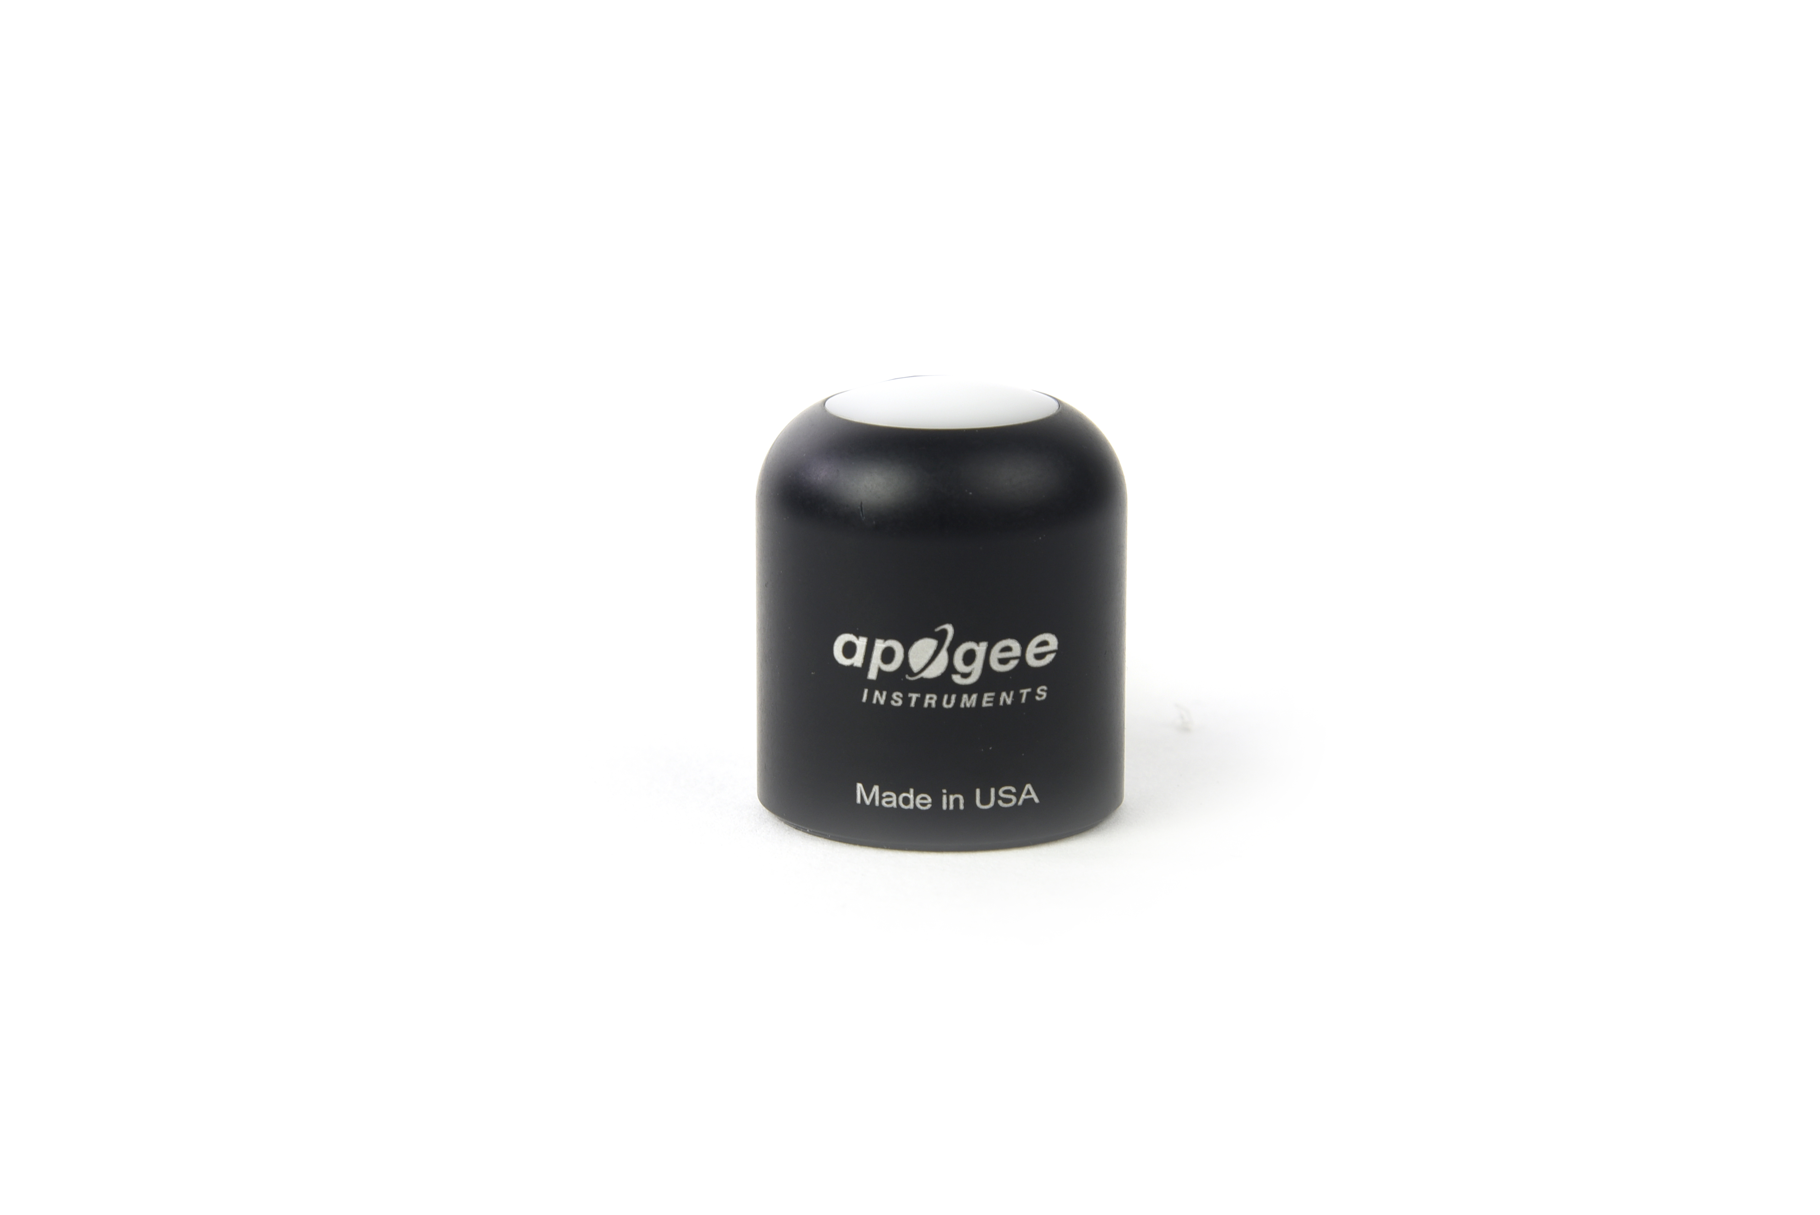

Table of Contents

Owner’s Manual 1

Certificate of Compliance 3

Introduction 4

Sensor Models 5

Specifications 6

Deployment and Installation 9

Cable Connectors 10

Operation and Measurement 11

Maintenance and Recalibration 15

Troubleshooting and Customer Support 17

Return and Warranty Policy 18

### Certificate of Compliance

**EU Declaration of Conformity**

This declaration of conformity is issued under the sole responsibility of the manufacturer:

Apogee Instruments, Inc.  
721 W 1800 N  
Logan, Utah 84321  
USA

for the following product(s):

Models: S2-141  
Type: PAR-FAR Sensor

The object of the declaration described above is in conformity with the relevant Union harmonization legislation:

2014/30/EU Electromagnetic Compatibility (EMC) Directive

2011/65/EU Restriction of Hazardous Substances (RoHS 2) Directive

2015/863/EU Amending Annex II to Directive 2011/65/EU (RoHS 3)

Standards referenced during compliance assessment:

EN 61326-1:2013 Electrical equipment for measurement, control, and laboratory use – EMC requirements

EN 50581:2012 Technical documentation for the assessment of electrical and electronic products with respect to the restriction of hazardous substances

Please be advised that based on the information available to us from our raw material suppliers, the products manufactured by us do not contain, as intentional additives, any of the restricted materials including lead (see note below), mercury, cadmium, hexavalent chromium, polybrominated biphenyls (PBB), polybrominated diphenyls (PBDE), bis (2-ethylhexyl) phthalate (DEHP), butyl benzyl phthalate (BBP), dibutyl phthalate (DBP), and diisobutyl phthalate (DIBP). However, please note that articles containing greater than 0.1 % lead concentration are RoHS 3 compliant using exemption 6c.

Further note that Apogee Instruments does not specifically run any analysis on our raw materials or end products for the presence of these substances, but we rely on the information provided to us by our material suppliers.

Signed for and on behalf of:

Apogee Instruments, March 2022



Bruce Bugbee  
President  
Apogee Instruments, Inc.

### Introduction

Specific wavelengths of radiation trigger distinct plant responses. Radiation that drives photosynthesis is called photosynthetically active radiation (PAR) and is typically defined as total radiation across a wavelength range of 400 to 700 nm. PAR is almost universally quantified as photosynthetic photon flux density (PPFD), the sum of photons from 400 to 700 nm in units of micromoles per square meter per second (µmol m-2 s-1, equal to microEinsteins m-2 s-1). While microEinsteins and micromoles are equal (one Einstein = one mole of photons), the Einstein is not an SI unit, so expressing PPFD as µmol m-2 s-1 is preferred. Daily total PPFD is typically reported in units of moles of photons per square meter per day (mol m-2 d-1) and is often called daily light integral (DLI).

The acronym PPF is also used and refers to the photosynthetic photon flux. The acronyms PPF and PPFD refer to the same variable. Both terms are used because there is not a universal definition of the term flux. Flux is sometimes defined as per unit area per unit time and sometimes defined as per unit time only. PPFD is used in this manual.

In addition to wavelengths within the PAR range, far-red wavelengths (those just beyond 700 nm) are of particular interest because they influence plant photosynthetic and morphogenic activity. Phytochrome pigments sensitive to varying ratios of red and far-red light provide information to the plant about the light environment, and therefore, influence growth patterns. Increasing the fraction of PAR, and specifically red radiation, relative to far-red radiation indicates less shading and generally results in more conservative vertical growth patterns. Increasing far-red radiation relative to PAR indicates more shading and results in more aggressive vertical growth patterns.

Sensors that measure PPFD are often called quantum sensors because they measure the number of incident photosynthetic photons, and one photon is a single quantum of radiation. Far-red sensors are similar in that they measure incident photons, but the wavelength range is different. Far-red sensors can be thought of as quantum sensors that measure radiation just beyond 700 nm. Sensors that pair detectors to measure both PPFD and far-red photon flux density can be called PAR-FAR sensors.

The primary application of PAR-FAR sensors is monitoring plant light environments, including calculation of the far-red fraction (far-red photon flux density / sum of PPFD and far-red photon flux density), in photobiology studies (e.g., researching plant morphogenic activity).

Apogee Instruments model S2-141 PAR-FAR sensors consist of a cast acrylic diffuser, pair of photodetectors that measure PAR and far-red wavelength ranges (400-700 nm for PAR, 700-760 nm for far-red), and signal processing circuitry mounted in an anodized aluminum housing, and a cable to connect the radiometer measurement device is also included. Sensors are designed for continuous measurement in indoor and outdoor environments. Model S2-141 sensors output two voltages, one from each photodetector, that are directly proportional to the radiation incident on a planar surface (does not have to be horizontal), where the radiation emanates from all angles of a hemisphere.

### Sensor Models

This manual covers the analog output PAR-FAR sensor, model S2-141 (listed in bold below). Additional models are covered in their respective manuals.

|  |  |
| --- | --- |
| Model | Signal |
| S2-141 | **0-40 mV** |
| S2-441 | SDI-12 |
| S2-442 | Modbus |

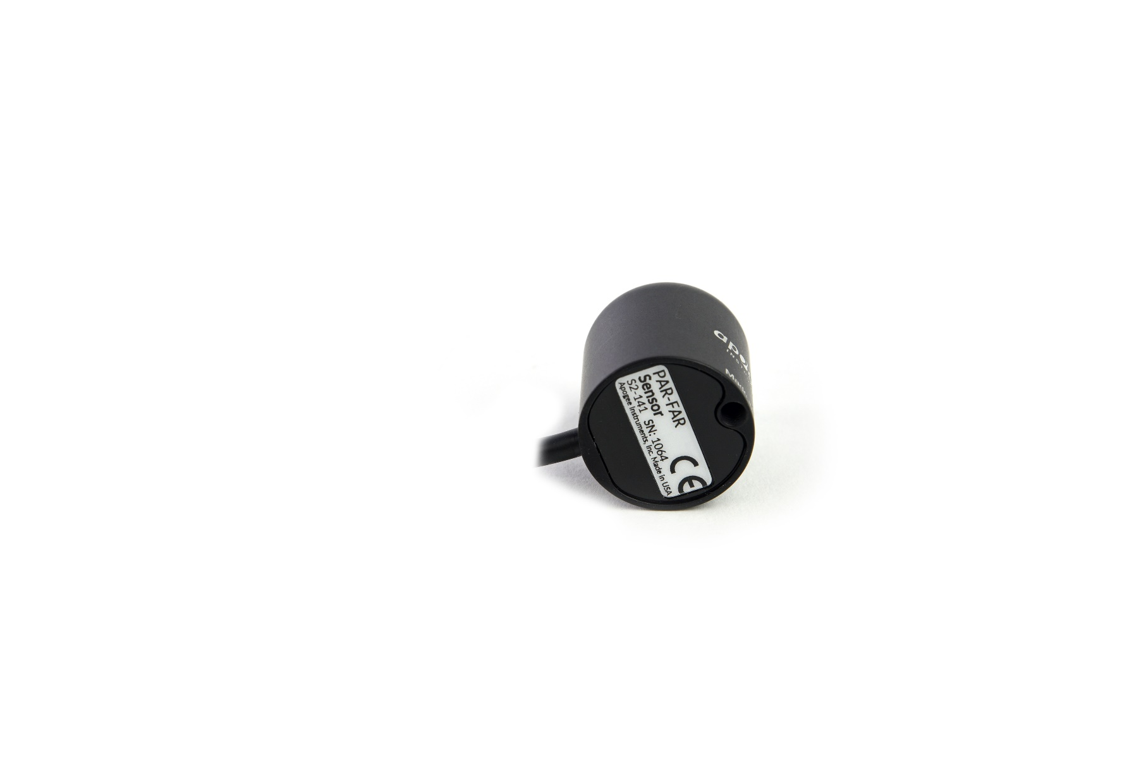

A sensor’s model number and serial number are located on the bottom of the sensor. If the manufacturing date of a specific sensor is required, please contact Apogee Instruments with the serial number of the sensor.

### Specifications

|  |  |
| --- | --- |
|  | **S2-141** |
| Power Supply | Self-powered |
| *Output (sensitivity) | 0.01 mV per µmol m⁻² s⁻¹ (PAR)  0.02 mV per µmol m⁻² s⁻¹ (Far-red) |
| *Calibration Factor (reciprocal of sensitivity) | 100 µmol m⁻² s⁻¹ per mV (PAR)  50 µmol m⁻² s⁻¹ per mV (Far-red) |
| Calibration Uncertainty | ± 5 % |
| *Output Range | 0 to 40 mV (PAR)  0 to 20 mV (Far-red) |
| Measurement Repeatability | Less than 1 % |
| Long-term Drift | Less than 2 % per year |
| Non-linearity | Less than 1 % (up to 4000 µmol m⁻² s⁻¹) (PAR)  Less than 1 % (up to 1000 µmol m⁻² s⁻¹) (Far-red) |
| Response Time | Less than 1 ms |
| Field of View | 180° |
| Spectral Ranges | 389 to 692 nm ± 5 nm (PAR)  702 to 761 nm ± 5 nm (Far-red) |
| Directional (Cosine) Response | ± 2 % at 45°; ± 5 % at 75° zenith angle |
| Temperature Response | Less than 0.1 % per C |
| Housing | Anodized aluminum body with acrylic diffuser |
| IP Rating | IP68 |
| Operating Environment | -40 to 70 C; 0 to 100 % relative humidity |
| Dimensions | 30.5 mm diameter, 37 mm height |
| Mass (with 5 m of cable) | 140 g |
| Cable | 5 m of shielded, twisted-pair wire; TPR jacket (high water resistance, high UV stability, flexibility in cold conditions); pigtail lead wires; stainless steel (316), M8 connector |
| *The Output, Calibration Factor, and Output Range are variable from sensor to sensor, and the specifications listed are typical values. | |

**Calibration Traceability**

The PAR sensor in Apogee S2 series PAR-FAR sensors is calibrated through side-by-side comparison to the mean of four transfer standard quantum sensors under a reference lamp. The transfer standard quantum sensors are calibrated with a quartz halogen lamp traceable to the National Institute of Standards and Technology (NIST).

The far-red sensor in Apogee S2 series PAR-FAR sensors is calibrated through side-by-side comparison to the mean photon flux density of four transfer standard far-red radiometers under far-red LEDs (735 nm peak, 710-760 nm range). The transfer standard far-red sensors are calibrated against a spectroradiometer (Apogee Instruments model PS-300) under the same far-red LEDs. The spectroradiometer is calibrated with a quartz halogen lamp traceable to the National Institute of Standards and Technology (NIST).

**Directional (Cosine) Response**

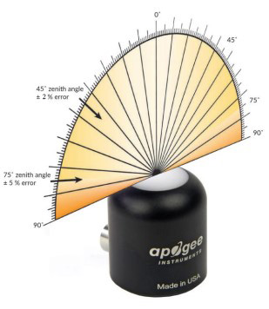

Directional (cosine) response is defined as the measurement error at a specific angle of radiation incidence. Error for Apogee S2 series PAR-FAR sensors is approximately ± 2 % and ± 5 % at solar zenith angles of 45° and 75°, respectively.

Mean directional (cosine) response of seven apogee PAR-FAR sensors. Directional response measurements were made on the rooftop of the Apogee building in Logan, Utah. Directional response was calculated as the relative difference of PAR-FAR sensors from the mean of replicate PAR detectors (LI-COR models LI-190 and LI-190R, Kipp & Zonen model PQS 1). Data were also collected in the laboratory using a reference lamp and positioning the sensor at varying angles.

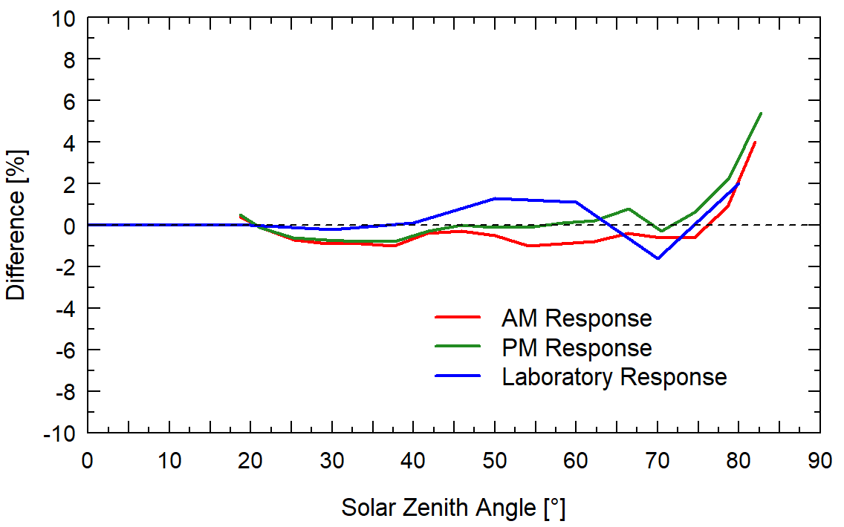

**Spectral Response**

Spectral response of PAR detector (blue) and Far-red detector (red) compared to the defined response of plants to photons (dashed).

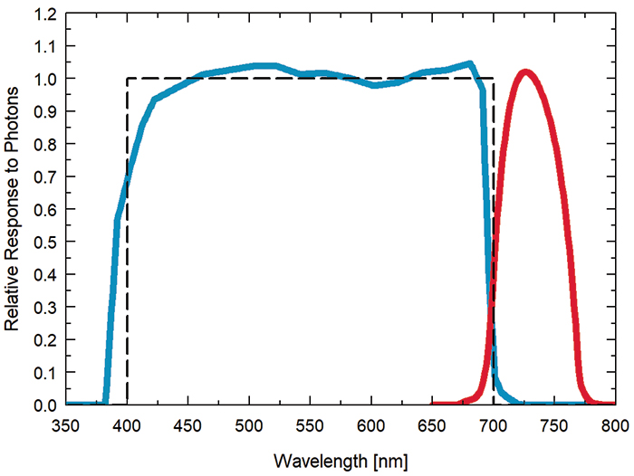

### Deployment and Installation

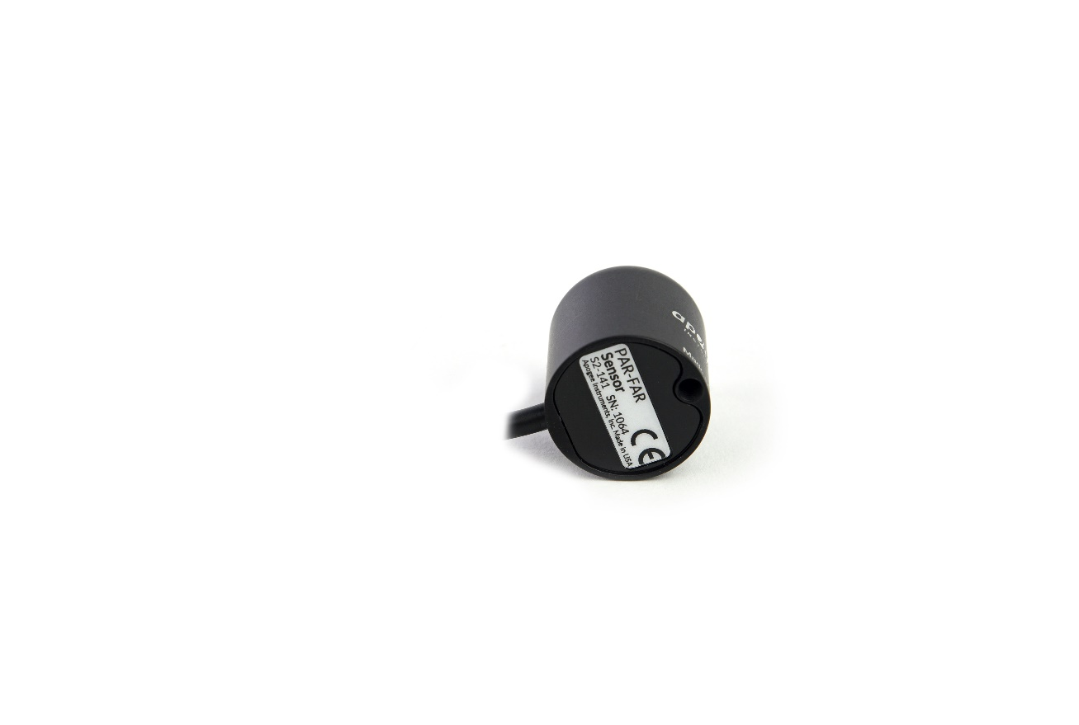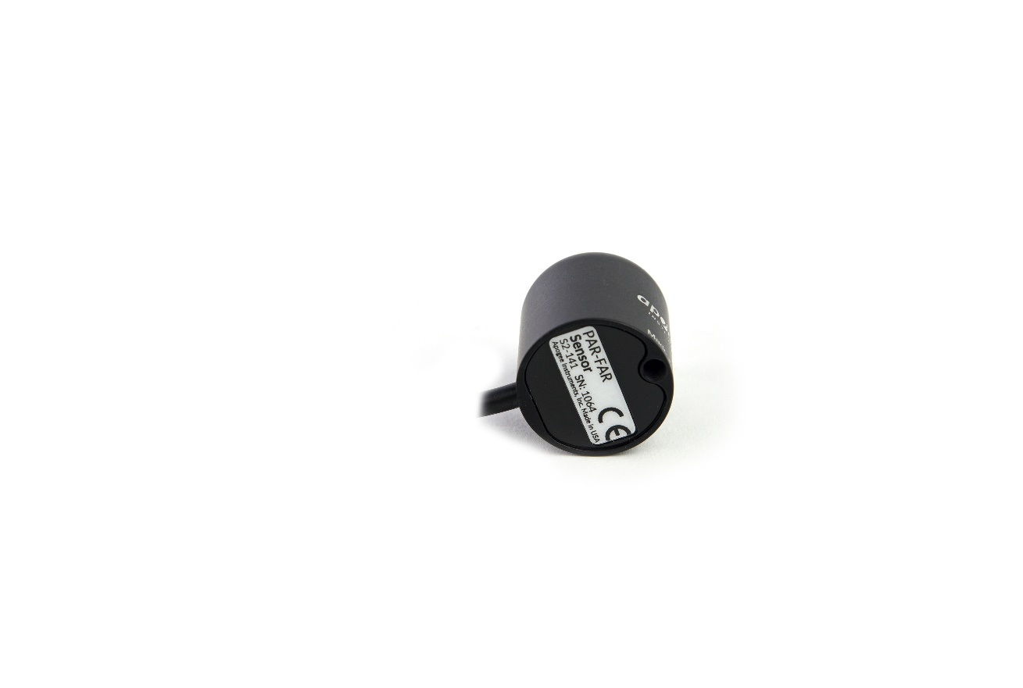Mount the sensor to a solid surface with the nylon mounting screw provided. To accurately measure PPFD incident on a horizontal surface, the sensor must be level. An Apogee Instruments model AL-100 leveling plate is recommended for this purpose. To facilitate mounting on a cross arm, an Apogee Instruments model AM-110 mounting bracket is recommended.

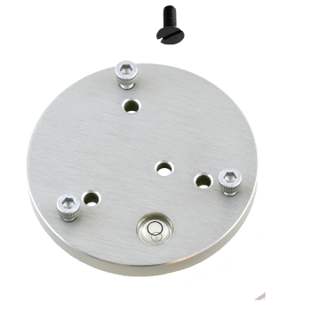

Nylon Screw: 10-32 x 3/8

Nylon Screw: 10-32 x 3/8

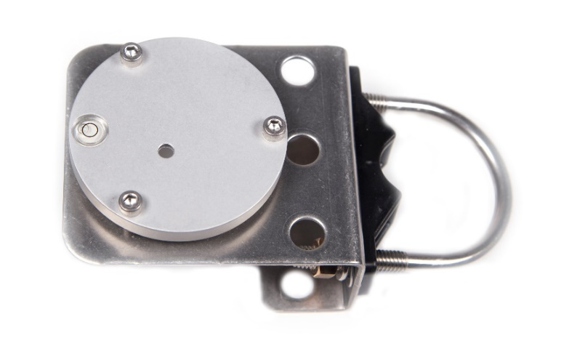C:\Users\emyers\AppData\Local\Microsoft\Windows\INetCache\Content.Word\screw.png

Model: AL-120

Model: AL-110

To minimize azimuth error, the sensor should be mounted with the cable pointing toward true north in the northern hemisphere or true south in the southern hemisphere. Azimuth error is typically less than 0.5 %, but it is easy to minimize by proper cable orientation.

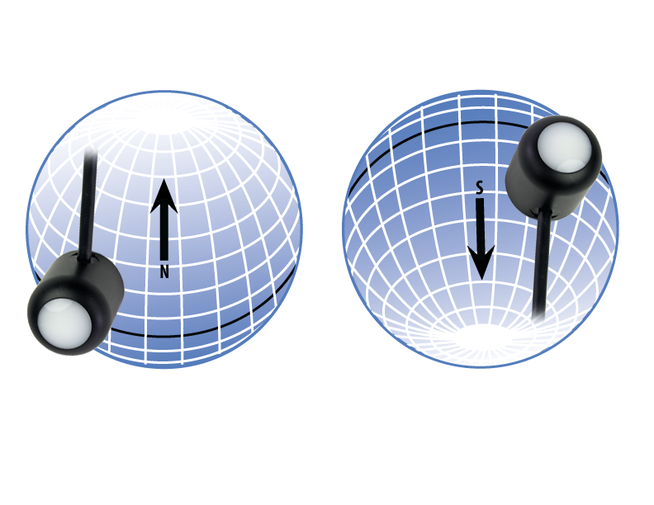

In addition to orienting the cable to point toward the nearest pole, the sensor should also be mounted such that obstructions (e.g., weather station tripod/tower or other instrumentation) do not shade the sensor. **Once mounted, the green cap should be removed from the sensor.** The green cap can be used as a protective covering for the sensor when it is not in use.

### Cable Connectors

|  |  |
| --- | --- |
| Apogee sensors offer cable connectors to simplify the process of removing sensors from weather stations for calibration (the entire cable does **not** have to be removed from the station and shipped with the sensor).  The ruggedized M8 connectors are rated IP68, made of corrosion-resistant marine-grade stainless-steel, and designed for extended use in harsh environmental conditions. | Inline cable connectors are installed 30 cm from the sensor head (pyranometer pictured). |

**Instructions**

|  |  |
| --- | --- |
| **Pins and Wiring Colors:** All Apogee connectors have six pins, but not all pins are used for every sensor. There may also be unused wire colors inside the cable. To simplify connection to a measurement device, the unused pigtail lead wire colors are removed.  If a replacement cable is required, please contact Apogee directly to ensure ordering the proper pigtail configuration.  **Alignment:** When reconnecting a sensor, arrows on the connector jacket and an aligning notch ensure proper orientation.  **Disconnection for extended periods:**  When disconnecting the sensor for an extended period of time from an installation, protect the remaining half of the connector still on the station from water and dirt with electrical tape or other method. | A reference notch inside the connector ensures  proper alignment before tightening.    When sending sensors back for recalibration, only send the section of cable that is hard-wired to the sensor. The section of cable with the pigtail is not required. |
| **Tightening:** Connectors are designed to be firmly finger-tightened only. There is an O-ring inside the connector that can be overly compressed if a wrench is used. Pay attention to thread alignment to avoid cross-threading. When fully tightened, one to two threads may still be visible.  **WARNING:** Do **not** tighten the connector by twisting the black cable, only twist the metal connector. | Finger-tighten firmly. |

### Operation and Measurement

Connect the sensor to a measurement device (meter, datalogger, controller) capable of measuring and displaying or recording a millivolt signal (an input measurement range of approximately 0-150 mV is required to cover the entire range of illuminance from the sun). In order to maximize measurement resolution and signal-to-noise ratio, the input range of the measurement device should closely match the output range of the quantum sensor. **DO NOT connect the sensor to a power source. The sensor is self-powered and applying voltage will damage the sensor.**

**Wiring for S2-141**

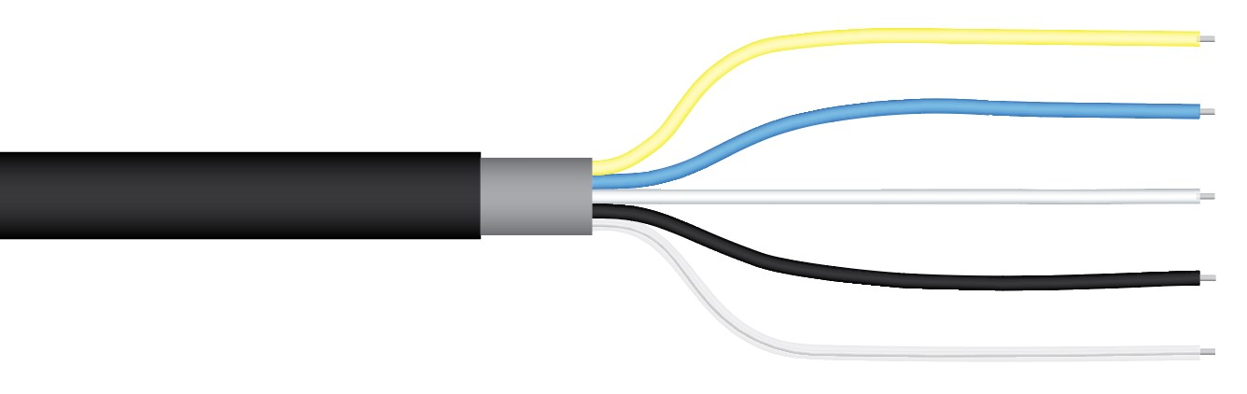

**Yellow:** Positive (signal from PAR sensor)

**Blue:** Negative (signal from PAR sensor)

**White:** Positive (signal from Far-red sensor)

**Black:** Negative (signal from Far-red sensor)

**Clear:** Shield

**Sensor Calibration**

The Apogee unamplified PAR-FAR sensor model S2-141 has approximate calibration factors of:

**100 mol m-2 s-1 per mV for PAR**

**50 mol m-2 s-1 per mV for Far-red**

Multiply the calibration factors by the measured voltages to convert sensor outputs to PPFD and far-red photon flux density (PFD) in units of mol m-2 s-1:

**PAR Calibration Factor (100 mol m-2 s-1 per mV) * Sensor Output (mV) = PPFD (mol m-2 s-1)**

**100 * 20 = 2000**

**Far-red Calibration Factor (50 mol m-2 s-1 per mV) * Sensor Output (mV) = Far-red PFD (mol m-2 s-1)**

**50 * 8 = 400**

**Full Sunlight**

**(2000 mol m-2 s-1)**

Example of PPFD measurement with an Apogee S2-141 PAR-FAR sensor. Full sunlight yields PPFD on a horizontal plane at the Earth’s surface of approximately 2000 mol m-2 s-1. This yields an output signal of 20 mV from the PAR sensor. The signal is converted to PPFD by multiplying by the calibration factor of 100 mol m-2 s-1 per mV. Conversion of the signal from the far-red detector is converted to far-red photon flux density the same way but using the far-red sensor calibration factor.

**Sensor Output**

**20 mV**

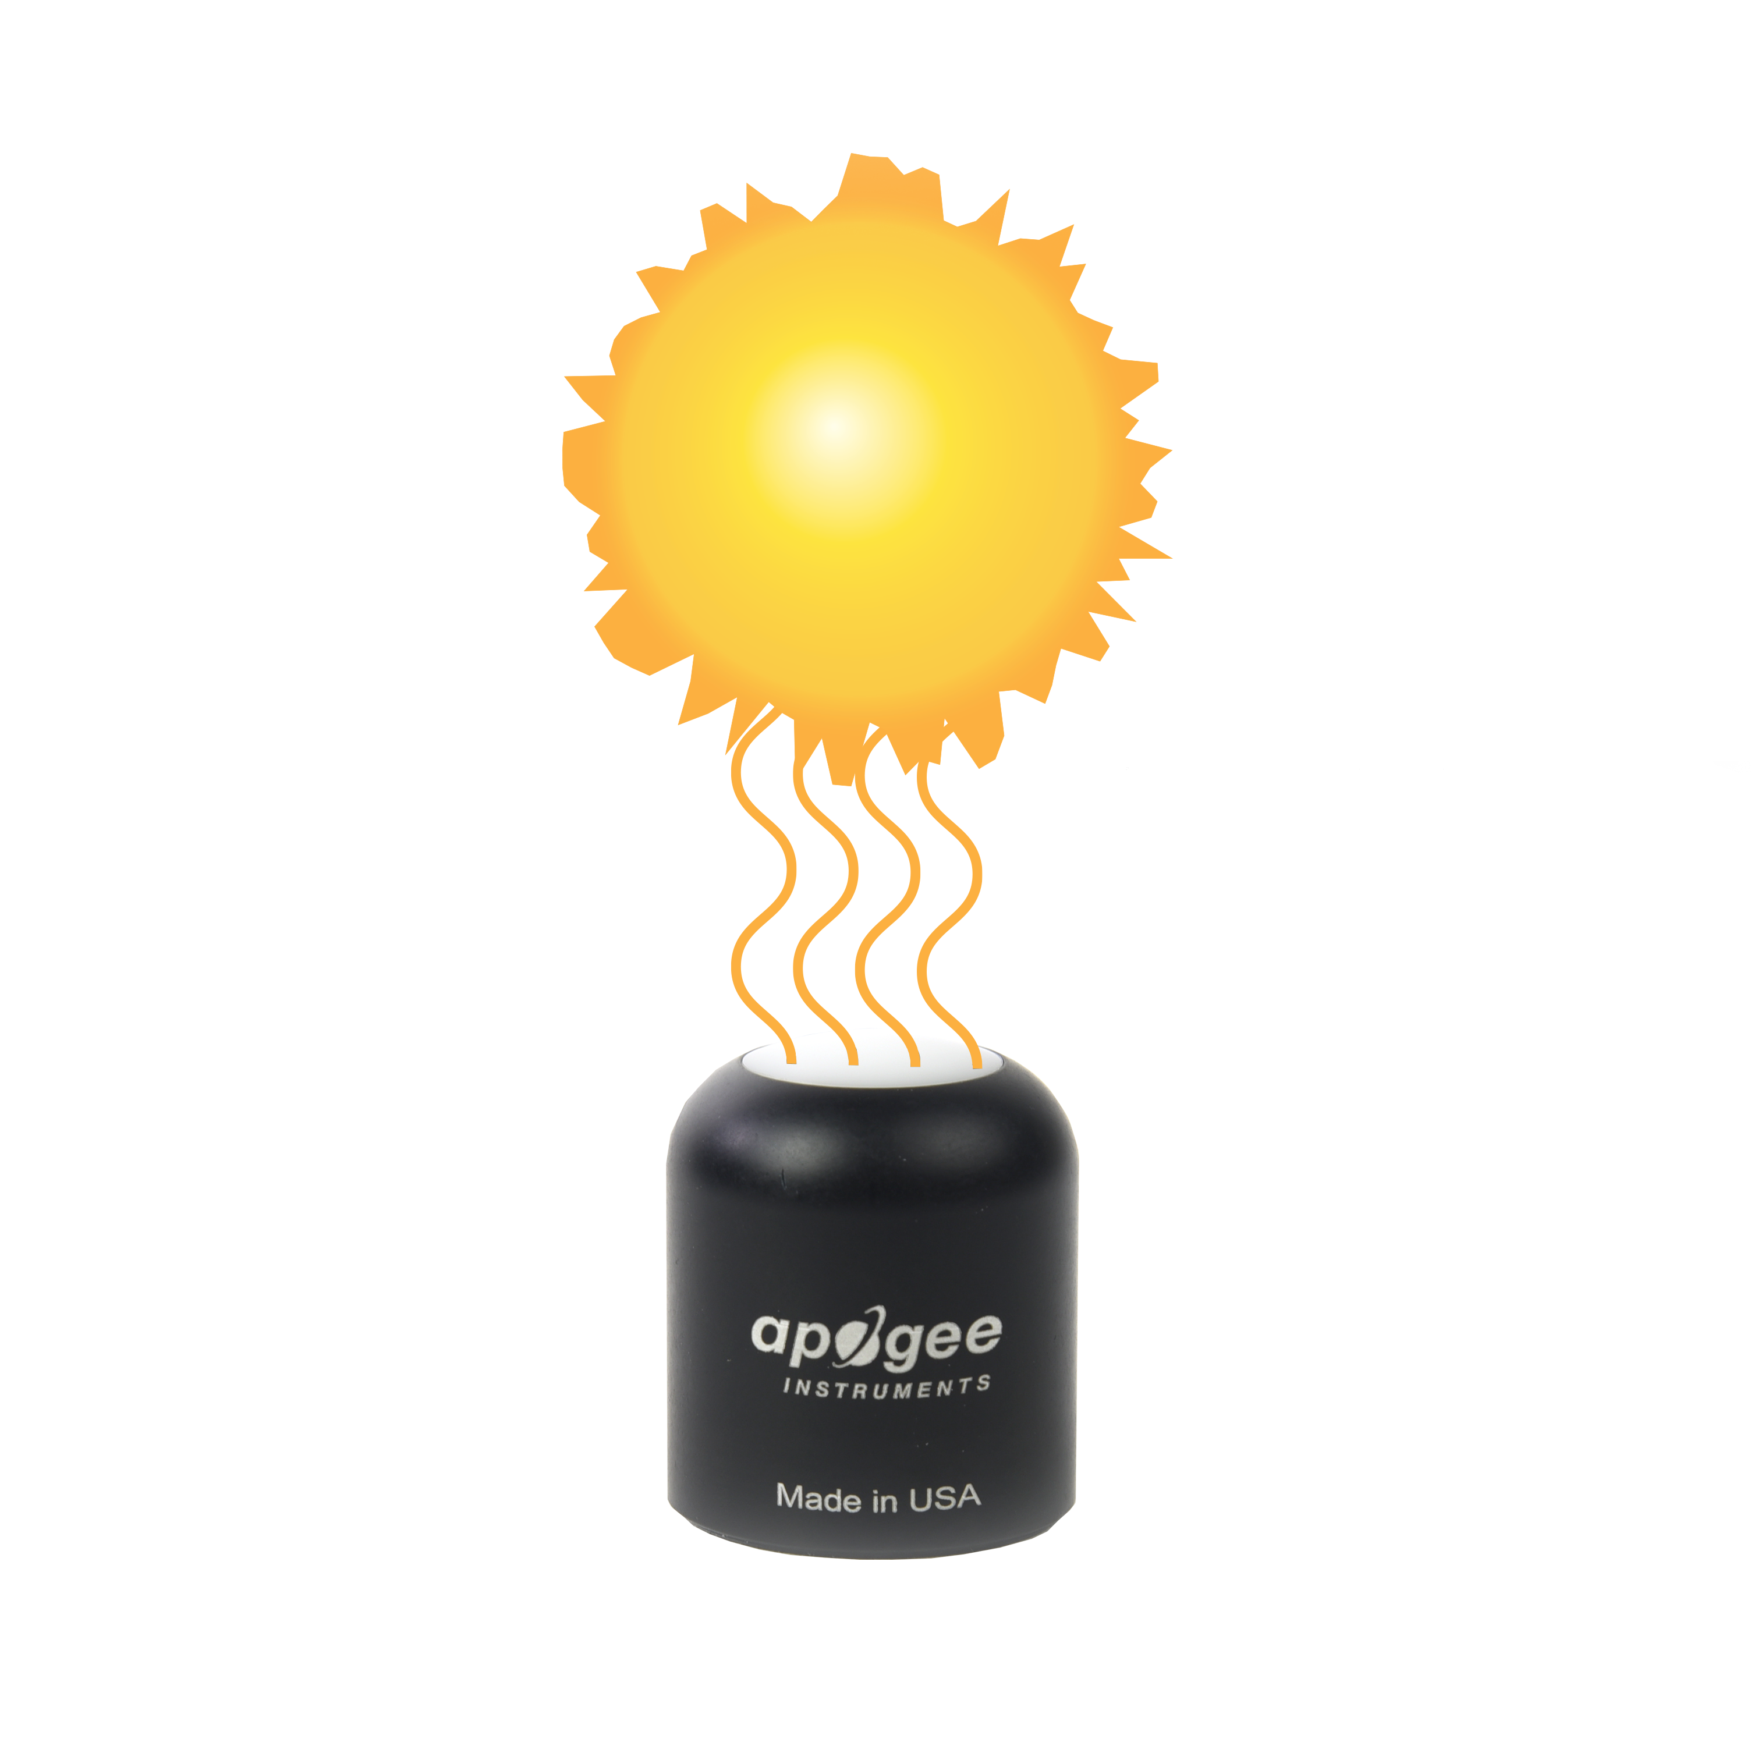

**Spectral Error**

The combination of diffuser transmittance, interference filter transmittance, and photodetector sensitivity yields spectral response of a quantum sensor. A perfect photodetector/filter/diffuser combination would exactly match the defined plant photosynthetic response to photons (equal weighting to all photons between 400 and 700 nm, no weighting of photons outside this range), but this is challenging in practice. Mismatch between the defined plant photosynthetic response and sensor spectral response results in spectral error when the sensor is used to measure radiation from sources with a different spectrum than the radiation source used to calibrate the sensor (Federer and Tanner, 1966; Ross and Sulev, 2000).

Spectral errors for PPFD measurements made under common radiation sources for growing plants were calculated for Apogee SQ-100 and SQ-500 series quantum sensors using the method of Federer and Tanner (1966). This method requires PPFD weighting factors (defined plant photosynthetic response), measured sensor spectral response (shown in Spectral Response section on page 7), and radiation source spectral outputs (measured with a spectroradiometer). Note, this method calculates spectral error only and does not consider calibration, directional (cosine), temperature, and stability/drift errors. Spectral error data (listed in table below) indicate errors less than 5 % for sunlight in different conditions (clear, cloudy, reflected from plant canopies, transmitted below plant canopies) and common broad spectrum electric lamps (cool white fluorescent, metal halide, high pressure sodium), but larger errors for different mixtures of light emitting diodes (LEDs) for the SQ-100 series sensors. Spectral errors for the SQ-500 series sensors are smaller than those for SQ-100 series sensors because the spectral response of SQ-500 series sensors is a closer match to the defined plant photosynthetic response.

Quantum sensors are the most common instrument for measuring PPFD, because they are about an order of magnitude lower cost the spectroradiometers, but spectral errors must be considered. If desired, the spectral errors in the table below can be used as correction factors for individual radiation sources.

**Spectral Errors for PPFD Measurements with Apogee S2-141 PAR-FAR Sensors**

|  |  |
| --- | --- |
| **Radiation Source (Error Calculated Relative to Sun, Clear Sky)** | **S2-141 Sensor**  **PPFD Error [%]** |
| Sun (Clear Sky) | 0.0 |
| Sun (Cloudy Sky) | 0.1 |
| Reflected from Grass Canopy | -0.3 |
| Transmitted below Wheat Canopy | 0.1 |
| Cool White Fluorescent (T5) | 0.1 |
| Metal Halide | 0.9 |
| Ceramic Metal Halide | 0.3 |
| High Pressure Sodium | 0.1 |
| Blue LED (448 nm peak, 20 nm full-width half-maximum) | -0.7 |
| Green LED (524 nm peak, 30 nm full-width half-maximum) | 3.2 |
| Red LED (635 nm peak, 20 nm full-width half-maximum) | 0.8 |
| Red LED (667 nm peak, 20 nm full-width half-maximum) | 2.8 |
| Red, Blue LED Mixture (80 % Red, 20 % Blue) | -3.9 |
| Red, Blue, White LED Mixture (60 % Red, 25 % White, 15 % Blue) | -2.0 |
| Cool White LED | 0.5 |
| Warm White LED | 0.2 |

Similar to PPFD spectral errors, far-red photon flux density spectral errors can be calculated from the far-red sensor spectral response, if a range of far-red radiation is defined. However, a widely accepted definition of far-red, analogous to equal weighting of all photons between 400 and 700 nm for PAR, does not exist. To provide an indication of spectral errors for far-red photon flux density measurements with the Apogee S2-141, far-red radiation had been defined as equal weighting of all photons between 700 and 760 nm. If desired, the spectral errors in the table below can be used as correction factors for individual radiation sources.

**Spectral Errors for Far-red Photon Flux Density Measurements with Apogee S2-141 PAR-FAR Sensors**

|  |  |
| --- | --- |
| **Radiation Source (Error Calculated Relative to Sun, Clear Sky)** | **S2-141 Sensor**  **Far-red Error [%]** |
| Sun (Clear Sky) | -1.9 |
| Sun (Cloudy Sky) | -3.6 |
| Reflected from Grass Canopy | -1.4 |
| Transmitted below Wheat Canopy | 0.1 |
| Cool White Fluorescent (T5) | -6.5 |
| Metal Halide | 4.3 |
| Ceramic Metal Halide | 2.1 |
| High Pressure Sodium | 2.7 |
| Cool White LED | -0.5 |
| Warm White LED | -0.7 |
| Far-red LED with 678 nm peak and 782 nm cutoff | -1.1 |
| Far-red LED with 735 nm peak and 688-759 nm range | 0.0 |
| Far-red LED with 739 nm peak and 700-761 nm range | -0.2 |
| Far-red LED with 732 nm peak and 698-750 nm range | 2.5 |
| Far-red LED with 722 nm peak and 674-747 nm range | -0.8 |

Federer, C.A., and C.B. Tanner, 1966. Sensors for measuring light available for photosynthesis. Ecology 47:654-657.

Ross, J., and M. Sulev, 2000. Sources of errors in measurements of PAR. Agricultural and Forest Meteorology 100:103-125.

### Maintenance and Recalibration

Blocking of the optical path between the target and detector can cause low readings. Occasionally, accumulated materials on the diffuser of the sensor can block the optical path in three common ways:

1. Moisture or debris on the diffuser.
2. Dust during periods of low rainfall.
3. Salt deposit accumulation from evaporation of sea spray or sprinkler irrigation water.

Apogee Instruments sensors have a domed diffuser and housing for improved self-cleaning from rainfall, but active cleaning may be necessary. Dust or organic deposits are best removed using water, or window cleaner, and a soft cloth or cotton swab. Salt deposits should be dissolved with vinegar and removed with a cloth or cotton swab. **Salt deposits cannot be removed with solvents such as alcohol or acetone.** Use only gentle pressure when cleaning the diffuser with a cotton swab or soft cloth, to avoid scratching the outer surface. The solvent should be allowed to do the cleaning, not mechanical force. **Never use an abrasive material or abrasive cleaner on the diffuser**.

Although Apogee sensors are very stable, nominal calibration drift is normal for all research-grade sensors. To ensure maximum accuracy, recalibration every two years is recommended. Longer time periods between recalibration may be warranted depending on tolerances. See the Apogee webpage for details regarding return of sensors for recalibration (<http://www.apogeeinstruments.com/tech-support-recalibration-repairs/>).

To determine if a specific sensor needs recalibration, the Clear Sky Calculator ([www.clearskycalculator.com](http://www.clearskycalculator.com)) website and/or smartphone app can be used to indicate PPFD incident on a horizontal surface at any time of day at any location in the world. It is most accurate when used near solar noon in spring and summer months, where accuracy over multiple clear and unpolluted days is estimated to be ± 4 % in all climates and locations around the world. For best accuracy, the sky must be completely clear, as reflected radiation from clouds causes incoming radiation to increase above the value predicted by the clear sky calculator. Measured PPFD can exceed PPFD predicted by the Clear Sky Calculator due to reflection from thin, high clouds and edges of clouds, which enhances incident PPFD. The influence of high clouds typically shows up as spikes above clear sky values, not a constant offset greater than clear sky values.

To determine recalibration need, input site conditions into the calculator and compare PPFD measurements to calculated PPFD for a clear sky. If sensor PPFD measurements over multiple days near solar noon are consistently different than calculated PPFD (by more than 6 %), the sensor should be cleaned and re-leveled. If measurements are still different after a second test, email [calibration@apogeeinstruments.com](mailto:calibration@apogeeinstruments.com) to discuss test results and possible return of sensor(s).

The Clear Sky Calculator does not calculate far-red photon flux density, but it can be approximated from PPFD returned from the calculator. The ratio of far-red photon flux density to PPFD on clear days near solar noon is typically within the range 0.20 to 0.22.

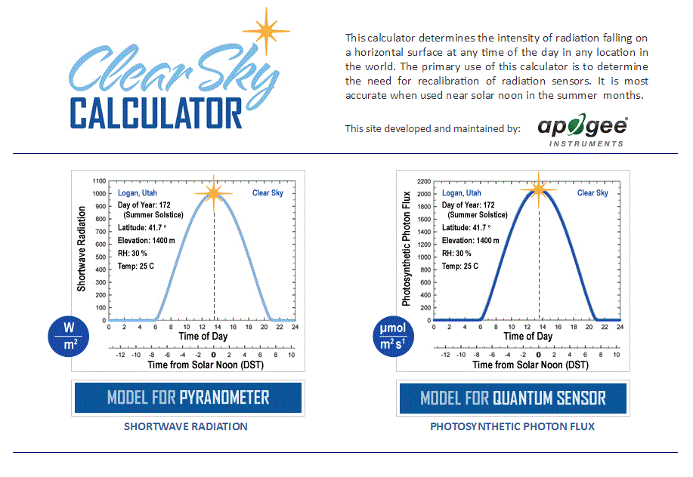

Homepage of the Clear Sky Calculator. Two calculators are available: one for quantum sensors (PPFD) and one for pyranometers (total shortwave irradiance).

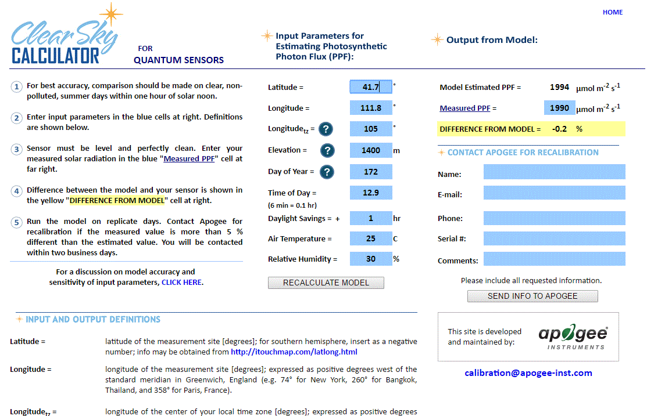

Clear Sky Calculator for quantum sensors. Site data are input in blue cells in middle of page and an estimate of PPFD is returned on right-hand side of page.

### Troubleshooting and Customer Support

**Independent Verification of Functionality**

Apogee S2-141 PAR-FAR sensors are self-powered devices and output two voltages, one proportional to PPFD and one proportional to far-red photon flux density. A quick and easy check of sensor functionality can be determined using a voltmeter with millivolt resolution. To check the PAR sensor, connect the positive lead wire from the voltmeter to the yellow wire from the sensor and the negative (or common) lead wire from the voltmeter to the blue wire from the sensor. Direct the sensor head toward a light source and verify the sensor provides a signal. Increase and decrease the distance from the sensor head to the light source to verify that the signal changes proportionally (decreasing signal with increasing distance and increasing signal with decreasing distance). Blocking all radiation from the sensor should force the sensor signal to zero. To check the far-red sensor, repeat the process above by connecting positive lead wire from the voltmeter to the white wire from the sensor and the negative lead wire from the voltmeter to the black wire from the sensor.

**Compatible Measurement Devices (Dataloggers/Controllers/Meters)**

Apogee S2-141 PAR-FAR sensors are calibrated with approximate calibration factors of 100 mol m-2 s-1 per mV for PPFD measurement and 50 mol m-2 s-1 per mV for far-red photon flux density measurement, yielding approximate sensitivities of 0.01 mV per mol m-2 s-1 and 0.02 mV per mol m-2 s-1, respectively. Thus, a compatible measurement device (e.g., datalogger or controller) should have voltage measurement resolution of at least 0.01 mV in order to provide PPFD resolution of 1 mol m-2 s-1 and 0.02 mV in order to provide far-red photon density resolution of 1 mol m-2 s-1.

An example datalogger program for Campbell Scientific dataloggers can be found on the Apogee webpage (https://www.apogeeinstruments.com/content/PAR-Far-Sensor-Unamplified.CR1).

**Cable Length**

When the sensor is connected to a measurement device with high input impedance, sensor output signals are not changed by shortening the cable or splicing on additional cable in the field. Tests have shown that if the input impedance of the measurements device is greater than 1 mega-ohm there is negligible effect on the calibration, even after adding up to 100 m of cable. All Apogee sensors use shielded, twisted pair cable to minimize electromagnetic interference. For best measurements, the shield wire must be connected to an earth ground. This is particularly important when using the sensor with long lead lengths in electromagnetically noisy environments.

**Modifying Cable Length**

See Apogee webpage for details on how to extend sensor cable length (<http://www.apogeeinstruments.com/how-to-make-a-weatherproof-cable-splice/>).

### Return and Warranty Policy

RETURN POLICY

Apogee Instruments will accept returns within 30 days of purchase as long as the product is in new condition (to be determined by Apogee). Returns are subject to a 10 % restocking fee.

WARRANTY POLICY

**What is Covered**All products manufactured by Apogee Instruments are warranted to be free from defects in materials and craftsmanship for a period of four (4) years from the date of shipment from our factory. To be considered for warranty coverage an item must be evaluated by Apogee.

Products not manufactured by Apogee (spectroradiometers, chlorophyll content meters, EE08-SS probes) are covered for a period of one (1) year.

**What is Not Covered**The customer is responsible for all costs associated with the removal, reinstallation, and shipping of suspected warranty items to our factory.

The warranty does not cover equipment that has been damaged due to the following conditions:

1. Improper installation, use, or abuse.

2. Operation of the instrument outside of its specified operating range.

3. Natural occurrences such as lightning, fire, etc.

4. Unauthorized modification.

5. Improper or unauthorized repair.

Please note that nominal accuracy drift is normal over time. Routine recalibration of sensors/meters is considered part of proper maintenance and is not covered under warranty.

**Who is Covered**This warranty covers the original purchaser of the product or other party who may own it during the warranty period.

**What Apogee Will Do**At no charge Apogee will:

1. Either repair or replace (at our discretion) the item under warranty.

2. Ship the item back to the customer by the carrier of our choice.

Different or expedited shipping methods will be at the customer’s expense.

**How To Return An Item**1. Please do not send any products back to Apogee Instruments until you have received a Return Merchandise Authorization (RMA) number from our technical support department by submitting an online RMA form at [www.apogeeinstruments.com/tech-support-recalibration-repairs/](http://www.apogeeinstruments.com/tech-support-recalibration-repairs/). We will use your RMA number for tracking of the service item. Call (435) 245-8012 or email techsupport@apogeeinstruments.com with questions.

2. For warranty evaluations, send all RMA sensors and meters back in the following condition: Clean the sensor’s exterior and cord. Do not modify the sensors or wires, including splicing, cutting wire leads, etc. If a connector has been attached to the cable end, please include the mating connector – otherwise the sensor connector will be removed in order to complete the repair/recalibration. ***Note:*** *When sending back sensors for routine calibration that have Apogee’s standard stainless-steel connectors, you only need to send the sensor with the 30 cm section of cable and one-half of the connector. We have mating connectors at our factory that can be used for calibrating the sensor.*

3. Please write the RMA number on the outside of the shipping container.

4. Return the item with freight pre-paid and fully insured to our factory address shown below. We are not responsible for any costs associated with the transportation of products across international borders.

**Apogee Instruments, Inc.   
721 West 1800 North Logan, UT  
84321, USA**

5. Upon receipt, Apogee Instruments will determine the cause of failure. If the product is found to be defective in terms of operation to the published specifications due to a failure of product materials or craftsmanship, Apogee Instruments will repair or replace the items free of charge. If it is determined that your product is not covered under warranty, you will be informed and given an estimated repair/replacement cost.

Products Beyond the Warranty Period

For issues with sensors beyond the warranty period, please contact Apogee at [techsupport@apogeeinstruments.com](mailto:techsupport@apogeeinstruments.com) to discuss repair or replacement options.

Other Terms

The available remedy of defects under this warranty is for the repair or replacement of the original product, and Apogee Instruments is not responsible for any direct, indirect, incidental, or consequential damages, including but not limited to loss of income, loss of revenue, loss of profit, loss of data, loss of wages, loss of time, loss of sales, accruement of debts or expenses, injury to personal property, or injury to any person or any other type of damage or loss.

This limited warranty and any disputes arising out of or in connection with this limited warranty ("Disputes") shall be governed by the laws of the State of Utah, USA, excluding conflicts of law principles and excluding the Convention for the International Sale of Goods. The courts located in the State of Utah, USA, shall have exclusive jurisdiction over any Disputes.

This limited warranty gives you specific legal rights, and you may also have other rights, which vary from state to state and jurisdiction to jurisdiction, and which shall not be affected by this limited warranty. This warranty extends only to you and cannot by transferred or assigned. If any provision of this limited warranty is unlawful, void, or unenforceable, that provision shall be deemed severable and shall not affect any remaining provisions. In case of any inconsistency between the English and other versions of this limited warranty, the English version shall prevail.

This warranty cannot be changed, assumed, or amended by any other person or agreement

**APOGEE INSTRUMENTS, INC. |** 721 WEST 1800 NORTH, LOGAN, UTAH 84321, USA

TEL: (435) 792-4700 | FAX: (435) 787-8268 | WEB: APOGEEINSTRUMENTS.COM

*Copyright © 2022 Apogee Instruments, Inc.*