

# Owner’s Manual

Ultraviolet Meter

Models MU-250

Rev: 31-Mar-2022

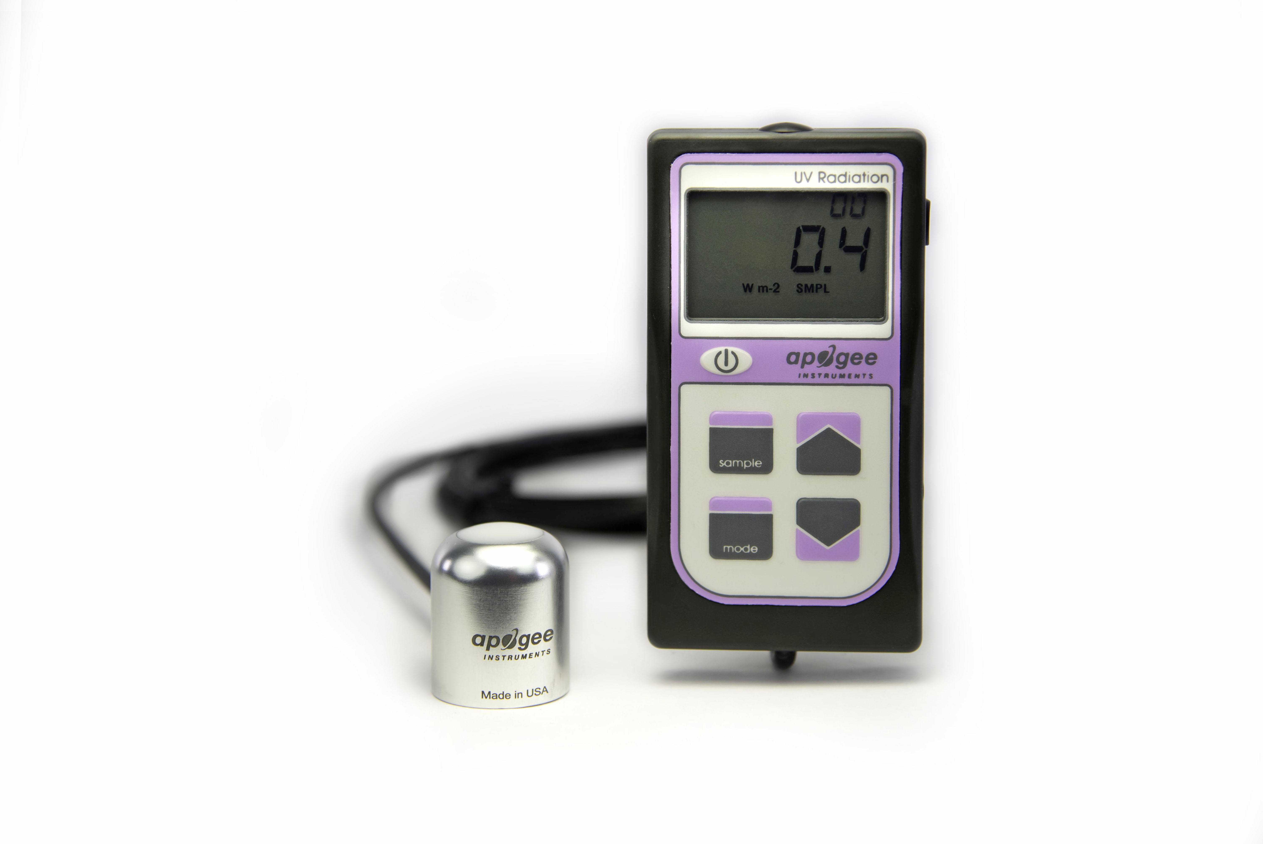

Table of Contents

Owner’s Manual 1

Certificate of Compliance 3

Introduction 4

Sensor Models 5

Specifications 6

Deployment and Installation 9

Battery Installation and Replacement 10

Operation and Measurement 11

Apogee AMS Software 13

Maintenance and Recalibration 15

Troubleshooting and Customer Support 16

Return and Warranty Policy 18

### Certificate of Compliance

**EU Declaration of Conformity**

This declaration of conformity is issued under the sole responsibility of the manufacturer:

Apogee Instruments, Inc.  
721 W 1800 N  
Logan, Utah 84321  
USA

for the following product(s):

Models: MU-250  
Type: Ultraviolet Sensor

The object of the declaration described above is in conformity with the relevant Union harmonization legislation:

2014/30/EU Electromagnetic Compatibility (EMC) Directive

2011/65/EU Restriction of Hazardous Substances (RoHS 2) Directive

2015/863/EU Amending Annex II to Directive 2011/65/EU (RoHS 3)

Standards referenced during compliance assessment:

EN 61326-1:2013 Electrical equipment for measurement, control, and laboratory use – EMC requirements

EN 50581:2012 Technical documentation for the assessment of electrical and electronic products with respect to the restriction of hazardous substances

Please be advised that based on the information available to us from our raw material suppliers, the products manufactured by us do not contain, as intentional additives, any of the restricted materials including lead (see note below), mercury, cadmium, hexavalent chromium, polybrominated biphenyls (PBB), polybrominated diphenyls (PBDE), bis (2-ethylhexyl) phthalate (DEHP), butyl benzyl phthalate (BBP), dibutyl phthalate (DBP), and diisobutyl phthalate (DIBP). However, please note that articles containing greater than 0.1 % lead concentration are RoHS 3 compliant using exemption 6c.

Further note that Apogee Instruments does not specifically run any analysis on our raw materials or end products for the presence of these substances, but we rely on the information provided to us by our material suppliers.

Signed for and on behalf of:

Apogee Instruments, March 2022



Bruce Bugbee  
President  
Apogee Instruments, Inc.

### Introduction

Ultraviolet (UV) radiation constitutes a portion of the electromagnetic spectrum from 100 to 400 nm and is further subdivided into three wavelength ranges: UV-A (315 to 400 nm), UV-B (280 to 315 nm), and UV-C (100 to 280 nm). Much of the UV-B and all of the UV-C wavelengths from the sun are absorbed by Earth’s atmosphere. There are also multiple artificial UV light sources available.

Most UV sensors designed for sunlight measurements are sensitive to UV radiation in the UV-A or UV-B ranges. Apogee Instruments MU-200 series UV-A meters detect UV radiation from 300 to 400 nm and are calibrated in energy flux density units of watts per square meter (W m-2, equal to Joules per second per square meter). The output can also be expressed in photon flux density units of micromoles per square meter per second (µmol m-2 s-1).

Typical applications of UV meters include incoming UV radiation measurement in outdoor environments or in laboratory use with artificial light sources (e.g., germicidal lamps).

Apogee Instruments MU-200 series UV-A meters are connected by cable to an anodized aluminum housing (MU-250). Separate sensors consist of a photodiode and filter, and are potted solid with no internal air space. MU series meters provide a real-time photon flux or energy flux (menu selectable) reading on the LCD display that determines the UV radiation incident on a planar surface (does not have to be horizontal), where the radiation emanates from all angles of a hemisphere. MU series meters include manual and automatic data logging features for making spot-check measurements or calculating integrated daily total values.

### Sensor Models

Apogee MU series UV meters covered in this manual are self-contained and come complete with handheld meter and sensor.

A sensor’s model number and serial number are located on a label on the backside of the handheld meter.

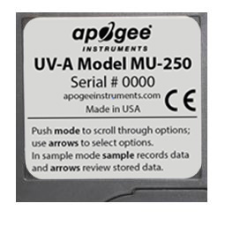

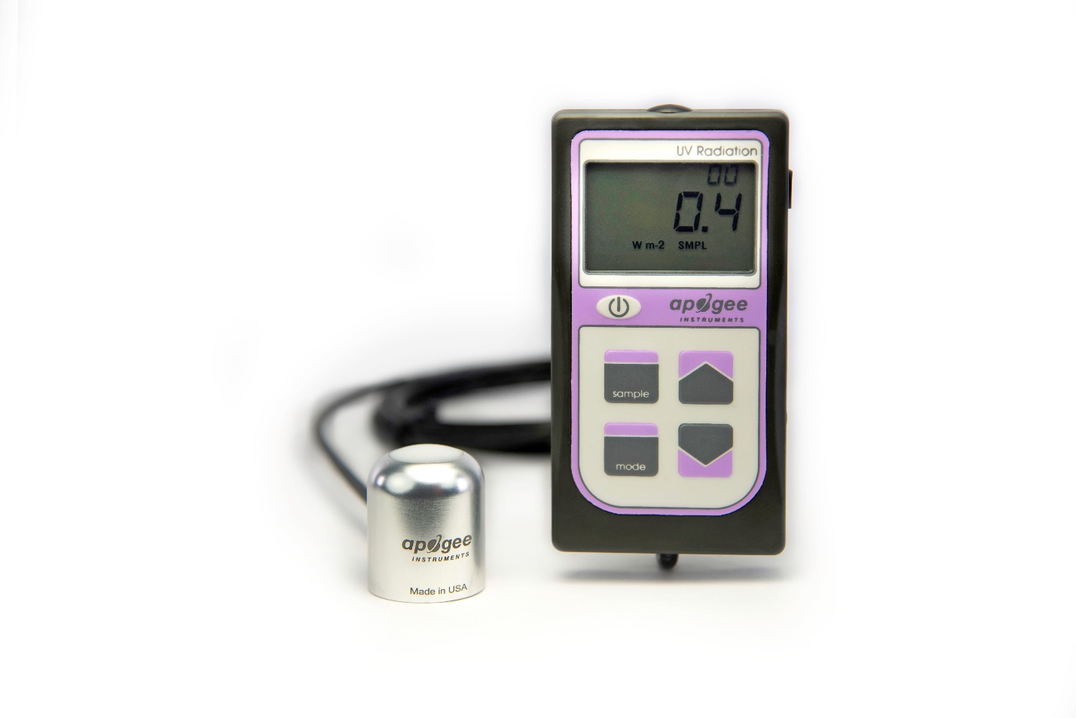

MU-250

### Specifications

|  |  |
| --- | --- |
|  | **MU-250** |
| Calibration Uncertainty | ± 10 % (see Calibration Traceability below) |
| Measurement Repeatability | Less than 0.5 % |
| Non-stability  (Long-term Drift) | Less than 2 % per year |
| Non-linearity | Less than 1 % |
| Response Time | Less than 1 ms |
| Field of View | 180° |
| Spectral Range | 300 nm to 400 nm (see Spectral Response below) |
| Directional (Cosine) Response | ± 2 % at 45°, ± 5 % at 75° zenith angle |
| Maximum Range | 104.9 W per m2 |
| Temperature Response | Less than ­0.1 % per C |
| Operating Environment | 0 to 50 C; less than 90 % non-condensing relative humidity up to 30 C; less than 70 % non-condensing relative humidity from 30 to 50 C |
| Meter Dimensions | 126 mm length; 70 mm width; 24 mm height |
| Sensor Dimension | 30.5 mm diameter, 37 mm height |
| Mass | 180 g |
| Cable | 2 m of two conductor, shielded, twisted-pair wire; TPR jacket (high water resistance, high UV stability, flexibility in cold conditions) |

**Calibration Traceability**

Apogee MU series UV-A meters are calibrated through side-by-side comparison to the mean of four transfer standard UV sensors under UV-enhanced T5 fluorescent tubes. The transfer standard UV sensors are calibrated through side-by-side comparison to an Apogee model PS-300 spectroradiometer under sunlight (clear sky conditions) in Logan, Utah. The PS-300 is calibrated with a quartz halogen lamp traceable to the National Institute of Standards and Technology (NIST).

**Cosine Response**

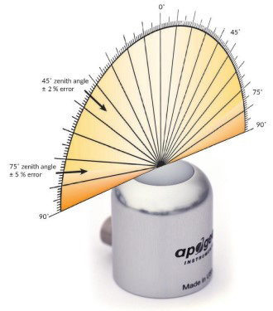

Directional, or cosine, response is defined as the measurement error at a specific angle of radiation incidence. Directional error for Apogee SU-200 series UV-A sensors is approximately ± 2 % and ± 5 % at solar zenith angles of 45° and 75°, respectively.

**Cosine Response Graph**

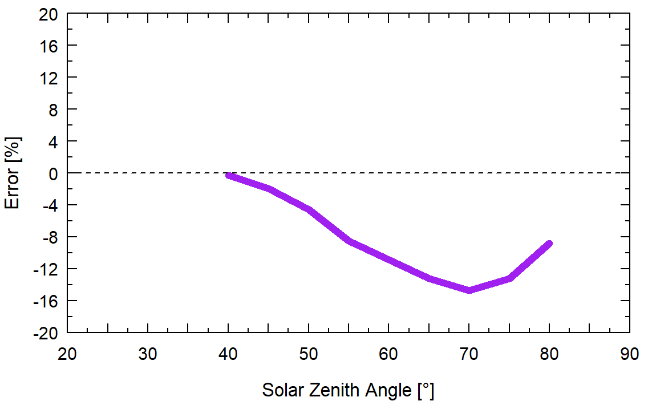

Mean cosine response of four Apogee UV-A sensors. Cosine response was calculated as the relative difference of UV-A sensors from the mean of replicate reference UV-A sensors deployed outdoors. These data are the average of the AM and PM response.

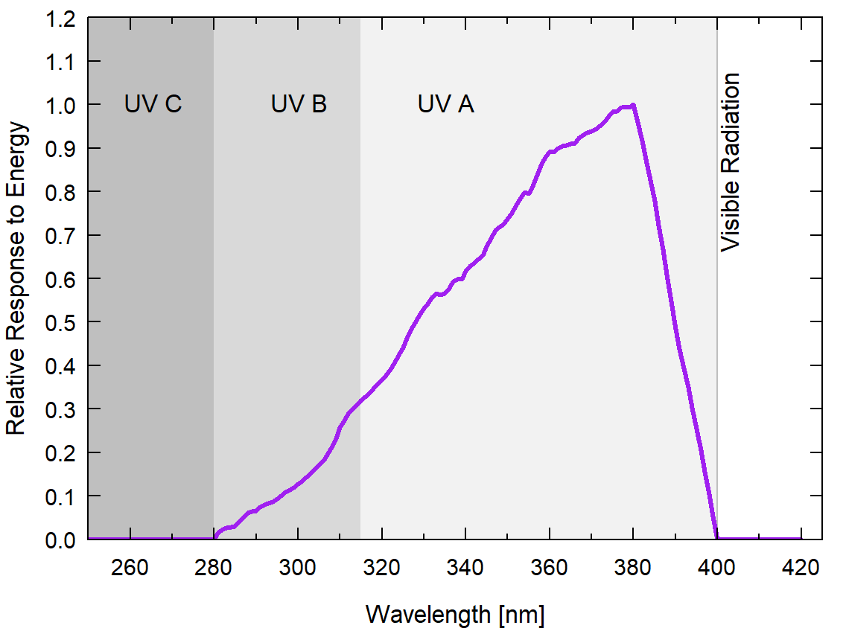**Spectral Response**

Spectral response estimate of Apogee MU series UV-A meters. Spectral response was modeled from sensitivity of the photodetector and transmittance of the diffuser.

### Deployment and Installation

Apogee MU series meters are designed for spot-check measurements, and calculation of integrated daily totals (total number of photons incident on a planar surface over the course of a day) through the built-in logging feature. To accurately measure UV-A radiation incident on a horizontal surface, the sensor must be level. For this purpose, each MU model comes with a different option for mounting the sensor to a horizontal plane.

The AL-100 leveling plate is recommended for use with the MU-250. To facilitate mounting to a cross arm, the AL-120 mounting bracket is recommended.

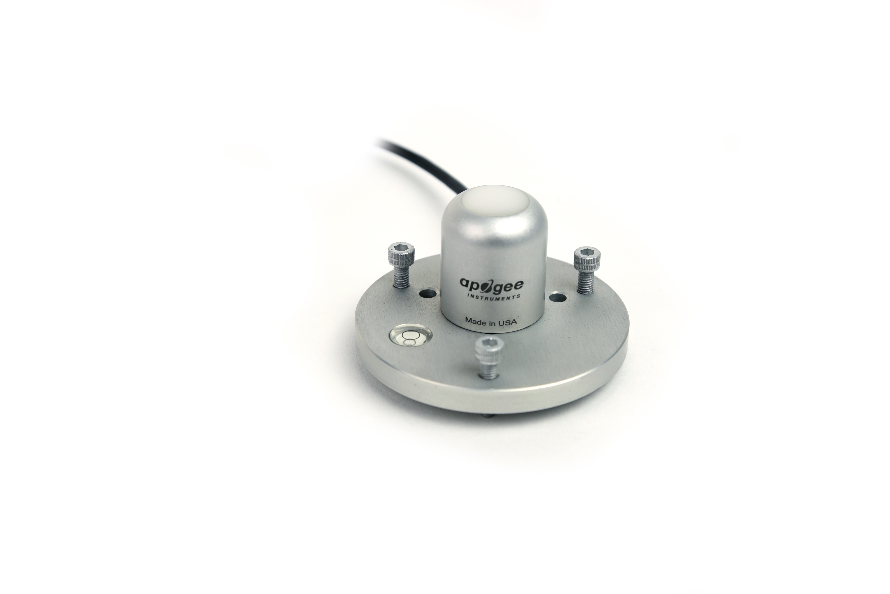

In addition to leveling, all sensors should also be mounted such that obstructions (e.g., weather station tripod/tower or other instrumentation) do not shade the sensor.

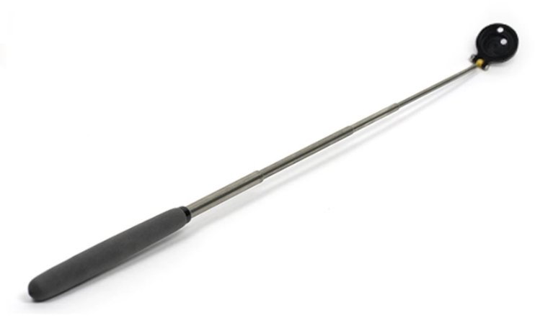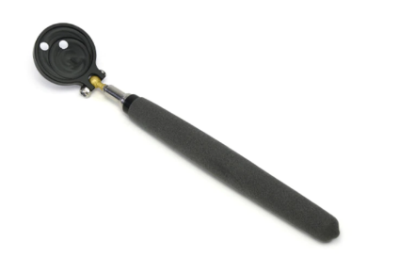The AM-310 Sensor Wand accessory incorporates a mounting fixture at the end of an extendable telescopic wand (up to 33 inches/84 cm). The wand is not suited for wet environments; however, it is excellent for greenhouses and growth chambers. Its ability to retract to a smaller size also makes it ideal for travel use.

AM-310 Extendable Sensor Wand

**NOTE:** The handheld meter portion of the instrument is **not** waterproof. Do **not** get the meter wet or leave the meter in high humidity environments for prolonged periods of time. Doing so can lead to corrosion that could void the warranty.

### Battery Installation and Replacement

Use a Phillips head screwdriver to remove the screw from the battery cover. Remove the battery cover by slightly lifting and sliding the outer edge of the cover away from the meter.

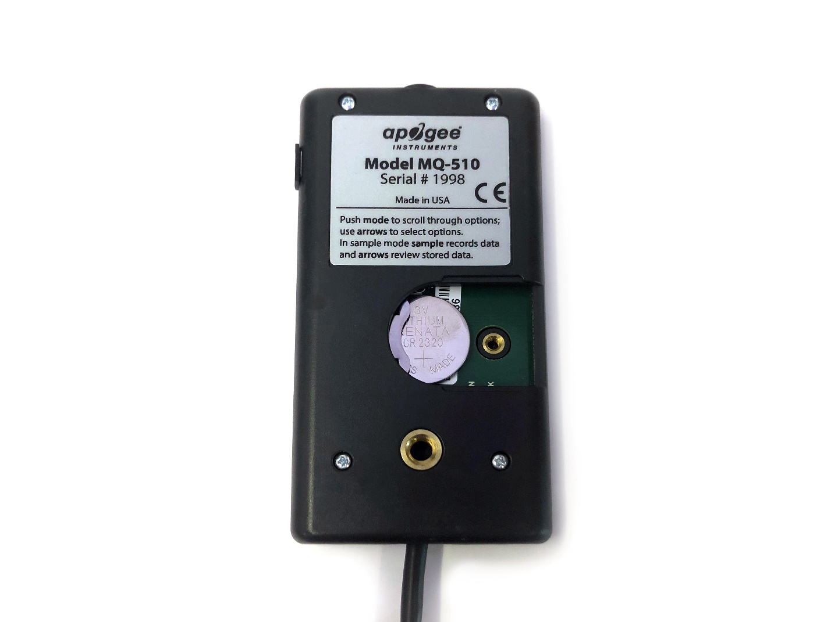To power the meter, slide the included battery (**CR2320**) into the battery holder, after removing the battery door from the meter’s back panel.

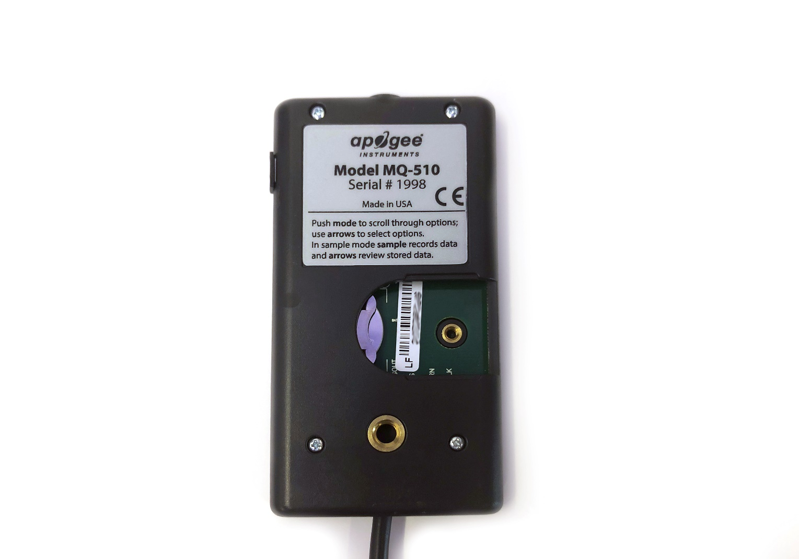

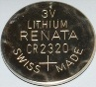

The positive side (designated by a “+” sign) should be facing out from the meter circuit board.

**NOTE:** The battery cradle can be damaged by using an incorrectly sized battery. If the battery cradle is damaged, the circuit board will need to be replaced and the warranty will be void. To avoid this costly problem, **use only a CR2320 battery.**

**Battery Removal**

Press down on the battery with a screwdriver or similar object. Slide battery out.

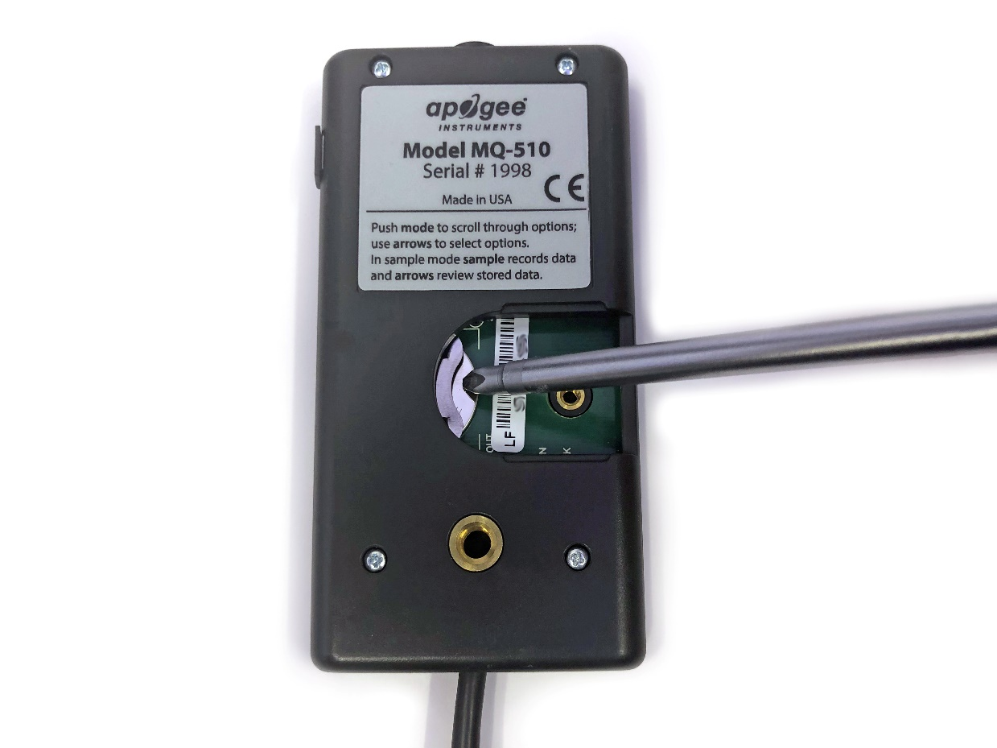

If the battery is difficult to move, turn the meter on its side so that the opening for the battery is facing downward and tap the meter downward against an open palm to dislodge the battery enough so that it can be removed with your thumb to slide the battery out of the battery holder.

### Operation and Measurement

MU series quantum meters are designed with a user-friendly interface allowing quick and easy measurements.

 Press the power button to activate the LCD display. After two minutes of non-activity the meter will revert to sleep mode and the display will shut off to conserve battery life.

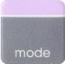 Press the mode button to access the main menu, where the appropriate unit (photon flux or energy flux) and manual or automatic logging are selected, and where the meter can be reset.

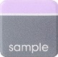 Press the sample button to log a reading while taking manual measurements.

 Press the up button to make selections in the main menu. This button is also used to view and scroll through the logged measurements on the LCD display.

 Press the down button to make selections in the main menu. This button is also used to view and scroll through the logged measurements on the LCD display.

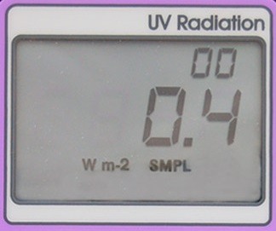

The LCD display consists of the total number of logged measurements in the upper right hand corner, the real-time UV measurement in the center, and the selected menu options along the bottom.

**Units:** To choose between units of energy flux (W m-2) or photon flux density (µmol m-2 s-1), push the mode button once and use the up/down buttons to make the appropriate selection. Once the desired mode is blinking, press the mode button three more times to exit the menu.

**Logging:** To choose between manual or automatic logging, push the mode button twice and use the up/down buttons to make the appropriate selection (SMPL or LOG). Once the desired mode is blinking, press the mode button two more times to exit the menu. When in SMPL mode press the sample button to record up to 99 manual measurements (a counter in the upper right hand corner of the LCD display indicates the total number of saved measurements). When in LOG mode the meter will power on/off to make a measurement every 30 seconds. Every 30 minutes the meter will average the sixty 30 second measurements and record the averaged value to memory. The meter can store up to 99 averages and will start to overwrite the oldest measurement once there are 99 measurements. Every 48 averaged measurements (making a 24 hour period), the meter will also store an integrated daily total in moles per meter squared per day (mol m-2 d-1).

**Reset:** To reset the meter, in either SMPL or LOG mode, push the mode button three times (RUN should be blinking), then while pressing the down button, press the mode button once. This will erase all of the saved measurements in memory, but only for the selected mode. That is, performing a reset when in SMPL mode will only erase the manual measurements and performing a reset when in LOG mode will only erase the automatic measurements.

**Review/Download Data:** Each of the logged measurements in either SMPL or LOG mode can be reviewed on the LCD display by pressing the up/down buttons. To exit and return to the real-time readings, press the sample button. Note that the integrated daily total values are not accessible through the LCD and can only be viewed by downloading to a computer.

Downloading the stored measurements will require the AC-100 communication cable and software (sold separately). The meter outputs data using the UART protocol and requires the AC-100 to convert from UART to USB, so standard USB cables will not work. Set up instructions and software can be downloaded from the Apogee website (<http://www.apogeeinstruments.com/ac-100-communcation-cable/>).



**UV-A Measurements and Spectral Errors**

Apogee Instruments model SU-200 UV-A sensors are calibrated to measure ultraviolet radiation from the sun between 300 and 400 nm in Watts per square meter. In addition to naturally occurring UV-A radiation from the sun, there are many electric light sources that emit UV-A radiation (e.g., cool white fluorescent, metal halide, mercury arc, and germicidal lamps). Although the relative wavelengths of UV-A radiation differ among sunlight and electric lights, the error estimates shown in the table below indicate the SU-200 provides reasonable estimates of UV-A radiation coming from electric lamps (table provides spectral error estimates for UV-A radiation measurements from radiation sources other than clear sky solar radiation). For most common lamps, the error is less than 10 %. The SU-200 is particularly useful for determining the UV-A filtering capacity of the transparent plastic and glass barriers that are commonly used below electric lamps.

|  |  |  |
| --- | --- | --- |
| Radiation Source (Error Calculated Relative to Sun, Clear Sky) | **Expected EFD Error [%]** | **Expected PFD Error [%]** |
| Clear Sky | 0.0 | 0.0 |
| Overcast | 0.0 | -1.1 |
| Direct Normal | -0.2 | -1.0 |
| Diffused Blue Light | 0.3 | 1.4 |
| CWF T5 | 8.2 | 9.2 |
| Metal Halide | 1.2 | -1.2 |
| Quartz Halogen | -2.3 | -3.8 |
| Mercury Arc | 16.2 | 16.9 |
| T12 Fluorescent UV-A Enhanced | 12.2 | 15.2 |
| UV-A LED (365 nm Peak) | 37.4 | 35.3 |
| UV-A LED (386 nm Peak) | 1.8 | -3.9 |
| UV-A LED (395 nm Peak) | -36.9 | -41.2 |

### Apogee AMS Software

Downloading data to a computer requires the [AC-100 communication cable](https://www.apogeeinstruments.com/ac-100-communication-cable/) and the free ApogeeAMS software. The meter outputs data using the UART protocol and requires the AC-100 to convert from UART to USB, so standard USB cables will not work.

**The most recent version of ApogeeAMS software can be downloaded at** [**http://www.apogeeinstruments.com/downloads/**](http://www.apogeeinstruments.com/downloads/)**.**

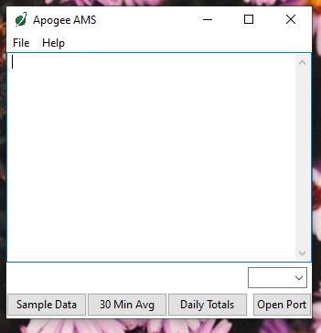

When the ApogeeAMS software is first opened, it will show a blank screen until communication with the meter is established. If you click “Open Port” it will say “connection failed.”

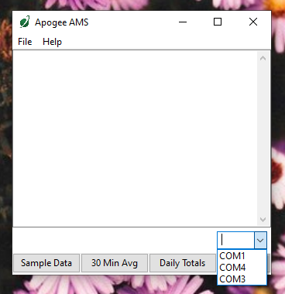

To establish communication, make sure the meter is plugged into your computer using the AC-100 communication cable. To connect click the dropdown menu button and “COM#” options will appear. For more details on how to figure out which COM is the right one, [watch our video](https://youtu.be/-lvw3rqOF5w?t=432).

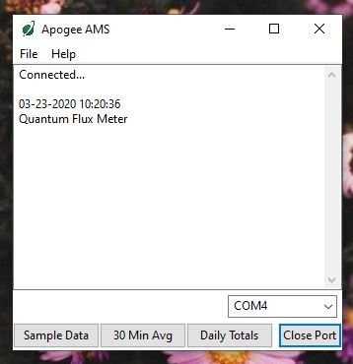

When you have connected to the correct COM#, the software will say “Connected”.

Click “Sample Data” to view saved sample readings.

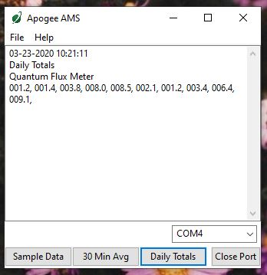

“Daily Totals” shows all of the saved Daily Light Integral (DLI) totals per day.

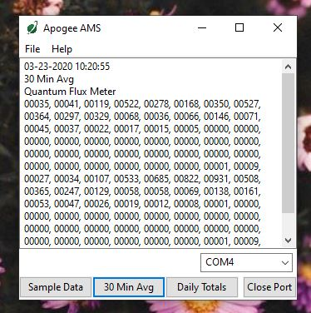

Click “30 Min Avg” to see the meter’s 99, 30-minute averages.

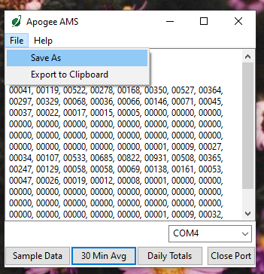

To analyze the data, click on “File” and “Save As” to save the data as a .csv file.

Or, you can highlight the numbers, copy, and paste them into a blank Excel spreadsheet. Data will need to be comma delimited.

### Maintenance and Recalibration

Moisture or debris on the sensor is a common cause of low readings. The sensor has a domed-shaped housing for improved self-cleaning from rainfall, but materials can accumulate on the photo-sensitive area (e.g., dust during periods of low rainfall, salt deposits from evaporation of sea spray or sprinkler irrigation water) and partially block the optical path. Dust or organic deposits are best removed using water, or window cleaner and a soft cloth or cotton swab. Salt deposits should be dissolved with vinegar and removed with a soft cloth or cotton swab. **Never use an abrasive material or cleaner on the sensor.**

Although Apogee sensors are very stable, nominal accuracy drift is normal for all research-grade sensors. To ensure maximum accuracy, we generally recommend sensors are sent in for recalibration every two years, although you can often wait longer according to your particular tolerances.

The Clear Sky Calculator ([www.clearskycalculator.com](http://www.clearskycalculator.com)) determines total shortwave radiation or photosynthetic photon flux density (PPFD) incident on a horizontal surface at any time of day at any location in the world. It is most accurate when used near solar noon in spring and summer months, where accuracy over multiple clear and unpolluted days is estimated to be ± 4 % in all climates and locations around the world.

Although the Clear Sky Calculator does not specifically report an estimated value for UV radiation, it can still be used to help determine the need for UV sensor recalibration by approximating the ratio of UV to total shortwave or the ratio of UV to PPFD. However, due to continuous changes in atmospheric conditions and their effect on UV radiation, the comparison of the UV sensor to the Clear Sky Calculator should only be made in the summer months near solar noon, and under completely clear skies.

To calculate a reference value of UV radiation in units of energy flux (W m-2), input site conditions into the calculator to determine the estimated total shortwave radiation. Then multiply the estimated total shortwave value by an approximated ratio value between 0.045 and 0.050 to convert the total shortwave radiation to total UV radiation.

To calculate a reference value of UV radiation in units of photon flux density (μmol m-2 s-1), input site conditions into the calculator to determine the estimated PPFD. Then multiply the estimated PPFD by an approximated ratio value between 0.070 and 0.075 to convert the PPFD to total UV radiation.

If UV sensor measurements over multiple days near solar noon are consistently different than calculated values (by more than 10 %), the sensor should be cleaned and re-leveled. If measurements are still different after a second test, email [calibration@apogeeinstruments.com](mailto:calibration@apogeeinstruments.com) to discuss test results and possible return of sensor(s).

### Troubleshooting and Customer Support

**Verify Functionality**

Pressing the power button should activate the LCD and provide a real-time UV measurement. Direct the sensor head toward the sun and verify the UV reading responds. Blocking all radiation from the sensor should force the UV reading to zero.

**Battery Life**

When the meter is maintained properly the coin cell battery (CR2320) should last for many months, even after continuous use. The low battery indicator will appear in the upper left hand corner of the LCD display when the battery voltage drops below 2.8 V DC. The meter will still function correctly for some time, but once the battery is drained the pushbuttons will no longer respond and any logged measurements will be lost.

Pressing the power button to turn off the meter will actually put it in sleep mode, where there is still a slight amount of current draw. This is necessary to maintain the logged measurements in memory. Therefore, it is recommended to remove the battery when storing the meter for many months at a time, in order to preserve battery life.

**Low-Battery Error after Battery Replacement**

A master reset will usually correct this error, please see the master reset section for details and cautions. If a master reset does not remove the low battery indicator, please double check that the voltage of your new battery is above 2.8 V, this is the threshold for the indicator to turn on.

**Master Reset**

If a meter ever becomes non-responsive or experiences anomalies, such as a low battery indicator even after replacing the old battery, a master reset can be performed that may correct the problem. Note that a master reset will erase all logged measurements from memory.

Step 1: press the power button so that the LCD display is activated.

Step 2: Slide the battery out of the holder, which will cause the LCD display to fade out.

Step 3: After a few seconds, slide the battery back into the holder.

The LCD display will flash all segments and then show a revision number (e.g. “R1.0”). This indicates the master reset was performed and the display should return to normal.

**Error Codes and Fixes**

Error codes will appear in place of the real-time reading on the LCD display and will continue to flash until the problem is corrected. Contact Apogee if the following fixes do not rectify the problem.

**Err 1:** battery voltage out of range. **Fix:** replace CR2320 battery and perform master reset.

**Err 2:** sensor voltage out of range. **Fix:** perform master reset.

**Err 3:** not calibrated. **Fix:** perform master reset.

**Err 4:** CPU voltage below minimum. **Fix:** replace CR2320 battery and perform master reset.

**Modifying Cable Length**

Although it is possible to splice additional cable to the separate sensor of the MU-250, note that the cable wires are soldered directly into the circuit board of the meter. Care should be taken to remove the back panel of the meter in order to access the board and splice on the additional cable, otherwise two splices would need to be made between the meter and sensor head. See Apogee webpage for further details on how to extend sensor cable length: (<http://www.apogeeinstruments.com/how-to-make-a-weatherproof-cable-splice/>).

### Return and Warranty Policy

RETURN POLICY

Apogee Instruments will accept returns within 30 days of purchase as long as the product is in new condition (to be determined by Apogee). Returns are subject to a 10 % restocking fee.

WARRANTY POLICY

**What is Covered**All products manufactured by Apogee Instruments are warranted to be free from defects in materials and craftsmanship for a period of four (4) years from the date of shipment from our factory. To be considered for warranty coverage an item must be evaluated by Apogee.

Products not manufactured by Apogee (spectroradiometers, chlorophyll content meters, EE08-SS probes) are covered for a period of one (1) year.

**What is Not Covered**The customer is responsible for all costs associated with the removal, reinstallation, and shipping of suspected warranty items to our factory.

The warranty does not cover equipment that has been damaged due to the following conditions:

1. Improper installation, use, or abuse.

2. Operation of the instrument outside of its specified operating range.

3. Natural occurrences such as lightning, fire, etc.

4. Unauthorized modification.

5. Improper or unauthorized repair.

Please note that nominal accuracy drift is normal over time. Routine recalibration of sensors/meters is considered part of proper maintenance and is not covered under warranty.

**Who is Covered**This warranty covers the original purchaser of the product or other party who may own it during the warranty period.

**What Apogee Will Do**At no charge Apogee will:

1. Either repair or replace (at our discretion) the item under warranty.

2. Ship the item back to the customer by the carrier of our choice.

Different or expedited shipping methods will be at the customer’s expense.

**How To Return An Item**1. Please do not send any products back to Apogee Instruments until you have received a Return Merchandise Authorization (RMA) number from our technical support department by submitting an online RMA form at [www.apogeeinstruments.com/tech-support-recalibration-repairs/](http://www.apogeeinstruments.com/tech-support-recalibration-repairs/). We will use your RMA number for tracking of the service item. Call (435) 245-8012 or email techsupport@apogeeinstruments.com with questions.

2. For warranty evaluations, send all RMA sensors and meters back in the following condition: Clean the sensor’s exterior and cord. Do not modify the sensors or wires, including splicing, cutting wire leads, etc. If a connector has been attached to the cable end, please include the mating connector – otherwise the sensor connector will be removed in order to complete the repair/recalibration. ***Note:*** *When sending back sensors for routine calibration that have Apogee’s standard stainless-steel connectors, you only need to send the sensor with the 30 cm section of cable and one-half of the connector. We have mating connectors at our factory that can be used for calibrating the sensor.*

3. Please write the RMA number on the outside of the shipping container.

4. Return the item with freight pre-paid and fully insured to our factory address shown below. We are not responsible for any costs associated with the transportation of products across international borders.

**Apogee Instruments, Inc.   
721 West 1800 North Logan, UT  
84321, USA**

5. Upon receipt, Apogee Instruments will determine the cause of failure. If the product is found to be defective in terms of operation to the published specifications due to a failure of product materials or craftsmanship, Apogee Instruments will repair or replace the items free of charge. If it is determined that your product is not covered under warranty, you will be informed and given an estimated repair/replacement cost.

Products Beyond the Warranty Period

For issues with sensors beyond the warranty period, please contact Apogee at [techsupport@apogeeinstruments.com](mailto:techsupport@apogeeinstruments.com) to discuss repair or replacement options.

Other Terms

The available remedy of defects under this warranty is for the repair or replacement of the original product, and Apogee Instruments is not responsible for any direct, indirect, incidental, or consequential damages, including but not limited to loss of income, loss of revenue, loss of profit, loss of data, loss of wages, loss of time, loss of sales, accruement of debts or expenses, injury to personal property, or injury to any person or any other type of damage or loss.

This limited warranty and any disputes arising out of or in connection with this limited warranty ("Disputes") shall be governed by the laws of the State of Utah, USA, excluding conflicts of law principles and excluding the Convention for the International Sale of Goods. The courts located in the State of Utah, USA, shall have exclusive jurisdiction over any Disputes.

This limited warranty gives you specific legal rights, and you may also have other rights, which vary from state to state and jurisdiction to jurisdiction, and which shall not be affected by this limited warranty. This warranty extends only to you and cannot by transferred or assigned. If any provision of this limited warranty is unlawful, void, or unenforceable, that provision shall be deemed severable and shall not affect any remaining provisions. In case of any inconsistency between the English and other versions of this limited warranty, the English version shall prevail.

This warranty cannot be changed, assumed, or amended by any other person or agreement

**APOGEE INSTRUMENTS, INC. |** 721 WEST 1800 NORTH, LOGAN, UTAH 84321, USA

TEL: (435) 792-4700 | FAX: (435) 787-8268 | WEB: APOGEEINSTRUMENTS.COM

*Copyright © 2022 Apogee Instruments, Inc.*