

# Owner’s Manual

Underwater Quantum Meter

Models MQ-510

Rev: 29-Mar-2022

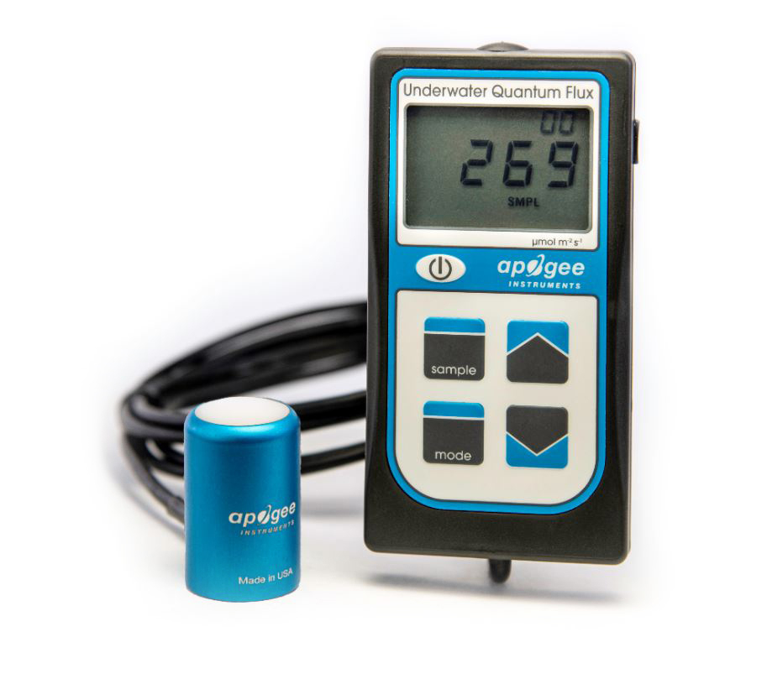

Table of Contents

Owner’s Manual 1

Certificate of Compliance 3

Introduction 4

Sensor Models 5

Specifications 6

Deployment and Installation 9

Battery Installation and Replacement 10

Operation and Measurement 11

Apogee AMS Software 17

Maintenance and Recalibration 19

Troubleshooting and Customer Support 21

Return and Warranty Policy 23

### Certificate of Compliance

**EU Declaration of Conformity**

This declaration of conformity is issued under the sole responsibility of the manufacturer:

Apogee Instruments, Inc.  
721 W 1800 N  
Logan, Utah 84321  
USA

for the following product(s):

Models: MQ-510  
Type: Quantum Meter

The object of the declaration described above is in conformity with the relevant Union harmonization legislation:

2014/30/EU Electromagnetic Compatibility (EMC) Directive

2011/65/EU Restriction of Hazardous Substances (RoHS 2) Directive

2015/863/EU Amending Annex II to Directive 2011/65/EU (RoHS 3)

Standards referenced during compliance assessment:

EN 61326-1:2013 Electrical equipment for measurement, control, and laboratory use – EMC requirements

EN 50581:2012 Technical documentation for the assessment of electrical and electronic products with respect to the restriction of hazardous substances

Please be advised that based on the information available to us from our raw material suppliers, the products manufactured by us do not contain, as intentional additives, any of the restricted materials including lead (see note below), mercury, cadmium, hexavalent chromium, polybrominated biphenyls (PBB), polybrominated diphenyls (PBDE), bis (2-ethylhexyl) phthalate (DEHP), butyl benzyl phthalate (BBP), dibutyl phthalate (DBP), and diisobutyl phthalate (DIBP). However, please note that articles containing greater than 0.1 % lead concentration are RoHS 3 compliant using exemption 6c.

Further note that Apogee Instruments does not specifically run any analysis on our raw materials or end products for the presence of these substances, but we rely on the information provided to us by our material suppliers.

Signed for and on behalf of:

Apogee Instruments, March 2022



Bruce Bugbee  
President  
Apogee Instruments, Inc.

### Introduction

Radiation that drives photosynthesis is called photosynthetically active radiation (PAR) and is typically defined as total radiation across a range of 400 to 700 nm. PAR is almost universally quantified as photosynthetic photon flux density (PPFD), the sum of photons from 400 to 700 nm in units of micromoles per square meter per second (µmol m-2 s-1, equal to microEinsteins m-2 s-1). While microEinsteins and micromoles are equal (one Einstein = one mole of photons), the Einstein is not an SI unit, so expressing PPFD as µmol m-2 s-1 is preferred. Daily total PPFD is typically reported in units of moles of photons per square meter per day (mol m-2 d-1) and is often called daily light integral (DLI).

The acronym PPF is also used and refers to the photosynthetic photon flux. The acronyms PPF and PPFD refer to the same variable. Both terms are used because there is not a universal definition of the term flux. Flux is sometimes defined as per unit area per unit time and sometimes defined as per unit time only. PPFD is used in this manual.

Sensors that measure PPFD are often called quantum sensors due to the quantized nature of radiation. A quantum refers to the minimum quantity of radiation, one photon, involved in physical interactions (e.g., absorption by photosynthetic pigments). In other words, one photon is a single quantum of radiation.

Quantum sensors are increasingly used to measure PPFD underwater, which is important for biological, chemical, and physical processes in natural waters and in aquariums. When a quantum sensor that was calibrated in air is used to make underwater measurements, the sensor reads low. This phenomenon is called the immersion effect and happens because the refractive index of water (1.33) is greater than air (1.00). The higher refractive index of water causes more light to be backscattered (or reflected) out of the sensor in water than in air (Smith,1969; Tyler and Smith,1970). As more light is reflected, less light is transmitted through the diffuser to the detector, which causes the sensor to read low. Without correcting for this effect, underwater measurements are only relative, which makes it difficult to compare light in different environments. The immersion effect correction factor for Apogee full-spectrum quantum sensors (model MQ-500 and SQ-500 series) is 1.25. The MQ-510 quantum meter is designed for underwater measurements, and already applies the immersion effect correction factor to the meter’s readings through firmware. The meter consists of a waterproof quantum sensors attached via waterproof cable to a handheld meter**. Note: The handheld meter is not waterproof, only the sensor and cable are waterproof.**

MQ meters consist of a handheld meter and a dedicated quantum sensor that is connected by cable to an anodized aluminum housing. Sensors consist of a cast acrylic diffuser (filter), photodiode, and are potted solid with no internal air space. MQ series quantum meters provide a real-time PPFD reading on the LCD display, that determine the radiation incident on a planar surface (does not have to be horizontal), where the radiation emanates from all angles of a hemisphere. MQ series quantum meters include manual and automatic data logging features for making spot-check measurements or calculating daily light integral (DLI).

### Sensor Models

Apogee MQ series quantum meters covered in this manual are self-contained and come complete with handheld meter and sensor.

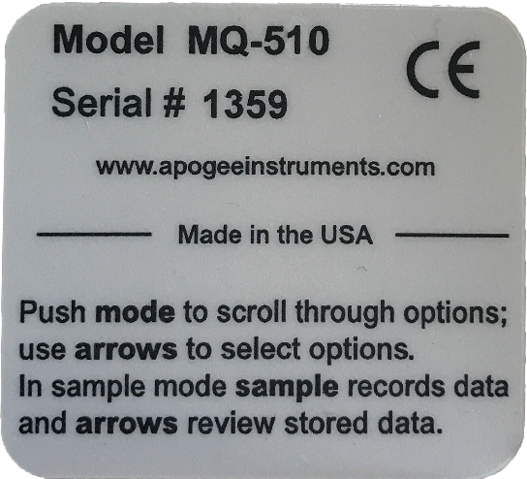

A sensor’s model number and serial number are located on a label on the backside of the handheld meter.

### Specifications

|  |  |
| --- | --- |
|  | **MQ-510** |
| Calibration Uncertainty | ± 5 % (see calibration Traceability below) |
| Measurement Range | 0 to 4000 µmol m-2 s-1 |
| Measurement Repeatability | Less than 0.5 % |
| Long-term Drift  (Non-stability) | Less than 2 % per year |
| Non-linearity | Less than 1 % (up to 4000 µmol m-2 s-1) |
| Response Time | Less than 1 ms |
| Field of View | 180° |
| Spectral Range | 389 to 692 nm ± 5 nm (wavelengths where response is greater than 50 %) |
| Spectral Selectivity | Less than 10 % from 412 to 682 nm ± 5 nm (see Spectral Response below) |
| Directional (Cosine) Response | ± 5 % at 75° zenith angle (see Cosine Response below) |
| Azimuth Error | Less than 0.5 % |
| Tilt Error | Less than 0.5 % |
| Temperature Response | -0.11 ± 0.04 % per C(see Temperature Response below) |
| Uncertainty in Daily Total | Less than 5 % |
| Detector | Blue-enhanced silicon photodidode |
| Housing | Anodized aluminum body with acrylic diffuser |
| IP Rating | IP68 |
| Operating Environment | 0 to 50 C; less than 90 % non-condensing relative humidity up to 30 C; less than 70 % non-condensing relativity humidity from 30 to 50 C; separate sensors can be submerged in water up to depth of 30 m |
| Meter Dimension | 126 mm length; 70 mm width; 24 mm height |
| Sensor Dimensions | 24 mm diameter; 37 mm height |
| Mass | 100 g (with 5 m of lead wire) |
| Cable | 2 m of two conductor, shielded, twisted-pair wire; additional cable available; TPR jacket |

**Calibration Traceability**

Apogee MQ series quantum meters are calibrated through side-by-side comparison to the mean of four transfer standard quantum sensors under a reference lamp. The reference quantum sensors are recalibrated with a 200 W quartz halogen lamp traceable to the National Institute of Standards and Technology (NIST).

**Spectral Response**

Mean spectral response measurements of six replicate Apogee SQ-100X (original X) and MQ-500 (full-spectrum) series quantum sensors. Spectral response measurements were made at 10 nm increments across a wavelength range of 300 to 800 nm with a monochromator and an attached electric light source. Measured spectral data from each quantum sensor were normalized by the measured spectral response of the monochromator/electric light combination, which was measured with a spectroradiometer.

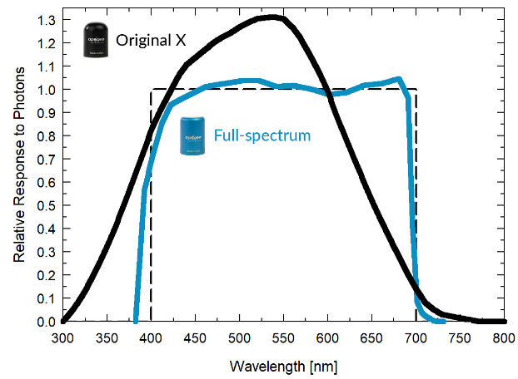

**Temperature Response**

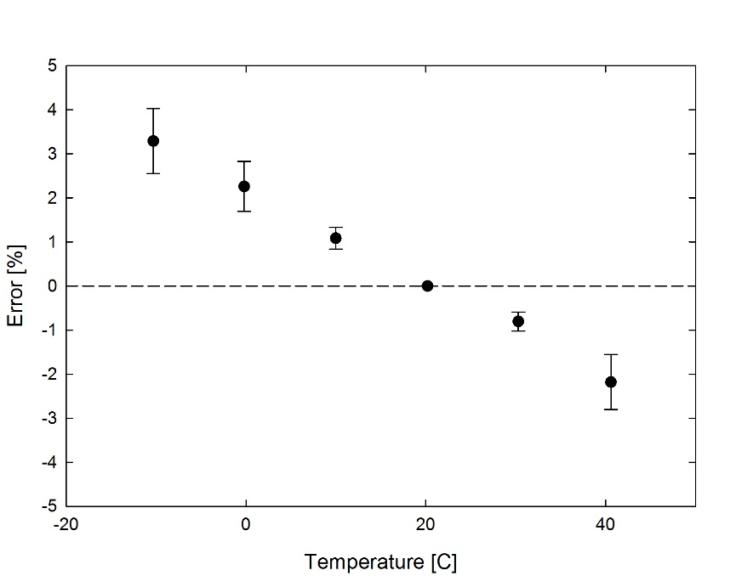

Mean temperature response of ten MQ-500 series quantum sensors (***errors bars represent two standard deviations above and below mean***). Temperature response measurements were made at 10 C intervals across a temperature range of approximately -10 to 40 C in a temperature controlled chamber under a fixed, broad spectrum, electric lamp. At each temperature set point, a spectroradiometer was used to measure light intensity from the lamp and all quantum sensors were compared to the spectroradiometer. The spectroradiometer was mounted external to the temperature control chamber and remained at room temperature during the experiment.

**Cosine Response**

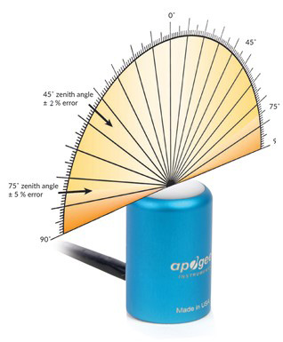

Directional (cosine) response is defined as the measurement error at a specific angle of radiation incidence. Error for Apogee MQ-500 series quantum sensors is approximately ± 2 % and ± 5 % at solar zenith angles of 45° and 75°, respectively.

Mean directional (cosine) response of seven apogee MQ-500 series quantum sensors. Directional response measurements were made on the rooftop of the Apogee building in Logan, Utah. Directional response was calculated as the relative difference of MQ-500 quantum sensors from the mean of replicate reference quantum sensors (LI-COR models LI-190 and LI-190R, Kipp & Zonen model PQS 1). Data were also collected in the laboratory using a reference lamp and positioning the sensor at varying angles.

was calculated as the relative difference of SQ-500 quantum sensors from the mean of replicate reference quantum sensors (LI-COR models LI-190 and LI-190R, Kipp & Zonen model PQS 1).

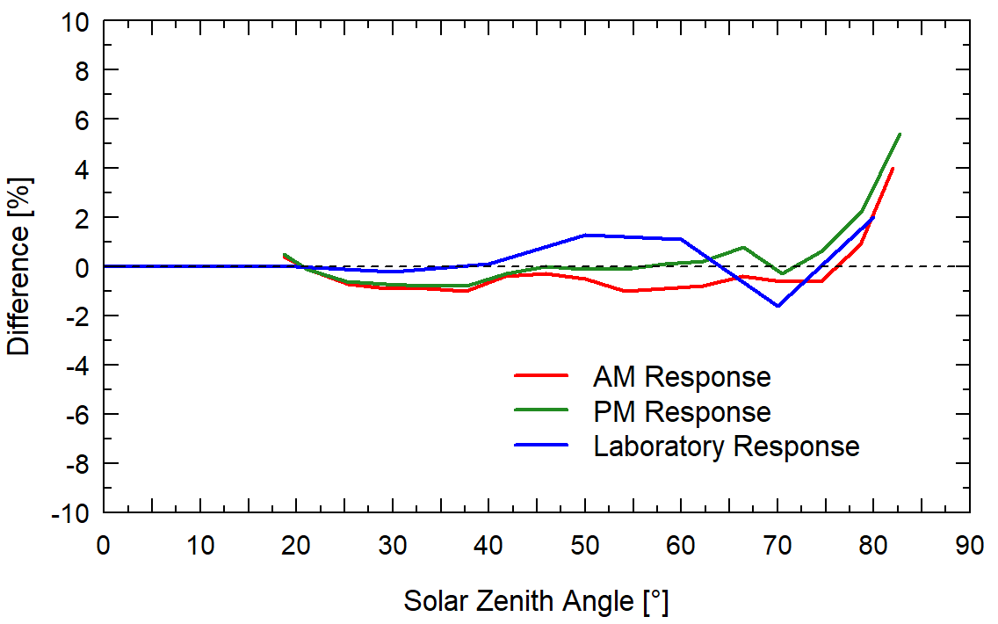

### Deployment and Installation

Apogee MQ series quantum meters are designed for spot-check measurements, and calculation of daily light integral (DLI; total number of photons incident on a planar surface over the course of a day) through the built-in logging feature. To accurately measure PFFD incident on a horizontal surface, the sensor must be level. The AL-100 accessory leveling plate is recommended for use with the MQ-510 to ensure the sensor is level when attached to a cross-arm. The bubble-level in the plate makes leveling simple and accurate.

MQ-510 sensor attached to an AL-100 leveling plate.

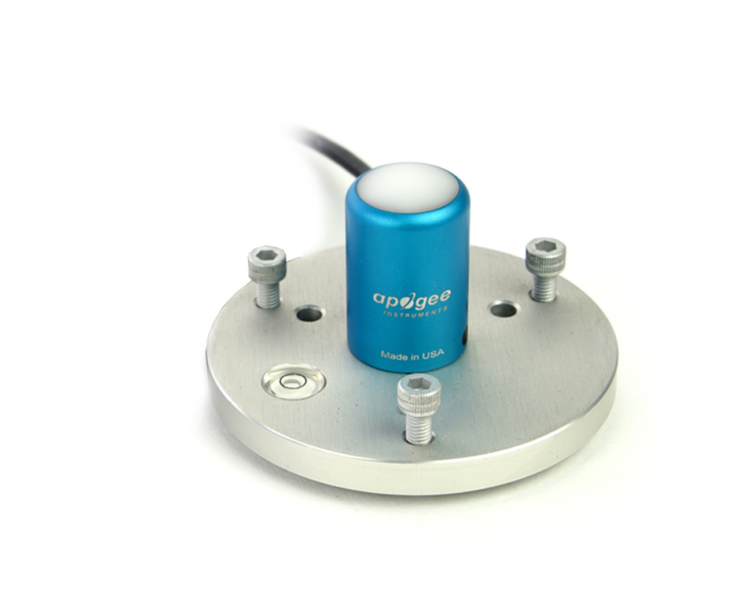

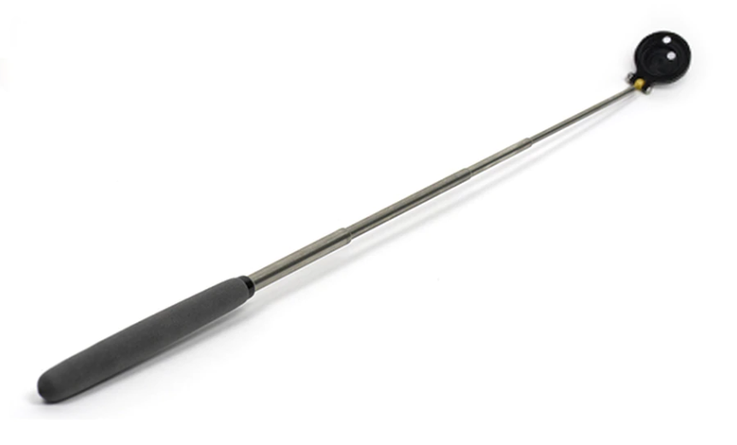The AM-310 Sensor Wand accessory incorporates a mounting fixture at the end of an extendable telescopic wand (up to 33 inches/84 cm). The wand is not suited for wet environments; however, it is excellent for greenhouses and growth chambers. Its ability to retract to a smaller size also makes it ideal for travel use.

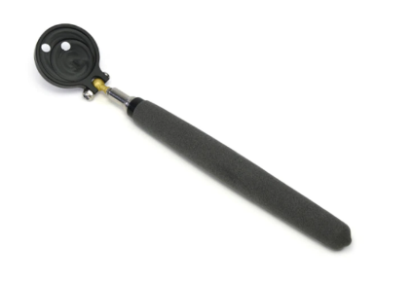

AM-310 Extendable Sensor Wand

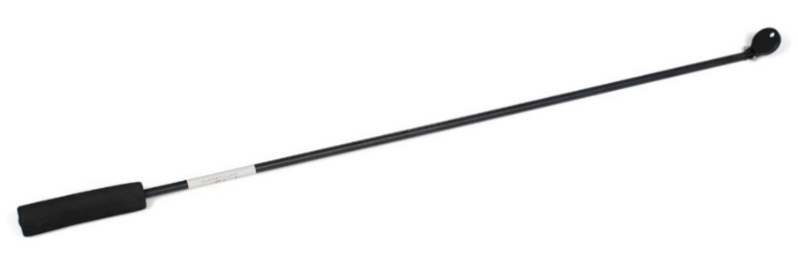The AM-320 Saltwater Submersible Sensor Wand accessory incorporates a mounting fixture at the end of a 40-inch segmented fiberglass wand and is well-suited for saltwater use. The wand allows the user to place the sensor in hard to reach areas such as aquariums.

AM-320 Saltwater Submersible Sensor Wand

**NOTE:** The handheld meter portion of the instrument is **not** waterproof. Do **not** get the meter wet or leave the meter in high humidity environments for prolonged periods of time. Doing so can lead to corrosion that could void the warranty.

### Battery Installation and Replacement

Use a Phillips head screwdriver to remove the screw from the battery cover. Remove the battery cover by slightly lifting and sliding the outer edge of the cover away from the meter.

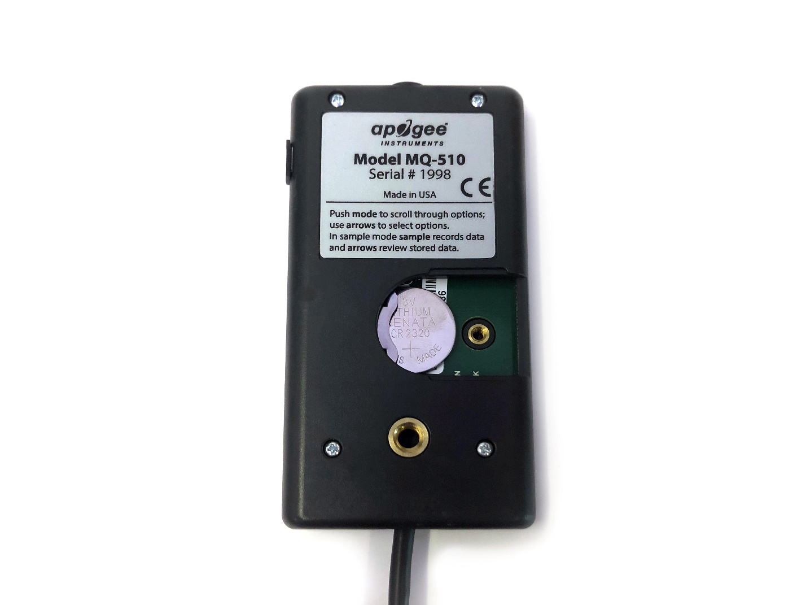To power the meter, slide the included battery (**CR2320**) into the battery holder, after removing the battery door from the meter’s back panel.

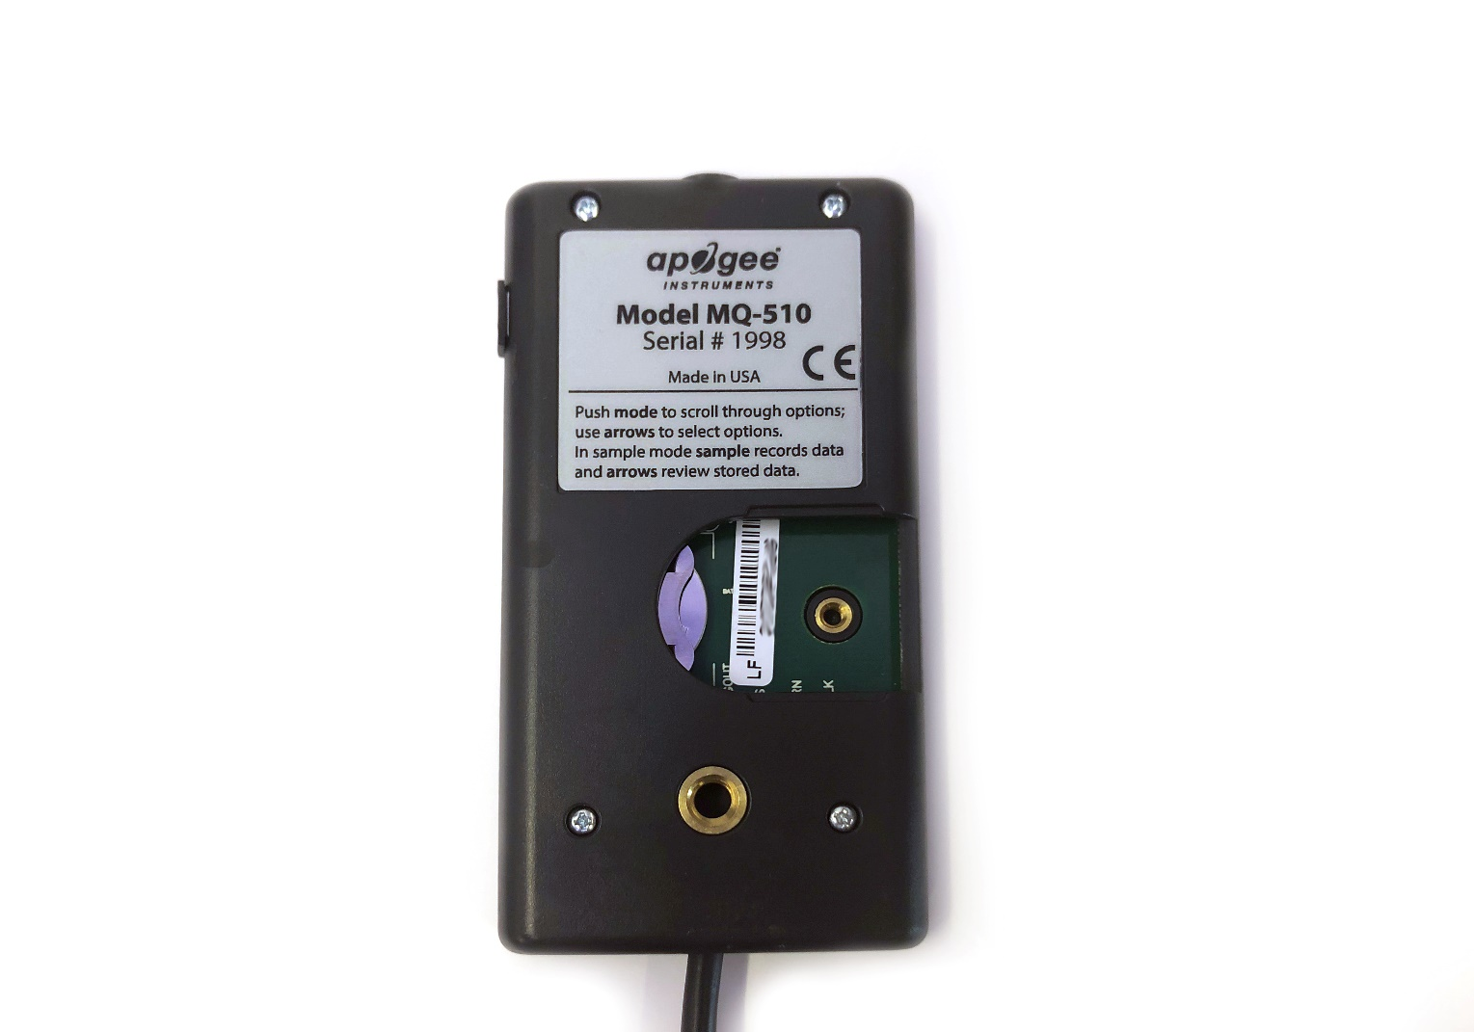

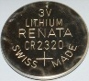

The positive side (designated by a “+” sign) should be facing out from the meter circuit board.

**NOTE:** The battery cradle can be damaged by using an incorrectly sized battery. If the battery cradle is damaged, the circuit board will need to be replaced and the warranty will be void. To avoid this costly problem, **use only a CR2320 battery**.

**Battery Removal**

Press down on the battery with a screwdriver or similar object. Slide battery out.

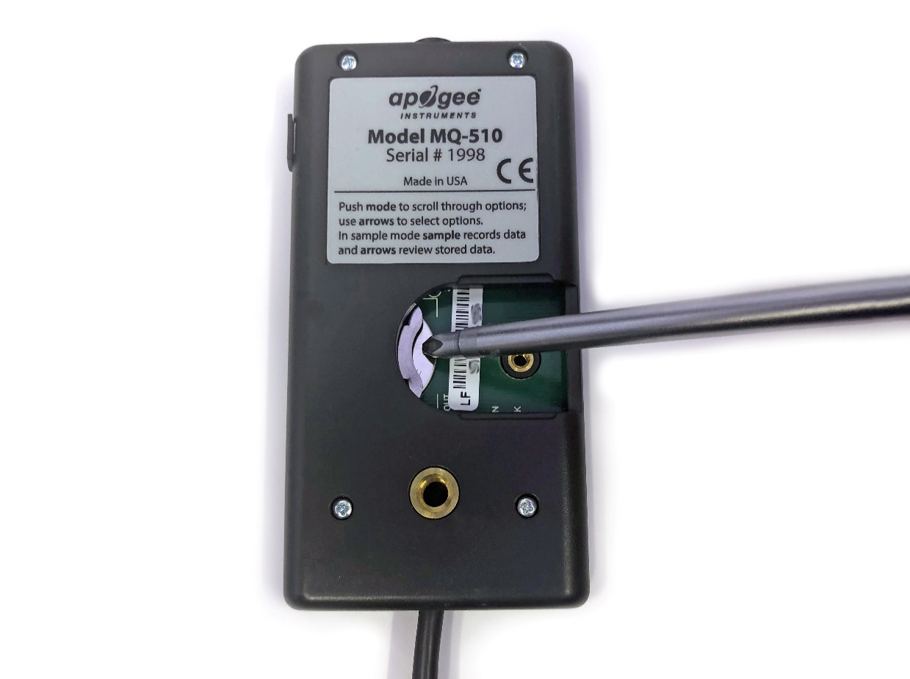

If the battery is difficult to move, turn the meter on its side so that the opening for the battery is facing downward and tap the meter downward against an open palm to dislodge the battery enough so that it can be removed with your thumb to slide the battery out of the battery holder.

### Operation and Measurement

MQ series quantum meters are designed with a user-friendly interface allowing quick and easy measurements.

Press the power button to activate the LCD display. After two minutes of non-activity the meter will revert to sleep mode and the display will shut off to conserve battery life.

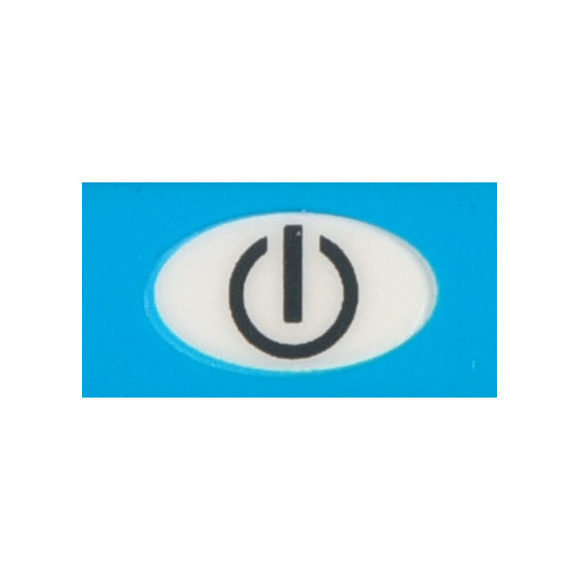

Press the mode button to access the main menu, where manual or automatic logging are selected, and where the meter can be reset.

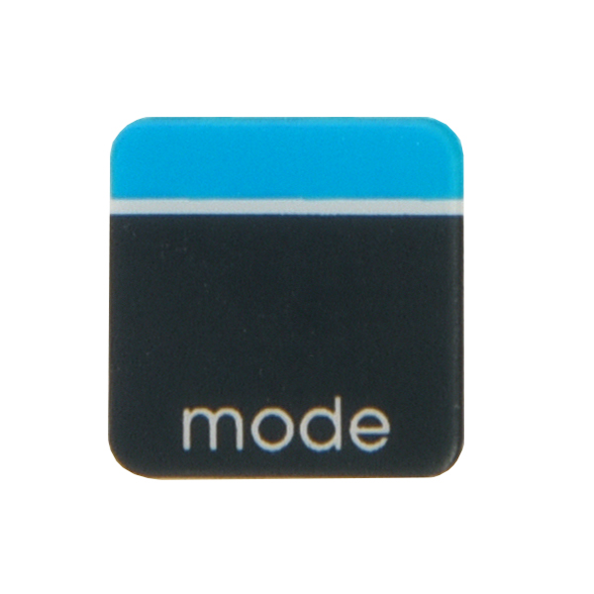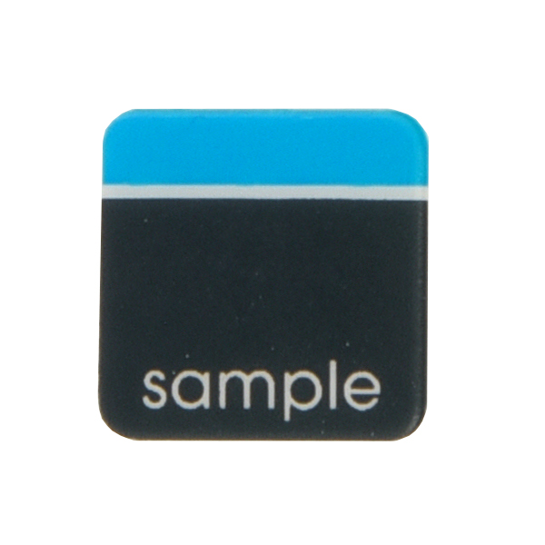

­­­Press the sample button to log a reading while taking manual measurements.

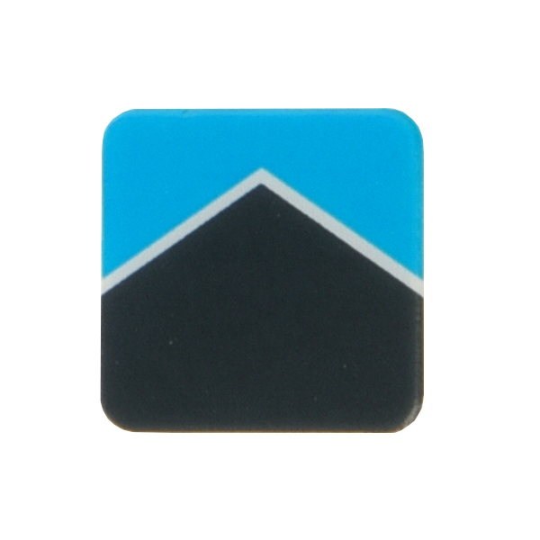

Press the up button to make selections in the main menu. This button is also used to view and scroll through the logged measurements on the LCD display.

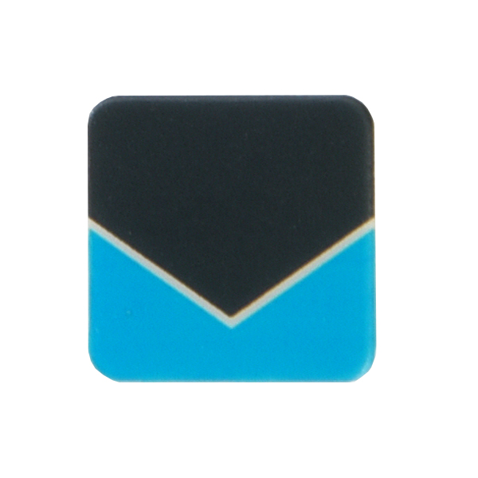

Press the down button to make selections in the main menu. This button is also used to view and scroll through the logged measurements on the LCD display.

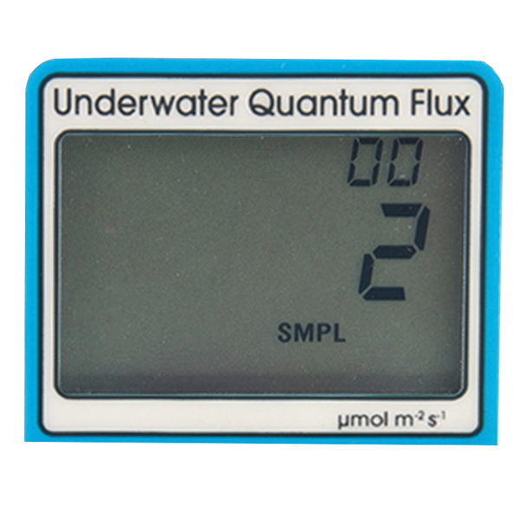

The LCD display consists of the total number of logged measurements in the upper right hand corner, the real-time PPFD value in the center, and the selected menu options along the bottom.

**Logging:** To choose between manual or automatic logging, push the mode button once and use the up/down buttons to make the appropriate selection (SMPL or LOG). Once the desired mode is blinking, press the mode button two more times to exit the menu. When in SMPL mode press the sample button to record up to 99 manual measurements (a counter in the upper right hand corner of the LCD display indicates the total number of saved measurements). When in LOG mode the meter will power on/off to make a measurement every 30 seconds. Every 30 minutes the meter will average the sixty 30 second measurements and record the averaged value to memory. The meter can store up to 99 averages and will start to overwrite the oldest measurement once there are 99 measurements. Every 48 averaged measurements (making a 24 hour period), the meter will also store an integrated daily total in moles per meter squared per day (mol m-2 d-1).

**Reset:** To reset the meter, in either SMPL or LOG mode, push the mode button three times (RUN should be blinking), then while pressing the down button, press the mode button once. This will erase all of the saved measurements in memory, but only for the selected mode. That is, performing a reset when in SMPL mode will only erase the manual measurements and performing a reset when in LOG mode will only erase the automatic measurements.

**Review/Download Data:** Each of the logged measurements in either SMPL or LOG mode can be reviewed on the LCD display by pressing the up/down buttons. To exit and return to the real-time readings, press the sample button. Note that the integrated daily total values are not accessible through the LCD and can only be viewed by downloading to a computer.

Downloading the stored measurements will require the AC-100 communication cable and software (sold separately). The meter outputs data using the UART protocol and requires the AC-100 to convert from UART to USB, so standard USB cables will not work. Set up instructions and software can be downloaded from the Apogee website (<http://www.apogeeinstruments.com/ac-100-communcation-cable/>).



**Spectral Error**

The combination of diffuser transmittance, interference filter transmittance, and photodetector sensitivity yields spectral response of a quantum sensor. A perfect photodetector/filter/diffuser combination would exactly match the defined plant photosynthetic response to photons (equal weighting to all photons between 400 and 700 nm, no weighting of photons outside this range), but this is challenging in practice. Mismatch between the defined plant photosynthetic response and sensor spectral response results in spectral error when the sensor is used to measure radiation from sources with a different spectrum than the radiation source used to calibrate the sensor (Federer and Tanner, 1966; Ross and Sulev, 2000).

Spectral errors for PPFD measurements made under common radiation sources for growing plants were calculated for Apogee SQ-100 and SQ-500 series quantum sensors using the method of Federer and Tanner (1966). This method requires PPFD weighting factors (defined plant photosynthetic response), measured sensor spectral response (shown in Spectral Response section on page 7), and radiation source spectral outputs (measured with a spectroradiometer). Note, this method calculates spectral error only and does not consider calibration, directional (cosine), temperature, and stability/drift errors. Spectral error data (listed in table below) indicate errors less than 5 % for sunlight in different conditions (clear, cloudy, reflected from plant canopies, transmitted below plant canopies) and common broad spectrum electric lamps (cool white fluorescent, metal halide, high pressure sodium), but larger errors for different mixtures of light emitting diodes (LEDs) for the SQ-100 series sensors. Spectral errors for the SQ-500 series sensors are smaller than those for SQ-100 series sensors because the spectral response of SQ-500 series sensors is a closer match to the defined plant photosynthetic response.

Quantum sensors are the most common instrument for measuring PPFD, because they are about an order of magnitude lower cost the spectroradiometers, but spectral errors must be considered. The spectral errors in the table below can be used as correction factors for individual radiation sources.

**Spectral Errors for PPFD Measurements with Apogee SQ-100x and SQ-500 Series Quantum Sensors**

|  |  |  |
| --- | --- | --- |
| **Radiation Source (Error Calculated Relative to Sun, Clear Sky)** | **SQ-100X Series**  **PPFD Error [%]** | **SQ-500 Series**  **PPFD Error [%]** |
| Sun (Clear Sky) | 0.0 | 0.0 |
| Sun (Cloudy Sky) | 0.2 | 0.1 |
| Reflected from Grass Canopy | 5.0 | -0.3 |
| Transmitted below Wheat Canopy | 7.0 | 0.1 |
| Cool White Fluorescent (T5) | 7.2 | 0.1 |
| Metal Halide | 6.9 | 0.9 |
| Ceramic Metal Halide | -8.8 | 0.3 |
| High Pressure Sodium | 3.3 | 0.1 |
| Blue LED (448 nm peak, 20 nm full-width half-maximum) | 14.5 | -0.7 |
| Green LED (524 nm peak, 30 nm full-width half-maximum) | 29.6 | 3.2 |
| Red LED (635 nm peak, 20 nm full-width half-maximum) | -30.9 | 0.8 |
| Red LED (667 nm peak, 20 nm full-width half-maximum) | -56.7 | 2.8 |
| Red, Blue LED Mixture (80 % Red, 20 % Blue) | -21.2 | -3.9 |
| Red, Blue, White LED Mixture (60 % Red, 25 % White, 15 % Blue) | -29.7 | -2.0 |
| Cool White LED | 7.3 | 0.5 |
| Warm White LED | -7.8 | 0.2 |

Federer, C.A., and C.B. Tanner, 1966. Sensors for measuring light available for photosynthesis. Ecology 47:654-657.

Ross, J., and M. Sulev, 2000. Sources of errors in measurements of PAR. Agricultural and Forest Meteorology 100:103-125.

**Yield Photon Flux Density (YPFD) Measurements**

Photosynthesis in plants does not respond equally to all photons. Relative quantum yield (plant photosynthetic efficiency) is dependent on wavelength (green line in figure below) (McCree, 1972a; Inada, 1976). This is due to the combination of spectral absorptivity of plant leaves (absorptivity is higher for blue and red photons than green photons) and absorption by non-photosynthetic pigments. As a result, photons in the wavelength range of approximately 600-630 nm are the most efficient.

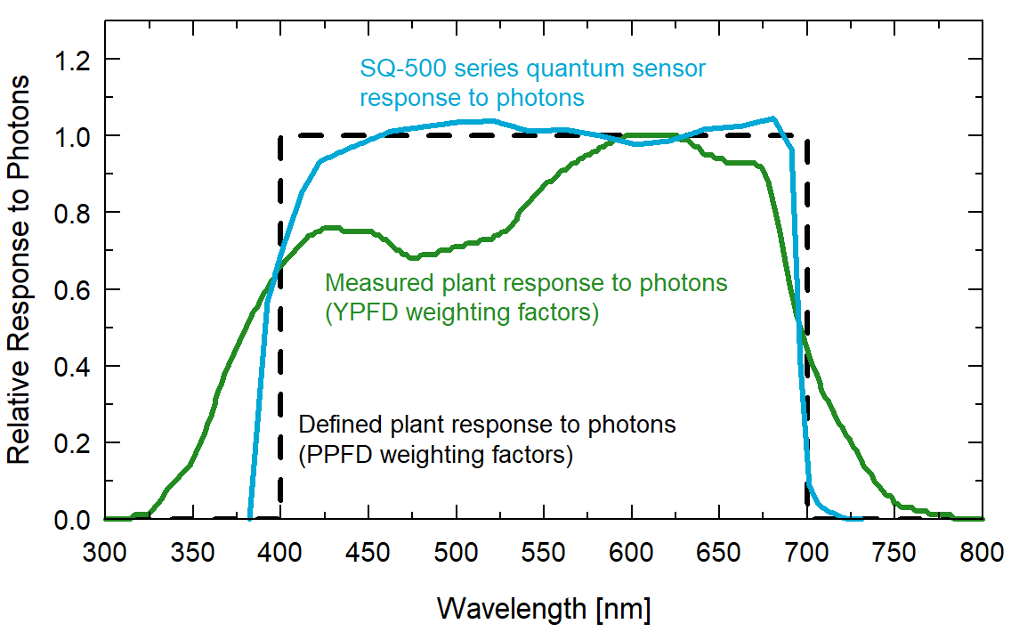

Defined plant response to photons (black line, weighting factors used to calculate PPFD), measured plant response to photons (green line, weighting factors used to calculate YPFD), and SQ-500 series quantum sensor response to photons (sensor spectral response).

One potential definition of PAR is weighting photon flux density in units of mol m-2 s-1 at each wavelength between 300 and 800 nm by measured relative quantum yield and summing the result. This is defined as yield photon flux density (YPFD, units of mol m-2 s-1) (Sager et al., 1988). There are uncertainties and challenges associated with this definition of PAR. Measurements used to generate the relative quantum yield data were made on single leaves under low radiation levels and at short time scales (McCree, 1972a; Inada, 1976). Whole plants and plant canopies typically have multiple leaf layers and are generally grown in the field or greenhouse over the course of an entire growing season. Thus, actual conditions plants are subject to are likely different than those the single leaves were in when measurements were made by McCree (1972a) and Inada (1976). In addition, relative quantum yield shown in the figure above is the mean from twenty-two species grown in the field (McCree, 1972a). Mean relative quantum yield for the same species grown in growth chambers was similar, but there were differences, particularly at shorter wavelengths (less than 450 nm). There was also some variability between species (McCree, 1972a; Inada, 1976).

McCree (1972b) found that equally weighting all photons between 400 and 700 nm and summing the result, defined as photosynthetic photon flux density (PPFD, in units of mol m-2 s-1), was well correlated to photosynthesis, and very similar to correlation between YPFD and photosynthesis. As a matter of practicality, PPFD is a simpler definition of PAR. At the same time as McCree’s work, others had proposed PPFD as an accurate measure of PAR and built sensors that approximated the PPFD weighting factors (Biggs et al., 1971; Federer and Tanner, 1966). Correlation between PPFD and YPFD measurements for several radiation sources is very high (figure below), as an approximation, YPFD = 0.9PPFD. As a result, almost universally PAR is defined as PPFD rather than YPFD, although YPFD has been used in some studies. The only radiation sources shown (figure below) that don’t fall on the regression line are the high pressure sodium (HPS) lamp, reflection from a plant canopy, and transmission below a plant canopy. A large fraction of radiation from HPS lamps is in the red range of wavelengths where the YPFD weighting factors (measured relative quantum yield) are at or near one. The factor for converting PPFD to YPFD for HPS lamps is 0.95, rather than 0.90. The factor for converting PPFD to YPFD for reflected and transmitted photons is 1.00.

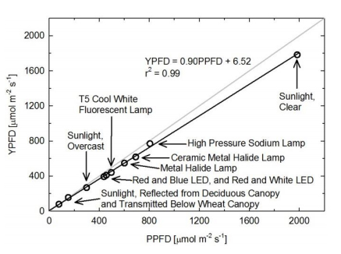

Correlation between photosynthetic photon flux density (PPFD) and yield photon flux density (YPFD) for multiple different radiation sources. YPFD is approximately 90 % of PPFD. Measurements were made with a spectroradiometer (Apogee Instruments model PS-200) and weighting factors shown in the previous figure were used to calculate PPFD and YPFD.

Biggs, W., A.R. Edison, J.D. Eastin, K.W. Brown, J.W. Maranville, and M.D. Clegg, 1971. Photosynthesis light sensor and meter. Ecology 52:125-131.

Federer, C.A., and C.B. Tanner, 1966. Sensors for measuring light available for photosynthesis. Ecology 47:654-657.

Inada, K., 1976. Action spectra for photosynthesis in higher plants. Plant and Cell Physiology 17:355-365.

McCree, K.J., 1972a. The action spectrum, absorptance and quantum yield of photosynthesis in crop plants. Agricultural Meteorology 9:191-216.

McCree, K.J., 1972b. Test of current definitions of photosynthetically active radiation against leaf photosynthesis data. Agricultural Meteorology 10:443-453.

Sager, J.C., W.O. Smith, J.L. Edwards, and K.L. Cyr, 1988. Photosynthetic efficiency and phytochrome photoequilibria determination using spectral data. Transactions of the ASAE 31:1882-1889.

**Underwater Measurements and Immersion Effect**

When a quantum sensor that was calibrated in air is used to make underwater measurements, the sensor reads low. This phenomenon is called the immersion effect and happens because the refractive index of water (1.33) is greater than air (1.00). The higher refractive index of water causes more light to be backscattered (or reflected) out of the sensor in water than in air (Smith,1969; Tyler and Smith,1970). As more light is reflected, less light is

**Immersion Effect Correction Factor**

When a radiation sensor is submerged in water, more of the incident radiation is backscattered out of the diffuser than when the sensor is in air (Smith, 1969; Tyler and Smith, 1970). This phenomenon is caused by the difference in the refractive index for air (1.00) and water (1.33), and is called the immersion effect. Without correction for the immersion effect, radiation sensors calibrated in air can only provide relative values underwater (Smith, 1969; Tyler and Smith, 1970). Immersion effect correction factors can be derived by making measurements in air and at multiple water depths at a constant distance from a lamp in a controlled laboratory setting.

The MQ-510 sensor has an immersion effect correction factor of 1.25. The immersion effect correction factor is already accounted for in the MQ-510 meter firmware so there is no need to apply the correction factor to your measurements. If you wish to use your meter to make measurements in air, simply divide the measured number by the immersion effect (1.25).

When making underwater measurements, only the sensor and cable can go in the water. The handheld meter is not waterproof and must not get wet. If the meter might get wet from splashing, we recommend placing it in a plastic bag or other container to help protect it from accidentally getting wet. Getting the meter wet can lead to corrosion that could void the warranty.

Further information on underwater measurements and the immersion effect can be found on the Apogee webpage (<http://www.apogeeinstruments.com/underwater-par-measurements/>).

Smith, R.C., 1969. An underwater spectral irradiance collector. Journal of Marine Research 27:341-351.

Tyler, J.E., and R.C. Smith, 1970. Measurements of Spectral Irradiance Underwater. Gordon and Breach, New York, New York. 103 pages.

### Apogee AMS Software

Downloading data to a computer requires the [AC-100 communication cable](https://www.apogeeinstruments.com/ac-100-communication-cable/) and the free ApogeeAMS software. The meter outputs data using the UART protocol and requires the AC-100 to convert from UART to USB, so standard USB cables will not work.

**The most recent version of ApogeeAMS software can be downloaded at** [**http://www.apogeeinstruments.com/downloads/**](http://www.apogeeinstruments.com/downloads/)**.**

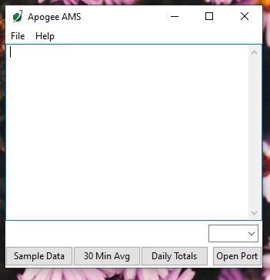

When the ApogeeAMS software is first opened, it will show a blank screen until communication with the meter is established. If you click “Open Port” it will say “connection failed.”

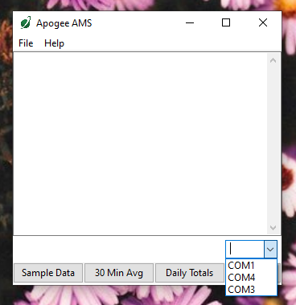

To establish communication, make sure the meter is plugged into your computer using the AC-100 communication cable. To connect click the dropdown menu button and “COM#” options will appear. For more details on how to figure out which COM is the right one, [watch our video](https://youtu.be/-lvw3rqOF5w?t=432).

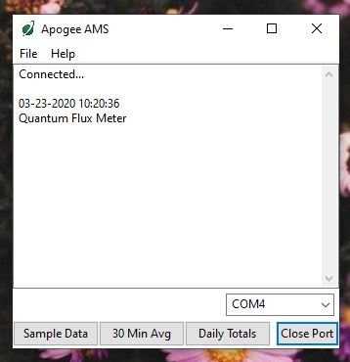

When you have connected to the correct COM#, the software will say “Connected”.

Click “Sample Data” to view saved sample readings.

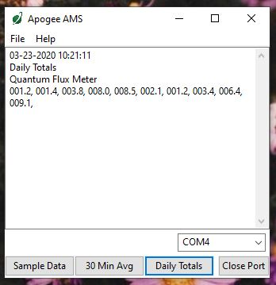

“Daily Totals” shows all of the saved Daily Light Integral (DLI) totals per day.

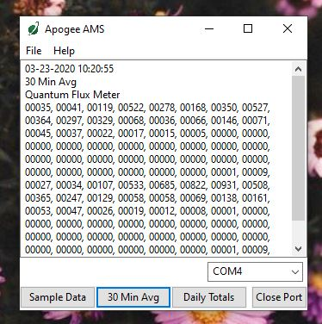

Click “30 Min Avg” to see the meter’s 99, 30-minute averages.

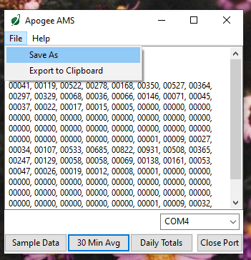

To analyze the data, click on “File” and “Save As” to save the data as a .csv file.

Or, you can highlight the numbers, copy, and paste them into a blank Excel spreadsheet. Data will need to be comma delimited.

### Maintenance and Recalibration

Blocking of the optical path between the target and detector can cause low readings. Occasionally, accumulated materials on the diffuser of the upward-looking sensor can block the optical path in three common ways:

1. Moisture or debris on the diffuser.
2. Dust during periods of low rainfall.
3. Salt deposit accumulation from evaporation of sea spray or sprinkler irrigation water.

Apogee Instruments upward-looking sensors have a domed diffuser and housing for improved self-cleaning from rainfall, but active cleaning may be necessary. Dust or organic deposits are best removed using water, or window cleaner, and a soft cloth or cotton swab. Salt deposits should be dissolved with vinegar and removed with a cloth or cotton swab. **Salt deposits cannot be removed with solvents such as alcohol or acetone.** Use only gentle pressure when cleaning the diffuser with a cotton swab or soft cloth to avoid scratching the outer surface. The solvent should be allowed to do the cleaning, not mechanical force. **Never use abrasive material or cleaner on the diffuser.**

Although Apogee sensors are very stable, nominal accuracy drift is normal for all research-grade sensors. To ensure maximum accuracy, we generally recommend sensors are sent in for recalibration every two years, although you can often wait longer according to your particular tolerances.

To determine if a specific sensor needs recalibration, the Clear Sky Calculator ([www.clearskycalculator.com](http://www.clearskycalculator.com)) website and/or smartphone app can be used to indicate PPFD incident on a horizontal surface at any time of day at any location in the world. It is most accurate when used near solar noon in spring and summer months, where accuracy over multiple clear and unpolluted days is estimated to be ± 4 % in all climates and locations around the world. For best accuracy, the sky must be completely clear, as reflected radiation from clouds causes incoming radiation to increase above the value predicted by the clear sky calculator. Measured PPFD can exceed PPFD predicted by the Clear Sky Calculator due to reflection from thin, high clouds and edges of clouds, which enhances incident PPFD. The influence of high clouds typically shows up as spikes above clear sky values, not a constant offset greater than clear sky values.

To determine recalibration need, input site conditions into the calculator and compare PPFD measurements to calculated PPFD for a clear sky. If sensor PPFD measurements over multiple days near solar noon are consistently different than calculated PPFD (by more than 6 %), the sensor should be cleaned and re-leveled. If measurements are still different after a second test, email [calibration@apogeeinstruments.com](mailto:calibration@apogeeinstruments.com) to discuss test results and possible return of sensor(s).

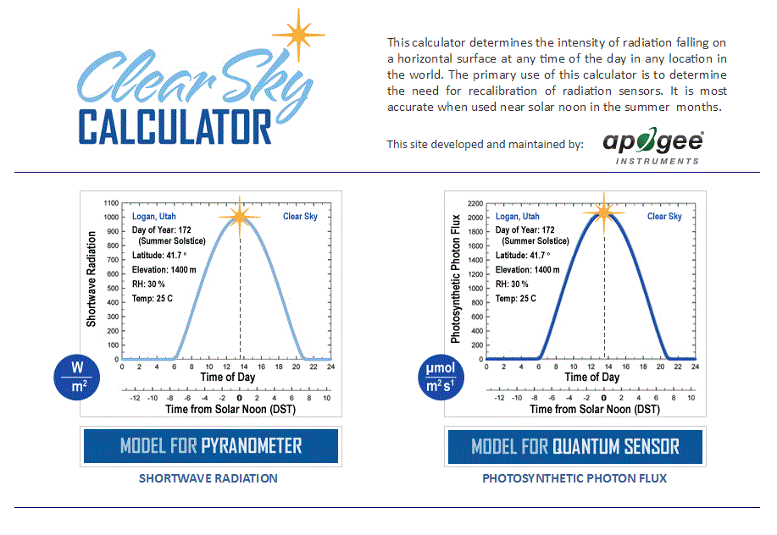

Homepage of the Clear Sky Calculator. Two calculators are available: one for quantum sensors (PPFD) and one for pyranometers (total shortwave radiation).

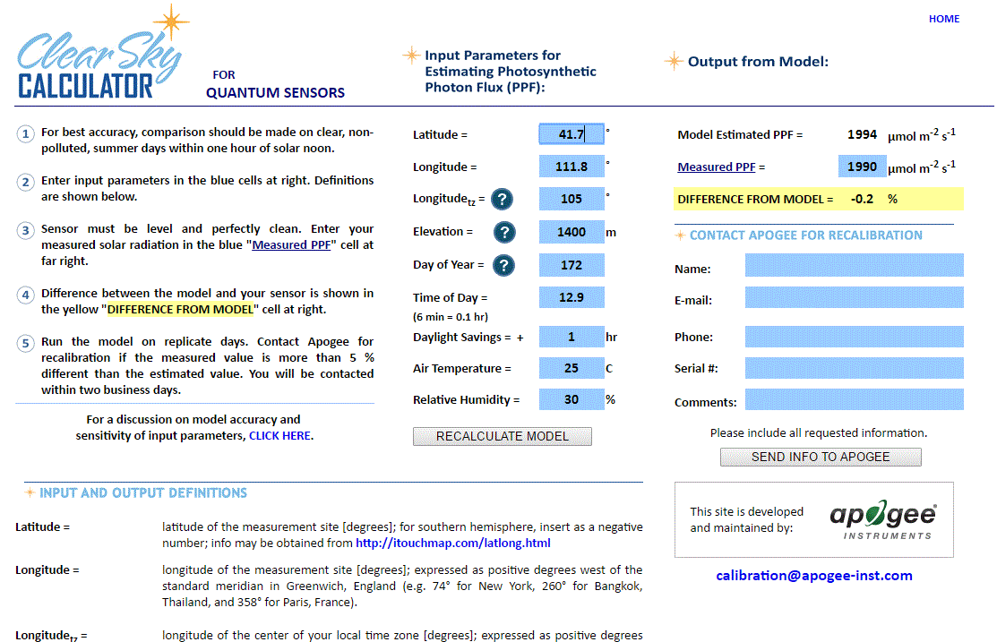

Clear Sky Calculator for quantum sensors. Site data are input in blue cells in middle of page and an estimate of PPFD is returned on right-hand side of page.

### Troubleshooting and Customer Support

**Verify Functionality**

Pressing the power button should activate the LCD and provide a real-time PPFD reading. Direct the sensor head toward a light source and verify the PPFD reading responds. Increase and decrease the distance from the sensor to the light source to verify that the reading changes proportionally (decreasing PPFD with increasing distance and increasing PPFD with decreasing distance). Blocking all radiation from the sensor should force the PPFD reading to zero.

**Battery Life**

When the meter is maintained properly the coin cell battery (CR2320) should last for many months, even after continuous use. The low battery indicator will appear in the upper left hand corner of the LCD display when the battery voltage drops below 2.8 V DC. The meter will still function correctly for some time, but once the battery is drained the pushbuttons will no longer respond and any logged measurements will be lost.

Pressing the power button to turn off the meter will actually put it in sleep mode, where there is still a slight amount of current draw. This is necessary to maintain the logged measurements in memory. Therefore, it is recommended to remove the battery when storing the meter for many months at a time, in order to preserve battery life.

**Low-Battery Error after Battery Replacement**

A master reset will usually correct this error, please see the master reset section for details and cautions. If a master reset does not remove the low battery indicator, please double check that the voltage of your new battery is above 2.8 V, this is the threshold for the indicator to turn on.

**Master Reset**

If a meter ever becomes non-responsive or experiences anomalies, such as a low battery indicator even after replacing the old battery, a master reset can be performed that may correct the problem. Note that a master reset will erase all logged measurements from memory.

Step 1: press the power button so that the LCD display is activated.

Step 2: Slide the battery out of the holder, which will cause the LCD display to fade out.

Step 3: After a few seconds, slide the battery back into the holder.

The LCD display will flash all segments and then show a revision number (e.g. “R1.0”). This indicates the master reset was performed and the display should return to normal.

**Error Codes and Fixes**

Error codes will appear in place of the real-time reading on the LCD display and will continue to flash until the problem is corrected. Contact Apogee if the following fixes do not rectify the problem.

**Err 1:** battery voltage out of range. **Fix:** replace CR2320 battery and perform master reset.

**Err 2:** sensor voltage out of range. **Fix:** perform master reset.

**Err 3:** not calibrated. **Fix:** perform master reset.

**Err 4:** CPU voltage below minimum. **Fix:** replace CR2320 battery and perform master reset.

**Modifying Cable Length**

Although it is possible to splice additional cable to the separate sensor of the appropriate MQ model, note that the cable wires are soldered directly into the circuit board of the meter. Care should be taken to remove the back panel of the meter in order to access the board and splice on the additional cable, otherwise two splices would need to be made between the meter and sensor head. See Apogee webpage for further details on how to extend sensor cable length: (<http://www.apogeeinstruments.com/how-to-make-a-weatherproof-cable-splice/>).

**Unit Conversion Charts**

Apogee SQ-500 series quantum sensors are calibrated to measure PPFD in units of µmol m-2 s-1. Units other than photon flux density (e.g., energy flux density, illuminance) may be required for certain applications. It is possible to convert PPFD from a quantum sensor to other units, but it requires spectral output of the radiation source of interest. Conversion factors for common radiation sources can be found in the Knowledge Base on the Apogee website (<http://www.apogeeinstruments.com/knowledge-base/>; scroll down to Quantum Sensors section). A spreadsheet to convert PPFD to energy flux density or illuminance is also provided in the Knowledge Base on the Apogee website (<http://www.apogeeinstruments.com/content/PPFD-to-Illuminance-Calculator.xls>).

### Return and Warranty Policy

RETURN POLICY

Apogee Instruments will accept returns within 30 days of purchase as long as the product is in new condition (to be determined by Apogee). Returns are subject to a 10 % restocking fee.

WARRANTY POLICY

**What is Covered**All products manufactured by Apogee Instruments are warranted to be free from defects in materials and craftsmanship for a period of four (4) years from the date of shipment from our factory. To be considered for warranty coverage an item must be evaluated by Apogee.

Products not manufactured by Apogee (spectroradiometers, chlorophyll content meters, EE08-SS probes) are covered for a period of one (1) year.

**What is Not Covered**The customer is responsible for all costs associated with the removal, reinstallation, and shipping of suspected warranty items to our factory.

The warranty does not cover equipment that has been damaged due to the following conditions:

1. Improper installation, use, or abuse.

2. Operation of the instrument outside of its specified operating range.

3. Natural occurrences such as lightning, fire, etc.

4. Unauthorized modification.

5. Improper or unauthorized repair.

Please note that nominal accuracy drift is normal over time. Routine recalibration of sensors/meters is considered part of proper maintenance and is not covered under warranty.

**Who is Covered**This warranty covers the original purchaser of the product or other party who may own it during the warranty period.

**What Apogee Will Do**At no charge Apogee will:

1. Either repair or replace (at our discretion) the item under warranty.

2. Ship the item back to the customer by the carrier of our choice.

Different or expedited shipping methods will be at the customer’s expense.

**How To Return An Item**1. Please do not send any products back to Apogee Instruments until you have received a Return Merchandise Authorization (RMA) number from our technical support department by submitting an online RMA form at [www.apogeeinstruments.com/tech-support-recalibration-repairs/](http://www.apogeeinstruments.com/tech-support-recalibration-repairs/). We will use your RMA number for tracking of the service item. Call (435) 245-8012 or email techsupport@apogeeinstruments.com with questions.

2. For warranty evaluations, send all RMA sensors and meters back in the following condition: Clean the sensor’s exterior and cord. Do not modify the sensors or wires, including splicing, cutting wire leads, etc. If a connector has been attached to the cable end, please include the mating connector – otherwise the sensor connector will be removed in order to complete the repair/recalibration. ***Note:*** *When sending back sensors for routine calibration that have Apogee’s standard stainless-steel connectors, you only need to send the sensor with the 30 cm section of cable and one-half of the connector. We have mating connectors at our factory that can be used for calibrating the sensor.*

3. Please write the RMA number on the outside of the shipping container.

4. Return the item with freight pre-paid and fully insured to our factory address shown below. We are not responsible for any costs associated with the transportation of products across international borders.

**Apogee Instruments, Inc.   
721 West 1800 North Logan, UT  
84321, USA**

5. Upon receipt, Apogee Instruments will determine the cause of failure. If the product is found to be defective in terms of operation to the published specifications due to a failure of product materials or craftsmanship, Apogee Instruments will repair or replace the items free of charge. If it is determined that your product is not covered under warranty, you will be informed and given an estimated repair/replacement cost.

Products Beyond the Warranty Period

For issues with sensors beyond the warranty period, please contact Apogee at [techsupport@apogeeinstruments.com](mailto:techsupport@apogeeinstruments.com) to discuss repair or replacement options.

Other Terms

The available remedy of defects under this warranty is for the repair or replacement of the original product, and Apogee Instruments is not responsible for any direct, indirect, incidental, or consequential damages, including but not limited to loss of income, loss of revenue, loss of profit, loss of data, loss of wages, loss of time, loss of sales, accruement of debts or expenses, injury to personal property, or injury to any person or any other type of damage or loss.

This limited warranty and any disputes arising out of or in connection with this limited warranty ("Disputes") shall be governed by the laws of the State of Utah, USA, excluding conflicts of law principles and excluding the Convention for the International Sale of Goods. The courts located in the State of Utah, USA, shall have exclusive jurisdiction over any Disputes.

This limited warranty gives you specific legal rights, and you may also have other rights, which vary from state to state and jurisdiction to jurisdiction, and which shall not be affected by this limited warranty. This warranty extends only to you and cannot by transferred or assigned. If any provision of this limited warranty is unlawful, void, or unenforceable, that provision shall be deemed severable and shall not affect any remaining provisions. In case of any inconsistency between the English and other versions of this limited warranty, the English version shall prevail.

This warranty cannot be changed, assumed, or amended by any other person or agreement

**APOGEE INSTRUMENTS, INC. |** 721 WEST 1800 NORTH, LOGAN, UTAH 84321, USA

TEL: (435) 792-4700 | FAX: (435) 787-8268 | WEB: APOGEEINSTRUMENTS.COM

*Copyright © 2022 Apogee Instruments, Inc.*