

# Owner’s Manual

Infrared Temperature Meter

Models MI-210, MI-220, MI-230, and MI-2H0

Rev: 1-Jun-2021

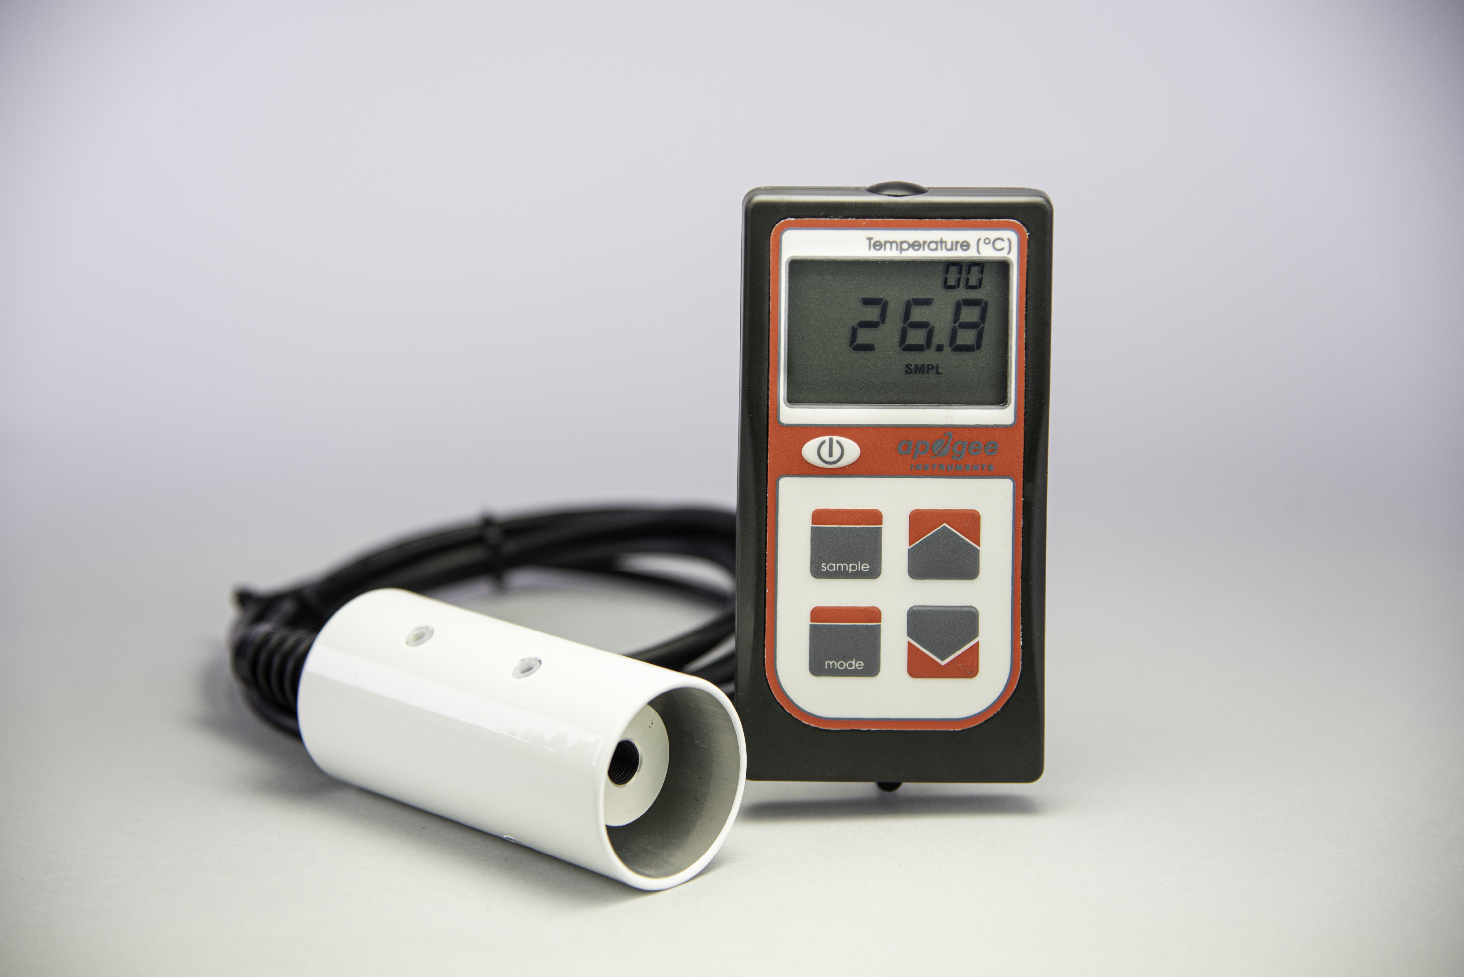

TABLE OF Contents

Owner’s Manual 1

Certificate of Compliance 3

Introduction 4

Sensor Models 5

Specifications 6

Deployment and Installation 7

Battery Installation and Replacement 9

Operation and Measurement 10

Apogee AMS Software 13

Maintenance and Recalibration 15

Troubleshooting and Customer Support 16

Return and Waranty Policy 18

### Certificate of Compliance

**EU Declaration of Conformity**

This declaration of conformity is issued under the sole responsibility of the manufacturer:

Apogee Instruments, Inc.  
721 W 1800 N  
Logan, Utah 84321  
USA

for the following product(s):

Models: MI-210, MI-220, MI-230, MI-2H0

Type: Infrared Radiometer

The object of the declaration described above is in conformity with the relevant Union harmonization legislation:

2014/30/EU Electromagnetic Compatibility (EMC) Directive

2011/65/EU Restriction of Hazardous Substances (RoHS 2) Directive

2015/863/EU Amending Annex II to Directive 2011/65/EU (RoHS 3)

Standards referenced during compliance assessment:

EN 61326-1:2013 Electrical equipment for measurement, control and laboratory use – EMC requirements

EN 50581:2012 Technical documentation for the assessment of electrical and electronic products with respect to the restriction of hazardous substances

Please be advised that based on the information available to us from our raw material suppliers, the products manufactured by us do not contain, as intentional additives, any of the restricted materials including lead (see note below), mercury, cadmium, hexavalent chromium, polybrominated biphenyls (PBB), polybrominated diphenyls (PBDE), bis(2-ethylhexyl) phthalate (DEHP), butyl benzyl phthalate (BBP), dibutyl phthalate (DBP), and diisobutyl phthalate (DIBP). However, please note that articles containing greater than 0.1% lead concentration are RoHS 3 compliant using exemption 6c.

Further note that Apogee Instruments does not specifically run any analysis on our raw materials or end products for the presence of these substances, but rely on the information provided to us by our material suppliers.

Signed for and on behalf of:

Apogee Instruments, June 2021



Bruce Bugbee  
President  
Apogee Instruments, Inc.

### Introduction

All objects with a temperature above absolute zero emit electromagnetic radiation. The wavelengths and intensity of radiation emitted are related to the temperature of the object. Terrestrial surfaces (e.g., soil, plant canopies, water, snow) emit radiation in the mid infrared portion of the electromagnetic spectrum (approximately 4-50 µm).

Infrared radiometers are sensors that measure infrared radiation, which is used to determine surface temperature without touching the surface (when using sensors that must be in contact with the surface, it can be difficult to maintain thermal equilibrium without altering surface temperature). Infrared radiometers are often called infrared thermometers because temperature is the desired quantity, even though the sensors detect radiation.

Typical applications of infrared radiometers include plant canopy temperature measurement for use in plant water status estimation, road surface temperature measurement for determination of icing conditions, and terrestrial surface (soil, vegetation, water, snow) temperature measurement in energy balance studies.

Apogee Instruments MI series infrared meters consist of a handheld meter and a dedicated infrared radiometer, which includes a thermopile detector, germanium filter, precision thermistor (for detector reference temperature measurement), and signal processing circuitry mounted in an anodized aluminum housing. All infrared meters also come with a radiation shield designed to minimize absorbed solar radiation, but still allowing natural ventilation. The radiation shield insulates the radiometer from rapid temperature changes and keeps the temperature of the radiometer closer to the target temperature. The separate sensors are potted solid with no internal air space and are designed for continuous temperature measurement of terrestrial surfaces in indoor and outdoor environments. The meters provide a real-time temperature reading on the LCD display and come equipped with manual and automatic data logging features for making spot-check measurements or monitoring temperature over time.

### Sensor Models

Apogee MI series infrared meters covered in this manual are self-contained and come complete with handheld meter, sensor, and radiation shield.

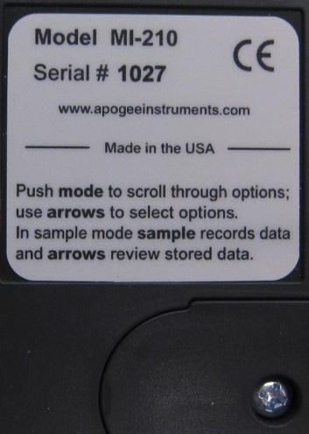

Sensor model number and serial number are located on a label on the backside of the handheld meter.

The four FOV options and associated model numbers are shown below:

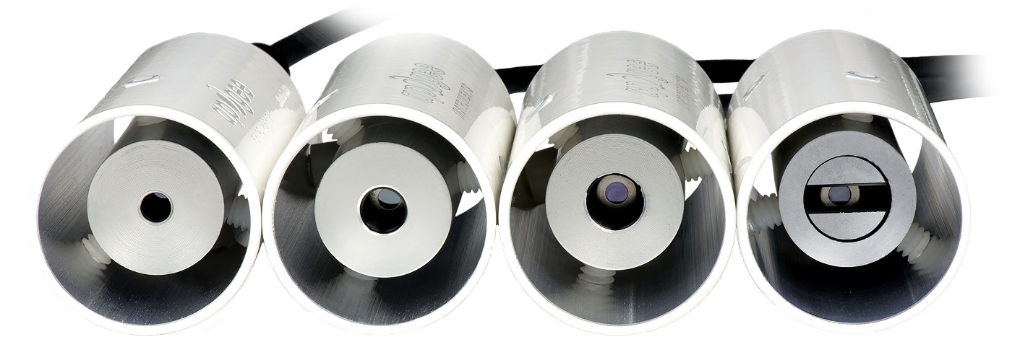

MI-230 MI-220 MI-210 MI-2H0

### Specifications

|  |  |  |  |  |
| --- | --- | --- | --- | --- |
|  | MI-210 | MI-220 | MI-230 | MI-2H0 |
| Calibration Uncertainty (-30 to 65 C), when target and detector temperature are within 20 C | ± 0.3 C | ± 0.3 C | ± 0.4 C | ± 0.3 C |
| Calibration Uncertainty (-40 to 80 C), when target and detector temperate are different by more than 20 C  (see Calibration Traceability below) | ± 0.5 C | ± 0.5 C | ± 0.6 C | ± 0.5 C |
| Measurement Repeatability | ± 0.1 C | | | |
| Stability (Long-term Drift) | less than 2 % change in slope per year when germanium filter is maintained in a clean condition (see Maintenance and Recalibration section below) | | | |
| Response Time | 0.6 s, time for detector signal to reach 95% following a step change; meter firmware averaging results in a 3 s response for digital output on meter screen | | | |
| Field of View | 22º half angle | 18º half angle | 14º half angle | 32º horizontal half angle; 13º vertical half angle |
| Spectral Range | 8 to 14 µm; atmospheric window (see Spectral Response below) | | | |
| Operating Environment | 0 to 50 C; less than 90 % non-condensing relative humidity up to 30 C; less than 70 % non-condensing-relative humidity from 30 to 50 C | | | |
| Meter Dimensions | 126 mm length; 70 mm width; 24 mm height | | | |
| Sensor Dimensions | 23 mm diameter; 60 mm length | | | |
| Mass | 270 g (with radiation shield) | | | |
| Cable | 2 m of four conductor, shielded, twisted-pair wire; additional cable available; TPR jacket (high water resistance, high UV stability, flexibility in cold conditions) | | | |

**Calibration Traceability**

Apogee MI series infrared temperature meters are calibrated to the temperature of a custom blackbody cone held at multiple fixed temperatures over a range of radiometer (detector/sensor body) temperatures. The temperature of the blackbody cone is measured with replicate precision thermistors thermally bonded to the cone surface. The precision thermistors are calibrated for absolute temperature measurement against a platinum resistance thermometer (PRT) in a constant temperature bath. The PRT calibration is directly traceable to the NIST.

**Spectral Response**

Spectral response of MI series infrared radiometers. Spectral response (green line) is determined by the germanium filter and corresponds closely to the atmospheric window of 8-14 µm, minimizing interference from atmospheric absorption/emission bands (blue line) below 8 µm and above 14 µm. Typical terrestrial surfaces have temperatures that yield maximum radiation emission within the atmospheric window, as shown by the blackbody curve for a radiator at 28 C (red line).

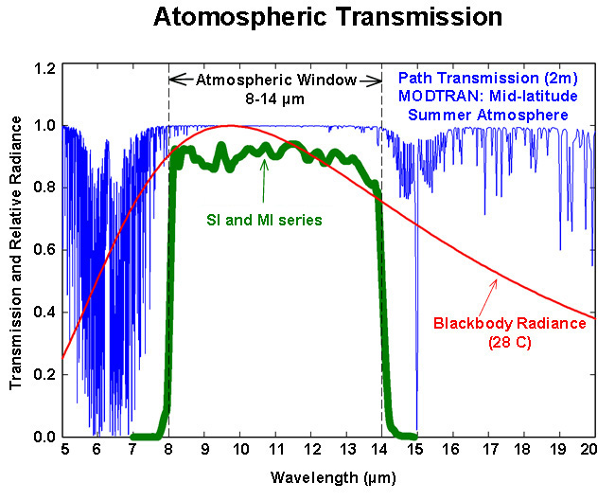

### Deployment and Installation

The mounting geometry (distance from target surface, angle of orientation relative to target surface) is determined by the desired area of surface to be measured. The field of view extends unbroken from the sensor to the target surface. Sensors must be carefully mounted in order to view the desired target and avoid including unwanted surfaces/objects in the field of view, thereby averaging unwanted temperatures with the target temperature (see Field of View below). **Once mounted, the green cap must be removed.** The green cap can be used as a protective covering for the sensor, when it is not in use.

An Apogee Instruments model AM-220 mounting bracket is recommended for mounting the sensor to a cross arm or pole. The AM-220 allows adjustment of the angle of the sensor with respect to the target and accommodates the radiation shield designed for all MI series infrared radiometers.

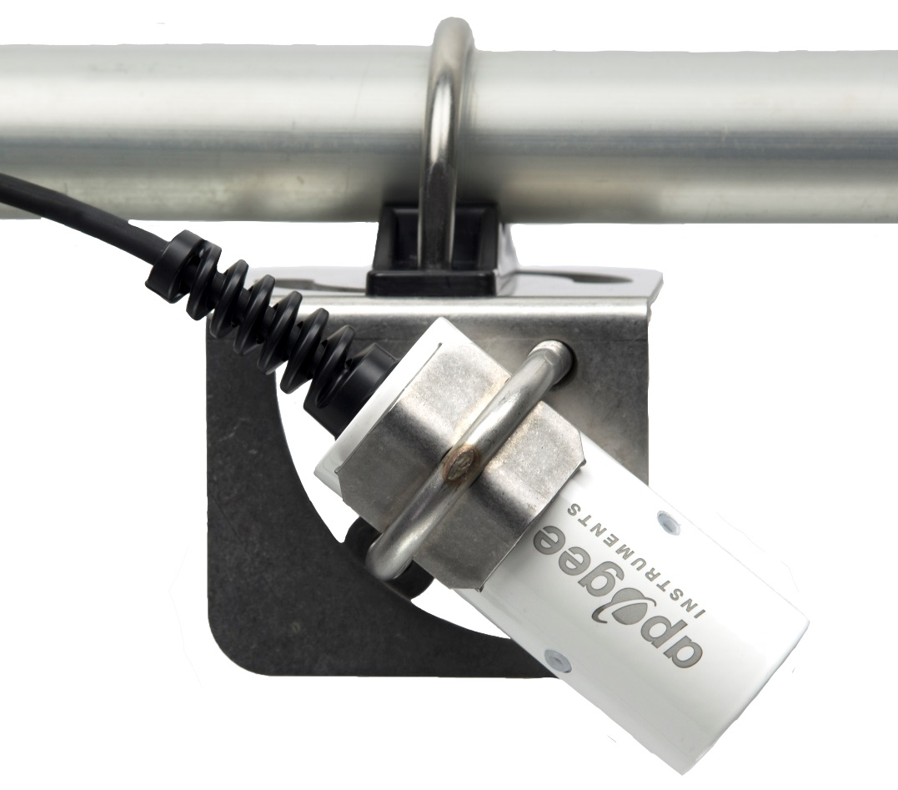

**Field of View**

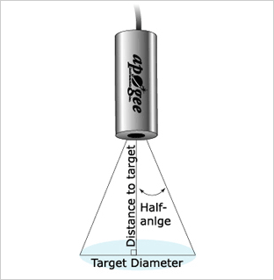The field of view (FOV) is reported as the half-angle of the apex of the cone formed by the target surface (cone base) and the detector (cone apex), as shown below, where the target is defined as a circle from which 98 % of the radiation detected by the radiometer is emitted.

Sensor FOV, distance to target, and sensor mounting angle in relation to the target will determine target area. Different mounting geometries (distance and angle combinations) produce different target shapes and areas, as shown below.

|  |  |  |  |  |  |  |  |  |  |  |  |  |
| --- | --- | --- | --- | --- | --- | --- | --- | --- | --- | --- | --- | --- |
| **CIRCULAR** | | | | | | **HORIZONTAL** | | | | | | |
|  | | | FOV Area (m²) | | |  | | Half Angle | | FOV Area (m²) | | |
| **Type** | **Model** | **Half Angle** | **0 Deg** | **45 Deg** | **60 Deg** | **Type** | **Model** | **Horizontal** | **Vertical** | **0 Deg** | **45 Deg** | **60 Deg** |
| Standard | SI-111 | 22° | 2.069 | 7.627 | 45.211 | Standard | SI-1H1 | 32° | 13° | 2.276 | 7.148 | 45.512 |
| IR-FOVNarrow | SI-121 | 18° | 1.337 | 4.461 | 18.865 | Narrow | SI-4HR | 16° | 5° | 0.403 | 1.15 | 3.341 |
| Ultra-Narrow | SI-131 | 14° | 0.787 | 2.447 | 8.544 |  |  |  |  |  |  |  |

-­­­

A simple FOV calculator for determining target dimensions based on infrared radiometer model, mounting height, and mounting angle, is available on the Apogee website: <https://www.apogeeinstruments.com/irr-calculators>.

### Battery Installation and Replacement

Use a phillips head screwdriver to remove the screw from the battery cover. Remove the battery cover by slightly lifting and sliding the outer edge of the cover away from the meter.

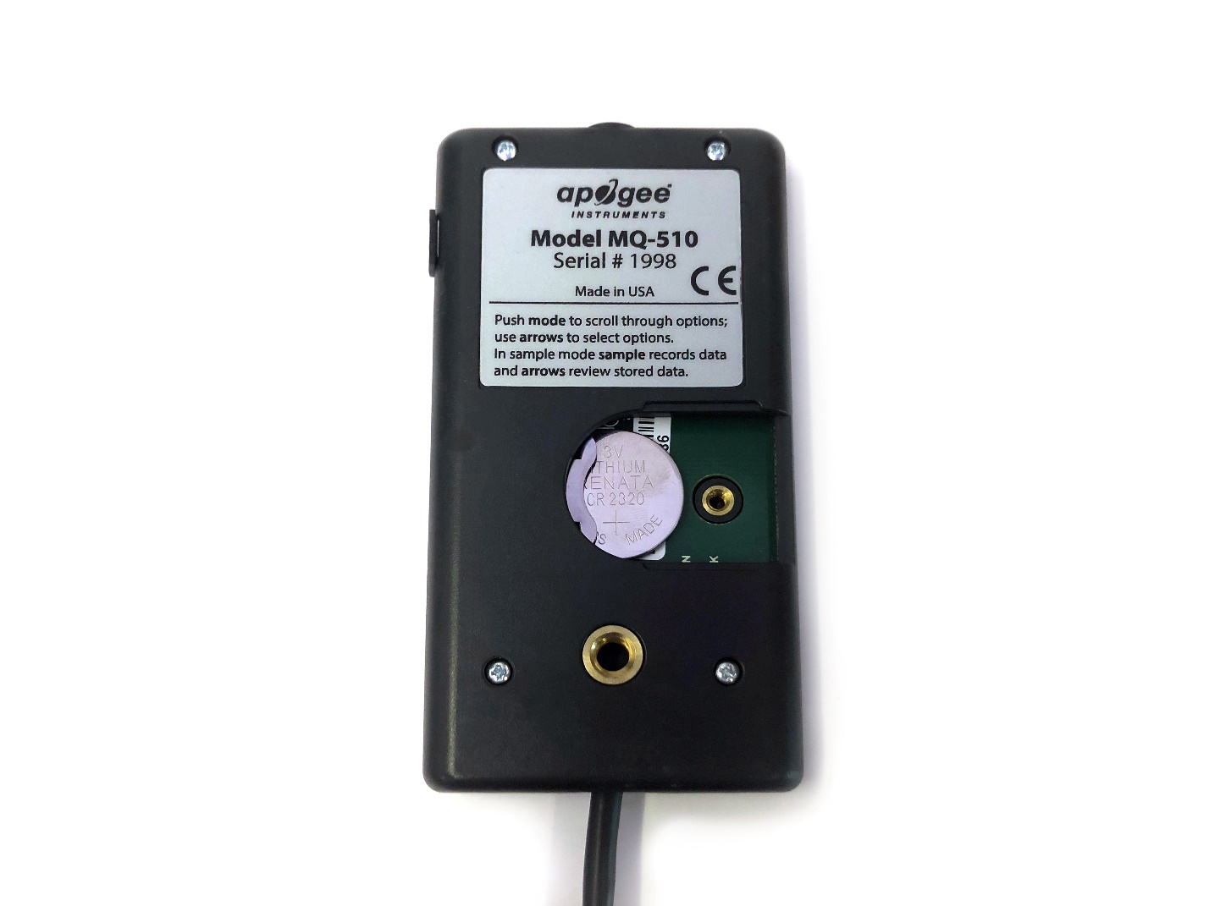To power the meter, slide the included battery (CR2320) into the battery holder, after removing the battery door from the meter’s back panel.

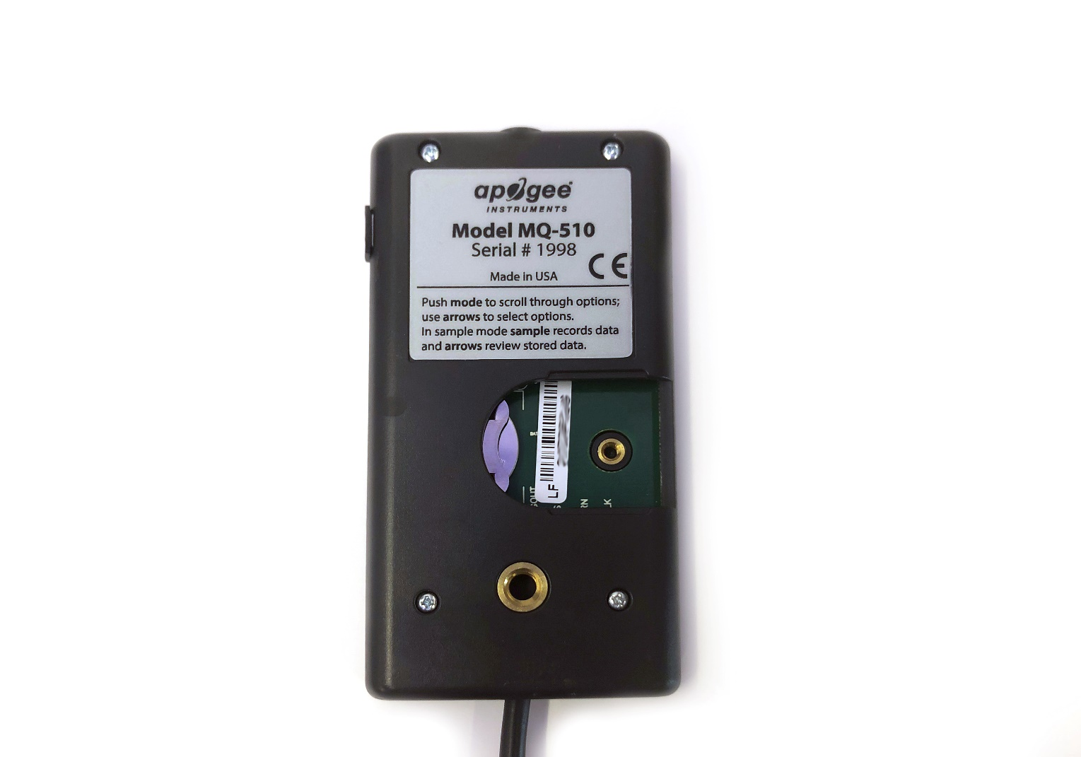

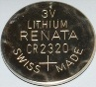

The positive side (designated by a “+” sign) should be facing out from the meter circuit board.

**NOTE:** The battery cradle can be damaged by using an incorrectly sized battery. If the battery cradle is damaged, the circuit board will need to be replaced. To avoid this costly problem, use only a CR2320 battery.

**Battery Removal**

Press down on the battery with a screwdriver or similar object. Slide battery out.

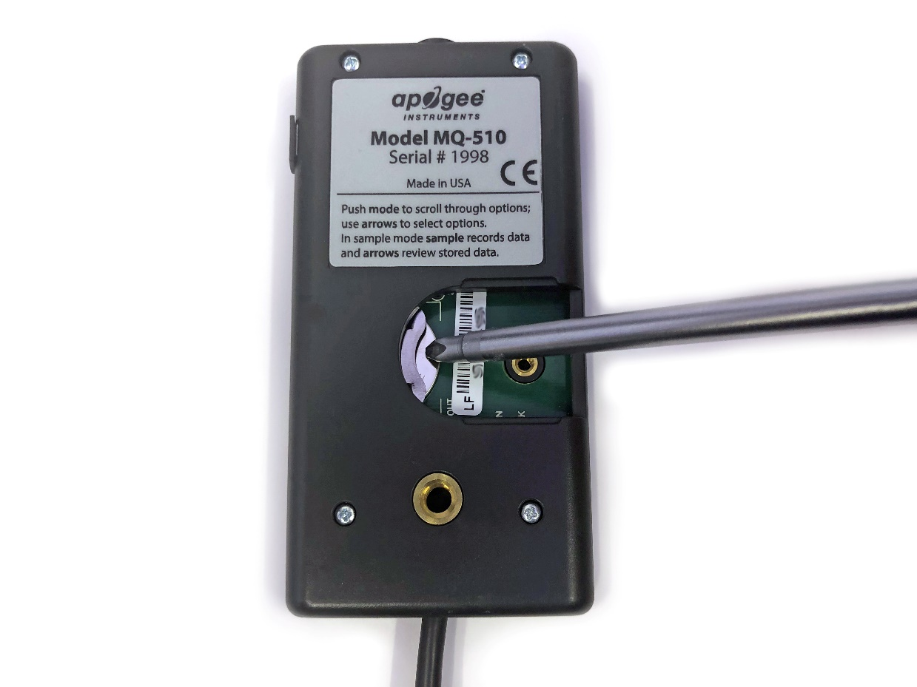

If the battery is difficult to move, turn the meter on its side so that the opening for the battery is facing downward and tap the meter downward against an open palm to dislodge the battery enough so that it can be removed with your thumb to slide the battery out of the battery holder.

### Operation and Measurement

MI series infrared temperature meters are designed with a user-friendly interface allowing quick and easy measurements.

 Press the power button to activate the LCD display. After two minutes of non-activity the meter will revert to sleep mode and the display will shut off to conserve battery life.

 Press the mode button to access the main menu, where the appropriate logging (manual or automatic) is selected and where the meter can be reset.

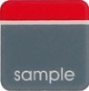 Press the sample button to log a reading while taking manual measurements.

 Press the up button to make selections in the main menu. This button is also used to view and scroll through the logged measurements on the LCD display.

 Press the down button to make selections in the main menu. This button is also used to view and scroll through the logged measurements on the LCD display.

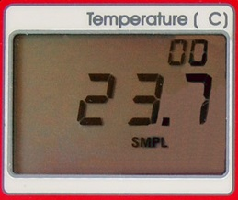

The LCD display consists of the total number of logged measurements in the upper right hand corner, the real-time temperature reading in the center, and the selected menu options along the bottom.

**Logging:** To choose between manual or automatic logging, push the mode button once and use the up/down buttons to make the appropriate selection (SMPL or LOG). Once the desired mode is blinking, press the mode button two more times to exit the menu. When in SMPL mode press the sample button to record up to 99 manual measurements (a counter in the upper right hand corner of the LCD display indicates the total number of saved measurements). When in LOG mode the meter will power on/off to make a measurement every 30 seconds. Every 30 minutes the meter will average the sixty 30 second measurements and record the averaged value to memory. The meter can store up to 99 averages and will start to overwrite the oldest measurement once there are 99 measurements. Every 48 averaged measurements (making a 24 hour period), the meter will also record an average daily value.

**Reset:** To reset the meter, in either SMPL or LOG mode, push the mode button twice (RUN should be blinking), then while pressing the down button, press the mode button once. This will erase all of the saved measurements in memory, but only for the selected mode. That is, performing a reset when in SMPL mode will only erase the manual measurements and performing a reset when in LOG mode will only erase the automatic measurements.

**Review/Download Data:** Each of the logged measurements in either SMPL or LOG mode can be reviewed on the LCD display by pressing the up/down buttons. To exit and return to the real-time readings, press the sample button. Note that the average daily values are not accessible through the LCD and can only be viewed by downloading to a computer.

Downloading the stored measurements will require the AC-100 communication cable and software (sold separately). The meter outputs data using the UART protocol and requires the AC-100 to convert from UART to USB, so standard USB cables will not work. Set up instructions and software can be downloaded from the Apogee website (<http://www.apogeeinstruments.com/ac-100-communcation-cable/>).



**Sensor Calibration**

Apogee MI series infrared temperature meters are calibrated in a temperature controlled chamber that houses a custom-built blackbody cone (target) for the radiation source. During calibration, infrared radiometers (detectors) are held in a fixture at the opening of the blackbody cone, but are thermally insulated from the cone. Detector and target temperature are controlled independently. At each calibration set point, detectors are held at a constant temperature while the blackbody cone is controlled at temperatures below (12 C), above (18 C), and equal to the detector temperature. The range of detector temperatures is -15 C to 45 C (set points at 10 C increments). Data are collected at each detector temperature set point, after detectors and target reach constant temperatures.

**Emissivity Correction**

Appropriate correction for surface emissivity is required for accurate surface temperature measurements. The simple (and commonly made) emissivity correction, dividing measured temperature by surface emissivity, is incorrect because it does not account for reflected infrared radiation.

The radiation detected by an infrared radiometer includes two components: 1. radiation directly emitted by the target surface, and 2. reflected radiation from the background. The second component is often neglected. The magnitude of the two components in the total radiation detected by the radiometer is estimated using the emissivity (ε) and reflectivity (1 - ε) of the target surface:

 (1)

where ESensor is radiance [W m-2 sr-1] detected by the radiometer, ETarget is radiance [W m-2 sr-1] emitted by the target surface, EBackground is radiance [W m-2 sr-1] emitted by the background (when the target surface is outdoors the background is generally the sky), and ε is the ratio of non-blackbody radiation emission (actual radiation emission) to blackbody radiation emission at the same temperature (theoretical maximum for radiation emission). Unless the target surface is a blackbody (ε = 1; emits and absorbs the theoretical maximum amount of energy based on temperature), Esensor will include a fraction (1 – ε) of reflected radiation from the background.

Since temperature, rather than energy, is the desired quantity, Eq. (1) can be written in terms of temperature using the Stefan-Boltzmann Law, E = σT4 (relates energy being emitted by an object to the fourth power of its absolute temperature):

 (2)

where TSensor [K] is temperature measured by the infrared radiometer (brightness temperature), TTarget [K] is actual temperature of the target surface, TBackground [K] is brightness temperature of the background (usually the sky), and σ is the Stefan-Boltzmann constant (5.67 x 10-8 W m-2 K-4). The power of 4 on the temperatures in Eq. (2) is valid for the entire blackbody spectrum.

Rearrangement of Eq. (2) to solve for TTarget yields the equation used to calculate the actual target surface temperature (i.e., measured brightness temperature corrected for emissivity effects):

. (3)

Equations (1)-(3) assume an infinite waveband for radiation emission and constant ε at all wavelengths. These assumptions are not valid because infrared radiometers do not have infinite wavebands, as most correspond to the atmospheric window of 8-14 µm, and ε varies with wavelength. Despite the violated assumptions, the errors for emissivity correction with Eq. (3) in environmental applications are typically negligible because a large proportion of the radiation emitted by terrestrial objects is in the 8-14 µm waveband (the power of 4 in Eqs. (2) and (3) is a reasonable approximation), ε for most terrestrial objects does not vary significantly in the 8-14 µm waveband, and the background radiation is a small fraction (1 – ε) of the measured radiation because most terrestrial surfaces have high emissivity (often between 0.9 and 1.0). To apply Eq. (3), the brightness temperature of the background (TBackground) must be measured or estimated with reasonable accuracy. If a radiometer is used to measure background temperature, the waveband it measures should be the same as the radiometer used to measure surface brightness temperature. Although the ε of a fully closed plant canopy can be 0.98-0.99, the lower ε of soils and other surfaces can result in substantial errors if ε effects are not accounted for.

### Apogee AMS Software

Downloading data to a computer requires the [AC-100 communication cable](https://www.apogeeinstruments.com/ac-100-communication-cable/) and the free ApogeeAMS software. The meter outputs data using the UART protocol and requires the AC-100 to convert from UART to USB, so standard USB cables will not work.

**The most recent version of ApogeeAMS software can be downloaded at** [**http://www.apogeeinstruments.com/downloads/**](http://www.apogeeinstruments.com/downloads/)**.**

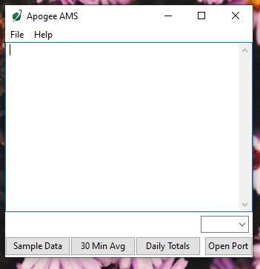

When the ApogeeAMS software is first opened, it will show a blank screen until communication with the meter is established. If you click “Open Port” it will say “connection failed.”

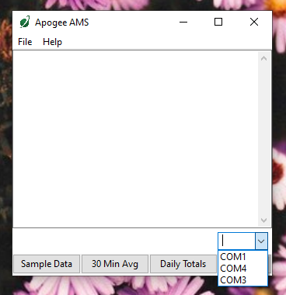

To establish communication, make sure the meter is plugged into your computer using the AC-100 communication cable. To connect click the dropdown menu button and “COM#” options will appear. For more details on how to figure out which COM is the right one, [watch our video](https://youtu.be/-lvw3rqOF5w?t=432).

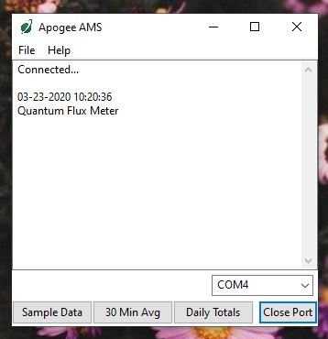

When you have connected to the correct COM#, the software will say “Connected”.

Click “Sample Data” to view saved sample readings.

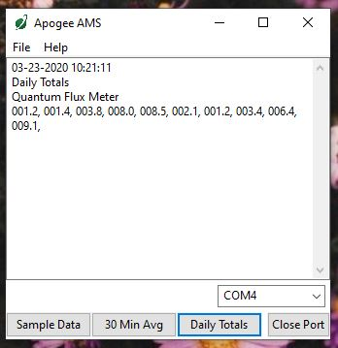

“Daily Totals” shows all of the saved Daily Light Integral (DLI) totals per day.

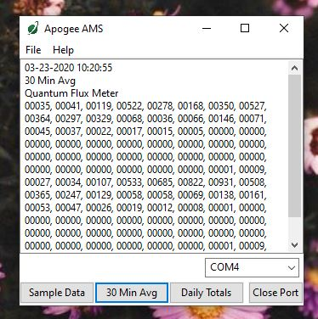

Click “30 Min Avg” to see the meter’s 99, 30-minute averages.

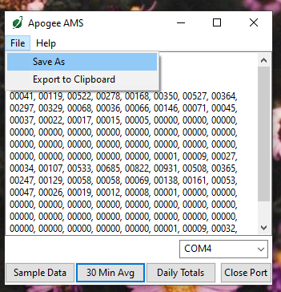

To analyze the data, click on “File” and “Save As” to save the data as a .csv file.

Or, you can highlight the numbers, copy, and paste them into a blank Excel spreadsheet. Data will need to be comma delimited.

### Maintenance and Recalibration

Blocking of the optical path between the target and detector, often due to moisture or debris on the filter, is a common cause of inaccurate measurements. The filter in the separate sensor of the MI series infrared temperature meters is inset in an aperture, but can become partially blocked in four ways:

1. Dew or frost formation on the filter.
2. Salt deposit accumulation on the filter, due to evaporating irrigation water or sea spray. This leaves a thin white film on the filter surface. Salt deposits can be removed with a dilute acid (e.g., vinegar). **Salt deposits cannot be removed with solvents such as alcohol or acetone.**
3. Dust and dirt deposition in the aperture and on the filter (usually a larger problem in windy environments). Dust and dirt are best removed with deionized water, rubbing alcohol, or in extreme cases, acetone.
4. Spiders/insects and/or nests in the aperture leading to the filter. If spiders/insects are a problem, repellent should be applied around the aperture entrance (not on the filter).

Clean inner threads of the aperture and the filter with a cotton swab dipped in the appropriate solvent. **Never use an abrasive material on the filter.** Use only gentle pressure when cleaning the filter with a cotton swab, to avoid scratching the outer surface. The solvent should be allowed to do the cleaning, not mechanical force.

It is recommended that infrared radiometers be recalibrated every two years. See the Apogee webpage for details regarding return of sensors for recalibration (<http://www.apogeeinstruments.com/tech-support-recalibration-repairs/>).

### Troubleshooting and Customer Support

**Verify Functionality**

Pressing the power button should activate the LCD and provide a real-time temperature reading. Direct the sensor toward a surface with a temperature significantly different than the detector. The real-time reading should respond accordingly (decreased reading when pointing at a low temperature surface and increased reading when pointing at a high temperature surface). Placing a piece of tinfoil over the front of the sensor should force the reading to ambient temperature.

**Battery Life**

When the meter is maintained properly the coin cell battery (CR2320) should last for many months, even after continuous use. The low battery indicator will appear in the upper left hand corner of the LCD display when the battery voltage drops below 2.8 V DC. The meter will still function correctly for some time, but once the battery is drained the pushbuttons will no longer respond and any logged measurements will be lost.

Pressing the power button to turn off the meter will actually put it in sleep mode, where there is still a slight amount of current draw. This is necessary to maintain the logged measurements in memory. Therefore, it is recommended to remove the battery when storing the meter for many months at a time, in order to preserve battery life.

**Low-Battery Error after Battery Replacement**

A master reset will usually correct this error, please see the master reset section for details and cautions. If a master reset does not remove the low battery indicator, please double check that the voltage of your new battery is above 2.8 V, this is the threshold for the indicator to turn on.

**Master Reset**

If a meter ever becomes non-responsive or experiences anomalies, such as a low battery indicator even after replacing the old battery, a master reset can be performed that may correct the problem. Note that a master reset will erase all logged measurements from memory.

Step 1: press the power button so that the LCD display is activated.

Step 2: Slide the battery out of the holder, which will cause the LCD display to fade out.

Step 3: After a few seconds, slide the battery back into the holder.

The LCD display will flash all segments and then show a revision number (e.g. “R1.0”). This indicates the master reset was performed and the display should return to normal.

**Error Codes and Fixes**

Error codes will appear in place of the real-time reading on the LCD display and will continue to flash until the problem is corrected. Contact Apogee if the following fixes do not rectify the problem.

**Err 1:** battery voltage out of range. **Fix:** replace CR2320 battery and perform master reset.

**Err 2:** sensor voltage out of range. **Fix:** perform master reset.

**Err 3:** not calibrated. **Fix:** perform master reset.

**Err 4:** CPU voltage below minimum. **Fix:** replace CR2320 battery and perform master reset.

**Modifying Cable Length**

Although it is possible to splice additional cable to the separate sensor of the MI series, note that the cable wires are soldered directly into the circuit board of the meter. Care should be taken to remove the back panel of the meter in order to access the board and splice on the additional cable, otherwise two splices would need to be made between the meter and sensor head. See Apogee webpage for further details on how to extend sensor cable length: (<http://www.apogeeinstruments.com/how-to-make-a-weatherproof-cable-splice/>).

### Return and Waranty Policy

RETURN POLICY

Apogee Instruments will accept returns within 30 days of purchase as long as the product is in new condition (to be determined by Apogee). Returns are subject to a 10 % restocking fee.

WARRANTY POLICY

**What is Covered**All products manufactured by Apogee Instruments are warranted to be free from defects in materials and craftsmanship for a period of four (4) years from the date of shipment from our factory. To be considered for warranty coverage an item must be evaluated by Apogee.

Products not manufactured by Apogee (spectroradiometers, chlorophyll content meters, EE08-SS probes) are covered for a period of one (1) year.

**What is Not Covered**The customer is responsible for all costs associated with the removal, reinstallation, and shipping of suspected warranty items to our factory.

The warranty does not cover equipment that has been damaged due to the following conditions:

1. Improper installation or abuse.

2. Operation of the instrument outside of its specified operating range.

3. Natural occurrences such as lightning, fire, etc.

4. Unauthorized modification.

5. Improper or unauthorized repair.

Please note that nominal accuracy drift is normal over time. Routine recalibration of sensors/meters is considered part of proper maintenance and is not covered under warranty.

**Who is Covered**This warranty covers the original purchaser of the product or other party who may own it during the warranty period.

**What Apogee Will Do**At no charge Apogee will:

1. Either repair or replace (at our discretion) the item under warranty.

2. Ship the item back to the customer by the carrier of our choice.

Different or expedited shipping methods will be at the customer’s expense.

**How To Return An Item**1. Please do not send any products back to Apogee Instruments until you have received a Return Merchandise Authorization (RMA) number from our technical support department by submitting an online RMA form at [www.apogeeinstruments.com/tech-support-recalibration-repairs/](http://www.apogeeinstruments.com/tech-support-recalibration-repairs/). We will use your RMA number for tracking of the service item. Call (435) 245-8012 or email techsupport@apogeeinstruments.com with questions.

2. For warranty evaluations, send all RMA sensors and meters back in the following condition: Clean the sensor’s exterior and cord. Do not modify the sensors or wires, including splicing, cutting wire leads, etc. If a connector has been attached to the cable end, please include the mating connector – otherwise the sensor connector will be removed in order to complete the repair/recalibration. ***Note:*** *When sending back sensors for routine calibration that have Apogee’s standard stainless-steel connectors, you only need to send the sensor with the 30 cm section of cable and one-half of the connector. We have mating connectors at our factory that can be used for calibrating the sensor.*

3. Please write the RMA number on the outside of the shipping container.

4. Return the item with freight pre-paid and fully insured to our factory address shown below. We are not responsible for any costs associated with the transportation of products across international borders.

**Apogee Instruments, Inc.   
721 West 1800 North Logan, UT  
84321, USA**

5. Upon receipt, Apogee Instruments will determine the cause of failure. If the product is found to be defective in terms of operation to the published specifications due to a failure of product materials or craftsmanship, Apogee Instruments will repair or replace the items free of charge. If it is determined that your product is not covered under warranty, you will be informed and given an estimated repair/replacement cost.

Products Beyond the Warranty Period

For issues with sensors beyond the warranty period, please contact Apogee at [techsupport@apogeeinstruments.com](mailto:techsupport@apogeeinstruments.com) to discuss repair or replacement options.

Other Terms

The available remedy of defects under this warranty is for the repair or replacement of the original product, and Apogee Instruments is not responsible for any direct, indirect, incidental, or consequential damages, including but not limited to loss of income, loss of revenue, loss of profit, loss of data, loss of wages, loss of time, loss of sales, accruement of debts or expenses, injury to personal property, or injury to any person or any other type of damage or loss.

This limited warranty and any disputes arising out of or in connection with this limited warranty ("Disputes") shall be governed by the laws of the State of Utah, USA, excluding conflicts of law principles and excluding the Convention for the International Sale of Goods. The courts located in the State of Utah, USA, shall have exclusive jurisdiction over any Disputes.

This limited warranty gives you specific legal rights, and you may also have other rights, which vary from state to state and jurisdiction to jurisdiction, and which shall not be affected by this limited warranty. This warranty extends only to you and cannot by transferred or assigned. If any provision of this limited warranty is unlawful, void or unenforceable, that provision shall be deemed severable and shall not affect any remaining provisions. In case of any inconsistency between the English and other versions of this limited warranty, the English version shall prevail.

This warranty cannot be changed, assumed, or amended by any other person or agreement

**APOGEE INSTRUMENTS, INC. |** 721 WEST 1800 NORTH, LOGAN, UTAH 84321, USA

TEL: (435) 792-4700 | FAX: (435) 787-8268 | WEB: APOGEEINSTRUMENTS.COM

*Copyright © 2021 Apogee Instruments, Inc.*