

# Owner’s Manual

Daily LIght Integral and photoperiod Meter

Models: DLI-400, DLI-500, and DLI-600

Rev: 31-Mar-2022

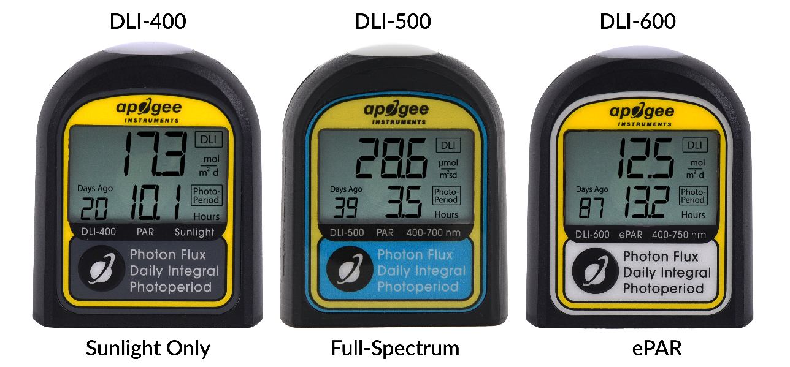

Table of Contents

Owner’s Manual 1

Certificate of Compliance 3

Introduction 4

Meter Models 5

Specifications 6

Deployment and Installation 10

Measurement and Operation 11

Maintenance and Recalibration 16

Troubleshooting and Customer Support 18

Return and Warranty Policy 19

### Certificate of Compliance

**EU Declaration of Conformity**

This declaration of conformity is issued under the sole responsibility of the manufacturer:

Apogee Instruments, Inc.  
721 W 1800 N  
Logan, Utah 84321  
USA

for the following product(s):

Models: DLI-400, DLI-500, DLI-600

Type: Daily Light Integral and Photoperiod Meter

The object of the declaration described above is in conformity with the relevant Union harmonization legislation:

2014/30/EU Electromagnetic Compatibility (EMC) Directive

2011/65/EU Restriction of Hazardous Substances (RoHS 2) Directive

2015/863/EU Amending Annex II to Directive 2011/65/EU (RoHS 3)

Standards referenced during compliance assessment:

EN 61326-1:2013 Electrical equipment for measurement, control, and laboratory use – EMC requirements

EN 50581:2012 Technical documentation for the assessment of electrical and electronic products with respect to the restriction of hazardous substances

Please be advised that based on the information available to us from our raw material suppliers, the products manufactured by us do not contain, as intentional additives, any of the restricted materials including lead (see note below), mercury, cadmium, hexavalent chromium, polybrominated biphenyls (PBB), polybrominated diphenyls (PBDE), bis (2-ethylhexyl) phthalate (DEHP), butyl benzyl phthalate (BBP), dibutyl phthalate (DBP), and diisobutyl phthalate (DIBP). However, please note that articles containing greater than 0.1 % lead concentration are RoHS 3 compliant using exemption 6c.

Further note that Apogee Instruments does not specifically run any analysis on our raw materials or end products for the presence of these substances, but we rely on the information provided to us by our material suppliers.

Signed for and on behalf of:

Apogee Instruments, March 2022



Bruce Bugbee  
President  
Apogee Instruments, Inc.

### Introduction

The DLI meter calculates daily light integral (DLI) and photoperiod. DLI refers to the total amount of PAR or ePAR incident on a plane in a 24-hour period, expressed in units of moles per square meter per day (mol m-2 d-1). Photoperiod is the total amount of time in which PAR or ePAR is incident on a plane during a 24-hour period and is expressed in units of hours (h). Both DLI and photoperiod influence plant growth and development, and they are often measured in greenhouses and growth chambers to aid in light management and decision making.

Apogee Instruments DLI meters consist of a cast acrylic diffuser (filter), optical filter, photodiode, signal processing circuitry, and an LCD display mounted in an ASA plastic housing. DLI meters are designed for single or continuous measurements of PPFD or ePPFD; DLI; and photoperiod. The DLI meter uses a USB-C cable (included with the meter) to download the stored data as a CSV file to a computer.

**PAR vs ePAR**

Radiation that drives photosynthesis is called photosynthetically active radiation (PAR) and is traditionally defined as total radiation across a wavelength range of 400 to 700 nm. However, additional research has indicated that photons outside of this range contribute to photosynthesis as well (Hogewoning et al., 2012; Murakami et al., 2018; Zhen and van Iersel, 2017; Zhen et al., 2019). Research has shown that far-red photons, wavelength range from 700 to 750 nm, work synergistically with photons in the traditional PAR range, but alone are inefficient at driving photosynthesis (Zhen and Bugbee, 2020a; Zhen and Bugbee, 2020b). As a result, an extended PAR (ePAR) definition has been proposed across a range of 400 to 750 nm (Zhen et al. 2021). Apogee DLI meters are designed to measure either PAR (models DLI-400 and DLI-500) or ePAR (model DLI-600). The DLI-400 and DLI-500 both measure PAR, however, the DLI-500 is accurate under all light sources, while the DLI-400 is a low-cost option that is accurate under sunlight and some broadband light sources only. PAR and ePAR are often expressed as photosynthetic photon flux density (PPFD) and extended photosynthetic photon flux density (ePPFD), respectively, in units of micromoles per square meter per second (µmol m-2 s-1).

Hogewoning et al. 2012. Photosynthetic Quantum Yield Dynamics: From Photosystems to Leaves. The Plant Cell, 24: 1921–1935.

Murakami et al. 2018. A Mathematical Model of Photosynthetic Electron Transport in Response to the Light Spectrum Based on Excitation Energy Distributed to Photosystems. Plant Cell Physiology. 59(8): 1643–1651.

Zhen et al. 2019. Far-red light enhances photochemical efficiency in a wavelength-dependent manner. Physiologia Plantarum. 167(1):21-33.

Zhen and Bugbee. 2020a. Far-red photons have equivalent efficiency to traditional photosynthetic photons: Implications for redefining photosynthetically active radiation. *Plant Cell and Environment*. 2020; 1–14.

Zhen and Bugbee. 2020b. Substituting Far-Red for Traditionally Defined Photosynthetic Photons Results in Equal Canopy Quantum Yield for CO2 Fixation and Increased Photon Capture During Long-Term Studies: Implications for Re-Defining PAR. *Frontiers in Plant Science.* 11:1-14.

Zhen and van Iersel. 2017. Far-red light is needed for efficient photochemistry and photosynthesis. Journal of Plant Physiology. 209: 115–122.

Zhen S, van Iersel M and Bugbee B (2021) Why Far-Red Photons Should Be Included in the Definition of Photosynthetic Photons and the Measurement of Horticultural Fixture Efficacy. Front. Plant Sci. 12:693445. doi: 10.3389/fpls.2021.693445

### Meter Models

This manual covers all three versions of the DLI meter. The table below shows available models and whether they measure PAR or ePAR. See SPECIFICATIONS on page 6 for spectral differences between these models.

|  |  |  |
| --- | --- | --- |
| Model | **Targeted Measurement** | **Meter Used For** |
| DLI-400 | PAR | Sunlight only |
| DLI-500 | PAR | All lights |
| DLI-600 | ePAR | All lights |

A DLI meter’s model number and serial number are located on the bottom of the meter. If the manufacturing date of a specific meter is required, please contact Apogee Instruments with the serial number of the meter.

### Specifications

|  |  |  |  |  |  |
| --- | --- | --- | --- | --- | --- |
|  | **DLI-400** | **DLI-500** | | | **DLI-600** |
| Calibration Uncertainty | ± 5 % | | | | |
| Measurement Repeatability | Less than 0.5 % | | | | |
| Measurement Range | 0 to 4000 mmol m-2 s-1 | | | | |
| Long-term Drift per Year | Less than 2 % per year | | | | |
| Field of View | 180° | | | | |
| Spectral Range (± 5 nm) | 370 to 650 nm | | 390 to 690 nm | | 390 to 760 nm |
| Directional (Cosine) Response | ± 5 % at 75° zenith angle | | | | |
| Azimuth Error | Less than 1 % | | | | |
| Temperature Response | -0.04 % per C | -0.11 ± 0.04 % per C | | | |
| Measurement Frequency | 3 minutes | | | | |
| Response Time | 2.5 seconds | | | | |
| Data Log Capacity | 99 days (DLI & Photoperiod), 10 days (30 min PPFD/ePPFD averages) | | | | |
| Time Accuracy | ± 53 seconds per month | | | | |
| Battery Type | 2 AAA batteries | | | | |
| Battery Life | Approximately 6 months | | | | |
| ADC Resolution | 24 bits | | | | |
| Mounting compatibility | Brass 1/4-20 threaded mount | | | | |
| Connectivity | CSV file via USB-C data transfer | | | | |
| Stored Data Resolution (PPFD) | 0.1 µmol m-2 s-1 (when ≥ 1000, the screen will not display the decimal) | | | | |
| Stored Data Resolution (DLI) | 0.1 mol m-2 day-1 (when ≥ 1000, the screen will not display the decimal) | | | | |
| Stored Data Resolution (Photoperiod) | 0.1 hours | | | | |
| Housing | ASA plastic | | | | |
| Ingress Protection | IP65 | | | | |
| Operating Environment | -10 to 60 C; 0 to 100 % relative humidity | | | -40 to 70 C; 0 to 100 % relative humidity | |
| Dimensions | 1.91 W x 2.31 H x 0.93 D (inches) | | | | |
| Mass | 67 g | | | | |
| Warranty | 4 years against defects in materials and workmanship | | | | |

**Calibration Traceability**

Apogee DLI meters are calibrated through side-by-side comparison to the mean of transfer standard quantum sensors placed under a reference LED (Ultraviolet: 1.5%; Blue: 36%; Green: 21%; Red: 41%; Far-Red: 0.5%). The reference quantum sensors are recalibrated with a 200 W quartz halogen lamp traceable to the National Institute of Standards and Technology (NIST).

**Spectral Response and Spectral Error**

Apogee DLI meters are calibrated to measure PPFD or ePPFD under sunlight and electric light. However, errors occur in various light sources due to changes in spectral output. If the light source spectrum is known, then errors can be estimated and used to adjust the measurements. The definitions, or weighting functions, of PPFD and ePPFD are shown in the graph below, along with the spectral responses of the three DLI meter models. The closer the spectral response matches the defined PPFD or ePPFD spectral weighting functions, the smaller the spectral errors will be. The table below provides spectral error estimates for PPFD and ePPFD measurements from light sources different than the calibration source. The method of Federer and Tanner (1966) was used to determine spectral errors based on the PPFD and ePPFD spectral weighting functions, measured sensor spectral response, and radiation source spectral outputs (measured with a spectroradiometer). This method calculates spectral error and does not consider calibration, cosine, or temperature errors.

PAR Definition

ePAR Definition

DLI-400

DLI-500

DLI-600

Mean spectral response of replicate DLI meters compared to PPFD and ePPFD weighting function. Spectral response measurements were made at 10 nm increments across a wavelength range of 300 to 800 nm in a monochromator with an attached electric light source. Measured spectral data from each meter were normalized by the measured spectral output of the monochromator/electric light combination, which was measured with a spectroradiometer.

|  |  |  |  |
| --- | --- | --- | --- |
| **Radiation Source** | **DLI-400** | **DLI-500** | **DLI-600** |
| **PPFD Error [%]** | **PPFD Error [%]** | **ePPFD Error [%]** |
| **Clear Sky** | 0.0 | 0 | 1.8 |
| **Overcast** | 0.2 | 0.1 | 1.9 |
| **CWF T5** | 7.2 | 0.1 | -1.2 |
| **Metal Halide** | 6.9 | 0.9 | 0.0 |
| **Ceramic Metal Halide** | -8.8 | 0.3 | -0.4 |
| **Mogul Base HPS** | 0.9 | 0.0 | -0.4 |
| **Dual-ended HPS** | -6.8 | -0.1 | -0.1 |
| **CW LED** | 9.4 | 0.9 | -1.6 |
| **WW LED** | -7.8 | 0.2 | -1.0 |
| **Blue LED (442 nm)** | 12.1 | -1.9 | -3.3 |
| **Cyan LED (501 nm)** | 27.7 | 3.6 | -1.4 |
| **Green LED (529 nm)** | 29.4 | 2.9 | -1.4 |
| **Amber LED (598 nm)** | 2.0 | -0.8 | -1.0 |
| **Red LED (666 nm)** | -55.8 | 2.7 | -1.0 |

Federer, C. A., and C. B. Tanner, 1966. Sensors for measuring light available for photosynthesis. Ecology 47:654-657.

**Directional Response**

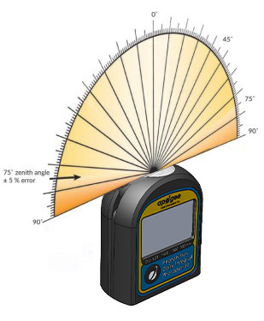

Directional, or cosine, response is defined as the measurement error at a specific angle of radiation incidence. Error for Apogee DLI meter is approximately ± 5 % at solar zenith 75°.

Mean directional response of replicate meters. Directional response measurements were made by direct side-by-side comparison to the mean of replicate reference quantum sensors.

### Deployment and Installation

Place the DLI meter wherever measurements are desired. To accurately measure PPFD incident on a horizontal surface, the sensor must be level. The ¼-20 threaded mount can be used to secure the meter in place and ensure consistent measurements. The mount also allows the use of most commercially available camera mounts, tripods, and various stakes. The DLI meter comes with a yellow soil stake for easy, immediate deployment.

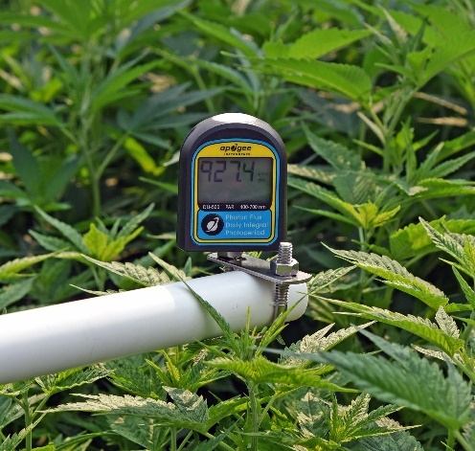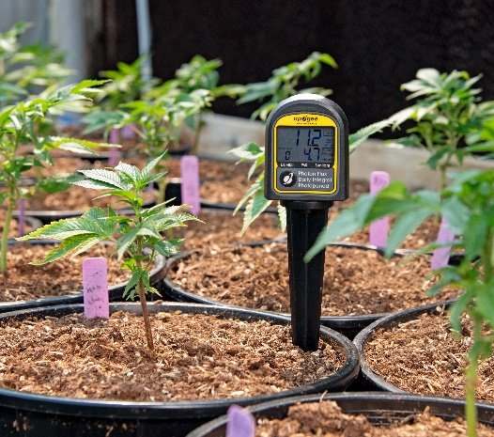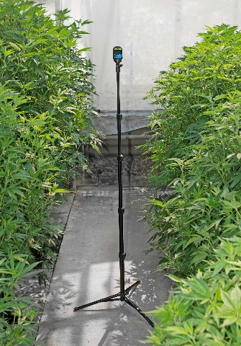

­­

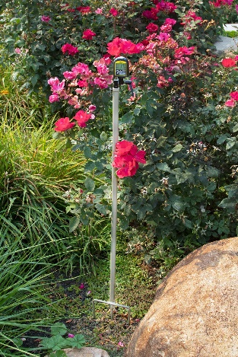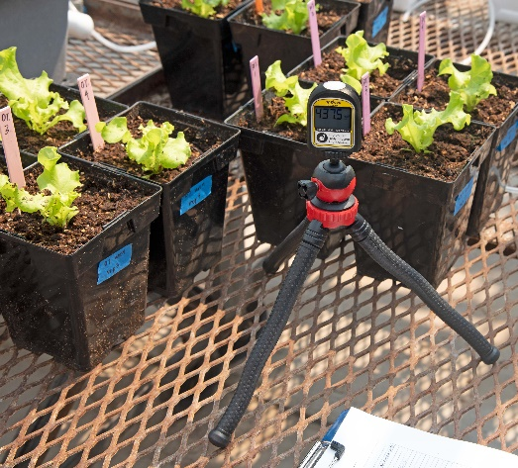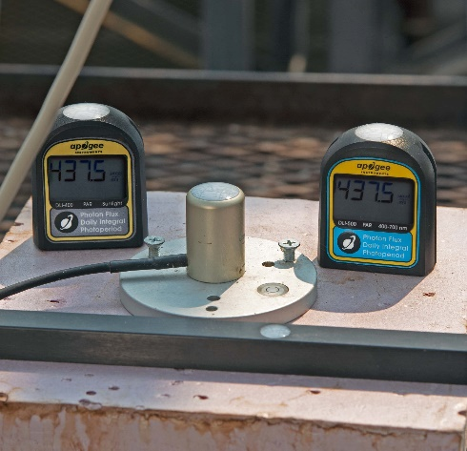

**NOTE:** The meter is officially IP65 rated against incoming dust and water. The meter is not rated for full immersion. While some users have reported successful deployments underwater at shallow depths and short durations, doing so may cause adverse effects or meter failure. Meter failure due to immersion is not covered by warranty.

### Measurement and Operation

Meter functionality covered in this section is the same for all models.

**NOTE:** Although the meter screen goes to sleep after three minutes of inactivity, the meter is always on in the background taking measurements. To turn off the meter completely or to prevent the batteries from possibly corroding inside the unit during long-term storage, we recommend removing the batteries (see the following page).

#### Measurement methodology for Daily light integral

Every 3 minutes, the DLI meter will automatically make 10 measurements over a 4-second period. These measurements are averaged together and saved to internal memory as a single value, representative of the 3-minute period. When 24 hours of data have been accumulated, a daily total (Daily Light Integral) is determined and saved to internal memory.

#### Measurement methodology for Photoperiod

Photoperiod is the accumulated number of hours (in a 24-hour period) in which the averaged measurement was over 0.1 µmol m-2 s-1. Every 6 minutes of light will increase the displayed photoperiod total by 0.1 hours. Since measurements are taken every 3 minutes, it is possible that the DLI meter can miss intermittent lighting events shorter than 3 minutes.

#### Initial Setup and Changing Batteries

Battery life is approximately 6 months. However, this can be reduced by usage and ambient conditions. When batteries need to be changed, the screen will display “**bAtt Lo**” upon waking up.

*Note:* For long-term storage, we recommend removing the batteries.

**IMPORTANT:** Removing the bottom cover will result in the loss of all current-day data.

*FOR INITIAL SETUP – SKIP TO STEP 3*

1. Using a small Phillips-head screwdriver, turn the two screws at the bottom until they turn freely (this should take roughly 5 turns).

*Note: The screws do not need to be fully removed.*

2. Remove the bottom cover. With the screws loosened, the batteries should begin to push off the cover. If needed, you can use the ¼-20 threaded mount with a matching bolt or screw to pull off the cover. If the cover seems stuck, verify the screws completely unthreaded.

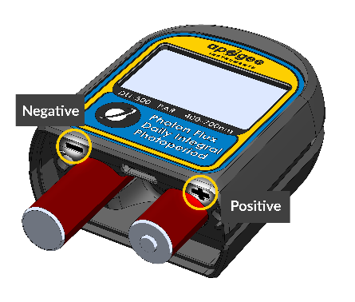3. Install 2 AAA batteries into the bottom, making note of the proper polarity marked next to each hole.

4. Replace the bottom cap and press firmly into place. The LCD screen should turn on. If it does not, check the battery orientation and try again.

5.Using a small Phillips screwdriver, tighten the two screws on the bottom cap by turning them until snug.

*Note: Do* ***NOT*** *over-tighten the screws.*

6. The meter is now ready to use and will begin making measurements as soon as the batteries are installed.

#### turning on and off the display and viewing live data

1. Turn on the display by pressing the button one time. The number displayed on the screen is a running average of PPFD or ePPFD (depending on the model) from the last 2.5 seconds.

2. Press and hold the button for about 2 seconds to manually turn off the display.

*Note: The display will automatically turn off after 3 minutes of inactivity. However, the meter is still on taking measurements in the background.*

#### Collecting timeseries Data

1. Once the batteries are installed, the meter will automatically make a measurement every 3 minutes, whether the screen is on or off.

2. Place the meter in the location you would like to measure and leave it there for the desired measurement duration. See DEPLOYMENT AND INSTALLATION on page 10 for more information.

#### viewing stored DLI and Photoperiod data

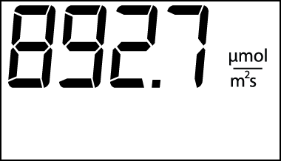1. Turn on the display by pressing the button one time, which shows the current measurement.

Current light measurement in units of µmol m-2 s-1.

2. Press the button one more time. Three numbers will appear on the display (shown in the photo). The first number (bottom left of the display) indicates the day in which the data were collected (0 days ago is today, 1 day ago was yesterday, and so on). The second and third numbers are the DLI and photoperiod in the top right and bottom right corners, respectively.

The daily light integral during the displayed day in units of mol m-2 d-1.

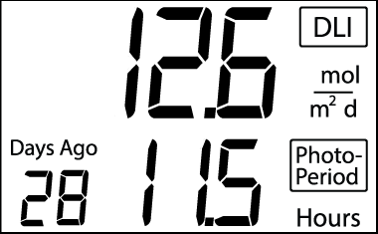

The day in which the data were collected.

The photoperiod during the displayed day in units of hours.

3. Press the button repeatedly to cycle through all previously collected days and return to the live data view.

*Notes:*

* *The meter will only display days in which data were collected.*
* *Press the button once to return to the live data view.*

#### Transferring Stored Data

**IMPORTANT:** Transferring stored data requires removal of the bottom cover, which will result in the loss of all current-day data.

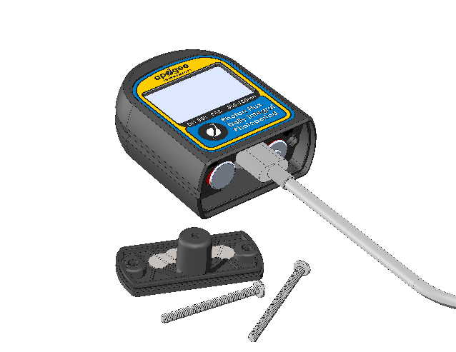1. Using a small Phillips-head screwdriver, turn the two screws at the bottom until they turn freely (this should take roughly 5 turns).

*Note: The screws do not need to be fully removed.*

2. Remove the bottom cover. With the screws loosened, the batteries should begin to push off the cover. If needed, you can use the ¼-20 threaded mount with a matching bolt or screw to pull off the cover. If the cover seems stuck, verify the screws are completely unthreaded.

3. Connect a USB-C cable to the DLI meter and a computer. Locate the meter (titled DLI METER) in file explorer as you would a thumb drive. There will be three files in this drive:

|  |  |
| --- | --- |
| **ABOUT.TXT** | This file contains calibration, firmware, and hardware information about your meter. |
| **DLI.CSV** | This four-column file contains the completed day number, days-ago label, DLI, and photoperiod data up to 99 days. |
| **MEAS.CSV** | This two-column CSV contains a record number and 30-minute PPFD averages up to the most recent 10 days. |

*Note: It can take up to 10 seconds for the DLI meter to connect to your computer.*

4. Copy files to your computer.

5. Disconnect the USB-C cable.

6. Replace the bottom cover. Using a small Phillips screwdriver, replace the screws and tighten until snug.

*Note: Do NOT* *over-tighten the screws.*

#### Resetting the Meter

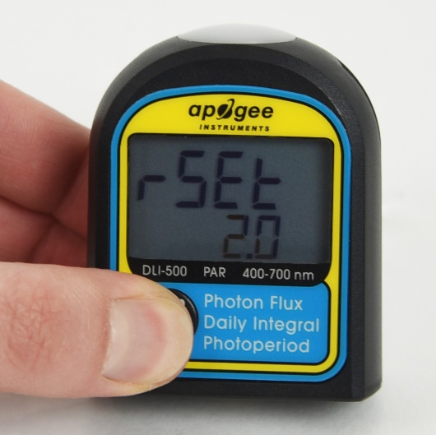1. Press and hold the button for about eight seconds until the reset timer appears on the display. If you **do not** want to reset the meter, release the button before the countdown is over to cancel the reset. If you **do** want to reset the meter, continue holding the button until the countdown reaches zero.

*Note: Resetting the meter will clear ALL previous data and begin new calculations beginning from that time. The first ‘day’ will last 24 hours or until the first hour of continuous darkness (less than 0.1 mmol m-2 s-1) is detected, whichever comes first. All subsequent days are 24 hours long.*

### Maintenance and Recalibration

Moisture or debris on the diffuser is a common cause of low readings. The meter has a domed diffuser and housing for improved self-cleaning from rainfall/irrigation, but materials can accumulate on the diffuser (e.g., dust during periods of low rainfall, salt deposits from evaporation of sea spray or sprinkler irrigation water) and partially block the optical path. Dust or organic deposits are best removed using water or window cleaner and a soft cloth or cotton swab. Salt deposits should be dissolved with vinegar and removed with a soft cloth or cotton swab. **Never use an abrasive material or cleaner on the diffuser.**

Although Apogee meters are very stable, nominal accuracy drift is normal for all research-grade instruments. To ensure maximum accuracy, we generally recommend meters are sent in for recalibration every two years, although you can often wait longer according to your particular tolerances.

To determine if your meter needs recalibration, the Clear Sky Calculator ([www.clearskycalculator.com](http://www.clearskycalculator.com)) website and/or smartphone app can be used to indicate the PPFD and ePPFD on a horizontal surface at any time of day at any location in the world. It is most accurate when used near solar noon in spring and summer months, where accuracy over multiple clear and unpolluted days is estimated to be ± 4 % in all climates and locations around the world. For best accuracy, the sky must be completely clear, as reflected radiation from clouds causes incoming PPFD to increase above the value predicted by the Clear Sky Calculator. Measured values of PPFD can exceed values predicted by the Clear Sky Calculator due to reflection from high, thin clouds and edges of clouds, which enhances incoming PPFD. The influence of high clouds typically shows up as spikes above clear sky values, not a constant offset greater than clear sky values.

To determine recalibration need, input site conditions into the calculator and compare PPFD measurements to calculated values for a clear sky. If meter PPFD measurements over multiple days near solar noon are consistently different than calculated values (by more than 6 %), the meter should be cleaned and re-leveled. If measurements are still different after a second test, email [calibration@apogeeinstruments.com](mailto:calibration@apogeeinstruments.com) to discuss test results and possible return of sensor(s).

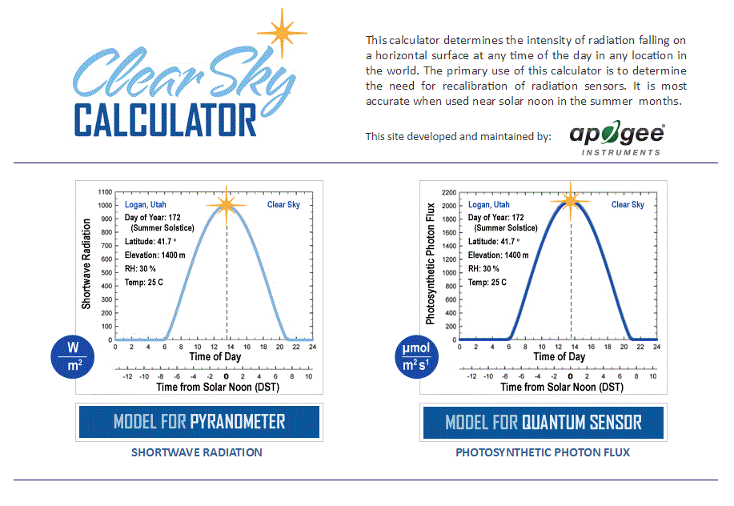

Homepage of the Clear Sky Calculator. Two calculators are available: one for quantum meters (PPFD) and one for pyranometers (total shortwave radiation).

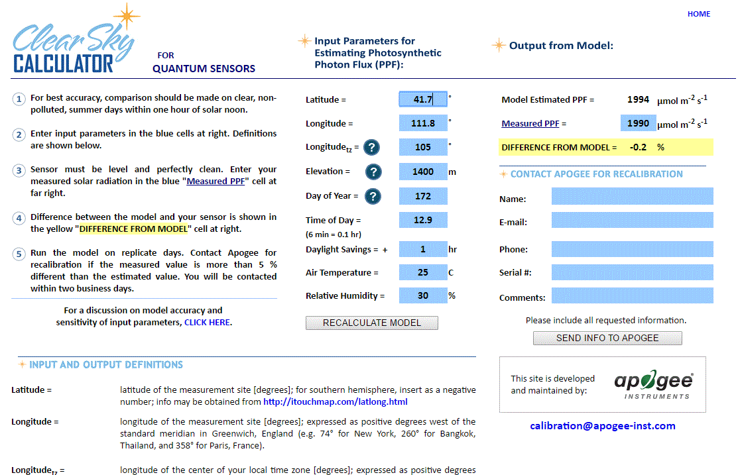

Clear Sky Calculator for quantum sensors. Site data are input in blue cells in the middle of page and an estimate of PPFD is returned on right-hand side of page.

### Troubleshooting and Customer Support

**Independent Verification of Functionality**

Apogee DLI meters display the current PPFD measurement. A quick and easy check of meter functionality can be determined by directing the sensor head toward a light source and verifying the sensor provides a reasonable measurement. Increase and decrease the distance from the sensor head to the light source to verify that the measurement changes proportionally (decreasing signal with increasing distance and increasing signal with decreasing distance). Blocking all radiation from the meter should force the meter to zero mmol m-2 s-1.

**Unit Conversion Charts**

Apogee DLI meters are calibrated to measure PPFD or ePPFD in units of µmol m-2 s-1. Units other than photon flux density (e.g., energy flux density, illuminance) may be required for certain applications. It is possible to convert the PPFD or ePPFD value from a quantum sensor to other units, but it requires spectral output of the radiation source of interest. Conversion factors for common radiation sources can be found on the Unit Conversions page in the Support Center on the Apogee website (<http://www.apogeeinstruments.com/unit-conversions/>; scroll down to Quantum Sensors section). A spreadsheet to convert PPFD or ePPFD to energy flux density or illuminance is also provided on the Unit Conversions page in the Support Center on the Apogee website (<http://www.apogeeinstruments.com/content/PPFD-to-Illuminance-Calculator.xls>).

### Return and Warranty Policy

RETURN POLICY

Apogee Instruments will accept returns within 30 days of purchase as long as the product is in new condition (to be determined by Apogee). Returns are subject to a 10 % restocking fee.

WARRANTY POLICY

**What is Covered**All products manufactured by Apogee Instruments are warranted to be free from defects in materials and craftsmanship for a period of four (4) years from the date of shipment from our factory. To be considered for warranty coverage, an item must be evaluated by Apogee.

Products not manufactured by Apogee (spectroradiometers, chlorophyll content meters, EE08-SS probes) are covered for a period of one (1) year.

**What is Not Covered**The customer is responsible for all costs associated with the removal, reinstallation, and shipping of suspected warranty items to our factory.

The warranty does not cover equipment that has been damaged due to the following conditions:

1. Improper installation, use, or abuse.

2. Operation of the instrument outside of its specified operating range, such as use underwater.

3. Natural occurrences such as lightning, fire, etc.

4. Unauthorized modification.

5. Improper or unauthorized repair.

Please note that nominal accuracy drift is normal over time. Routine recalibration of sensors/meters is considered part of proper maintenance and is not covered under warranty.

**Who is Covered**This warranty covers the original purchaser of the product or another party who may own it during the warranty period.

**What Apogee Will Do**At no charge, Apogee will:

1. Either repair or replace (at our discretion) the item under warranty.

2. Ship the item back to the customer by the carrier of our choice.

Different or expedited shipping methods will be at the customer’s expense.

**How to Return an Item**1. Please do not send any products back to Apogee Instruments until you have received a Return Merchandise Authorization (RMA) number from our technical support department by submitting an online RMA form at [www.apogeeinstruments.com/tech-support-recalibration-repairs/](http://www.apogeeinstruments.com/tech-support-recalibration-repairs/). We will use your RMA number for tracking of the service item. Call (435) 245-8012 or email techsupport@apogeeinstruments.com with questions.

2. For warranty evaluations, send all RMA sensors and meters back in the following condition: Clean the sensor’s exterior and cord. Do not modify the sensors or wires, including splicing, cutting wire leads, etc. If a connector has been attached to the cable end, please include the mating connector – otherwise the sensor connector will be removed in order to complete the repair/recalibration.

3. Please write the RMA number on the outside of the shipping container.

4. Return the item with freight pre-paid and fully insured to our factory address shown below. We are not responsible for any costs associated with the transportation of products across international borders.

**Apogee Instruments, Inc.   
721 West 1800 North Logan, UT  
84321, USA**

5. Upon receipt, Apogee Instruments will determine the cause of failure. If the product is found to be defective in terms of operation to the published specifications, due to a failure of product materials or craftsmanship, Apogee Instruments will repair or replace the items free of charge. If it is determined that your product is not covered under warranty, you will be informed and given an estimated repair/replacement cost.

Products Beyond the Warranty Period

For issues with sensors beyond the warranty period, please contact Apogee at [techsupport@apogeeinstruments.com](mailto:techsupport@apogeeinstruments.com) to discuss repair or replacement options.

Other Terms

The available remedy of defects under this warranty is for the repair or replacement of the original product. Apogee Instruments is not responsible for any direct, indirect, incidental, or consequential damages, including but not limited to loss of income, loss of revenue, loss of profit, loss of data, loss of wages, loss of time, loss of sales, accruement of debts or expenses, injury to personal property, or injury to any person or any other type of damage or loss.

This limited warranty and any disputes arising out of, or in connection with, this limited warranty ("Disputes") shall be governed by the laws of the State of Utah, USA, excluding conflicts of law principles and excluding the Convention for the International Sale of Goods. The courts located in the State of Utah, USA, shall have exclusive jurisdiction over any Disputes.

This limited warranty gives you specific legal rights, and you may also have other rights, which vary from state to state and jurisdiction to jurisdiction, and which shall not be affected by this limited warranty. This warranty extends only to you and cannot by transferred or assigned. If any provision of this limited warranty is unlawful, void, or unenforceable, that provision shall be deemed severable and shall not affect any remaining provisions. In case of any inconsistency between the English and other versions of this limited warranty, the English version shall prevail.

This warranty cannot be changed, assumed, or amended by any other person or agreement.

**APOGEE INSTRUMENTS, INC. |** 721 WEST 1800 NORTH, LOGAN, UTAH 84321, USA

TEL: (435) 792-4700 | FAX: (435) 787-8268 | WEB: APOGEEINSTRUMENTS.COM

*Copyright © 2022 Apogee Instruments, Inc.*