

# Owner’s Manual

SDI-12 converter

Model AC-421

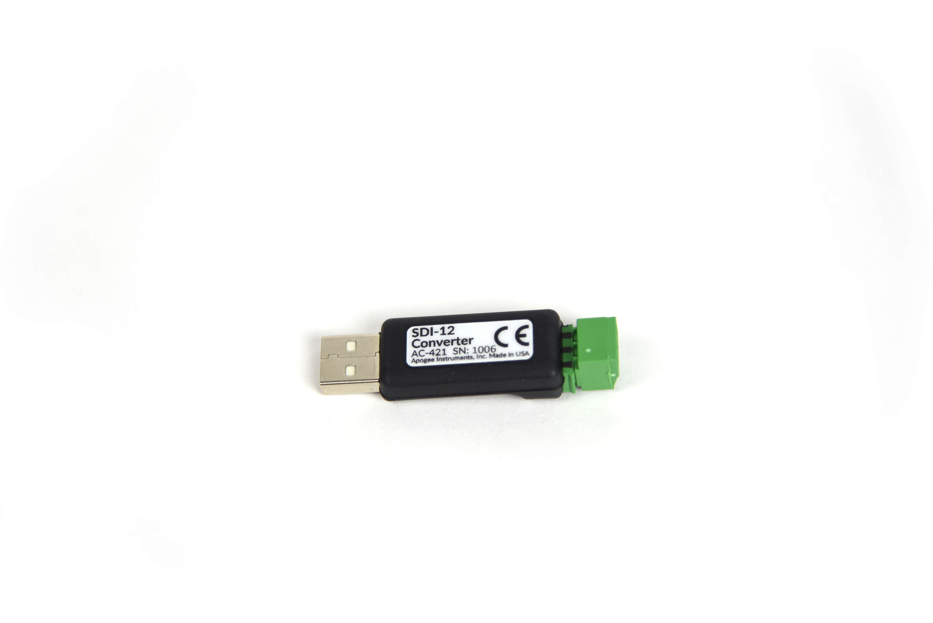

Table of Contents

Owner’s Manual 1

Declaration of Conformity 3

Introduction 4

Sensor Models 4

Specifications 4

Deployment and Installation 5

Operation and Measurement 6

Spreadsheet Table of Majority of SDI-12 Commands 7

Maintenance and Recalibration 8

Troubleshooting and Customer Support 9

Return and Warranty Policy 15

### Declaration of Conformity

**EU Declaration of Conformity**

This declaration of conformity is issued under the sole responsibility of the manufacturer:

Apogee Instruments, Inc.  
721 W 1800 N  
Logan, Utah 84321  
USA

for the following product(s):

Models: AC-421  
Type: SDI-12 Converter

The object of the declaration described above is in conformity with the relevant Union harmonization legislation:

2014/30/EU Electromagnetic Compatibility (EMC) Directive

2011/65/EU Restriction of Hazardous Substances (RoHS 2) Directive

2015/863/EU Amending Annex II to Directive 2011/65/EU (RoHS 3)

Standards referenced during compliance assessment:

EN 61326-1:2013 Electrical equipment for measurement, control and laboratory use – EMC requirements

EN 50581:2012 Technical documentation for the assessment of electrical and electronic products with respect to the restriction of hazardous substances

Please be advised that based on the information available to us from our raw material suppliers, the products manufactured by us do not contain, as intentional additives, any of the restricted materials including lead (see note below), mercury, cadmium, hexavalent chromium, polybrominated biphenyls (PBB), polybrominated diphenyls (PBDE), bis(2-ethylhexyl) phthalate (DEHP), butyl benzyl phthalate (BBP), dibutyl phthalate (DBP), and diisobutyl phthalate (DIBP). However, please note that articles containing greater than 0.1% lead concentration are RoHS 3 compliant using exemption 6c.

Further note that Apogee Instruments does not specifically run any analysis on our raw materials or end products for the presence of these substances, but rely on the information provided to us by our material suppliers.

Signed for and on behalf of:

Apogee Instruments, October 2019



Bruce Bugbee  
President  
Apogee Instruments, Inc.

### Introduction

This device is used for testing and addressing SDI-12 sensors. It also allows customer utilize the serial USB port to connect a SDI-12 sensor and communicate with it through its own software. This tool can be used to familiarize oneself with SDI-12 commands as well as troubleshooting individual sensor performance.

### Sensor Models

|  |  |  |
| --- | --- | --- |
| Model | Output | |
| SDI-12 converter | **USB** |

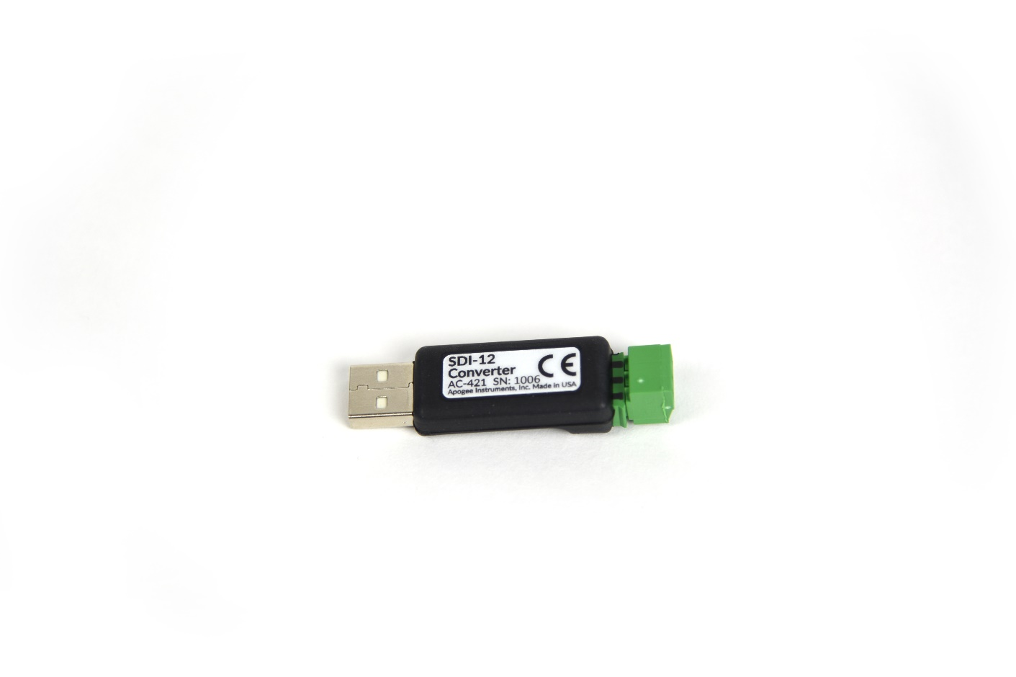

Sensor model number and serial number are located on the top of the USB device. If you need the manufacturing date of your sensor, please contact Apogee Instruments with the serial number of your sensor.

### Specifications

|  |  |
| --- | --- |
|  | AC-421 |
| Input Voltage Requirement | 5 V USB |
| Current Draw | 13 mA |
| Response Time | 0.6 s, time for detector signal to reach 95 % following a step change; fastest data transmission rate for SDI-12 circuitry is 1 s |
| Operating Environment | -45 to 80 C; 0 to 100 % relative humidity (non-condensing) |
| Dimensions | 60.40 mm x 17.40 mm x 12.45 mm |
| Mass | 11 g |

### Deployment and Installation

Plug into USB port and open up DSI software.

Apogee DSI software can be downloaded from: <https://www.apogeeinstruments.com/downloads/>

**Apogee Digital Sensor Opening Screen**

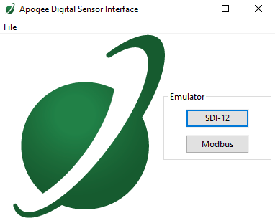

### Operation and Measurement

Wire up to green block and plug in **making sure to connect the ground wire first**. Then, connect the signal line second and the power line last. Below is common wiring up of Apogee Instruments SDI-12 sensors. Please check your individual sensor manual for wiring instructions.

**VERY IMPORTANT: Apogee changed all wiring colors of our bare-lead sensors in March 2018 in conjunction with the release of inline cable connectors on some sensors. To ensure proper connection to your data device, please note your serial number or if your sensor has a stainless-steel connector 30 cm from the sensor head then use the appropriate wiring configuration.**

**Common Apogee Sensor Wiring Configurations**

Below are the two possible sensor wiring configurations of Apogee sensors. Please see your respective sensor’s product manual to find the correct wiring configuration for your sensor.

Red: Power In (4.5-24 V DC) (connect last)

Black: SDI-12 Data Line

Clear: Ground (shield wire) (connect first)

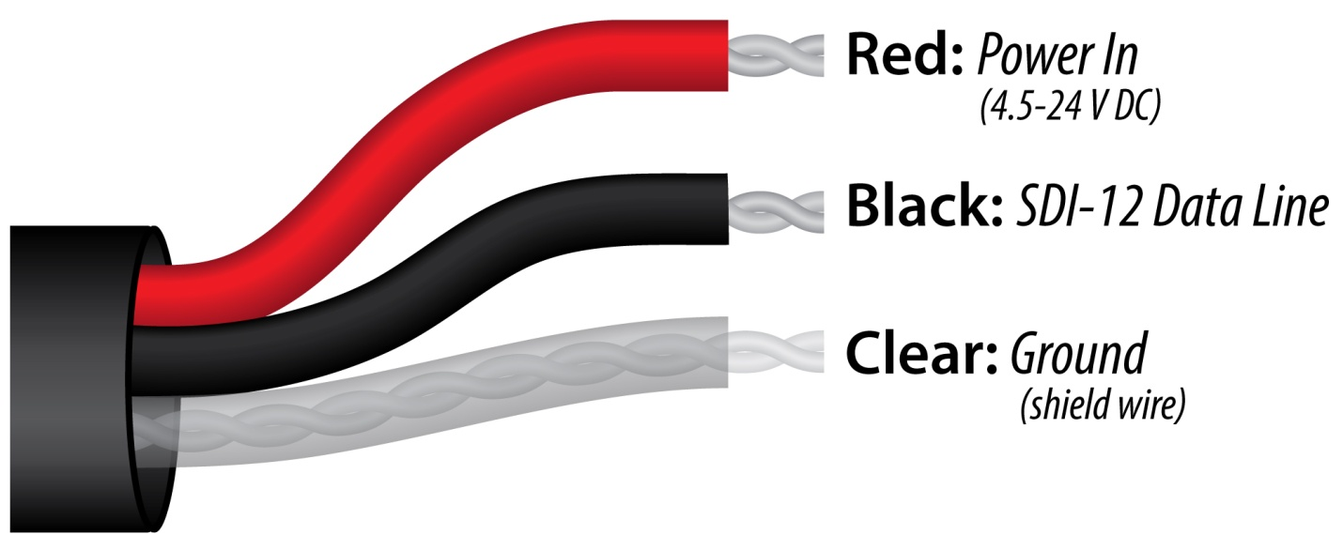

**­**

Black: Ground (for sensor signal and input power) (connect first)

Red: Power In (4.5-24 V DC) (connect last)

White: SDI-12 Data Line

Clear: Shield/Ground

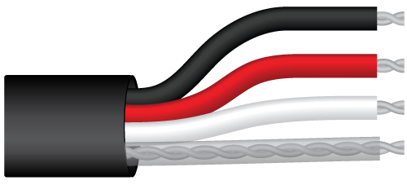

### Spreadsheet Table of Majority of SDI-12 Commands

|  |  |  |
| --- | --- | --- |
| **AC-421 SDI-12 Command Quick Reference** | | |
| **SDI-12 Command**  **(a = sensor address)** | **What sensor does** | **SDI-12 Return\*** |
| ? | Queries sensor addresses | Returns current address for sensors on the data line  Ex: ?! 🡪 0 |
| a | Confirm communication | Returns current sensor address  EX: 0I! 🡪 0 |
| aI | Returns sensor information (e.g., sensor model, serial number, firmware version, etc.) | Varies, please consult your sensor’s manual**  EX: 0I! 🡪 013Apogee SI-4210.62210 |
| aV | Displays internal saved data (e.g., calibration coefficients, offsets, etc.) | Varies, please consult your sensor’s manual**  EX: 0V! 🡪 00007  0D0! 🡪 0+1.72402r+09+1.01104e+07+82608.4  0D1! 🡪 0-2.92505e+06+23518-29598+6.2210 |
| aAx | Change sensor address to a new value (x = 1-9 or A-Z) | Sensor will return the value of the new address  EX: 0A1! 🡪 1 |
| aM, aM1, aM2 … | Used to take a measurement | Varies, please consult your sensor’s manual**  EX: 0M! 🡪 00011  0M! 🡪 0  0D0! 🡪 0+28.04520 |
| aMC, aMC1,  aMC2 … | Used to take a measurement. Data is returned with a check character | Varies, please consult your sensor’s manual**  EX: 0MC! 🡪 00011  0M! 🡪 0  0D0! 🡪 0+28.23737BXE |
| aC, aC1, aC2 | Used to take a measurement when more than one sensor is used on the same data line | Varies, please consult your sensor’s manual**  EX: 0C! 🡪 000101  0D0! 🡪 0+28.00574 |
| aCC, aCC1, aCC2 | Used to take a measurement when more than one sensor is used on the same data line. Data is returned with a check character | Varies, please consult your sensor’s manual**  EX: 0CC! 🡪 000101  0D0! 🡪 0+28.19998Iee |
| aD0, aD1,  aD2 … *** | Used to return recorded measurements from the M!, C!, or CC! commands | Varies, please consult your sensor’s manual**  See above examples |
| *Example command outputs taken using an Apogee SI-421-SS IR sensor | | |
| **Sensor manuals can be found online at: <https://www.apogeeinstruments.com/product-manuals/> | | |
| ***AC-421 automatically does display command with any measurement command | | |

### Maintenance and Recalibration

Keep dry and free of dust and it should last forever. There is no need to send back for calibration as it only converts digital signals and doesn’t actually measure anything.

### Troubleshooting and Customer Support

**Independent Verification of Functionality**

The simplest way to check sensor functionality is the a! command. This will return the address of the unit. Most sensors have a default address of “0.”

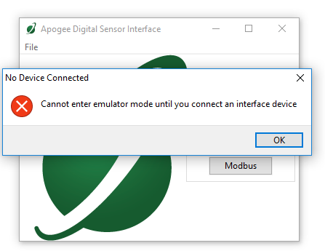**Error when DSI Software is Open Without an AC-421 Plugged In**

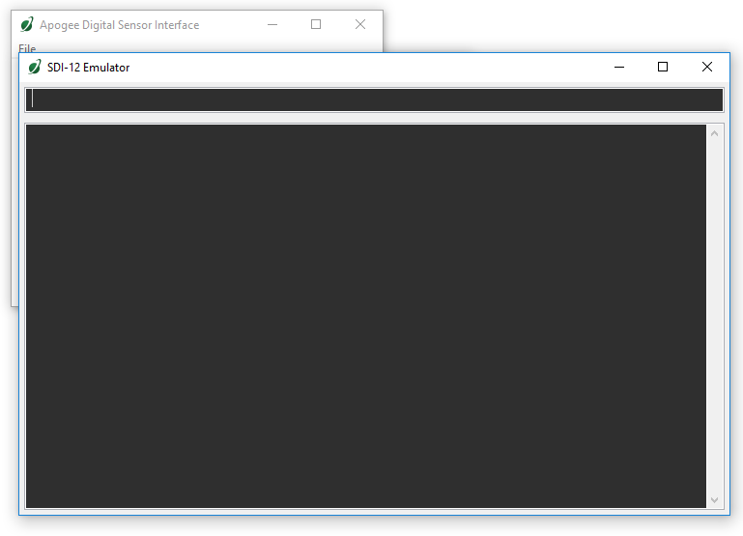**Correctly Opening SDI-12 Emulator with AC-421 Plugged Into USB Port**

**SDI-12 Sensor Incorrectly Wired up to AC-421**

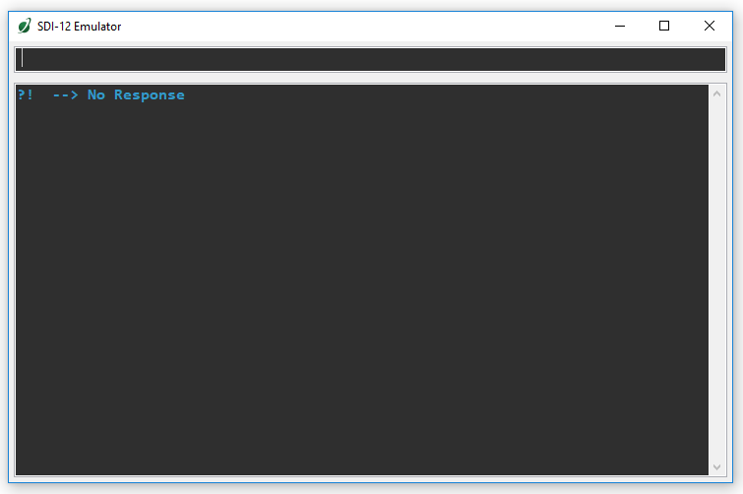

**If the AC-421 becomes unplugged with emulator window still open and you attempt to send an SDI-12 command.**

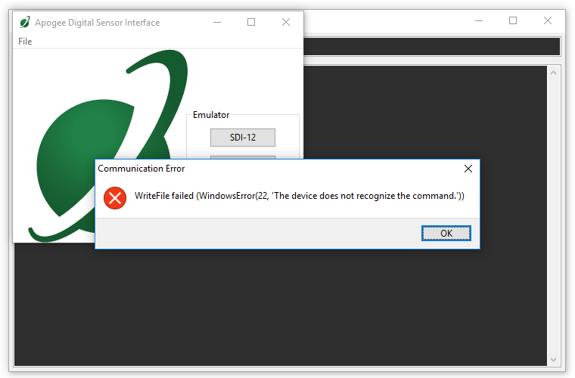

**Query Entered in Emulator to Determine Sensor Address**

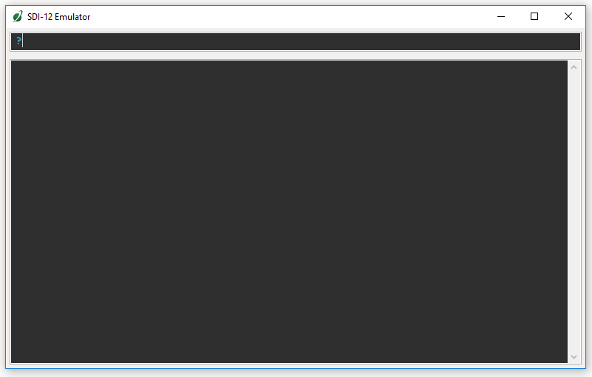

**Emulator Returns Query and Address of Sensor**

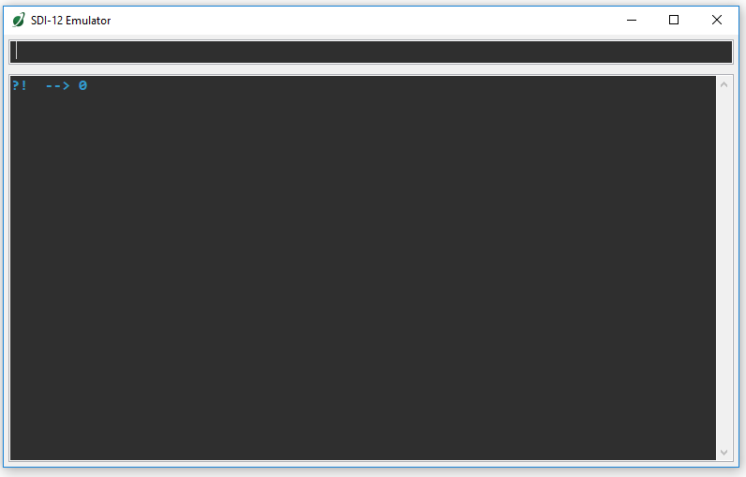

**Command Entered to Change Address**

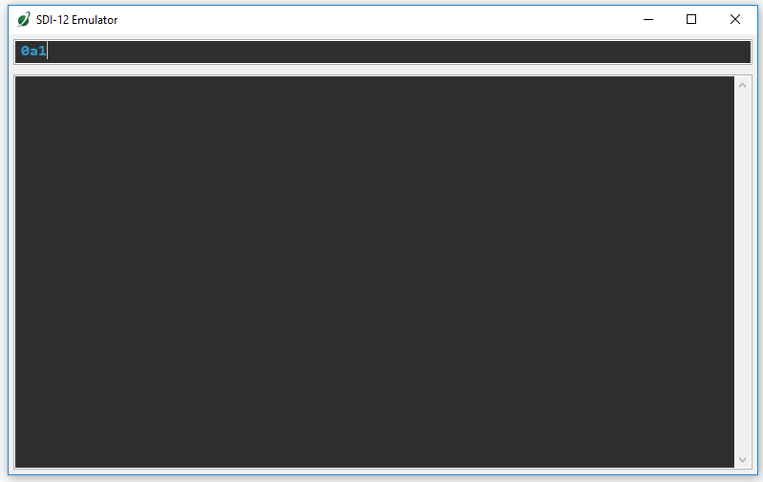

**Emulator Returns with Confirmation Address is Changed**

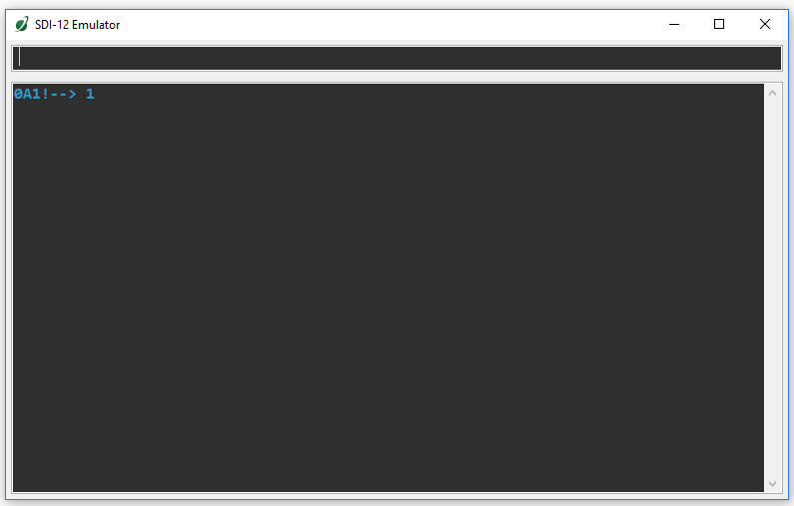

**Correct M1 Command with Correct Address Entered in Command Line**

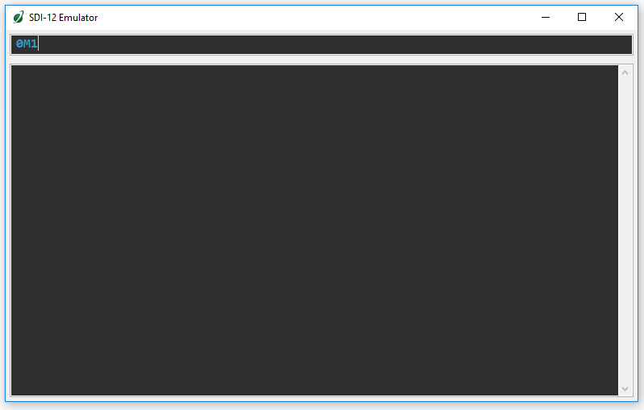

**Response when Wrong Address is Attempted when Sending a Command**

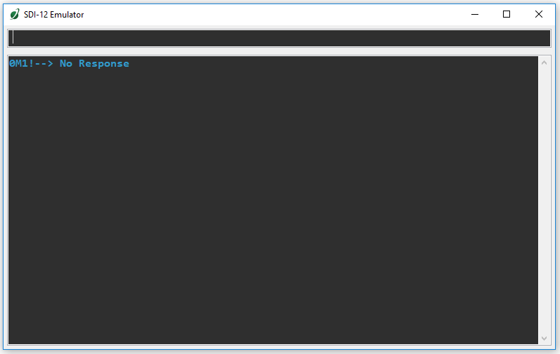

**M1 Command Entered Into Emulator Command Line**

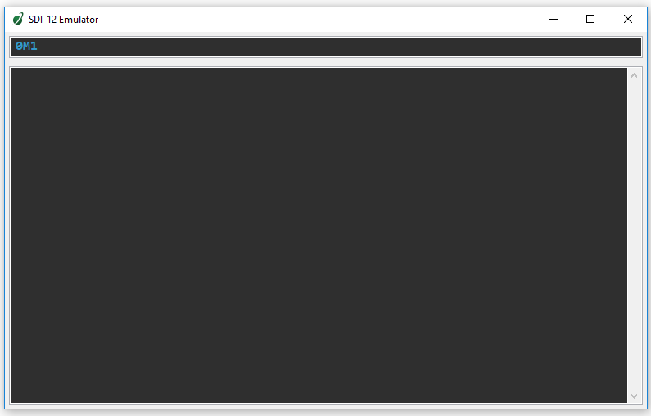

**M1 Command Sent with Correct Address. Example given showing output from SI-411**

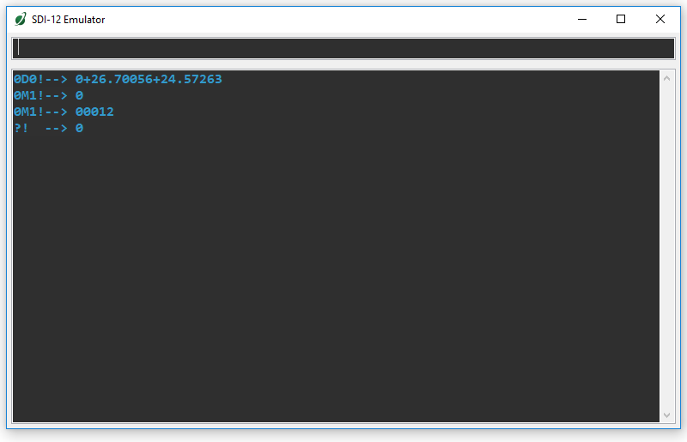

*Note that the AC-421 automatically does the D0 command after a M1 is sent in order to display the results of the measurement.

### Return and Warranty Policy

RETURN POLICY

Apogee Instruments will accept returns within 30 days of purchase as long as the product is in new condition (to be determined by Apogee). Returns are subject to a 10 % restocking fee.

WARRANTY POLICY

**What is Covered**All products manufactured by Apogee Instruments are warranted to be free from defects in materials and craftsmanship for a period of four (4) years from the date of shipment from our factory. To be considered for warranty coverage an item must be evaluated either at our factory or by an authorized distributor.

Products not manufactured by Apogee (spectroradiometers, chlorophyll content meters) are covered for a period of one (1) year.

**What is Not Covered**The customer is responsible for all costs associated with the removal, reinstallation, and shipping of suspected warranty items to our factory.

The warranty does not cover equipment that has been damaged due to the following conditions:

1. Improper installation or abuse.

2. Operation of the instrument outside of its specified operating range.

3. Natural occurrences such as lightning, fire, etc.

4. Unauthorized modification.

5. Improper or unauthorized repair.

Please note that nominal accuracy drift is normal over time. Routine recalibration of sensors/meters is considered part of proper maintenance and is not covered under warranty.

**Who is Covered**This warranty covers the original purchaser of the product or other party who may own it during the warranty period.

**What We Will Do**At no charge we will:

1. Either repair or replace (at our discretion) the item under warranty.

2. Ship the item back to the customer by the carrier of our choice.

Different or expedited shipping methods will be at the customer’s expense.

**How To Return An Item**1. Please do not send any products back to Apogee Instruments until you have received a Return Merchandise Authorization (RMA) number from our technical support department by calling (435) 792-4700 or by submitting an online RMA form at www.apogeeinstruments.com/tech-support-recalibration-repairs/. We will use your RMA number for tracking of the service item.

2. Send all RMA sensors and meters back in the following condition: Clean the sensor’s exterior and cord. Do not modify the sensors or wires, including splicing, cutting wire leads, etc. If a connector has been attached to the cable end, please include the mating connector – otherwise the sensor connector will be removed in order to complete the repair/recalibration.

3. Please write the RMA number on the outside of the shipping container.

4. Return the item with freight pre-paid and fully insured to our factory address shown below. We are not responsible for any costs associated with the transportation of products across international borders.

5. Upon receipt, Apogee Instruments will determine the cause of failure. If the product is found to be defective in terms of operation to the published specifications due to a failure of product materials or craftsmanship, Apogee Instruments will repair or replace the items free of charge. If it is determined that your product is not covered under warranty, you will be informed and given an estimated repair/replacement cost.

**Apogee Instruments, Inc.   
721 West 1800 North Logan, UT  
84321, USA**

Other Terms

The available remedy of defects under this warranty is for the repair or replacement of the original product, and Apogee Instruments is not responsible for any direct, indirect, incidental, or consequential damages, including but not limited to loss of income, loss of revenue, loss of profit, loss of wages, loss of time, loss of sales, accruement of debts or expenses, injury to personal property, or injury to any person or any other type of damage or loss.

This limited warranty and any disputes arising out of or in connection with this limited warranty ("Disputes") shall be governed by the laws of the State of Utah, USA, excluding conflicts of law principles and excluding the Convention for the International Sale of Goods. The courts located in the State of Utah, USA, shall have exclusive jurisdiction over any Disputes.

This limited warranty gives you specific legal rights, and you may also have other rights, which vary from state to state and jurisdiction to jurisdiction, and which shall not be affected by this limited warranty. This warranty extends only to you and cannot by transferred or assigned. If any provision of this limited warranty is unlawful, void or unenforceable, that provision shall be deemed severable and shall not affect any remaining provisions. In case of any inconsistency between the English and other versions of this limited warranty, the English version shall prevail.

This warranty cannot be changed, assumed, or amended by any other person or agreement.

**APOGEE INSTRUMENTS, INC. |** 721 WEST 1800 NORTH, LOGAN, UTAH 84321, USA

TEL: (435) 792-4700 | FAX: (435) 787-8268 | WEB: APOGEEINSTRUMENTS.COM

*Copyright © 2019 Apogee Instruments, Inc.*